Site Investigation Case study
The plan in question is to build a proposed restaurant, ice cream parlour and Managers Apartment on Swansea Foreshore. In this section I will be exploring the history of the site in question (see picture below). The site is located between the Civic Centre car park and the Marriot hotel car park in the Maritime Quarter of Swansea bay. Before proposing any plans, it is paramount that we fully understand the history of the site in question as this could have a vast impact on the construction and implementation of the project.
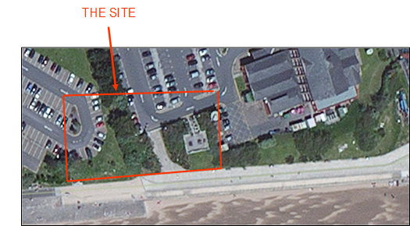

On the 25th of March 1807 the fee-paying passenger railway service was built. This was to be known as the Oystermouth railroad, later it was renamed as Swansea and Mumbles railway. This railway was the first of its kind as it was the first fee paying passenger railway in the world. The carriages were originally horse drawn which later changed to steam locomotion and later converted to electric power (Grant 2017).
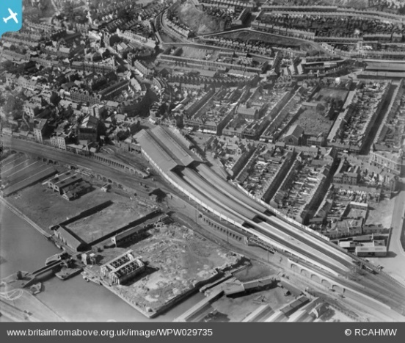
There were two main purposes of the railway, the first was for transportation and removal of limestone and the second was to transport coal from Clyne Valley. The limestone would be removed from quarries located in mumbles to Swansea’s city centre and from there it would be transported up and down Britain (Grant 2017). The train yard was located approximately 200 metres away from Swansea dock Yard. The Railway was commissioned in 1804 and closed in 1960 as it was cheaper and more accessible to get around by motor buses. The only remaining physical evidence of this railway is in Blackpill Swansea which is a steel frame being used as a barricade.
Picture showing Swansea Bay 1910
https//www.britainfromabove.co.uk

On the 1st of September 1939 Great Britain went to war with Germany amongst other countries. Due to Swansea’s dock yard and perhaps its railway it was a target for the Germans. In order to stop Great Britain from transporting any goods or weapons, Germany attacked Swansea with the use of bombs. On the 19th February 1941 Swansea went through what we refer to as “the three-night blitz”. German planes dropped an estimated 800 high explosive bombs to cripple Swansea’s exports (Dullin 2016).
The area now has had a lot of development, there has been residential and commercials buildings built. There are numerous amounts of restaurants, bars, cafes and a hotel located at the Maritime Quarter. The docks here are still active with fishing and pleasure boats.

In order to create a new restaurant and ice-cream parlour, due to the historical context of this site it is vital that we undertake a variety of investigations to ensure the site is deemed appropriate and safe to undergo this work. Some investigations are more significant than others given its historic background.
As part of the site investigation one of the first surveys that would need to be carried out is an unexploded ordnance survey. An unexploded ordnance survey (UXO) is the process of probing and scanning the land to assess if there is any unexploded material embedded in the subsurface of the site, ensuring the project can be carried out to the scheduled timescale with as little risk as possible (www.1stlinedefence.co.uk). If any unexploded material is found it will need to be removed and disposed of correctly before any work can be carried out. Unexploded bombs still pose a risk to the UK even though it’s almost been 70 years since the war. It is estimated that ten percent of bombs dropped on London alone did not detonate and therefore could still be a threat (www.landmark.co.uk). As a result of flooding and recent turbulent weather, there has been a rise in the amount of ordnance surveys being carried out. It has been reported that since December 2013 the Royal Navy’s Dive Unit have recovered and disposed of over 244 items of ordnance (www.landmark.co.uk). Due to history of bombing in the Swansea dock area a possibility of unexploded bombs is still present. Wales Online have reported an unexploded bomb was found on the 15/07/2019 on the beach opposite the Amazon Site on Swansea’s Fabian way, approximately 1.5 miles away from the site(www.walesonline.co.uk). When UXO’s are discovered it usually generates media attention and can cause major disruption to the public. Fortunately, history shows that the risk of casualties are very low, however it is still considered a high consequence event so appropriate allowance must be made at the design stage of any project (Stone, Murray, Cooke, Foran, Gooderham, 2009).
As the site under question is located on Swansea Bay, the sand here may affect the bearing capacity of the soil. The structure we are building will require a high bearing capacity so obtaining an undisturbed soil sample will tell us the bearing capacity, settlement rate of the soil, water table and with further testing the permeability of the soil. High permeability of the soil below a structure may result in subsidence if the incorrect foundations are used. Our soil sample testing would reveal if there is any soil contamination at the site. As previously mentioned, the Oystermouth railway ran across this site so investigating for any historical debris and soil contamination linked to the railway will have to be carried out before any foundations can be built on the site.
Due to the site’s proximity to a water source a water table check would need to be carried out, a water table check will help verify the permeability of the soil and its bearing capacity. With knowledge of this it will help to determine what foundation is needed for the structure. The proximity of the site to the water means that a flood plain survey will need to be carried out, this will inform you of the maximum height of the tide, from this we can decide if flooding is going to be an issue. If flooding is deemed to be an issue for the site flood defences will need to be in place.
As we are looking to construct on this site a utilities survey will need to be carried out next. This will check for all utility mains, electrical power, natural gas, water, television/telephone cables, sanitary sewers and storm drains (Clayton, 2013). All these utilities are needed for the project in question and by having this survey done will give you more information to work out the timescale for the project to be completed. There will be a smaller timescale for the project if the utilities already exist.
With the amount of coal mining that happened throughs Swansea’s History the next part of the investigation needs to be an underground survey, this will present any mining that happened on or near the site that may affect the grounds stability. These surveys are performed beneath the surface of the ground in connection with tunnelling, construction and exploration of any subterranean passageways (Russell, Minnick, 1987). A Ground Penetrating Radar (GPR) survey is a method of detecting any structures in the subsurface, is uses radar pulses to image the sub surface and reflected signals from any structures in the subsurface to make them apparent (Utsi ,2017).
Topographic surveys gather data on the elevation points of the land whether these be manmade or natural (Wilson H, 2011). Having this survey carried out before any construction work has begun will give you an estimation of how much soil will have to be excavated and removed from the site. This information can be gained from using a total station.
The next part to the investigation would be to establish what restrictions come with the site area, the land will need to have special permissions if it is a conservation area. The location of the site on Swansea bay will need to be checked for any protected wildlife, verifying this will give you answer as to whether you can build on the site. Another restriction that will be present is traffic, with only one road giving you access to the site transporting machinery and supplies to and from the site will be difficult (Clayton, 2013). You will need to check with the local authority what times the site can be worked on and delivered to in order to prevent even further issues with the traffic in that area.
The Maritime Quarter has recently been developed on with residential and commercial properties, with the amount of development on the land the ground stability with need to be checked through the undisturbed soil sample. Residents and stakeholders will be affected by noise and traffic pollution so speaking to the local authority will give you appropriate times for construction and deliveries. Speaking to local stakeholders will also bring to light any issues and restrictions they had when building their construction. The local authority will be able to advise on planning permission needed and if any project has been refused previously and for what reasons it was refused, this information will allow you to plan in further detail what precautions are needed.

The building regulation from which my recommendations are derived are as follows;
Approved Document A: Structure

From my research through the British Geological Survey I have been able to verify how the shape of the land has been affected by its geology. By pin pointing the site in question it provides information such as:
Superficial Geology
Superficial Lithology
Blown sand – Sand. Superficial deposits formed up to 3 million years ago in the Quaternary period.
Geological Environment
These sedimentary deposits are aeolian in origin. They are detrital, comprising medium to fine grained materials, forming lenses, beds and locally dunes.
Bedrock Geology
Bedrock Lithology
South Wales Middle Coal Measures Formation – Mudstone, Siltstone and Sandstone. Sedimentary bedrock formed approximately 310 to 318 million years ago in the Carboniferous period.
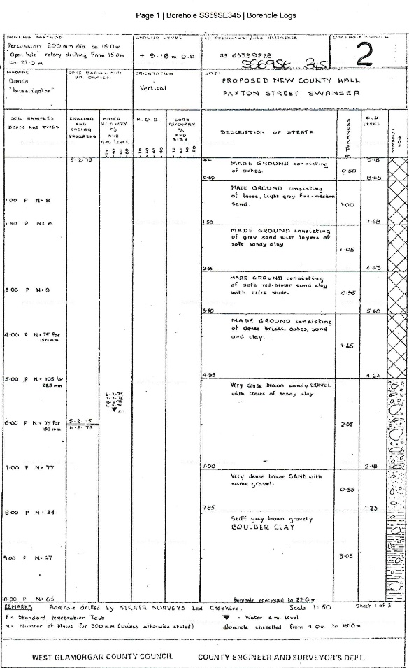
Geological Environment
These sedimentary rocks are fluvial, palustrine and shallow marine in origin. They are detrital, forming deposits reflecting the channels, floodplains and details of a river in a coastal setting.
Following my research through the British Geological survey, I have located a borehole from Paxton street, Swansea this was for a proposed new county hall to be located there. The sample taken from this borehole verifies what is mentioned above. The borehole states the sample is very dense brown sandy gravel with traces of sandy clay. As our site is closer to the beach than this borehole, the sample at your site will have higher levels of sandy clay.
From this information we can determine that subsidence is a potential hazard for a construction to be built on the site. If the soil here was tested for its permeability there would be a high level of water passing through the sample meaning the land would not have a high enough bearing capacity if using a regular foundation. The foundation I recommend for this site is a pile-enhanced raft foundation.
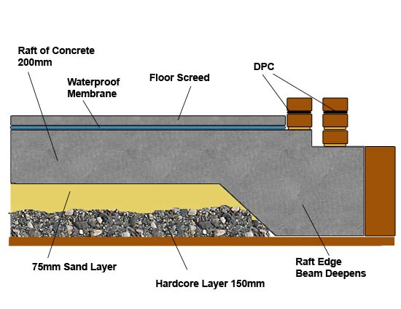
A Raft Foundation is typically used in construction for shallow depths, it requires less excavation and loads are spread over a larger area (Poulos, Small, Chow, 2011). This means it is more suited for soils with a low bearing capacity. Raft foundations consist of large concrete slabs that are spread out under the build, they can support several walls and columns (www.diydoctor.org.uk). The raft is laid on a hardcore or scalping bed and usually thickened at the edges, it can be strengthened by beams during construction. It lowers the contact pressure compared to the traditionally used trench or strip footings.
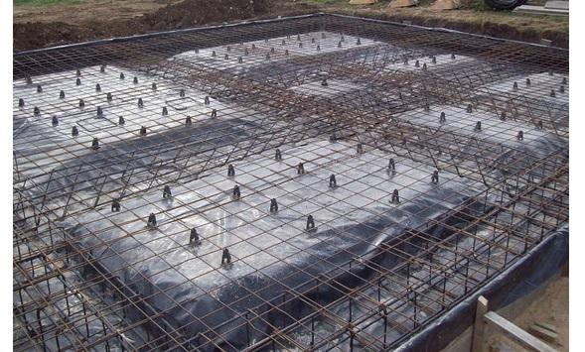

Picture of a raft foundation https://www.labc.co.uk/news/raft-foundation-basics
Picture illustrating a diagram of a raft foundation
https://www.diydoctor.org.uk/projects/rafts.htm

References
- Carradice P, 2011, The Mumbles Railway, Viewed 11/12/19, <https://www.bbc.co.uk/blogs/waleshistory/2011/03/the_mumbles_railway.html
- Clayton D, 2013, Effective Site Investigation, ICE Publishing, Scotland
- David Dullin, 2016, Swansea still regenerating 75 years after blitz, viewed 10/12/2019
<https://www.bbc.co.uk/news/uk-wales-south-west-wales-35494885>
- Donald J Grant, 2017, Directory of the Railway Companies of Great Britain, Troubador Publishing Ltd, England
- Kyakula M, 2006, Considerations in Vertical Extension of Reinforced Concrete Structures, Viewed 11/12/2019, < https://www.sciencedirect.com/topics/engineering/soil-investigation>
- Landmark Information, Unexploded Ordnance – is your site at risk? Viewed 10/12/19, <https://www.landmark.co.uk/news-archive/unexploded-ordnance-%E2%80%93-your-site-risk>
- Martin E, Oystermouth Railway, Site of Swansea to Mumbles, Wales, UK, Viewed on 11/12/19, < http://www.engineering-timelines.com/scripts/engineeringItem.asp?id=1414>
- Mike Edwards, Concrete Raft Foundations – How they are constructed, when they should be used and the advantage and disadvantages of Raft foundations, viewed 10/12/2019 <https://www.diydoctor.org.uk/projects/rafts.htm>
- Picture https://www.britainfromabove.org.uk/en/image/WPW006115
- Poulos H, Small J, Chow H, 2011, Piled Raft Foundations for Tall Buildings, Geotechnical Engineering Journal, Sydney
- Russell C, Minnick R, 1987, The Surveying Handbook, Springer-Science+Business Media, Berlin
- Stone K, Murray A, Cooke S, Foran J, Gooderham L, 2009, Unexploded ordnance UXO; a guide for the construction industry, London
- Utsi E, 2017, Ground Penetrating Radar; Theory and Practise, Butterworth-Heinemann, England
- <https://www.walesonline.co.uk/news/wales-news/explosion-heard-near-amazon-after-16590929>
- Wilson H, 2011, Topographic surveying, J. Wiley &sons, New York
- <https://www.1stlinedefence.co.uk/services/uxo-surveys/>

