Michael Oldham (2235684)
2235684@student.uwtsd.ac.uk
Databases and application development
Design and Implementation of a Centralised Relational Database System for Melody Hwb

Contents
Case Study: The MelodyHwb Music Store 2
Database Creation 3
Inserting records into the database 6
Functionality Checking: 10
Transaction Rollback: 11

Case Study: The MelodyHwb Music Store

MelodyHwb is a popular music store that specializes in selling a wide range of music instruments, equipment, and accessories. The store caters to both professional musicians and amateurs, providing them with high-quality products and exceptional customer service. MelodyHwb aims to become the go-to destination for musicians looking for their musical needs.
The store offers a diverse inventory that includes guitars, keyboards, drums, amplifiers, microphones, cables, and more. Customers can visit the store in person or place orders through the MelodyHwb website. The company also provides repair and maintenance services for musical instruments.
To efficiently manage their operations and provide a seamless customer experience, MelodyHwb plans to implement a robust backend relational database and IT system. This centralized database will be the foundation for their computerized processes, enabling efficient inventory management, sales tracking, customer relationship management, and service scheduling.

Database Creation
-- Create the database
CREATE DATABASE MelodyHwb;

-- Use the database
USE MelodyHwb;

Table Creation:
-- Create the OrderDetails table
CREATE TABLE OrderDetails (
OrderID INT,
ProductID INT,
Quantity INT,
FOREIGN KEY (OrderID) REFERENCES Orders(OrderID),
FOREIGN KEY (ProductID) REFERENCES Products(ProductID)
);

-- Create the Services table
CREATE TABLE Services (
ServiceID INT PRIMARY KEY,
CustomerID INT,
ServiceType VARCHAR(255),
ScheduledDate VARCHAR(255),
Status VARCHAR(255),
FOREIGN KEY (CustomerID) REFERENCES Customers(CustomerID)
);

-- Create the Products table
CREATE TABLE Products (
ProductID INT PRIMARY KEY,
ProductName VARCHAR(255),
Description TEXT,
Price DECIMAL(10, 2),
QuantityInStock INT
);

-- Create the Customers table
CREATE TABLE Customers (
CustomerID INT PRIMARY KEY,
FirstName VARCHAR(255),
LastName VARCHAR(255),
Email VARCHAR(255),
Phone VARCHAR(15)
);

-- Create the Orders table
CREATE TABLE Orders (
OrderID INT PRIMARY KEY,
CustomerID INT,
OrderDate VARCHAR(255),
PaymentInfo VARCHAR(255),
DeliveryPreferences VARCHAR(255),
FOREIGN KEY (CustomerID) REFERENCES Customers(CustomerID)
);

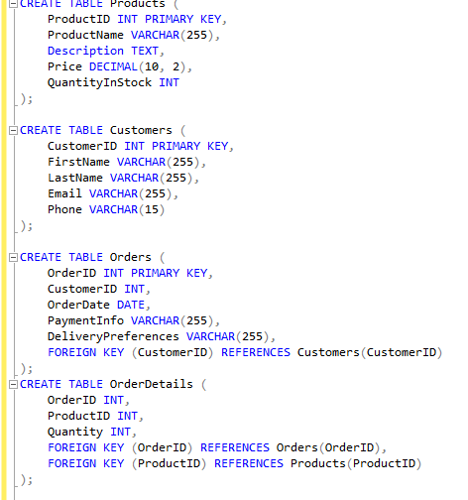
Screenshot of the code being executed in SSMS:

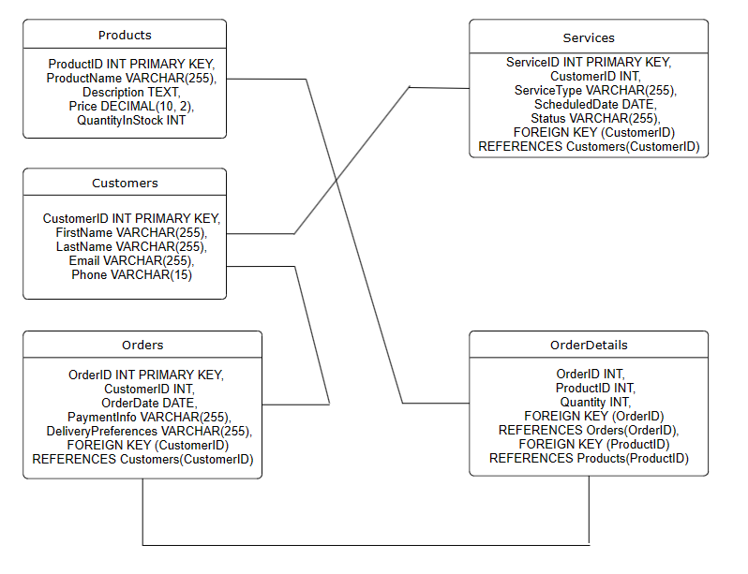

Here is my Database Schema showing the 5 tables that I have created along with their attributes, details including what the type is (INT, VARCHAR) and limitations on the number of characters.
The relationships shown are between the Products and OrderDetails being theProductID. Customers to Services as the CustomerID. Customers and Orders as the CustomerID. Orders to OrderDetails as the OrderID.
It also shows each Primary and foreign key for each table.

Inserting records into the database

To insert records into the MelodyHwb Database, the following statement can be used:

INSERT INTO table_name (column1, column2, column3,)
VALUES (value1, value2, value3,);

Here is the code which I have used to populate my products table:
INSERT INTO Products
(ProductID, ProductName, Description, Price, QuantityInStock)
VALUES (1, 'Acoustic Guitar', 'Hollow body guitar that naturally amplifies the vibrations of the strings', 700, 8),
(2, 'Electric Guitar', 'Solid body guitar which is plugged into an amplifier to project the sound', 1200, 5),
(3, 'Piano', 'stringed instrument where the strings are struck with wooden hammers coated in a soft material', 500, 3),
(4, 'Violin', '4 string instrument smallest in the violin family and high-pitched', 80, 15),
(5, 'Drum Kit', 'set of drums hit with a pair of sticks to provide rhythm', 850, 2);

When I run the SELECT * FROM Products; here is the outcome:
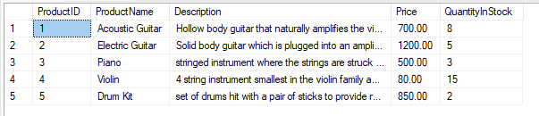

This shows that all my products have been inserted into the table with the correct details.

Here is the code used to populate the records in my customers table:
INSERT INTO Customers (CustomerID, FirstName, LastName, Email, Phone)
VALUES
(1, 'Galven', 'Toderbrugge', 'gtoderbrugge0@squarespace.com', '8221587382'),
(2, 'Grant', 'Setchfield', 'gsetchfield1@1und1.de', '8977732893'),
(3, 'Rosemonde', 'McGrady', 'rmcgrady2@slate.com', '6034326078'),
(4, 'Del', 'McMearty', 'dmcmearty3@hibu.com', '5168377139'),
(5, 'Fiona', 'Szymanowski', 'fszymanowski4@apple.com', '8514303659'),
(6, 'Cathy', 'Wearden', 'cwearden5@cbc.ca', '9674896088'),
(7, 'Priscella', 'Chason', 'pchason6@com.com', '4579345642'),
(8, 'Hulda', 'Haddleton', 'hhaddleton7@google.com.hk', '1785854325'),
(9, 'Burty', 'Havenhand', 'bhavenhand8@yandex.ru', '4407415698'),
(10, 'Patrica', 'Francom', 'pfrancom9@privacy.gov.au', '2938949282'),
(11, 'Nealson', 'Tolemache', 'ntolemachea@last.fm', '8136572530'),
(12, 'Cchaddie', 'Grist', 'cgristb@quantcast.com', '3129640818'),
(13, 'Corine', 'Melody', 'cmelodyc@163.com', '7855970762'),
(14, 'Katrine', 'Emerson', 'kemersond@discovery.com', '4174800953'),
(15, 'Bibi', 'Leyre', 'bleyree@slashdot.org', '5378489411'),
(16, 'Starr', 'McCarrick', 'smccarrickf@cnn.com', '4559352560'),
(17, 'Elnora', 'Alphonso', 'ealphonsog@illinois.edu', '6911093057'),
(18, 'Durante', 'Minucci', 'dminuccih@ebay.com', '4427321916'),
(19, 'Almira', 'Dominighi', 'adominighii@elpais.com', '1121266065'),
(20, 'Randall', 'Duncan', 'rduncanj@bloglovin.com', '3941061332');

Outcome:
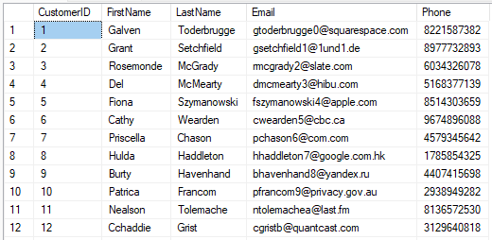

Code to Insert Order records into the database:
INSERT INTO Orders
(OrderID, CustomerID, OrderDate, PaymentInfo, DeliveryPreferences)
VALUES
(1, 8,'01.01.2024','Debit Card','NA'),
(2, 5,'13.01.2024','Credit Card','Storage box'),
(3,4,'13.01.2024','Credit Card','NA'),
(4,12,'16.01.2024','Debit Card','NA'),
(5,12,'17.01.2024','Debit Card','NA');

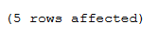

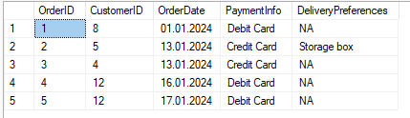

Order Details record inserts:
INSERT INTO OrderDetails (OrderID, ProductID, Quantity)
VALUES
(1,4,1),
(2,5,1),
(3,2,1),
(4,2,1),
(5,1,2);

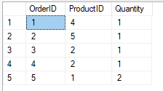

Code to insert records into the Services table:
INSERT INTO Services (ServiceID, CustomerID, ServiceType, ScheduledDate, Status)
VALUES
(1, 13, 'Repair', '17.01.2024', 'Received'),
(2, 2, 'Service', '02.02.2024', 'Awaiting Arrival'),
(3, 7, 'New Strings', '16.01.2024', 'In Progress'),
(4, 5, 'New Strings', '01.01.2024', 'Completed'),
(5, 2, 'Tuning', '03,02.2024', 'Received');
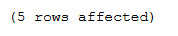

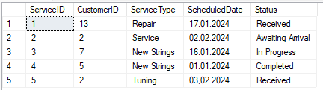

Functionality Checking:

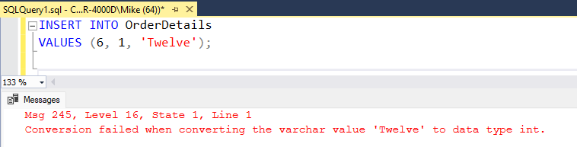

Here I am testing the constraints on the OrderDetails table. All of the column in this table have an INT constraint meaning that only numbers can be entered and not text. As text has been entered for the 3rd value, this is causing the SQL code and transaction to fail.

In SQL a primary key is a field or combination of fields that uniquely identifies each record in a table. Primary Keys must contain unique values and cannot contain NULL values.

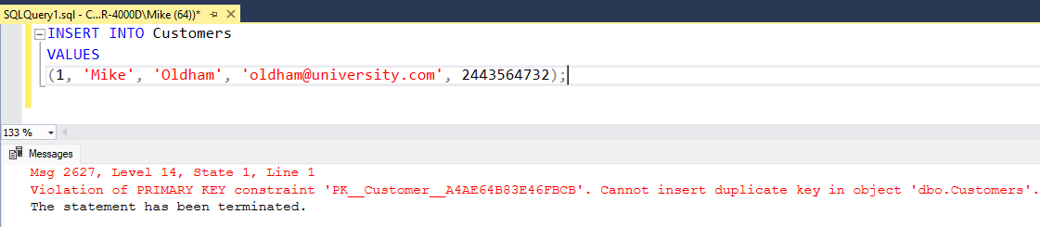

Above I have tested trying to insert a record into the Customers table where a CustomerID of 1 already exists. Therefore, the constraint is shown by preventing the record from being inserted or overwriting the existing record.

Transaction Rollback:

Here is my test for a transaction with rollback:
BEGIN TRANSACTION;

-- Deduct the quantity of the product from the inventory
UPDATE Products
SET QuantityInStock = QuantityInStock - 1
WHERE ProductID = 2;

-- If the quantity is insufficient, rollback the transaction
IF @@ROWCOUNT = 0
BEGIN
ROLLBACK TRANSACTION;
PRINT 'Order failed. Insufficient quantity in inventory.';
RETURN;
END

-- Insert the new order into the Orders table
INSERT INTO Orders(OrderID,CustomerID,OrderDate,PaymentInfo,DeliveryPreferences)
VALUES (6, 1,'01.01.2024','Debit Card','NA');

-- If the insert fails, rollback the transaction
IF @@ERROR <> 0
BEGIN
ROLLBACK TRANSACTION;
PRINT 'Order failed. Could not insert order into Orders table.';
RETURN;
END

-- If all operations were successful, commit the transaction
COMMIT TRANSACTION;
PRINT 'Order placed successfully.';

As the conditions were met, a new order has been created in the orders table:
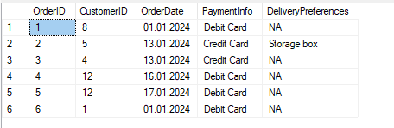

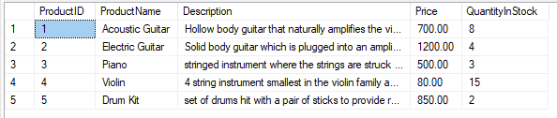
The screenshot above also shows the transaction updating the QuantityInStock column for the Electric Guitar down to 4.

I have then used this code to update the stock to 0 in order to retry the rollback transaction:
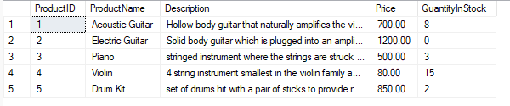
Once I ran the code a few more times, this resulted in the Quantity going down to -2 as a constraint had not been added to prevent this.
I then proceeded to add the constraint using the following code:
ALTER TABLE Products
ADD CONSTRAINT chk_QuantityInStock_nonnegative CHECK (QuantityInStock >= 0);
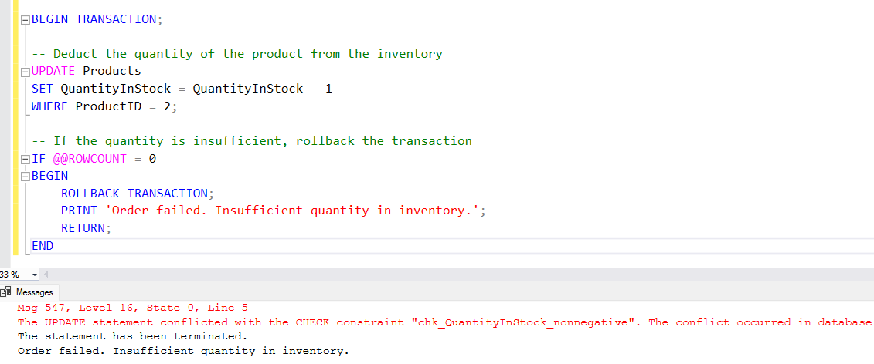

Once the code is re-run, an error is produced and the Print ‘ Order Failed’ is shown due to insufficient quantity in the store.

