Dynamic Stress-strain investigation
A physics analysis using computational modeling
Jon Walton (2028159)
2023

Abstract
This report covers an investigation of dynamic stress observed in a computational model carried out using ABAQUS. In order to do this, a simulant bullet was ‘fired’ into a simulant plate and the results analised and compared against a slightly modified version of the same simulation. The simulations carried out were nearly identical in make up save for the material properties of the projectile. One was steel and the other aluminium, both being fired at an aluminium plate. The conclusion looks at how the investigation could be improved to increase accuracy and what results could have been gleamed if those improvements were to occur.
Contents
Introduction – description of the problem 2
Methodology 2
The Method 2
Material choice 4
Simulation 5
Steel bullet simulation 5
Aluminium bullet simulation 10
Conclusion 13
References 14

Figure 1 Bullet and projectile before simulation 3
Figure 2 Bullet and projectile before simulation, with mesh visible 3
Figure 3 Parameters for the Johnson-Cook plasticity model, aluminium 6061-T6 and steel 4340, C-30 [2] 4
Figure 4 Parameters for the Johnson-Cook dynamic failure model, aluminium 6061-T6 and steel 4340, C-30 [2] 4
Figure 5 Input parameters for Johnson-Cook plasticity and dynamic failure models for aluminium Al5083 H116 [3] 5
Figure 6 Steel bullet vs aluminium plate step 1, 1.012E-05 5
Figure 7 Steel bullet vs aluminium plate at step 5, 5.0076E-05 6
Figure 8 Steel bullet, comparing tensile and shear stresses at step 5, 5.0076E-05 7
Figure 9 Steel bullet, comparing tensile and shear stresses at step 21, 2.1006E-04 8
Figure 10 Steel bullet, comparing tensile and shear stresses at step 80, 8.0003E-04 9
Figure 11 Steel bullet furthest point of penetration, step 74, 7.4003E-04 10
Figure 12 Velocity graph for steel bullet 10
Figure 13 Aluminium bullet tensile and shear stress comparison, step 5, 5.0047E-05 11
Figure 14 Aluminium bullet tensile and shear stress comparison, step 20, 2.0005E-04 12
Figure 15 Aluminium bullet furthest point of penetration, step 25, 2.5012E-04 13
Figure 16 Velocity graph for aluminium bullet 13

Introduction – description of the problem
This report covers an investigation into how changing the material of a projectile can affect its penetrative capabilities against an aluminium plate, and comparing the stress values in a simulation to determine the mode of failure. To carry out the above task, a piece of software capable of computational modeling needs to be used to construct the components and assign properties to govern their material properties and the characteristics of their interaction.

Methodology

The Method
In order to carry out an investigation into differing materials and how they affect a bullets penetrative power, it was deemed necessary to use a program designed for computational modelling. The program available is ABAQUS. Bellow is the step by step process used to construct the part assemblies.
- Create two parts in the PART module: projectile and target. Geometry can be taken from ballistics_paper1 in Moodle but you are not obliged to take these precise values.
- In the PROPERTY module:
  - Enter material properties for the various materials you might want to assign.
  - Create a Section for each material.
  - Assign Section to corresponding component.

- In the ASSEMBLY module create an instance for each part and orientate correctly.
- In the STEP module create an Explicit Dynamics Solver step with a sensible maximum simulation time
- In the LOAD module:
  - Assign a velocity to the projectile as a PREDEFINE FIELD.
- Create a Surface-to-Surface contact interaction in the INTERACTION module between the projectile and the target element nodes. Create a node set first of nodes that might be hit on the target plate.
- In the MESH module:
  - Mesh each part
  - Decide whether to delete an element when it’s fully damaged
  - Decide whether to convert elements into SPH particles
- In the JOB module create a job and submit it for execution.
- In the VISUALIZER module, the various direct and shear stress components can be inspected. Velocity of the projectile can be plotted.
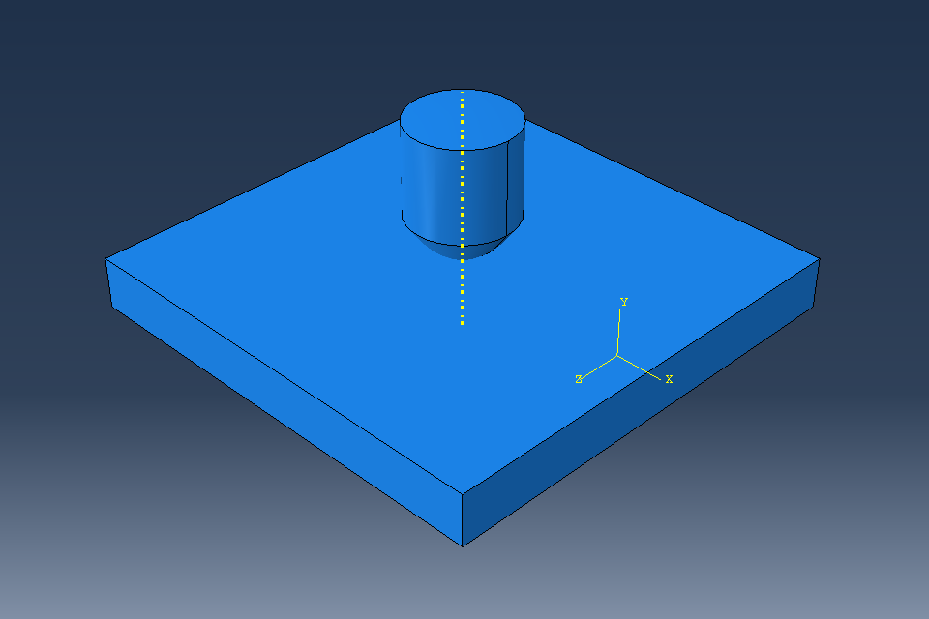
Figure 1 Bullet and projectile before simulation
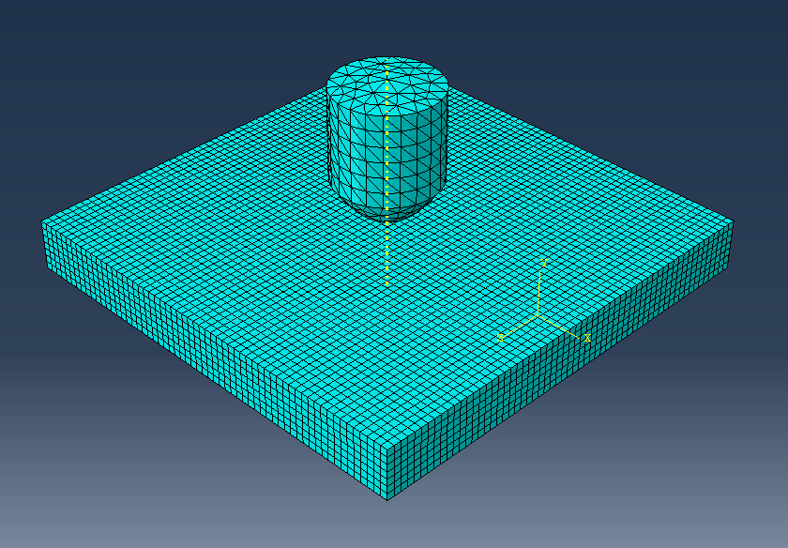
Figure 2 Bullet and projectile before simulation, with mesh visible

Material choice
Two metals were chosen for simulation in line with the assignment requirements. To ensure that results could be easily compared, the two metals chosen had to have very different physical properties. Steel and aluminium met these requirements. For the specific metals, two sources were used to provide both the material properties for the aluminium plate and the projectiles, see figures 3, 4 and 5.
For the aluminium plate, Aluminium 6061-T6 was selected. Some additional properties were gathered from matlab.com to fill in the blanks not available in the papers that most of the information was gathered from [1].
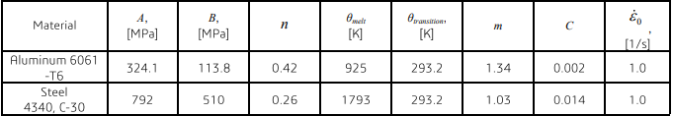
Figure 3 Parameters for the Johnson-Cook plasticity model, aluminium 6061-T6 and steel 4340, C-30 [2]
For the steel projectile 4340, C-30 steel was selected. For the aluminium projectile aluminium Al5083 H116 was selected.

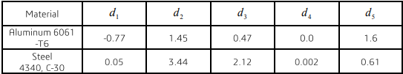
Figure 4 Parameters for the Johnson-Cook dynamic failure model, aluminium 6061-T6 and steel 4340, C-30 [2]
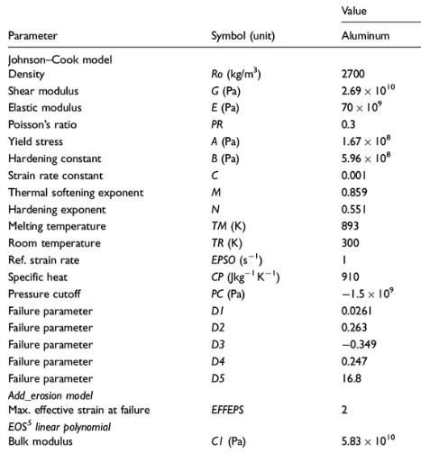
Figure 5 Input parameters for Johnson-Cook plasticity and dynamic failure models for aluminium Al5083 H116 [3]

Simulation

Steel bullet simulation
The first simulation to take place was using the steel projectile. As per figure 6, initial impact shows enormous levels of stress in the bullet and the start of the propagation of stress throughout the aluminium plate.
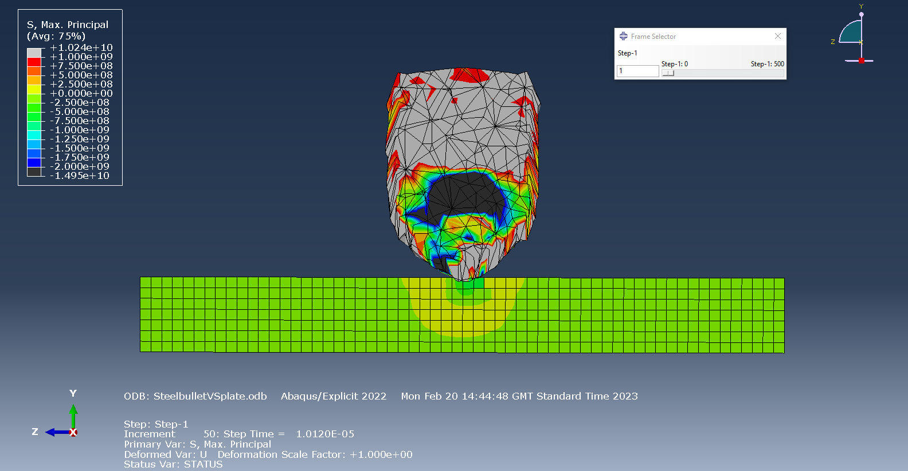
Figure 6 Steel bullet vs aluminium plate step 1, 1.012E-05

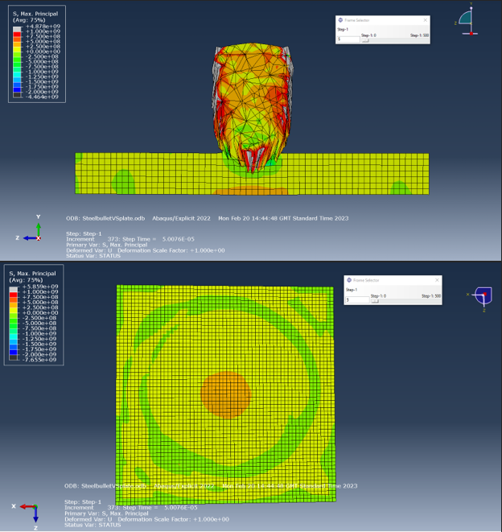
Figure 7 Steel bullet vs aluminium plate at step 5, 5.0076E-05

50 microseconds into the simulation, pressure waves can be seen across the aluminium plate, with some begin to reflect through the material as can be seen in figure 7. In figure 8, side by side shots of the same moment allow for direct comparisons between the stress levels of both the tensile (Max. Principle) and shear (S23) stresses. By comparing the two images, it is possible to deduce that the plate is going to fail from tensile stresses rather than shear, as the tensile stress values are considerably higher, meeting or exceeding the ultimate tensile strength of the aluminium plate.
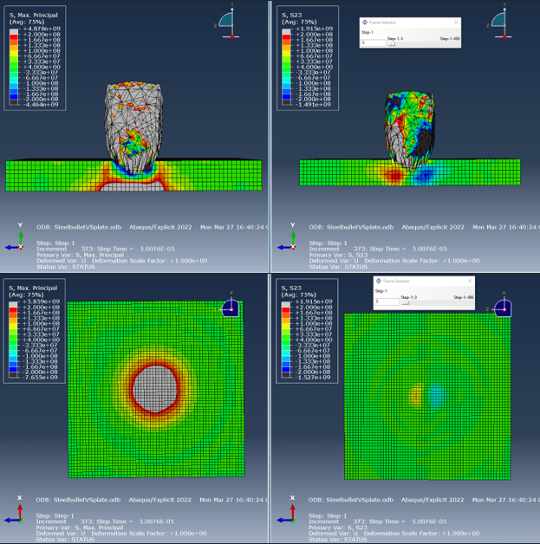
Figure 8 Steel bullet, comparing tensile and shear stresses at step 5, 5.0076E-05

The shapes of the tensile stress profile, see figure 8, point towards plate failure resulting in deformation and spalling. For the shear stress profile, the shape is more conical, but has substantially lower stress values.
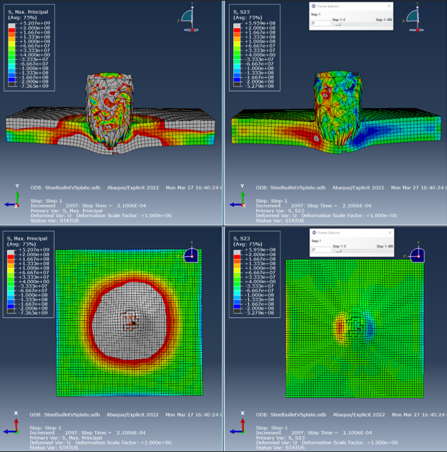
Figure 9 Steel bullet, comparing tensile and shear stresses at step 21, 2.1006E-04

Figure 9 very clearly shows the stark difference in the types of stress levels present in the plate as the steel bullet starts to brake the back face of the aluminium plate. The Max. Principle view shows tensile stresses well in excess of 2E8 Pascals throughout the plate, both on the front and rear faces, some as high as 5.207E9 Pascals. The S23 view does have shear stress values that exceed 2E8 Pascals, but top out at only 5.959E Pascals, but in very small, isolated areas.
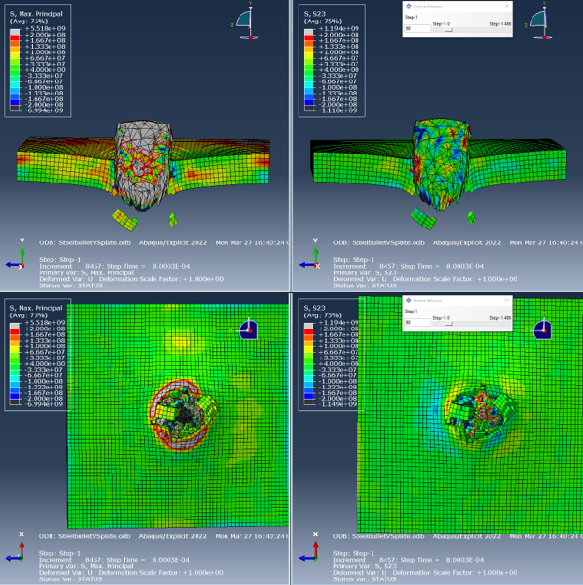
Figure 10 Steel bullet, comparing tensile and shear stresses at step 80, 8.0003E-04

Spalling can be seen to be coming off the back of the aluminium plate in figures 10 and 11. It can be observed that after the furthest point of penetration, the shear stresses fall off very quickly whilst pressure waves can still be seen reverberating through the plate when examining the tensile stresses, see figures 10 and 11.
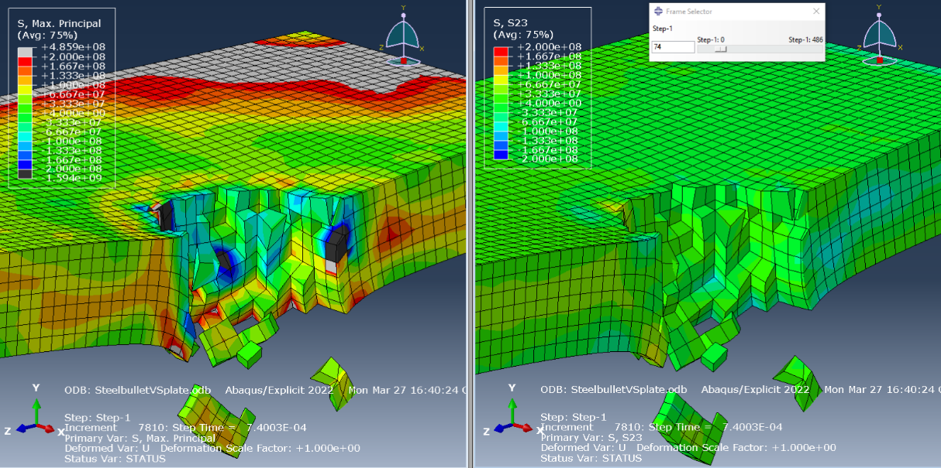
Figure 11 Steel bullet furthest point of penetration, step 74, 7.4003E-04

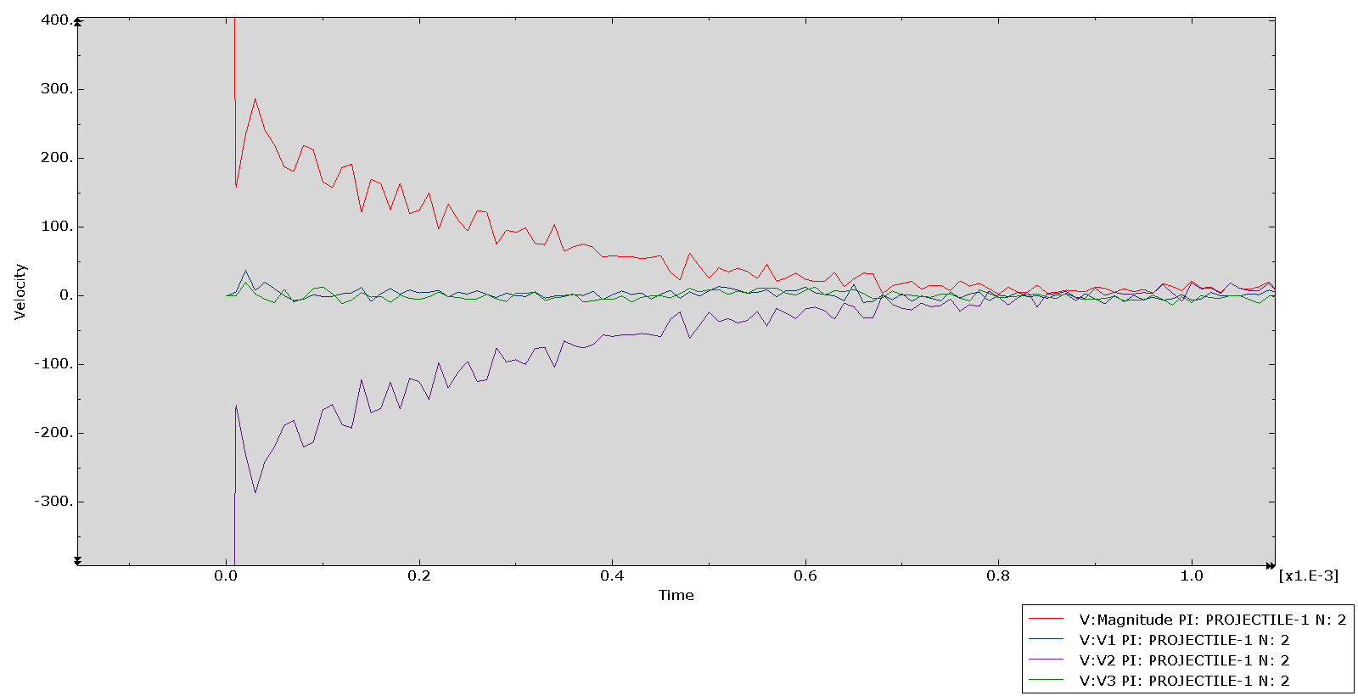
Figure 12 Velocity graph for steel bullet
When examining the magnitude of the projectile during the simulation, it was noted that a great deal of oscillation occurred during the impact, showing not just deceleration, but reflection of the stresses being imparted into the aluminium plate.

Aluminium bullet simulation
Before the simulation of the aluminium bullet, it was predicted that there would be less penetration due to significant differences in material properties, see figures 3, 4 and 5. This did turn out to be the case, however, the same stress patterns were still visible in the aluminium plate, as can be seen in figures 13, 14 and 15.
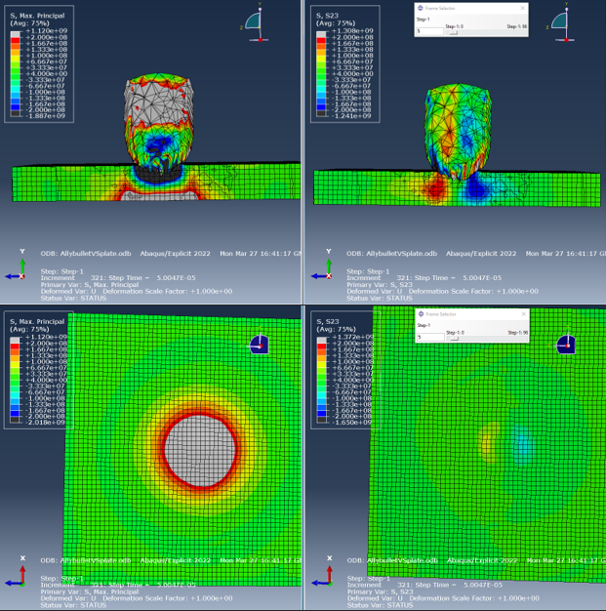
Figure 13 Aluminium bullet tensile and shear stress comparison, step 5, 5.0047E-05
As per figure 13, the cone like stress build up can be seen when looking at the shear stresses (S23) much like the steel bullet created, but very little stress buildup can be see on the underside of the plate in comparison with the tensile stresses observed (Max. Principle).
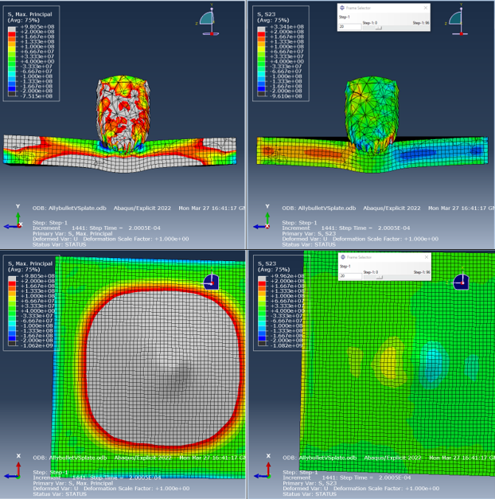
Figure 14 Aluminium bullet tensile and shear stress comparison, step 20, 2.0005E-04
Dispite the lack of penetration, many similarities can be seen in the stress patterns of both the steel bullet and aluminium bullet simulations. The biggest difference besides the lack of penetration was the speed and propegation of the stresses through the aluminium plates. With the steel bullet, material failure ahead of the bullet tip occures almost immediately as can be seen in figure 8, specifically when looking at the tensile stress (Max. Principle) values in comparison to the highly stresses but still visible nodes on the aluminium plate in figure 13. The black area at the face of the bullet shows a highly compressed section of the aluminium plate which are nodes that have not yet been deleated as a result of being fully damaged.
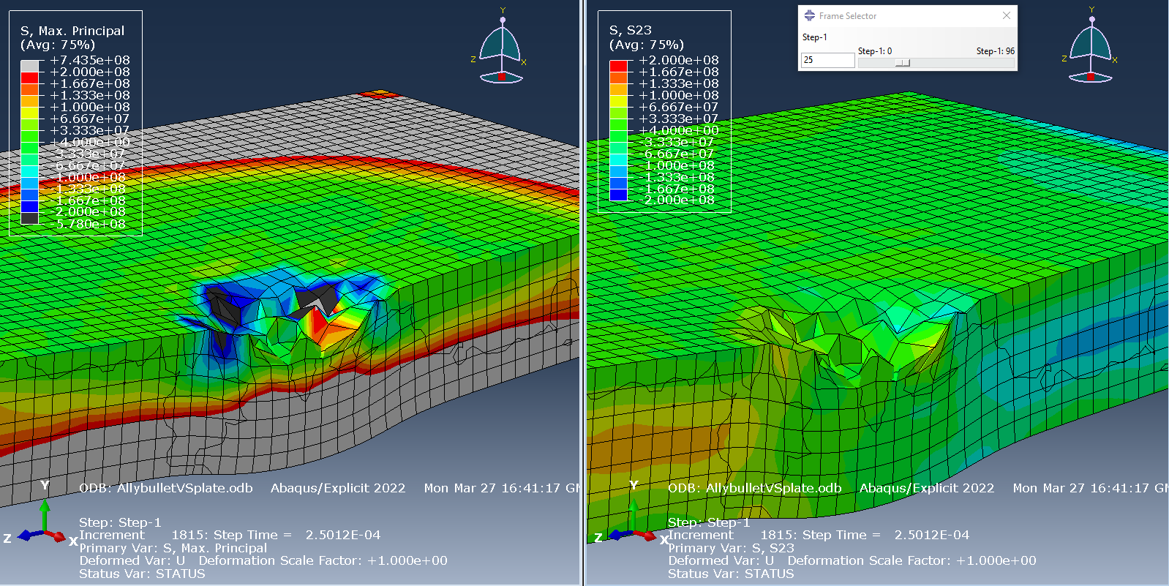
Figure 15 Aluminium bullet furthest point of penetration, step 25, 2.5012E-04
Although no penetration occurred, the aluminium plate shows a great deal of deformation as a result of high levels of tensile and compressive stresses.
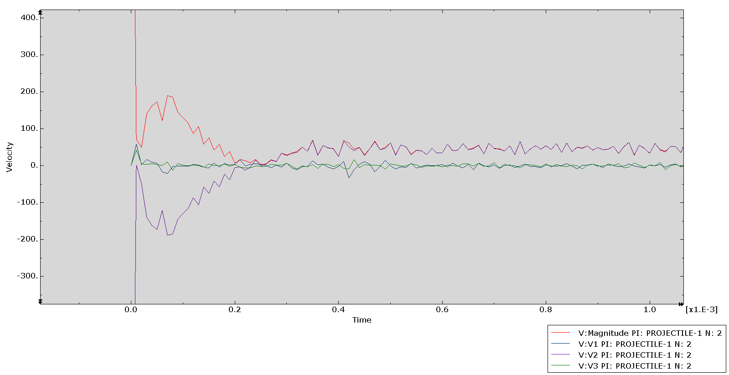
Figure 16 Velocity graph for aluminium bullet
Much like figure 12, figure 16 shows the deceleration and oscillation within the aluminium bullet detailing the reflection of stresses with the components. The sustained velocity that occurs starting around 0.2E-3 seconds, is due to the aluminium bullet failing to penetrate and ricocheting away from the face of the aluminium plate.

Conclusion
As informative as the simulations were, they were both fairly inaccurate. The material properties of the bullets had to be simplified to get the simulation working. Lots of crashes and simulation errors occurred when the values for the dynamic failure model were inputed in the bullet properties. If the full material properties were included and succesful simulations were run, there would be much more valuble information to be gathered from the damage incurred by the bullets. It is possible that the bullets would have failed from a different kind of stress allowing for interesting comparisons to made between both the plate and the bullets. Another factor that affected the accuracy of the simulation was the dimentions of both components. The bullets were not representative of any small arms ammuntion and as a result, the velocity of each bullet had to be increased to over 1500m/s. With more time, and a more experianced had operating the computational modeling program, it is more than likely that a succesful simulation would have been possible.
Dispite the inacuracies of the investigation, it was possible to see different types of stress present simultaniously, and with very levels of severity. This allowed an analysis of the failure modes in a simulation to be scrutenised and the likely maner of failure to be identified.

References

[1] | Matweb, “Aluminum 6061-T6; 6061-T651,” Matweb, [Online]. Available: https://www.matweb.com/search/DataSheet.aspx?MatGUID=b8d536e0b9b54bd7b69e4124d8f1d20a&ckck=1. [Accessed 20 February 2023].
[2] | SIMULIA, “Simulation of the ballistic performation of aluminium plates and Abaqus/Explicit,” Dassault Systemes, 2012.
[3] | A. Rashed, M. Yazdani, P. H. Parvin and A. A. Babaluo, “Investigation on high-velocity impact performance of multi-layered alumina ceramic armors with polymeric interlayers,” Sage journals, vol. 50, no. 25, 28 July 2016.

