“Developing a Sustainable Packaging Solutions Company for E-commerce SMEs: A Business Development Proposal”

Table of Contents
Chapter 1: Introduction 3
1.1 Background and Context 3
1.2 Problem or Opportunity Statement 4
1.3 Initial Observation of Demand 4
1.4 Aim, Objectives and Research Questions 5
1.5 Scope and Boundaries 5
1.6 Structure of the Report 6
Chapter 2: Company Description 7
2.1 Business Identity and Legal Structure 7
2.2 Product or Service and the Problem Solved 7
2.3 Founding Idea and Brief History 7
2.4 Mission, Vision and Values 8
2.5 Business Objectives and Goals 8
2.6 Alignment with Trends and Opportunity 9
References 10

Chapter 1: Introduction

1.1 Background and Context
With the surge in eCommerce, the amount and significance of packaging materials that insulate, move and deliver products to customers has grown even more. While e-commerce provides a great deal of commercial opportunities for small and medium-sized companies (SMEs), it can put strain on the environment due to the packaging, transportation and product return elements of its logistics chain. Business-to-consumer e-commerce means a growing number of smaller packages, deliveries and returns, and it is time to look at packaging and logistics in a new light, to reduce the environmental impact.
This is a problem on a scale that is illustrated by recent European data. In 2023, 79.7 million tonnes of packaging waste were generated in the EU. This is equivalent to 177.8 kg per capita, which represents a decrease of 8.7 kg per capita from 2022 (Europa, 2025). Out of all the packaging waste generated, 40.4% was paper and cardboard, 19.8% was plastic, 18.8% glass, 15.8% wood, 4.9% metal and 0.2% other packaging (Europa, 2025).
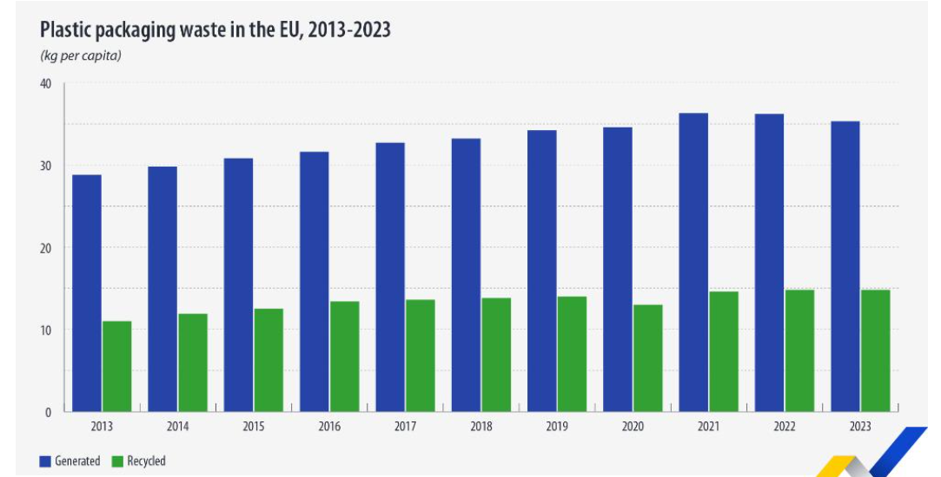
Figure 1: “Plastic Packaging waste”
(Source: Europa, 2025)
The innovation drives companies to be more sustainable with their packaging and practices. This pressure is additionally increasing due to regulatory changes; for example, the European packaging policy outlines the goal of making packaging more economically viable to recycle by 2030 (Europa, 2025). However, this can be a challenge for e-commerce SMEs due to higher costs, limited availability of materials and technical issues. Thus, a niche business that can offer cost-effective and feasible sustainable packaging solutions could be feasible.

1.2 Problem or Opportunity Statement
The main problem of e-commerce SMEs is the challenge of finding packaging that not only fulfills environmental expectations but also customer needs and economic constraints. Alayón et al. (2022) points out limited technical skills and restricted supplier availability, as well as higher material costs, are significant barriers for the adoption of sustainable packaging by SMEs. This is important as SMEs are likely to have less financial and operational resources to work with compared to larger organisations. The volume of packaging waste and evolving regulatory requirements provide a potential market opportunity at the same time. So the business opportunity is to create a specialist company that can offer sustainable packaging solutions that are both commercially viable and environmentally responsible to e-commerce SMEs.

1.3 Initial Observation of Demand
Initial results indicate that customer and market conditions are becoming more favourable for sustainable packaging. Almost three quarters of European consumers (73%) are willing to only buy products that are sustainable if they are as price competitive as conventional products, while only 27% are willing to pay more for sustainable products, whatever the prices (Spnews, 2025). This means that packaging sustainability can shape consumer expectations which in turn, can impact e-commerce businesses' buying decisions.
Furthermore, a significant amount of packaging waste is produced every day, which also has an environmental and business justification for finding other packaging solutions. The evidence does not prove the specific desire on the part of e-commerce SMEs to pay for sustainable packaging, but it does suggest there is a relevant market need to be explored. Uncertainty in customers' willingness to pay premium prices is mentioned as one of the problems in the development of a sustainable business by Lee et al. (2022).

1.4 Aim, Objectives and Research Questions
Aim:
This business development proposal is to assess the opportunity and create an initial commercially viable and environmentally friendly packaging solutions business model for the e-commerce SMEs.
Objectives:
- To discuss the sustainable packaging needs, challenges and emerging trends for e-commerce SMEs.
- To assess market demand and external environmental, regulatory, economic and technological influences for the adoption of sustainable packaging.
- To evaluate industry competitiveness by evaluating the requirements of customers and possible parts of a business model through the use of suitable business development frameworks.
- To create a viable and sustainable packaging business model, that is as affordable as possible, while simultaneously providing value to the customer, being environmentally friendly, and being commercially viable.
Research Questions:
- What are the key sustainable packaging needs and challenges for e-commerce SMEs?
- What quantitative and qualitative market trends suggest a market opportunity for sustainable packaging solutions?
- What might be some of the external and competitive factors that can impact the sustainability of an e-commerce SME's packaging provider?
- How to reconcile sustainability, affordability and operational efficiency in a business model?

1.5 Scope and Boundaries
The proposed work centres on the sustainable packaging solutions for e-commerce SMEs, especially emphasizing recyclable, biodegradability and compostable packaging. Market demand, customer needs, environmental and regulatory changes, competitiveness of industry and business model development will be taken into account. The proposal will rely on secondary data sources which include academic literature, market research, Government documents and Industry reports. This stage would not involve primary survey and interviews, as detailed financial forecasting and full operational implementation would be outside the scope of this stage and as suggested in the proposed secondary-data methodology.

1.6 Structure of the Report
Chapter 2 presents the proposed sustainable packaging company and provides an explanation on who the company is, what it does, why it has been formed, the mission, vision, values and initial business objectives. In the following chapters, the methodology, market opportunity, competitive environment and business model will be discussed. The proposal will then look at restrictions, time limits and overall summary or conclusions. This structure helps to build a flow between recognizing the packaging issue and evaluating a business solution.

Chapter 2: Company Description

2.1 Business Identity and Legal Structure
Proposed venture will be a new company for sustainable packaging solutions named ‘EcoPack Solutions' which will be specifically targeted towards small and medium enterprises within the e-commerce sector. Initially, the business will be small with the aim of supplying sustainable packaging products and packaging related support. A private limited company structure is suggested because it offers a suitable structure for a business venture and is a way of separating the company from the owners.

2.2 Product or Service and the Problem Solved
EcoPack Solutions will provide a range of sustainable packaging solutions, such as recyclable, biodegradable and compostable packaging materials, as well as general packaging-selection support. The service will be based on the actual needs of e-commerce SMEs, such as order fulfilment, product protection, packaging costs and environmental friendly packaging.
The proposed offer is a solution to the problem identified in Chapter 1. In conclusion, the EU generated 35.3 kg of plastic packaging waste per capita in 2023, with just 14.8 kg being recycled, showing that significant progress remains to be made in closing the recycling-packaging waste loop (Europa, 2025). EcoPack Solutions will therefore work to identify packaging solutions that will cut down on unnecessary packaging consumption and ensure product protection for SMEs.
The first value proposition is available and viable sustainable packaging solutions for e-commerce small and medium-sized enterprises. The company will attempt to bring environmental sense and cost consciousness together, not at the cost of charging customers a higher price. This is especially pertinent in the context of SMEs, who may be required to pay higher prices for sustainable materials, and may experience constraint from suppliers.

2.3 Founding Idea and Brief History
It is proposed that a new venture, EcoPack Solutions, will be established. Based on the gap, the business idea emerged as being sustainable packaging solutions, given the growing needs for sustainable packaging and the challenges faced by smaller e-commerce businesses. Packaging is recognized as a critical part of environmental concerns related to the e-commerce logistics chain according to Park et al. (2024), as the number of small packages and deliveries in B2C e-commerce are growing. This provides a reason why someone should have a specialist business dedicated to the packaging needs of the smaller online retailer.

2.4 Mission, Vision and Values
Mission:
The challenge of EcoPack Solutions is to offer e-commerce SMEs eco-friendly, practical and accessible packaging options to cater to their business needs and to minimize use of less sustainable packaging materials.
Vision:
The company's vision is to become a recognised sustainable packaging partner for e-commerce SMEs and be part of the overall shift to more circular and resource-efficient packaging.
The business will be run on the four values. Sustainability will be a factor when choosing materials and suppliers. Affordability will take into account smaller businesses' financial constraints. Packaging solutions will be based on actual operational requirements, through Customer focus. A continuous improvement process will encourage the company to be responsive to the changes in materials, technology, regulatory and customer requirements. These principles are consistent with Patel's (2023) argument that successful sustainable packaging approaches need to balance sustainability, functionality and cost efficiency.

2.5 Business Objectives and Goals
EcoPack Solutions will set measurable early stage goals for the first 12 months. The business plan aims to:
- Within 6 months build the base portfolio of no less than 10 sustainable packaging products.
- Develop at least three good packaging supplier relationships in the first six months.
- Get 25 e-commerce SME customers in the first 12 months of business.
- Provide at least 85% customer satisfaction during the first year (as evidenced by customer feedback and repeat-order performance).
- Implement a packaging-material sustainability monitoring system, supplier performance monitoring system and customer requirements monitoring system within the first year.

2.6 Alignment with Trends and Opportunity
EcoPack Solutions is well-positioned based on the trends in the environment and the market that were identified in Chapter 1. The environmental justification is significant as well: according to Recoup (2025), the amount of packaging waste created in the EU during 2023 was 79.7 million tonnes and the average amount of plastic packaging waste was 35.3 kg per capita.
Newly enacted laws or regulations enhance the strategic value of the proposed business. The European Commission's packaging policy aims to ensure that packaging is recyclable in an economically viable way by 2030, minimize the use of virgin materials and promote the circular economy. EcoPack Solutions thus reacts to the pressure from nature, expectations of consumers and regulations. But further market and feasibility studies must determine if SMEs are willing to pay commercially viable prices for these solutions.

References
Alayón, C.L., Säfsten, K. and Johansson, G., (2022). Barriers and enablers for the adoption of sustainable manufacturing by manufacturing SMEs. Sustainability, 14(4), p.2364.
Europa (2025) 35.3 kg of plastic packaging waste Available at: https://ec.europa.eu/eurostat/web/products-eurostat-news/w/ddn-20251022-1 (Accessed on: 15/08/2026)
Europa (2025) Packaging waste Available at: https://ec.europa.eu/eurostat/web/products-eurostat-news/w/ddn-20251022-1 (Accessed on: 15/08/2026)
Europa (2025) Plastic packaging waste Available at: https://ec.europa.eu/eurostat/statistics-explained/index.php?title=Packaging_waste_statistics (Accessed on: 15/08/2026)
Europa (2025) Recycling Available at: https://environment.ec.europa.eu/topics/waste-and-recycling/packaging-waste_en (Accessed on: 15/08/2026)
Lee, B.H., Georgallis, P.P. and Struben, J., (2022). Sustainable entrepreneurship under market uncertainty: Opportunities, challenges and impact. Handbook on the Business of Sustainability, pp.252-272.
Park, J., Waqar, Z. and Snyder, W.R., (2024). Environmental analysis of returnable packaging systems in different eCommerce business and packaging management models. Journal of industrial ecology, 28(6), pp.1493-1506.
Recoup (2025) Waste in EU Available at: https://www.recoup.org/members-update/reduction-in-plastic-packaging-waste-in-the-eu/ (Accessed on: 15/08/2026)
Spnews (2025) Consumer survey Available at: https://spnews.com/pro-cartons-consumer-survey/ (Accessed on: 15/08/2026)

