

Programme: BSc Applied Computing
Module: Scripting and Programming Concepts
Module code: ACCA5036
Lecturer: Dr Mobolanle Bello
Assignment: Coursework Programming Assignment with Associated Documentation
Student: Joaquin Alexander Canales Garcia
GitHub Link: Smart Home Device Manager
Link: Smart Home Device Manager Bright Minds Academy · alexgarcia049012/testuing@c8bec7e
Student ID: 2427434
Date: 23/07/26
Contents
1.0 INTRODUCTION. 2
2.0 REQUIREMENT ANALYSIS 3
3.0 SOFTWARE DESIGN AND DEVELOPMENT 5
3.1 Design 5
3.1.1 Flowchart 6
3.1.2 Pseudocode 8
3.2 Implementation Decision 12
3.2.1 Data Structures 12
3.2.2 Programming Constructs 13
3.2.3 Python Modules and Libraries 14
4.0 TESTING AND DEBUGGING 16
4.1 Role of Testing in Software Environment 16
4.2 Type of Errors in Programming 16
4.3 Example of Test Cases 17
5.0 EVALUATION 21
Challenges Faced 21
Future Improvements 22
Self-Reflections 22
REFERENCES 23

INTRODUCTION.
Smart technologies are increasingly used in educational environments to improve classroom management, energy efficiency, security, and the monitoring of connected devices. As schools adopt more Internet of Things (IoT) technologies, staff require reliable software to organise and manage these devices efficiently. Manual management can result in inconsistent records, delayed maintenance, and difficulties monitoring device status, making computer-based solutions essential for improving operational efficiency.
Software engineering is the systematic application of engineering principles to the design, development, testing, and maintenance of software systems to ensure they are reliable, maintainable, and capable of meeting user requirements [1]. Applying these principles helps produce software that is organised, reusable, and easier to maintain throughout its lifecycle.
This project presents the development of a Smart Home Device Manager for Bright Minds Academy using Python. The console-based application enables users to display registered devices, add new devices, update operational status, search for existing records, delete obsolete devices, and generate summary statistics. The system demonstrates key programming concepts, including dictionaries, user-defined functions, selection and iteration statements, input validation, and exception handling.
This report discusses the analysis, design, implementation, testing, and evaluation of the application, demonstrating how structured software development techniques were applied to produce a reliable and maintainable solution while providing a foundation for future enhancements.

2.0 REQUIREMENT ANALYSIS
Requirement analysis is a fundamental stage of the software development lifecycle because it identifies the functionality that a software system must provide to satisfy user needs and project objectives [1]. Conducting a clear analysis before implementation reduces development risks, supports effective planning, and ensures that the completed application meets both functional and non-functional requirements.
The objective of this project was to develop a Python-based Smart Home Device Manager capable of supporting the daily management of smart devices installed throughout Bright Minds Academy. As the number of connected devices increases, manually recording their locations and operational status becomes inefficient and more susceptible to human error. The proposed application addresses this problem by providing a centralised console-based system that enables users to organise and monitor smart devices through a simple menu-driven interface.
The prototype implements the core functional requirements specified within the assignment. Users can display all registered devices, add new devices, update operational status, search for devices by name, delete obsolete records, and generate summary statistics showing the number of devices in each operational state. These features were selected because they demonstrate the practical application of dictionaries, functions, control structures, iteration, input validation, and exception handling while remaining appropriate for the scope of the module.
In addition to the functional requirements, several non-functional requirements influenced the design of the application. The software was designed to be reliable through comprehensive input validation and error handling, preventing invalid menu selections, duplicate device names, and incomplete user input. The program was also developed using modular programming principles, with each major operation implemented as an independent function to improve readability, maintainability, and future scalability. Although advanced features such as database integration, user authentication, and graphical user interfaces were intentionally excluded from this prototype, the completed application successfully satisfies the required learning outcomes while providing a solid foundation for future development.

MOSCOW TABLE
MUST HAVE | SHOULD HAVE
View all devices: ☑  essential to display stored devices  Add new devices: ☑  required to register new smart devices.  Update device status: ☑  allows users to keep device information up to date.  Search for a device: ☑  help users quickly locate a specific device. | Delete a device: ☑  useful for removing devices that are no longer required.  Show device statistics: ☑  provides a summary of the current system status.
COULD HAVE | WON’T HAVE
Save data to a file: ⮽  not required for this prototype.  User login system: ⮽  beyond the scope of the assignment | Database integration: ⮽  the assignment specifies using python data structures rather than a database.

STRUCTURED DIAGRAM

3.0 SOFTWARE DESIGN AND DEVELOPMENT
Software design and development are essential stages of the Software Development Life Cycle (SDLC), transforming user requirements into a structured and functional software solution. The design phase defines the system architecture, algorithms, and data organisation before implementation begins, reducing programming errors and improving software maintainability. It also helps ensure that the completed application satisfies the identified functional and non-functional requirements [1].
For this project, a structured design approach was used to develop the Smart Home Device Manager. Before implementation, the system was planned to use a flowchart and pseudocode to represent the program logic and decision-making processes. These design techniques provided a clear framework for translating the system requirements into Python code.
The application follows a modular programming approach, with each major task implemented as a separate function to improve readability, testing, debugging, and maintenance. A Python dictionary was selected as the primary data structure because it enables efficient storage and retrieval of device information using unique device names as keys. The implementation uses variables, functions, selection statements, iteration, dictionaries, exception handling, and input validation to produce a reliable and maintainable application that successfully meets the project requirements.

3.1 Design
Software design is the process of planning how a software solution will function before implementation begins. It defines the system structure, program logic, and data organisation, helping developers identify potential issues early while ensuring that the software meets its functional requirements. Effective design improves software quality, maintainability, and reliability while reducing development time and programming errors [1].
For the Smart Home Device Manager, the design was developed using a flowchart and pseudocode to represent the system workflow before coding. A modular design was also adopted, enabling the application to be implemented as independent functions that improve readability, testing, and maintenance.

3.1.1 Flowchart
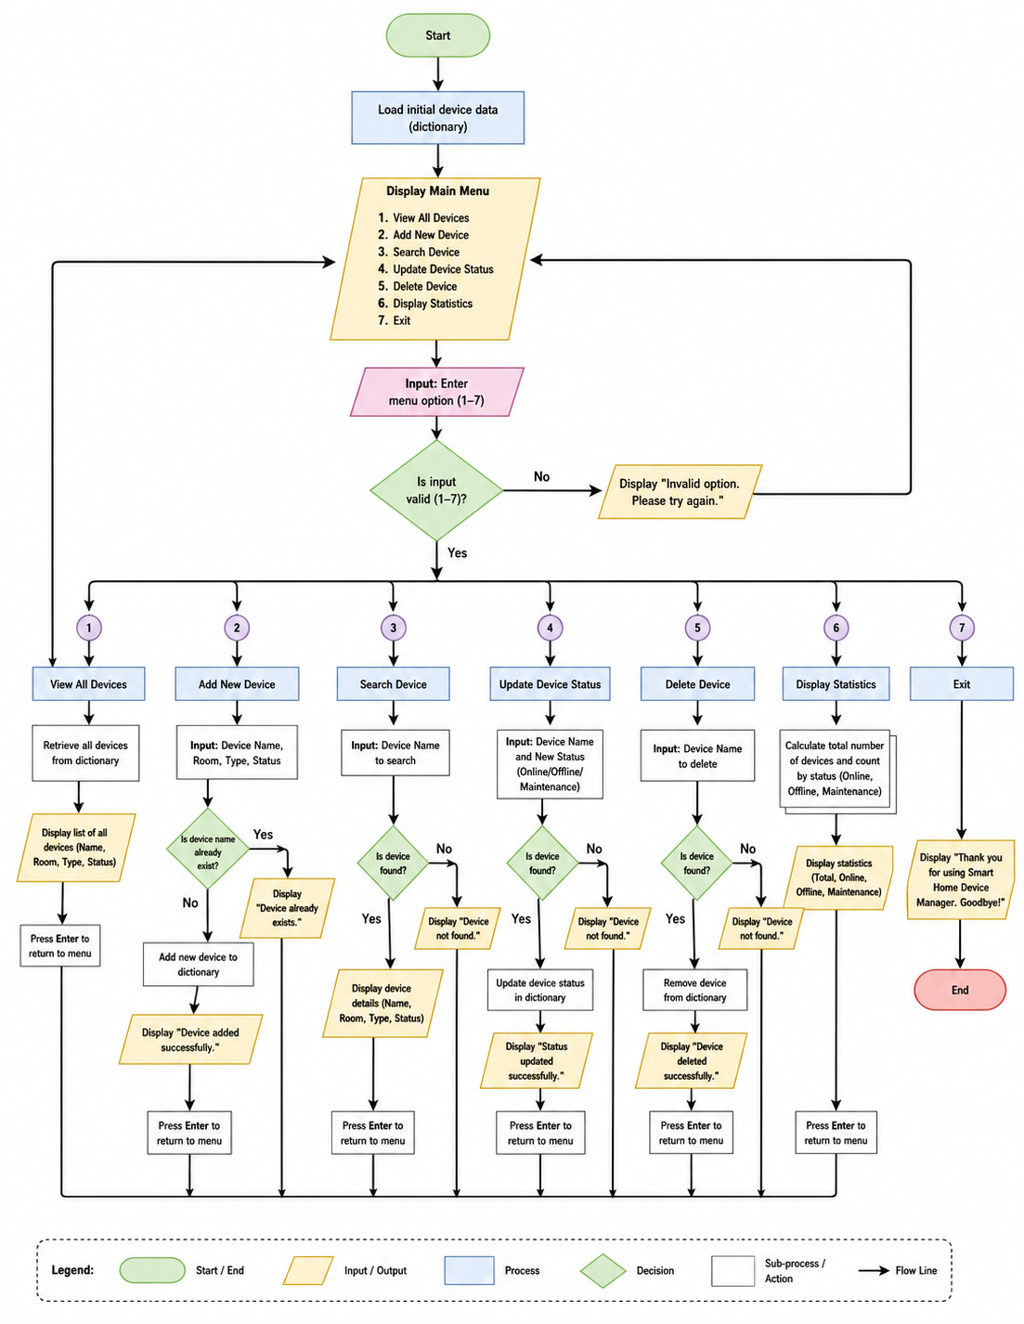

A flowchart is a graphical representation of an algorithm or process that uses standard symbols connected by arrows to illustrate the sequence of operations, decision points, inputs, and outputs within a program [2]. Flowcharts are widely used during software development because they help developers visualise program logic before implementation, making processes easier to understand while identifying potential design errors early.
For the Smart Home Device Manager, the flowchart was developed before writing the Python code to provide a clear overview of the application's operation. It acted as a planning tool that organised user interactions and internal processing, ensuring that all functional requirements were incorporated into the final system while reducing logical errors during development.
The flowchart begins with the Start terminator, which marks the beginning of program execution. The application then initialises the device dictionary and predefined status constants required to store and manage smart device information throughout execution.
After initialisation, the program displays the main menu, presenting users with options to display registered devices, add a new device, update a device's operational status, search for a device, delete a device, display statistical information, or exit the application. This menu-driven approach provides a simple and organised method for navigating the system.
The program then receives the user's selection and evaluates it using a decision structure. Each menu option directs execution to the corresponding function. When adding a device, users enter the device name, location, and operational status. The application validates the input before storing the information, preventing duplicate device names and incomplete records to maintain data integrity.
For the Update Device Status option, the program requests an existing device name before allowing its status to be modified. If the device cannot be found, an appropriate error message is displayed, allowing the application to continue without interruption. Similarly, the Search Device function enables users to retrieve device information by entering a device name. If a matching record exists, its details are displayed; otherwise, the user is informed that the device was not found. The Delete Device function follows a similar process by confirming that a device exists before removing it from the dictionary. The flowchart also includes the Show Statistics function, which analyses all registered devices and calculates the number of devices that are online, offline, or under maintenance. This feature provides users with a quick summary of the overall operational status without requiring them to inspect each individual record.
After completing any operation, control returns to the main menu, allowing users to continue managing devices without restarting the application. This cycle repeats until the Exit option is selected, transferring control to the End terminator and completing program execution.
Overall, the flowchart provides a clear visual representation of the Smart Home Device Manager by illustrating how user input, decision-making, processing, and output are coordinated throughout the application. Developing the flowchart before implementation supported a structured design process, reduced logical errors, and contributed to the creation of a reliable, modular, and maintainable Python application.

3.1.2 Pseudocode
The pseudocode below is excluded from the word count.

BEGIN

Create a dictionary containing predefined smart devices

REPEAT

Display Main Menu
Display:
1. View All Devices
2. Add New Device
3. Update Device Status
4. Search Device
5. Delete Device
6. Show Statistics
7. Exit

INPUT userChoice

IF userChoice = 1 THEN

IF no devices exist THEN
Display "No devices available"
ELSE
Display all devices with:
Device Name
Room
Status
ENDIF

ELSE IF userChoice = 2 THEN

INPUT deviceName

IF deviceName is empty THEN
Display error message

ELSE IF device already exists THEN
Display duplicate device message

ELSE

INPUT room
IF room is empty THEN
Display error message

ELSE

Add device to dictionary

Set status to Offline

Display confirmation message

ENDIF

ENDIF

ELSE IF userChoice = 3 THEN

IF no devices exist THEN

Display "No devices available"

ELSE

Display numbered list of devices

INPUT device number

Validate selection

Display status options

INPUT status option

Validate selection

Update selected device status

Display confirmation message

ENDIF

ELSE IF userChoice = 4 THEN

INPUT device name

IF device exists THEN

Display device details

ELSE

Display "Device not found"

ENDIF

ELSE IF userChoice = 5 THEN

IF no devices exist THEN

Display "No devices available"

ELSE

Display numbered list of devices

INPUT device number

Validate selection

Delete selected device

Display confirmation message

ENDIF

ELSE IF userChoice = 6 THEN

Count total devices

Count Online devices

Count Offline devices

Count Maintenance devices

Display statistics

ELSE IF userChoice = 7 THEN

Display goodbye message

EXIT PROGRAM

ELSE

Display "Invalid menu option"

ENDIF

UNTIL user chooses Exit

END

Pseudocode is an informal method of representing the logic of an algorithm using structured English rather than the syntax of a specific programming language. It describes the sequence of operations a program should perform while remaining independent of programming language rules [2]. Unlike source code, pseudocode focuses on the logical structure of a solution, allowing developers to plan algorithms, communicate ideas, and identify potential design issues before implementation.
Within the Software Development Life Cycle (SDLC), pseudocode acts as a bridge between system design and implementation. It enables developers to verify that an algorithm satisfies the required functionality before translating it into executable code. Because pseudocode is easier to understand than programming syntax, it also provides an effective way to communicate program logic during the development process.
For the Smart Home Device Manager, pseudocode was created before writing the Python code to define the application's behaviour in a logical and structured manner. Planning the algorithm in advance simplified implementation by providing a clear sequence of operations and reducing the likelihood of logical errors.
The pseudocode begins by initialising the program, including the declaration of status constants and the creation of the dictionary used to store smart device information. These steps prepare the application before user interaction begins.
After initialisation, the algorithm enters the main program loop, where the menu is displayed repeatedly until the user chooses to exit. This iterative structure allows multiple tasks to be completed during a single execution while providing a consistent and user-friendly interface.
When the user selects a menu option, a selection structure determines which function is executed. Each option corresponds to a dedicated module responsible for a single task, supporting a modular design that improves readability, testing, and maintenance.
The Display Devices module retrieves all records stored in the dictionary and presents the device name, location, and operational status. The Add Device module collects user input, validates the information, and stores new records while preventing duplicate device names and incomplete entries. Similarly, the Update Device Status module verifies that a device exists before modifying its operational status, displaying an appropriate message if the requested device cannot be found.
The Search Device module allows users to locate a specific device using its unique name, while the Delete Device module removes records only after confirming that they exist. The Show Statistics module analyses all registered devices and calculates the number of devices that are online, offline, or under maintenance, providing users with a summary of the system's operational status.
After each operation, control returns to the main menu so users can continue managing devices without restarting the application. The program repeats this process until the Exit option is selected, at which point execution ends in a controlled manner.
Overall, the pseudocode provided a clear framework for implementing the Smart Home Device Manager. Planning the algorithm before coding improved software organisation, reduced development complexity, and supported the creation of a reliable, modular, and maintainable Python application.

3.2 Implementation Decision

3.2.1 Data Structures
A data structure is a specialised method of organising and storing data within a computer so that it can be accessed, managed, and modified efficiently [3]. Selecting an appropriate data structure is an important software design decision because it directly affects the performance, maintainability, and scalability of an application. Different data structures provide different advantages depending on the operations that the system must perform, making it essential to choose the most suitable structure for the project requirements.
The Smart Home Device Manager uses a Python dictionary as its primary data structure to store information about registered smart devices. A dictionary stores data as key-value pairs, where each key is unique and is associated with a corresponding value. In this application, the device name is used as the unique key, while the value stores related information such as the device location and operational status. This approach provides an organised and efficient method for managing smart device records.
A dictionary was selected because it supports fast searching, updating, and deletion of records using unique keys. When users search for a device by name, the application can retrieve the associated record directly without searching through every stored item. Since each device must have a unique name, the dictionary also prevents duplicate identifiers and simplifies record management.
The shared dictionary is accessed by all major functions, including Display Devices, Add Device, Update Device Status, Search Device, Delete Device, and Show Statistics. Using a single data structure ensures that all functions work with consistent information while supporting the modular design of the application. This approach improves code organisation and makes future modifications easier to implement.
Alternative data structures were considered but were less suitable for the project requirements. A list could store multiple device records; however, searching for a specific device would require checking each element sequentially. Tuples are immutable, making them unsuitable because device information must be updated regularly. Sets efficiently store unique values but cannot associate additional information such as location and operational status with each device. Consequently, a dictionary provides the most practical solution for this application.
The dictionary also improves data integrity by supporting input validation. Before adding a new device, the program checks whether the device name already exists. Likewise, update and delete operations first verify that the requested device is present before making changes, reducing the likelihood of runtime errors caused by invalid user input.
The main variables used within the application include the devices dictionary, which stores all registered smart device records, device_name, which identifies individual devices, location, which records where a device is installed, status, which stores its operational state, and choice, which stores the user's menu selection. These variables support the core functionality of the system while maintaining a clear and organised program structure.
Overall, the Python dictionary was the most appropriate data structure for the Smart Home Device Manager because it provides efficient data management, supports modular programming, and offers the flexibility required to expand the application with additional device information in future versions.

3.2.2 Programming Constructs
Programming constructs are the fundamental building blocks used to develop software applications. They define how a program stores data, makes decisions, repeats tasks, organises functionality, and responds to user input. By combining different programming constructs, developers can create structured, maintainable, and efficient software solutions capable of solving complex problems [4]. The Smart Home Device Manager incorporates variables, constants, functions, selection statements, iteration, exception handling, and input validation to satisfy the project's functional requirements.
The application uses variables to store information that changes during program execution, including device names, locations, menu selections, and operational status. These variables allow the program to process user input and update device records dynamically.
The program also defines constants representing the valid operational states of smart devices: ONLINE, OFFLINE, and MAINTENANCE. Unlike variables, constants remain unchanged during execution. Using constants improves readability, reduces typographical errors, and simplifies future maintenance by storing fixed values in a single location.
A modular programming approach is adopted through user-defined functions, with each function performing a specific responsibility such as displaying devices, adding records, updating device status, searching, deleting, or generating statistics. Separating tasks into individual functions improves code organisation, simplifies testing and debugging, and makes the application easier to maintain and extend.
Selection statements implemented using Python's if, elif, and else statements, control decision-making throughout the application. They evaluate menu selections and determine which function should be executed. Selection structures are also used to verify whether a device exists before updating or deleting records and to display appropriate messages when invalid input is detected.
The application uses iteration through while and for loops. A while loop repeatedly displays the main menu until the user chooses to exit, allowing multiple operations during a single execution. For loops process all stored devices when displaying records or calculating statistics, reducing code repetition and improving efficiency.
To improve reliability, the program implements exception handling using Python's try and except statements. These statements prevent unexpected program termination when users enter invalid data, such as text instead of numerical menu selections. Rather than crashing, the application displays an informative error message and allows the user to continue.
The application also performs input validation to ensure that only valid information is processed. Before adding a new device, it checks for duplicate device names and verifies that the required information has been entered. Similarly, update and delete operations confirm that the specified device exists before making any changes. These validation procedures help maintain data integrity and reduce logical errors.
Overall, these programming constructs work together to produce a reliable and well-structured application. Variables and constants manage data, functions organise program logic, selection statements and loops control execution, while exception handling and input validation improve robustness and user experience. Their combined use demonstrates good programming practice and supports the successful implementation of the Smart Home Device Manager.

3.2.3 Python Modules and Libraries
Python modules are files that contain reusable code, including functions, classes, and variables, which can be imported into other Python programs to extend their functionality and promote code reuse [5]. Modules help developers organise software by separating related functionality into independent components, improving readability, maintainability, and scalability. Python also provides a comprehensive standard library containing built-in modules for tasks such as file handling, mathematical calculations, date and time processing, and operating system interaction.
The Smart Home Device Manager was intentionally developed as a single-file console application because the assignment focused on demonstrating fundamental programming concepts rather than advanced software architecture. Consequently, the project relies primarily on Python's built-in language features instead of importing external modules. This design keeps the application simple, easy to understand, and aligned with the learning objectives of the Scripting and Programming Concepts module.
Although additional modules were not required, the application makes extensive use of Python's core features, including dictionaries, user-defined functions, loops, conditional statements, exception handling, and string manipulation. These built-in capabilities provide all the functionality necessary to implement the required operations while avoiding unnecessary dependencies.
The application's modular design is achieved through user-defined functions rather than imported modules. Each function performs a specific responsibility, such as displaying devices, adding records, updating operational status, searching for devices, deleting records, or generating statistical summaries. Dividing the application into independent functions improves code organisation, simplifies testing and debugging, and makes future maintenance easier.
If the Smart Home Device Manager were expanded beyond the current project requirements, several standard Python modules could be integrated to provide additional functionality. For example, the datetime module could record timestamps whenever devices are added or updated, creating a maintenance history. The Json module could store device information permanently between program executions, while the csv module could export device records for reporting or analysis. In addition, the os module could support file management and interaction with the operating system.
Despite these possible enhancements, excluding additional modules from the current implementation was an appropriate design decision. The primary objective of the project was to demonstrate core programming concepts, including algorithm design, modular programming, data structures, and program logic, rather than advanced software engineering techniques. Using Python's built-in features allowed greater focus on these learning outcomes while maintaining a clear and reliable application.
Overall, the Smart Home Device Manager demonstrates that effective software can be developed using Python's built-in capabilities without relying on external libraries. The combination of user-defined functions and core language features resulted in a reliable, maintainable, and well-structured application that satisfies the project requirements while providing a solid foundation for future expansion.

4.0 TESTING AND DEBUGGING

4.1 Role of Testing in Software Environment
Program testing is the systematic process of evaluating software to verify that it satisfies its specified requirements and operates correctly under different conditions. The primary purpose of testing is to identify defects, confirm that the program behaves as expected, and improve the overall quality, reliability, and performance of the software before deployment [6]. Testing is an essential stage of the Software Development Life Cycle (SDLC) because it helps ensure that software functions accurately and consistently.
During the development of the Smart Home Device Manager, testing was carried out throughout the implementation process rather than only after completion. Each major function, including displaying devices, adding records, updating device status, searching, deleting, and generating statistics, was tested individually before integrating the complete application.
Both normal and abnormal test scenarios were performed. Valid inputs confirmed that the application produced the expected results, while invalid menu selections, duplicate device names, missing records, and incorrect data types verified that the system handled errors appropriately. Input validation and exception handling prevented unexpected program termination and maintained data integrity by displaying informative error messages instead of allowing the application to crash.
Overall, continuous testing improved the reliability and stability of the Smart Home Device Manager and confirmed that it satisfied the project's functional requirements.

4.2 Type of Errors in Programming
Programming errors are defects that prevent software from functioning as intended. Identifying and correcting these errors is an essential part of software development because they can produce incorrect results or cause an application to terminate unexpectedly [6]. During the development of the Smart Home Device Manager, three main categories of programming errors were considered: syntax, runtime, and logical errors.
Syntax errors occur when code does not follow Python's grammatical rules, such as missing colons, incorrect indentation, or unmatched brackets. These errors are detected before program execution and corrected during development.
Runtime errors occur while the program is running, often because of unexpected user input. In the Smart Home Device Manager, input validation and Python's try and except statements were used to handle invalid data, preventing the application from crashing and allowing users to continue.
Logical errors occur when a program executes successfully but produces incorrect results. These were identified by comparing the application's output with the expected behaviour, particularly when updating device records and generating statistics.
Debugging involved locating, correcting, and retesting errors until the program operated correctly. This process improved the reliability, stability, and overall quality of the Smart Home Device Manager.

4.3 Example of Test Cases
Software testing was conducted to verify that each functional requirement of the Smart Home Device Manager operated correctly under normal and abnormal conditions. Every major function was tested individually to ensure that the program produced the expected results while handling invalid input appropriately. The testing process confirmed that the application met the project requirements and maintained reliable performance throughout execution.
Table 4.1 – Functional Test Cases
Test ID | Function  Tested | Test  Input | Expected  Result | Actual Result | Status
TC01 | Display Devices | Select option 1 | All registered devices are displayed correctly | Devices displayed successfully | Pass
TC02 | Add Device | Valid device information | New device is added to the dictionary | Device added successfully | Pass
TC03 | Add Device | Duplicate device name | System rejects duplicate record | Duplicate prevented with error message | Pass
TC04 | Update Status | Existing device name | Device status updated successfully | Status updated correctly | Pass
TC05 | Update Status | Non-existent device | Error message displayed | Appropriate message shown | Pass
TC06 | Search Device | Existing device name | Device information displayed | Correct device located | Pass
TC07 | Search Device | Unknown device name | Device not found message | Correct message displayed | Pass
TC08 | Delete Device | Existing device | Device removed successfully | Device deleted correctly | Pass
TC09 | Delete Device | Non-existent device | Error message displayed | Correct message displayed | Pass
TC10 | Statistics | Several registered devices | Correct totals displayed | Statistics calculated correctly | Pass
TC11 | Invalid Menu Option | Enter value outside menu range | User prompted to try again | Invalid option handled correctly | Pass
TC12 | Invalid Data Type | Enter text instead of a number All registered devices are displayed correctly | Exception handled without program crash | Error handled successfully | Pass

The results presented in Table 4.1 demonstrate that all core functions of the Smart Home Device Manager operated as expected during testing. Functional testing confirmed that users could successfully manage smart devices by adding, updating, searching, deleting, and displaying records while maintaining the integrity of the stored data. Statistical calculations also produced accurate summaries of device status, confirming that the dictionary was updated consistently after each operation.
Testing using invalid input was equally important because it demonstrated the application's ability to respond safely to unexpected user behaviour. Duplicate device names were correctly rejected, attempts to modify or delete non-existent devices generated informative messages, and invalid menu selections were handled without terminating the program. Exception handling successfully prevented runtime failures when incorrect data types were entered, allowing users to continue interacting with the application after correcting their input.
Overall, the testing process confirmed that the Smart Home Device Manager satisfies all functional requirements identified during the analysis stage. The combination of functional testing, input validation, and exception handling produced a reliable and user friendly application capable of operating consistently under a variety of normal and abnormal conditions.

Figure 4.1: Screenshot of Test Case TC02
showing the successful addition of a new smart device.
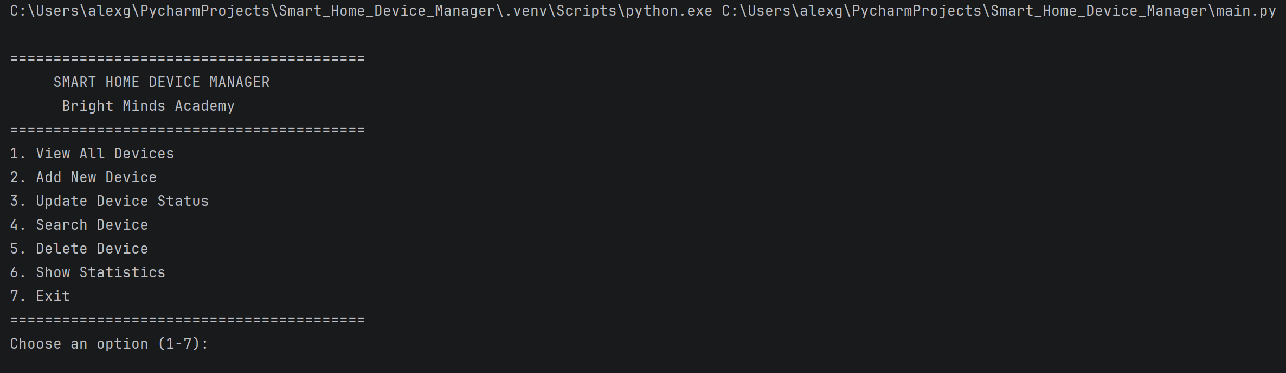
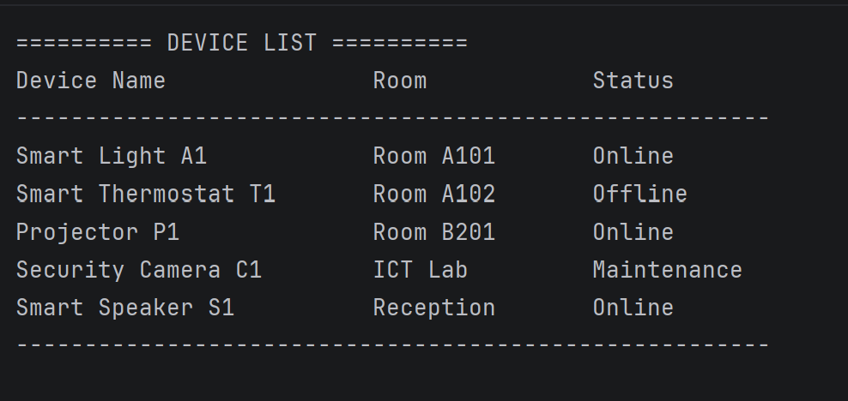
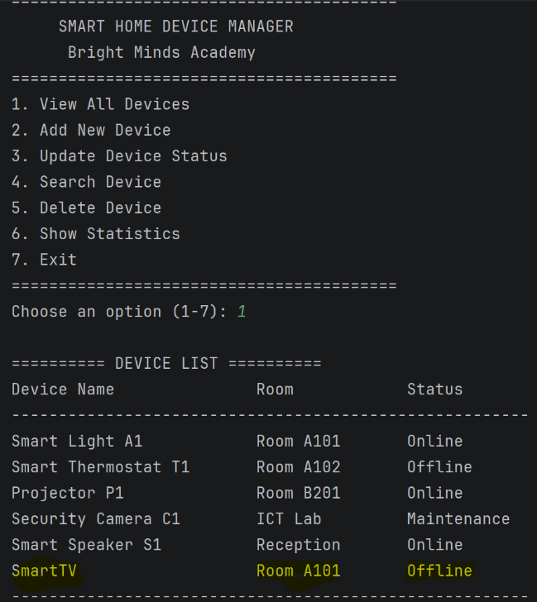
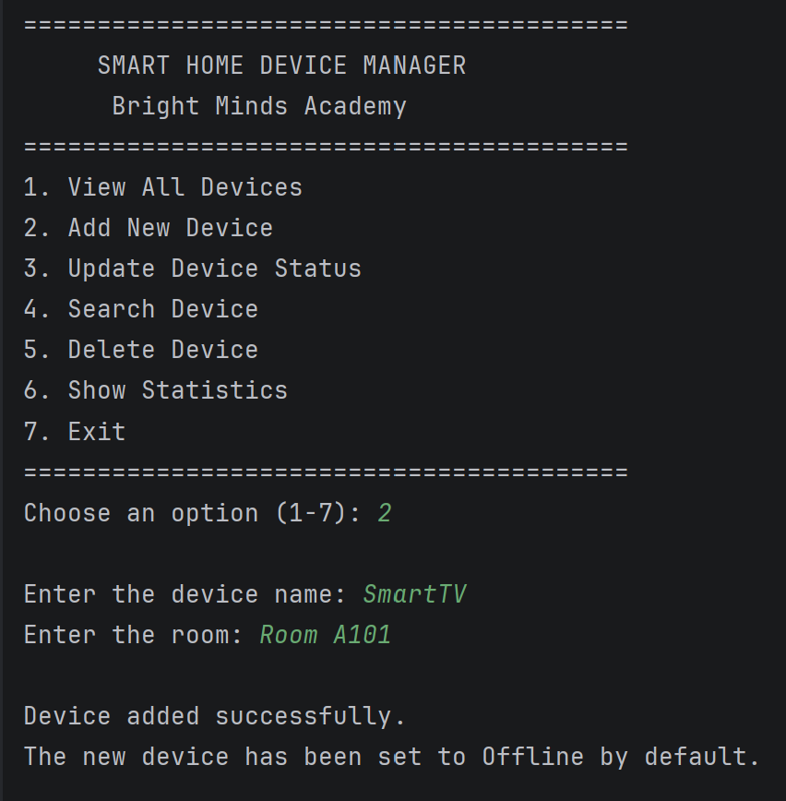

Figure 4.2: Screenshot of Test Case TC06
showing the successful search for an existing smart device.
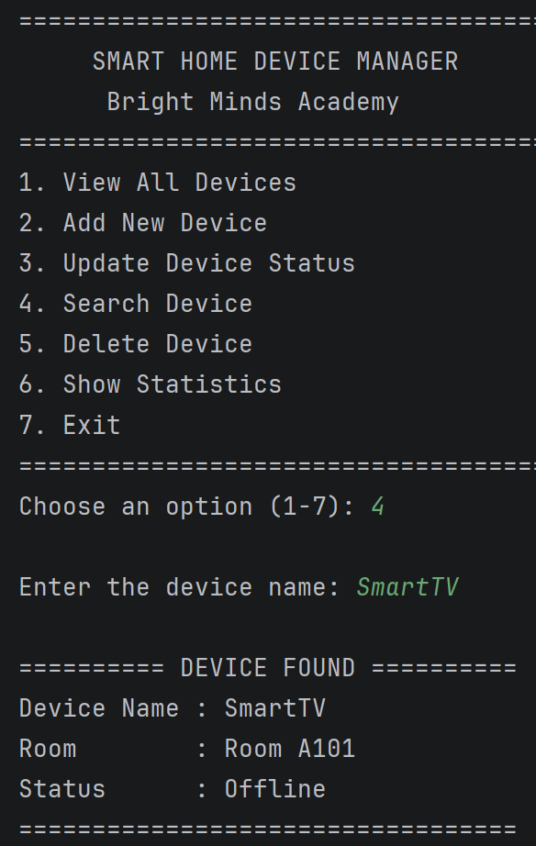

5.0 EVALUATION
The Smart Home Device Manager project provided the opportunity to apply software development principles throughout the complete Software Development Life Cycle (SDLC), from analysing the system requirements and designing algorithms to implementing, testing, and evaluating the final application. The project successfully achieved its primary objective of developing a console-based Python application capable of managing smart home devices through a simple and intuitive menu-driven interface. Users can display registered devices, add new devices, update operational statuses, search for existing devices, delete obsolete records, and generate statistical summaries. Throughout the project, fundamental software engineering principles, including modular programming, structured design, appropriate data structures, input validation, exception handling, and systematic testing, were applied to produce a reliable, maintainable, and user-friendly solution. The development process also reinforced the importance of planning software before implementation and demonstrated how careful design decisions contribute directly to the quality, reliability, and maintainability of the final application.

Challenges Faced
One of the main challenges during the development of the Smart Home Device Manager was designing a program that was organised, maintainable, and easy to extend. Instead of placing all program logic in a single block of code, a modular programming approach was adopted. Separate user defined functions were created to display devices, add records, update device status, search, delete, and generate statistics. This structure improved readability, simplified debugging, and supported future modifications.
Another challenge was selecting an appropriate data structure. The application required efficient searching, updating, deleting, and displaying of device records. A Python dictionary was chosen because it stores data as key-value pairs, allowing each device name to act as a unique identifier while grouping related information such as location and operational status. This approach improved data organisation and simplified record management.
Input validation also required careful consideration. Users could enter invalid menu options, duplicate device names, or incorrect data types. Validation checks and Python's try and except statements were implemented to handle these situations, preventing unexpected program termination and providing informative error messages.
Finally, continuous testing using both valid and invalid inputs helped identify and correct logical issues, ensuring the Smart Home Device Manager met its functional requirements and operated reliably.

Future Improvements
Although the Smart Home Device Manager successfully meets the project's objectives, several enhancements could improve its functionality and usability in future versions.
A major improvement would be the addition of permanent data storage. Currently, device information is stored only in a Python dictionary and is lost when the program closes. Using JSON, CSV files, or a lightweight database such as SQLite would allow data to be retained between sessions, making the application more practical.
Another enhancement would be the development of a graphical user interface (GUI). While the console interface effectively demonstrates programming concepts, a GUI created with libraries such as Tkinter or PyQt would provide a more intuitive experience through windows, buttons, menus, and forms. Security could also be strengthened by implementing user authentication with different permission levels. For example, administrators could manage device records, while standard users would have read only access.
Additional features could include storing maintenance history, installation dates, warranty information, and timestamps for status changes. Advanced search and filtering options could also improve usability.
Finally, integrating the application with Internet of Things (IoT) devices through APIs would enable automatic status updates, transforming the current educational prototype into a more practical smart home management system.

Self-Reflections
This project provided valuable practical experience in applying Python programming and software engineering principles to solve a realistic problem. Throughout the development process, I improved my understanding of system analysis, software design, algorithm development, coding, testing, debugging, and software evaluation. It also reinforced the importance of planning solutions using flowcharts and pseudocode before implementation.
The project strengthened my ability to use Python dictionaries, user-defined functions, loops, selection statements, input validation, and exception handling to develop a complete software application. Applying modular programming demonstrated how dividing tasks into separate functions improves code organisation, readability, and maintainability. Testing and debugging also highlighted the importance of identifying programming errors early, reducing development time and improving software reliability.
Overall, this project significantly enhanced my programming, analytical, and problem-solving skills. It demonstrated the value of structured software development, systematic testing, and continuous improvement while reinforcing the importance of producing software that is reliable, maintainable, and user focused. The knowledge and practical experience gained through this project provide a strong foundation for future programming modules and more advanced software development projects.

REFERENCES
[1] I. Sommerville, Software Engineering, 11th ed. Harlow, UK: Pearson, 2021.
[2] Y. D. Liang, Introduction to Python Programming and Data Structures, 3rd ed. Hoboken, NJ, USA: Pearson, 2023.
[3] S. Saha, Data Structures and Algorithms Using Python. Cambridge, UK: Cambridge University Press, 2023.
[4] S. Kalkan, O. T. Şehitoğlu and G. Üçoluk, Programming with Python for Engineers. Cham, Switzerland: Springer, 2024.
[5] C. Cafiero, An Introduction to Programming and Computer Science with Python, 2nd ed. Burlington, VT, USA, 2025.
[6] B. Allbee, Hands-On Software Engineering with Python, 2nd ed. Birmingham, UK: Packt Publishing, 2025.
[7] Python Software Foundation, Python 3 Documentation. Available: https://docs.python.org/3/. [Accessed: 23-Jul-2026].
[8] Python Software Foundation, The Python Tutorial. Available: https://docs.python.org/3/tutorial/. [Accessed: 23-Jul-2026].
[9] Python Software Foundation, Built-in Types. Available: https://docs.python.org/3/library/stdtypes.html. [Accessed: 23-Jul-2026].
[10] Python Software Foundation, Exceptions. Available: https://docs.python.org/3/tutorial/errors.html. [Accessed: 23-Jul-2026].
[11] Python Software Foundation, The Python Standard Library. Available: https://docs.python.org/3/library/. [Accessed: 23-Jul-2026].
[12] N. Gupta and R. Nayak, Data Structures for Engineers and Scientists Using Python. Boca Raton, FL, USA: CRC Press, 2025.
[13] S. Sridhar, J. Indumathi and V. M. Hariharan, Python Programming. Noida, India: Pearson India, 2023.
[14] A. Fan, B. Gokkaya, M. Harman, M. Lyubarskiy, S. Sengupta, S. Yoo and J. M. Zhang, "Large Language Models for Software Engineering: Survey and Open Problems," 2023.
[15] S. Shukla, P. Gatti, Y. Kumar, V. Yadav and A. Mishra, "Towards Making Flowchart Images Machine Interpretable," 2025.
[16] M. He, J. Zeng, Y. Jiang, W. Zhang, Z. Liu, X. Shi and A. Zhou, "Flow2Code: Evaluating Large Language Models for Flowchart-based Code Generation Capability," 2025.

