
Engineering Design
(M4X01160) DRILL PRESS MAIN SLIDING UNIT

February 22, 2019
Abi Price 1707799
BEng Mechanical and Manufacturing Engineering

Executive Summary

This report will critically analyse the concept design of the (Drill Press Main Sliding Unit) DPMSU.
It will discuss the potential materials that will be considered for the new design, it will also discuss the method of manufacture for the new design.
Lastly the new design will be explained and critically analysed. It will be compared to the concept design.

Table of Contents
Executive Summary 1
Introduction 2
Original Design 3
Materials Considered 4
Manufacturing Process to be used 5
Material to be used 5
New Design 6
Conclusion 8
References 9
Reference list 9

Introduction

Original Design

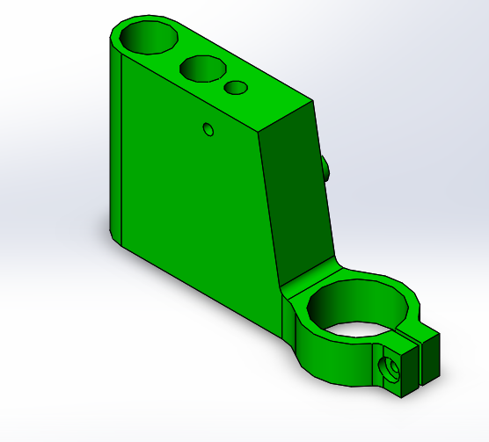
The original Design of the DPMSU is quite a large unit made up of a lot of material, this intern making the component quite thick and heavy. Thick designs can pose a problem when it comes to moulding as many moulding processes such as injection moulding do not like thick moulds. Thick moulds can result in the molten material not being able to flow as smoothly through the mould cavity and may result in the whole mould not being fully filled. Thick sections can also lead to other defects such as “warping and sinking”. (Hazenbosh, 2019)
Also with this concept design the transition for the change in wall thickness is not very smooth and the edges are rather abrupt. Not having a smooth transition will stop the material from flowing freely and as a result the material probably will not fill the cavity properly, you will get a build-up in some areas and no material in others. It is important to create a “smooth transition” (Hazenbosh, 2019). This concept also applies to edges. Edges should be rounded also to ensure that good material flow is achieved. Sharp edges and corners can cause added stress which intern can result in weaker parts and ultimately failure.
The design of the holes on the top surface is not very accurate and you have no way of guaranteeing whether or not the holes will even be in the correct location. I don’t see a need for this much material and lack of accuracy when it comes to the main body.
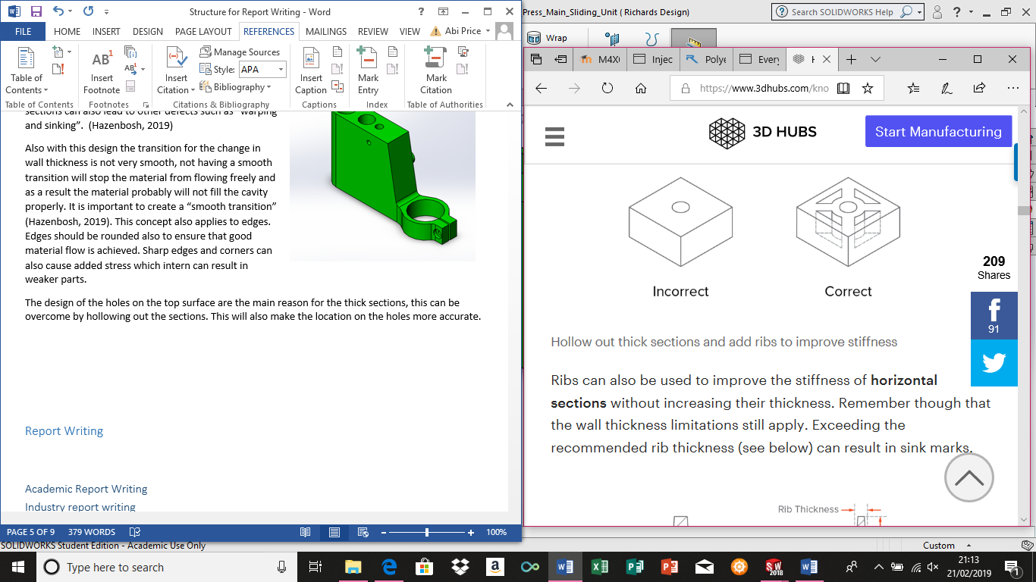
(Hazenbosh, 2019)

Also with the concept design the main body of the DPMSU is rather tall, meaning a lot of material would need to be used to compensate this. Not only would this result in a higher cost due to the amount of material required but it would be a waste of material. I also think that this would result in the DPMSU being not as structurally strong as it could be.

Materials Considered

One of the materials considered for the DPMSU was Polyetherimide. This is known as one of the most versatile plastics available. This polymer is often used for medical components, chemistry tools and auto transmission components, demonstrating that it is commonly used high production items. It is mainly used in applications that need a high neat resistance, high chemical resistance and need to be high in strength. (Polymer properties, 2015)
Another material considered was ABS, this polymer is resistant to corrosive chemicals and physical impacts. It is also known for its easy machine capabilities and making it “particularly simple to use for injection moulding” (Rogers, 2015) ABS is not usually used where is can be subject to high heat, it is most commonly found in things such as power tool housing, Lego toys and computer key boards. This material is used for housings and casings as it displays very good strength when subject to external impacts.
The last material considered was polycarbonate, this material is known for its extremely high impact resistance. It is mainly used for applications such as machine guards, sports equipment and clear moulds for urethane and silicone casting. This material is a thermoplastic, enabling it to easily be injection moulded. This is an “amorphous” plastic, meaning it can have the tendency to “gradually soften”. (Rogers, Everything you need to know about polycarbonate , 2015)

Manufacturing Process to be used

The process that will be used to manufacture the DPMSU will be injection moulding.
Injection moulding allows you to manufacture a wide variety of tools quickly and efficiently. This is key for the manufacture of the DPMSU as it needs to be able to produce 1000 units per week. Injection moulding also offers very good product constancy and dimension control. Sometimes there can only be roughly only 15-30 seconds between cycles.
The labour costs are low as it is an automated process that requires minimum supervision, also demonstrating as to why it is such a quick process.
The disadvantages to injection moulding would be the high initial tooling and machinery cost, once you have designed your part and had the mould made it is costly to change it and lastly small runs can be costly. (Clarke, 2016)

Material to be used

The material that will be used for the manufacture of the DPMSU will be Polyetherimide. This material will be used because of its high resistance to impact and its ease to work with. It also has a combination of high specific strength, flexibility and dimensional strength. Strength is key for the DPSMU as it will be subject to loadings. It is often used in the automotive industry where it will be subject to many forces and it is constantly required to be long lasting. Polyetherimide is often used as a “metal Replacement” and is known for its resistance to deformation.
Some limitations that Polyetherimide would be the cost of the material being high.

I think that the second best material that could be used would be polycarbonate as it is resistant to impact and it thermoplastic making it good for injection moulding. However, it has been said to gradually soften as it is amorphous.

New Design
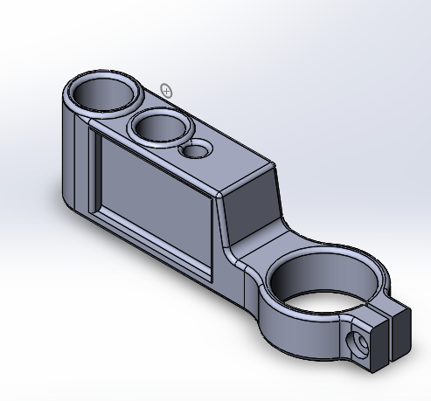

The new design for the DMPSU demonstrates a much smaller main body in length. The size of the main body has been halved. This is to save on the amount material used for the DPMSU, this will also save money on the mould costs and manufacturing costs bringing the overall cost for the tool down. Making the tool smaller can also allow more money to spend on the material used.
A smaller body will also offer more strength as the straights are much shorter and don’t have to span as long which means that they will support themselves much more efficiently. Hopefully with the body being smaller the material being injected will have a higher chance of filling the mould.
The angle or degree of the slope from the top of the main body has been increased and shortened to offer more strength from top to bottom. As it was rather a large distance before.
The sides of the main body have also been thinned. This will not only save money by not requiring as much material, but also will allow the material to flow around the mould much more freely as it is not just one big thick body. It will also give the material a better chance of filling the mould correctly and not being left with air holes and weak spots.
The previous design did not have any filleted or chamfered edges. All of the edges on the new design have been filleted. This has added strength by smoothing the edges which eliminates some stress from the edges and prevents some weakening. It also allows the material to flow better through the mould.
I would have liked to hollow out around the holes to make them more accurate, however I wasn’t sure how to do this on solid works so I couldn’t show this on the design. This would offer less material being used as it would require a thinner structure and the overall accuracy on the critical points would be improved.
I also wanted to hollow out the centre of my design to reduce the amount of material and avoid a think main body. I would then have put “bracing” inside to maximise the strength without thickening the body. This would reduce the risk of material not filling the mould. However, again I didn’t know how to do this on solid works so the drawing doesn’t show this.

Conclusion

To conclude, the material the new DPMSU will be made from will be Polyetherimide as this offers excellent strength and resistance to deformities. I think this is important as the DPMSU will be subject to multiple downward forces.
This polymer is also very easy to injection mould as it is a thermoplastic, it is widely used for a range of items requiring high strength and good durability.
The new design demonstrates a smaller tool which requires less material, a smaller mould tool and a stronger structure. Overall showing better qualities for injection moulding.

References
Clarke, C. (2016). Advantages and Disadvantages of injection moulding . Retrieved from www.martinsrubber.co.uk: https://www.martins-rubber.co.uk/blog/advantages-and-disadvantages-of-injection-moulding/
Hazenbosh, S. (2019). How to design parts for injection molding . Retrieved from www.3dhubs.com: https://www.3dhubs.com/knowledge-base/how-design-parts-injection-molding#rules
Polymer properties. (2015). Retrieved from polymerdatabase.com: http://polymerdatabase.com/polymer%20classes/Polyetherimide%20type.html
Rogers, T. (2015). Everything you need to know about ABS plastic . Retrieved from www.creativemechanisms.com: https://www.creativemechanisms.com/blog/everything-you-need-to-know-about-abs-plastic
Rogers, T. (2015). Everything you need to know about polycarbonate . Retrieved from www.creativemechanisms.com: https://www.creativemechanisms.com/blog/everything-you-need-to-know-about-polycarbonate-pc

Reference list

