DS 1 Template

My Screenshots/Photos
- Please add 4–6 screenshots or photos of your digital life.
- You can use your phone or laptop.
- For each screenshot, write one or two sentences explaining what it shows.

Screenshot/Photo 1
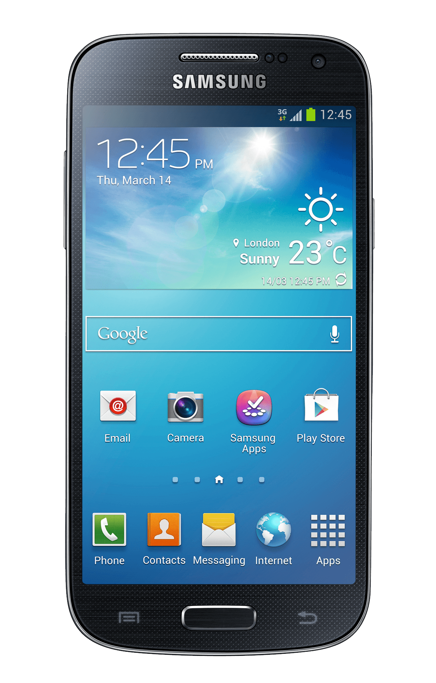
Here is my phone I use this for communications and daily doom scrolling and task reminders. This helps me also communicate with other people and lets me search on the internet for cooking recipes and information I require at any given time.

Screenshot/Photo 2
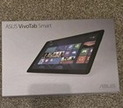
This is my Windows Tablet which I use at work for programming and monitoring security systems and programming.
This tablet is just like a normal windows desktop pc but is portable so when I am on a job site it is easier for me to complete my tasks and be present at the systems I am working on at that time so I can be able to monitor it during start up and operations and trouble shoot problems in real time
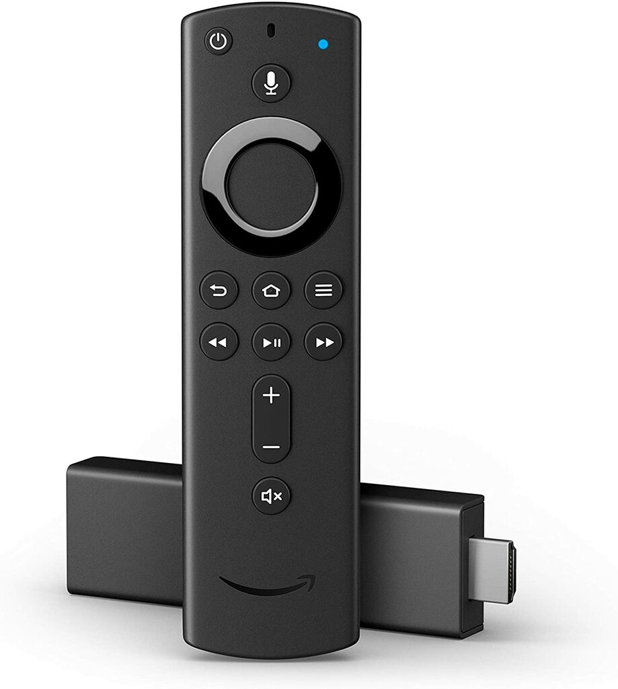
This is my Amazon fire stick which I use for entertainment purposes with my children.
On this device we have downloaded other media apps such as Netflix and Disney+.

Screenshot/Photo 4
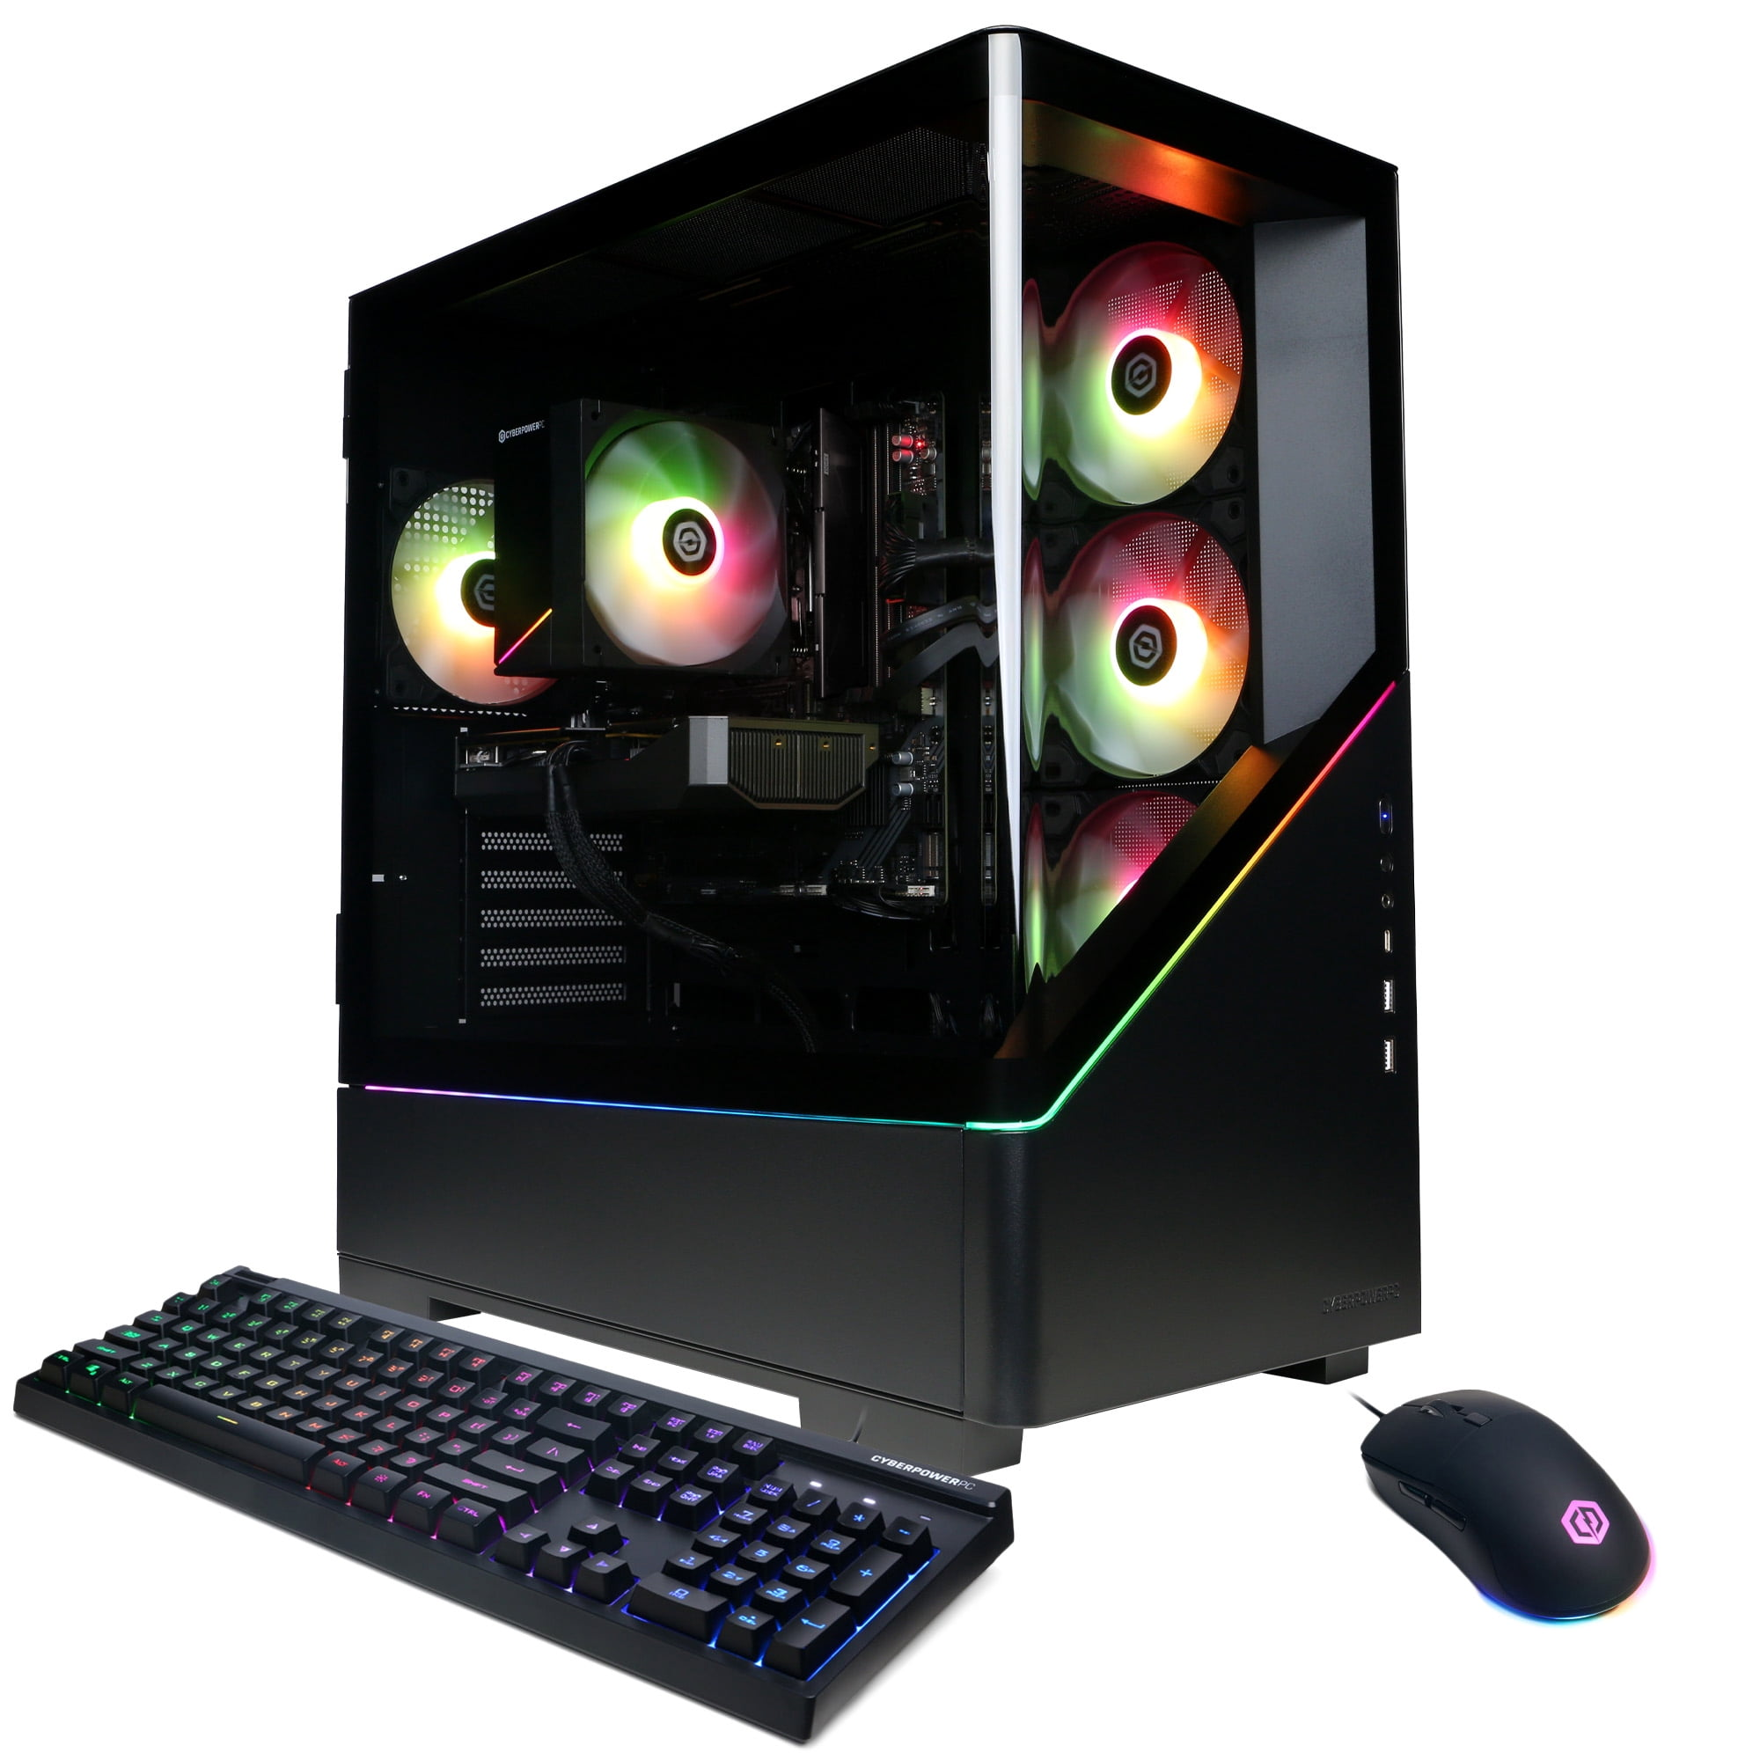
This is my desktop pc which I use for Running my business and playing games.
On this pc I run my own business from it and do everything from invoices and quotes to design and plans for clients, and use email to respond to clients and other companies.
I use many different entertainment apps on this pc for gaming services.
I also use discord for communications for friends and clients all over the world.

Screenshot/Photo 5
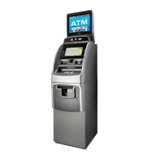
this is an atm machine, this allows me to withdraw money using my bank card.
This uses security protocols to identify that I am using my card and that card is linked to my bank account and allows me to withdraw money within my account and nothing more within a short period of time

Screenshot/Photo 6
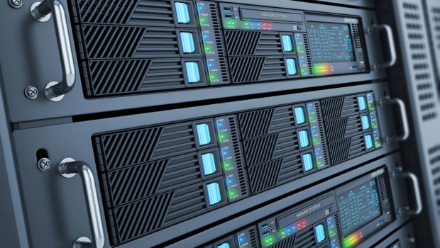
This is a server I use at for digital storage of photos and documents.
This server runs in the back ground keeping my data safe and secure whilst also letting me access it whenever I want.
I also run programmes on my server for VMS systems and Security relay device operations.

My Short Reflection
- Write 5–8 simple sentences about your digital life.
- You can use the sentence starters below if helpful.
I use digital skills in pretty much every aspect in my day to day life from organising my day out to communicating with other people. I am confident with my digital skills on a moderate level I have been using computers and different devices for many years and am confident to say I can work with them and am a fast learner when it comes to new devices and technology. I use the phone and computer mostly in my digital life I am always with 1 or both at most times and rely on them highly in my life. Digital skills are important in my life as without them I wouldn’t be able to manage my schedule properly and wouldn’t be able to work when I needed to, I would also lose communications with many clients and family members and friends.

Sentence starters
- I use digital tools to …
- I feel confident when I …
- I want to improve …
- I often use these tools: …
- I sometimes feel nervous about …
- I hope this module will help me …
- Digital skills are important for me because …
You can write more if you want.

Submission Checklist
Before you submit, please check:
​​​ ☒ I added 4–6 screenshots
☒ I wrote short sentences for each screenshot
☐ I wrote my short reflection
☒ My work is my own
☒ My file opens correctly
​​☒ My file opens correctly

