

Programme: Master of Business Administration

Module Name: Financial Management
Module Code: LCMB7002
Assignment Title: Assessment component: Financial performance and management

Student Name: Peri Hiteshkumar Patel
Student ID: 2504928

Lecturer’s Name: Isaiah Oino

Word count: 5389

Term 1
Table of Contents
Introduction 4
Financial Health Check 4
Profitability ratios 4
Liquidity ratios 5
Efficiency ratios 6
Gearing ratios 6
Investment ratios 7
Cash flow ratios 7
Corporate Failure Prediction: Altman Z-Score 8
Working Capital Management Analysis 8
Cash Operating Cycle (COC) Analysis 8
Reasons for inefficiency 9
Short-term vs long-term financing 150 10
Improvement strategies 10
Strategic Financial Restructuring Plan 11
Divestiture 11
Acquisition 12
Equity Injection 12
Merger 13
International and ethical consideration 14
Investment Appraisal and Capital Budgeting 15
Theoretical Overview 15
Analysis of Investment Projects 16
Capital Rationing decisions 18
Critical Evaluation 18
Conclusion 19
Appendices 30
Appendix 1: Gross Margin Ratio 30
Appendix 2: Profitability Ratios 30
Appendix 3: Operating Profit Margin 31
Appendix 4: Net Profit Margin Ratio 32
Appendix 5: Liquidity Ratios 32
Appendix 6: Current Ratio 33
Appendix 7: Quick Ratio 34
Appendix 8: Cash Ratio 35
Appendix 9: Efficiency Ratios 35
Appendix 10: Asset Turnover Ratio 36
Appendix 11: Fixed Assets Turnover Ratio 37
Appendix 12: Gearing Ratios 37
Appendix 13: Interest Coverage Ratio 38
Appendix 14: Debt to Equity Ratio 39
Appendix 15: Debt to Capital Ratio 40
Appendix 16: Investment Ratios 40
Appendix 17: Return on Assets 41
Appendix 18: Return on Invested Capital 42
Appendix 19: Return on Equity 43
Appendix 20: Cash Flow to Debt Ratio 44
Appendix 21: Cash Flow Margin 45
Appendix 22: Operating Cash Flow Ratio 46
Appendix 23: Cash Flow Ratios 46
Appendix 24: Altman's Z score of probability of going Bankrupt 47
Appendix 25: Cash Conversion Cycle of General Electronics 48
Appendix 26: Payback Period 49
Appendix 27: Accounting Rate of Return (ARR) 51
Appendix 28: Net Present Value 52
Appendix 29: Profitability Index (PI) 53
Appendix 30: Internal Rate of Return (IRR) 54
Appendix 31: Capital Rationing 57

Introduction
The purpose of the report is to critically evaluate challenges faced by General Electronics during the past five years in terms of financial and overall health of the entity. The report strives to discover the core problems of GE in terms of liquidity, profitability, and solvency position. General Electronics is a multinational company in the consumer electronics industry. The financial performance of GE will be analysed using various key ratios, a cash flow statement, and suggesting a way out strategy to become sustainable. Furthermore, the broad scope of the report is to recommend a restructuring plan and potential investments through budgeting and forecasting to improve its financial performance.

Financial Health Check
Ratio analysis is a tool to analyse a company’s financial health in terms of profitability, liquidity, solvency, and leverage by examining its overall financial statement. The broadly used key ratios are Liquidity ratio, Profitability ratio, Gearing or Leverage ratio, Investment ratio, Efficiency ratio, and Cash Flow ratio (Ginting, 2021). The objective of the study is to evaluate the financial strength and weaknesses of General Electronics through ratio analysis.

Profitability ratios
A Profitability ratio determines a company’s ability to generate profit from its assets, total equity, and revenue sources (Fadillah et al, 2024). From Appendix 1, it can be seen that General Electronics' trend of Gross profit has been the same throughout 2020 to 2024. According to Appendix 2, GE’s gross profit is over 28% except 23% in 2023, suggesting GE’s strength in its operation to maintain a stable cost and price (Haralayya, 2021).
By following Appendix 3, it can be found out GE’s operating profit has been downward since 2020, except in 2023. From the Appendix 2 table, it can be interpreted that GE’s total expenses outweighed its operating profit due to a negative operating profit ratio of 3.87% as of 2024. This threat indicates GE’ business operation is loss-making and has high expenses (Astuti, 2021).
From Appendix 4, it is seen that GE has a negative and downsized trend in its net profit, suggesting heavy losses over revenue. Hence, from Appendix 2, it can be interpreted that GE’s negative net profit ratio of 6.09% as of 2024 suggests a significant decline in revenue. This threat depicts GE has a poor cost strategy or inefficient price management structure (Widiasmara et al, 2022). In the DuPont model, the profit margin determines an entity’s financial performance in terms of profitability (Jani, 2021). Thus, following the DuPont model, it is seen that GE’s net profit margin position has decreased, and it is unable to generate profit as an ongoing entity.

Liquidity ratios
The Liquidity ratio helps determine a company’s liquidity position, such as its ability to pay off short-term debts with current assets (Lalithchandra and Rajendhiran, 2021). From Appendix 6, it can be seen that GE has a downward trend in its current ratio from 2020 to 2024. By looking at Appendix 5, it is understood that GE’s current ratio is 1.53 times as of 2024. As a result, it is facing the threat of reduced creditworthiness, weakened short-term paying ability, and high borrowing expenses (Kosasih and Maria, 2022).
According to Appendix 7, it can be understood that GE’s trend of Quick ratio is almost similar from 2020 to 2024. Therefore, following Appendix 5, it can be said that GE’s ability to meet short-term obligations has been slightly decreased by 0.03 (1.06 -1.03) times as of 2024 (FIDRIA, 2025). It indicates GE is facing a threat from reduced financial stability and liquidity position.
Similarly, Appendix 8 depicts that its cash ratio is facing downward trends from 2020 to 2024. Thus from the Appendix 5, it can be interpreted, GE’s reduced cash ratio was 0.17 times in 2024. It denotes that GE is facing a threat of high financial risk and cash shortage (Chairunisa et al, 2023).

Efficiency ratios
Efficiency ratio describes how efficiently an entity generates revenue to earn profit using its assets (Rashid, 2021). From Appendix 10, it can be seen that GE’s asset turnover has a rising trend except in 2022, where it is 1.08 lower than ever. Thus, from Appendix 9, it can be interpreted that GE’s 1.22 increase in its Asset turnover as of 2024 suggests its strength to successfully be able to generate revenue using its assets (Gunawan et al, 2022).
Following Appendix 11, it is seen that GE’s Fixed asset turnover has a rising upward trend since 2020. From Appendix 9, it can be said that there is an increase in GE’s fixed asset turnover as of 2024. It suggests GE’s strength in effective asset management to use its property, plant, and equipment and other fixed assets to generate revenue (Dini et al, 2022).

Gearing ratios
The Gearing ratio or leverage ratio helps to understand a company’s reliance on debt funds and owners’ equity (Ezennia and Amahalu , 2024). From Appendix 13, it can be seen that GE’s Interest coverage ratio has emerged from a negative to a positive trend line. Thus, from Appendix 12, it can be analysed that GE is facing a threat from very low operating income or EBIT, resulting in bankruptcy and financial instability (Setiany, 2021).
Similarly, from Appendix 14, it is seen that GE has a rising trend in its Debt to Capital ratio it depends highly on debts. Thus, from Appendix 12, it can be interpreted that GE is a highly geared or leveraged firm; although GE faces threat from high financial risks and reduced operating flexibility (Rahmawati and Hadian, 2022).
Appendix 15 indicates that GE has an upward rising trend in its Debt to Capital ratio, however; its declining trend in 2024 compared to the past years. From Appendix 12, it can be said that GE’s Debt to capital ratio is lowered from 0.06 to 0.05 in 2024. Following the trade-off theory, GE's dependence on debt is proportional to its total debt plus equity, which is highly risky for GE and reduces financial flexibility resulting in high interest on expenses. The Trade-off theory suggests using debt funds as leverage to build-up an optimal capital structure (Ai et al, 2020).

Investment ratios
Investment ratio is used to derive a company’s profitability through investing in assets, equity, and other investments (Panigrahi and Vachhani, 2021). From Appendix 17, it can be seen that GE’s ROA is reduced in a downward trend. Thus, following Appendix 16, it can be interpreted that GE’s negative 7.43% ROA, it is unable to earn profit by investing in assets and attract investors for investments (Tantra et al, 2022).
From Appendix 18, it can be viewed that GE’s ROIC has become -12% from almost 12% positive in 2020. Henceforth, it can be said that analysing Appendix 16 GE’s profit-generating ability has significantly decreased and is facing a threat due to its inability to pay dividends, and generate profit using its investments (Gaytán Cortés, 2025).
Similar to ROIC, GE’s rate of ROA has a downward falling trend since 2020, as can be seen from Appendix 19. Thus, following Appendix 16, it can be interpreted that GE is facing a threat of fewer investors and the company's overall reputation (Putri and Putri 2023).

Cash flow ratios
Cash flow ratio helps to determine a company’s ability to discharge debt obligations using its operating income (Itan and Riana, 2021). From Appendix 20, it is viewed that GE’s cash flow to debt ratio has a downward facing trend and decreased to 1.61 in 2024. From Appendix 23, it can be seen that GE is facing threat from increased financial risk, increased borrowing costs, and a low credit rating (Pompeng and Rambak, 2022).
From Appendix 21, it can be seen that GE has a significant downsizing trend of 0.04 in its Cash flow margin in 2024. Thus, from Appendix 23, it can be interpreted, similar to Cash flow to debt, GE is facing a threat from its Cash flow margin as well and decreased to 0.09 in 2024. As a result, it is facing threat from financial distress, meeting daily operating expenses, and failure in generating revenue (Itan and Riana, 2021).
Appendix 22 shows that GE has a declining trend in its Operating cash flow ratio. Henceforth, referring to Appendix 23, it is seen that GE is unable to generate profit with its operating cash flow and suffering from high threats such as reduced inventory, inability to pay debts, and daily expenses (Sugiana and Hidayat, 2023).

Corporate Failure Prediction: Altman Z-Score
Altman Z-Score is a framework used to forecast a company’s chances of going bankrupt in terms of its liquidity, profitability, leverage, and solvency performance (Alcalde et al, 2021). It uses mainly five key ratios to predict the liquidity position of a given entity, and each ratio is weighted using values, starting from 1.2, 1.4, 3.3, 0.6, and 1.0 at the end. Thereafter, it categorises the company into gray (1.81 to 2.99), safe (>2.99) and distress (<1.81) areas (Rashid et al, 2023). As can be seen from Appendix 24, General Electronics’ 2.82 scoring suggests that GE is in the gray zone, indicating it is not in immediate danger, although it is not in the safe zone as well. Therefore, it requires continuous monitoring to get to the safe area and become financially stable to mitigate the probable chances of going bankrupt from a CFO’s point of view (Cındık and Armutlulu, 2021).

Working Capital Management Analysis
Working capital management can be defined as an entity’s ability to meet its daily operating expenses using its current assets. An improved working capital structure is necessary for smooth business operation to maintain increased creditworthiness and flexibility of quick cash generation ability. To understand General Electronics’s quick cash generation and short-term obligation meeting ability, a Cash Conversion Cycle analysis can be done.

Cash Operating Cycle (COC) Analysis
Cash Conversion Cycle (COC)is the periodic ongoing process of a company of getting its cash back from its total investments. This cycle continues from investing liquid cash assets and eventually ends with cash from operations (Aldubhani et al, 2022).
From Appendix 25, it can be seen that GE’s Accounts receivable days or cash collection period have increased over the years. Its debtors velocity of 105 days as of 2024 suggests that GE is inefficient in cash collection from its debtors. As a result, GE suffers from strain in liquidity and increased cost (Kalyan, 2024).
Furthermore, GE’s Accounts payable days or payment to suppliers period has increased from 2020 to 2024. As of 2024, GE’s creditors velocity or time to pay off its creditors is 84 days more than in the past years, indicating GE’s inability to pay off its suppliers within due time. As a result, GE can face threats such as poor vendor relationships, decreased creditworthiness, and weakening overall financial health (Dibie, 2022).
Similarly, GE’s inventory velocity has an increasing effect compared to 2020 to 2024. It indicates GE is ineffective in its inventory management operation and in generating revenue from its speedy inventory turnover. As a result, GE faces high handling, storage costs, and reduced cash flows (Penske Logistics, 2025).
GE’s overall Cash Conversion Cycle (CCC) has increased from 53 days to 130 days from 2020 to 2024, as can be seen from Appendix 35. From the above, it can be said that the reason behind GE’s increase in Cash Cycle is due to the impact of its high receivables, payables, and inventory velocity. As a result, it impacted GE’s overall operating obligation meeting ability.

Reasons for inefficiency
Reasons for GE’s high Cash Conversion Cycle:
External and Internal factors: General Electronics’ 105-day rising trend of debtors velocity suggests its poor time management in cash collection. The reason behind GE’s increased Accounts receivable days as of 2024 can be from both external as well internal inefficiencies. Internal factors such as poor cash and cost management and external factors such as environment, volatile market conditions or unsatisfied customers can affect the increase of accounts receivable days (Emagia, 2025a).
Ineffective cost management: The main reasons for high accounts payable days indicate outstanding payments (DPO) to its suppliers. GE’s increased 84-day creditors velocity compared to 35 days as of 2020 indicates its poor cost management and relationship with its vendors. It could be from disorganised cash and cost management or other financial difficulties (Basyith et al, 2021).
Poor performance and inventory management: As of 2024, GE’s increase of 109 days' average inventory period suggests it is not able to properly manage its inventory. As a result, it affects the sales and increases in handling, godown, and other incidental costs. The increase in GE’s Average inventory days could occur from its poor market performance or fault in its products and services. Another reason behind GE’s high Average inventory days could be from a hidden series of problems, such as ineffective inventory management, sales performance, and other internal factors (Soliman, 2025).
Thus, from the above, it can be said that GE’s Cash Conversion Cycle has increased throughout the year, following various reasons that it needs to mitigate to become profitable.

Short-term vs long-term financing
Short-term vs long-term financing options for GE’s turnaround strategy:
Short-term: GE ‘s should consider taking short-term loans in its capital structure, comparing its increased total current liabilities of £158,291 million, including accrued compensation, lines of credit, and trade payables in 2024. To address its immediate short-term obligations and daily operating expenses, GE should support its daily operation and sustain its liquidity position (Zheng et al, 2023). However, to go back to its previous form and mitigate all threats that exist, it needs a long-term financing option as a way-out strategy.
Long-term: GE should think of long-term financings as well, more than it has in its capital structure. Comparing its total long-term liabilities of £170,249 million, including accrued income taxes, lease obligations, and deferred income taxes as of 2024. Henceforth, GE should consider borrowing further debt options and offering equities to strengthen its capital structure (White, 2025).
Therefore, considering General Electronic’s loss-making position and negative indications, it can be said GE needs both long-term and short-term financing options for its turnaround.

Improvement strategies
To improve its overall Cash Conversion Cycle (CCC), GE should improve its Accounts receivable days, Accounts payable days, and average inventory days. Improvement of the Cash cycle suggests a company’s improved cash flow management and efficient working capital management (Ishikawa et al, 2025). To improve its cash collection period or Accounts receivable days, GE should enable a worthy credit management, proper allocation of invoices, on time-collection practices, and set credit limits in its operations (Van Deventer, 2023). Similarly, to stabilise its Accounts payable days, GE would require a balanced approach of proper cost management and strong supplier relations. It should utilise the discount facilities by the creditor paying suppliers promptly, properly maintain the general ledger, negotiate payment terms, and form a strong business relationship (Odey, 2021). Lastly, GE can improve its average inventory days by using safety stock practices in different situations, tools like Just-in-Time inventory management and optimal ordering strategy (Defacto, 2025). This way, General Electronics can improve its overall Cash Conversion Cycle to become flexible and meet daily operating obligations.

Strategic Financial Restructuring Plan
Analysing General Electronics’ overall financial health using financial ratio analysis and ineffective working capital management, it is certain that GE requires a restructuring strategy to improve its financial stability and become profitable. The various restructuring plan options have been presented to GE to choose suitable strategies to mitigate its financial distress.
Restructuring options and evaluating their impact
There exist various restructuring options for companies to diversify their business operations, such as Acquisition, Merger, Divestiture, Equity Injection, and so on (Potharla, 2025). Below are the key restructuring plans that are widely used by companies to become diversified:

Divestiture
Divestiture is a restructuring strategy where a company liquidates or sells its part of a business unit or subsidiary. This type of restructuring strategic plan is mainly focused on reducing costs from non-performing assets or business units, paying off debts, and improving effective cost management (Pearce II and Patel, 2022). Using a divestiture strategy GE can mitigate its financial distress by meeting daily operating expenses, repaying its debts and creating a liquid reserve (Akkannavar, 2021). Moreover, it can be said that by using a divestiture strategy, GE can significantly increase its shareholders’ value to fulfil their motive to achieve profitability (M&A Community, 2025). Similarly, it can impact debt structure by repaying its borrowed funds and by adopting divestiture strategy and as a result, it can increase its overall operational flexibility (Pebl, 2025). However, adopting a divestiture strategy is more complex than mergers and acquisitions. GE can face disadvantages like loss of intellectual property, shared asset utilisation, synergy benefits, and reduced goodwill (Ansarada, 2025).

Acquisition
An Acquisition strategy is a diversification plan, where a company acquires another company to achieve its organisational objectives. Acquisition strategy is integral for internationalisation as, using this strategy, companies can benefit from the local international market (ActiveDev, 2025). GE can use an acquisition strategy to build itself a competitive edge by achieving economies of scale, diversifying risks, and expanding its market presence (M&A Community, 2024). Similarly, using an acquisition strategy, GE can increase its shareholders’ value to achieve profitability through investment opportunities (Setu and Rothman, 2023). Moreover, it can help to reduce GE’s default debt risk by paying off its debts and considering taking new loans to strengthen its leverage position (Wang et al, 2021). As a result, GE sustains a flexible business operation to become profitable. However, acquisition can be costly, and even though it may purchase another entity, it would be hard to continue its existing business operations (Niedzwiedz, 2023).

Equity Injection
Equity injection can be defined as an investment in a company, in the form of equity or liquid cash to provide funding. Equity injection strategy is mostly used when a company has been going through financial distress and is facing heavy losses (Chen, 2024). Following an Equity injection strategy, GE can improve its solvency and liquidity position to become financially viable (Equirus, 2025). It can have both positive and negative impacts on a business depending on its utilization of the funds. Equity injection can help GE to maximise its shareholders value and mitigate debt obligations to achieve a successful and flexible operational efficiency by achieving shareholders’ objective (PVW Partners, 2023). However, there exists risk with an equity injection, such as, Government-imposed restrictions, increased debt burden and future profit sharing with the investors (Equirus, 2025).

Merger
Merger is a diversification strategy where two companies come together to form a new entity to achieve their mutual goal. Companies form mergers to become financially strong, utilise common resources and share risk and rewards equally (Open Oregon, 2025). By forming mergers with financially strong companies, GE can achieve high economies of scale, share risks mutually, and establish geographical existence to build up its brand name (Corporate Counsels, 2024). However, there is no positive or certain benefit of merger in increasing shareholders value. For a short-term period, Merger may provide benefits, although it is not really for the long run in benefiting shareholders wealth (Upadhyay, 2021). On the other hand, a merger helps to mitigate the debt obligations and improve the levels of debt structure, which could be beneficial to GE. Hence, using merger GE can improve its debt structure by increasing capacity and lowering its cost of debt, ultimately achieving flexible operational efficiency (Levine and Yu, 2021). However, the major drawbacks associated with a merger strategy are that it is not always able to meet the shareholders’ expectations. Indicating, high costs of forming merger, legal, cultural and other challenges (Aksoy, 2021).
From the above, it can be said that the most suitable restructuring strategies for GE would be Divestiture and Acquisition. These strategies are recommended due to their leveraging effect of reducing GE’s overall financial distress and ability to achieve its shareholders objective to increase their wealth. Importantly, these strategies will be beneficial to GE to improve its debt structure and maintain a flexible operational efficiency. Though a merger may be able to provide equal benefits, the effect of merger on shareholders’ value is not certain, and the benefits are time-bound. Despite the advantages of divestiture and acquisition, they have equal drawbacks as well. These strategies are costly to undertake and include high complexities such as loss of synergy benefits, resources, and brand name.

International and ethical consideration
Currency Risk and Inflation
Inflation and currency have potentially impacted the consumer electronics industry on its products, and eventually the cost of living. It may have a negative impact on GE’s consumers' buying preference and their patronage (Jeffords, 2025). Due to a rise in inflation, it is increasing the price of raw materials, labour costs, and as a result, it is changing the buyers behaviour (Numerator, 2022). Currency exchange risks are equally responsible for the price hike in the raw materials of electronic companies, as for GE (Venture Outsource, 2025). In GE’s current loss-making position, as a CEO, the top priority should focus on creating a strategic plan to address these challenges to improve its effective cost management and its impact on GE. The CFO should implement a risk management plan to assess and diminish identified risks and a proper strategic plan for moving forward to achieve business goals (DeLoach, 2022).
Ethical consideration and CSR
Adhering to Corporate Social Responsibility (CSR) and ethical considerations for consumer electronics companies, GE can strive to establish a strong customer relationship, build trust, and create brand loyalty (Datta and Singh, 2023). Henceforth, it can be said that CSR and ethical responsibilities can help GE to re-establish its market position, brand goodwill, and sustain profitability to become financially fit. Thus, as a CFO of GE, the top priority should be to abide by the legal, ethical considerations, CSR implementation, and other compliances. As a result, GE would be able to create strategic planning, risk management structure, and achieve an effective operational management (KEY ESG, 2024).
Taxation
Taxation creates a heavy impact on the product prices of the consumer electronics industry. Similarly, it can ease the burden of consumers by reducing taxation policies. Products with lower taxes encourage consumers to purchase alternative products, which may vary from product to product. Most importantly, tax on electronic products is a crucial source of revenue which could be beneficial to GE to increase its revenue stream (Sodawala and Gharpurkar, 2023). As a CFO of General Electronics, the primary focus should be on overseeing GE’s compliance with governmental tax policies to ensure that it meets GE’s timely tax requirements (Britton, 2024).

Investment Appraisal and Capital Budgeting
Capital budgeting can be defined as the process of evaluating a project's cash flow generation for the long run mainly, used for equipment and other long-term investments. The basic budgeting techniques are Payback Period, Discounted Payback, Net Present Value, Profitability Index, and Internal Rate of Return (Association for Financial Professionals, 2025). By using the capital budgeting metrics, the study strives to evaluate the suitable long-term project for GE’s investment options to recover its financial viability.

Theoretical Overview
Payback Period (PBP)
Payback period is one of the basic capital budgeting techniques for capital investment options. It is easy to use and evaluate a projects’ financial viability (Sinaga et al, 2023).
Accounting Rate of Return (ARR)
ARR capital budgeting tool measures a project’s profitability by dividing the average annual income by the total capital outlay (Kadam and Singh, 2025).
Net Present Value (NPV)
Adhering to the time value of money, net present value calculates a project's feasibility in terms of achieving the expected return on the invested capital. Projects are selected if they are more than or equal to one (Sinaga et al, 2023).
Profitability Index (PI)
The profitability index evaluates a project's viability by dividing the sum of discounted cash inflows by the total capital outlay or discounted outlay (Kadam and Singh, 2025).
Internal Rate of Return (IRR)
IRR helps to evaluate a project or investment’s financial viability and calculates the discounting rate when the NPV is equal to zero (Wang, 2021).

Analysis of Investment Projects
Payback Period
There’s no fixed time for a good payback period, although 3-5 years is considered a common payback period for project appraisal (CoCountant, 2025). From Appendix 26, it can be seen that using the payback period, Project A can recover its initial cost within 3.04 years or approximately 4 years. This is due to the uneven cash inflows in Project A. Thus, by choosing Project A, it will take a longer period to cover its initial investment in its current loss-making position. Similarly, it is seen project B can recover its initial investment within 1 year, due to its uniform annual cash inflows. Therefore, it can be said, if GE selects Project B that there's a chance that it can recover its investment cost within a year and pay off its financial obligations to become financially stable. It is seen that, similar to Project A, Project C also requires approximately 4 years to recover its initial cost invested. This is due to its uneven cash inflows for 5 years. Henceforth, it can be derived that, similar to Project A, Project B would take more than a year to recover its initial cost, which will be difficult for GE in its current financial distress.
Accounting Rate of Return (ARR)
ARR is selected based on the criteria of comparing each project's annual rate of return. If a project's evaluated rate of return is more than or equal to the other projects’ rate of return, then the project is selected (Emagia, 2025b). From Appendix 27, it can be seen that using the ARR method, Project A is able to secure an annual rate of 10.8%. Thus, it can be said GE can opt to choose Project A, as it would provide GE with a high rate of return to achieve its overall objective. Again, it can be interpreted that Project B has the lowest rate of return in comparison with the other projects. It can be seen that Project B would not be able to help in GEs’ overall objective of retaining growth. Thus, to recover GE’s overall financial stability, Project B is not suitable to meet its restructuring plan. However, it can be evidenced that Project C has the highest average rate of return in comparison with the other projects. Therefore, Project C can help GE recover more than its initial investment of £50m to support its restructuring plan.
Net Present Value
Net present Value helps to evaluate the current value of the probable future cash flow on which investments are made. A project is accepted if its NPV is positive and rejected if it is less than or negative (Dai et al, 2022). From Appendix 28, it can be evidenced that Project A has a positive NPV of 1.324, indicating it is able to generate profit and is considered worth investing in. Thus, Project A can help to provide remedial actions in recovering GE’s financial distress. On the other hand, Project B’s NPV has -7.255 negative NPV as its discounted cash inflows are less than its total investment plan. Hence, it can be said that Project B would not be able to help in recovering GE’s financial health. Furthermore, it can be interpreted from Appendix 28, Project C has the potential to recover more than GE’s total investments due to the high and positive NPV of 4.225. Thus, it can be said that Project C, among others, can help it reduce its financial burden and achieve profitability.
Profitability Index (PI)
With the Profitability Index, projects are ranked on the basis of their profit-generating ability in the long run. If a project is more than 1.00, the project is selected, and if it is less than 1.00, the project is rejected (Failasufa and Mukhtaruddin, 2025). From Appendix 29, it can be interpreted that Project A has PI >1, indicating it is able to generate future cash inflows with a high probability of growth. Thus, it can help GE to recover its financial stability and restructure its organisation. On the other hand, Project B’s PI<1, which suggests it is a loss-oriented project. Thus, investing in Project B would not be suggested. However, Project C equally has the potential to generate revenue and recover total investment with its high PI of 1.085. Thus, it can be said that promisingly, GE can recover its overall financial health by investing in Project C.
Internal Rate of Return
Projects are selected in IRR when the evaluated project's rate meets or exceeds the expected rate of return (Tipalti, 2024). From Appendix 30, it can be seen that Project A has a high IRR of 17.9%, indicating it is a profitable investment. Thus, Investment in Project A, would be highly profitable for GE to address its financial shortcomings and become profitable. Project B’s internal rate of return of 4.7% indicates it is equally able to generate profit and recover its total capital outlay. Thus, it is seen that Project B can help to mitigate GE’s financial distress; however, its IRR is significantly lower than Project A. On the other hand, Project C has second place after Project A, indicating its high IRR of 14.52%. Hence, by investing in Project C, GE can recover its financial health and meet its debt obligations.
From the above analysis, it can be said, considering the payback period, Project B is most beneficial among all. From the accounting Rate of Return, Project A and C can be beneficial for GE’s restructuring plan. Similarly, following the NPV and Profitability Index methods, Project A, after Project C, has a high profit-generating ability. Although from the IRR point of view, Project A is equally beneficial to Project C. Thus, it can be said, considering all the projects, Project C is the most suitable option for GE to achieve its organizational objective.

Capital Rationing decisions
Capital rationing is the process of limiting a company's total investments. Simply stated, when there’s a limit in a company’s budget to allocate to projects. Capital rationing is done through allocating the total budget among projects selected based on Profitability factors (Becker, 2025). From Appendix 31, it is seen that the budget of £60m has been divided into Project A and Project C with the help of capital rationing. The first priority has been given to Project C due to its increased annual rate of return, high NPI, PI, and internal rate of return, and allocated £50m as per PI. Considering the profitability factor, the next priority is given to Project A and a distributed balance of £10m out of a£60m capital budget.

Critical Evaluation
It can be said that GE can invest in projects with the help of capital budgeting to increase its profitability position and build up a cost-saving management (Association for Financial Professionals, 2025). Although capital budgeting techniques cannot determine whether a project can increase its liquidity position, capital budgeting tools are generally used to evaluate long-term financial viability. Henceforth, it can be recommended that GE’s investment in Project A and C is worth investing due to their potential to generate profit and meet GE’s overall financial goal. However, there exist shortcomings with the projects evaluated using capital budgeting. For example, a project with high levels of cash flow value can increase an entity’s financial distress and cause cash flow volatility (Shubita, 2023) [Refer to Appendix 27,28,29,30]. Risk contained with A Project is moderate as compared to Project C which is less risky and highly profitable among all. Similarly, there are other risks associated with a project, such as, lack of production, and procurement, operational risks and so on (Eby, 2022).

Conclusion
It can be concluded, after analysing the current overall financial health of General Electronics using ratio analysis, that GE is suffering from financial distress and a heavy burden of debts. Moreover, it is seen from analysing GE’s Cash Conversion Cycle (CCC), that it has hurdles in meeting its short-term obligations and has decreased operational efficiency. As a way out of its financial distress, an acquisition and divestiture strategy has been recommended to reorganise GE’s capital structure and its impact on shareholders’ wealth and debt obligations. Lastly, with a limited budget of £60m, two suitable projects were recommended with the help of capital budgeting tools such as IRR, PI, NPV, ARR, and Payback period. Henceforth, it can be said that using acquisition, divestiture strategy, and investing in the profitable projects, GE can become financially viable, ethically sound, and globally recognisable.

References
ActiveDev. (2025) Acquisition Strategy: Definition and Importance for Growth. Available at : https://www.activdev.com/en/acquisition-strategy-definition-and-importance-for-growth/ (Accessed 15 November 2025)
Ai, H., Frank, M. Z., and Sanati, A. (2020). The trade-off theory of corporate capital structure.Oxford Research Encyclopedia of Economics and Finance. Available at : https://papers.ssrn.com/sol3/papers.cfm?abstract_id=3595492
Akkannavar, A., T. (2021) Top Benefits of Divestiture for a Business Growth. Available at : https://www.globalconsultantsreview.com/news/top-benefits-of-divestiture-for-a-business-growth-nwid-1812.html
Aksoy, E. (2021). An analysis on Turkey's merger and acquisition activities: MAIRCA method. Gümüşhane Üniversitesi Sosyal Bilimler Dergisi, 12(1), pp.1-11. Available at : https://dergipark.org.tr/en/download/article-file/1419440
Alcalde, R., Alonso de Armiño, C., and García, S. (2022). Analysis of the economic sustainability of the supply chain sector by applying the Altman Z-score predictor. Sustainability, 14(2), pp.851. Available at : https://doi.org/10.3390/su14020851
Aldubhani, M. A., Wang, J., Gong, T., and Maudhah, R. A. (2022). Impact of working capital management on profitability: evidence from listed companies in Qatar. Journal of Money and Business, 2(1), pp.70-81. Available at : https://www.emerald.com/insight/content/doi/10.1108/jmb-08-2021-0032/full/html
Ansarada. (2025) Divestiture Strategy For Growth Or Poor Performance. Available at : https://www.ansarada.com/article/mergers-acquisitions-divestiture-strategy (Accessed 15 November 2025)
Association for Financial Professionals. (2025) Capital Budgeting. Available at : https://www.financialprofessionals.org/topics/fp-a-topics/capital-budgeting (Accessed 15 November 2025)
Astuti, W. (2021). A literature review of net profit margin. Social Science Studies, 1(2), pp.115-128. Available at :https://profesionalmudacendekia.com/index.php/sss/article/download/226/109
Basyith, A., Djazuli, A., and Fauzi, F. (2021). Does working capital management affect profitability? Empirical evidence from Indonesia listed firms. Asian Economic and Financial Review, 11(3), pp.236. Available at :https://search.proquest.com/openview/91f1e30f7c6eb902fd9da411846ad818/1?pq-origsite=gscholar&cbl=1786341
Becker. (2025) Capital Rationing Definition. Available at : https://www.becker.com/accounting-terms/capital-rationing (Accessed 15 November 2025)
Britton, N. (2024) How the evolving role of the CFO is impacting corporate tax departments. Available at : https://www.thomsonreuters.com/en-us/posts/tax-and-accounting/cfo-evolving-role/ (Accessed 15 November 2025)
Chairunisa, S. S., Digdowiseiso, K., and Karyatun, S. (2023). The Effect of Total Assets Turnover, Debt to Assets Ratio, Cash Ratio and Current Ratio on Financial Performance of Companies The Hotel, Restaurant and Tourism Subsector in IDX for The Period 2016-2020. Jurnal Syntax Admiration, 4(3), pp.548-558. Available at : https://jurnalsyntaxadmiration.com/index.php/jurnal/article/view/907
Chen, O.(2024). What Is an Equity Injection?. Available at :https://www.nerdwallet.com/business/loans/learn/equity-injection
Cındık, Z., and Armutlulu, I. H. (2021). A revision of Altman Z-Score model and a comparative analysis of Turkish companies’ financial distress prediction. National Accounting Review, 3(2), pp.237-255. Available at : https://www.aimspress.com/aimspress-data/nar/2021/2/PDF/NAR-03-02-012.pdf
CoCountant. (2025) What is Payback period?. Available at : https://cocountant.com/glossary/payback-period/ (Accessed 15 November 2025)
Corporate Counsels. (2024) Unlocking Growth Potential: Exploring the Benefits and Drawbacks of Mergers and Acquisitions. Available at : https://corporatecounsels.vn/unlocking-growth-potential-exploring-the-benefits-and-drawbacks-of-mergers-and-acquisitions/ (Accessed 15 November 2025)
Dai, H., Li, N., Wang, Y., and Zhao, X. (2022, March). The analysis of three main investment criteria: NPV IRR and payback period. Atlantis Press. pp. 185-189. Available at : https://doi.org/10.2991/aebmr.k.220307.028
Datta, S., and Singh, D., D. (2023). SUSTAINABLE PROCUREMENT AND ETHICAL SOURCING IN THE ELECTRONICS SECTOR. INTERNATIONAL JOURNAL OF EXPLORING EMERGING TRENDS IN ENGINEERING, 10(2), pp.12-18. Available at : https://papers.ssrn.com/sol3/Delivery.cfm?abstractid=2399154
Defacto. (2025) What is days inventory outstanding (DIO) & how can you optimize it?. Available at : https://www.getdefacto.com/article/days-inventory-outstanding-dio (Accessed 15 November 2025)
DeLoach, J. (2022) How CFOs Can Solve The Inflation Puzzle. Available at : https://www.forbes.com/sites/jimdeloach/2022/02/22/how-cfos-can-solve-the-inflation-puzzle/ (Accessed 15 November 2025)
Dibie, R. A. (2022). Cash management and financial performance of listed manufacturing firms in Nigeria. Accounting and taxation review, 6(3), pp.12-23. Available at : https://savearchive.zbw.eu/bitstream/11159/631084/1/1860893228_0.pdf
Dini, S., Saraswati, A., and Putri, B. F. (2022). The effect of fixed asset turnover, capital structure, dividend policy and company size on the value of property and real estate companies listed on the idx. Journal Research of Social Science Economics and Management, 1(10), pp.1755-1775. Available at : https://www.academia.edu/download/104628009/398.pdf
Eby, K. (2022) A Guide to Project Risk: Categories, Types, and Expert Advice. Available at : https://www.smartsheet.com/content/project-risk-types?srsltid=AfmBOopg7l5Xdzhg_BJFnLavzhU974hNWROOtAy0gGj4VCHvDWJSa73T (Accessed 15 November 2025)
Emagia. (2025a) Unlocking Cash Flow: A Comprehensive Guide to Why the Accounts Receivable Collection Period is So Important. Available at : https://www.emagia.com/resources/glossary/why-is-the-accounts-receivable-collection-period-so-important/ (Accessed 15 November 2025)
Emagia. (2025b) What is Accounting Rate of Return (ARR): Your Complete Guide to Mastering Investment Profitability. Available at : https://www.emagia.com/resources/glossary/what-is-accounting-rate-of-return-arr/ (Accessed 15 November 2025)
Equirus. (2025) Capital Injection. Available at : https://www.equirus.com/glossary/capital-injection (Accessed 15 November 2025)
Ezennia, A., S. and Amahalu, N., N. (2024) GEARING RATIO AND PROFITABILITY OF LISTED CONSTRUCTION FIRMS IN NIGERIA.INTERNATIONAL REVIEW OF FINANCIAL STUDIES. Available at :https://journals.unizik.edu.ng/irofs/article/view/5672/4708
Fadillah, I. R., Nadiyah, N., Rohmah, L., Haryadi, D., and Wahyudi, W. (2024). Profitability ratio analysis to assess the financial performance. International Journal of Applied Finance and Business Studies, 11(4), pp. 964-969. Available at: https://ijafibs.pelnus.ac.id/index.php/ijafibs/article/view/243/190
Failasufa, M., and Mukhtaruddin, M. (2025). THE INFLUENCE OF CAPITAL BUDGETING METHODS ON THE FEASIBILITY OF COMPANY INVESTMENT: A LITERATURE REVIEW STUDY. Jurnal Manajemen Perbankan Keuangan Nitro, 1(1), pp. 60-69. Available at : https://ojs.nitromks.ac.id/index.php/JMPKN/article/view/546/210
FIDRIA, H. (2025) Liquidity Performance Review of PT Aneka Tambang Tbk: Comparison Current Ratio, Quick Ratio, Cash Ratio, and Cash Turn Over. Faculty of Economics and Business. Muhammadiyah University of Palop. Available at : https://dx.doi.org/10.2139/ssrn.5125089
Gaytán Cortés, J. (2025). Financial and economic indicators. ROIC (Return on Invested Capital), as a metric of financial efficiency. Mercados y negocios, 26(56). Available at : https://www.scielo.org.mx/scielo.php?pid=S2594-01632025000300006&script=sci_arttext&tlng=en
Ginting, E. S. (2021). Ratio-Based Financial Performance Analysis of PT. Mustika Ratu, Tbk. Enrichment: Journal of Management, 11(2), pp. 456-462. Available at :https://www.enrichment.iocspublisher.org/index.php/enrichment/article/view/124/92
Gunawan, R., Widiyanti, M., Malinda, S., and Adam, M. (2022). The effect of current ratio, total asset turnover, debt to asset ratio, and debt to equity ratio on return on assets in plantation sub-sector companies listed on the Indonesia stock exchange. International Journal of Economic, Business, Accounting, Agriculture Management and Sharia Administration (IJEBAS), 2(1), pp.19-28. Available at : https://www.academia.edu/download/97177044/126.pdf
Haralayya, B. (2021). Ratio analysis at NSSK, Bidar. Iconic Research And Engineering Journals, 4(12), pp.170-182. Available at : https://www.researchgate.net/profile/Dr-Haralayya/publication/352819249_Ratio_Analysis_at_NSSK_Bidar/links/60db185a299bf1ea9ecc8249/Ratio-Analysis-at-NSSK-Bidar.pdf
Ishikawa, T., Gemba, K., and Oda, T. (2025). The influence of cash conversion cycle on profitability: A quantitative analysis of Japanese software firms. Access Journal, 6(1), pp.84-102. Available at : https://journal.access-bg.org/journalfiles/journal/issue-6-1-2025/the_influence_of_cash_conversion_cycle_on_profitability.pdf
Itan, I., and Riana, W. (2021). The impact of cash flow statement on firm value in indonesia. In FORUM EKONOMI: Jurnal Ekonomi, Manajemen Dan Akuntansi. 23(3), pp. 442-453. Available at : https://repository.uib.ac.id/5343/1/1s4.pdf
Jani, D. G. (2021). A Study of Financial Performance of NTPC Ltd Using DuPont Analysis. GAP Interdisciplinarities A Global Journal of Interdisciplinary Studies, 5(3), pp.24-28. Available at : https://www.gapinterdisciplinarities.org/res/articles/Dhruti%20G%20Jani.pdf
Jeffords, T. (2025). The impact of inflation on the electronics supply chain
.
Available at : https://www.amplio.com/post/the-impact-of-inflation-on-the-electronics-supply-chain (Accessed 15 November 2025)
Kadam, M., and Singh, N.(2025) A Study of Identification of Capital Budgeting Tools applied in Investment Decision. Research Gate. 20(1). Pp.671-676. Available at : https://doi.org/10.63001/tbs.2025.v20.i01.pp671-676
Kalyan, N. (2024). Overview of Financial Efficiency in India’s Power Sector. Saudi Journal of Economics and Finance, 8(10), pp.343-363. Available at : https://www.academia.edu/download/118943073/Overview_of_Financial_Efficiency_in_India_s_Power_Sector.pdf
KEY ESG. (2024) Elevating ESG strategy: The critical role of CFOs in sustainability leadership. Available at : https://www.keyesg.com/article/elevating-esg-strategy-the-critical-role-of-cfos-in-sustainability-leadership (Accessed 15 November 2025)
Kosasih, M., and Maria, E. (2022). the Impact of Current Ratio, Debt To Equity Ratio and Return on Equity Towards Firm Value on Consumer Goods Industry Listed on the Indonesia Stock Exchange. Journal of Accounting and Management Innovation, 6(2).pp 1-9 Available at : https://ejournal-medan.uph.edu/jam/article/view/582
Lalithchandra, B. N., and Rajendhiran, N. (2021). Liquidity ratio: an important financial metrics. Turkish Journal of Computer and Mathematics Education (TURCOMAT), 12(2), pp.1113-1114. Available at : https://pdfs.semanticscholar.org/ede5/dc76432ee0669d67aa2ea4a36923001a8a69.pdf
Levine, O., and Wu, Y. (2021). Asset volatility and capital structure: Evidence from corporate mergers. Management Science, 67(5), pp.2773-2798. Available at : https://papers.ssrn.com/sol3/Delivery.cfm?abstractid=2399154
M&A Community. (2024) Power of mergers and acquisitions: Benefits for today’s businesses. Available at : https://mnacommunity.com/insights/mergers-and-acquisitions-benefits/ (Accessed 15 November 2025)
M&A Community. (2025) Divestiture: Definition, reasons, process overview. Available at : https://mnacommunity.com/insights/divestiture/ (Accessed 15 November 2025)
Niedzwiedz, M. (2023) Strategic Growth Approaches: The Pros And Cons Of Acquisitions. Available at : https://www.forbes.com/councils/forbesbusinessdevelopmentcouncil/2023/08/17/strategic-growth-approaches-the-pros-and-cons-of-acquisitions/ (Accessed 15 November 2025)
Numerator. (2022) The Impact of Inflation on Consumer Electronics. Available at : https://www.numerator.com/resources/report/impact-inflation-consumer-electronics/ (Accessed 15 November 2025)
Odey, C. A. (2021). Improvement strategies of SMEs operators for effective management of cash and accounts payable in Cross River State, Nigeria. International Journal of Small Business and Entrepreneurship Research, 9(3), pp.6-21. Available at : https://papers.ssrn.com/sol3/papers.cfm?abstract_id=3925079
Open Oregon. (2025) Corporate Mergers. Available at : https://openoregon.pressbooks.pub/socialprovisioning2/chapter/17-1-corporate-mergers/ (Accessed 15 November 2025)
Panigrahi, C. M. A., and Vachhani, K. (2021). Financial analysis by return on equity (ROE) and return on asset (ROA)-A comparative study of HUL and ITC. Journal of Management Research and Analysis, 8(3), pp. 131-138. Available at : https://papers.ssrn.com/sol3/papers.cfm?abstract_id=3940100
Pearce II, J. A., and Patel, P. C. (2022). Reaping the financial and strategic benefits of a divestiture by spin-off. Business horizons, 65(3), pp.291-301. Available at : https://www.sciencedirect.com/science/article/pii/S0007681321000690
Pebl. (2025) What Is a Divestiture?. Available at : https://hellopebl.com/glossary/divestiture/ (Accessed 15 November 2025)
Penske Logistics. (2025) What Is Inventory Velocity?. Available at : https://www.penskelogistics.com/insights/logistics-glossary/what-is-inventory-velocity/ (Accessed 15 November 2025)
Pompeng, O. D. Y., and Rambak, J. E. (2022). Cash Flow Ratio Analysis as a Measuring Tool for The Company's Financial Performance at PT. Astra International Tbk. In Proceeding of The International Conference on Economics and Business.1(2), pp. 01-08. Available at : http://download.garuda.kemdikbud.go.id/article.php?article=2997497&val=27014&title=Cash%20Flow%20Ratio%20Analysis%20as%20a%20Measuring%20Tool%20for%20The%20Company%27s%20Financial%20Performance%20at%20PT%20Astra%20International%20Tbk
Potharla, S. (2025). From Debt to Divestiture: How Indian and Global Firms Reshaped Through Corporate Restructuring. Available at : https://papers.ssrn.com/sol3/papers.cfm?abstract_id=5348941
Putri, G. C. T., and Putri, E. (2023). The Influence of Return On Assets (ROA), Return On Equity (ROE), Debt To Asset Ratio (DAR), Debt To Equity Ratio (DER), Dividend Payout Ratio (DPR), and Net Profit Margin (NPM) on Stock Prices. The International Journal of Business Management and Technology, 7(1), pp. 580-591. Available at : https://theijbmt.com/archive/0949/759166482.pdf
PVW Partners (2023) Benefits and Pitfalls of Injecting Private Equity Into Your Business. Available at : https://www.pvwpartners.com/benefits-and-pitfalls-of-injecting-private-equity-into-your-business/ (Accessed 15 November 2025)
Rahmawati, Y., and Hadian, H. N. (2022). The influence of debt equity ratio (DER), earning per share (EPS), and price earning ratio (PER) on stock price. International Journal of Financial, Accounting, and Management, 3(4), pp.289-300. Available at : https://www.neliti.com/publications/410766/the-influence-of-debt-equity-ratio-der-earning-per-share-eps-and-price-earning-r
Rashid, C. A. (2021). The efficiency of financial ratios analysis to evaluate company’s profitability. Journal of Global Economics and Business, 2(4), pp.119-132. Available at : https://www.researchgate.net/profile/Chnar-Rashid/publication/348686551_THE_EFFICIENCY_OF_FINANCIAL_RATIOS_ANALYSIS_TO_EVALUATE_COMPANY'S_PROFITABILITY/links/600ad9df92851c13fe2b24ba/THE-EFFICIENCY-OF-FINANCIAL-RATIOS-ANALYSIS-TO-EVALUATE-COMPANYS-PROFITABILITY.pdf
Rashid, F., Khan, R. A., and Qureshi, I. H. (2023). A comprehensive review of the altman z-score model across industries. Available at : https://papers.ssrn.com/sol3/papers.cfm?abstract_id=5044057
Setiany, E. (2021). The effect of investment, free cash flow, earnings management, and interest coverage ratio on financial distress. Journal of Social Science, 2(1), pp. 64-69. Available at : https://www.academia.edu/download/108676402/105.pdf
Setu, A., and Rothman, H. (2023) Why some acquirers are seeing a big boost in shareholder returns. Available at : https://www.ey.com/en_us/insights/strategy/how-mergers-and-acquisitions-can-create-value-defying-m-and-a-skeptics (Accessed 15 November 2025)
Shubita, M., F. (2023). Cash flow volatility and leverage: Evidence from non-financial Jordanian companies. Investment Management and Financial Innovations, 20(2), pp. 286-294. Available at : https://www.businessperspectives.org/images/pdf/applications/publishing/templates/article/assets/18376/IMFI_2023_02_Shubita.pdf
Sinaga, A. S., Sari, M. M., Hutasuhut, A. A., Zahara, S. T., Amanda, A., Fitri, A., and Caesario, M. A. (2023). Comparison of capital budgeting methods: NPV, IRR, PAYBACK period. World Journal of Advanced Research and Reviews, 19(2), pp. 1078-1081. Available at : https://pdfs.semanticscholar.org/35f5/923a958b071288b38d4e960e8268477ec19a.pdf
Sodawala, Y. and Gharpurkar, H. (2023). The Impact of Tax on Electronics Goods and Products. International Journal of Advanced Research in Science, Communication and Technology (IJARSCT), 3(6), pp.1-11. Available at : https://www.ijarsct.co.in/Paper14762.pdf
Soliman, M. H. A. (2025). Lean Inventory Management: From Waste to Flow. Mohammed Hamed Ahmed Soliman. Available at : https://books.google.com/books?hl=en&lr=&id=5NqOEQAAQBAJ&oi=fnd&pg=PP11&dq=+high+average+inventory++days&ots=i8JNQOONOr&sig=wfZG8hkORzfJzo-Gs6SUVXxzOLY
Sugiana, N. A., and Hidayat, W. W. (2023). The effect of operating cash flow, operating capacity and sales growth on financial distress. Indonesian Journal of Business Analytics, 3(3), pp.785-802. Available at : http://repository.ubharajaya.ac.id/32306/1/FORMOSA-ICI-Jjuni2023-sudah.pdf
Tantra, A. R., Jayanti, F. D., Ani, D. A., and Indarto, B. A. (2022). The effect of ROA, ROE and EPS on company value (on construction and building sector companies). In the Virtual International Conference on Economics, Law and Humanities.1(1), pp. 88-98. Available at : https://callforpaper.unw.ac.id/index.php/ICOELH/article/view/154
Tipalti. (2024) Internal Rate of Return (IRR): See How Your Investment Performs. Available at : https://tipalti.com/resources/learn/internal-rate-of-return/ (Accessed 15 November 2025)
Upadhyay, R. (2021). Impact of Merger Deal on Shareholders‟ Value Creation: An Instance of State Bank of India Group. International Journal of Innovative Science and Research Technology, 6 (1), pp.1365-1370. Available at : https://www.academia.edu/download/65664539/PAPER_10_IJISRT_JAN_2021.pdf
Van Deventer, I. A. (2023). A study of trade credit: Best practices for managing accounts receivable. International Journal of Accounting Research, 8(2), pp.53-58. Available at : https://j.arabianjbmr.com/index.php/ijar/article/view/1195
Venture Outsource. (2025) Equipment pricing strategy: How currency exchange rates impact manufacturing costs. Available at : https://ventureoutsource.com/contract-manufacturing/equipment-pricing-strategy-how-currency-exchange-rates-impact-manufacturing-costs/ (Accessed 15 November 2025)
Wahyuni, P. D. (2024). The effect of current ratio, debt to equity ratio and sales growth on financial distress. Journal of Accounting and Finance Management, 5(2), pp.71-80. Available at :https://dinastires.org/JAFM/article/view/362/315
Wang, K., T., Wu. Y., and Sun. A. (2021). Acquisitions and the cost of debt: Evidence from China. 78(1). Available at : https://doi.org/10.1016/j.irfa.2021.101925
Wang, Y. (2021). The development and usage of NPV and IRR and their comparison. Atlantis Press. pp. 2044-2048. Available at : https://www.atlantis-press.com/proceedings/icemci-21/125966320
White, C., (2025). Short Term vs Long Term Financing: Which Is Right For Your Business?. Available at : https://whiteroomfinance.com.au/short-term-vs-long-term-financing-which-is-right-for-your-business/
Widiasmara, A., Kusherawati, A., Cahyaningati, R., and Paramita, R. W. D. (2022). The Effect of Current Ratio, Debt to Equity Ratio, Return On Assets, and Net Profit Margin on Profit Growth. Assets: Jurnal Ilmiah Ilmu Akuntansi, Keuangan Dan Pajak, 6(1), pp.8-15. Available at : https://doi.org/10.30741/assets.v6i1.831
Zheng, L., Liao, J., Yu, Y., Mo, B., and Liu, Y. (2023). The effect credit term structure of monetary policy on firms'" short-term debt for long-term investment" behavior: empirical evidence from China. Electronic Research Archive, 31(3).pp. 1498-1523. Available at: https://www.researchgate.net/profile/Jia-Liao/publication/367236757_The_effect_credit_term_structure_of_monetary_policy_on_firms'_short-term_debt_for_long-term_investment_behavior_empirical_evidence_from_China/links/64acbe8fb9ed6874a50b9a1b/The-effect-credit-term-structure-of-monetary-policy-on-firms-short-term-debt-for-long-term-investment-behavior-empirical-evidence-from-China.pdf

Appendices

Appendix 1: Gross Margin Ratio
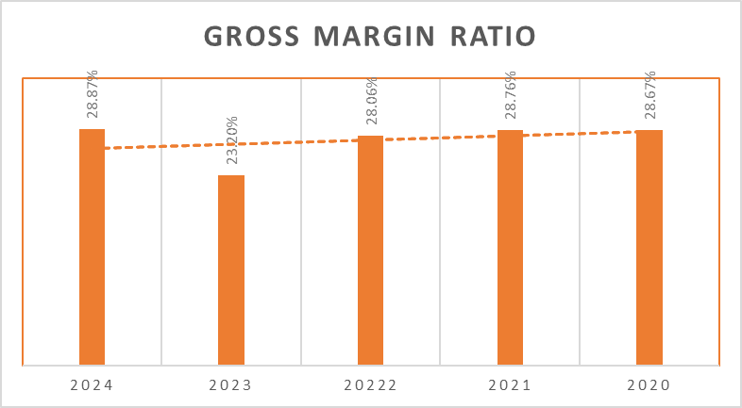
(Source: Self-created)

Appendix 2: Profitability Ratios
Ratios | Formulas | 2024 | 2023 | 2022 | 2021 | 2020
Gross Margin Ratio | Gross Profits / Sales | (113994 / 394879) = 28.87% | (97560 / 420457) = 23.30% | (152292 / 542751) = 28.06% | (173016 / 601602) = 28.76% | (176256 / 614680) =  28.67%
Operating Margin Ratio | Operating Income / Sales | (-15297 / 394879) =  -3.87% | (-85301 / 420457) =  -20% | (14548 / 542751) = 2.68% | (23253 / 601602) = 3.87% | (37267 / 614680) = 6.06%
Net Profit Margin Ratio | Net Profit / Sales | (-24029 / 394879) = -6.09% | (-98238 / 420457) = -23.36% | (407 / 542751) = 0.07% | (5301 / 601602) = 0.88% | (38572 / 614680) = 6.28%
(Source: Self-created)

Appendix 3: Operating Profit Margin
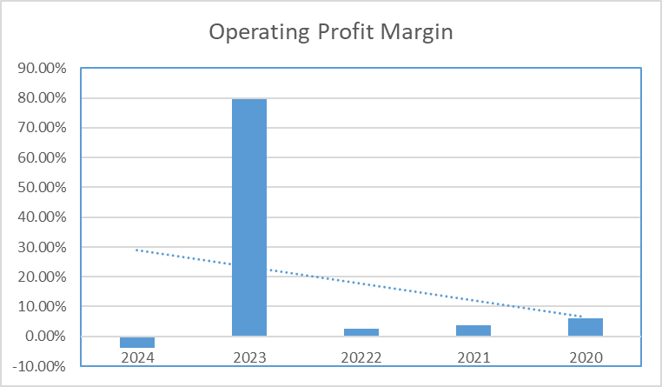
(Source: Self-created)

Appendix 4: Net Profit Margin Ratio
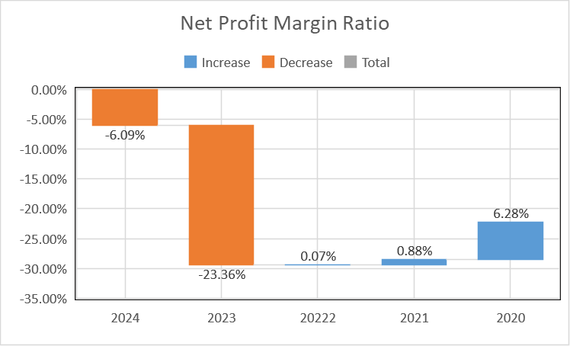
(Source: Self-created)

Appendix 5: Liquidity Ratios
Ratios | Formulas | 2024 | 2023 | 2022 | 2021 | 2020
Current Ratio | Current Assets / Current Liabilities | (242494 / 158291) = 1.53 times | (258851 / 161148) = 1.61 times | (338040 / 216473) = 1.56 times | (337146 / 216473) = 1.56 times | (326843 / 179510) = 1.82 times
Quick Ratio | Current Assets -Inventory/ Current Liabilities | (242494-79355) / 158291 = 1.03 time | (258851-88273 / 161148 = 1.06 times | (338040-140181 / 216473 = 0.91 times | (337146-134469 / 216473 = 0.94 times | (326843- 120430/ 179510 = 1.15 times
Cash Ratio | Cash / Current Liabilities | (26783 / 158291) = 0.17 times | (42751 / 161148) = 0.27 times | (66740 / 216473) = 0.31 times | (60813 / 216473) = 0.28 times | (57153 / 179510) = 0.32 times
(Source: Self-created)

Appendix 6: Current Ratio
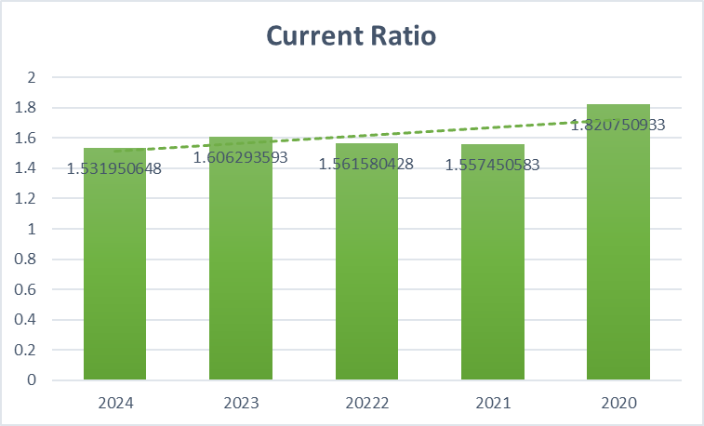
(Source: Self-created)

Appendix 7: Quick Ratio
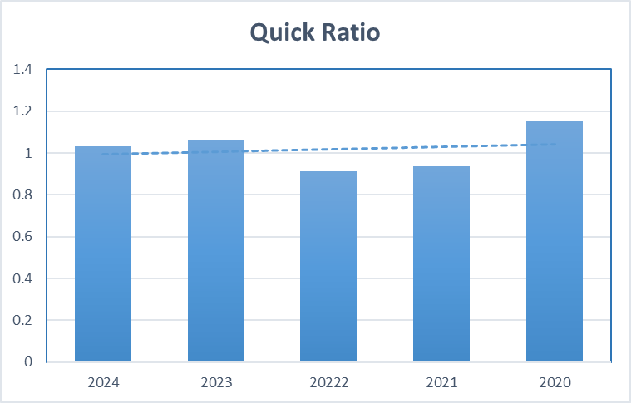
(Source: Self-created)

Appendix 8: Cash Ratio
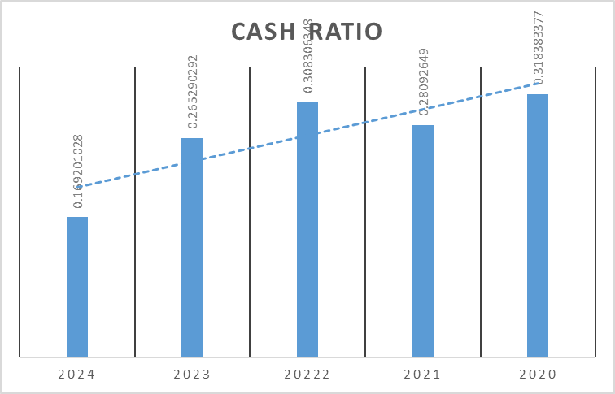
(Source: Self-created)

Appendix 9: Efficiency Ratios
Ratios | Formulas | 2024 | 2023 | 2022 | 2021 | 2020
Asset Turnover Ratio | Sales / Total Assets | (394879 / 323354) = 1.22 times | (420457 / 355872) = 1.18 times | (542751 / 504163) = 1.08 times | (601602 / 510348) = 1.18 times | (614680 / 510290) = 1.20 times
Fixed asset Turnover Ratio | Sales / Total Fixed Assets | (394879 / 80860) = 4.88 times | (420457 / 97021) = 4.33 times | (542751 / 166123) = 3.27 times | (601602 / 173202) = 3.47 times | (614680 / 183447) = 3.35  times
(Source: Self-created)

Appendix 10: Asset Turnover Ratio
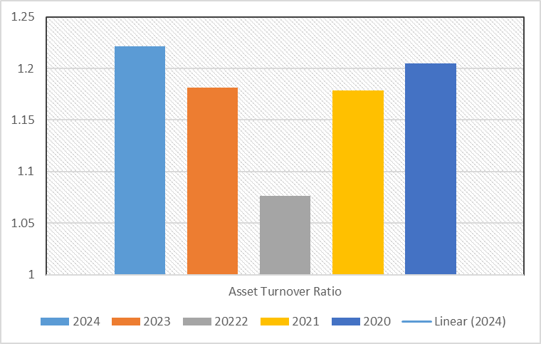
(Source: Self-created)

Appendix 11: Fixed Assets Turnover Ratio
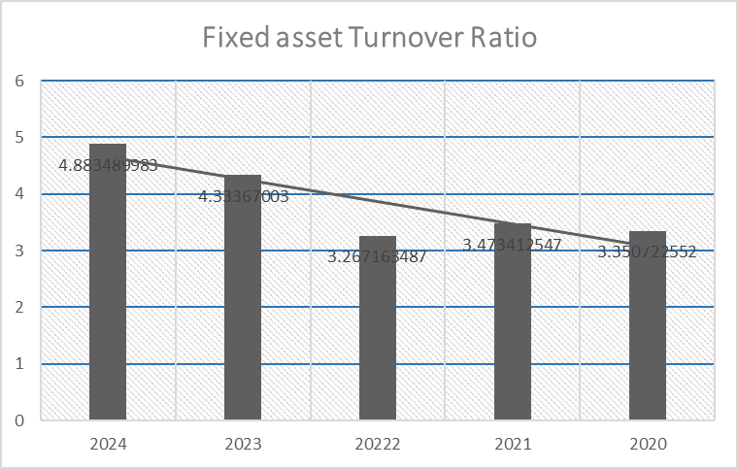
(Source: Self-created)

Appendix 12: Gearing Ratios
Ratios | Formulas | 2024 | 2023 | 2022 | 2021 | 2020
Interest Coverage Ratio | EBIT / Interest Expenses | (-15297 / -3361) = 4.55 times | (-85301 / -4332) = 19.69 times | (14548 / -2200) = -6.61 times | (23253 / -566) = -41.08 times | (37267 / -1422) = -26.21 times
Debt-Equity Ratio | Total Debt / Total Equity | (9232 / 153105) = 0.06 | (12560 / 178920) = 0.07 | (15027 / 268406) = 0.06 | (14266 / 275949) = 0.05 | (13681 / 313301) = 0.04
Debt-to-Capital Ratio | Total Debt / (Total Equity + Total Debt) | 9232 / (9232+153105) = 0.05 | 12560 / (12560+178920) = 0.06 | 15027 / (15027+268406) = 0.05 | 14266 / (14266+275949) = 0.04 | 13681 / (13681+313301) = 0.04
(Source: Self-created)

Appendix 13: Interest Coverage Ratio
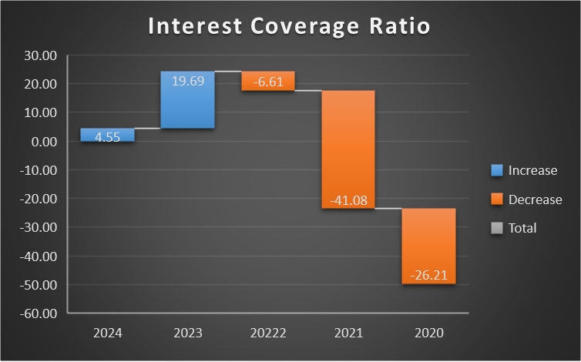
(Source: Self-created)

Appendix 14: Debt to Equity Ratio
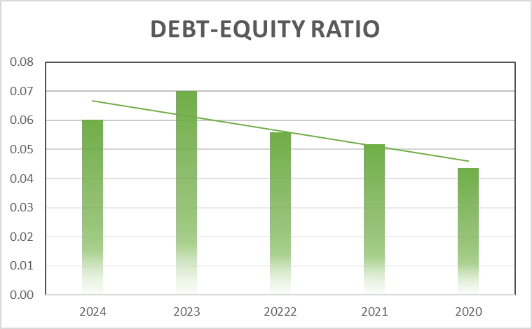
(Source: Self-created)

Appendix 15: Debt to Capital Ratio
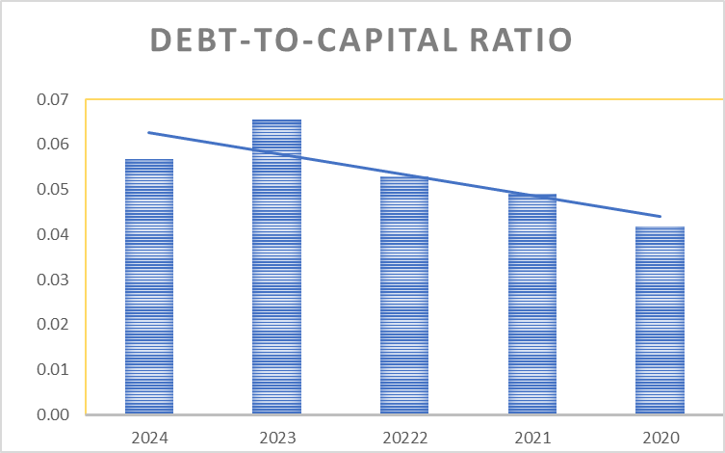
(Source: Self-created)

Appendix 16: Investment Ratios
Ratios | Formulas | 2024 | 2023 | 2022 | 2021 | 2020
Return on Assets (ROA) | Net Income / Total Assets | (-24029 / 323354) = -7.43% | (-98238 / 355872) =  -27.60% | (407 / 504163) =  0.09% | (5301 / 510348) =  1.04% | (38572 / 510290) = 7.56%
Return on Invested Capital (ROIC) | EBIT-Taxation / Total Equity + Net Debt | (-15297-5431) / 153105 + (-17551) = -12% | (-85301- 5984) / 178920 + (-30191) = 43.6% | (14548- 10986) / 268406 + (-51713) = 1.64% | (23253- 10779) / 275949+ (-46547) = 5.44% | (37267-5333) / 313301+(-43472) = 11.83%
Return on Equity (ROE) | Net Income / Total Equity | (-24029 / 153105) = -15% | (-98238 / 178920) = -55% | (407 / 268406) = 0.15% | (5301 / 275949) =  1.92% | (38572 / 313301) = 12.31%
(Source: Self-created)

Appendix 17: Return on Assets
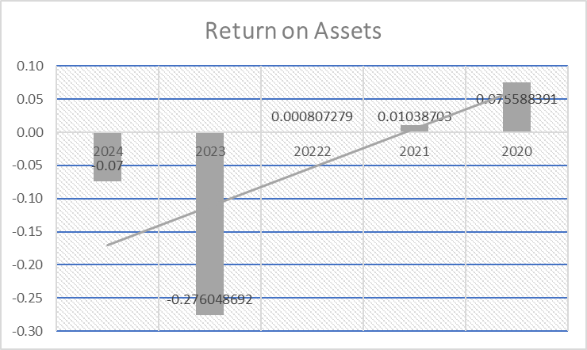
(Source: Self-created)

Appendix 18: Return on Invested Capital
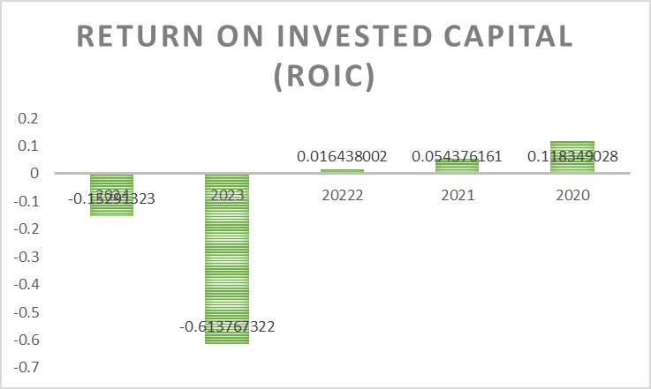
(Source: Self-created)

Appendix 19: Return on Equity
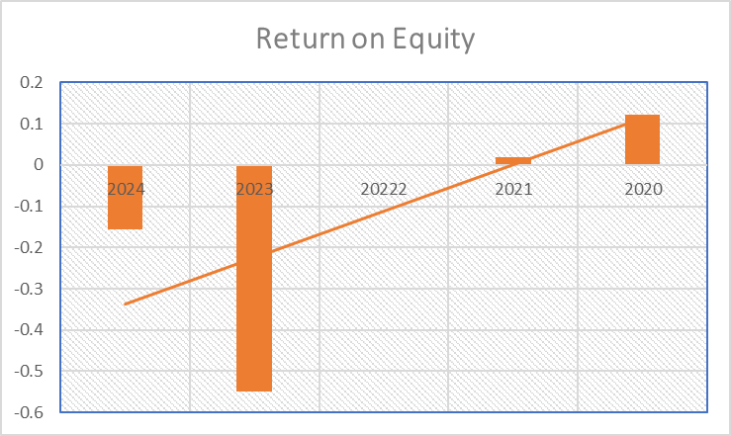
(Source: Self-created)

Appendix 20: Cash Flow to Debt Ratio
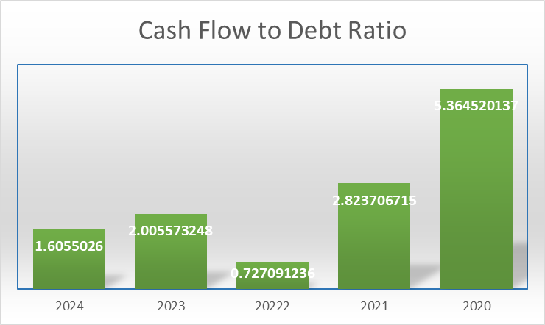
(Source: Self-created)

Appendix 21: Cash Flow Margin
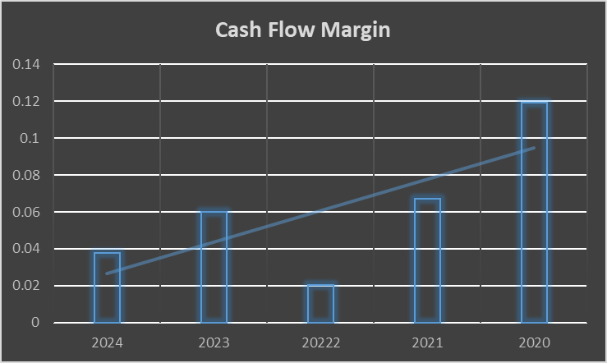
(Source: Self-created)

Appendix 22: Operating Cash Flow Ratio
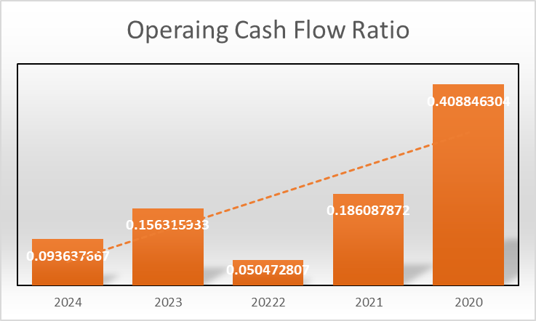
(Source: Self-created)

Appendix 23: Cash Flow Ratios
Ratios | Formulas | 2024 | 2023 | 2022 | 2021 | 2020
Cash Flow to Debt Ratio | Operating Cash Flow / Total Debt | (14822 / 9232) = 1.61 | (25190 / 12560) = 2.01 | (10960 / 15027) = 0.73 | (40283 / 14266) = 2.82 | (73392 / 13681) = 5.36
Cash Flow Margin | Operating Cash Flow / Sales | (14822 / 394879) = 0.04 | (25190 / 420457) = 0.06 | (10960 / 542751) = 0.02 | (40283 / 601602) = 0.07 | (73392 / 614680) = 0.12
Operating Cash Flow Ratio | Operating Cash Flow / Current Liabilities | (14822 / 158291) = 0.09 | (25190 / 161148) = 0.16 | (10960 / 216473) = 0.05 | (40283 / 216473) = 0.19 | (73392 / 179510) = 0.41
(Source: Self-created)

Appendix 24: Altman's Z score of probability of going Bankrupt
Altman's Z score of General Electronics for 2024
Ratios |  | Five components  (1) | Weight  (2) | Calculation  (3 = 1*2)
Working Capital / Total Assets | (242494-158291) / 323354 = 0.26 | A | 1.2 | 0.31
Retained Earnings / Total Assets | (2,08,431 / 323354) = 0.64 | B | 1,4 | 0.90
Earnings Before Interest and Taxes (EBIT) / Total Assets | (-15297 / 323354) = -0.04 | C | 3.3 | -0.16
Market Value of Equity / Total Liabilities | (153105 / 170249) = 0.89 | D | 0.6 | 0.54
Net Sales / Total Assets | (394879 / 323354) = 1.22 | E | 1.0 | 1.22
Total Z |  |  |  | 2.82
Note : Here, Book value is taken as market value
(Source: Self-created)

Appendix 25: Cash Conversion Cycle of General Electronics
Ratios | Formula | 2024 | 2023 | 2022 | 2021 | 2020
Accounts Receivables Days | Average Accounts Receivable/ Average Daily Sales | 105 days | 98 days | 81 days | 78 days | 38 days
Accounts Payables Days | Average Accounts Payable / Cost of Goods Sold per day | 84 days | 73 days | 77 days | 75 days | 35 days
Average Inventory Days | Average Inventory / Cost of Goods Sold per day | 109 days | 129 days | 128 days | 109 days | 50 days
Cash Conversion Cycle (CCC)  [Receivables Days-Payables Days Inventory Days] |  | 130 days | 154 days | 132 days | 112 days | 53 days
Notes:
1. Average Daily Sales = Total Credit Sales / 365
2. It is assumed all sales are in Credit
3. Cost of Goods Sold per day = COGS/365
4. Average Accounts Receivable = Opening Receivable + Closing Receivable
5. Average Accounts Payable = Opening Payable + Closing Payable
6. In absence of opening balance of 2020, only closing value is considered in debtors, creditors and inventory days.
(Source: Self-created)

Appendix 26: Payback Period
Annual Cash Inflow
 | Project A (£m) | Cumulative Cash Inflow | Project B (£m) | Cumulative Cash Inflow | Project C (£m) | Cumulative Cash Inflow
Initial Cash Outlay | 40 |  | 30 |  | 50
Year
1 | 10 | 10 | 6 | 6 | 5 | 5
2 | 12 | 22 | 6 | 12 | 10 | 15
3 | 14 | 36 | 6 | 18 | 20 | 35
4 | 10 | 46 | 6 | 24 | 25 | 60
5 | 8 | 54 | 6 | 30 | 15 | 75

Notes:
Payback period = Balance Cash Outlay/ Cumulative Cash Inflow remaining year
Project A: 3+(40-36)/10 = 3.04 years or 4 years
Project B: = 5 Year
Project C: 3+(50-35)/25 = 3.06 years or 4 years
(Source: Self-created)

Appendix 27: Accounting Rate of Return (ARR)
Initial Cash Outlay | 40 | 30 | 50
 | Project A (£m) | Project B (£m) | Project C (£m)
Year
1 | 10 | 6 | 5
2 | 12 | 6 | 10
3 | 14 | 6 | 20
4 | 10 | 6 | 25
5 | 8 | 6 | 15
Total | 54 | 30 | 75
Average Investment | 20 | 15 | 25
Average Annual Profit | 10.8 | 6 | 15
Rank | 1 | 3 | 2
Notes:
1. Average Investment = Initial Investment + Scrap value / 2
2. Here, Scrap value is NIL
3. Accounting Rate of Return (ARR) = Average Annual Profit / Average Investment
(Source: Self-created)

Appendix 28: Net Present Value
 | Discounting Factor @ 10% | Project A (£m) | Present Value (£m) | Project B (£m) | Present Value (£m) | Project C (£m) | Present Value (£m)
Initial Cash Outlay |  | (40) |  | (30) |  | (50)
Year
1 | 0.909 | 10 | 9.091 | 6 | 5.455 | 5 | 4.545
2 | 0.826 | 12 | 9.917 | 6 | 4.959 | 10 | 8.264
3 | 0.751 | 14 | 10.518 | 6 | 4.508 | 20 | 15.026
4 | 0.683 | 10 | 6.830 | 6 | 4.098 | 25 | 17.075
5 | 0.621 | 8 | 4.967 | 6 | 3.726 | 15 | 9.314
NPV |  |  | 1.324 |  | -7.255 |  | 4.225

Notes:
Net Present Value (NPV) = CF1 / (1+r) + CF2 / (1+r)2 + CF3 / (1+r)3 +…+ CFn / (1+r)n- Capital Outlay
CF = Cash Flow
r= Rate of Return or Discounting period
(Source: Self-created)

Appendix 29: Profitability Index (PI)
 | Discounting Factor @ 10% | Project A (£m) | Present Value (£m) | Project B (£m) | Present Value (£m) | Project C (£m) | Present Value (£m)
Initial Cash Outlay |  | 40 |  | 30 |  | 50
Year
1 | 0.909 | 10 | 9.091 | 6 | 5.455 | 5 | 4.545
2 | 0.826 | 12 | 9.917 | 6 | 4.959 | 10 | 8.264
3 | 0.751 | 14 | 10.518 | 6 | 4.508 | 20 | 15.026
4 | 0.683 | 10 | 6.830 | 6 | 4.098 | 25 | 17.075
5 | 0.621 | 8 | 4.967 | 6 | 3.726 | 15 | 9.314
Sum of Discounted Cash Inflows |  |  | 41.324 |  | 22.745 |  | 54.225
Profitability Index (PI) |  |  | 1.033 |  | 0.569 |  | 1.085
Rank |  |  | 2 |  | 3 |  | 1

Notes:
Profitability Index (PI) = Sum of Discounted Cash Inflows / Initial Cash Outlay
(Source: Self-created)

Appendix 30: Internal Rate of Return (IRR)
Project A
 | Project A (£m) | Discounting Factor @ 12% | Present Value (£m) | Discounting Factor @ 6% | Present Value (£m)
Initial Cash Outlay | 40
Year
1 | 10 | 0.893 | 8.929 | 0.943 | 9.434
2 | 12 | 0.797 | 9.566 | 0.890 | 10.680
3 | 14 | 0.712 | 9.965 | 0.840 | 11.755
4 | 10 | 0.636 | 6.355 | 0.792 | 7.921
5 | 8 | 0.567 | 4.539 | 0.747 | 5.978
Net Present Value (NPV) |  |  | -0.646 |  | 45.768
(Source: Self-created)
Project B
Initial Cash Outlay 30
 | Project B (£m) | Discounting Factor @ 5% | Present Value (£m) | Discounting Factor @ 3% | Present Value (£m)
Year
1 | 6 | 0.952 | 5.714 | 0.971 | 5.825
2 | 6 | 0.907 | 5.442 | 0.943 | 5.656
3 | 6 | 0.864 | 5.183 | 0.915 | 5.491
4 | 6 | 0.823 | 4.936 | 0.888 | 5.331
5 | 6 | 0.784 | 4.701 | 0.863 | 5.176
Net Present Value (NPV) |  |  | -4.023 |  | 27.478
(Source: Self-created)
Project C
 | Project C (£m) | Discounting Factor @ 15% | Present Value (£m) | Discounting Factor @ 5% | Present Value (£m)
Initial Cash Outlay 50
Year
1 | 5 | 0.870 | 4.348 | 0.952 | 4.762
2 | 10 | 0.756 | 7.561 | 0.907 | 9.070
3 | 20 | 0.658 | 13.150 | 0.864 | 17.277
4 | 25 | 0.572 | 14.294 | 0.823 | 20.568
5 | 15 | 0.497 | 7.458 | 0.784 | 11.753
Net Present Value (NPV) |  |  | -3.189 |  | 63.429
(Source: Self-created)
Internal Rate of Return
Particulars | Project A | Project B | Project C
IRR = L+ NPV_{L} / NPV_{L}- NPV_{H} (H-L) | 0.179165 or 17.9% | 0.047446 or 4.7% | 0.145213 or 14.52%
Rank | 1 | 3 | 2

Notes:
L= Lower rate
H= Higher rate
NPVL= NPV at lower rate
NPVH= NPV at higher rate
(Source: Self-created)

Appendix 31: Capital Rationing
Projects | Investment of Projects | Cost Allocation (Budget £60m) | Profitability Index (PI) | Rank as per PI
A | 40 | 10 | 1.033 | 2
B | 30 | - | 0.569 | 3
C | 50 | 50 | 1.085 | 1
(Source: Self-created)

