University of Wales Trinity Saint David
Computer Aided Manufacturing and Design for Additive Manufacturing Technologies

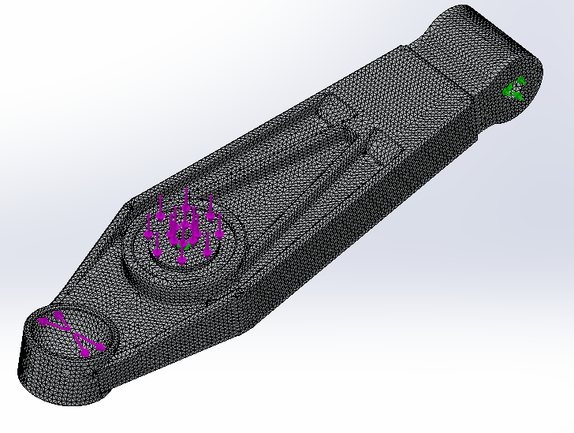

Manufacturing Design & Technology
M5X02070
Jordan Ross Jenkins
P149066
Due: 15/03/2019

Contents

Title page
Contents page
1 Introduction 3
1.1 Aim 3
1.2 Objectives 3
2 Background research 4
2.1 Component selection 4
2.2 Case study 4
2.3 Traditional Manufacturing technique 5
2.4 Sand Casting 6
2.5 Sand Casting and the Automotive Industry 6
3 Metallic Additive Manufacturing 7
3.1 Direct Metal Laser Sintering 8
3.2 Design Considerations for DMLS 8
3.3 Failure Mode Effects Analysis 9
4 Control Arm Redesign 10
4.1 Calculations 10
4.2 topology optimisation 13
5 Methodology for production 18
6 Conclusion 18
7 References 19

Introduction
Recent advancement in additive Manufacturing has revolutionised rapid prototyping in the automotive manufacturing industry. Additive manufacturing technology has enabled the industry to improve the efficiency in the product development stages, enabling manufacturers to decrease the overall time to market for new products (EOS GmbH, 2018). Increasingly, however, automotive manufacturers are studying ways in which additive manufacturing could benefit the manufacture of production vehicles. Porsche, for example, recently announced the use of selective laser sintering and selective laser melting in the production of low production volume parts for previous production models ( Porsche AG, 2018).
Additive manufacturing processes such as stereolithography, fused deposition modelling and selective laser sintering/melting can bring a host of benefits to many manufacturing sectors, these include;
- Speeding up the time to market.
- Reducing costs of product development.
- Environmental advantage in the reduction of waste material.
- Enabling mass customisation.
- Enabling the construction of complex geometries.
- Increasing the overall customer satisfaction.
This report will focus on direct metal laser sintering, and how it may enable the redesign of vehicle components by allowing the construction of geometries that are unachievable given traditional manufacturing processes.

Aim
The aim of this report is to demonstrate how the application of additive manufacturing processes over traditional manufacturing techniques can be advantageous in the automotive manufacturing industry.

Objectives
- Identify a component that may benefit from optimisation and the application of additive manufacturing processes.
- Create an appraisal of the traditional manufacturing techniques used to create the part.
- Identify the design for manufacture features of the current design iteration.
- Define the reasoning for the redesign.
- Redesign the component using optimisation techniques.
- Explain the features of the final design and Justify using analytical techniques.

Background research

Component selection
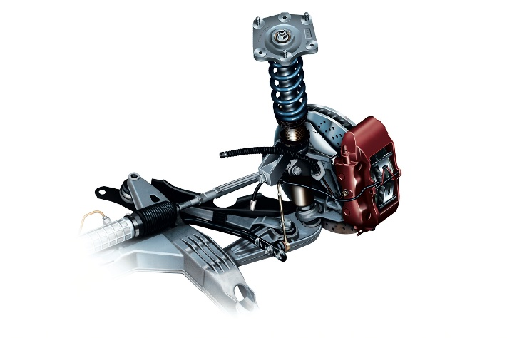
Suspension components are among the most crucial assemblies on a vehicle in terms of safety, performance, ride comfort and noise pollution. A simple McPherson strut system (figure 1) comprises of 3 main sub-assemblies:
Figure 1
Lower control arm
Wheel hub
Suspension strut
- Suspension Strut.
- Wheel Hub.
- Lower Control Arm.
It has long been known that light weight construction is a major factor in the manufacture of components for performance vehicles. In addition to the relationship between engine power output and vehicle weight, unsprung mass is of utmost importance when performance and safety are the primary design drivers (Hrovat, 1988). Large unsprung masses lead to issues with damping, wheel rebound control, handling, ride comfort and road noise. (purdy & simmer, 2004)
(Total911, 2018)
Lower control arms are perhaps the most eligible suspension components for mass reduction through optimisation techniques such as topology. In comparison to the other suspension components they have large volumes and simplistic fixed geometries.

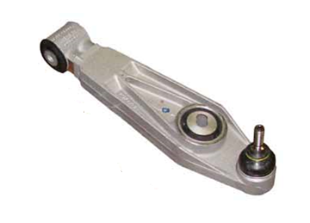
Case study
Figure 2
Although mass reduction of lower control arms may not be a key interest to most high-volume road vehicle manufacturers, those who primarily create performance vehicles seek to reduce the mass of each and every component, especially those that increase the unsprung weight of the vehicle.
The lower control arm case study selected (figure 2) is from a Porsche 991 GT3, a Performance oriented vehicle, where mass reduction of components is a major design driver. The current design already has aspects of optimisation, including ribbed support structure around the mounting locations and extruded geometries to reduce thickness and mass.
(Tarret Engineering , 2017)

Traditional Manufacturing technique
There are multiple traditional techniques that are currently used to manufacture control arms, some of the most common are:
- Stamping sheet steel.
- Die, sand and investment casting.
- Machining.
- Forging.
- Extrusion.
The Case study control arms are made from cast aluminium, the appearance of the components, such as the suggest that are sand cast.
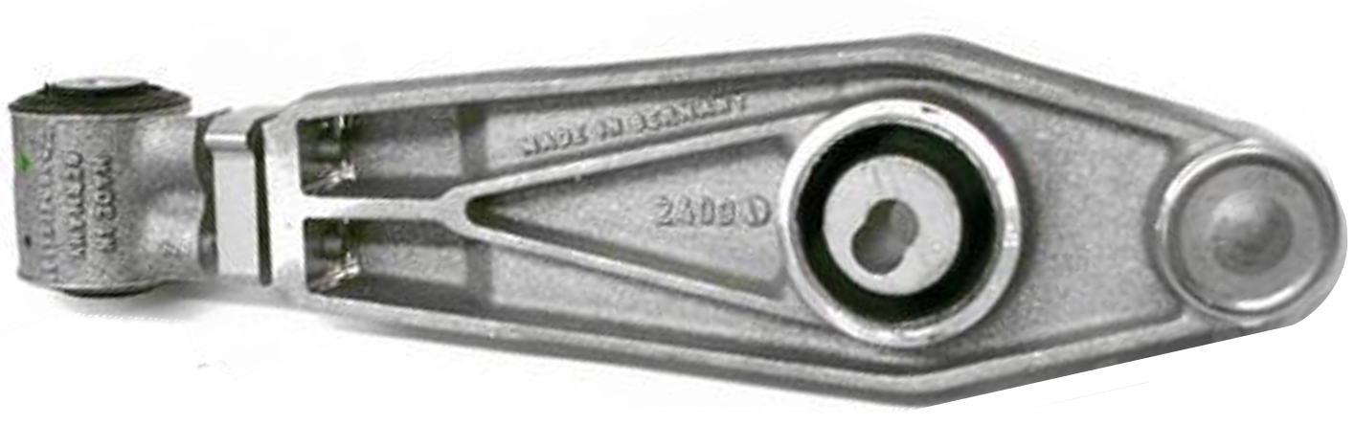
Figure 3

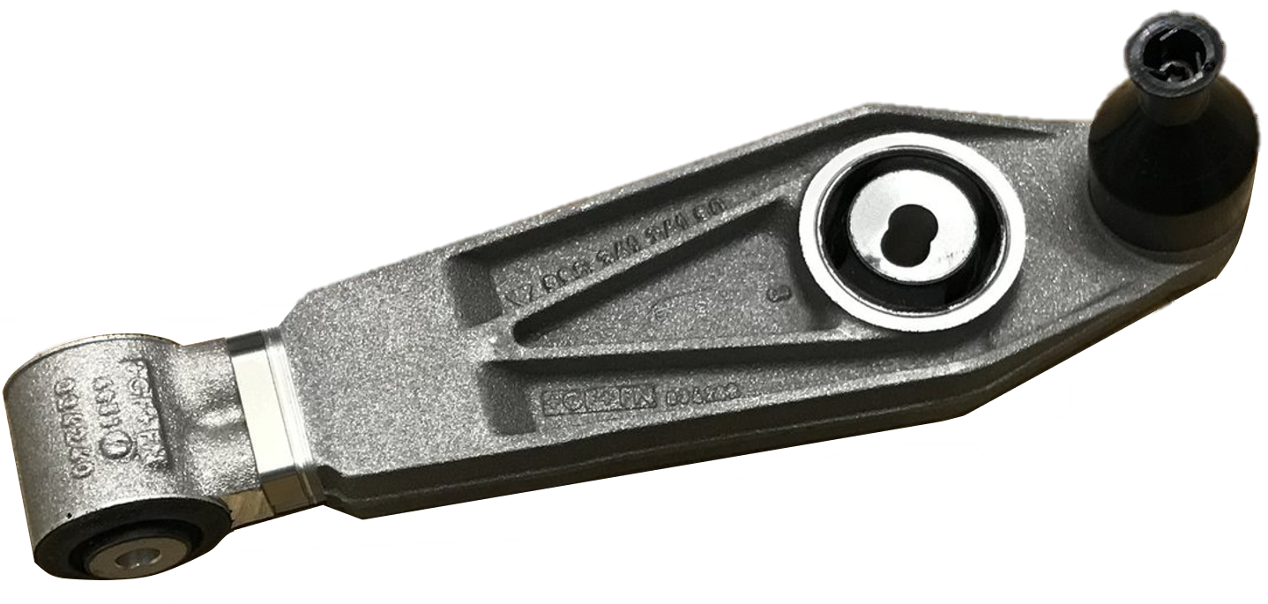
(Design911, n.d.)

(stuttgart-classica, n.d.)

According to (Zainuddain, 2009) a rough granular surface finish is indicative of sand casting, the surface finish of sand cast components is dependent on the compaction on the sand, the sand grain, the alloy used and the cooling and shrinkage rate. Although surface finish using other techniques such as die casting and investment casting is variable, generally they yield smoother surface finishes.
The thick, distinct parting line is also a common feature in sand casting when compared with other casting methods, this is due to larger tolerance between the mating surface of the mould cavities.

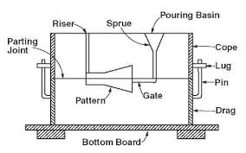
Sand Casting
Figure 4
Sand casting is a process where molten metal is poured into expendable sand moulds to create the components geometry. The first step in the sand-casting process is making the mould. Firstly, a pattern must be created that replicates the geometry of the component being cast. Patterns are commonly made from metal or plastic and are normally manufactured by traditional machining techniques such as turning and milling (Borui Casting International , 2014). The pattern is covered in a parting compound which is usually fine silica. The pattern is then placed on a sand covered bottom board. More sand is added to the bottom board and compressed to create the bottom half of the mould, called the drag. The top half of the mould, called the cope, is created by inverting the pattern and repeating this process. The two half moulds are brought together to create the moulding flask, the molten metal feeding system (figure 4) must then be added to the moulding flask, this feeding system consists of a pouring basin, sprue & runner, ingate and risers.
(Mechanica Technical, 2014)
According to (Uday A.Dabade et al. 2013) the design and strategic placement of the feeding system are imperative to the quality of the final cast, poor feeding can result in major casting defects and ultimatley cast rejection. More recently however, Engineers use Computer aided casting simulation software as an optimisation technique to predict how changes to the system will affect the quality of the final cast, limiting the number of defects and rejections.
The moulding flask is then separated, and the pattern removed. Once complete, a lubricant is added to the inner walls of the cast to enable easier removal of the finished component, as well as better flow of the molten metal during the pouring process. Molten metal is then poured into the pouring basin, flowing through the feeding system and into the mould cavity. Here the placement of the risers is detrimental to the final cast quality, (M Nandagopal, 2017) explains that the risers act as a reservoir of molten metal that compensate for the shrinkage as the cast solidifies.
Once the cast is fully solidified, the mould flask is broken, and the cast component is removed. Excess sand is removed by shot blasting and the metal feeding system is cut away, depending on the specification, components will often require secondary machining to be fit for purpose.

Sand Casting and the Automotive Industry
Dry sand casting is the most commonly used sand-casting method in the automotive industry. Dry sand casting is a more sophisticated technique, that uses a binding agent mixed into the sand during the mould making process, as well as baking the mould to around 250⁰C to increase its strength. Excellent dimensional accuracy can be achieved by implementing the dry sand-casting technique (Engineershandbook, 2006).
Benefits of using dry sand casting
- Stronger moulds decrease the possibility of cast defects and rejection.
- Excellent dimensional control and accuracy.
- Smoother surface finish than traditional casting techniques.
Limitations of using dry sand casting
- The already large Leadtime in the mould making process is increased due to the binding and baking processes.
- The process is more expensive than traditional sand casting.
- Drying time of the baking process is a determining factor in the final cast quality.

Metallic Additive Manufacturing
Renishaw defines additive manufacturing as “a process used to create three-dimensional parts from a digital file. It usually involves building up, or solidifying, thin layers of material to create complete parts” (Renishaw PLC, 2019).
Additive manufacturing has been used in the automotive industry for some years now, however, the technology has largely been constrained to rapid prototyping applications. Previously, a lack of structural properties in the materials used in most Laser powder bed fusion techniques, as well as limited production volumes and a High costs per component, meant that most components created using such techniques where used as visualisation tools or as mock-ups. (Molitch-Hou, 2017)
Using Additive processes for rapid prototyping means that concept components can be created and tested without expensive dedicated tooling. (3deo, 2018) states that the lead time from design prototype to a physical prototype can be reduced from weeks to hours using additive processes. Automotive manufacturers have streamlined the product development stages by employing these techniques and hence decreased the overall time to market for new products. Recent development of tooling and materials means that automotive manufacturers are increasingly looking to implement Additive manufacturing processes in the manufacture of components for production vehicles. Volkswagen for example unrevealed that they are planning on using SLS and DMLS to produce components for mass production (Plewa, 2018).
Additive manufacturing processes enable a greater design freedom in terms of component geometries. Airbus have recently redesigned complex aircraft components, the geometric flexibility allowed them to reduce the mass of the components whilst maintaining the components mechanical properties (ku, 2015).
Environmental advantage in the reduction of waste material is another benefit to additive manufacturing, unlike traditional subtractive manufacturing, such as machining, only material used to physically build the components geometry are used in the process, excess materials are collected and reused in further productions. Also, fast production means manufacturers don’t need to waste materials and consume energy manufacturing components to store, production quantities can be linked even more closely with demand. The logistical aspect is also a consideration, if components can be made in house rather than in dedicated machine shops or foundries, there is no need to transport them between the manufacturer and sub-contractor (Plewa, 2018).
Mass customisation many not be a major benefit to the automotive industry, nevertheless, many other sectors such as the medical and fashion industries benefit from being able to offer their customers one hundred percent customisation based on their requirements, leading to an increase in customer satisfaction. One such example in the automotive industry is that Porsche have announced the use of selective laser sintering, and selective laser melting in the production of low production quantity parts for previous production models ( Porsche AG, 2018). Meaning customers now have access to replacement parts that were infeasible to create using traditional techniques.

Direct Metal Laser Sintering
Figure 5
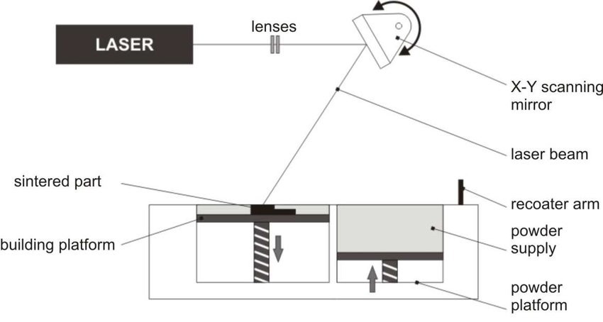

(Hudak, 2015)
Direct Metal Laser Sintering is a sub-category of Laser Powder Bed Fusion. The process begins with creating the component in CAD software. The component geometries are then exported to the sintering machine where it is interpreted as a series of layers for manufacture. The building platform is preheated, however, not enough to melt the build material. There are a wide range of powdered materials available for use with DMLS, the most commonly used in the automotive industry are aluminium (AISI10Mg), aluminium alloy (AM205) and titanium (Ti6Al4V) (3trpd, 2018). A layer of material around 30 microns thick is spread across the building platform by the recoater arm. A high-power laser beam is then reflected through a series of mirrors that rotate about the x and y axis, called the x-y scanning mirror. The laser is now incident on the layer of powder material on the building platform. The laser sinters the material as it is interpolated around the geometry of the component. The process is repeated for the number of layers necessary to create the part, this is calculated by the software at the start of the process.

Design Considerations for DMLS
As above, traditional manufacturing methods such as casting and machining place constraint on what geometries a component can have, this principle is always balanced against the need to remove material to reduce component weight, as well as maintain its mechanical properties. When redesigning a component for an additive process it is important to reconsider the design techniques used, according to (Konstantinos Salonitis et al. 2015) there are 5 steps to consider when redesigning a component for manufacture using DMLS:
- Analysis of the functional specification, what are the material properties required, the loading on the component and the capabilities of the chosen manufacturing process.
- A “block” design of the component is created, limited by the maximum component geometry. A FEA study of worst-case loads is created to define the maximum deflection the component is likely to sustain.
- A topology study of the design is conducted, optimal load paths are calculated, and a projection of removable material is created.
- Final design iteration, using the results of the topology study to recreate the component in its optimal mass to stiffness ratio.
- Final evaluation, does the component meet the specification, consider the manufacturability and cost, will the component need secondary techniques?

Failure Mode Effects Analysis
Failure mode effect analysis is an important tool to consider when developing any component, it is used to predict and eliminate failures of a component, and to suggest ways in which such failures can be avoided. Values for the severity, occurrence and detection probability are entered and a risk priority number is calculated. The higher the RPN number the higher priority the risk is given.
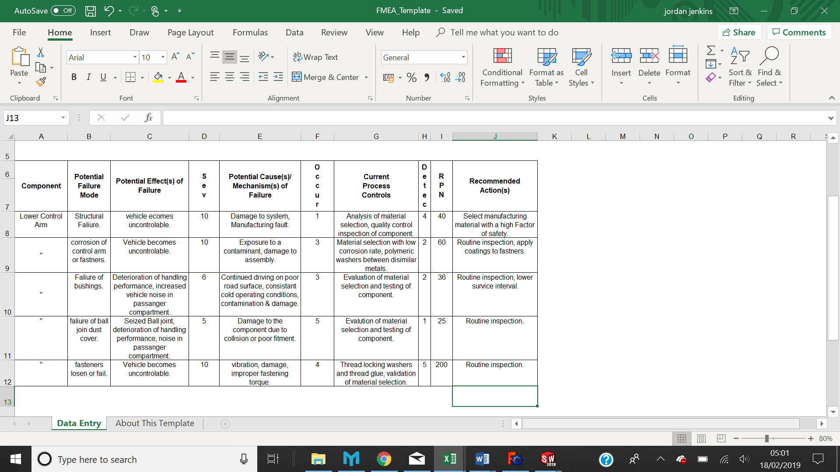
Below is a FMEA for a Lower control arm.

Control Arm Redesign
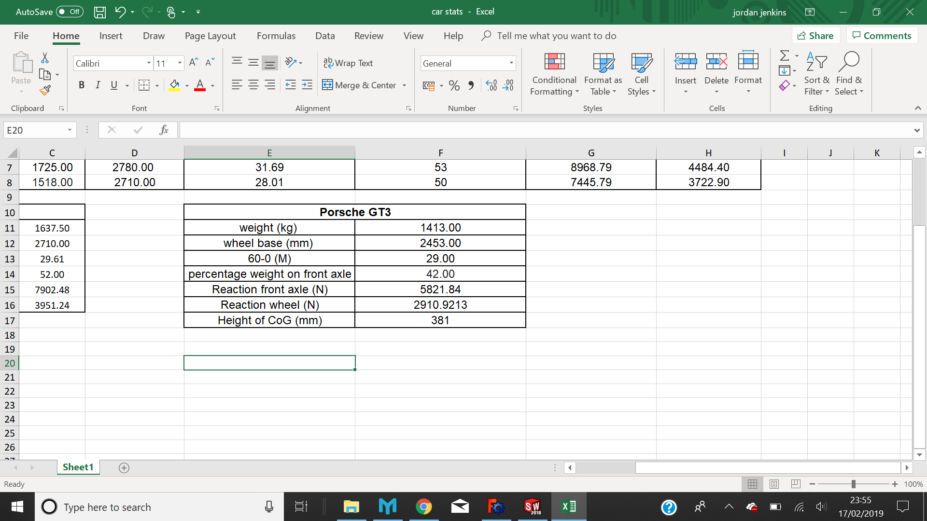
As Above, the case study for the component redesigned for additive manufacture is a lower control arm from a Porsche 991 GT3, The Porsche 991 GT3 is a relatively low production performance car with only 4250 units made annually. The control arms are sand cast aluminium.

Calculations
Calculating Static forces on a wishbone.
Mass of car = 1413.00kg.
Weight distribution = 42:58.
weight on front axle = 1413.00 x 0.42 = 5821.84N.
Longitudinal weight transfer = vehicle weight x centre of gravity height / wheel base.
1413.00 x (381 x10⁻³) / (2453.00 x 10⁻³) = 219.47kg.
deceleration = 1413.00 x (381 x10⁻³) / (2453.00 x 10⁻³) = 219.47kg x 9.81 = 2153N.
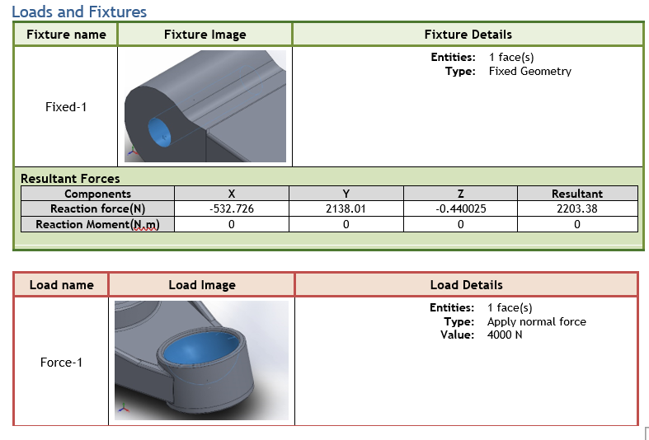
5821.84N + 2153 N / 2 = 3987N.
The Above image shows the load point and fixing point of the original component design for FEA analysis, the load point is the ball joint socket with 4000N applied as calculated above. The fixing point is the hole where the lower control arm would be fastened to the subframe on the vehicle, as well as the front link location.
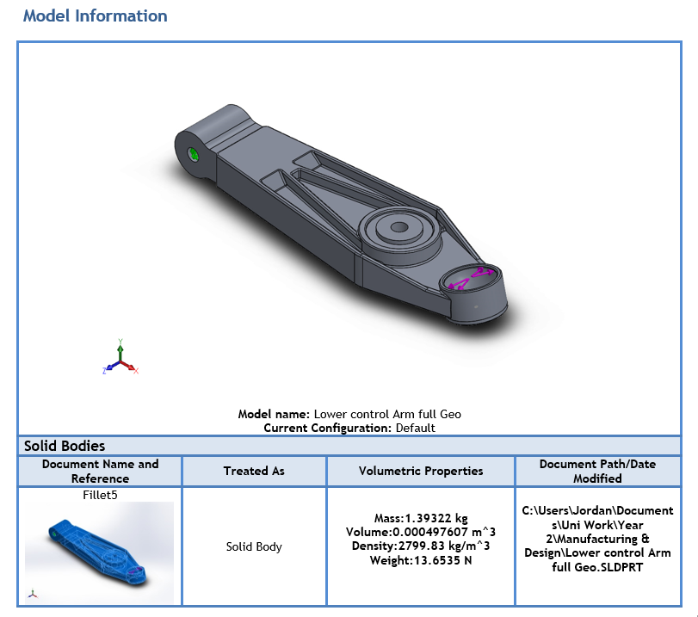

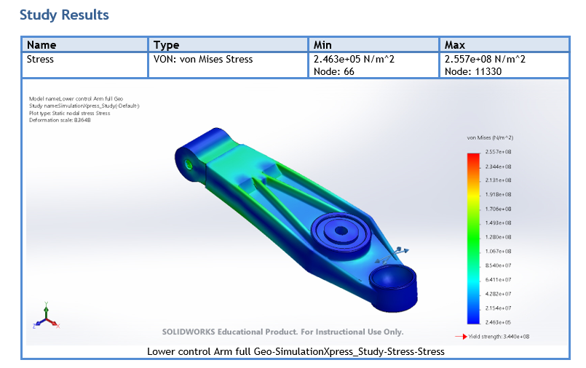
the above image shows the CAD Model for the original control arm, the mass is calculated as 1.39kg.

The diagram above is a visual representation of the Von Mises stress acting on the control arm, there are no red shaded areas, hence the original design doesn’t come close to the yield strength of the aluminium used to create the component.
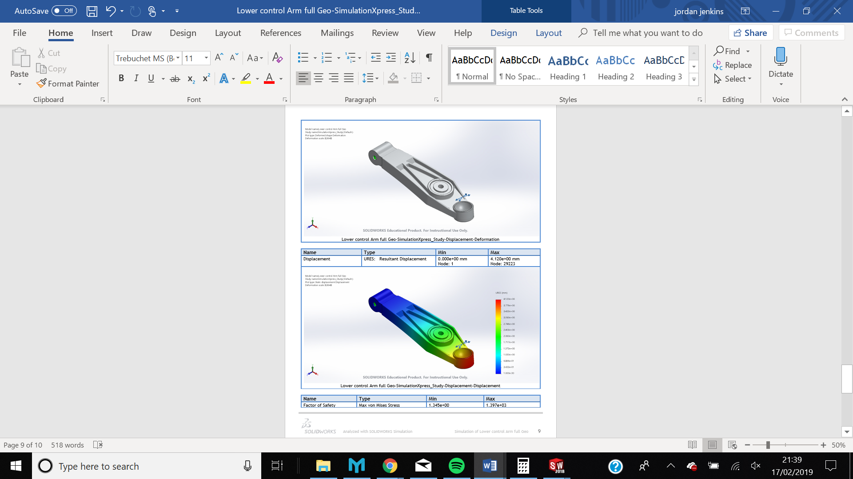
Below is an image of the displacement experienced by the standard component, as explained above, this deflection value may not be indicative of the real-world value experienced by the control arm. This is because the resolution of the forces is static in the equations calculated above and in the real world, they would be dynamic. An assumption of 2g was also made to account for mass transfer on heavy breaking of the motor vehicle.
the multi-coloured image above shows the displacement of the original component from its original geometry, the graph suggests that the ball joint socket has been displaced by around 4mm.

topology optimisation
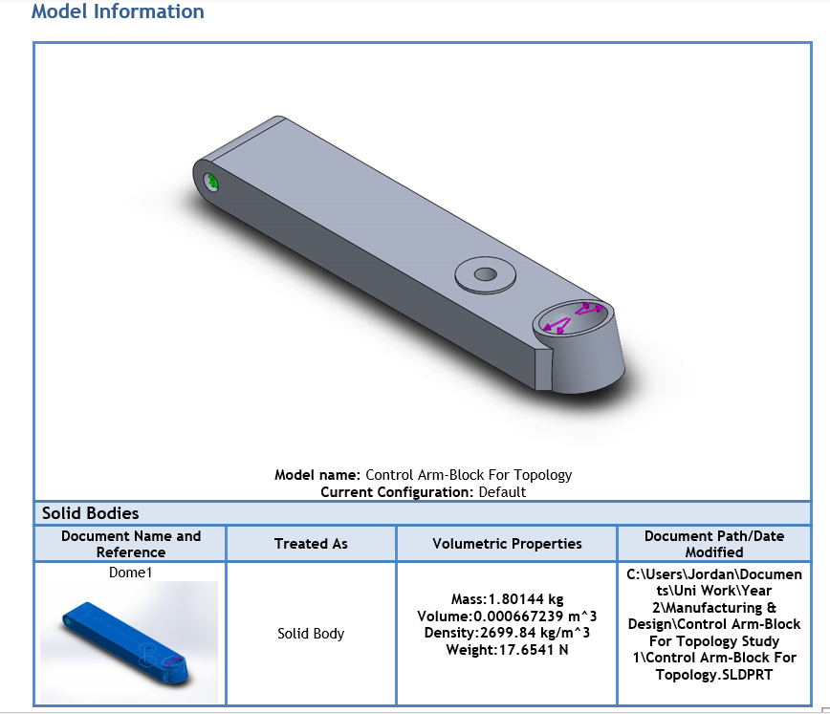
Below is an image of a block design based on the geometry of the original component, the ball joint socket, front link arm and subframe mounting locations are the same, however the body geometry of the arm Is much smaller.

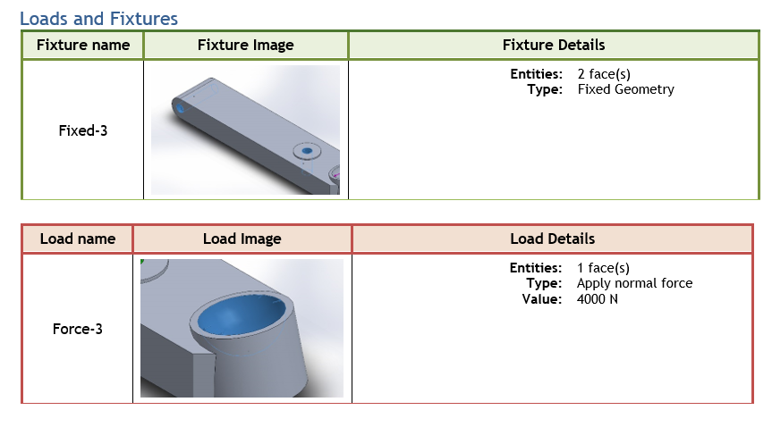
The mass of the component has increased here due to the fact that the component is now a solid block.

Above is a diagram to show the loading and fixing points for the FEA of the block design. The fixing points remain between the subframe and the end of the control arm and the front link arm mounting point. The loading point is the ball joint socket.
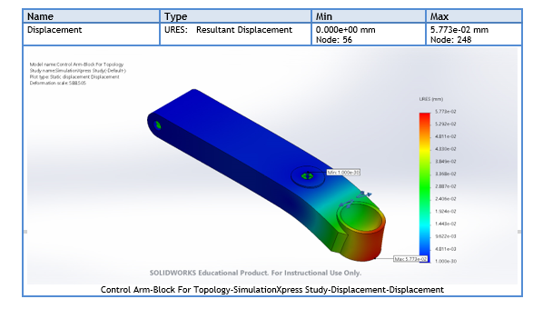
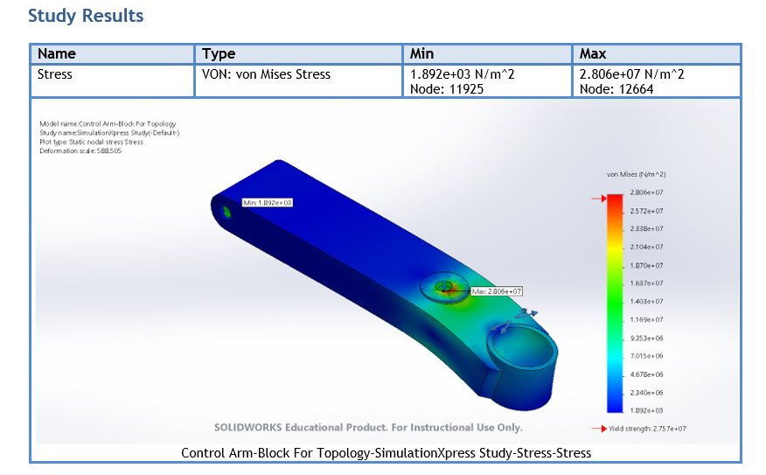
Below are the results for the von Mises stress test, the results show that for the most part the stress does not exceed the yield strength of the material, however there is one small point of high stress at the fixing point for the front link arm. Although the calculated forces are somewhat exaggerated, the most probable reason for the spike in stress is the fixing method used in the study. The fixing method in this study only counts the internal wall of the fixing point as a load baring surface, however in reality the force would be spread around the whole mating surface between the link and control arm.
Above is a displacement diagram, although the red shading at the ball joint socket may suggest the components is suffering serious deflection, the actual maximum displacement value is very small, just 0.057mm.
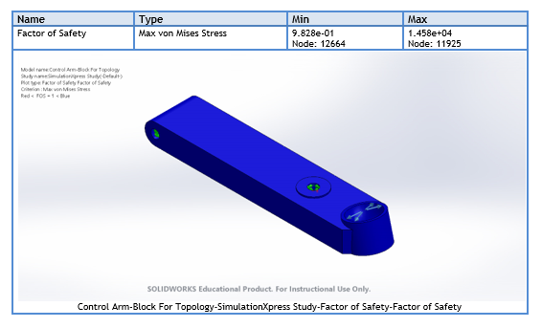
Below is a diagram to show the factor of safety of the block design. The factor of safety is commonly used as a preliminary check to see if the component can be optimised through topology mass reduction. Generally only models with a minimum factor of safety above 1 are optimised. The results show that the minimum factor of safety for this design is 0.98, however it is also plausible that this is due to the fact that the fixing point selection only enables the face of the point to be selected, meaning the force interaction between the link arm and the control arm is not correctly spread along the mating surfaces of the two components.
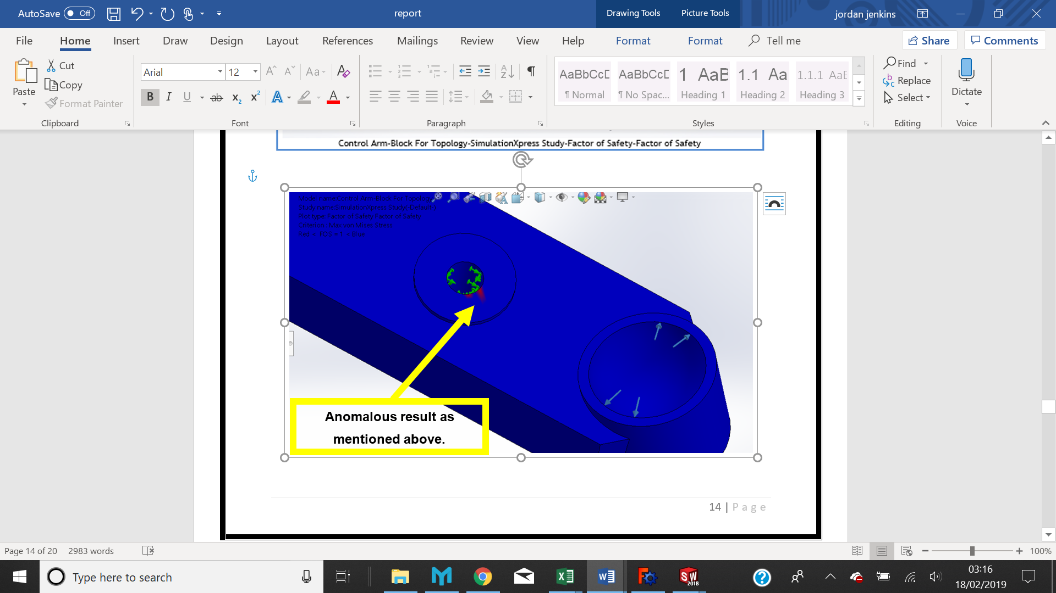
Once the Factor of safety test was complete, the topology study was created. The same fixing and loading points used in the FEA studies above were implemented in the topology study. A series of manufacturing constraints were also used to ensure the basic fixing geometries of the control arm remained the same. A symmetrical design constraint was also used, placed on the x axis and intersecting the component to create 2 symmetrical halves. A standard tetrahedral mesh was used, with a globe size of 3.75mm and a tolerance of 0.17mm.
The topology study removed almost half of the component volume and reduced the mass by 0.5kgs, a saving of 35.71% based on the original design.

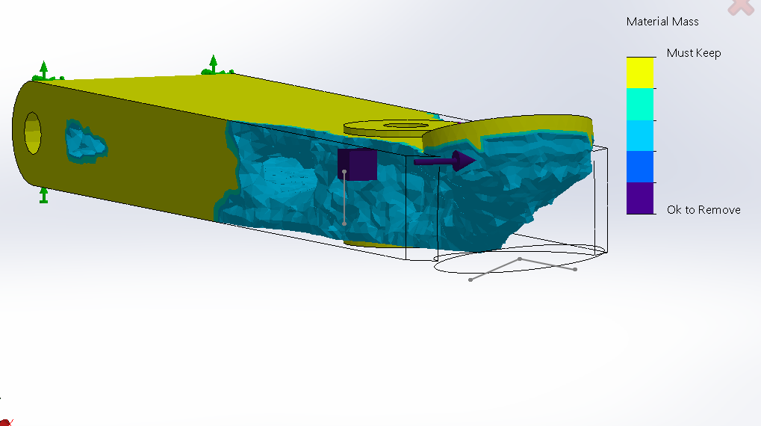

Below is a cross section image showing a large volume of removed material from inside the control arm design.
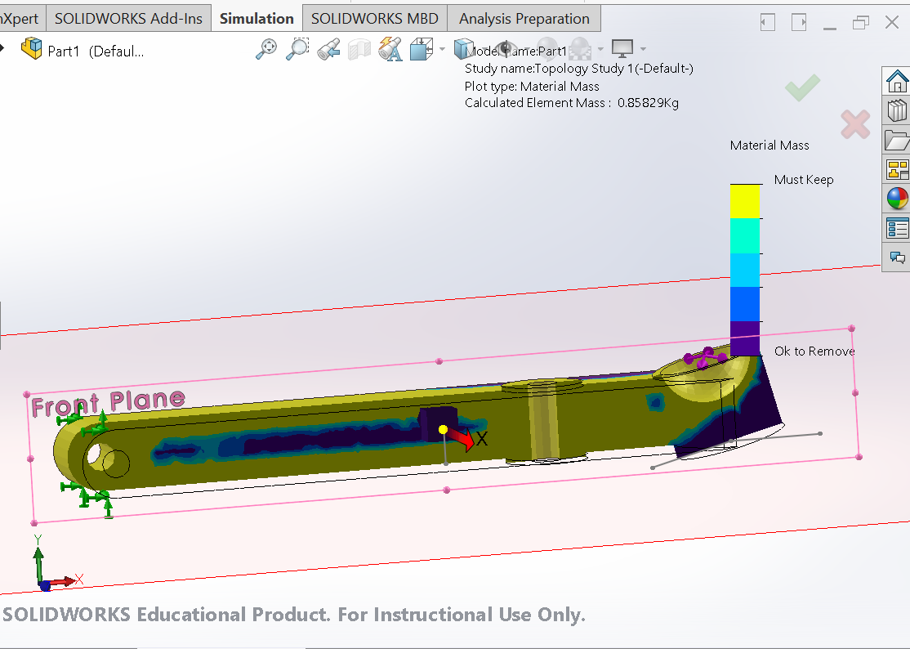

The image below shows the complex geometries created when using topology optimisation.
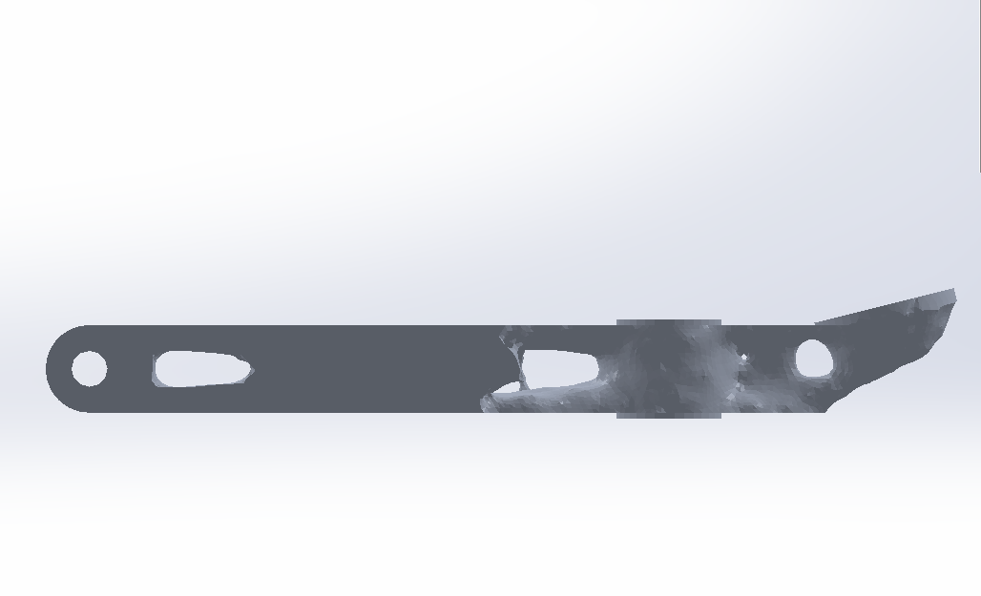

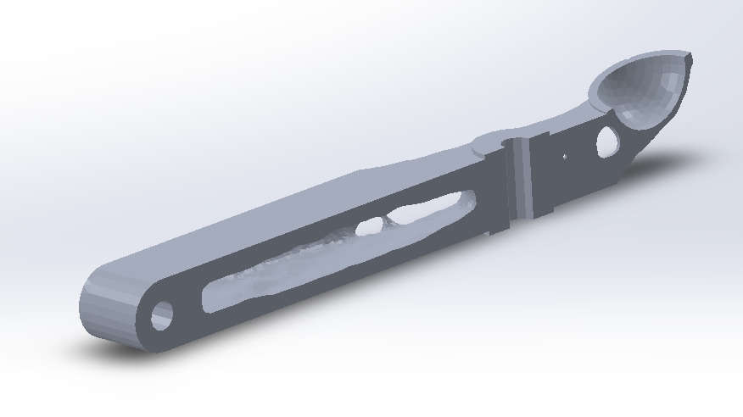
A cross section view, displaying the quantity of material removed from the inside of the block design.

Methodology for production
If the lower control arm design above was to be produced, the best Additive manufacturing technique to produce it would be direct metal laser sintering. DMLS would allow the component to maintain its mechanical properties, even with the complex geometries shown. Due to the case studies low production volume, the benefits offered by direct metal laser sintering are unrivalled by traditional techniques, it would be impossible to replicate the geometries created in the topology study with any traditional casting or machining technique.
The material used must have a high yield strength and a low mass per unit volume, from this perspective it is feasible to produce the component from either an aluminium powder or a titanium powder. The price difference between titanium Ti6Al4V and aluminium AM205 means that aluminium alloy AM205 is the best economic choice, while still retaining good strength and weight characteristics.

Conclusion
The redesigned lower control arm was a successful proof of concept, additive manufacturing techniques can stand to improve the performance characteristics of automotive components is certain applications. Whilst the current design iteration requires more finite element analysis and may benefit from more cycles of topology optimisation the initial investigation was able to save 35.71% of the initial components weight.
Additive manufacturing techniques are still a niche in the automotive industry, however the technology has developed at a blistering rate in recent years, from being the focus of theoretical journals and papers, to being adopted as a wide spread rapid prototyping technique in many industries.
At this moment, DMLS cannot compete with the production quantities offered by tradition casting techniques such as sand casting. DMLS is currently reserved for low production, high value components for the aerospace industry, race teams and high-end performance vehicles. However, with major manufacturers such as; airbus, Renishaw and Volkswagen already developing methods to utilise additive processes like DMLS and SLS, it is plausible to predict that even mass production volume vehicles may have topology optimised, additive manufactured components in the near future.

References
Porsche AG, 2018. newsroom The Media Portal of Porsche. [Online]
Available at: https://newsroom.porsche.com/fallback/en/company/porsche-classic-3d-printer-spare-parts-sls-printer-production-cars-innovative-14816.html
3deo, 2018. Prototype to Production. [Online]
Available at: https://news.3deo.co/metal-additive-manufacturing-will-drastically-improve-new-product-development
3trpd, 2018. Building Success Layer by Layer. [Online]
Available at: https://www.3trpd.co.uk/dmls/dmls-materials.htm
Borui Casting International , 2014. Introducing the pattern for casting process. [Online]
Available at: http://www.iron-foundry.com/pattern-for-casting.html
Design911, n.d. GT3 Trailing Arms. s.l.:s.n.
Engineershandbook, 2006. Manufacturing: Metal Casting. [Online]
Available at: http://www.engineershandbook.com/MfgMethods/drysandmolding.htm
EOS GmbH, 2018. EOS Automotive. [Online]
Available at: https://www.eos.info/automotive
Hrovat, D., 1988. Journal of Sound and Vibration. Influence of unsprung weight on vehicle ride quality, 124(3), pp. 497-516.
Hudak, R., 2015. DMLS Technology Principle. s.l.:s.n.
Konstantinos Salonitis*, S. A. Z., 2015. Redesign Optimization for Manufacturing Using Additive Layer. CIRP 25th Design Conference Innovative Product Creation , p. 195.
ku, C., 2015. 3-D Printed Parts on Airplanes Are Just the Beginning of a Movement. [Online]
Available at: https://apex.aero/airbus-boeing-3D-print-stratasys
M Nandagopal, S. K. S. G. S. M., 2017. Study of Sand Casting Gating System. International Journal of Recent Engineering Research and Development, 02(11), p. 22.
Mechanica Technical, 2014. Diagram of the Sand Casting Process. s.l.:s.n.
Molitch-Hou, M., 2017. engineering.com. [Online]
Available at: https://www.engineering.com/3DPrinting/3DPrintingArticles/ArticleID/15202/7-Issues-to-Look-Out-for-in-Metal-3D-Printing.aspx
Plewa, K., 2018. sculpteo. [Online]
Available at: https://www.sculpteo.com/blog/2018/09/28/additive-manufacturing-the-ultimate-game-changer-for-mass-production/
Precision Forging Co., n.d. Customized Die Forging Aluminium Suspension Control Arm. s.l.:s.n.
purdy, d. & simmer, d., 2004. Brief investigation into the effect on suspension motions of high unsprung mass. Journal of Battlefield Technology, 7(1), pp. 15-20.
Renishaw PLC, 2019. Metal 3D printing. [Online]
Available at: https://www.renishaw.com/en/metal-3d-printing--32084
stuttgart-classica, n.d. GT3 Coffin Arm. s.l.:s.n.
Tarret Engineering , 2017. 991 Lower Control Arm Library Photo. s.l.:s.n.
Total911, 2018. Image 911 suspension. Bath: Future Publishing limited.
Uday A.Dabade, R. C. B., 2013. Casting Defect Analysis using Design of Experiments (DoE) and Computer Aided Casting Simulation Technique, Maharashtra, India: Elsevier.
Zainuddain, M., 2009. A Study on Mold Material And Coating Effect In the Sand Casting Process, Pahang: University of Malaysia.

