Material Culture Of Death – Amara and Akhenaten/ Amenhotep IV

Introduction
First, it is important to have some background information on who Akhenaten was in life to properly understand the views of death and the afterlife they may have had. In order to gain insight into views of death and the afterlife, I shall be discussing the architecture, art and material culture of the tomb.
Akhenaten was the 10th pharaoh of the 18th dynasty c. 1352-1336. (Shaw, I. 2004 Page 485) During the 5th year of his reign, Akhenaten changed his name from Amenhotep IV and severed all ties with the traditional religious capital of Egypt and Amun its God. He opted to build an entirely new capital on fresh grounds dedicated to the Cult of Aten Called Amarna. (Shaw, I. 2004 Page 269) According to the Amarna Project, it was there that he “pursued his vision of a society dedicated to the cult of one god, the power of the sun (the Aten).” (Home – Amarna project., 2021) This was something that his father, Amenhotep III, had experimented with and was certainly not a new idea as there is evidence of Sun Cults being worshipped since the Old Kingdom. (Snape, S. 2010 Page 207) However, the main departure from the traditional religious beliefs of Egypt at the time was the rejection of polytheism. Amarna has been labelled as “full-blooded monotheism” by Snape with Akhenaten being the intermediary between Aten and people on earth. (Snape, S. 2010 Page 207)
The city of Amarna founded by Akhenaten was abandoned shortly after his death by his successor and son Tutankhamun. This was followed by the court moving back to Memphis and Thebes becoming once more the religious capital of the country (Shaw, I. 2004 Page 281) overriding his father’s effort to secure Aten as the main religious cult of Egypt.
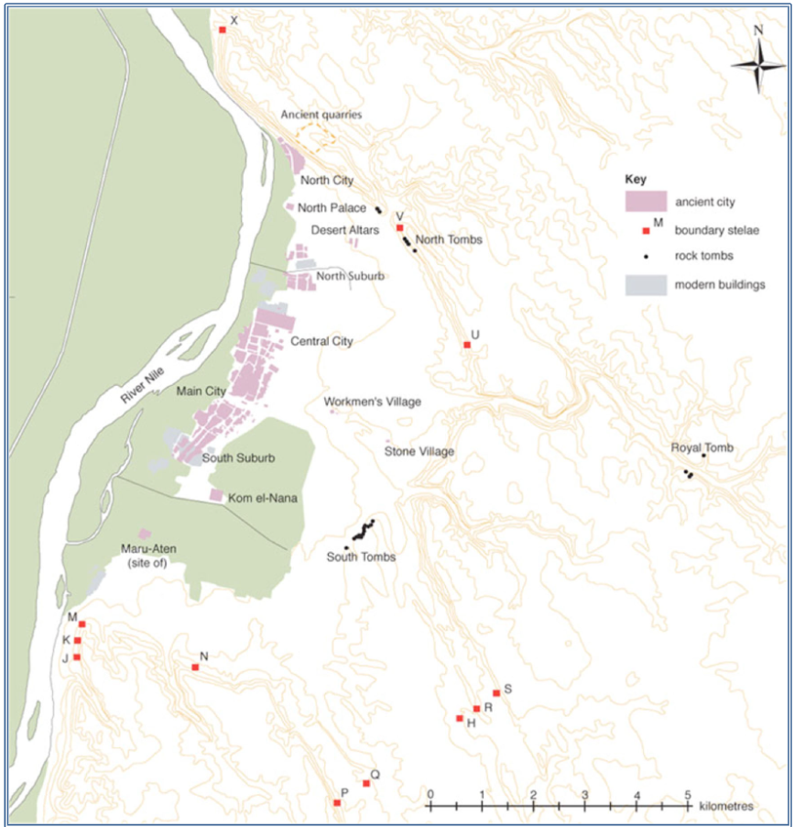
(Arp-Neumann, J. 2020 page 2)

Akhenaten’s Tomb
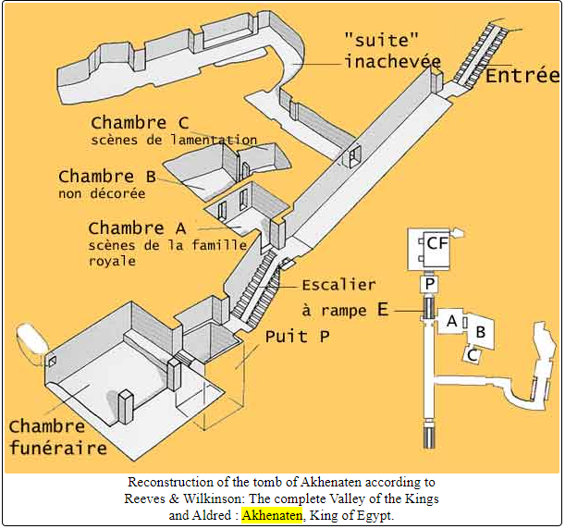
(Benderitter, T., 2021)
The tomb has an east facing entrance (Benderitter, T., 2021) presumably because that is where Aten or the sun rises. The tomb starts with a steep stairway descending 28 metres. As you can see from the plan above, the corridor leads to two side chambers and then finally opens into an antechamber that gives access to the funeral chamber. The corridor differs from other contemporary tombs of the period as it ends straight into the funeral chamber Benderitter suggests that this is to allow the deceased to be able to step directly out into the sunlight. (Benderitter, T., 2021)
The well before the funeral chamber spans 3m and is relatively shallow when compared to other tombs. The well protected the tomb from flooding however this did not work as a crack in the ceiling of the roof of the funeral chamber allowed for water to enter into the tomb and flood the funeral chamber. (Anubis4_2000.tripod.com., 2021) The well had been decorated with carved floral bouquets and art depicting the king and queen making offerings to Aten (the sun). (Benderitter, T., 2021)
The funeral chamber had been sealed with a limestone brick wall which covered the square chamber the wall was about 10 meters across and extended 3.5 meters to the ceiling. The room shows signs of planned further expansion for more side chambers however this was never completed (Benderitter, T., 2021) so we can never truly know what the room’s purpose would have been. Inscriptions close to the ceiling of the funeral chamber on the plaster wall were also erased shortly after the death of the king this inscription listed the titles of Akhenaten the fact that they were destroyed so soon after his death could mean that the people of the time no longer recognised Akhenaten as a legitimate ruler of Egypt. Maybe even symbolising the reversal of Akhenaten’s efforts to secure Aten as the main religious cult of Egypt.
While the main funeral chamber seems never to have been completed and damaged deliberately. Some side chambers seem to be complete with decoration. Room A illustrates Aten rising in the east and set in the west while the royal family with five of their daughters make offerings in the courtyard of a temple dedicated to Aten. (Benderitter, T., 2021) Room C is the smallest of the side chambers only 3.5 metres square with a ceiling at 1.8. The room has images of funerary furniture with a large image of a deathbed on the wall the name of the woman on the deathbed had been removed along with her image. The image which also has displayed a military funeral parade with chariots nearby “stands a wet nurse breastfeeding a small child, which she holds in her arms (and who might be identified as Tutankhamun, though without proof), followed by two fan-bearers. A large group of courtesans, ladies-in-waiting and officials join in the lamentations, their attitudes denoting great grief. On the opposite wall, a scene associated with the previous one shows the king and queen followed by the four surviving princesses and a group of mourners throwing dust on their heads. Benderitter, T., 2021) The removal of depictions and names of people throughout this tomb is very interesting as it shows the will of people trying to remove them from history and leave them forgotten about. Despite the depictions on the wall showing grief, the tombs material culture displays a far different story with the reaction to the occupant of the tomb.

Material Culture Of Akhenaten’s Tomb

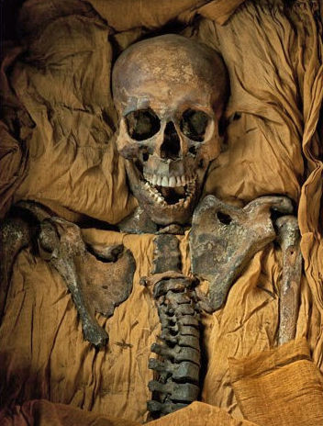
(Anubis4_2000.tripod.com., 2021)
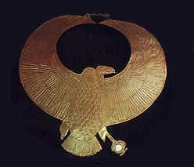
All that remains of the mummy is this skeleton the wooden bier on which the coffin laid had rotten and the coffin had fallen leaving the lid partially off. It is possible that this was caused by the leaking of water into the tomb however the coffin could also have been left open during ancient times. (Anubis4_2000.tripod.com., 2021) When this mummy was discovered it was unwrapped and many of the teeth and cloth reportedly turned to dust when touched. (Anubis4_2000.tripod.com., 2021) The poor state of the mummy and that it was unwrapped mean that we have lost what information we could derive from it using modern methods. However, found on the mummy was what was labelled as a crown however we can see that in fact, it was a gold necklace that had been placed on the forehead of the mummy some researchers have said that this was intentional as a parody to mock them during the afterlife. The picture below shows the golden necklace that was placed on the forehead of the mummy. (Anubis4_2000.tripod.com., 2021) I am inclined to agree as I find it unlikely that it was placed there for another for any other purpose as the ancient Egyptians did not see the head as evident from the removal and disposal of the brain. This could possibly be an attempt to embarrass the mummy in the afterlife. The coffin also contained small sheets of gold however it is impossible to know exactly where they were in relation to the mummy as this was never recorded at the time of excavation. (Anubis4_2000.tripod.com., 2021) Some reports say the mummy was wrapped in gold and others say the gold pieces were arranged in a symmetrical pattern around the mummy.
The sarcophagi were also in a state of deliberate disrepair the coffins had been smashed leaving fragments of the pink granite on the floor. (Benderitter, T., 2021) This sarcophagus was originally intended for a woman but had been adapted for a kingly burial. (Anubis4_2000.tripod.com., 2021) Perhaps another attempt at humiliating the dead while the names on the sarcophagi had been removed further evidence for a repurposed coffin. (Anubis4_2000.tripod.com., 2021) To add to this despite being a male in the coffin the mummy was laid out in a traditionally female way. (Anubis4_2000.tripod.com., 2021) Another sarcophagi’s lid also was split into a series of grey granite chunks. Two further coffins were also present, but they were smashing into small pieces and scattered around the room (Benderitter, T., 2021) because of the poor conservation of the coffins and mummies from the time that they were buried this act appears to make sure that their physical bodies on earth were destroyed. The death mask on the coffin lid had also been damaged in antiquity the gold face of the coffin had mostly been torn off. (Anubis4_2000.tripod.com., 2021) Importantly, the point of mummification was in order to preserve the body for their journey to the afterlife (Canadian museum of history, 2021) to retain their image. The deliberate damaging of the sarcophagi essentially stops this from happening

Conclusion
The unfinished nature and the deliberate mutilation of the tomb its names, artefacts, and sarcophagi after the occupants of the tomb died and were interred clearly shows that despite being a royal tomb many did not see Akhenaten as the true son of Aten on earth. Akhenaten attempted to reform the traditional cults into Egypt and reform the religious cult with him being the sole intermediary between Aten and the people. (Sobat, E., 2013 Page 4) The position of the mummy in the coffin was also set to be in a traditionally feminine position despite being later found out to be a male’s skeleton. (Anubis4_2000.tripod.com., 2021) This only adds to the idea that the tomb was set out in a way in order to deliberately humiliate the occupant of the coffin. Additionally, the pectoral being placed on the mummies head has been compared to a Nekhbet crown often worn by royal women. These factors lead me to believe that many of the aspects of this particular tomb were done deliberately to humiliate the occupant in the afterlife.
The tomb shows signs of being pillaged after the death of Akhenaten and further looting at the end of the 19th century. The unfinished nature of the Akhenaten’s tomb could show that after the death of Akhenaten the people of Egypt lost interest in following Aten and considered the worship of Aten heresy. I find this explanation to be likely as the removal of inscriptions of titles and names is almost trying to make sure that if the tomb was found, they could never be recognised as the legitimate royal family of Egypt. Furthermore, this is shown by his own son Tutankhamun who changed his name to be dedicated to Amun the traditional God of ancient Egypt (Shaw, I 2004. Page 281) possibly to gain the support of the people of Egypt after ascending to the throne. This all paints a vivid picture of an attempt to erase the memory of Akhenaten and Aten.

Bibliography

Amarnaproject.com. 2021. Home – Amarna Project.. [online] Available at: https://www.amarnaproject.com/ [Accessed 23 September 2021].
Anubis4_2000.tripod.com. 2021. The KV55 Mummy: Akhenaten or Smenkhkare?. [online] Available at: <http://anubis4_2000.tripod.com/mummypages1/18C.htm> [Accessed 24 September 2021].
Arp-Neumann, Janne, 2020, Amarna: Private and Royal Tombs. In Willeke Wendrich (ed.), UCLA Encyclopedia of Egyptology, Los Angeles. ISSN 2693-7425. http://digital2.library.ucla.edu/viewItem.do?ark=21198/zz002knv2r
BENDERITTER, T., 2021. [online] Osirisnet.net. Available at: https://www.amaraproject.com/ [Accessed 23 September 2021].
Canadian museum of history, 2021. Egyptian civilization - Religion - Mummification. [online] Historymuseum.ca. Available at: <https://www.historymuseum.ca/cmc/exhibitions/civil/egypt/egcr06e.html#:~:text=The%20purpose%20of%20mummification%20was,transported%20to%20a%20spiritual%20afterlife.> [Accessed 24 September 2021].
Snape, S., 2010. Ancient Egyptian tombs: the culture of life and death. Wiley-Blackwell
Shaw, I., 2004. Ancient Egypt. Oxford: Oxford University Press.
Sobat, E., 2013. The Pharaoh’s Sun-Disc: The Religious Reforms of Akhenaten and the Cult of the Aten. McGill University

