Is an Energy from Waste facility in Gloucestershire an example of sustainable development?

Alex Roberts
P151169
M7X01253
2198 words

Abstract:

This report aims to determine whether or not an energy from waste facility in Gloucestershire is an example of sustainable development. The report commences by exploring the historic meaning of sustainability and more recent definitions of sustainable development. The report explains why energy from waste incineration is being developed by briefly explaining climate change and waste challenges within a context of sustainable development. The report then reviews the environmental aspects associated with the case study site and reviews how the risks can be managed and enhanced, before reviewing social impacts where caution is cited to ensure the project has a positive social impact by evaluation social return on investment and economic impacts. The report concludes that the facility is an example of sustainable development in line with a policy led definition of sustainable development; however it is not a true example of sustainability in the historic sense.

Contents

- Abstract

- Introduction

- Why energy from waste?
  - Waste policy

- Case study location

- Environmental impacts

  - Ecology
  - Visual impact
  - Air pollution
  - Carbon emissions
  - Noise
  - Transport
  - Waste
  - Flooding

- Social and economic value

  - Social return on investment
  - Community engagement and social value
  - Cost of energy from waste incineration

- Conclusion

Is an Energy from Waste facility in Gloucestershire an example of sustainable development?

- Introduction

Sustainability has its origins in forestry, where it referred to not felling more trees than could be replenished in new growth (Kuhlman and Farrington, 2010). More recently, policy makers have used the term sustainable development, defined in Brundtland (1987:23) as:

Development that meets the needs of current generations without compromising the ability of future generations to meet their own needs.

This move towards a developmental focus of sustainability has led to the concept of the three pillars of sustainability, whereby sustainability is achieved through balancing environmental, social and economic considerations (Elkington, 1994). Some commentators argue that sustainable development is a contradiction in terms and is not in fact possible because of the compromise of the environment and society in order to achieve and economic outcomes (Robinson, 2004). Others argue that society and economy are treated as separate entities when in fact they are one and the same (Kuhlman and Farrington, 2010).

A key issue at the heart of sustainable development challenge is climate change, which has already caused widespread impacts on natural and human systems and has been caused by anthropogenic greenhouse gas emissions (IPCC 2014). Another challenging issue is waste, both construction and municipal solid waste. This is because UK construction, demolition and excavation contributes the most of any sector to landfill and produces more than half of UK total waste volumes each year (DEFRA, 2018). A similar challenge exists with municipal solid waste; in UK households in 2016 produced over 12 million tonnes of waste and only 45.2% was recycled (DEFRA, 2018).

Energy from waste incineration is one technique that can potentially help to address the waste and climate change challenges. Energy from waste incineration achieves this by reducing waste going to landfill and also reduced carbon emissions from energy production compared to fossil fuels (Jamasb and Nepal, 2010) . However, some commentators argue that communities that have energy from waste incinerators will reduce recycling rates, although evidence from Scandinavian and American countries shows that this is not the case and energy from waste facilities and higher recycling rates can coexist (Bahor and Weitz, 2016) (Jamasb and Nepal, 2010).

Construction and operation of an energy waste facility will impact upon the environment, the local community and the economy. The extent to which these impacts, both positive and negative are realised, will determine whether such a facility is an example of sustainable development. The objectives that will be achieved in this report are to analyse the impacts of the energy from waste facility on environmental, social and economic aspects. It is beyond the scope of this report to discuss the local opposition to the scheme and potential health benefits and whether or not the facility should go ahead, as planning has been approved the report assumes these issues have been satisfied in line with local policy for the scheme to go ahead.

- Why energy from waste?

  - Waste policy

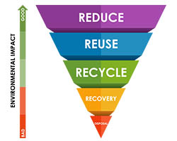
Waste policy is framed around the waste hierarchy (see figure 1), whereby landfill is the least preferred method of waste management because it not only is loss of valuable resource, but also gives off methane emissions, which are a potent greenhouse gas that contribute to climate change (Jewswani and Azapagic, 2016). Policy and regulation such as the Landfill Directive in Europe have sought to reduce landfill waste and promote recycling and resource recovery, in the UK part of the strategy to achieve this has been a stepped increase in landfill tax, to act as an economic incentive to reduce waste going to landfill (Jeswani and Azapagic, 2016). Policy is now gearing towards a circular economy which aims to lead to landfilling of recyclable materials to be banned in the European Union by 2025 (Jewswani and Azapagic, 2016).
Figure 1: Waste Hierarchy (Source: lboro.ac.uk) 2018)

- Case study site location

The site is located on a former airfield adjacent to the M5 motorway which is located around 75m from the western site boundary, the site is comprised of derelict ground, hardstanding and vegetated areas and is 5.1 ha in size (Urbaser, 2012).

Figure 1: Site location
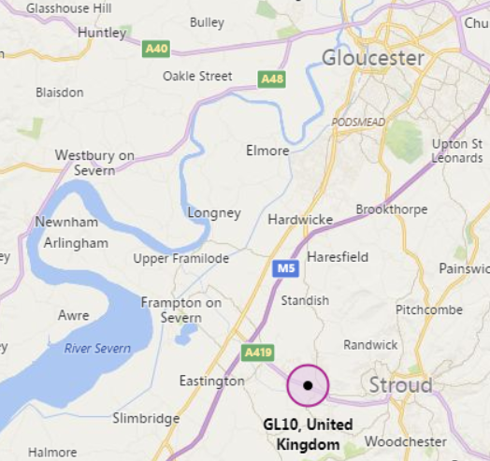

- Environmental impacts

Environmental impacts associated with the construction and operation of the facility must be prevented, or reduced as far as practicable and where possible environmental value added (DBW, 2018). During the construction the contractor should manage environmental impacts in line with best practice, for example by following ISO14001 Environmental Management System or British Standard Environmental Management BS 8555 (WRAP, 2015). However, an Environmental Management System only goes so far and outcomes truly aligned with sustainable development will need to be influenced through sustainability strategy and through specification (Lam et al.,, 2011). Environmental impacts associated with the facilities operational phase should also be considered and addressed throughout the design stages of the project and also continue to be addressed during operational phase to ensure sustainable development objectives are realised, BREEAM is a sustainability assessment tool that could facilitate this (DBW, 2018).

  - Ecology

An extended phase 1 habitat survey was carried out in line with (JNCC, 2010). Ecological features on the site include a watercourse runs across the southern and western site boundary which is lined with trees and scrub and there are a few mature ash trees located at the south east corner of the site (Urbaser, 2012). The watercourse and scrub together is a priority habitat within Gloucestershire and therefore the habitat should be protected during construction, this could be achieved by preventing plant or machinery from working near the watercourse and also by preventing pollutants such as silt, oils or chemicals from entering the watercourse as outline in Pollution Prevention Guidance 6 (PPG6, 2014).

Several protected and priority species were identified on the site, see table 1 and 2. These species must be protected during construction, for example by programming works outside of bird nesting season (RSPB, 2018), by not digging within 10 meters of a badger sett with machinery or working near a sett between July and November (NRW, 2018) and by protecting trees in line with British Standard for Trees in relation to design, demolition and construction (BS 5837:2012).

For the development to achieve true sustainable development, rather than just legal compliance, developers should consider enhancing the habitats (Hostetler et al.,, 2011).
Table 1 Protected species found on site (Source Urbaser, 2012)

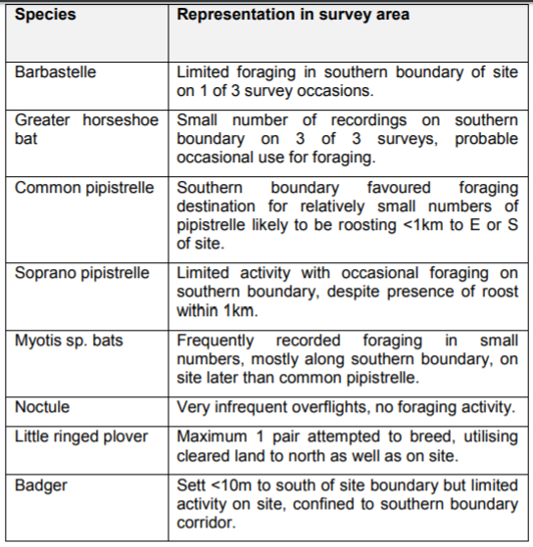
Table 2 Priority species found on site (Source Urbaser, 2012)
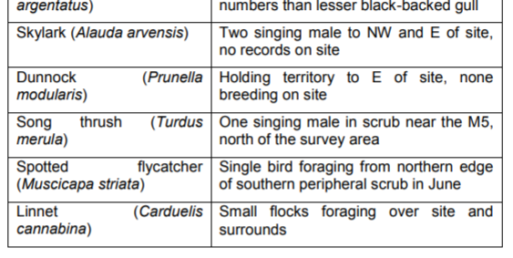
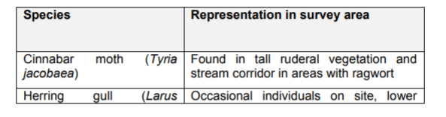
  - Visual impact

The building design is oriented along an east west axis so to reduce the visual impact from the east, which includes views from the Costwolds Area of Outstanding Natural Beauty (Urbaser, 2012). Furthermore to reduce the visual impact to a greater extent, the tallest elements of the facility have been designed to be on the west side of the site, in addition to this the building will be finished in matt green (Urbaser, 2012). Whilst visual impact assessments are a useful tool, they are limited by their subjective nature; improvements in technology such as virtual reality and 3D modelling are helping to address the subjectivity (Torres-Sibille, 2009).

  - Air pollution

Moya et al., (2017) discuss how the most significant environmental impact of this process is the production of greenhouse gas emissions. However, Jamasb and Nepal (2010) explain how the greenhouse gas emissions are lower than fossil fuels used to produce electricity (Jamasb and Nepal, 2010). Another issue is the public health impacts of the emissions such as hydrogen fluoride, sulphur dioxide, total organic carbon, hydrogen chloride, nitrogen oxide carbon monoxide, dust and volatile heavy metal (Ashworth et al.,, 2014). The perceived health risks are one of the main reasons for a low uptake on incineration in the UK (Azpagic, 2016). These emissions are now controlled with legislation and more advanced technologies reduce the volatile heavy metals being released, although public opposition still exists (Wu et al, 2014).

  - Carbon emissions

There will be carbon emissions associated with the construction and operation of the facility, carbon emissions during construction should be reduced as far as possible, this could be achieved by using efficient plant and equipment such as LED temporary lighting, hybrid generators and energy efficient site accommodation (Carbon Trust, 2012).

Energy efficiency should be designed into the building using a fabric first approach and following the principles of the energy hierarchy (see figure 2.. There is evidence to suggest however this is not far enough as a performance gap exists, whereby buildings often do not operate as intended, this could be addressed with training, seasonal commissioning or completing a post occupancy evaluation or soft landings approach (CIBSE, 2012). Some commentators suggest the performance gap could present challenges to the construction sector, similar to the Volkswagen emissions scandal (Porritt, 2015)

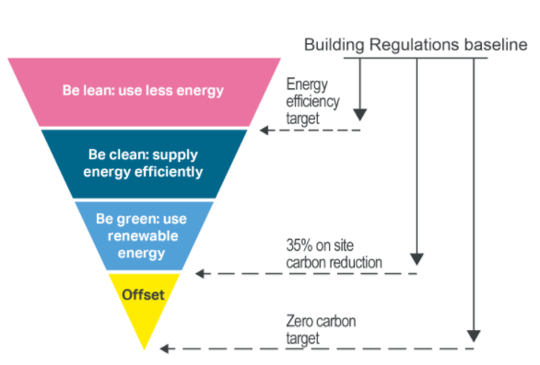

Figure 2. The energy hierarchy (source GLA 2012)

  - Noise

Landscaping bunds have been designed to the eastern boundary of the site and the north east of the main car park to mitigate noise impacts from the facility (Urbaser, 2012). The predicted noise levels of the site were modelled in line with ISO 9613-2 (Urbaser, 2012). Construction should follow BS 5228:2009 to mitigate impacts of construction noise (Urbaser, 2012).

  - Transport

The site is adjacent to Junction 12 of the M5, which has recently been modified to reduce congestion meaning even at rush hour delays are rare, so whilst there are significant vehicle movements, as shown in table 3, the local infrastructure should be able to cope (Urbaser, 2012). There is also the benefit that the site is located away from population centres (Urbaser, 2012). Whilst this is advantageous as it limits the impact of increased traffic on local populations, is does mean sustainable transport options for staff will be limited when the site is operational. The operators of the site have committed to developing a travel plan could to identify the sustainable travel options, Publicly available standard (PAS 500:2008) for travel plans could act as a framework for completing this and will ensure it is robust, implementing such a plan would help the facility work towards being a sustainable development.

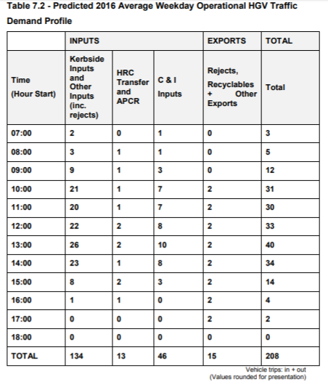
Table 3. Predicted weekday operational HGV traffic

  - Waste

The UK construction industry produces more than 100 million tonnes of waste a year; this figure includes around 13 million tonnes of unused materials, this is inherently unsustainable (Liu et al., 2011). Management practices on site, such as financial penalties or incentives, or training, have been shown to reduce construction waste volume and could be implemented on site (Ajayi et al.,, 2007). However, the biggest gains in reductions are from designing out waste as early in the design stage as possible (WRAP, 2018). However, “strong” sustainable development would now be focussed beyond just waste reduction and striving towards achieving a circular economy (Adams et al, 2017).

  - Flooding

The site is not located in a flood risk zone, however in order for the facility to adhere to the principles of sustainable development; surface water run off should be managed in a sustainable way (GCC, 2018).

- Social and economic impacts

  - Local spend and employment

The Environmental Statement on the local authority planning portal explains that around 40 people will be permanently employed at the site during operation and there will be a peak day time staffing level of 25. The construction will also provide employment opportunities provide stimulation of the local economy. Contractual requirements could be implemented to help achieve increases in local employment; however this could increase cost and impact programme and quality if the skilled workforce are not available in the local area (DBW, 2018).

  - Community engagement and social value

A community fund of £25,000 (index linked) per annum, for the duration of the contract of the operation of the facility has been agreed to benefit local groups and parishes adjacent to the facility, a community fund group has been set up to determine how best to distribute these funds meaning the project has potential to have a positive impact on the community (Community Liason Group Minutes, 2018). However, the spend must be approached with caution to ensure that it leaves a positive legacy, the benefit of investment in the local community could be evaluated with a methodology to calculate the social value return on investment (Lingane et al, 2004).

  - Cost of energy from waste incineration
Compared to landfills, incinerators also have higher capital and operational costs (Bozorgirad et al, 2013). However, as landfill taxes rise the incentive will financial incentive will move further away from landfill disposal. Also, as a commercial organisation, the operator will be investing in the development and operation of the facility to make a profit, and therefore it is inherently financially sustainable.

- Conclusion

The energy from waste facility is an example of sustainable development as defined by Brundtland et al., (1987). It helps reduce waste to landfill and ensures value is derived from waste materials; it can also help to reduce greenhouse gas emissions.

The environmental impacts of the project can be reduced through effective management and design of the facility, for strong sustainable development environmental impacts must be enhanced.

The project is set to have a positive social impact, through a community engagement fund and also through local employment and local spend, in order for this to maximise value the methods should be evaluated with a social value return on investment tool.

The project is financially sound, as the commercial developer is investing to make a profit. This will become more financially attractive as policy pressure to divert waste from landfill and increased landfill tax come to fruition.

Whilst the above points demonstrate that the project is in line with the policy makers definition of sustainable development, it may not be in line with true, historic definition of sustainability. A truly sustainable approach to waste management and climate change would be to focus higher up the waste hierarchy of reduction and re-use and also energy production from renewable energy sources.

Reference List:

Adams et al. (2017). Circular economy in construction. Proceedings of the Institution of Civil Engineers: Waste Management, 15-24.

Ajayi et al.,. (2007). Critical management practices influencing on-site waste minimization in construction projects. Waste Management, 330-339.

Ashworth et al.,. (2014). Waste incineration and adverse birth and neonatal outcomes: a systematic review. Environment International, 120-132.

Bahor and Weitz. (2016). Modern waste-to-energy as an energy and environmental management. Waste to Energy Research and Technology Council.

Bozorgirad et al. (2013). Environmental impact and cost assessment of incineration and ethanol. Intnl Journal of Life Cycle Assessment, 1501-1512.

Carbon Trust. (2012, February 1). Retrieved March 20, 2018, from https://www.carbontrust.com/news/2012/02/building-a-lower-carbon-construction-industry-1/

CIBSE. (2012). Performance Gap. Retrieved March 20, 2018, from https://www.cibse.org/getmedia/55cf31bd-d9eb-4ffa-b2e2-e567327ee45f/cb11.pdf.aspx

Community Liason Group Minutes. (2018, January 16). Retrieved March 20, 2018, from https://static1.squarespace.com/static/598c3f56e6f2e1a6fa2bfd66/t/5a6874fa53450ae499525820/1516795131423/CLG+Jan+18.pdf

DBW. (2018, February 07). Sustainability in building design and construction. Retrieved March 19, 2018, from Designing Buildings Wiki: https://www.designingbuildings.co.uk/wiki/Sustainability_in_building_design_and_construction

DEFRA. (2018, February 22). UK Statistics on Waste. Retrieved March 19, 2018, from DEFRA: https://www.gov.uk/government/uploads/system/uploads/attachment_data/file/683051/UK_Statisticson_Waste_statistical_notice_Feb_2018_FINAL.pdf

Elkington. (1994). Towards the sustainable corporation: Win-win-win business strategies for sustainable development. Manage, 90-100.

GCC. (2018). Surface water run off. Retrieved March 20, 2018, from https://www.gloucestershire.gov.uk/media/8012/standing_advice_-_march_2015-63336.pdfGLA. (n.d.). Minimising greenhouse gas emissions. Retrieved March 20, 2018, from https://www.london.gov.uk/what-we-do/planning/london-plan/new-london-plan/draft-new-london-plan/chapter-9-sustainable-infrastructure/policy-si2-minimising-greenhouse-gas

Hostetler et al.,. (2011). Conserving urban biodiversity? Creating green infrastructure is only the first step. Landscape and Urban Planning, 369-371.

Jamasb and Nepal. (2010). options in waste management: A social cost–benefit analysis of waste to energy in the UK. Resources, Conservation and Recyling , 1341-1352.
Jeswani and Azapagic. (2016). Assessing the environmental sustainability of energy recovery from. Waste Management, 346-363.

JNCC. (2010). Phase 1 Habitat Surveys. Retrieved March 20, 2018, from JNCC: http://jncc.defra.gov.uk/PDF/pub10_handbookforphase1habitatsurvey.pdf

Kuhlman and Farrington. (2010). What is Sustainability? Sustainability , 3436-3448.

Lam et al.,. (2011). Environmental management system vs green specifications: How do they complement each other in the construction industry? Journal of Environmental Management, 788-795.

Lingane et al. (2004). Guidelines for social return on investment. California Management Review.

Moya et al.,. (2017). Municipal solid waste as a valuable renewable energy resource: a. Energy Procedia, 286-295.

NRW. (2018). Badgers and development. Retrieved March 19, 2018, from NRW: https://naturalresources.wales/media/3889/guidance-on-undertaking-work-close-to-badger-setts-that-cannot-be-licensed-under-the-protection-of-badgers-act-1992.pdf

Porritt. (2015, December 21). If VW built houses. Retrieved March 20, 2018, from http://www.jonathonporritt.com/blog/if-volkswagen-built-homes

PPG6. (2014, April 23). Pollution Prevention Guidance in construction and demolition. Retrieved March 19, 2018, from GOV.UK: https://www.gov.uk/government/publications/construction-and-demolition-sites-ppg6-prevent-pollution

Robinson. (2004). Squaring the Circle: Some ideas of the idea of sustainable development. Ecological Economics, 369-384.

RSPB. (2018). Protecting birds from development. Retrieved March 19, 2018, from https://www.rspb.org.uk/globalassets/downloads/get-involved/campaigning/protecting-birds-from-development---wales.pdf

Torres-Sibille. (2009). Aesthetic impact assessment of solar power plants: An objective and a subjective approach. Renewable and Sustainable Energy Reviews, 986-999.

Urbaser. (2012). Gloucester Residual Waste Project. Environmental Statement, Main Report.

WRAP. (2015, March 01). Your guide to environmental management systems. Retrieved March 19, 2018, from WRAP: http://www.wrap.org.uk/sites/files/wrap/WRAP%20EMS%20guide%20Mar2015.pdf

WRAP. (2018). Design out Waste. Retrieved March 20, 2018, from WRAP: http://www.wrap.org.uk/sites/files/wrap/Designing%20out%20Waste%20-%20a%20design%20team%20guide%20for%20civil%20engineering%20-%20Part%201%20%28interactive%291.pdf

Wu et al. (2014). "Effect of waste incineration and gasification processes on heavy metal distribution. Fuel processing technology, 67-72.

