UNIVERSITY OF WALES
TRINITY SAINT DAVID

BA BUSINESS MANAGEMENT

Student name: GEORGE EDUARD VODISLAV
Student ID: 1917506
Module Title: THE GLOBAL BUSINESS ENVIRONMENT
Assignment Title: ENVIRONMENTAL ANALYSIS OF AN INDUSTRY

Module Lecturer’s Name: Syed Jaffery

Contents
Introduction 3
Findings and Discussion 3
Forces shaping the global business environment 3
PESTLE Analysis of the automobile industry 4
Porter’s Five Forces Analysis of the automobile industry 8
Organisational policies and international trading 11
Conclusion 12
References 13

Introduction
Every year on an average, 60 million cars are sold worldwide. These include Hatchbacks, Sedans, passenger cars, SUVs, electric cars, trucks, and many more. Toyota, the world's largest car manufacturing and selling company, manufactures 10 million vehicles each year. In the United Kingdom alone according to the "Society of Manufacturers and Traders (SMMT)" in 2019 2,311,140 units of cars were sold and 1.3 million cars were built in the same period. One hundred sixty-eight thousand people are directly employed by the industry.
In comparison, 823,000 people gain employment and earn a livelihood from the allied sectors and automobile accounts for 14% of the total export adding 44 Billion Pounds to the economy. The purpose of the assignment is to explore the global automobile industry including the United Kingdom automobile industry and conduct an environmental analysis to identify major forces that are likely to have an impact on the industry in the future, especially in the post-pandemic economy. Several accepted academic frameworks such as the Porters 5 forces analysis and the PESTLE framework are used in the assignment to complete the external environmental analysis. These frameworks have been rigorously studied for their efficacy and be extremely useful for conducting environmental analysis and as such, have been included in the study.

Findings and Discussion

Forces shaping the global business environment
The business environment is subject to continuous change and development, and often organisations adapt to meet the needs of the business sector. The automobile sector is not an exception and is much influenced by the factors of globalisation as other known industrial manufacturing sectors. Cultural exchange, improved transportation, technology, and free trading opportunities are four factors of globalisation that influence the automobile sector. Technological innovation and a focus on environmental sustainability are driving the growth of the electric car manufacturing industry (Mikalauskiene et al. 2016). Tesla was one of the very few companies that invested in developing environmentally conscious transportation.
In contrast, others like Ford, Nissan, General Motors followed suit as the general public warmed up to the idea of owning vehicles that are convenient, luxurious, and run on sustainable fuel. Currently, the electric car industry is still at its infancy. Still, data analysts and experts argue that it might become more mainstream as the cost of fossil fuels is rising phenomenally. Besides, politically, international bodies like the United Nations and the European Union are working together to counter the effects of climate change and are thus urging automobile manufacturers to develop more fuel-efficient technologies. However, by far developing technology, the digital revolution, growth of data analytics, easy trading policies, regulations, competition, customer perception, and environmental concerns are the most important factors that are shaping the global business environment.

PESTLE Analysis of the automobile industry
The PESTLE analysis is a known, accepted academic framework that is used to assess the industry environmental condition. It provides for two important benefits, one, it allows companies to fathom their position in the market and two its also allows companies to identify threats or opportunities in the market. Both of these factors are important in creating economic sustainability.
Politics: Political stability is important for economic stability and political turmoil similarly influences the automobile sector as it would influence other manufacturing sectors. Factors like government policies, corruption, taxation, trade restriction, foreign trade policies, and environmental laws affect the profitability of the automobile industry. For instance, the United Kingdom has long been a part of the European Union and as such regulations levied across Europe were also applicable in the United Kingdom however following Brexit the UK will have to reconfigure its foreign trade policies as it will no longer remain a part of the Union (chathamhouse.org, 2020). The “UK trade policy” is a collaboration between the “University of Sussex” and the “Chatham House” that will overlook the policy reconfiguration process and aims to develop a system that will allow the country to navigate the international trading landscape.
Economic: The economy has a profound influence on the automobile sector. In 2020, automobile sales volume has plunged by 20% owing to the ongoing economic crisis event triggered by the pandemic. Factors like interest rate, inflation, taxes, exchange rate, demand, and supply affect the automobile industry. The automobile industry imports 35-40% of its raw components and as such, is sensitive to exchange rates, for instance, after the Brexit Pound depreciated by as much as 13.24% which implies that the importing cost and consequently the production cost for the automobile industry has significantly increased in the United Kingdom.
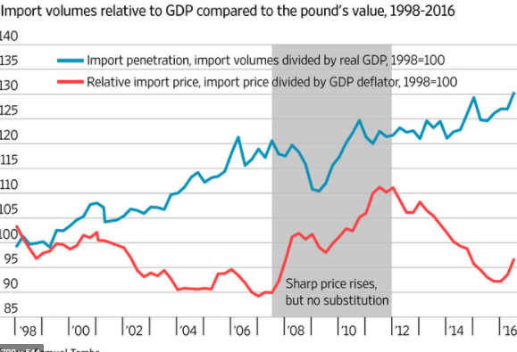
Figure 1: Pound Devaluation
(Source: WallStreet Journal, 2019)

Social: The social factor in the PESTLE analysis is a person-centred factor that evaluates the importance of people and their beliefs for an industry. Although the customer profile of the automobile industry includes people of all demographics, yet young people play an important role in determining the focus of the industry (researchgate.net, 2020). The present population are environmentally conscious and are aware of their participation in the climate change process and as such are looking forward to products that provide fuel economy, improved emissions, and better mileage besides design and safety (researchgate.net, 2020).
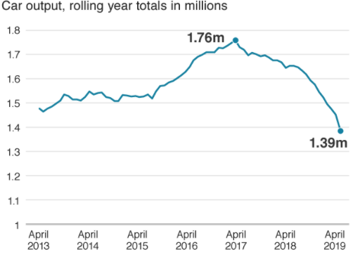
Figure 2: UK Car Manufacturing Plummets.
(Source: BBC)
Technology: The automobile sector is known for its dependence on technology for growth and development. Two types of technology are affecting the industry, communications technology, and automobile technology. Improved communication channel is allowing industry players to connect and engage with their intended audiences while development in automobile technology is allowing them to erase obstacles that are impeding the development of zero-carbon emission vehicles (De Stefano et al. 2016).
Legal: Government regulations play an important role in the automobile sector. Legislations about emission, fuel economy, design, component, supply chain, marketing regulations, and safety standards are subject to changes. They are regularly revised in the light of conclusive evidence that aims to improve customer safety and overall user experience. As a result, in many instances, rules and regulations dictate production cost, operation procedures, and marketing strategies that influence the profitability of the automobile sector. For instance, in the United States, the "Corporate Average Fuel Economy" provides a standard guideline for automobile manufacturers to abide by while designing their vehicles. According to the guideline, automobile manufacturers are supposed to aim for improving their "fuel efficiency standard" by 54.4 miles per gallon by 2025 (sciencedirect.com, 2010).
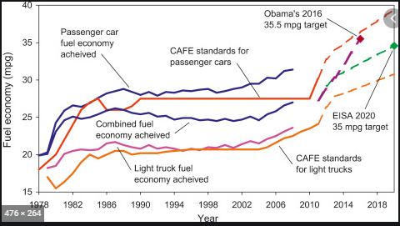
Figure 3: Corporate Average Fuel Economy Standards.
(Source: Sciencedirect.com)
Similarly, in the United Kingdom, according to the "Vehicle Certification Agency" providing information relevant to fuel consumption and emission in compliance with the "Worldwide Harmonised Light Vehicle Test Procedure" is a statutory requirement. This implies that companies cannot gloss over their emission data or mislead consumers into believing that their offerings are more efficient than they truly are and cheat customers (asa.org.uk, 2020). This also means that companies have a legal obligation to fulfil the government stated criteria to keep continuing their business in the region. Legal requirements vary and are subject to the constitutional jurisdiction of the country that they are operating in and are not constant. However, they influence the sector by setting rules that ultimately affect production, marketing, and distribution cost.
Environmental: The automobile industry has environmental consequences. It has been established beyond a doubt that burning fossil fuel generates carbon dioxide, which is a principal component of the greenhouse gases that leads to global warming. Indeed, taking a passenger vehicle, for example, running on gasoline releases 4.6 metric tonnes of carbon dioxide annually. In recent times international bodies have taken upon and deliberated over the long-term repercussions of using fossil fuels and have mandated that the automobile industry takes the matter seriously and invest in developing cost-efficient fuel (epa.gov, 2020). The European Union has pledged to invest 100 Million Pound in enabling fossil-fuel reliant countries to make a transition to clean fuel. It aims to achieve “Climate Neutrality” by 2050 by cutting down its fossil fuel emissions to zero (Emre Pecker, 2019). It comes in response to the “Paris climate accord” and following the ‘United Nations Climate Gathering” that took place in Madrid. The "green deal" includes a mandate for the automobile sector to implement changes in their design and a shift to clean wherever necessary to phase out the dependency on fossil fuels completely. For companies like Tesla, Nissan, Ford, and Faraday that are already into manufacturing electric cars, the directive will incentivise their efforts into creating a truly fossil-fuel independent automobile. In contrast, for others, it is an opportunity to work on developing new technologies, improving on their fuel usage and combustion to decrease emission rates to meet government standards (Soto et al. 2018).

Porter’s Five Forces Analysis of the automobile industry
Michael Porter developed the 5 Force model as a framework to analyse and understand competition and the external business environment in which entrepreneurship ventures operate. There are five components to the model,
- Competition in the industry
- Potential of new entrants in the industry
- Bargaining power of the suppliers
- Bargaining power of the customers
- The threat of substitute products.
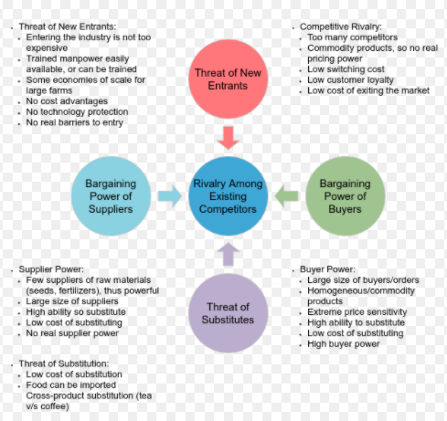
Figure 4: Porter’s 5 Forces Model
(Source: https://online.visual-paradigm.com/diagrams/templates/five-forces-analysis/auto-industry/)
Competition is ubiquitous and beneficial in the long run as it encourages companies to develop creative products. Still, it is also a determinant factor that influences the reach and profitability of organisations and as such, diminishes the power that companies can have in a market. New entrants are similar to the competition factor in that new companies will compete in the sector and will likely cut in into the market. Still, it also reflects how tolerant a market is to emerging brands. Bargaining power of supplier and customer measures the relative importance of suppliers and consumers in the market (Omsa et al. 2017). Although the power of suppliers can vary; however, in most industries, consumers hold an important position and customer perception is regarded with great importance. The following is Porter's 5 Forces of the automobile industry in detail,
Competition: The automobile industry is extremely competitive, and both domestic and international brands compete in the same market. Besides, recognised brands also compete with regards to design, technology, safety measure components and many more and as such internal rivalry among existing brands in the industry is considerably high (Aghion et al. 2020). Automobile firms invest aggressively in product development, and marketing, often using innovative approaches like social media campaigns and multi-channel endorsements to hype a product and outperform competitors (Lakshmi and Sengottuvelu, 2017). Besides, the sector is at its peak, it is maturing and as such is not seeing as much growth as it used to at some point.
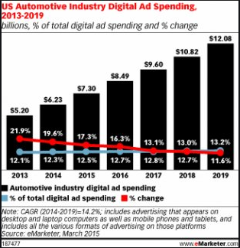
Figure 5: US Automotive Industry Digital Ad Spending Data
(Source: eMarketer, 2015)
New Entrants: The automobile is a cost and labour-intensive industry. The establishment cost is particularly high and makes market penetration difficult. Further, manufacturing is a fraction of the process that delivers profit. Distribution, marketing, and franchising are also equally important processes that require qualified, trained individuals who have the knowledge and the expertise to undertake such responsibilities (Law, 2017). And expertise is expensive and drives the cost for new entrants effectively diminishing the threat of emerging establishments.
Bargaining Power of Suppliers: Supplier bargaining power in the automobile industry is low as suppliers outnumber manufacturers and suppliers are insignificant in dimension compared to the recognised industry names (marketrealist.com, 2020). As such in the sector suppliers have to make amendments to meet the needs of the buyers. For instance, car manufacturer Nissan has stringent rules that suppliers have to fulfil and comply with to keep continuing to work with them.
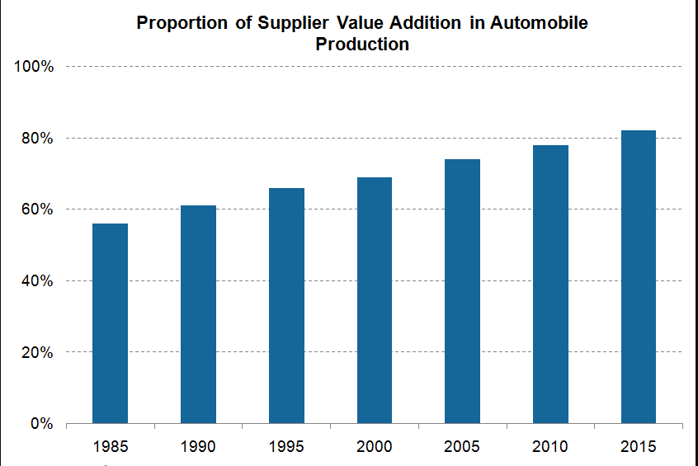
Figure 6: Power of Suppliers
(Source: Statista, 2020)
Bargaining Power of Consumers: Consumers have moderate to high bargaining power as companies take cognisance of consumer perception in product development. Competition within the industry is high which implies that consumers have choices in terms of brand reputation, designs, and offerings which make consumers an important force to reckon within the industry (Guajardo et al. 2016). Besides, the cost of switching is insignificant, and in a fairly good market, consumers have vast options to choose from and therefore exercise considerable power.
Substitution Threat: The threat of substitution is low, mostly because of convenience that is unparalleled and unmatched in the alternatives. Also, competition is stiff in the automobile industry, and brand loyalty assumes a greater position which makes substitution difficult (Deyo, 2016).

Organisational policies and international trading
Penetrating the international market is a long drawn difficult process fraught with challenges, yet organisations tend to invest heavily in expansion policies. A possible reason behind this expansionist approach is market saturation. The automobile industry is highly competitive, and market saturation happens quite often leading to a decline in profitability. In such circumstances, a company can either choose to invest in product development or seek out the potential that will be conducive to its existing product line (Pattnaik et al. 2020). In simple terms, profitability is the major reason behind expansionist policies. Another auxiliary purpose of the expansion is to take advantage of resources at affordable costing that the developing market can offer. Mostly it refers to human resources, for example, most automobile companies have factories in China, cheap labour and an emerging market is lucrative to many companies that look for both while seeking uncharted territories (Erixon, 2018).

Conclusion
Convenient transportation fuelled the growth of the automobile industry that at present has become one of the most productive industries globally and almost exclusively contributes to the growing economy. It is being speculated that a decline in demand in the automobile sector has led to the economic slowdown that was prominently observed in the first quarter of 2020 besides the pandemic crisis. However, the automobile sector, like other manufacturing industries is sensitive to changes in its external environment, a subject that has been explored in the assignment. Here using the PESTLE and Porter's 5 Forces model, a brief analysis of the industry and the international market is done to recognise the events that are shaping the global automobile industry. Events like Brexit, environmental pacts, the Paris Accord are influencing the sector. Still, it is also incentive growth in the domestic market and providing opportunities to companies to develop fuel-efficient designs.

References
Books
Deyo, F.C. ed., 2016. Social reconstructions of the world automobile industry: Competition, power and industrial flexibility. Springer.
Law, C.M., 2017. Restructuring the global automobile industry (Vol. 4). Taylor & Francis.
Journals
De Stefano, M.C., Montes-Sancho, M.J. and Busch, T., 2016. A natural resource-based view of climate change: Innovation challenges in the automobile industry. Journal of Cleaner Production, 139, pp.1436-1448. DOI: https://doi.org/10.1016/j.jclepro.2016.08.023
Guajardo, J.A., Cohen, M.A. and Netessine, S., 2016. Service competition and product quality in the US automobile industry. Management Science, 62(7), pp.1860-1877. DOI: http://dx.doi.org/10.1287/mnsc.2015.2195\
Mikalauskiene, A., Streimikiene, D. and Mulagalejeva, K., 2016. Assess the impact of globalisation processes by indices. Economics & Sociology, 9(4), p.82. DOI: 10.14254/2071-789X.2016/9-4/5
Omsa, S., Abdullah, I.H. and Jamali, H., 2017. Five competitive forces model and the implementation of Porter’s generic strategies to gain firm performances. DOI: doi: 10.11648/j.sjbm.20170501.12
Pattnaik, C., Singh, D. and Gaur, A.S., 2020. Home country learning and international expansion of emerging market multinationals. Journal of International Management, p.100781. DOI: https://doi.org/10.1016/j.intman.2020.100781
Soto, J.J., Cantillo, V. and Arellana, J., 2018. Incentivising alternative fuel vehicles: the influence of transport policies, attitudes and perceptions. Transportation, 45(6), pp.1721-1753. DOI: 45:1721–1753 https://doi.org/10.1007/s11116-018-9869-4
Online articles
Aghion, P., Bénabou, R., Martin, R. and Roulet, A., 2020. Environmental Preferences and Technological Choices: Is Market Competition Clean or Dirty? (No. w26921). National Bureau of Economic Research. Available at: https://scholar.princeton.edu/sites/default/files/rbenabou/files/w26921.pdf [Accessed on: 18-08-2020]
Erixon, F., 2018. The Economic Benefits of Globalization for Business and Consumers. European Centre for International Political Economy. Available at: https://d1wqtxts1xzle7.cloudfront.net/58847598/Globalization-paper-final.pdf? _&Key-Pair-Id=APKAJLOHF5GGSLRBV4ZA [Accessed on: 18-08-2020]
Lakshmi, K.R. and Sengottuvelu, C., 2017. Social media as a tool for brand building in the automobile industry. TRANS Asian Journal of Marketing & Management Research (TAJMMR), 6(8), pp.19-29. Available at: http://www.indianjournals.com/ijor.aspx?target=ijor:tajmmr&volume=6&issue=8&article=002 [Accessed on: 18-08-2020]
researchgate.net, (2020), Influences_of_Environmental_Consciousness_and_Attitudes_to_Transportation_on_Electric_Vehicle_Purchase_Intentions, available at: https://www.researchgate.net/publication/282866284_Influences_of_Environmental_Consciousness_and_Attitudes_to_Transportation_on_Electric_Vehicle_Purchase_Intentions [Accessed on: 18-08-2020]
sciencedirect.com, (2010), Corporate Average Fuel Economy, available at https://www.sciencedirect.com/topics/engineering/corporate-average-fuel-economy#:~:text=in%20the%20USA%2C%20the%20average,passenger%20cars%20or%20light%20trucks. [Accessed on 18-08-2020]
Websites

asa.org.uk, (2020), Fuel Consumption and Emission, available at: https://www.asa.org.uk/advice-online/motoring-fuel-consumption-and-emissions-figures.html#:~:text=The%20requirement%20to%20display%20fuel,it%20is%20a%20statutory%20requirement. [Accessed on: 18-08-2020]
chathamhouse.org, (2020), UK Foreign Trade Policy, available at: https://www.chathamhouse.org/about/structure/international-economics-department/uk-trade-policy-observatory-project#:~:text=Following%20the%20decision%20to%20leave,a%20manner%20that%20benefits%20all. [Accessed on: 18-08-2020]
Emre Pecker, (2019), EU Pledges to Cut Greenhouse Gas Emissions to Zero by 2050, available at https://www.wsj.com/articles/eu-to-cut-greenhouse-gas-emissions-to-zero-by-2050-11576203017#:~:text=BRUSSELS%E2%80%94European%20Union%20leaders%20agreed,early%20Friday%20after%20contentious%20negotiations. [Accessed on 18-08-2020]
epa.gov, (2020), Greenhouse Gas Emissions by Passenger Vehicles, available at https://www.epa.gov/greenvehicles/greenhouse-gas-emissions-typical-passenger-vehicle#:~:text=typical%20passenger%20vehicle%3F-,A%20typical%20passenger%20vehicle%20emits%20about%204.6%20metric%20tons%20of,8%2C887%20grams%20of%20CO2. [Accessed on 18-08-2020]
marketrealist.com, (2020), Supplier Power in the Automobile Industry, available at https://marketrealist.com/2015/02/suppliers-power-increasing-automobile-industry/ [Accessed on 18-08-2020]

