University of Wales Trinity Saint David
School of Engineering

Energy in a Flywheel
Engineering Science 1
M4X00385

Richard Parker
1902504
13/12/19
Contents
1 Introduction 1
1.1 Aims 1
1.2 Objectives 1
2 Experimental Procedure 2
3 Results 3
4 Analysis 5
5 Conclusions 7
6 Evaluation 7
7 References 9

Introduction

Aims
This experiment aims to demonstrate and prove the theory for energy stored in a flywheel, by showing that the given moment of inertia for all the parts is roughly the same as the value calculated from the experiment’s results.

Objectives
- Conduct experiment as explained in ES9 workbook
- Use these results to find values for potential energy loss, (mg-ma)r and a/r
- Chart a graph for (mg-ma)r against a/r, in which the gradient will give a value for I
- Compare this value for I with the total value of the parts given in the workbook
- Analyse other results to see what else they show

Experimental Procedure

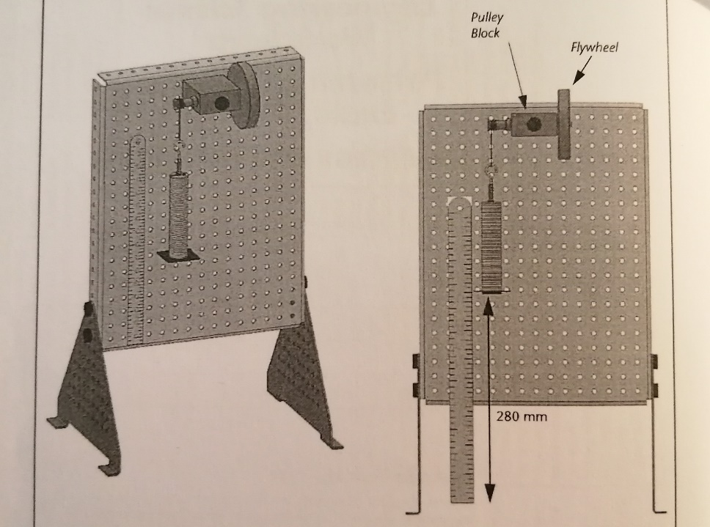
Figure 1 – Diagram of set up

1 - Set up the pulley block, flywheel, cord and weight hanger as in Figure 1.
2 – Allow the weight hanger to reach the full length of the cord, ensuring it won’t hit the table, then align the bottom of the ruler with the bottom of the weight hanger. This height is h₀.
3 – Wind the flywheel up so that the bottom of the weight hanger is now 280mm above it’s bottom height. This height is h₁.
4 – Add weight so including the hanger it is 0.1kg, then some of the team measure the time it takes to drop and reach its’s maximum height, t_{total}. Others in the team watch to see the maximum height it reaches, h₂.
5 – Do these 3 times and take averages for 0.1kg, 0.2kg, 0.3kg, 0.4kg and 0.5kg. Record the results in a table for mass, t_{total}, and h₂.

Results
Table 1 - Results from Experiment

In Table 1 are the results from the experiment, along with other values calculated from those results.
To find the Potential energy, we calculated mgh₁ for each value of m, with g = 9.81ms⁻².
PE loss would not have been accurate as the differing heights the masses reached would have affected the results. To make them more reliable to interpret, we multiplied it by the height ratio, so it only took into account the loss in potential energy with respect to the mass, not h₂. We used this equation:
PE loss (adjusted) = mg(h₁-h₂) x h₁/(h₁+h₂)
Falling time was the total time multiplied by the height ratio: t_{total} x h1/(h₁+h₂)
Acceleration was found using: a = h₁ / t_{f} ².
As a = v/t, v = at_{f}.
Liner velocity was converted to angular velocity using ω=2πv/c, where c (circumference of pulley including cord) = 0.0408m.
(mg-ma)r and a/r were then calculated using r = 0.0065m for the shaft including the cord.
The given value of I for the flywheel was 3.862 x10⁻⁴kgm², and the value for the shaft and pulley was 0.834 x10⁻⁴kgm², so the total value for I is 4.696 x10⁻⁴kgm².
Kinetic energy was calculated using this given total value for I, using I = ½ I ω². This should be a value for the kinetic energy the flywheel system has when the weights are at h₀.

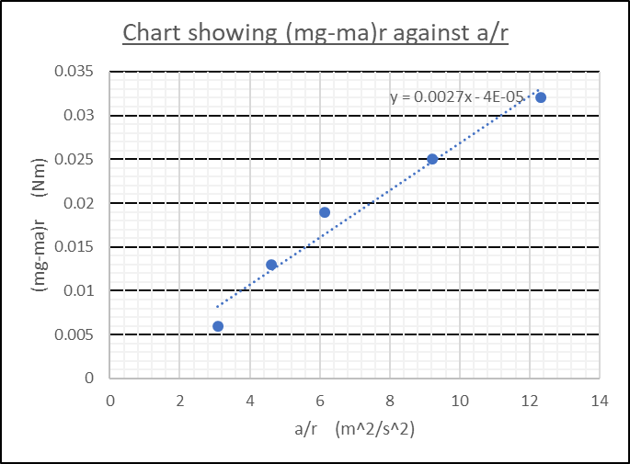
Figure 2 - Chart showing (mg-ma)r against a/r

I then plotted a chart of (mg-ma)r against a/r, shown in Figure 2, and made a line of best fit. The gradient of this line gives us an experimental value for I for the shaft, pulley and flywheel system, which is 0.0027kgm². The reasoning for the gradient being a value for I is given below:
F = mg-ma Τ = Iα
Τ = Fr α = a/r
So Τ = (mg-ma)r So Τ = I(a/r)
Combining these: (mg-ma)r = I(a/r)
So if (mg-ma)r is a y value, and a/r is an x value, then I gives the relationship between them.

Analysis
I expected to get a value of I from the gradient which was reasonably close to the value given in the workbook. I expected it to be marginally lower though as our workings don’t take into account friction, so the work done by friction would slow the masses acceleration and would lower the value for h₂, in the same way that a flywheel of a lower moment of inertia would store less energy and also lead to a lower h₂.
What we actually saw was a value of I from the chart of 0.0027kgm², which is 5.75 times higher than the nominal total value for I of 0.0004696kgm². This does not meet the expectations in any way.
Surprisingly, h₂ peaked at 0.3kg when they started reaching lower heights as mass increased. I would have expected this value to keep increasing as mass increased, but during the experiment we noticed they had a much more jerky action at this point, so maybe some energy was lost in lateral movements or vibrations through the system and to the table.
Potential energy losses increased steadily up to 0.3kg, then they increased more after that. This is misleading though, as the initial potential energy was larger with larger masses. So if you consider PE loss as a fraction of the initial potential energy, they peaked at 0.3kg and then declined, as they did with h_{2.} Table 2 shows these values.
Mass / kg | Initial PE / J | PE loss adjusted / J | PE loss as a fraction / J
0 | 0 | 0 | 0
0.1 | 0.27 | 0.03 | 1 / 9 of 0.27
0.2 | 0.55 | 0.04 | 1 / 13.8 of 0.55
0.3 | 0.82 | 0.05 | 1 / 16.4 of 0.82
0.4 | 1.1 | 0.07 | 1 / 15.7 of 1.1
0.5 | 1.37 | 0.12 | 1 / 11.4 of 1.37
Table 2 - PE Losses as Fractions
The maximum kinetic energy of the flywheel was also much lower than expected. As demonstrated below, KE_{MAX} = mgh₁ = mgh₂ + PE loss + Work Done against Friction. If you use mgh₁ and rearrange to find a value for Work Done against friction, the value you get is very small but reasonable. However, the value that we found for KE_{MAX} is much smaller than the initial PE when they should be almost equal, showing that there was some significant error with the experiment. This error could also be the reason the value of I we found was so different from the expected value. The values for Work Done against Friction using mgh₁ are given in Table 3.

Mass / kg | Work Done against Friction using mgh₁ / J
0 | 0
0.1 | 0.01
0.2 | 0.03
0.3 | 0.03
0.4 | 0.06
0.5 | 0.09
Table 3 - Work Done against Friction

Mathematical workings:
@ h₁ KE = 0 PE₁ = PE_{MAX} = mgh₁
@ h₀ KE_{MAX} = mgh₁ PE = 0
@ h₂ KE = 0 PE₂ = PE_{MAX} – PE loss – Work Done against Friction
As KE_{MAX} = PE_{MAX}, KE_{MAX} = PE₂ + PE loss + Work Done against Friction

Conclusions

As the result we got for I was so different to the expected value, I believe there was some error in the experiment. Possibilities for these errors will be looked into further in the Evaluation section. As discussed above, when using mgh₁ to find a value for Work Done against Friction, you get a very small but reasonable result, but when you use the value that we found for KE, the equation doesn’t give a reasonable result. I believe that this proves that the theory is correct and there was a problem with the experiment.

Evaluation
In the workbook there is a note that says to ensure the brake on the pulley block is unscrewed. If the brake was on partially it would have added friction to the system and slowed the mass’s acceleration. This is the same effect as a flywheel with a lower moment of inertia would have given. However, the value we got for I was much higher than expected, so while it is a potential source of error, it contradicts the results even more.
When we conducted the experiment, we didn’t weigh the weight hanger or the weights at all, and just used the masses that it had written on them. There could be a discrepancy between the given values and their actual masses, but this would have been only a small difference. If the experiment had given a value for I that was much closer than ours was, then it would have been good to repeat the experiment and accurately weigh each mass to get more accurate results.
We only have results at 100g increments, which was plenty given the amount of calculations we had to do for each set of results. While this was enough to see patterns in the results, we would have been able to see the patterns in more detail if we had more sets of results, such as using 50g increments.
The main aim of our experiment was to measure the change in acceleration of different weights, so that we could plot a chart of (mg-ma)r against a/r. In these equations, a is the only unknown value as we would choose the masses and radius of flywheel. All steps in the calculation of a mean that accuracy is lost through rounding, and potential for human or systematic error increases. In an experiment run by the Memorial University of Newfoundland, they used a light-gate clamped to a table, and the flywheel had bar tape wrapped around it. As the mass dropped and the flywheel rotates, the bar tape passes through the light gate at increasing velocity, then the results are used to find acceleration. The set up is shown in Figure 3. I don’t know if the software linked to the light-gate could measure acceleration directly, but it definitely do it in a lot less steps than our method did. Our method also relied on human judgement for the value of h₂ and t_{total}, whereas this method would have been much more accurate. (MUN, 2019)


As mentioned previously, 0.1kg and 0.2kg acted very smoothly and steadily, giving easy to judge results. 0.3kg was noticeably more jerky, and 0.4kg and 0.5kg were even more so, meaning the results were less accurate. Using smaller masses and a flywheel of larger moment of inertia would have improved this, as the actions would have been steadier and the times would have been greater so our errors in judgement would have made less of a difference.
Figure 3 - Memorial University of Newfoundland Experiment
If I was to do this experiment again I would use a larger flywheel, smaller masses, masses increasing at smaller increments, and I’d use a light gate to gather more accurate results.

References
MUN, 2019. Memorial University of Newfoundland - P1050 Experiment 6 - Moment of Inertia. [Online]
Available at: https://www.mun.ca/physics/undergraduates/fylabs/p1050/experiment6.pdf
[Accessed 13 12 2019].

