
Student Name: | Faiz Hussain
Student ID Number: | 2527683
Programme: | Certificate of Higher Education Skills for the Workplace (Health and Social Care)
Module Title: | Introduction to Public Health
Module Code: | LCHS4008
Lecturer: | Gillian Weaver (Module Lead)
Internal Verifier: | Dr. Besty Jose
Assignment Title: | Assessment 2 -  Report on a Health Issue
Submission Deadline: | 21st July 2026

Table of Contents
Introduction .................................................................................................................................... 3
Main Body ..................................................................................................................................... 4
2.1 Different Approaches Used to Measure and Monitor Depression ....................................... 4
2.2 Control of Depression .......................................................................................................... 5
2.3 Consequences of Depression on People in the Community ................................................ 6
2.4 Health and Social Care Support Services Required to Meet the Needs of Individuals Affected by Depression within the Community ........................................................................... 7
Conclusion ..................................................................................................................................... 8
References .................................................................................................................................... 10

Introduction
Depression is a common mental health disorder characterised by persistent low mood, loss of interest or pleasure, and impaired emotional, cognitive and physical functioning that significantly affects daily life (World Health Organization (WHO), 2025). Unlike temporary sadness, clinical depression is diagnosed when symptoms persist for at least two weeks and interfere with social, educational or occupational functioning (National Institute for Health and Care Excellence (NICE), 2022). Common symptoms include persistent sadness, fatigue, sleep disturbances, changes in appetite, poor concentration, feelings of hopelessness and suicidal ideation. Globally, depression affects approximately 280 million people and remains one of the leading causes of disability worldwide (WHO, 2025). In the United Kingdom, around one in six adults experiences moderate to severe depressive symptoms, placing increasing pressure on NHS mental health services and community care (Office for National Statistics, 2025). This report critically examines how depression is measured, monitored and controlled, and evaluates its impact on communities and health and social care provision.
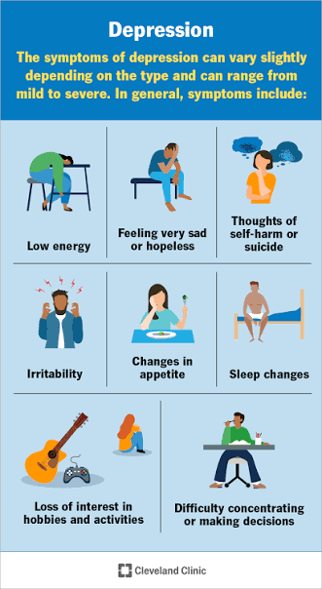
(Merck, 2026)

2.1 Different Approaches Used to Measure and Monitor Depression
Accurate measurement and monitoring of depression are essential for identifying disease burden, evaluating treatment outcomes and planning effective health and social care services. As depression cannot be confirmed through laboratory investigations, healthcare professionals rely on validated assessment tools, clinical diagnosis and population surveillance to identify individuals requiring support and monitor trends within communities (NICE, 2022).
Within UK primary care, General Practitioners (GPs) routinely use the Patient Health Questionnaire-9 (PHQ-9) to assess symptom severity, support diagnosis and monitor patients' response to treatment. The PHQ-9 provides a standardized score that enables clinicians to evaluate whether symptoms improve, remain unchanged or worsen following psychological therapy or antidepressant medication (Kendrick et al., 2022). Where rapid assessment is required, the shorter PHQ-2 may be used initially before a comprehensive clinical evaluation. These tools facilitate early identification, allowing patients to access NHS Talking Therapies before symptoms become more severe.
Diagnosis is further supported through internationally recognized criteria, including the Diagnostic and Statistical Manual of Mental Disorders (DSM-5-TR) and the International Classification of Diseases (ICD-11), ensuring consistent diagnosis across healthcare settings and improving communication between multidisciplinary professionals (American Psychiatric Association, 2022; Reed et al., 2022). Standardized diagnostic frameworks also strengthen research quality by enabling comparisons of depression prevalence across different populations.
At the population level, depression is monitored using routinely collected NHS data, including General Practice records, the Mental Health Services Data Set (MHSDS) and national surveys undertaken by the Office for National Statistics. These systems enable Integrated Care Systems to identify geographical variations in depression, monitor service demand and allocate resources according to local population needs (NHS England, 2024; Office for National Statistics, 2025). However, reliance on self-reported symptoms and healthcare attendance may underestimate prevalence because stigma and limited help-seeking behaviour discourage some individuals from accessing services (Thornicroft et al., 2022). Therefore, combining clinical assessment with national surveillance provides a comprehensive approach to monitoring depression and supporting evidence-based public health decision-making.

2.2 Control of Depression
Controlling depression requires a comprehensive approach that combines prevention, early diagnosis, evidence-based treatment and continuous community support. As depression is a non-communicable mental health disorder, disease control focuses on reducing its prevalence, preventing relapse and improving long-term recovery rather than eliminating the condition (NICE, 2022).
Primary prevention aims to reduce risk factors before depression develops. In the UK, public health campaigns promote mental health awareness, stress management and healthy lifestyles, while schools and workplaces implement wellbeing programmes that encourage resilience and early help-seeking. Social prescribing has also become an important intervention, enabling GPs to refer individuals to community activities such as exercise groups, volunteering and peer support to reduce loneliness and improve mental wellbeing (NHS England, 2024).
Secondary prevention focuses on early identification and prompt intervention. During primary care consultations, GPs use validated screening tools, including the PHQ-9, to identify depressive symptoms and refer suitable patients to NHS Talking Therapies. Early access to cognitive behavioural therapy (CBT), counselling or guided self-help improves clinical outcomes and reduces the likelihood of symptom progression or hospital admission (Kendrick et al., 2022).
Tertiary prevention aims to prevent relapse and support long-term recovery among individuals with established depression. Treatment plans are tailored according to symptom severity and may combine antidepressant medication with psychological therapies, regular clinical reviews and relapse prevention strategies recommended by NICE (2022). Community Mental Health Teams provide coordinated care involving psychiatrists, psychologists, mental health nurses, occupational therapists and social workers, ensuring that clinical treatment is integrated with practical support for housing, employment and daily living. This multidisciplinary approach addresses both the medical and social determinants of mental health, improving adherence to treatment, reducing repeat crises and enabling individuals to maintain independence within the community. Consequently, integrated prevention and person-centred care remain fundamental to controlling depression and reducing its long-term burden on health and social care services.

2.3 Consequences of Depression on People in the Community
Depression has significant consequences that extend beyond the individual, creating substantial challenges for families, communities and health and social care services. Persistent symptoms such as low mood, reduced motivation and impaired concentration often affect an individual's ability to maintain employment, education and social relationships, increasing the risk of financial hardship and social isolation (Patel et al., 2022). Depression is also associated with poorer management of long-term physical conditions, resulting in increased hospital admissions and greater use of NHS services (Herrman et al., 2022).
Families frequently experience emotional, physical and financial pressures when supporting a relative with depression. Informal carers may need to provide continuous emotional support, assist with daily activities and manage periods of mental health crisis, which can negatively affect their own wellbeing and increase caregiver burden (Carers UK, 2023). Children living with parents experiencing depression may also experience emotional difficulties, reduced educational achievement and poorer social development, demonstrating the wider impact of the condition across generations.
At a community level, depression contributes to reduced workforce productivity through sickness absence, presenteeism and early retirement, placing economic pressure on employers and public services. Rising demand for mental health assessments, crisis intervention and community treatment has increased pressure on General Practitioners, NHS Talking Therapies and Community Mental Health Teams, leading to longer waiting times and challenges in meeting service demand (NHS England, 2024). Furthermore, stigma surrounding mental illness continues to discourage some individuals from seeking professional help, delaying diagnosis and increasing the likelihood of severe illness and emergency intervention (Thornicroft et al., 2022). Consequently, addressing depression requires not only effective clinical management but also policies that reduce stigma, improve mental health literacy and tackle wider social determinants such as poverty, unemployment and housing insecurity. These measures are essential for reducing inequalities and improving health outcomes across communities.
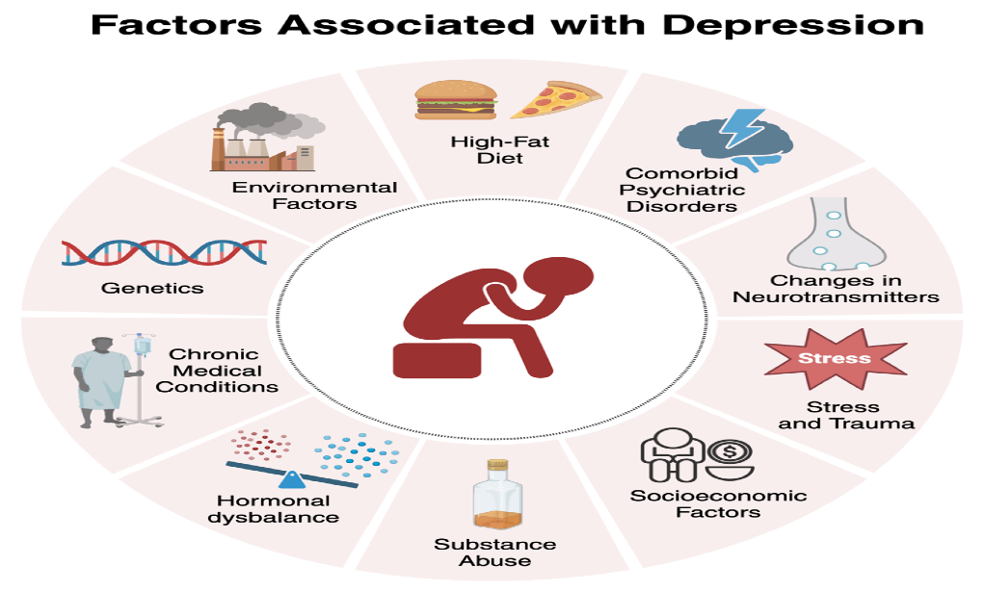
(Souza, 2024)

2.4 Health and Social Care Support Services Required to Meet the Needs of Individuals Affected by Depression within the Community
Effective management of depression requires integrated health and social care services that address both clinical symptoms and the wider social factors influencing recovery. Within the UK, General Practitioners (GPs) act as the first point of contact by assessing symptoms, initiating treatment and referring individuals to appropriate mental health services. Through regular reviews, GPs monitor treatment effectiveness and coordinate ongoing care, ensuring timely intervention when symptoms deteriorate (NICE, 2022).
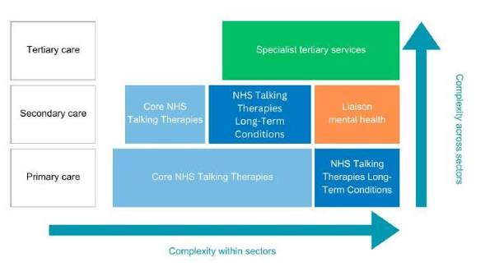 (NHS England, 2024)
Individuals with mild to moderate depression are commonly referred to NHS Talking Therapies, where trained practitioners provide evidence-based interventions such as cognitive behavioural therapy (CBT), counselling and guided self-help. These services promote early recovery and reduce the need for more intensive specialist care (NHS England, 2024). For people experiencing severe or recurrent depression, Community Mental Health Teams (CMHTs) deliver multidisciplinary support involving psychiatrists, psychologists, mental health nurses, occupational therapists and social workers. This collaborative approach enables personalised care plans that combine medication management, psychological treatment and social support according to individual needs.
Social workers play a vital role in addressing wider determinants of health by supporting access to housing, welfare benefits, safeguarding services and community resources. Occupational therapists help individuals rebuild daily routines, improve independent living skills and facilitate a safe return to education or employment, promoting long-term recovery and social inclusion. In addition, voluntary organisations such as Mind and Samaritans provide peer support, crisis helplines and mental health education that complement statutory NHS services by reducing isolation and encouraging early help-seeking (Carers UK, 2023). Collectively, these integrated services support person-centred care, reduce the risk of relapse and improve quality of life by addressing both the medical and social challenges associated with depression within community settings.

Conclusion
Depression remains a major public health challenge that affects individuals, families and communities while placing considerable demands on UK health and social care services. This report has demonstrated that effective management depends on accurate measurement and monitoring through validated assessment tools, clinical diagnostic criteria and national surveillance systems that support evidence-based decision-making. It has also shown that controlling depression requires integrated strategies, including prevention, early identification, timely psychological and pharmacological treatment, and coordinated multidisciplinary care. The report highlighted that depression has significant social, economic and healthcare consequences, reinforcing the need for interventions that address both clinical symptoms and wider social determinants of health. Furthermore, person-centred support delivered through General Practitioners, NHS Talking Therapies, Community Mental Health Teams, social care professionals and voluntary organisations is essential for improving recovery and reducing inequalities. Continued investment in accessible, community-based mental health services and early intervention will be fundamental to improving outcomes and reducing the long-term burden of depression.

References
American Psychiatric Association (2022) Diagnostic and Statistical Manual of Mental Disorders. 5th edn, Text Revision (DSM-5-TR). Washington, DC: American Psychiatric Association.
Bains, N. and Abdijadid, S. (2023) ‘Major depressive disorder’, in StatPearls. Treasure Island, FL: StatPearls Publishing.
Carers UK (2023) State of Caring 2023. London: Carers UK.
Cuijpers, P., Karyotaki, E., Ciharova, M., Miguel, C., Noma, H. and Furukawa, T.A. (2023) ‘The effects of psychotherapies for depression in adults: An overview of systematic reviews’, World Psychiatry, 22(1), pp. 105–115.
Herrman, H., Patel, V., Kieling, C., Berk, M., Buchweitz, C., Cuijpers, P., Furukawa, T.A., Kessler, R.C., Kohrt, B.A., Maj, M., McGorry, P., Reynolds, C.F., Weissman, M.M., Chibanda, D., Dowrick, C., Howard, L.M., Hoven, C.W., Knapp, M., Mayberg, H.S., Penninx, B.W.J.H., Xiao, S., Trivedi, M., Uher, R., Vijayakumar, L. and Wolpert, M. (2022) ‘Time for united action on depression: A Lancet–World Psychiatric Association Commission’, The Lancet, 399(10328), pp. 957–1022.
Kendrick, T., Pilling, S., Mavranezouli, I., Megnin-Viggars, O., Ruane, C., Eadon, H. and Kapur, N. (2022) ‘Management of depression in adults: Summary of updated NICE guidance’, BMJ, 378, p. o1557.
National Institute for Health and Care Excellence (2022) Depression in adults: Treatment and management (NG222). London: NICE. Available at: NICE Guideline NG222
NHS England (2024) Mental Health Services Data Set (MHSDS): Monthly Statistics. London: NHS England.
Office for National Statistics (2025) Personal well-being and depressive symptoms in Great Britain. Newport: Office for National Statistics.
Patel, V., Saxena, S., Lund, C., Thornicroft, G., Baingana, F., Bolton, P., Chisholm, D., Collins, P.Y., Cooper, J.L., Eaton, J., Herrman, H., Herzallah, M.M., Huang, Y., Jordans, M.J.D., Kleinman, A., Medina-Mora, M.E., Morgan, E., Niaz, U., Omigbodun, O., Prince, M., Rahman, A., Saraceno, B., Sarkar, B.K., De Silva, M., Singh, I., Stein, D.J., Sunkel, C. and Unutzer, J. (2022) ‘The Lancet Commission on global mental health and sustainable development’, The Lancet, 399, pp. 2264–2280.
Reed, G.M., First, M.B., Kogan, C.S., Hyman, S.E., Gureje, O., Gaebel, W., Maj, M., Stein, D.J., Maercker, A. and Tyrer, P. (2022) ‘Innovations and changes in the ICD-11 classification of mental, behavioural and neurodevelopmental disorders’, World Psychiatry, 21(2), pp. 205–216.
Thornicroft, G., Sunkel, C., Aliev, A.A., Baker, S., Brohan, E., El Chammay, R., Davies, K., Demissie, M., Duncan, J., Fekadu, W., Gronholm, P.C., Gurung, D., Habtamu, K., Kohrt, B.A., Magana, S., Maulik, P.K., Rössler, W., Semrau, M., Shidhaye, R., Sorsdahl, K., Evans-Lacko, S. and Henderson, C. (2022) ‘The Lancet Commission on ending stigma and discrimination in mental health’, The Lancet, 400(10361), pp. 1438–1480.
World Health Organization (2025) Depressive disorder (depression). Geneva: World Health Organization. Available at: WHO Depression Fact Sheet

