Table 1 Starter
Component | Objectivist Approach | Subjectivist Approach
Research Question | What measurable impacts/relationships can be identified? (e.g., "What is the impact of X on Y?") | How do people experience/interpret this situation? (e.g., "How do stakeholders perceive...?")
Ontology | Consider: What facts and numbers can be measured? | Consider: Whose perspectives matter here?
Epistemology | List 2-3 specific sources of data you will use | List 2-3 ways you will gather people's experiences
Axiology | How will you maintain objectivity? | How will you handle different viewpoints?
Methodology | Quantitative methods like … | Qualitative methods like ….

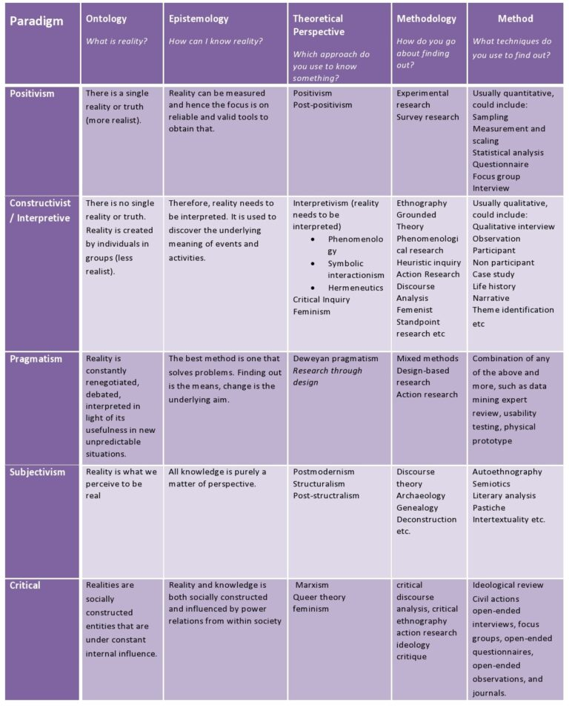
Table 2 Basic Paradigm Table

Aspect | Positivism | Post-positivism | Interpretivism | Social Constructionism | Critical Realism | Pragmatism
Core Question | What are the facts? | What are the probable facts? | How do individuals interpret their reality? | How do groups create shared meaning? | What mechanisms cause what we observe? | What works?
View of Reality (Ontology) | Single, objective reality exists independent of observers | Single reality exists but can only be known imperfectly | Each person constructs their own reality based on personal experiences and interpretations | Reality is created through shared understanding and social agreement | Reality exists in layers (empirical, actual, and real) | Reality is whatever proves practical
Nature of Knowledge (Epistemology) | Knowledge is objective and discoverable through measurement | Knowledge is probabilistic and tentatively established | Knowledge is subjective and based on personal interpretation | Knowledge is constructed through social interaction and agreement | Knowledge combines empirical observation with rational interpretation | Knowledge comes from practical experience
Role of Values (Axiology) | Research is value-free; values must be excluded | Values can be controlled but may influence research | Values are inseparable from research; researcher acknowledges own values | Values are central to research; shared values shape understanding | Values influence research but can be examined critically | Values guide what is worth studying
Role of Researcher | Detached observer | Objective but aware of bias | Interpreter of individual meanings | Participant in meaning creation | Critical observer of multiple levels | Problem solver
Typical Methods | Quantitative | Mainly quantitative with some qualitative | Qualitative (individual focus) | Qualitative (group focus) | Mixed methods | Whatever works
Business Research Use | Testing theories and establishing facts | Testing theories while acknowledging uncertainty | Understanding how individuals make sense of business situations | Understanding how organizations develop shared practices and meanings | Understanding complex organizational mechanisms | Finding practical solutions

Table 3 Comprehensive Paradigm Table

Aspect | Positivism | Post-positivism | Interpretivism | Social Constructionism | Critical Realism | Pragmatism
Ontology (Nature of Reality) | Naive realism - single, tangible reality exists | Critical realism - reality exists but can only be probabilistically known | Relativism - multiple, individual realities | Relativism - reality is socially constructed | Stratified reality - empirical, actual, and real domains | Reality is what is practical and useful
Epistemology (Nature of Knowledge) | Objectivism | Modified Objectivism | Subjectivism | Constructionism | Modified Objectivism | Varies based on research question
Axiology (Role of Values) | Value-free research; researcher is detached | Values in research but can be controlled | Value-bound research; researcher is part of what is researched | Values are integral to research; researcher and participants co-create understanding | Value-aware research; researcher is as objective as possible | Values guide research choices
Core Belief | Truth exists independently of consciousness | Knowledge can be approximated but not perfectly known | Truth is based on individual interpretation | Truth is created through social processes | Truth exists but understanding is socially influenced | Truth is what works in practice
How Knowledge is Created | Through careful observation and measurement | Through approximation and probability | Through personal meaning-making and individual experience | Through social processes and shared meaning-making | Through combining objective measurement with social interpretation | Through testing and practical application
Role of Reality | Reality is fixed and discoverable | Reality exists but can only be approximated | Reality is personal and individual | Reality is socially constructed | Reality exists but is interpreted through social lens | Reality is what proves useful
Simple Analogy | Taking a photograph - capturing what's really there | Taking multiple photos from different angles | Writing a personal diary - purely individual perspective | Writing a Wikipedia article - knowledge created through collective input | Reading a map - terrain is real but interpretation varies | Fixing a car - focus on what works rather than theory
Methodology | Quantitative | Mainly Quantitative, some Qualitative | Qualitative | Qualitative | Mixed Methods | Mixed Methods
Research Design Focus | Testing and measurement | Probabilistic understanding | Subjective understanding | Understanding meaning and context | Multiple levels of analysis | Practical outcomes
Quality Criteria | Validity and reliability | Internal/External validity | Trustworthiness | Credibility and authenticity | Explanation power | Usefulness
Role of Researcher | Objective observer | Detached but aware | Involved interpreter | Active participant | Critical interpreter | Problem solver
Primary Methods | Statistical analysis | Mixed statistical/interpretive | Individual interviews | Group observation | Mixed methods | Action research
Data Types | Numerical data, metrics | Mixed data types | Personal narratives | Social interactions | Multiple data sources | Outcome-based data
Data Collection Methods | Surveys, metrics, experiments | Mixed methods with emphasis on quantitative | Personal interviews, diaries | Interactive interviews, observation | Multiple methods | Whatever methods solve the problem
Analysis Approach | Quantitative analysis | Mixed analysis | Interpretive analysis | Discourse analysis | Multi-level analysis | Effectiveness analysis
Typical Research Topics | Performance metrics, market share | Complex phenomena with measurable aspects | Individual experiences, personal decision-making | Team dynamics, organizational culture | Complex organizational changes | Problem-solving, improvement initiatives
Type of Knowledge Produced | Statistical relationships and patterns | Probabilistic understanding of relationships | Individual experiences and motivations | Shared meanings and social factors | Multi-level causal explanations | Practical solutions and interventions
Business Research Example | Measuring the impact of training on productivity using performance metrics | Testing theories with statistical probability | Understanding individual employee experiences of workplace change | Examining how teams develop shared understanding of quality | Analyzing both financial performance and how stakeholders interpret it | Testing different management approaches to see which improves performance
Business Application | Policy making | Evidence-based decision making | Personal support | Cultural change | Comprehensive strategy | Direct action
Research Question Style | "What is the measurable impact of X on Y?" | "What is the probable relationship between X and Y?" | "How does individual X interpret Y?" | "How is X understood through interaction?" | "What are both the measurable and interpreted aspects of X?" | "What approach to X works best?"
Expected Outcomes | Generalizable findings | Probabilistic generalizations | Individual insights | Group-level understanding | Multi-level explanation | Practical solutions
Knowledge Independence | Knowledge exists independently of consciousness | Knowledge can be approximated | Knowledge is based on individual interpretation | Knowledge is socially constructed | Knowledge combines objective and subjective elements | Knowledge is based on practical outcomes
Method Emphasis | Emphasis on scientific method | Modified scientific approach | Emphasis on personal meaning | Emphasis on shared meaning | Emphasis on underlying mechanisms | Emphasis on what works
Primary Focus | Focus on observable phenomena | Recognition of probability | Focus on individual experiences | Focus on social interactions | Focus on multiple levels of reality | Focus on solutions
Goal Orientation | Seeks universal laws and patterns | Absolute certainty is impossible | Seeks understanding of perspectives | Seeks understanding of shared meaning | Seeks causal explanations | Seeks practical applications
Best Business Application Context | When seeking to understand regularities in business phenomena; testing existing theories; examining relationships between variables; developing generalizable knowledge about business processes; particularly suited for PhD research aiming to contribute to theoretical knowledge | When acknowledging the complexity of business environments while still seeking to identify patterns and relationships; suitable for research requiring rigorous methodology while recognizing inherent uncertainties in business contexts | When aiming to understand how individuals make sense of business phenomena; exploring personal experiences of management practices; understanding subjective decision-making processes; particularly valuable in leadership and organizational behavior research | When investigating how shared business meanings and practices emerge; studying how organizational knowledge is collectively created; understanding how business practices evolve through social interaction; especially relevant for organizational culture studies | When examining complex business phenomena that require understanding of both observable events and underlying mechanisms; particularly useful for studying organizational change and strategic management where multiple levels of reality interact | When the primary aim is solving specific business problems; where research needs to directly inform practice; when flexibility in approach is needed to address complex business challenges; particularly suited for applied business research and consultancy

