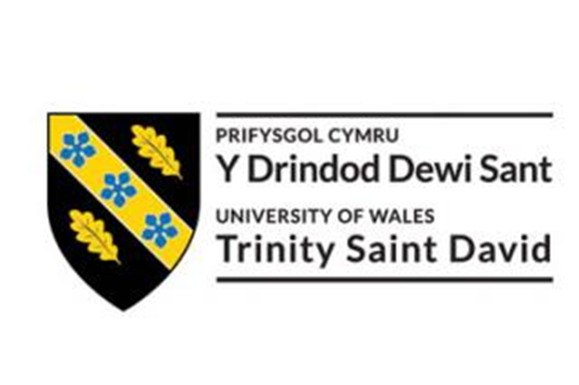

Professional Career Development
PCD BMSW4005

Student Name: Mariana Dzharova
Student Number: 2129921
Lecturer’s Name: Husam Alharahsheh

Table of Contents
Introduction 3
Chosen Career Path 3
Current Skills 3
Gaps in Skills 5
Systematic Approach to Skills Acquisition 6
Recruitment and Selection (Reflection on the Job Interview) 7
Description 7
Feelings 8
Evaluation 8
Analysis 8
Conclusion 8
Action Plan 9
Conclusion and Recommendations on Career Progression 9
Reference List 10
Appendix A: Job Advert (Job Description & Personal Specification) 11

Introduction
Recruitment is the process of advertising an available vacancy and encouraging people to apply for that vacancy. On the other hand, selection is the process of selecting the most suitable candidate for the job from all applicants (Thiruvenktaraj and Nirmal, 2018). To succeed at finding their dream job, applicants must be able to identify the skills required for the job, the skills that they possess as well as the skill gaps that they have to work on in order to increase their chances of being selected for the job.

Chosen Career Path
I am currently undertaking a course at the University at Wales that is aimed at improving my employability skills. This will help me to achieve my career goals, which is to become a senior manager at a large corporation like Tesco. However, I am still at the beginning of my career path and now I have applied to become a team manager at Tesco’s Brent Cross Store. Generally, team managers manage day-to-day issues and provide guidance to their team members. They set targets, implement guidelines and assist the employees with any issues that they might have. The main role of the team manager is to ensure that all team members understand the team’s objectives and to ensure that the members work together in order to achieve them.

At Tesco’s, the team manager is a role model that helps his colleagues to know and love the products and services that Tesco offers. By becoming a team manager, I will have the chance to put my skills, experience and instinct to the test because I will chase opportunities and will be looking for new ways to better the working conditions of my subordinates. In addition to this, I will be looking at how I can maximise sales by ensuring that everyone is at the right place at the right time (uk.linkedin.com, n.d.).

Current Skills
Team managers have a wide range of responsibilities, which means that good team managers will have a wide set of leadership skills. I believe that I am suitable for the job because I have the following skills that fit into my chosen career:
- Communication Skills – communication skills are crucial for team managers because they need to be able to communicate effectively in order to unify and motivate the team. I have been able to develop my communication skills throughout number of years working as a customer assistant. I believe that my strong communication skills will help me to support my team, to ensure that projects are completed on time, to be successful and to help the organisation to achieve its goals.

- Emotional Intelligence – emotional intelligence refers to the ability to perceive, interpret, control and use emotions to communicate and relate to other effectively and constructively (Cherry, 2023). Naturally, I am a very compassionate person who can understand the emotions of others. I am also very self-aware of my personal emotions. As a team member, my emotional intelligence will allow me to identify team members who are feeling overwhelmed and to provide them with adequate support that is going to help his mental and physical wellbeing.

- Team-Work – a team manager must have excellent team working skills because he is both a team leader and a team member. Teamwork is also important because it fosters loyalty, higher morale, efficiency, creative thinking and comprehension. My studies and my work experience have helped me to develop good team working skills. Therefore, I believe that I will be able to foster good relationship between the members, I will be able to find unique talents and to adjust roles to capitalise on the particular capabilities of each team member.

- Strategic Thinking – strategic thinking is the ability to generate new ideas and to implement strategies for success (Indeed Career Guide, n.d.). Although, I have not worked as a manager before, I am a very creative individuals so, I believe that I will be able to apply strategic thinking that will improve the productivity of my team. This will help me to achieve objectives and to contribute towards the overall success of the business.

- Decision-Making – team managers manage day-to-day issues so, they are often required to make decisions. Therefore, a good team manager should be able to operate well under pressure and to make good decisions. I am a very rational thinker and a person that can think on his feet. Therefore, I believe that I will be able to make adequate decisions that are best for the situation at hand.

Gaps in Skills
Although I have most of the skills listen in the personal specification in the job advert, I have identified several skill gaps. The skills that I need to develop or improve are:
- Organisation – organisation is an essential skill for all managers because they need to be able to organise their time and workload. Managers need to conduct a physical organisation of their desks, but they also need to apply their organisation skills to time management, goal setting, decision-making strategic planning etc. (Riserbato, 2022). The lack of organisation skills can affect the manager’s productivity and effectiveness. Therefore, it is crucially important to come up with a systematic approach that will help me to improve my organisation skills.

- Time Management – time management is a skill that helps you to organise your time by planning how to divide your time between different activities (CFI Team, 2022). Time management is very important for team managers because teams usually have a goal that they have to achieve before a specific deadline. Therefore, the manager must be able to manage his own time as well as the time of the team as effectively as possible in order to ensure that each task is completed within a specified timeframe and that the team will achieve its goals before the deadline. Unfortunately, I do not possess good time management skills, which causes me to run behind schedules, to work overtime, which leads to addition stress and exhaustion. Therefore, in order to increase my chances of being hired for the job, I have to improve my time management skills in order to be able to coordinate tasks and activities and to maximise mine as well as my team’s effectiveness.

- Delegation – delegation is the management skill of assigning tasks to others and giving them the authority to do whatever is necessary to accomplish those tasks. Team managers must be successful at delegation in order to ensure effective utilisation of the human capital of the business. Unfortunately, I think I will struggle at delegation because I am used to do everything on my own, and as a result, I am not used to rely on others to get the work done.

Systematic Approach to Skills Acquisition
Overall, the skills that I need to develop are organisation, time management and delegation skills. Organisation skill are foundational because they support growth and development of other areas such as critical thinking and communications (Birt, 2022). Therefore, to improve my organisation skills I will commit to the following:
- I will create and maintain a clean workspace by decluttering unnecessary documents and other items. With fewer distractions, I will find it easier to concentrate on my work.
- Every day, I will build a to-do list that will outline the tasks that I have to complete for the day. This will help me to ensure that all tasks for the day have been completed. If I am dealing with a bigger project, I will break it up into smaller and more manageable tasks.
Time management is a technique used for managing your time productively and efficiently. It is all about organising and planning how to divide your time between different tasks. The strategy that I will use to improve my time management skills is through the use of a Gantt Chart. The Gantt Chart is a graphical depiction of a project schedule. It is a visualisation that helps you to schedule, manage and monitor specific tasks (Gant, 2021). I will create a Gantt Chart for every new project or goal in order to ensure that the tasks that have to be completed to accomplish that goal will be completed before the deadline.

Lastly, to learn to delegate effectively, I will have to practice by playing with my employees’ strengths and goals. To learn to delegate, I also need to practice to let go and must be able to provide the right resources and level of authority to ensure that the employee will be able to complete the task that I have given him. To avoid micromanaging, I also need to establish clear communication channels that will allow me to help my subordinates and to track their progress (Landry, 2020).

Recruitment and Selection (Reflection on the Job Interview)
Gibb’s Reflective Cycle is one of the most commonly used methods to examine experiences and to allow yourself to learn and to plan for the future (The University of Edinburgh, 2020). For this reason, I will use Gibb’s Reflective Cycle to reflect on the job interview that I have completed as part of my assignment for this module. The cycle covers 6 stages, which are description of the experience, feelings about the experience, evaluation, analysis, conclusion, and an action plan for the future.


Description
The job-interview was a role play that was conducted in a classroom setting. As part of the role play, I had to apply for a job and had to sit through an interview where I was the interviewee, and a classmate was the interviewer. The goal of the process was to mimic real-life interviews in order to improve my skills and to increase my chances of being selected among the pool of applicants when I apply for a job in the future. The job that I have decided to apply for was for the role of a Team Manager at Tesco because my career goal is to become a senior manager at a large corporation.

Feelings
At the beginning, I was feeling very confident that I will perform well at the job interview because I know that I have the skill and the knowledge required for the position. However, as the time of the interview approach, I noticed that I started to feel more anxious because I was no longer feeling that I was well prepared.

Evaluation
Although I was very nervous about the interview, I believe that it went well because I managed to calm myself down and at the beginning of the interview, I was no longer feeling that anxious. I think I managed to build my confidence because I reviewed potential interview questions online and practices answering such questions with my husband. However, I believe that I should have given more detailed answers in order to show the interviewer that I am aware of the requirements for the position and that I am a suitable candidate for the job.

Analysis
I think the reason that caused me to feel anxious about the interview is the fact that English is my second language and because I am not that confident to speak English. However, by reviewing potential questions that I may be asked to answer and by practicing with my husband, I managed to build my confidence, which helped me to become less stressed about the interview.

Conclusion
To conclude, I have learnt that to be successful at an interview, you have to practice potential questions that you may get asked. This will help you to become more confident as you will be more prepared. In addition to this, I have also learnt that applicants must begging to prepare for the selection process even before they apply for the job. For example, I wanted to apply for the role as a team manager, but I lacked some of the skills that were required for the job. For this reason, it is important to ensure that you have the right skillset before you apply for a specific job in order to increase your chances of being selected.

Action Plan
In the future, I will conduct regular personal SWOT analyses in order to identify my weaknesses and to create a personal development plan that will help me to improve my overall skills and abilities.

Conclusion and Recommendations on Career Progression
To conclude, conducting the role play was a valuable experience that has helped me to improve my employability skills. As a result, I am more prepared and more confident to apply for a managerial position in the real world. To achieve my career goals, I have to remain determined and have to continue to improve my skills in order to remain relevant and to increase my chances of being selected for the position that I am applying for.

Reference List
Birt, J. (2022). Organizational Skills: Definition and Examples | Indeed.com. [online] www.indeed.com. Available at: https://www.indeed.com/career-advice/career-development/organizational-skills [Accessed 4 May 2023].
CFI Team (2022). Time management. [online] Corporate Finance Institute. Available at: https://corporatefinanceinstitute.com/resources/management/time-management-list-tips/ [Accessed 4 May 2023].
Cherry, K. (2022). What is Emotional Intelligence? [online] Verywell Mind. Available at: https://www.verywellmind.com/what-is-emotional-intelligence-2795423 [Accessed 5 Apr. 2023].
Grant, M. (2021). Understanding Gantt Charts. [online] Investopedia. Available at: https://www.investopedia.com/terms/g/gantt-chart.asp [Accessed 4 May 2023].
Indeed Career Guide. (n.d.). 21 Skills of a Good Manager. [online] Available at: https://www.indeed.com/career-advice/career-development/skills-of-a-good-manager [Accessed 4 May 2023].
Landry, L. (2020). How to Delegate Effectively: 7 Tips for Managers | HBS Online. [online] Harvard Business School Online. Available at: https://online.hbs.edu/blog/post/how-to-delegate-effectively [Accessed 4 May 2023].
Riserbato, R. (2022). How to Improve Organizational Skills at Work. [online] blog.hubspot.com. Available at: https://blog.hubspot.com/marketing/organizational-skills [Accessed 4 May 2023].
The University of Edinburgh (2020). Gibbs’ Reflective Cycle. [online] The University of Edinburgh. Available at: https://www.ed.ac.uk/reflection/reflectors-toolkit/reflecting-on-experience/gibbs-reflective-cycle [Accessed 4 May 2023].
Thiruvenktaraj, T.R. and Nirmal, K.R. (2018). A STUDY ON RECRUITMENT AND SELECTION PROCESS. International Journal of Scientific Development and Research, [online] 3(4). Available at: https://www.ijsdr.org/papers/IJSDR1804022.pdf [Accessed 4 May 2023].
uk.linkedin.com. (n.d.). Tesco hiring Team Manager - Brent Cross Hendon Way Superstore in London, England, United Kingdom | LinkedIn. [online] Available at: https://uk.linkedin.com/jobs/view/team-manager-brent-cross-hendon-way-superstore-at-tesco-3595369785 [Accessed 4 May 2023].

Appendix A: Job Advert (Job Description & Personal Specification)

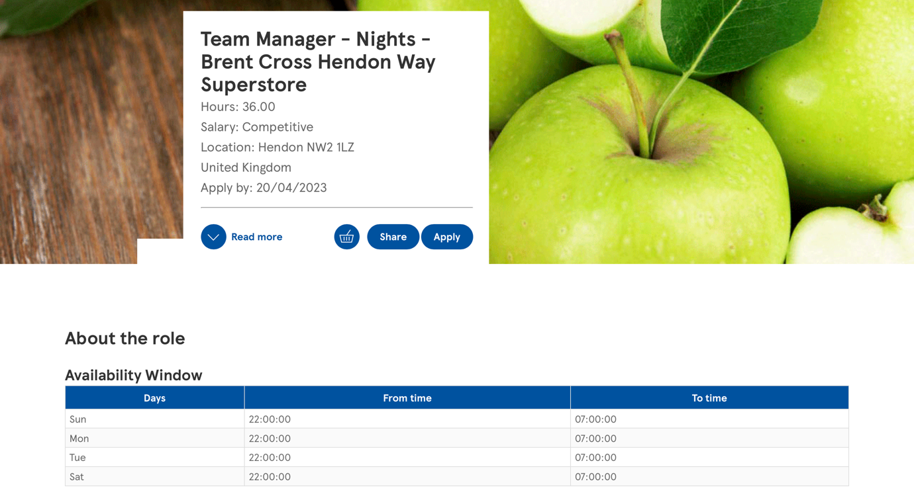
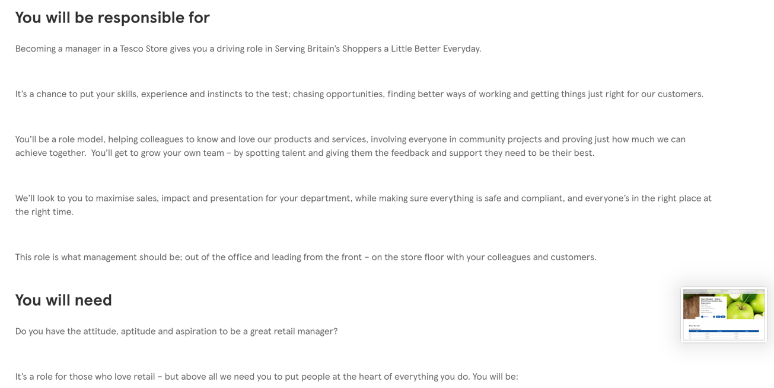

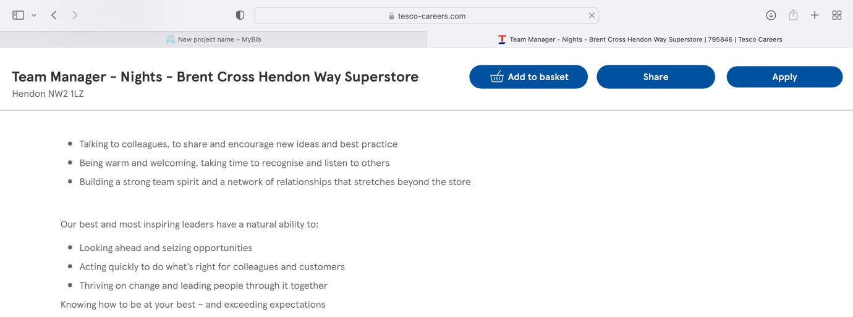

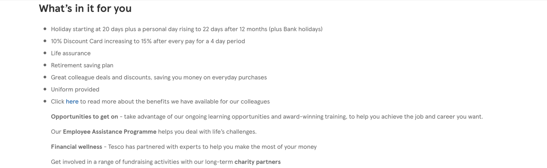
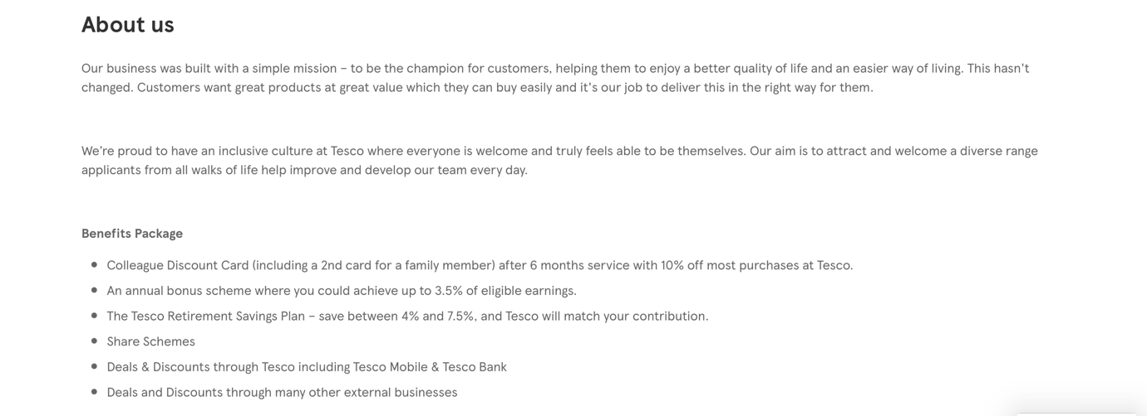

Job Application



