Victoria Weeks
2116992
Material Science and Building Services Lighting Layout and Sound Index Calculation

Task A
Calculate-
1) The Room Index
2) The Utilisation Factor (from tables
3) The Number of lamps required
4) A suitable layout (value of S) for the lamp fittings

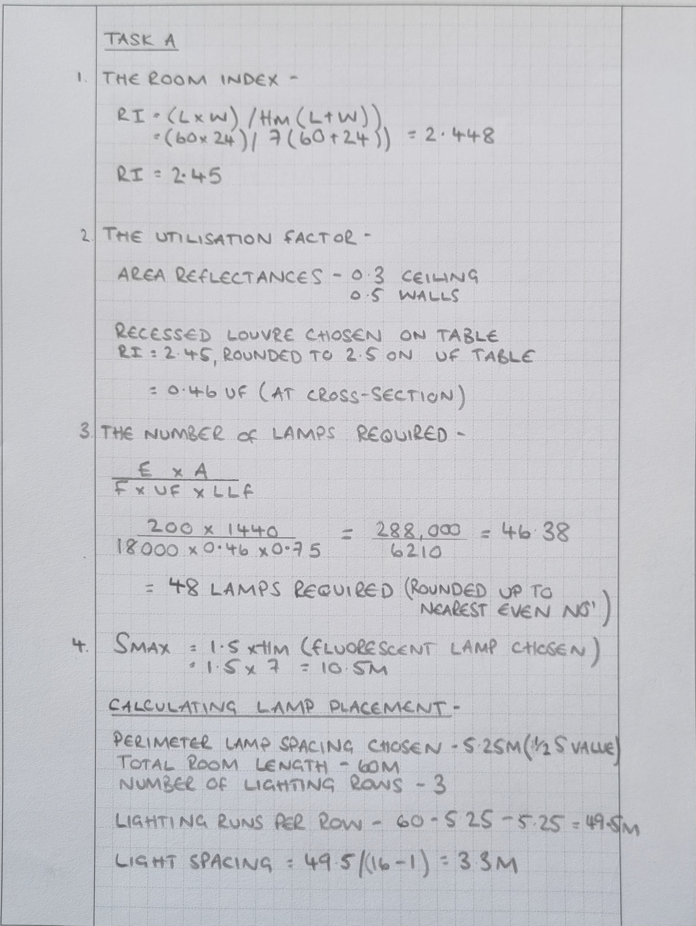
Image 1- Calculation for Room Index, Utilisation Factor, S Value and Number of Lamps Required

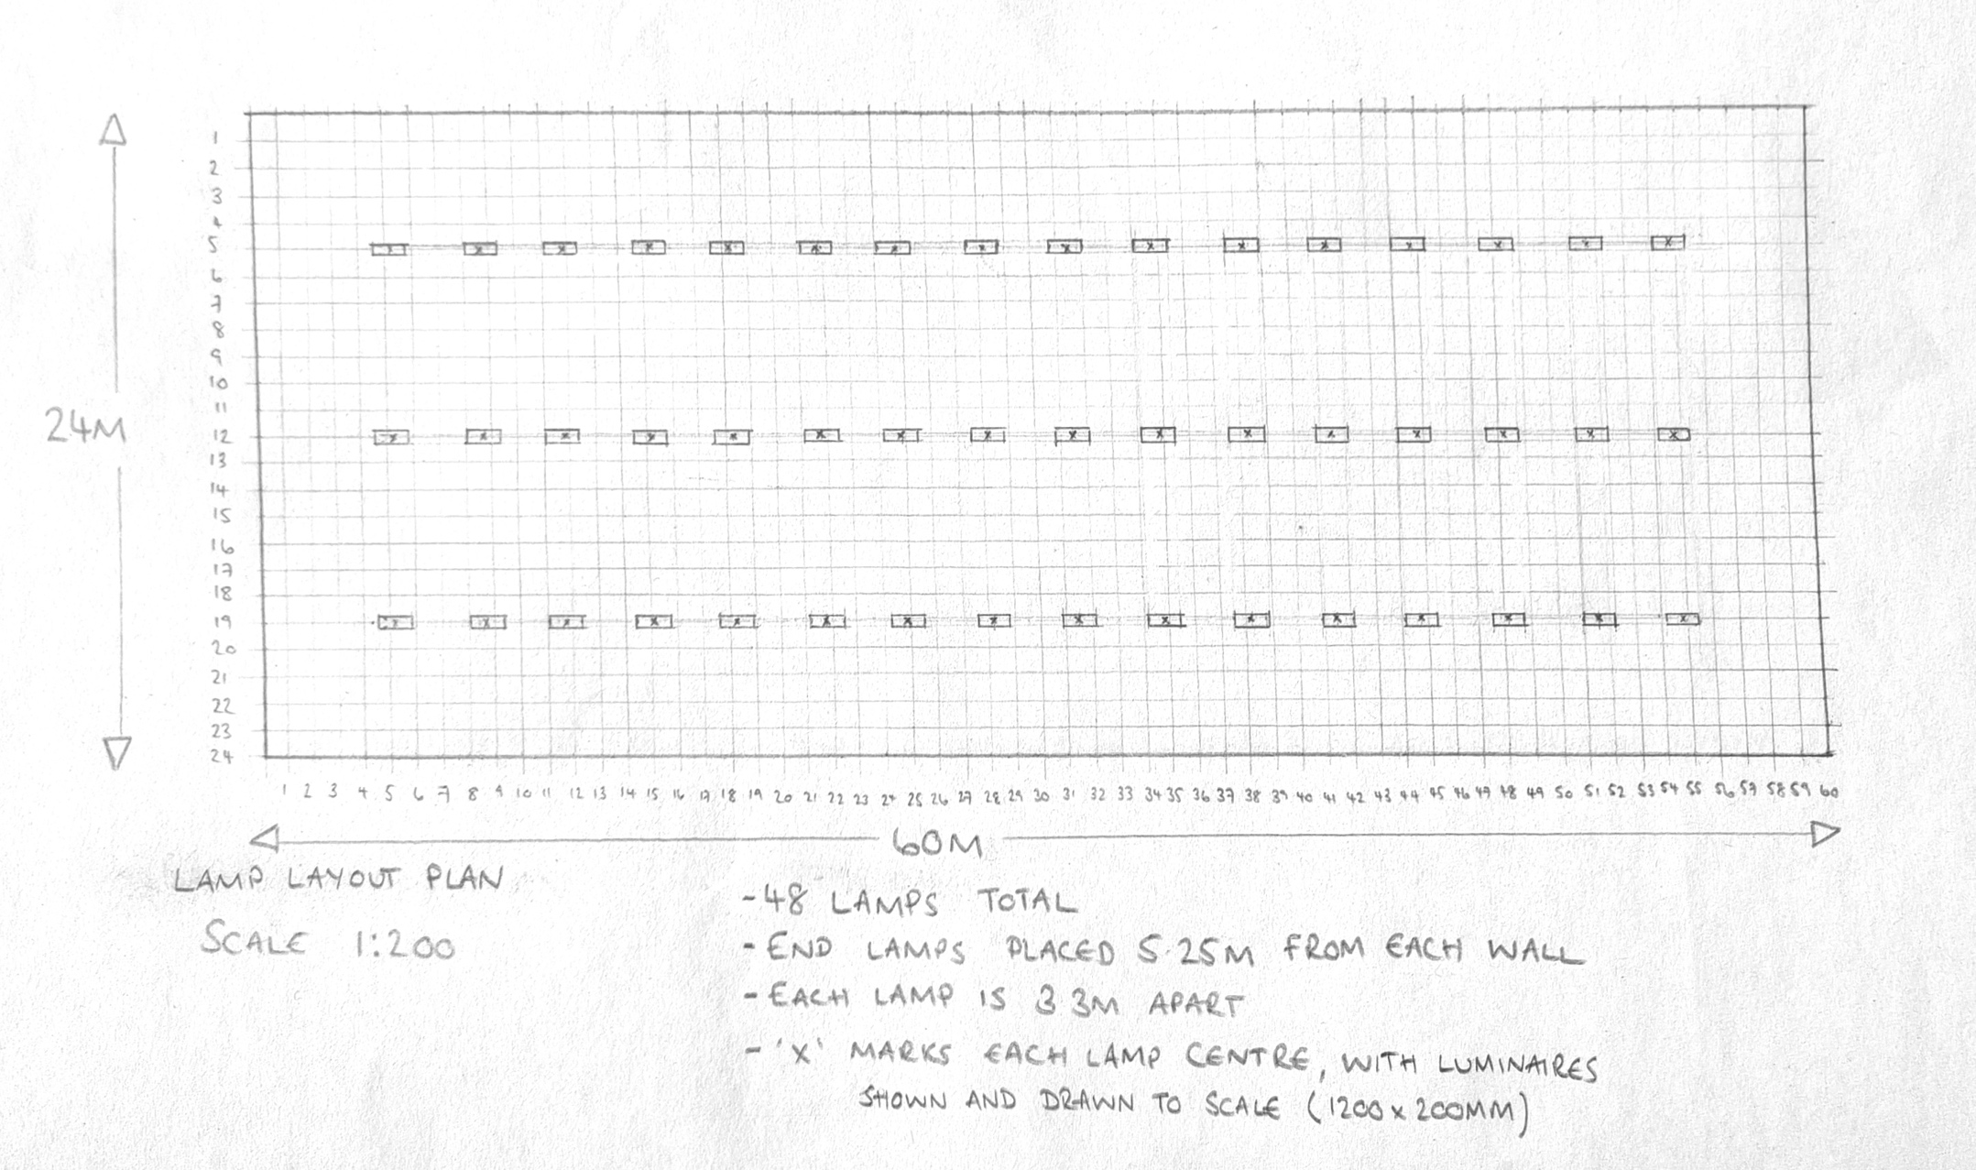
Image 2- Lamp Layout

TASK B
Calculate the overall sound reduction index for the entire wall.

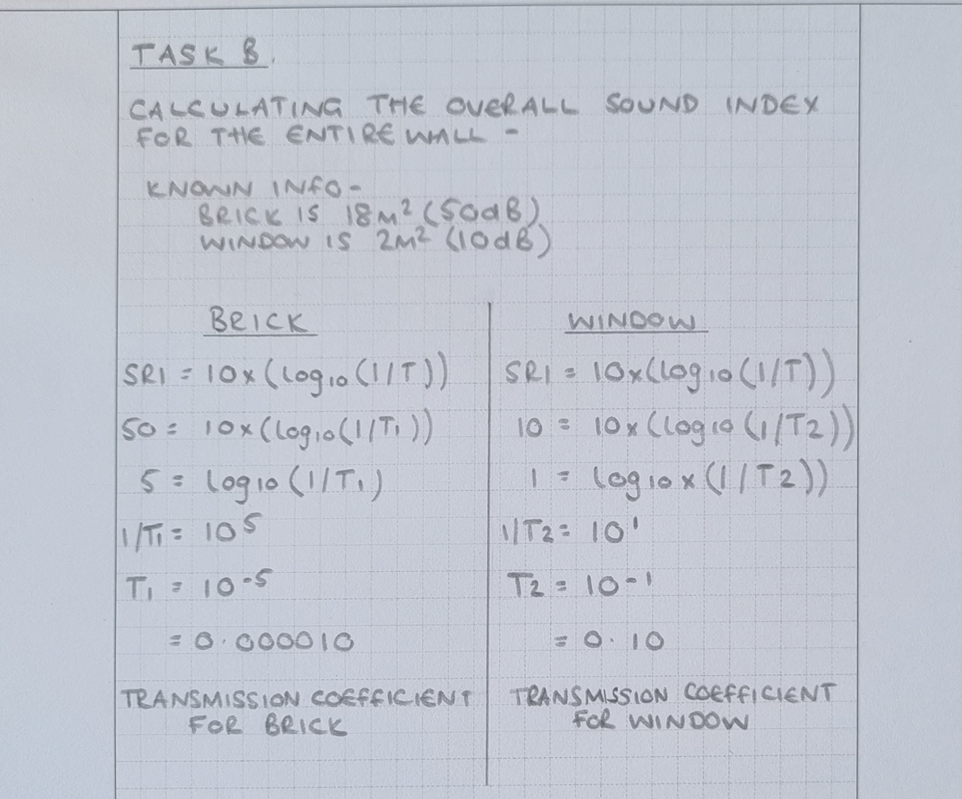
Image 3- Calculation for the overall sound reduction index
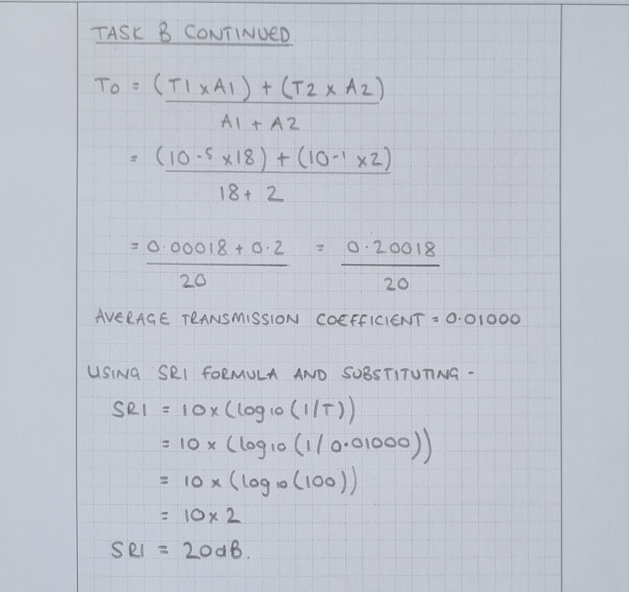
Image 4- Task B continued

Discuss the implications of the factors of frequency and wavelength in:
1). Building fabric resonance

Sounds are typically defined as vibrations of air particles, which are audible to the human ear. Most sounds are produced by vibrating objects, which cause the surrounding particles of air to move in unison. Sound can be further broken down into-

- Amplitude- the maximum excursion of a particle of the medium from the particle’s undisturbed position
- Wavelength-the horizontal line of one cycle of the wave
- Period- the time taken for one cycle
- Frequency- the number of vibrations per second

Sounds are identified as either airborne or impact sounds. An impact sound is created when the building fabric is vibrated by direct contact, e.g., being struck by a hammer, compared to an airborne sound, which only affects the building fabric, when the sound wave reaches the structure. The vibrations caused by the airborne sound will then be transmitted through the building fabric, to the internal rooms, thus causing potential issues and annoyances for its users.

The building fabric is usually insulated, to assist with thermal control, as well as sound control to within acceptable levels. This is measured in units of decibels (dB). The Building Regulations, Approved Document E, provides the minimum requirements for sound insulation for buildings of different uses.

Each object vibrates at its own frequency, when disturbed. The shape, density and stiffness of the object will dictate its frequency. When the frequency of the object is disturbed by vibration, resonance takes place, which in turn, can reduce the sound insulating qualities of the object. In Environmental Science in Building 7th ed., resonant frequencies are described as being low “and most likely to cause trouble in the air spaces of cavity construction” (McMullan, 2012, p. 210).

2). Partition wall construction technique

As previously discussed, there are minimum requirements and standards that sound insulation needs to meet (The Building Regulations, Approved Document E: Resistance to the Passage of Sound).

The image below, shows construction details of several partition wall options. A brief comparison of the construction techniques below, shows that timber and blockwork partitions rely on thickness and density of standard construction materials, to provide the sound insulation required, whereas metal frame partitions are relatively thin and slender in comparison and require additional sound proofing, in the form of mineral wool (or its equivalent), to obtain the minimum requirements to meet building regulations.

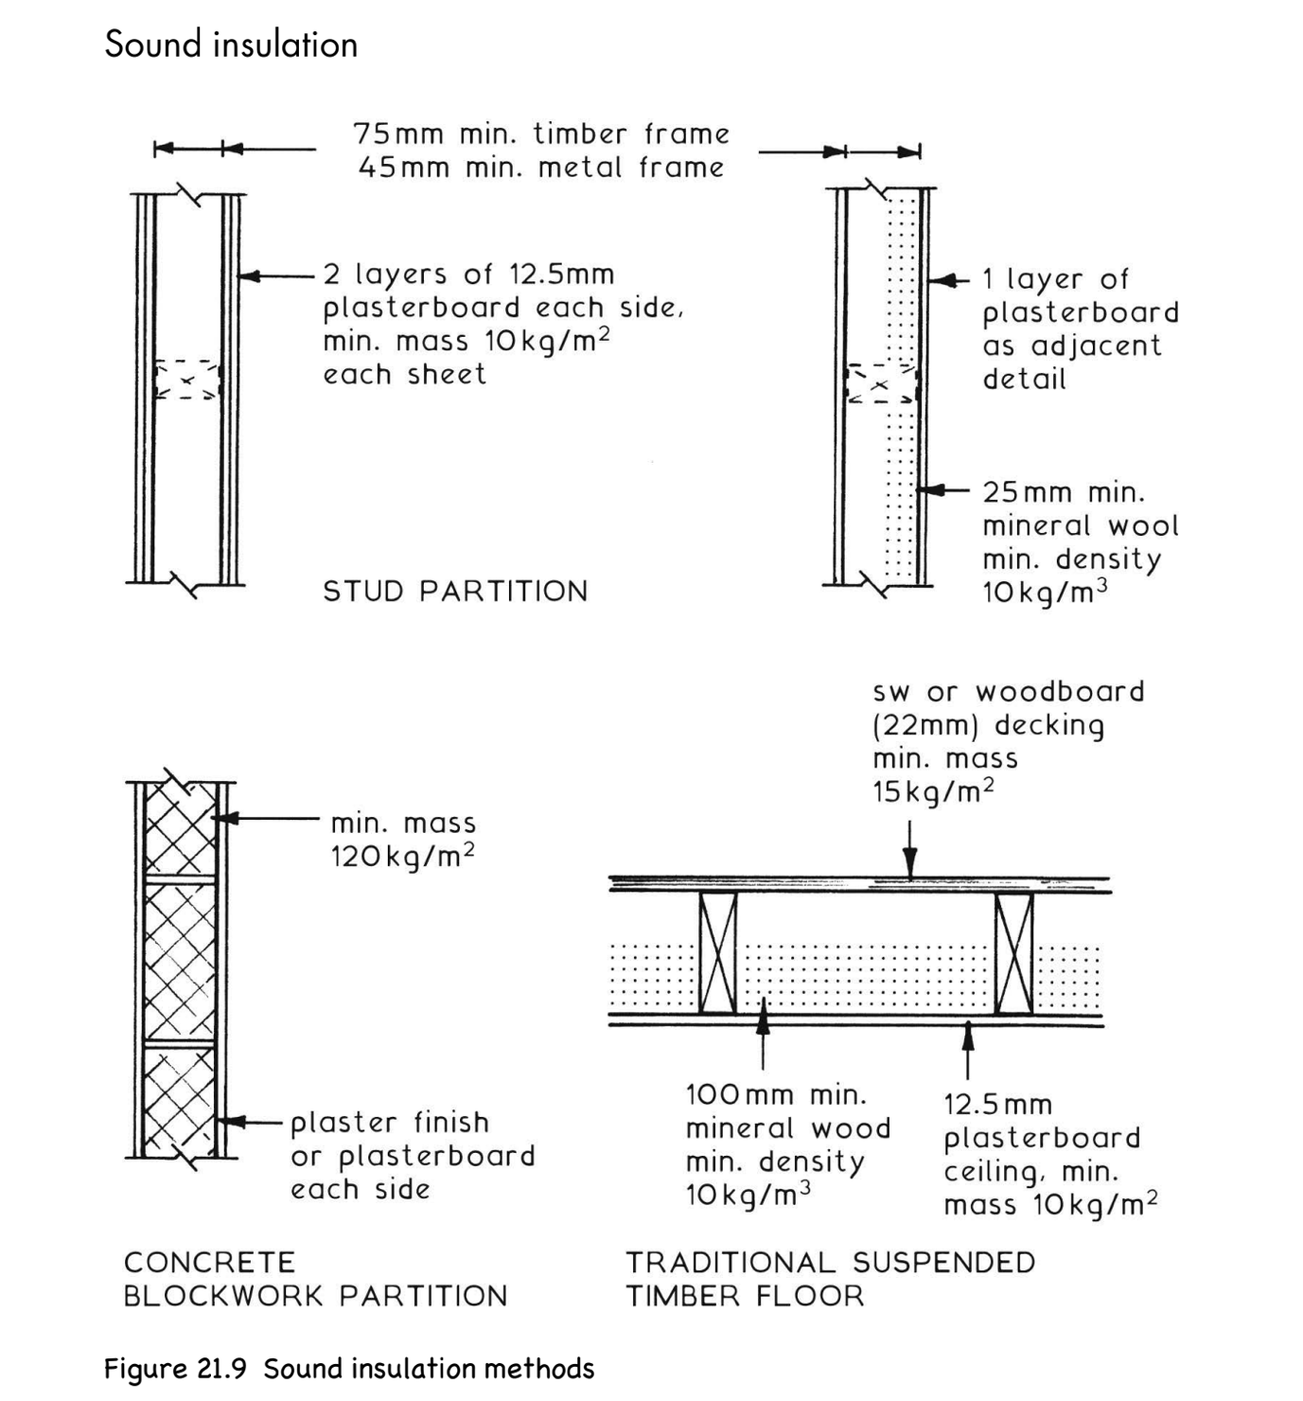
Image 1- Partition Wall Details (Chudley and Greeno, 2020, p. 702)

As Environmental Science in Building explains, materials with flexibility and high mass, provide the best sound insulation, however being flexible would result in poor structural properties provided by the wall or floor.

To determine what type of partition wall is needed, the expected and required sound levels will need to be calculated. This will allow for the most appropriate level of sound proofing and materials to be selected.

The Sound Reduction Index (SRI) calculates the insulation against direct transmission of airborne sound. Varying frequencies pass through insulation differently, meaning that the SRI would be different for each band of frequency. Knowing what type of frequencies to expect, will help identify which type of insulation (and therefore which type of partition wall), would be best suited to provide adequate sound proofing.

3). The Insulation material choice.

When considering the insulation material required, the type of frequencies and vibrations, dependent on the use of the building and its surrounding environment, will need to be taken into consideration. Different materials will help transmit, reflect or absorb sound differently (within certain spaces), thus having an impact on each frequency. To help reduce unwanted sound, for varying frequencies, devices and barriers are used to help absorb and reflect the sounds.

Sound can be reflected, just like light, when the right type and sized objects are used. By using reflection correctly, the distribution of sound can be controlled and sound levels suitable for desired use can be provided for users. Varying types of reflectors are often used, dependent on the type of sound that is required. Rooms intended for specific uses/events are also structured in very specific shapes, to ensure satisfactory acoustics are produced. Inward curves tend to focus sound, whereas outwards curves can disperse sound. Reflectors and absorbers can be added to further enhance or change the acoustics of a room, to produce the desired acoustic outcome.

In addition to this, the type of materials chosen in any build will also impact the sound quality within. Heavyweight construction provides great sound insulation because it is harder to vibrate heavier walls. Airtight walls reduce sound loss, as sound travels easier through air gaps, between materials, however, nails and stud links can often jeopardise this insulation through resonance being created. There is tabled data available to help designers calculate absorption levels and noise reduction. The NRC (Noise Reduction Coefficient) for each material is included in this table, clearly explaining how sound reacts when it hits different materials, thus allowing for maximum comfort levels to be catered for, in relation to sound. The combination of different elements and materials need to be assessed separately, to calculate the total coefficient of a composite.

Reference List

Chudley, R. and Greeno, R. (2020) Chudley & Greeno’s Building Construction Handbook. Oxon: Routledge, p. 708, illus.

McMullan, R. (2012) Environmental Science in Building. 7th edn. Hampshire: Palgrave MacMillan

