APlus Chauffeur
Business Plan

By Razvan Bucalau
University Wales Trinity Saint David’s
BMSW4006 – Managing Enterprise in the 21st Century

- Why private chauffeur?

People now are relying more and more on taxi services.
The Covid-19 situation has made people much more reluctantly to choose public transport, so the private transport is more popular. It offers the peace of mind when it comes to safety, as there are no other passengers to encounter. It's also more convenient because they are picked up from their desired location, and dropped off where they want, compared to public transport where you must travel to stations.

- AIMS AND OBJECTIVES

- To provide a premium transportation service that is accessible to all, easy to book, and safe.
- To make regular trips and maintain a basic client list of repeat customers.
- To offer an easy way of booking with the help of a phone app.
- To increase social media activity and reach out to a larger number of individuals online.
- To make the transition from a sole trader to a limited company.
- To increase the number of drivers and cars.
- To make an overall financial profit of 25% each year.

The main objective is to provide a premium transportation service that is accessible to all, that is easy to book, and safe.
I aim to make regular trips and maintain a basic client list of repeat customers.
One of the first thing to do would be to develop a phone app which will provide a simple way to book.
Another objective to reach would be to focus more on the marketing and to increase social media activity and reach out to a larger number of individuals online.
I aim to make the transition from a sole trader to a limited company, to increase the number of drivers and cars and to make an overall financial profit of 25% each year.

- Services offered

- Business transport
- Chauffeur services
- Airport transfers
- Door to door transfer
- Easy and affordable
- Availability at any time day or night
- Trained and experienced drivers
- New and improved vehicles

The main services offered would be: business transport, which will be a service specifically done for businesses that require professional cars and transport for business meetings, chauffeur services which is booking a professional chauffeur either for events or for traveling for a set period, airport transfer is transfer to or from the airport with pick up from arrival gate, door to door transfer means being picked up from your desired location and dropped off where you want, thus saving time on traveling or commuting.
Studying the market is what helps me making it easy to use and affordable. By researching the market, I can help design an app easy to use by all user’s category and researching the competition can help to make a lower price or offer some extras that will make the customers choose me over the competition.
I will offer availability at any time day or night for pre-booked services, trained and experience drivers and new and improved vehicles.

- Marketing strategy

- Focusing on digital marketing
- Surveys
- Improving the presence on social media
- Creating and optimising the user app
- Creating and optimising the website
- Paid advertising
- Reward returning customers

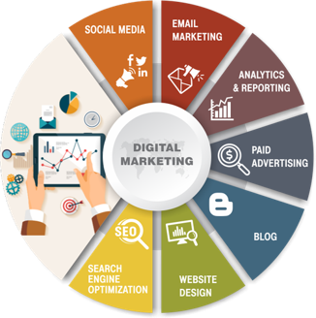
The dictionary definition for marketing is: ''the provision of goods or services to meet consumer’s needs.'' To put it another way, marketing entails determining what people want and then meeting those needs while generating a profit. Successful marketing involves having the right product in the right place at the right time, as well as ensuring that the customer is aware of it. (WESTWOOD, 2013)
Marketing has a long history of placing the customer at the centre of all marketing actions. (Schnaars, 1998) This is something that I will be following as well.
Considering that this is a private hire business, compared to a taxi service, one is not allowed to pick passengers on the curb, but is a requirement that you need to have a reservation made beforehand on a website or an app and payment being purely online. That means that for a business like this to strive, the focus should be on digital marketing.
People change because of technology. Consumers' relationships with products and marketplaces are altering as a result of digital technology. Our computers aren't the only ones being reprogrammed; our consumers are as well. The internet shopper demonstrates the necessity for new marketing strategies to fulfil their needs. These internet users want to be able to customise everything - from the look to the feel of products and services they purchase, the information they seek, and the price at which they are willing to pay for it. (Wind and Mahajan, 2002)
The first marketing tactic would be to conduct a questionnaire survey. This help in getting to know my clients, determining whether the service I'm attempting to provide is truly needed, where it is most needed, and what extras, such as free water, Wi-Fi, or playing their own music in the car, would be most appealing to potential consumers.
The next stage would be to increase my social media presence and get my services known to as many people as possible. I'd need to design and optimise a user app to help me with my day-to-day work. By making the app user-friendly, easy to use, and accessible, I can tip the balance in customers' favouring me over the competitors.
Then I'll use the advantages of paid advertising to attract new customers, and I'll set up a reward programme for return customers.

- Physical resources

Physical resources are assets that are used in a company's day-to-day operations. Physical resources required for this private hire business include a car, a smartphone, and, as a professional setting business that provides a business and luxurious service, a few black suits.

- Expenses and Financial resources

The word "financial resources" refers to the organization's total financial assets. Financial resources are an element of the organization's assets from an economic standpoint (property).
The initial costs are primarily for physical resources, as seen in this slide. The car will be the most expensive item. Because it is one of the assets that will be utilised the most in day-to-day operations, it is also one of the assets that must consider a variety of factors such as safety, comfort, and fuel consumption. This is going to cost around 32.000 £. The next item on the budget is a smart phone and a few black suits, which will cost roughly £1.500. Another initial outlay would be on the legal side, such as the car and driver's licence required for this type of business. After conducting extensive research on the Transport for London website, it is estimated that this will cost around 1.000£, including all essential papers and tests, such as a MOT or a language requirement exam.
The secured funding for starting this business is 37.000 £, which is made up of 7.000 £ from personal savings and 30.000 £ from a business loan. I picked a bank loan because it offers several advantages, including the ability to expand my business while maintaining complete control, bank security, business-friendly interest rates, and the possibility of additional services, such as covering my business's online payments. (Philps, 2020)

- Human resources

On the legal side, I'll need to register as a self-employed with HMRC, obtain a car and driver's licence from Transport for London, and purchase hire and reward comprehensive insurance.
I'll need to keep track of all incoming and outgoing funds, and I'll need the assistance of an accountant to ensure that everything is properly recorded for annual tax assessments.

- SWOT analysis

To help me determine my company's strengths and weaknesses, I utilised a SWOT analysis. As you can see on my slide, my strengths and opportunities outnumber my threats and weaknesses, providing me with a sound approach for prioritising the work I need to undertake to grow my company.
I am convinced that with the appropriate mindset and planning, I can build and expand a lucrative business while providing excellent service.
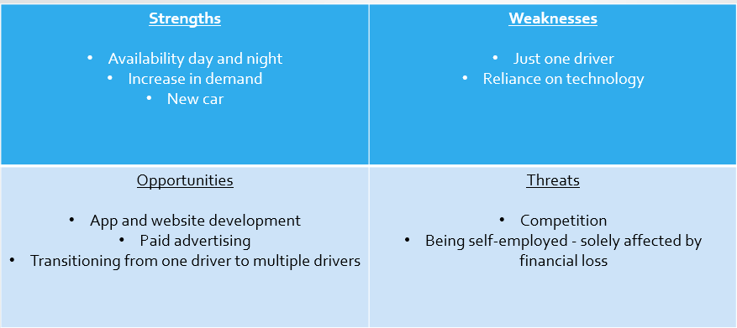

- Cash flow

Cash flow from Operating Activities in 12 months | Amount in £
Money earned from customers | 50000£
Petrol expenses | - 22000£
Insurance | - 2000£
Parking expenses | - 2000£
Accountant | - 200£
Water and other expenses for customers | - 300£
Profit generated | 23500£

References:

- Aaker, D.A., 2012. Building strong brands. Simon and Schuster.
- Chaffey, D. and Ellis-Chadwick, F., 2019. Digital marketing. Pearson uk.
- Charlesworth, A., 2014. Digital marketing: A practical approach. Routledge.
- Fifield, P., 1998. Marketing Strategy. 2nd ed. London: The Chartered Institute of Marketing.
- Financial resources, Finance. In: ManagementMania.com [online]. Wilmington (DE) 2011-2021, 12/14/2016 [cit. 11/14/2021]. Available at: https://managementmania.com/en/financial-resources-finance
- Leigh, D. (2009). SWOT Analysis. In Handbook of Improving Performance in the Workplace: Volumes 1-3 (eds K.H. Silber, W.R. Foshay, R. Watkins, D. Leigh, J.L. Moseley and J.C. Dessinger). https://doi.org/10.1002/9780470592663.ch24
- Matters, T., 2021. Apply for a private hire driver licence. [online] Transport for London. Available at: <https://tfl.gov.uk/info-for/taxis-and-private-hire/licensing/private-hire-driver-licence> [Accessed 11 November 2021].
- Matters, T., 2021. Apply for a private hire vehicle licence. [online] Transport for London. Available at: <https://tfl.gov.uk/info-for/taxis-and-private-hire/licensing/private-hire-vehicle-licence> [Accessed 10 November 2021].
- Philps, R., 2020. Bank Loan Advantages and Disadvantages for Small Businesses. [online] Nerdwallet.com. Available at: <https://www.nerdwallet.com/uk/business-loans/pro-and-cons-of-bank-loans-for-small-businesses/> [Accessed 13 November 2021].
- Schnaars, S., 1998. Marketing Strategy. 2nd ed. New York: The Free Press, p.2.
- WESTWOOD, J., 2013. HOW TO WRITE A MARKETING PLAN. 4th ed. KOGAN PAGE.
- Wind, J. and Mahajan, V., 2002. Digital Marketing Symphonya. Emerging Issues in Management, 1(1), pp.43-54.

