Managing Projects in the Organisation

Student Name: Shiuli Akter
Student ID: 1706999
Module Code: BMSK5004
Tutor Name: Dr Rexon Nting

Contents
Introduction: 4
Task 01: Critical Assessment of the Usefulness of Project Management Tools and Techniques 5
1. Waterfall Technique: 5
2. Prince2 Approach: 6
3. Agile Approach: 6
4. Rational Unified Process (RUP): 7
Task 02 Project Management: Opening A School 8
2.1 Project Initiation: First stage 8
2.1.1 Project Introduction/ Problem Statement of the Project: 8
2.1.2 Project Title: 8
2.1.3 Project Aims and Objectives: 8
2.1.4 Project Scope Statement: 9
2.1.5 Project Methodology: 10
2.1.6 Stakeholder Analysis: 10
2.1.7 Project Budget: 12
2.1.8 Timescale: 12
2.1.9 Characteristics of Project Managers: 13
2.2 Project Planning: Second Stage 14
2.2.1 Project Organisation/ Organisational Structure to Support the Project: 14
2.2.2 Work Breakdown Structure: 15
2.2.3 Communication Plan: 16
2.2.4 Project Schedule: 18
2.2.6 Gantt chart 20
2.2.7 Network Diagram: 23
2.2.5 Project Budget: 24
2.2.8 Risk Management Plan: 25
2.3 Project Implementation: Third Stage 27
2.3.1 Appreciation of Soft Skills of the Project Manager: 27
2.4 Project Controlling: Fourth Stage 28
2.5 Project Termination: Fifth Stage 28
2.6 Benefits of Project Management: 28
Task 03 Critical Evaluation of My performance and Self-development Plan for Further Improvement: 29
3.1 Critical Evaluation of My Performance: 29
3.2 Self-development Plan: 29
Conclusion: 30
References: 31

Introduction:
The undertaking intends to provide information about the project management for opening a new school in Swansea, Wales. The report can be divided into three portions, that is, the critical assessment of the project management tools and techniques, project management, and critical evaluation of my own performance and self-development plan. The critical assessment depicted the strengths and weaknesses of the project tools and appropriateness of project tools for different types of project. The project management for “Swansea High” has been sub-divided into five stages of the project life cycle, that is, project initiation, planning, implementation, project control, and termination. The project management also focused on some other discussions like the benefits of project management, characteristics of project management, appreciation of soft-skills, etc. lastly, the self-assessment has articulated the strengths and weaknesses identified during managing the project and communicate a plan as to how I aspire to overcome the weaknesses.

Task 01: Critical Assessment of the Usefulness of Project Management Tools and Techniques
Project management alludes to the application of methods, processes, knowledge, skills, experience, and efforts to attain some specific and predetermined project deliveries. The projects differ from one another based on project size, complexity, scope, risks involved, goals and objectives, impact on the environment, and other characteristics of a project. These differing characteristics of projects worked as reinforcers behind the emergence of different tools and techniques that are used to manage projects. The project management tools and techniques range from traditional to innovative ones, which exhibits different features are appropriate for different kinds of project.

1. Waterfall Technique:
Though being a traditional technique like the classic approach, a waterfall technique is considered superior to it and has taken the classic approach to a new level. The technique requires the planned tasks to be executed sequentially, that is, the next stage or task starts only when the preceding task has been successfully carried out (Rozenes, 2016). This project management technique works well for a complex project where successful project delivery hinges on rigid work structuring and comprehensive phrasing is required.
The project management tool ensures the compliance of timescales as the deadline for each task is predetermined so that procrastination cannot exist, staves off the financial surprises as it enables the project team to estimate the project budget with a reasonable level of certainty, facilitates the project monitoring and controlling as the success criteria are clearly communicated. However, the biggest drawback of the method is the lack of flexibility and the lag that prevails if any of the tasks is disrupted as the execution of the next tasks depend on it.

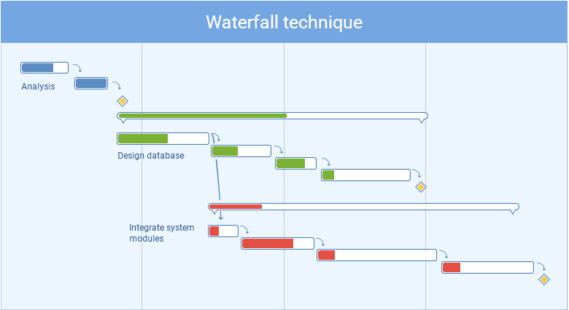
Figure 1: Waterfall Project Management Approach, Source: (David, 2019)

2. Prince2 Approach:
The Prince2 method is appropriate for projects that are to be managed in a controlled environment, which means each project initiates with a comprehensive project plan, every stage of the project is palpably structured, and any loose ends are tied up after the project is finished. Every stage of this project maintains separate planning and execution tools, which enhances the accountability among the members (Rose, 2017). The method also fosters continuous controlling, which the waterfall approach failed to address. However, this method is also very rigid and it appears to be cumbersome for the team members to adapt quickly to any change.

3. Agile Approach:
This method refers to a value-centered approach comprising a set of principles, which dictates splitting of project activities into short sprints capitalising on flexible planning and continual improvement and fosters collaboration and self-organisation of the team to produce maximum value. The technique is frequently used in a software development project that requires iterations and quick change in response to the dynamic trends.
The agile approach has overcome the major drawback, that is, lack of adaptability, of the waterfall approach, however, the method is also susceptible to criticism. The technique lacks clarity of project activities, requires advanced skill, suffers from insufficient training.

4. Rational Unified Process (RUP):
The RUP technique is intuitively important for projects that should be flexible enough to incorporate the feedback of customers/ end users into project management activities. When the satisfaction of the specific end users is key to the success of a project, this methods works well. The major strengths of this method are its feature that enables the customers to engage in the project that is likely to culminate in customer satisfaction. The disadvantages of this approach relate to the lack of knowledge of customers regarding the project process, unending demand of customers, and conflicts among the customers and project team, which can question the existence of the project.

Task 02 Project Management: Opening A School
Project Lifecycle and Type of Project:
The project management goes through five distinct but interconnected stages of its lifecycle, that is, project initiating, planning, implementing, controlling, and closing stage performed by the project manager and project team members to meet some success criteria within a specific period with a limited resource allocation for each task (Clements, and Gido, 2017). The project is a mix of construction project and management project.

2.1 Project Initiation: First stage

2.1.1 Project Introduction/ Problem Statement of the Project:
The authority of Hampton High has decided to open a new school in Wales aimed at providing education at key stage 3 & 4. However, as Hampton High is a very reputed school in Hampton, Middlesex, the authority is very concerned about the quality of education and educational facilities to be provided in the new school. The project of the school involves developing the infrastructure of the school, hiring and training the faculty members, administrative staffs, and other supporting staffs. The project sponsors expect the project objectives should be achieved within approximately one and a half year to start the official curriculum from September 2020.

2.1.2 Project Title:
“Developing a new school named Swansea High in Wales for providing KS3 and KS4 education”

2.1.3 Project Aims and Objectives:
Project Aim: “Opening a school in Wales ensuring high-qualified faculty members and sophisticated educational facilities”.
Project Objectives: The aim of the project describes a general direction of the project, which is vague by nature and hence project objectives, often known as SMART goals supply the specific direction to the project team.
- Handling Construction of the building and other physical infrastructure of the premise of the school
- Designing the structure of the classroom, laboratory, computer lab, etc.
- Hiring the administrative staffs and supporting staffs to aid in the project process
- Procuring the equipment, computer, stationery items to support the modern education system
- Developing qualified and committed faculty members
- Helping to formulate the administrative processes like registration, complaint management, hiring process, etc.
- Conducting marketing activities to attract students to enroll in the school

2.1.4 Project Scope Statement:
The scope of the project determines the boundary of the project, establishes success criteria, and delineates the key assumptions and constraints (Collins, 2018). The project will be covering the construction of the school, procurement of equipment required for developing the information system of the school, development of the computer labs, science laboratory, and other educational facilities, hiring of the human resources, conducting of the marketing activities, and design of the administrative processes.
Key Success Factors:
- The completion of the construction process within the stipulated time (discussed in detail in the project schedule)
- The efficiency and innovation in administrative processes fostering convenience for the parents of the students
- The qualification, experience, and morale of the hired faculty members
- Number of students enrolled compared to the capacity of the school (measuring the efficiency of promotional activities)
- The educational facilities developed in the school compared to other private schools
Assumptions:
- The project client will finance the project wholly and the project activities will not be hampered due to fund shortage
- External environmental factors like political, economic factors will be less likely to affect the project
- The project team is committed to carrying out their responsibilities and will get adequate administrative support
- The project sponsor or other influential stakeholders of the project will not disrupt the project process.

2.1.5 Project Methodology:
The different project management tools and techniques described earlier exhibited different distinct characteristics, which suits the project with specific features. Considering the needs and requirement of this project, the project manager has decided to use the waterfall project management approach to manage the project as the project requires a robust process, which will be executed in a sequential manner.

2.1.6 Stakeholder Analysis:
The stakeholder analysis is considered as a process for identifying all the stakeholders, documenting their needs, assessing the interest and influence of the project stakeholder, managing the stakeholder expectations (Missonier, and Loufrani-Fedida, 2014). The project decisions are likely to affect the interest of the project stakeholder and the stakeholder analysis offers an opportunity to evaluate the impact of the decisions on the stakeholder.
Stakeholders of the Project | Respected Parties | Influence on Project decisions | Interest | Communication methods
Project Client | Hampton High | Moderate | As a project Client, the school will also finance the project and is interested in the opening of the school by September 2020. | Control charts, weekly, monthly, and quarterly status reports, audit reports, safety reports, meetings with the project sponsor
Project Sponsors | Higher Management Team | Significant | The project sponsor will be likely to ensure the utilisation of the resources injected in the project. | Project status reports, project budget, project schedule, audit reports etc.
Project Champion | Principle of Hampton High | Moderate | The project champion will try to address the different obstacles of the project and communicate it with the project manager to smoothen the success of the project | Project status report, project management oversight report, legal documents, HAZOP, etc.
Project Manager | Myself | Critical | The manager will endeavour to assure that the project team are performing their activities as desired and are following the planned project tasks accordingly. | Direct observation, status reports, email, fax, legal documents, control charts, performance report, conflict report etc.
Project Team Members | Selected Members from the School | Critical | Their interest relates to the individual performance within the stipulated time and allocated budget. | Email, fax, telephone, legal document, performance appraisal report, physical communication etc.
Purchaser of the Service | Parents of the Students | Low | Sophisticated and superior educational facilities and qualified teachers | Advertising and promotional activities, email, the official website of the school, telephone, etc.
Table 1: Project Stakeholder Analysis, Source: Author

2.1.7 Project Budget:
The project budget is an estimation of the total costs that are to be incurred throughout the project processes or lifecycles. The detailed project budget aimed at allocating a specific portion of the total among individual project tasks to promote accountability and utilisation of the limited resources (Woodhall, and Stuttard, 2014). Both overestimation and underestimation can be proved hazardous for the project as fund shortage problems are likely to disrupt the project activities and can delay the project. If such problems are not properly addressed and solved such delay can defer the inception of the academic curriculum for one more academic calendar year. The budget for this project is initially estimated to be at £1051820 and the detailed budget is enclosed in the following stage.

2.1.8 Timescale:
The project schedule intends to communicate the deadline for each task so that the project can be finished within the expected period and the school can start its curriculum accordingly. Too lenient or too strict deadlines are likely to adversely affect the morale of the team and hence timescale should be designed considering the optimal time required for a task. The total period of the project is gauged to be two year and two months or 782 days.

2.1.9 Characteristics of Project Managers:
Project managers possess some distinct attributes, which distinguishes them from others and enable them to succeed in their objectives.
One of the major characteristics of project managers is their decision-making ability, that is, how quickly they can adapt to the changing situations and can make decisions accordingly.
The vision of the project manager leads the project team members in the right direction.
The stress management of the project managers helps them to remain calm during the times of chaos or any other unexpected events.
The negotiation skill is required to get the best deal for the project sponsor and project client.
The team-building skill of a project manager helps to develop the right team for the job.
Communication skills of the project managers allow them to communicate the tasks clearly, handle interpersonal conflict, and build trust.
The technical skill of a project manager is required to direct and evaluate the activities of the technical team (Garton, and McCulloch, 2016
The other skills that a project manager exhibits are empathy, leadership skills, flexibility, organisation, etc.

2.2 Project Planning: Second Stage
The success of the project heavily depends on the project as it shows the roadmap, which the team members will follow to reach the project destination and any confusion or ambiguousness can mislead the members to deviate from the actual path to success (Craddock et al. 2017). The project planning process provides the most comprehensive and detailed information about each task and person responsible for that task as it underpins the foundation, which will be used for monitoring, evaluating, and controlling the project performance.

2.2.1 Project Organisation/ Organisational Structure to Support the Project:
The project organisation intends to draw the line of authority, which will further help to carve the work breakdown structure and communication plan. The project organisation attempts to demonstrate the hierarchy, which will communicate the employees about the persons they should report regarding their tasks.

Figure 2: Organisation Structure of the Project, Source: Author

2.2.2 Work Breakdown Structure:
The purpose of the work breakdown is to split the project activities into manageable portions (Sharon, and Dori, 2017). Projects tasks can be specifically assigned to an individual project team member using the WBS easily.

Figure 3: Work Breakdown Structure, Source: Author

2.2.3 Communication Plan:
Communication Methods:
The project management team can use several communication methods to share information and communicate with the stakeholders. However, every communication method has its own advantages and drawbacks and hence the project management team here decided to use the combination of the three communication methods to communicate with different stakeholder to skim off the benefits of each communication method and in this process some of the drawbacks will be offset by the benefits of other methods.
1. Interactive Communication:
As the name implies, this method is used when the stakeholders engage in live communication with each other, for example, video conferencing, phone calls, live chat, etc. can be used as an interactive communication tool. The project team will use this method to communicate with each other and with the project manager and project sponsor.
2. Push Communication:
When the feedback is not necessary or relevant, push communication can be used. This method refers to the instructions that the project manager provides to the project team. Project managers also can send emails, memos, status reports, faxes, letters, etc. using the push notification mechanism to the project team (Yang, and Ho, 2013). However, one drawback of this communication type is that the project managers cannot ensure that the information conferred to the recipient is understood by him/ her or not.
3. Pull Communication:
The method requires the project manager to store the information into the server or IT system, which the team members and stakeholders can access at their convenient time. The project manager can communicate with the project team and the project sponsor using this method.

Communication Methods to be used with Different Stakeholders:
SL No. | Communicating Party | Stakeholder | Method
1 | Project Sponsor | Project Manager | Interactive
2 | Project Manager | Project Team | Interactive, Push, and Pull Communication
3 | Project Manager | Project Sponsor | Interactive, Pull Communication
 | Project Team | Project Manager | Interactive, Pull Communication
Table 2: Communication methods to be used in the project, Source: Author
Project Communication Map:

Figure 4: Project Communication Map, Source: Author
The project communication map shows who can communicate with whom. In this project, the project manager has the right to communicate with every stakeholder of the project. However, the department heads will be empowered to communicate with the project sponsor if they perceive that the project manager is not acting in the best interests of the project sponsor.

2.2.4 Project Schedule:
Serial No. | Task Name | Duration | Start | Finish | Predecessors | Resource Names
1 | Organise a meeting with the project stakeholder | 2 days | Mon 4/29/19 | Tue 4/30/19 |  | Project Sponsor
2 | Sign the project agreement | 1 day | Wed 5/1/19 | Wed 5/1/19 | 1 | Project Sponsor
3 | Decide the project goals | 2 days | Thu 5/2/19 | Fri 5/3/19 | 2 | Project Sponsor and Manager
4 | Recruit the project team | 7 days | Mon 5/6/19 | Tue 5/14/19 | 3 | Project Manager
5 | Train the project team | 21 days | Wed 5/15/19 | Wed 6/12/19 | 4 | Project Manager
6 | Assign the project tasks | 5 days | Thu 6/13/19 | Wed 6/19/19 | 5 | Project Manager
7 | Stipulate the deadlines | 3 days | Thu 6/20/19 | Mon 6/24/19 | 6 | Project Team
8 | Allot the fund to each activity | 1 day | Thu 6/20/19 | Thu 6/20/19 | 6 | Project Team
9 | Establish the communication plan | 2 days | Thu 6/20/19 | Fri 6/21/19 | 6 | Project Team
10 | Assess and plan for risk mitigation | 7 days | Thu 6/20/19 | Fri 6/28/19 | 6 | Project Team
11 | Develop a resource management plan | 3 days | Mon 5/6/19 | Wed 5/8/19 | 3 | Project Team
12 | Request bids from building contractors | 10 days | Thu 5/9/19 | Wed 5/22/19 | 11 | Project Team
13 | Select the contractor on the most advantageous terms | 7 days | Thu 5/23/19 | Fri 5/31/19 | 12 | Project Manager
14 | Start the construction of the building | 365 days | Mon 6/3/19 | Fri 10/23/20 | 13 | Contractor
15 | Design the classroom, faculty lounge, conference room, labs etc. | 15 days | Mon 10/26/20 | Fri 11/13/20 | 14,10 | Project Team
16 | Procure the necessary equipment to build sophisticated educational facilities | 30 days | Mon 10/26/20 | Fri 12/4/20 | 14 | Project Team
17 | Install the equipment to develop the infrastructure | 20 days | Mon 12/7/20 | Fri 1/1/21 | 16 | Project Team
18 | Test run the equipment | 3 days | Mon 1/4/21 | Wed 1/6/21 | 17 | Project Team
19 | Employ the administrative staffs | 30 days | Mon 10/26/20 | Fri 12/4/20 | 14 | Project Team
20 | Hire the faculty members | 45 days | Mon 11/16/20 | Fri 1/15/21 | 15 | Project Team
21 | Conduct promotional activities | 90 days | Thu 1/7/21 | Wed 5/12/21 | 18 | Project Team
22 | Develop the administrative processes | 25 days | Mon 1/18/21 | Fri 2/19/21 | 14,20 | Project Manager
23 | Evaluating the actual performance on the basis of planned performance | 15 days | Thu 5/13/21 | Wed 6/2/21 | 21,22 | Project Manager
24 | Pinpoint performance deficiencies | 6 days | Thu 6/3/21 | Thu 6/10/21 | 23 | Project Manager
25 | Take corrective actions | 3 days | Fri 6/11/21 | Tue 6/15/21 | 24 | Project Manager
26 | Handing over the keys to the project sponsor | 1 day | Wed 6/16/21 | Wed 6/16/21 | 25 | Project Manager
27 | Closing the project | 1 day | Thu 6/17/21 | Thu 6/17/21 | 26 | Project Sponsor
Table 3: Project Schedule, Source: Author

2.2.6 Gantt chart
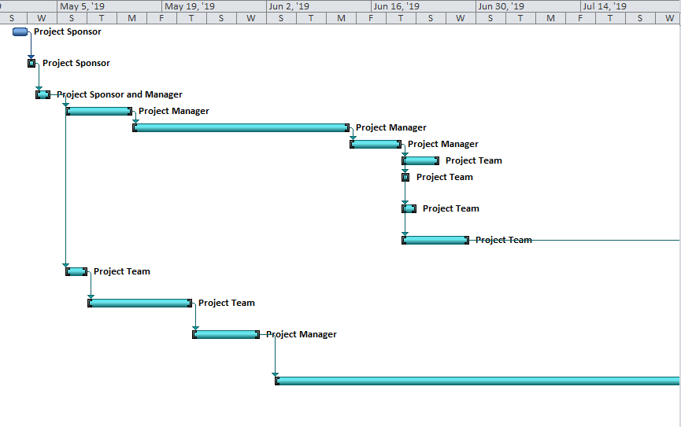
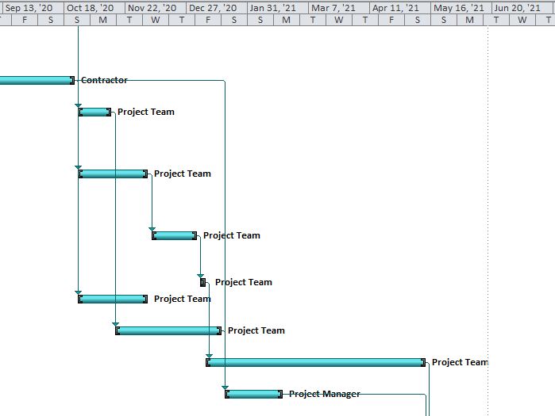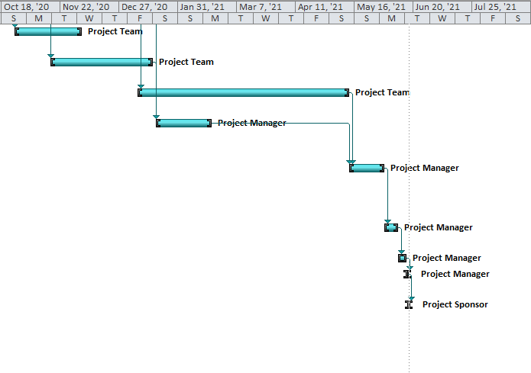
Figure 5: Project Gantt chart, Source: Author

2.2.7 Network Diagram:
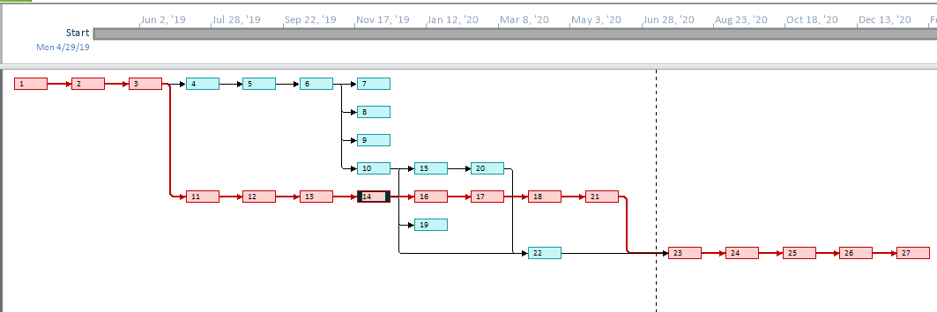
Figure 6: Network diagram of the Project.

2.2.5 Project Budget:
Table 4: Project Budget, Source: Author

2.2.8 Risk Management Plan:
Risk Management Techniques:
The project entails different types of risks that is, budget risk, governance risk, technological failure risk, transportation risk, environmental risks, etc. and these risks are capable enough to question the viability or implementation and success of the project if not addressed and managed properly (Krause, 2017). To manage these types of risks different methods have been evolved over time.
1. Risk avoidance: The project team can avoid the risks by simply not engaging in that particular task or abandon some project activity, which is likely to reduce the return from the project as well (Bissonette, and Bissonette, 2016). For example, the team can avoid installing sophisticated technology to avoid the technical risk, however, the payoff for this is not justified.
2. Risk mitigation: The team can minimise the adverse impacts stemming from some specific risks. For example, the project team can strictly adhere to regulation and local plans and investing more in safety measures to mitigate the risks.
3. Risk Transfer: The project management team can transfer the risk to a third party in exchange of premium, for example, the team can transfer transportation and environmental risks by taking an insurance policy.
4. Risk acceptance: The project management team can simply accept the risks up to a certain level so that the cost of risk mitigation or risk transfer does not outweigh the benefits from risk management.
Risk Management Plan: Risk Matrix
Score
Score | 1 | 2 | 3 | 4 | 5
Impact | Negligible | Minor | Moderate | Significant | Critical
Probability | Unlikely | Less Likely | Occasional | Probable | Most likely

Sl. No. |  | Risk | Probability | Impact | Risk Score | Risk Management Plan
1 |  | Construction Risk | 3 | 5 | 15 | Risk Mitigation
2 |  | Technological risk | 3 | 5 | 15 | Risk Mitigation
3 |  | Governance risk | 2 | 5 | 10 | Risk Acceptance
4 |  | Budget risk | 3 | 3 | 9 | Risk Acceptance
5 |  | Schedule risk | 3 | 3 | 9 | Risk Acceptance
6 |  | Environmental Risk | 4 | 2 | 8 | Risk Transfer
7 |  | Operational risk | 2 | 4 | 8 | Risk Acceptance
8 |  | Legal risk | 2 | 4 | 8 | Risk Mitigation
9 |  | Transportation risk | 2 | 4 | 8 | Risk Transfer
10 |  | Logistical Risk | 3 | 2 | 6 | Risk Acceptance
Figure 7: Risk Management Plan, Source: Author

2.3 Project Implementation: Third Stage
In this stage, the project team will execute all the activities planned in the project management stage. The team solicit bids from the different real estate companies or building contractor and after receiving offers, the team and manager will evaluate the offers and select the best one. The team will instruct the contractor to initiate the construction and, in the meantime, the team will design the structure of the classroom, conference, teacher lounge, science laboratory, computer labs, playground, etc. The technical and procurement team will collaborate to procure the information technology and equipment necessary to build the modern educational platform where students will get all the modern educational facilities. The HR team will hire the administrative staffs and faculty members and along with them will design the administrative processes. After that, the marketing team will be directed to conduct promotional activities to attract students/ parents to enroll in the school. Finally, the project will come to an end and the project manager will hand over the keys of the school to the project sponsor.

2.3.1 Appreciation of Soft Skills of the Project Manager:
The soft skills of the project manager like communication skills, leadership, and management skills are central to the success of the project. Because, the leadership skills enable the project manager to direct and govern the activities of the project team, without which the team will lack direction and project performance could have deviated. The communication skills help the manager to share the information in an efficient manner, to resolve interpersonal conflicts, and to build the trust so that the team members abide by the instruction of the manager (Richman, and Richman, 2018). The management skill of the manager brings efficiency in budget allocation, schedule management, risk management, etc. The team-building skills help the manager to choose the right person for the right job and develop the cross-functional team with a proper mix of different expertise.

2.4 Project Controlling: Fourth Stage
The success criteria of the project are tied with the quality of the project performance, that is, whether the construction of the project is going smoothly or there prevails any bottleneck or occurs any disruption, whether the administrative processes are comprehensive and efficient enough or there exists any loopholes, etc. (Flyvbjerg, 2013). The controlling process will be carried out continuously throughout the project and the final controlling measures will be executed upon completing the project. The project team will assess the performance and will identify the difference between expected and actual performance to take corrective actions to bring back the performance on track accordingly.

2.5 Project Termination: Fifth Stage
Finally, the project manager will complete the controlling activities and ensure that all the project deliveries, aims, and objectives have been achieved. The manager will hand over the school keys to the project sponsor and will declare the termination of the project in the project closing ceremony.

2.6 Benefits of Project Management:
Though the benefits of project management are many and can vary project to project, some of the benefits that are relevant to this project can be listed as below:
Increases the chances of achieving the project goals
Ensures the efficiency in resource management
Addresses and manages risk to stave off the disruptions or reduce the negative impacts of risks
Fosters consistent communication among the team members and the other project stakeholders
Helps to prepare for contingent situations
Enhances the quality management of the project deliveries
Promotes accountability and responsibility.

Task 03 Critical Evaluation of My performance and Self-development Plan for Further Improvement:

3.1 Critical Evaluation of My Performance:
The undertaking has developed me as a person, who is now more organised, visionary, and agile than I was before managing the report. The project management plan enriched my knowledge about the components of the project management plan and key considerations to turn the project into a successful one. I also learned about how to see the big picture to incorporate all the related factors in the decision-making process.
My key strengths throughout the project management turned out to be my development of communication plan, choice of project management tool, the establishment of project budget and schedule. However, I identified some of my weaknesses, which relate to risk assessment and management, designing project control, lack of negotiation skills, and handling the interpersonal conflicts among the team members. Another weakness of mine is the indecisiveness, which I think I should work on the most.

3.2 Self-development Plan:
Merely pinpointing weaknesses will not improve my abilities as a project manager and hence the self-development plan comes into play ameliorate my performance.
I have determined to observe how my superiors manage manage interpersonal conflicts among employees.
I will attend several negotiation meetings to learn how to turn the negotiation in favour of my client.
I will overcome my indecisive problem by taking the small decisions quickly such as choosing foods items at restaurants, holiday plans, transportation mode, shopping choices, etc.
I will consult an industry expert to seek advice about how to improve my skills in a better way.
These are the ways I intend to overcome the weaknesses that I noticed during the project management.

Conclusion:
The assessment of the project management tool divulged that the waterfall project management approach is the most appropriate for the project at hand. The project scope is limited to constructing of the building, design of the classroom, conference room and other similar rooms, hiring human resources for the school, conducting marketing activities, and formulating administrative processes. The project planning underpinned the foundation for project implementation, which has been described elaborately. The controlling measures are carved such that any performance deficiency can be tracked and necessary measures can be taken to eliminate the performance deviations. The self-assessment was aimed at recognising my own strengths and weaknesses to develop a self-development plan for improving my performance.

References:
Bissonette, M. and Bissonette, M. (2016). Project Risk Management. Newtown Square, PA: Project Management Institute.
Clements, J. and Gido, J. (2017). Effective project management. Mason, Ohio: South-Western Cengage Learning.
Collins, R. (2018). Project management. New York: Nova Science Publishers.
Craddock, A., Roberts, B., Stapleton, J. and Godwin, J. (2017). Agile Project Management. Ashford: Agile Business Consortium Limited.
David, R. (2019). Project Management Tools and Technique. [online] Available at: https://www.actitime.com/project-management/project-management-tools-and-techniques.
Flyvbjerg, B. (2013). Quality control and due diligence in project management: Getting decisions right by taking the outside view. International Journal of Project Management, 31(5), pp.760-774.
Garton, C. and McCulloch, E. (2016). Fundamentals of technology project management. Lewisville, Tex.: MC Press.
Krause, A. (2017). Risk management. Bradford, England: Emerald Group Pub.
Missonier, S. and Loufrani-Fedida, S. (2014). Stakeholder analysis and engagement in projects: From stakeholder relational perspective to stakeholder relational ontology. International Journal of Project Management, 32(7), pp.1108-1122.
Richman, L. and Richman, L. (2018). Successful project management. [Saranac Lake, N.Y.]: American Management Association.
Rose, K. (2017). Modern Project Management: Successfully Integrating Project Management Knowledge Areas and Processes. Project Management Journal, 33(1), pp.60-61.
Rozenes, S. (2016). The Impact of Project Management Methodologies on Project Performance. International Journal of Information Technology Project Management, 2(2), pp.64-73.
Sharon, A. and Dori, D. (2017). A Model-Based Approach for Planning Work Breakdown Structures of Complex Systems Projects. IFAC Proceedings Volumes, 45(6), pp.1083-1088.
Woodhall, G. and Stuttard, A. (2014). Financial management. Houndmills, Basingstoke, Hampshire: Macmillan.
Yang, P. and Ho, M. (2013). The Studying on Design Communication and Conveyance in Project Plan. Applied Mechanics and Materials, 311, pp.286-292.

