

Programme name: Master of Business Administration

Assessment component 1: Individual report

Module name:
International Marketing: Principles and Practices

Module code:
LCMB7026

Lecturer name:
Tushara Balendran

Student name:
Pew Peakhom

Student ID:
2433833

Submission date:
10-08-2026

Acknowledgment

USE OF GENERATIVE AI IN ASSESSMENT

RESEARCH | For this assessment, you can use Generative AI to support you in research and data analysis. | Yes ☒  No ☐
STRUCTURE | For this assessment, you can use Generative AI to support you in structuring your submission, including creating a draft argument structure, identifying parts  and headings, etc. | Yes ☐  No ☒
PROOFREADING | For this assessment, you can use Generative AI to check your own text/creation for grammatical and syntactical mistakes, including getting suggestions to  rephrase your work. | Yes ☒  No ☐
WRITING | For this assessment, you can use Generative AI to create text for submission. | Yes ☐  No ☒
CREATIVE | For this assessment, you can use Generative AI to create creative materials, such as images. | Yes ☒  No ☐
PROGRAMING | For this assessment, you can use Generative AI to create and check code. | Yes ☐  No ☒
NONE | For this assessment, you are not allowed to use any type of Generative AI support. This includes research support, structure support, writing/proofreading  support and creative support. | ☐

Table of Contents
Introduction 4
Background information about the company 4
Section 1 5
PESTEL 5
Political 5
Economic 6
Social 7
Hofstede framework 7
Technological 10
Legal 10
Environmental 10
STP (Segmentation, Targeting, and Positioning) 11
Segmentation 11
Targeting 12
Positioning 12
Similarities and Differences 12
Perceptual Map for India 13
International Marketing Mix (7Ps) 14
Product 14
Price 15
Place 15
Promotion 17
People 17
Process 18
Physical Evidence 18
Market Entry 20
Ethical Issues 21
Recommendations and Conclusion 22
Recommendation 1 22
Recommendation 2 23
Recommendation 3 23
Section 2 24
Description 24
Feelings 24
Evaluation 24
Analysis 25
Conclusion 26
Action Plan 26
Conclusion 26
References 28

Introduction
Marketing is a process which discovers the consumer’s needs and wants. It helps in creating goods and services products which meet those needs. It is followed by pricing, promotion and delivery of those goods and services. This report is aimed at critically comparing and contrasting the impact of the socio-cultural differences and similarities in countries while marketing. The report begins with the identification of Cadbury as it analyses it in the host countries (India and the US). It follows with PESTLE analysis, Hofstede framework, STP and marketing mix. This is followed by identifying the market entry strategy. It also identifies ethical and practical frameworks of marketing globally and practical recommendations. A reflective account of the report will be provided using the Gibbs Reflective Cycle.

Background information about the company
Cadbury is selected as it is one of the most recognised confectionery brands. It was originally founded in Birmingham, UK, in 1824 by John Cadbury (Mondelēz International, 2023). Mondelēz International's (2025b) growth can also be assessed through its increasing revenue of US$38.54 billion with a 5.8% year-on-year increase, showing continued strength of the portfolio.
One of the key drivers of growth was also its expansion in the United States and India. In 2025, Hershey generated USD11,692.6 million in revenue with 4.4% increase (Hershey, 2026a). In India, Mondelēz entered in 1948 and has majorly dealt in Dairy Milk, Gems, Silk, Bournvita and 5 star reporting ₹12,502.95 crore revenue in 2025 (ET BrandEquity, 2026). This shows a strong potential market despite a slight decline.
These two markets are chosen because the United States reflects a mature consumer market with snacking, whereas in India it is mostly limited to the chocolate confectionery sector, making it suitable to analyse multinational firms. It has partially followed the Uppsala model of internationalisation.

Section 1

PESTEL
PESTLE analysis is a model which studies the key external factors including Political, Economic, Social, Technological, Legal and Environment which influences organisation and helps in strategic decision-making (CIPD, 2025).
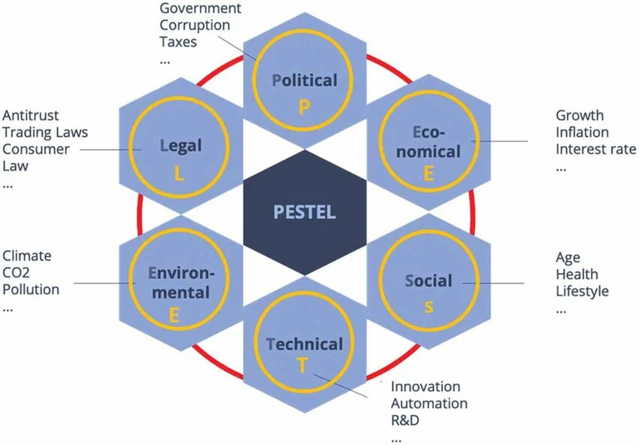
Figure 1: PESTLE analysis
Source: Khan et al., (2023)

Political
India is an attractive country because of government initiatives such as Make in India, providing production-linked incentives to encourage domestic manufacturing. As per PIB (2025a), India has attracted US$81.04 billion in Foreign Direct Investment (FDI) in FY 2024-2025, which shows foreign investor confidence.
Contrastingly, the US is facing volatile trade measures. As it introduced reciprocal trade tariffs, the chocolate is meant to be expensive (Teixeira, 2025). This increases input costs.
Hence, politically, India is more favourable than the US as key industrial policies support low import costs and manufacturing expansion.

Economic
India is one of fastest growing economies, with real GDP projected at 6.4% in 2025 with rising disposable income of Indians (PIB, 2026). In fact, Mondelez in India has a dominant presence as it captures 80% of market share in retail chocolate along with other brands such as Ferrero, Mars and Nestle (IBEF, 2025).

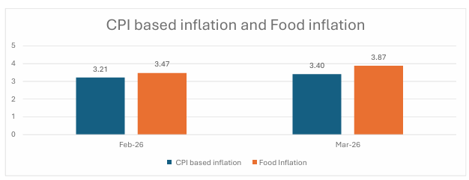
Figure 2: Food Inflation in India
Source: NATIONAL STATISTICS OFFICE (2026)

Though Food inflation has shown an increase from 3.47 in February 2026 to 3.87 in March 2026, it only impacts discretionary spending in the short term (NATIONAL STATISTICS OFFICE, 2026).
Contrastingly, in the US, Hershey (2026a) has a more mature market with $11,692.6 million in sales. The US is also the largest economy with a nominal GDP of more than US$30 trillion in 2025 (Marieatte and Labadie, 2024). The consumer purchasing power is high, with GDP per capita of more than US$94.43 thousand (IMF, 2026). Though food inflation increased only 0.2% from April 2026 to May 2026, there is a prediction of an overall 3.2% increase in food prices in the US (Sweitzer and Davidenko, 2025). Moreover, Hershey has demonstrated strong performance, but there is a difference in price-led sales gains as volumes declined by 5 points. This reflects the impact of high prices on consumer demand (Zacks Equity Research, 2026).
Thus, India provides strong purchasing volume and growth opportunities, but the US has high average spending per consumer and low long-term expansion so both are favourable.

Social
Indian consumers are also opting for dark, sugar free and artisanal varieties. The 15-30 age group drives major demand; middle-class consumers see it as a convenient alternative to traditional sweets, especially during festivals like Diwali or Raksha Bandhan, as shown through campaigns such as “Kuch Meetha ho Jaye” (IBEF, 2025).
Cultural gifts do not drive the US consumer, but more by clean labels, low sugar options. They have a high focus on child obesity and general sugar intake. Nonetheless, some reports also show high candy intake, as it boosts mood, leading to an 11% increase in their sales. Consumers also show high brand loyalty, which makes market penetration difficult (Grand View Research, 2023). Hence, social factors show equally strong opportunities in the US and India.

Hofstede framework
Hofstede is a widely used national cultural framework in management, marketing, sociology and psychology studies. The dimensions, assigned indexes on each to all nations which are connected with demographic, economic, geographic and political society, which is unmatched by different frameworks. It is useful to form a hypothesis for comparative cross-cultural studies (Soares, Farhang Mehr and Shoham, 2007). However, it is assumed that the whole nation has a similar ideology, values that are ignoring the individual differences or sub-cultures. Moreover, it is relying on surveys of employees that were working during the 1970s and 1980s (Hofstede, 2011). Thus, they are unable to capture modern shifts in culture that happened due to globalisation. Thus, Hofstede has oversimplified cultural nuances and is now less relevant in the globalized world (Greene, 2021). It is only operating on narrow definition and general trends which cannot be applied particularly. Furthermore, it ignores multiculturalism which is increasingly used in multicultural exchanges today
Hofstede’s Cultural Theory provides a framework to compare the Cultural dimensions across Power distance (PDI), individualism (IDV), masculinity (MAS), uncertainty avoidance (UAI), indulgence (IVR) and long term orientation (LTO) (Hofstede, 2011). The figure below provides a comparison and marketing implications-
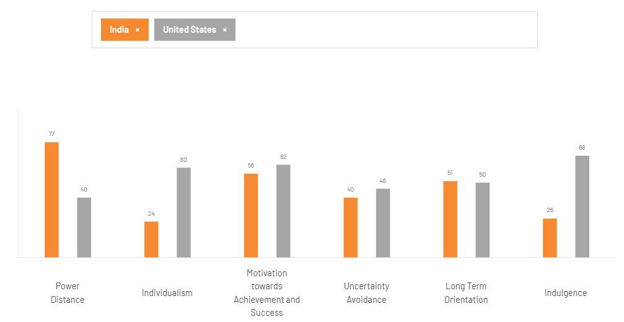
Figure 3: Hofstede Insights for US and India
Source: Hofstede Insights (2025)
As per the above figure, India will respond well to authority-based advertising whereas in the US the consumer will prefer equality or relatability. India would prefer a family-oriented market with low individualism, whereas the US emphasis on personal freedom (Komisarof and Akaliyski, 2025). This is the most significant cultural difference, which shows that in India, hierarchical relationships and respect for authority are deeply embedded. Cadbury's advertising in India has also featured respect for family members and community celebrations to reinforce this tradition and trust providing a distinct advantage for emotional connect. Contrastingly, US marketing is more focused on peer relationships and authentic consumer experience. In respect of culture and trust through power distance, India is more favourable for Cadbury as the people follow with emotional brand attachments. The individualism score also reflects that the US has reflected a culture that values independence and individual decision making whereas India has shown a collectivist society where social groups influence purchasing decisions. The campaigns such as “Kuch Meetha Ho Jaye” and “Shubh Aarambh” link chocolate with festivals and family celebrations (Parab and Poddar, 2019). However, in the US market, Hershey positions Cadbury as individual enjoyment and personal treats. Individualism shows the greatest difference in both countries, being equally favourable. It is favourable for Cadbury as it requires different positions benefitting from personal enjoyment and consumption requirements as well. However, MAS scores show that both societies appreciate motivation for achievement and success, but the US has a somewhat stronger response to personal accomplishments. Premium products such as Cadbury silk and dark milk are appealing to consumers who seek status and quality in India. It is favourable for Cadbury as premiumisation strategies might be implemented in both the markets though status signalling seems strong in India. Similarly, the UAI scores show that the markets are receptive to innovation or new product launches. This creates a favourable condition where Cadbury can introduce seasonal flavours or limited editions for both countries. Similar scores in LTO shows balance of traditions and innovations across both cultures, which means that it can adapt its strategies in India. However, IVR scores show that US consumers are more likely to purchase self-indulgence, whereas in India it is linked to gifting or celebration, which shows a favourable culture in India and US both. It is also seen in the present strategy where Cadbury's Indian marketing is linked with gifting traditions during Diwali or weddings, whereas in the US it is heavily focused on self-consumption or seasonal locations like Easter and Halloween, marking an advantage for Cadbury to increase revenue.
Overall, culture is favourable for India and US in Cadbury as the company successfully adapts to marketing strategies with local values. Nonetheless, India has more emotionally driven relationships whereas the US has more premiumisation, impulse purchase and individual consumption.

Technological
India is experiencing high digital transformation with over 970 million internet users (PIB, 2025c). Expanding digital payments have accelerated purchases through Swiggy Instamart, Blink it and Big basket (Ganapathy and Gupta, 2024). This has changed impulsive brick-and-mortar purchases to rapid online buying. However, their presence in rural India is still limited.
The US is already technologically advanced, shown through automated logistics and mature e-commerce. E-commerce contributed to retail sales as also forecasted to grow to USD 12.7 billion by 2031, showing opportunity for confectionery producers (Mordor Intelligence, 2025).
Hence, both countries have infrastructure and opportunity, but the US has more mature logistics and automation systems, so the US is more favourable.

Legal
Food Safety and Standards Authority of India (FSSAI), mandated nutritional labelling and appropriate advertising regulations. The brand cannot use generic terms such as pure or promote chocolate as a “healthy” alternative (Food Safety and Standards (advertising and claims) regulations, 2018). Recently, India’s Supreme Court also emphasised warning labels, which states that it should consider mandating front-of-pack labelling for products high in sugar or calories for informed consumer decisions (The Hindu, 2026).
The US has the Food and Drug Administration (FDA), where there are stricter regulations for ingredient disclosures and allergen labels (U.S. Food and Drug Administration, n.d). It has strictly forbidden the use of vegetable fats in place of cocoa butter. The advertisements are monitored by the Federal Trade Commission (FTC).
Hence, legal compliance is essential in both markets, with slightly more strict compliance in the US showing that India is more favourable.

Environmental
India has restrictions on the use of single-use plastics implemented in 2022. It also encourages Extended Producer Responsibility (EPR). Mondelez International (2022) also implements a Cocoa Life Sustainability program with a US$1 billion investment to improve sourcing and farmers' conditions.
The US has more regulatory demands for ethical sourcing origins and compliance with deforestation-free and fair labour harvesting standards (US Department of Labour, 2026). However, the environmental regulations in the US vary from state to state. Thus, environmental regulations increase the cost in both countries so it is equally favourable.
Overall, India represents a principal market for growth as it has high market penetration and volume expansion. The US is a more mature market where competitiveness depends on premium product, brand differentiation. However, it is limited because of high tariff rates due to the war.

STP (Segmentation, Targeting, and Positioning)
STP is a framework which aids in the identification of potential consumer groups. Segmentation identifies potential consumers, targeting identifies the selection of market segments, and positioning creates a perception in consumers about the brand, its products and services (Sharp, Dawes and Victory, 2024).

Segmentation
Cadbury applies multi-variable segmentation. In India, demographic segmentation is essential because of a high population exceeding 1.46 billion (PIB, 2026). It offers Dairy milk, Perk, Fuse, Silk and Bournville’s which serves children, teenagers, young professionals and families (Mondelēz International, 2023).
Cadbury has also positioned its chocolate as an emotion to cater to family dynamic behavioural and psychographic segmentation (Mahapatro and Mali, 2025). It has promoted its products for festivals, weddings and happy moments to replace traditional sweets.
In the US, it is mainly for adults or consumers who value premiumization. Cadbury appeals to consumers who seek a British heritage product with flavours unavailable in mainstream US brands. Geographically, it is anchored in nationwide retail chains such as Walmart and Super Mart networks. Its behavioural segmentation is also essential as it observes high sales during Christmas, Halloween and Easter.

Targeting
Cadbury has adopted different strategies in each of the countries as per different market structures. In India, it follows differentiated mass marketing. It serves each consumer segment as it offers chocolate in different price points from Dairy Milk to Bournville. It also has different packages for its premium gifting products such as Cadbury Celebrations. The broad strategy has led to high sales, especially in the Indian middle class who have a rising disposable income.
However, the US has a selective targeting strategy. The mainstream chocolate is dominated by the domestic brands so Cadbury is concentrated on consumers who are valuing a British heritage confectionery. Its products like Dairy Milk, Flake and Crunchie are available in supermarkets and online platforms. These are targeted at consumers who seek differentiation.

Positioning
In India, Cadbury is an emotional brand which is linked with family relationships and celebrations (Mahapatro and Mali, 2025). The iconic Dairy Milk cricket commercial has repositioned chocolate from the occasional children's snack into a product which is linked with achievements in everyday celebration. Another strategy was the introduction of Cadbury's celebration gift boxes, which have reinforced the positioning as it competes with traditional Indian sweets during festivals.
However, in the US, it has positioned itself around premium products with British heritage (Hershey, 2026b). It is not directly competing with other affordable chocolate brands. It has differentiated itself by a rich milk chocolate formulation linked with British confectionaries. It has appealed to consumers who seek premium experiences.

Similarities and Differences
In both countries, the segmentation has included Cadbury as a global brand identity which is focused on trust and Emotional appeal. Product innovation is also supported in both markets by seasonal launches and premium extensions. However, India has a young population with a collectivist culture and strong gifting traditions. Here, Cadbury is adopting a targeting market strategy through emotional advertising. In contrast, in the US, there is a mature market where a more selective approach based on premium positioning is witnessed. Lastly, it has positioned itself as a Cultural symbol in both countries, with Price-quality relationships in India.

Perceptual Map for India
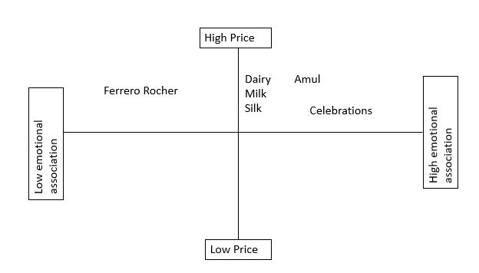
Figure 4: Perceptual Map
Source: Self-made, inspired by Cadbury : gifting (no date), Amte (2024),Anupam (2014)
Cadbury has high emotional association with different products ranging from high to medium prices such as its Cadbury celebrations are around ₹ 500 whereas its dairy milk ranges around 10-100 depending on flavour (Cadbury : gifting, no date). They have a high emotional connection with the audience due to festival celebrations and advertisements. Amul Chocolate is competing with affordability and weak brand symbols and weak marketing (Anupam, 2014). Comparatively, Ferrero Rocher are competing in a high price market but there is no emotional association, it is mostly linked with luxury gifting that makes it less accessible to price-sensitive consumers (Amte, 2024). Thus, Cadbury has a favourable position as it combines affordable products with emotional differentiation.

International Marketing Mix (7Ps)

Product
There are impulse products such as Gems, 5 Star and Dairy Milk aligned with premium products such as celebration gift boxes (Mondelēz International, 2023). In the US, it is more linked with British identity (Dairy Milk, Crunchie), which are premium products (Hershey, 2026b).
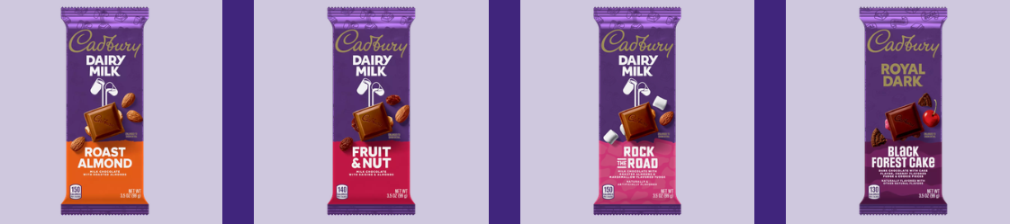
Figure 5: Dairy Milk Chocolate in US
Source: Hershey (2025)
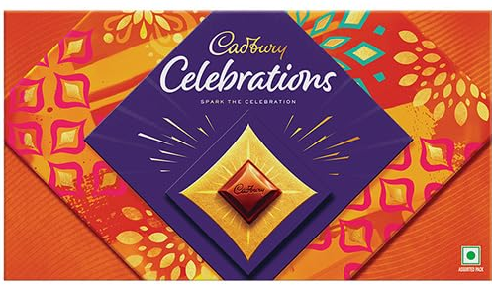
Figure 6: India’s Celebration packaging
Source: Amazon (no date)
India follows a symbolic packaging with purple colour but festive imagery, whereas the US has more informational packaging with FDA labels. India has a product width of eight lines with many variants which includes dairy milk (variants: Fruit&Nut, Crackle, Roast Almond, Whole Nut, Family packs and value packs), Dairy Milk Silk (variants: Oreo, Silk Oreo, Fruit&Nut Silk, Bubbly, Ganache), 5 Star (variants: Classic, 3D, home treats and mini packs), Perk (variants: mini, double, standard, home treats), Gems, Fuse, Bournville (variants: Rich Cocoa, Raisins&Nuts, Cranberry, Dark Chocolate), Celebrations (variants: Rich Dry fruit, Assorted gift box, festival pack). The US has a narrower product width of four lines namely, dairy milk bars, Caramelo, Royal dark bar and seasonal easter product such as Creme eggs. US product depth includes variants such as Dairy Milk Chocolate (Rock the road, Fruit&Nut, Roast almond), Caramello (Standard bar, king size bar), Royal Dark -Standard dark chocolate) and Creme eggs, caramel egg, chocolate creme eggs with different sizes. India has greater product depth than the US products with more than 30 variants across the product lines and seasonal introductions.

Price
In India, price is usually dependent on competition-based or demand-based prices as there is high price sensitivity and income varies considerably. Therefore, Cadbury adopts Stock Keeping Units (SKUs) for different income groups such as Dairy Milk (13.2 g) starting with ₹10. There is also demand based pricing where they adopt a sales maximisation by competition based pricing because this is a price sensitive market. India usually has a competition based and demand-based pricing. The market is price-sensitive with Nestle (starting at ₹5,10 to 20) and Ferrero (premium products starting at ₹150) as major competitors.
In the US, there is premium competition-based pricing as Cadbury is linked with an experience of products that have high quality. They employ a profit oriented pricing as Dairy Milk 3.5oz costs US$4.48 at Walmart, compared to Hershey Milk chocolate 4.4oz at US$2.68. This pricing reflects adaptation and not standardisation.

Place
In both the markets Cadbury has an intensive distribution strategy. In India, there is a more fragmented distribution through three level channel distribution such as manufacturer, carrying forward agents, wholesalers, retailers and consumers. The major products are distributed through Kirana stores, hypermarkets, convenience stores and quick Commerce platforms such as Blink it. Traditional retail is still important for low price consumers in rural areas.
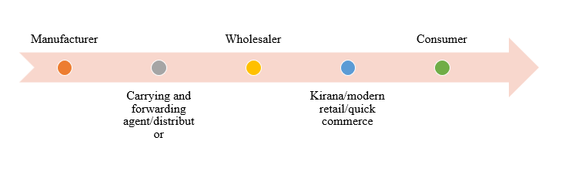
Figure 7: Channel Distribution in India
Source: Author’s illustration based on Mulky (2013) and Mondelēz International (no date b).
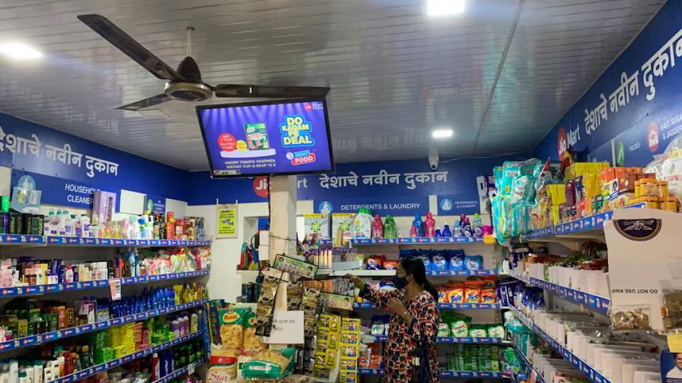
Figure 8: Kirana Stores in India
Source: Mitter (2022)
In the US, there is shorter organised distribution consisting manufacturer, distributor, wholesaler, modern retail/e-commerce, consumers. The products are mainly available in supermarkets such as Walmart, Kroger and Amazon.
Secondly, Mondelēz operates as the wholly owned subsidiary which means it has full control on Cadbury’s production. However, Hershey has an exclusive US license for manufacturing and distribution using its American facilities.
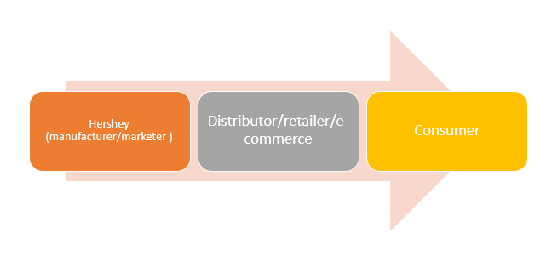
Figure 9: Distribution Channel US
Source: Author’s illustration based on The Hershey Company (2026)

Promotion
Integrated Marketing Communication is a management process which integrates all the communications for achieving brand coherence (Nadube, 2018).
India has a high-context culture where communication is dependent on family values, emotions and symbolism. Hence, campaigns such as Cadbury celebrations are linked with festivals and relationships through digital and direct marketing (Parab and Poddar, 2019). The promotion objectives in India is increasing consumer trust, brand loyalty by emotional appeal as evidenced through campaigns such as “Kuch Meetha Ho jaaye”, “Shubh Aarambh” are linked with auspicious beginnings. There are also sales promotions through seasonal offers at offline stores, sponsorships and influencer and television media campaigns that complement advertisement in both markets.
However, the United States has a low context culture where the objective of advertising is linked with high sales and brand awareness through digital marketing. For instance, campaigns use Bunny try-out advertisements to attract pet owners (Hershey, 2019). There are limited edition packaging during Easter and Halloween.

People
Cadbury is heavily relying on relationships with its retailers and distributors to maintain product availability across rural and urban regions in India. Though there are no published figures for Cadbury alone, Mondelez has 3500 people across India (Mondelēz International, no date b). The training and motivation include leadership development programmes (Mondelēz international, no date a). Diversity and Inclusion are other motivational strategies. Contrastingly, the consumer experience in the United States is more organised through retail chains and automated inventory systems of Hershey. Cadbury-specific workforce data are not separately disclosed. Hershey (2023) employees approximately 20,000 employees across its US portfolio (Hershey, 2023). There are many motivational programs such as flexible working, workplace safety and performance management reports.

Process
Cadbury is supported in India by the rapid growth of digital payments and quick commerce. In the United States, there is a mature logistics infrastructure with click-and-collect services and online grocery shopping. In India and US, complaints are handled officially through the consumer's page through email, telephone, contact form. Customers must provide product name, batch, manufacturing, photographs, purchase details and issue. This is followed by Quality Assurance reviews and resolutions such as replacement or compensation.

Physical Evidence
Physically, Cadbury has maintained its purple packaging in India and the US. However, it also incorporates multilingual information, gift orientation and festive designs in India.
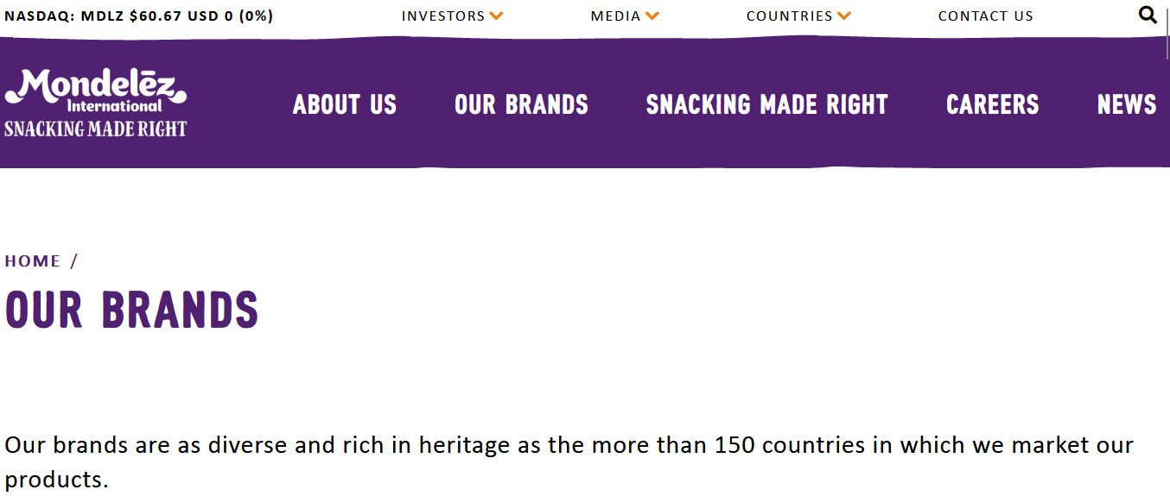
Figure 10: Cadbury India website
Source: Mondelēz International (no date c)
Figure 11: India’s Celebration packaging
Source: Amazon (no date)

Contrastingly, in the US, emphasis is on premium appearance and nutritional information.
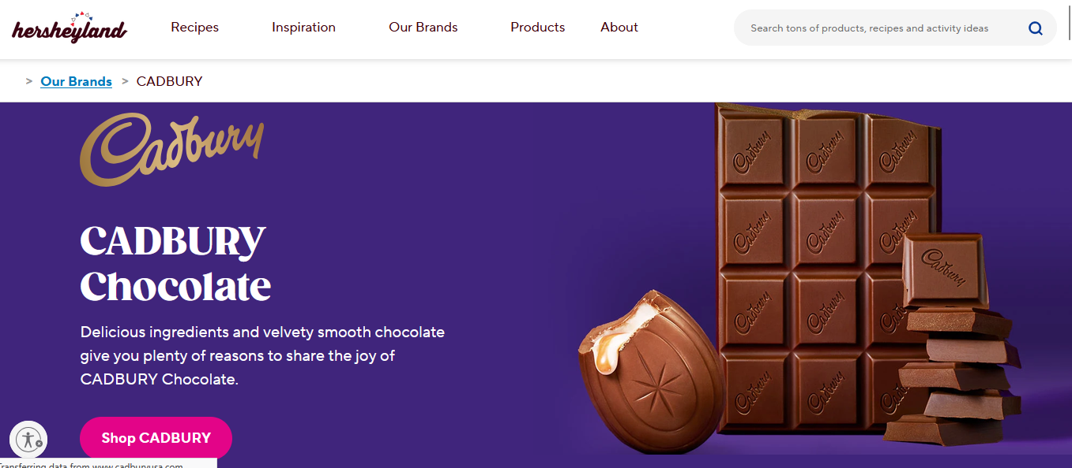
Figure 12 : US Cadbury website
Source: Hershey (2026b)
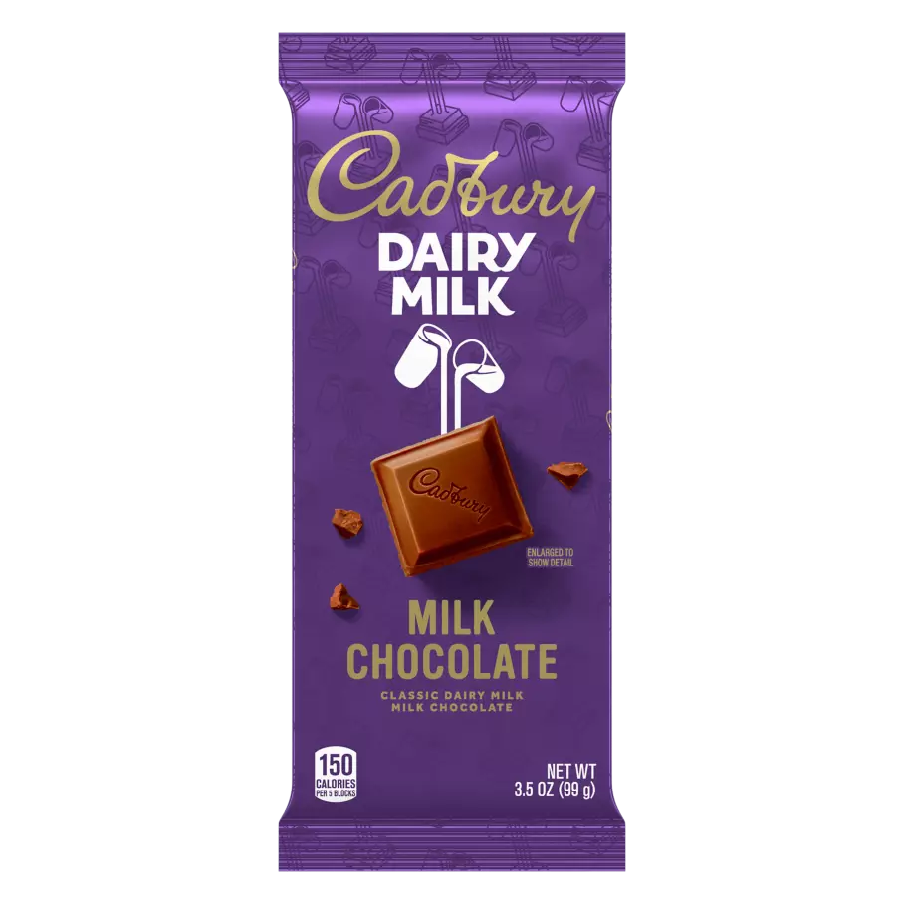
Figure 13: US Cadbury Product
Source: Hershey (2025)
Thus, similarities include using purple branding and intensive multi-level distribution and integrated marketing communication. They are using a structured customer complaint process and employee training and motivation by Mondelez. However, India emphasises an affordable unit, festival-oriented product and emotional promotions. Contrastingly, the US is focused on premium British heritage product organized distribution and benefit-led promotions. The adaptations of Cadbury also reflect that since India has a price sensitive and festival oriented market an emotional appeal is majorly included in many of the decisions. However, US has an individualistic culture where there is a high purchasing power and a mature retail infrastructure that supports a premium positioning and organised distribution

Market Entry
International firms can enter the market through licensing, export, strategic alliances, joint ventures, wholly owned subsidiaries and acquisition (Divrik, 2023). The choice of entry is dependent on market size, investment risk, government regulation and long-term growth. Cadbury entered India in 1948 and then merged with Schweppes Plc in 1969 which created Cadbury Schweppes Plc, which was then acquired by Kraft in 2010 and Mondelēz in 2012 through Kraft’s reorganisation . Hence, Cadbury operates in India through wholly owned subsidiaries (Fernandes, Gupta and Vidyasagar, 2016). However, it faced limitations in the form of Cadbury as a children’s product, limited to gifts. There was a major cultural barrier where traditional Indian sweets dominated the celebration. There was limited adult consumption. It faced a major issue in 2003 with a worm reported in its milk bars (Coman et al., 2020).
India was an attractive destination for FDI with the economy projected to grow at 6.3%-6.8% in 2025 reflecting continued investor confidence (PIB, 2025b). There were also different government incentives for businesses in India. Wholly owned subsidiaries provided many benefits in India such as managerial and operational control. This enabled Mondelez for adapt the products as per India’s population. Secondly, the local production in Maharashtra, Malanpur and Baddi led to reduced transportation cost. This also led to affordable products for Indian consumers. Thirdly, direct ownership protected the trademark, proprietary technology and manufacturing technologies.
However, it required substantial investment and high financial risk. Wholly owned subsidiaries exposed the firm to regulatory challenges, high taxes and operational complexities. Additionally, there were logistical issues in India because of regional infrastructure disparities.

Ethical Issues
Ethics is the general conduct where businesses act morally, respectfully and in a socially responsible manner. This section is explained through the Justice approach where distributive justice ensures that organisations should be fair in distribution of burden or benefits (Nameda et al., 2023). Procedural justice is fairness of decision-making whereas corrective justice is correcting the harm done. Cadbury has reflected this through its Cocoa Life program, where it aims to source cocoa responsibly. The program was launched in 2012 for improving farmer’s livelihoods, reduction of child labour and empower women (Mondelez International, 2022). This strengthens their product element as it improves credibility and supports environmentally conscious consumers. This shows a distributive justice approach by fair distribution of economic and social benefits to consumers. It strengthens the products of Cadbury as ethically sourced cocoa will enhance brand credibility.
Secondly, their sustainable packaging also supports their Extended Producer Responsibility (EPR). Mondelez has partnered with The Energy and Resources Institute (TERI) for plastic waste collection and recycling (Mondelez International, 2021). As per Mondelēz International (2025a), 96% of their packaging is designed as recyclable. It provides protective and informational functions demonstrating distributive justice. It supports Physical evidence of 7Ps as the environmentally responsible packaging means reinforces sustainability credentials.
Though Cadbury is a leading Chocolate brand in India, it has been linked with ethical and unethical practices. The first example is the Worm Contamination Crisis in 2003, where consumers found worms in its Dairy Milk in Maharashtra. They reported that it was due to poor storage conditions and not manufacturing issues (Coman et al., 2020). This led to a 30% decline in their sales. Later, Cadbury invested ₹15 crore in tamper-proof double-layer packaging and launched the chocolate through advertisements featuring a prominent Bollywood actor (Amitabh Bachchan) to restore consumer trust. Explaining the Justice approach, Cadbury did procedural justice by managing the crisis. They applied honest communication and restored the trust of consumers.
Secondly, Cadbury has been criticised as they promote high sugar confectioneries for children (Department of Consumer Affairs, 2014). There have been constant arguments that chocolates that advertise cartoons and family-oriented campaigns are encouraging excessive sugar consumption in children. However, critics have argued that emotional promotional campaigns are frequently normalised, which leads to confectionery consumption such as Gems having dangerous levels of sugar for children.

Recommendations and Conclusion
Based on the above analysis, Cadbury must continue to adapt in India and premium differentiation in the US.

Recommendation 1
The marketing analysis has reflected that Cadbury is positioned as a premium chocolate brand in the United States. The United States also demonstrates high purchasing power but has faced alternatives from brands like Mars and Hershey's. Hence it is recommended that Cadbury must expand the portfolio of its premium products such as limited edition flavours, reduced sugar variants and dark chocolates for addressing the growing consumer demand for a healthier and premium confectionery. It is also supported by the PESTLE analysis that has identified increased health consciousness in the US market.

Recommendation 2
The PESTLE analysis has reported that India is going through a rapid digital transformation and quick expansion of e-commerce platforms like Insta Mart and Blink it. This has also increased consumer purchasing behaviour. Hence, Cadbury must increase partnerships with the platforms by introducing an exclusive online bundle or a Premium personalised gift bag which is exclusively available on these platforms. It will improve accessibility for urban consumers and complement the existing distribution.

Recommendation 3
Thirdly, the ethical issues reported are that critics in India are concerned about the high level of sugar in Cadbury’s products. Hence, it is recommended that Cadbury must introduce a reduced sugar or a no-sugar variant in the core ranges such as Dairy Milk Silk. It should also have front-of-pack labels with a target to formulate at least 10% of its confectionery portfolio for children’s health.

Section 2

Description
The present report required a critical analysis of Cadbury's international marketing strategy while comparing its operations in India and the United States. I read the brief and researched different companies given for the report. At last, I selected Cadbury because it has vast data available. While researching, I read the websites of Mondelez and Hershey, their annual reports and market research reports such as Grand View Research to collect the data. In this report, I applied different international marketing frameworks such as PESTLE, Hofstede, STP and the 7Ps of marketing. Initially, I assumed that this report would include a description of the models and then applying it to Cadbury. However, as I read the brief, I realised that the expectation was a consultancy-style analysis linked with real evidence and academic theory.

Feelings
While starting the research report, I found that there was a huge volume of information, which made me feel overwhelmed, as Cadbury operates in different countries. I was also anxious, as much of the information was either outdated or lacked credibility. I was also concerned about differentiation between academic sources and commercial websites. I was fearful as I found it challenging to compare two markets that have different economic and regulatory environments.

Evaluation
One of the strengths was using high quality peer review sources and US, India based website sources instead of only relying on websites. Academic studies and official reports helped in objectively comparing the recommendations rather than forming a subjective opinion. Overall, I believe that this report has successfully integrated theory with practice. It made me understand the application of PESTLE, Hofstede and STP. I have understood the significance of cultural analysis in marketing by conducting cultural analysis of India and the US in line with Cadbury. PESTLE analysis helped me understand India's favourable economic growth and expansion of the middle class. It helped me in understanding and refining my research skills. However, it was difficult to obtain recent country-specific data, especially about the marketing expenditure or pricing strategies, because the commercial information was not disclosed publicly. Another limitation which I faced during preparation was that I described marketing theories rather than critical evaluation. For instance, my first discussion about the Hofstede framework only focused on explaining the cultural dimensions without recognising its application in India or within the context of Hofstede’s limitations. This made the report descriptive. Similarly, early comparison of the marketing mix was only concentrated on identification of differences rather than any explanation of why Cadbury has adopted such changes in response to the consumer behaviour of the market structure. When I revised these sections, it helped me in improving the analytical depth by linking the marketing decisions with the cultural and environmental factors.

Analysis
This assessment has helped me understand the significance of primary and secondary research in marketing. I have learnt that international marketing decisions should be made with an objective mindset. It must be based on key frameworks such as macro environmental analysis or cultural analysis. Researching ethical marketing also helped me understand that sustainability initiatives such as Cocoa Life are not only regulatory methods but also strengthen brand reputation.
Initially, I assumed that the comparison of the United States and India would include different economic and cultural environments. However, it was incomplete as an effective comparison also required explaining why Cadbury is adapting to the market strategy rather than only describing it. For example, while doing Hofstede analysis, I presented it as a factual difference between two countries, but while reading further I understood that the cultural frameworks have to be critically evaluated with the contemporary behaviour and market evidence (Hofstede, 2011). This resulted in a more balanced discussion.
One factor which has improved my analysis is triangulation from government publications, academic reports and company reports. Using multiple sources reduced my reliance on corporate information that will only present organisational performance positively. The approach is also consistent with the critical research principle that has suggested that different sources shall improve the validity and credibility of findings (Bans-Akutey and Tiimub, 2021). One factor which limited the preparation was also the availability of country-specific company data. Information such as Cadbury's workforce or promotional expenditure is often reported at Mondelez and not only for Cadbury alone. Hence, it required careful evaluation and interpretation to prevent any unsupported conclusions.
Finally, the preparation process has also reinforced critical thinking over description. Even research on higher education has emphasised that critical analysis requires evaluating evidence, questioning assumptions and synthesising different perspectives rather than only summarising information (Sri and Rao, 2026).

Conclusion
In summary, this assessment has helped me in developing an understanding of the application of international marketing theories in practice. This has also improved my ability to evaluate evidence and compare international market reports.

Action Plan
For the future, I plan on improving my market research databases by using Mintel, Statista or Euromonitor. I will research them for 2 hours each week for practical self-development for at least six months. It shall improve my research skills. It will help me in accessing more detailed consumer and competitor information. I shall continuously develop my ability to synthesise multiple theoretical frameworks through regular practice.

Conclusion
This is a consultancy report that analysed Cadbury’s marketing presence in the US and India. Cadbury’s localisation strategy seems to be more effective in India because of its political, environmental, and cultural factors. The key driver is the cultural contrast, where India is a more collectivist society whereas the US is focused on individualistic consumers. Ethical initiatives such as sustainable packaging are in the positive light, but concerns about high sugar content in the chocolates still remain. Hence, the highest priority must be expanding into healthier and reduced sugar products through India’s quick e-commerce partnerships.

References
“Food safety and standards (advertising and claims) regulations” (2018). Available at: https://www.fssai.gov.in/upload/uploadfiles/files/Compendium_Advertising_Claims_Regulations_14_12_2022.pdf (Accessed: 20 July 2026).
Amazon (no date) Cadbury Celebrations Assorted Chocolate Gift Pack, 141.68 g (Pack of 4) . Available at: https://www.amazon.in/Cadbury-Celebrations-Assorted-Chocolate-Gift/dp/B07F6C9992?ref_=ast_sto_dp&th=1 (Accessed: 20 July 2026).
Amte, R. (2024) “Impact of Ferrero rocher & Cadbury ltd. ’s branding strategies on their sales revenue during lockdown,” International Education and Research Journal, 10(8). Available at: https://doi.org/10.21276/IERJ24737370081628.
Anupam , S. (2014) Branding and Brand Management: Case of Amul, ResearchGate. unknown. Available at: https://www.researchgate.net/publication/290959987_Branding_and_brand_management_Case_of_Amul (Accessed: August 1, 2026).
Bans-Akutey, A. and Tiimub, B.M. (2021) “Triangulation in research,” Academia Letters [Preprint]. Available at: https://doi.org/10.20935/AL3392.
Cadbury : gifting (no date) Amazon.in. Available at: https://www.amazon.in/stores/Cadbury/page/29471FD2-BB9F-4B2D-9C9A-DF613DDD5A3B (Accessed: 30 July 2026).
CIPD (2025) PESTLE analysis. Available at: https://www.cipd.org/en/knowledge/factsheets/pestle-analysis-factsheet/.
Coman, C., Briciu, V.-A., Itou, C., Bularca, M.C. and Anghel, D.A. (2020) “Crisis communication. Case study: Cadbury worm controversy,” 11Th international conference on information science and information literacy, pp. 40–55. Available at: https://doi.org/10.2478/9788395815065-004.
Department of Consumer Affairs (2014) Chocolates How solid is the cocoa?, Consumer Affairs. Available at: https://consumeraffairs.gov.in/public/upload/admin/cmsfiles/consumer_products/Chocolates_consumer_products.pdf.
Divrik, B. (2023) “International market entry strategies,” in Origin and Branding in International Market Entry Processes , pp. 1–10. Available at: http://dx.doi.org/10.4018/978-1-6684-6613-1.ch001.
ET BrandEquity (2026) Mondelez India FY25 revenue slips 2 pc to Rs 12,503 cr, ETBrandEquity.com. PTI. Available at: https://brandequity.economictimes.indiatimes.com/news/business-of-brands/mondelez-india-fy25-revenue-slips-2-pc-to-rs-12503-cr/126561415? (Accessed: 20 July 2026).
Fernandes, S.F., Gupta, P. and Vidyasagar, A. (2016) “Cadbury India – sweet turning sour,” Ushus - Journal of Business Management, 15(4), pp. 37–54. Available at: https://doi.org/10.12725/ujbm.37.3.
Ganapathy, V. and Gupta, D.C. (2024) “Critical success factors for quick commerce grocery delivery in India: An exploratory study.,” Sustainability, Agri, food and environmental research, 12(10). Available at: https://doi.org/10.7770/safer-V12N1-art691.
Grand View Research (2023) U.S. Confectionery Market (2023 - 2030) , www.grandviewresearch.com. Available at: https://www.grandviewresearch.com/industry-analysis/us-confectionery-market (Accessed: 20 July 2026).
Greene, J. (2021) “Hofstede’s cultural dimensions theory,” EBSCO [Preprint]. Available at: https://www.ebsco.com/research-starters/business-and-management/hofstedes-cultural-dimensions-theory (Accessed: July 28, 2026).
Hershey (2019) Cadbury brand is giving pets the chance to be a tv star. Available at: https://www.thehersheycompany.com/content/hershey-corporate/en-us/home/newsroom/press-release/2019-02-20-Cadbury-Brand-Is-Giving-Pets-The-Chance-To-Be-A-Tv-Star.html (Accessed: 30 July 2026).
Hershey (2023). The Hershey Company Named One of the Best Workplaces in Manufacturing & Production™ in 2023 by Great Place to Work® and Fortune. Available at: www.thehersheycompany.com/en_us/home/newsroom/press-release/2023-09-14-The-Hershey-Company-Named-One-of-the-Best-Workplaces-in-Manufacturing-Production-TM-in-2023-by-Great-Place-To-Work-R-and-Fortune.html (Accessed: July 30, 2026).
Hershey (2025) CADBURY DAIRY MILK chocolate candy bar, 3.5 oz, Hersheyland.com. Available at: https://www.hersheyland.com/products/cadbury-dairy-milk-milk-chocolate-candy-bar-3-5-oz.html (Accessed: 20 July 2026).
Hershey (2026a) “Hershey reports fourth-quarter and full-year 2025 financial results; provides 2026 outlook,” Prnewswire.com, 5 February. Available at: https://www.prnewswire.com/news-releases/hershey-reports-fourth-quarter-and-full-year-2025-financial-results-provides-2026-outlook-302679521.html (Accessed: July 30, 2026).
Hershey (2026b) Cadbury chocolate | shop premium chocolate bars and candy, www.cadburyusa.com. Available at: https://www.cadburyusa.com/cadbury (Accessed: 20 July 2026).
Hofstede Insights (2025) Country comparison tool, Theculturefactor.com. Available at: https://www.theculturefactor.com/country-comparison-tool?countries=india%2Cunited+states (Accessed: 20 July 2026).
Hofstede, G. (2011) “Dimensional zing Cultures: The Hofstede Model in Context ,” Online Readings in Psychology and Culture, 2(1). Available at: https://scholarworks.gvsu.edu/cgi/viewcontent.cgi?article=1014&context=orpc (Accessed: July 28, 2026).
IBEF (2025) Decoding the growth of India’s chocolate market, India Brand Equity Foundation. IBEF. Available at: https://www.ibef.org/blogs/decoding-the-growth-of-india-s-chocolate-market (Accessed: 20 July 2026).
IMF (2026) GDP per capita, current prices , Imf.org. Available at: https://www.imf.org/external/datamapper/NGDPDPC@WEO/USA/DEU (Accessed: 20 July 2026).
Khan, U.U., Ali, Y., Petrillo, A. and De Felice, F. (2023) “Macro-environmental factors and their impact on startups from the perspective of developing countries,” International Journal of Sustainable Engineering, 16(1), pp. 166–183. Available at: https://doi.org/10.1080/19397038.2023.2238754.
Komisarof, A. and Akaliyski, P. (2025) “New developments in Hofstede’s Individualism-Collectivism: A guide for scholars, educators, trainers, and other practitioners,” International journal of Intercultural relations, 107, p. 102200. Available at: https://doi.org/10.1016/j.ijintrel.2025.102200.
Mahapatro, A. and Mali, D.R. (2025) “Analysis of Consumer Preferences for Cadbury Chocolates in India,” International Research Journal on Advanced Science Hub, 7(3). Available at: https://doi.org/10.47392/IRJASH.2025.025
Marieatte , N. and Labadie, B. (2024) Recent US policies and their likely implications for the ECCU, Eastern Caribbean Central Bank. Available at: https://www.eccb-centralbank.org/blogs/recent-us-policies-and-their-likely-implications-for-the-eccu (Accessed: 20 July 2026).
Mitter, S. (2022) EXCLUSIVE: Reliance’s JioMart Kirana stores find new revenue stream in supplier ads; revenue jumps 4x - Business Today, Business Today. Available at: https://www.businesstoday.in/latest/corporate/story/exclusive-reliances-jiomart-kirana-stores-find-new-revenue-stream-in-supplier-ads-merchant-base-grows-4x-332838-2022-05-09 (Accessed: July 28, 2026).
Mulky, A.G. (2013) “Distribution challenges and workable solutions,” IIMB Management Review, 25(3), pp. 179–195. Available at: https://doi.org/10.1016/j.iimb.2013.06.011.
Mondelez International (2021) Press Release. Available at: https://www.mondelezinternational.com/assets/Country/India/Press-Releases/2021/Press-Release--Mondelez-India-Invests-to-Recycle-Multi-Layered-Plastics-in-India.pdf. (Accessed: 30 July 2026).
Mondelez International (2022) “Cocoa LIFE strategy to help protect children,” in. Available at: https://assets.ctfassets.net/qggsjlmpzfmx/74Id59vs1ke7JAIY5d18sH/7ff72ba39295ba83890814bfdefb15e4/cocoa-life-strategy-to-help-protect-children.pdf (Accessed: 20 July 2026).
Mondelēz International (2023) Cadbury, Mondelēz International, Inc. Available at: https://www.mondelezinternational.com/our-brands/Cadbury/ (Accessed: 20 July 2026).
Mondelēz International (2025a) Mondelēz International Continues Progress Against “Snacking Made Right” Priorities, Mondelēz International, Inc. Available at: https://ir.mondelezinternational.com/news-releases/news-release-details/mondelez-international-continues-progress-against-snacking-made (Accessed: 20 July 2026).
Mondelēz International (2025b) Mondelēz International Reports Q4 and FY 2025 Results. Available at: https://ir.mondelezinternational.com/static-files/92e0cc2f-2e58-4f47-92a8-13dae82ab870 (Accessed: 20 July 2026).
Mondelēz international (no date a) Culture and talent development | Mondelēz international, inc. Available at: https://www.mondelezinternational.com/snacking-made-right/culture-and-talent-development/ (Accessed: 30 July 2026).
Mondelēz international (no date b) Our Business in India. Available at: https://www.mondelezinternational.com/India/India-Business/ (Accessed: July 28, 2026).
Mondelēz international, inc. (no date c). Our Brands. Available at: https://www.mondelezinternational.com/Our-Brands/ (Accessed: July 28, 2026).
Mordor Intelligence (2025) North America Confectionery Market Size & Share Analysis - Growth Trends and Forecast (2026 - 2031), www.mordorintelligence.com. Available at: https://www.mordorintelligence.com/industry-reports/north-america-confectionery-market (Accessed: 20 July 2026).
Nadube, P.M. (2018) “Understanding integrated marketing communication: Concepts, definitions and dimensions,” International Journal of Innovations in Economic and Management Science, 8(2), pp. 1–15. Available at: https://www.researchgate.net/publication/336774744_Understanding_integrated_marketing_communication_Concepts_definitions_and_dimensions.
Nameda, A., Kumaki, Y., Hashimoto, Y. and Toda, Y. (2023) “Distributive justice and development: Toward an integrative understanding of reward and responsibility distributions,” Journal of Moral Education, 52(4), pp. 435–452. Available at: https://doi.org/10.1080/03057240.2022.2134095.
NATIONAL STATISTICS OFFICE (2026) PRESS RELEASE OF CONSUMER PRICE INDEX ON BASE 2024=100 FOR MARCH, 2026. Available at: https://mospi.gov.in/uploads/latestreleasesfiles/1776078391571-Press_Release_of_CPI_March_2026.pdf (Accessed: 20 July 2026).
Parab, S.Z. and Poddar, D.P. (2019) “EFFECTS OF ADVERTISING ON CULTURE: AN EMPIRICAL STUDY MADE ON THE MARKETING STRATEGY OF CADBURY CREATING IMPACT ON CULTURE IN THE URBAN SETUP OF INDIA,” International Journal of Advance and Innovative Research, 6(1), pp. 5–8. Available at: https://www.iaraedu.com/pdf/ijair-volume-6-issue-1-xxix-january-march-2019-part-3.pdf (Accessed: 20 July 2026).
PIB (2025a) India records USD 81.04 Billion FDI inflow in FY 2024–25, Pib.gov.in. Available at: https://www.pib.gov.in/PressReleasePage.aspx?PRID=2131716&reg=48&lang=2 (Accessed: 20 July 2026).
PIB (2025b) India Becoming An Economic Powerhouse, Pib.gov.in. Available at: https://www.pib.gov.in/PressNoteDetails.aspx?NoteId=154660&ModuleId=3&reg=3&lang=2 (Accessed: 20 July 2026).
PIB (2025c) Curbing cyber frauds in Digital India, Pib.gov.in. Available at: https://www.pib.gov.in/pressreleasepage.aspx?prid=2176146&reg=48&lang=2 (Accessed: 20 July 2026).
PIB (2026) The middle class journey: Progress powered by policy, Pib.gov.in. Available at: https://www.pib.gov.in/pressreleasepage.aspx?prid=2268223 (Accessed: 20 July 2026).
Sharp, B., Dawes, J. and Victory, K. (2024) “The market-based assets theory of Brand competition,” Journal of Retailing and consumer services, 76(5), pp. 103566–103566. Available at: https://doi.org/10.1016/j.jretconser.2023.103566.
Soares, A.M., Farhang Mehr, M. and Shoham, A. (2007) “Hofstede’s dimensions of culture in international marketing studies,” Journal of Business Research, 60(3), pp. 277–284. Available at: https://doi.org/10.1016/j.jbusres.2006.10.018.
Sri, Ch.S. and Rao, C.S. (2026) “Critical thinking: an indispensable ability for decision making and problem solving,” The Review of Contemporary Scientific and Academic Studies, 6(2). Available at: https://doi.org/10.55454/rcsas.6.02.2026.001.
Sweitzer, M. and Davidenko, V. (2025) USDA ERS - summary findings, www.ers.usda.gov. Available at: https://www.ers.usda.gov/data-products/food-price-outlook/summary-findings (Accessed: 20 July 2026).
Teixeira, M. (2025) “Chocolate prices set to remain high this Halloween in the US, report says,” Reuters, 9 October. Available at: https://www.reuters.com/business/chocolate-prices-set-remain-high-this-halloween-us-report-says-2025-10-09/ (Accessed: 20 July 2026).
The Hindu (2026) “ Supreme Court asks FSSAI to consider warning labels for packaged foods high in sugar, salt and saturated fat .” Available at: https://www.thehindu.com/news/national/supreme-court-fssai-warning-labels-foods-high-in-sugar-salt-saturated-fat/article70634859.ece (Accessed: 20 July 2026).
U.S. Food and Drug Administration (No date) “Food allergen labelling and consumer protection act of 2004(Falcpa).” Available at: https://www.fda.gov/food/food-allergensgluten-free-guidance-documents-regulatory-information/food-allergen-labeling-and-consumer-protection-act-2004-falcpa (Accessed: 30 July 2026).
UNITED STATES SECURITIES AND EXCHANGE COMMISSION (2025) Mondelēz International, Inc.: FORM 10-K, Sec.gov. Available at: https://www.sec.gov/Archives/edgar/data/1103982/000162828026005345/mdlz-20251231.htm.
US Department of Labour (2026) Assessing Labour Abuses in Cocoa Supply Chain. Available at: https://www.dol.gov/sites/dolgov/files/ILAB/Cocoa%20SC%20Report_508%20compliant.pdf. (Accessed: 30 July 2026).
Zacks Equity Research (2026) Hershey chocolate sales rise on pricing: Can volumes recover?, Yahoo finance. Yahoo! Finance. Available at: https://finance.yahoo.com/markets/stocks/articles/hersheys-chocolate-sales-rise-pricing-125700850.html (Accessed: 20 July 2026).

