Student Name: Gabriela Sobieraj
P Number: 2100458
Programme of Study: BA Graphic Design
Module: ADAD5003 Research in context
Tutor’s name: Donna Williams

Word count: 2254

Question4: Why is Information Design important? Explore how Information Design helps to shape the world around us as well as our understanding of it.

In the modern age we are constantly bombarded with an endless influx of information. Everywhere we go, we are confronted with new knowledge, from road signs to shop fronts and the multitude of advertisements around every corner, we simply do not have the capacity to absorb everything. ‘Information Design’ often requires expertise from a wide range of disciplines (Tomboc, 2019) meaning there are various definitions. However, the central concept always remains the same. For example, the International Institute for Information Design emphasises ‘the defining, planning, and shaping of the contents of a message and the environments in which it is presented, with the intention to satisfy the information needs of the intended recipients.’ Whereas, Walker and Barrat (no date given) define it as being ‘concerned with making complex information easier to understand and to use.’ Based on this, I define Information Design as presenting information in a clear and succinct manner, tailored to an audience. In this essay I seek to investigate how the discipline of information design aims to communicate and streamline the flow of information we perceive daily and, how this shapes and informs our understanding of the world. This understanding unwittingly moulds the world so it better fits with underlying societal constrictions. In contrast, I will also explore the impact of poorly applied information design.
Information Design proposes a very effective solution to the problem of international communication. In a world increasingly striving for diversity, there is need for a means of communication that is not limited by language barriers. Even amidst the rise of translation tools available at a moment’s notice, one cannot deny the importance of a universal standard of presenting information: ‘Information design is a worldwide consideration and not related to any particular language or culture’ (Pettersson, 2010). One way that we have achieved this is by using pictograms, eliminating the need for written language in certain scenarios. It is perhaps one of the most reliable means of portraying information, and something humans are intimately familiar with. Arguably the cave paintings found throughout the world are an example of some of the earliest information design, depicting instructions on hunting and ways of life before written language was even established. We have always relied on symbols to communicate information. In the 1920s there was another investigation into the use of pictograms to establish something akin to a common language, with the appearance of the International System of Typographic Picture Education, isotype for short, a language created to unite the world without using words at all (Marshall, 2018).

Figure 1: Photograph of Bathroom Signs (2014)
A good example of the effectiveness of pictograms in modern day are the humble indicators on bathroom stalls. The signs indicating male and female bathrooms are an easily overlooked piece of information design that flawlessly executes its function. They are easily interpreted and accessible to everyone, regardless of their language or level of literacy. As Glancey puts it in the 2014 article ‘The last thing anyone wants, on Earth as in space, is to be faced with a baffling lavatory.’ The same principle can be applied to the fire exit signs present in just about every public building. It is an integral part of assuring safety in the case of an emergency, reliably indicating a safe passage, yet we do not actively acknowledge it outside of limited situations.
However, Information Design is also used to communicate safety while transcending language barriers. The way maps and signs are presented is particularly important seeing as there is a clarity of design needed to be reliably used by people. Road signs are yet another example of the application of the principles of isotypes in everyday information design; where the shapes and colours are indicative of the message being portrayed, without the need for words. At a glance, one can distinguish between the information being presented b the shape of the sign itself. For example, circles give orders, triangles denote a warning and rectangles offer general information. (Britain:, G. 2007). This demonstrates the importance of applied information design as the information is available at a glance and easy to interpret, assuring road safety while never sacrifacing the convenience of pictographs. The simplicity allows for the information to be absorbed without taking the drivers attention away from the road. The ramifications of road signs that are difficult to interpret at speed would be disastrous. Our brains can only focus on so many things at once and those new to driving in particular would have a hard time navigating around.
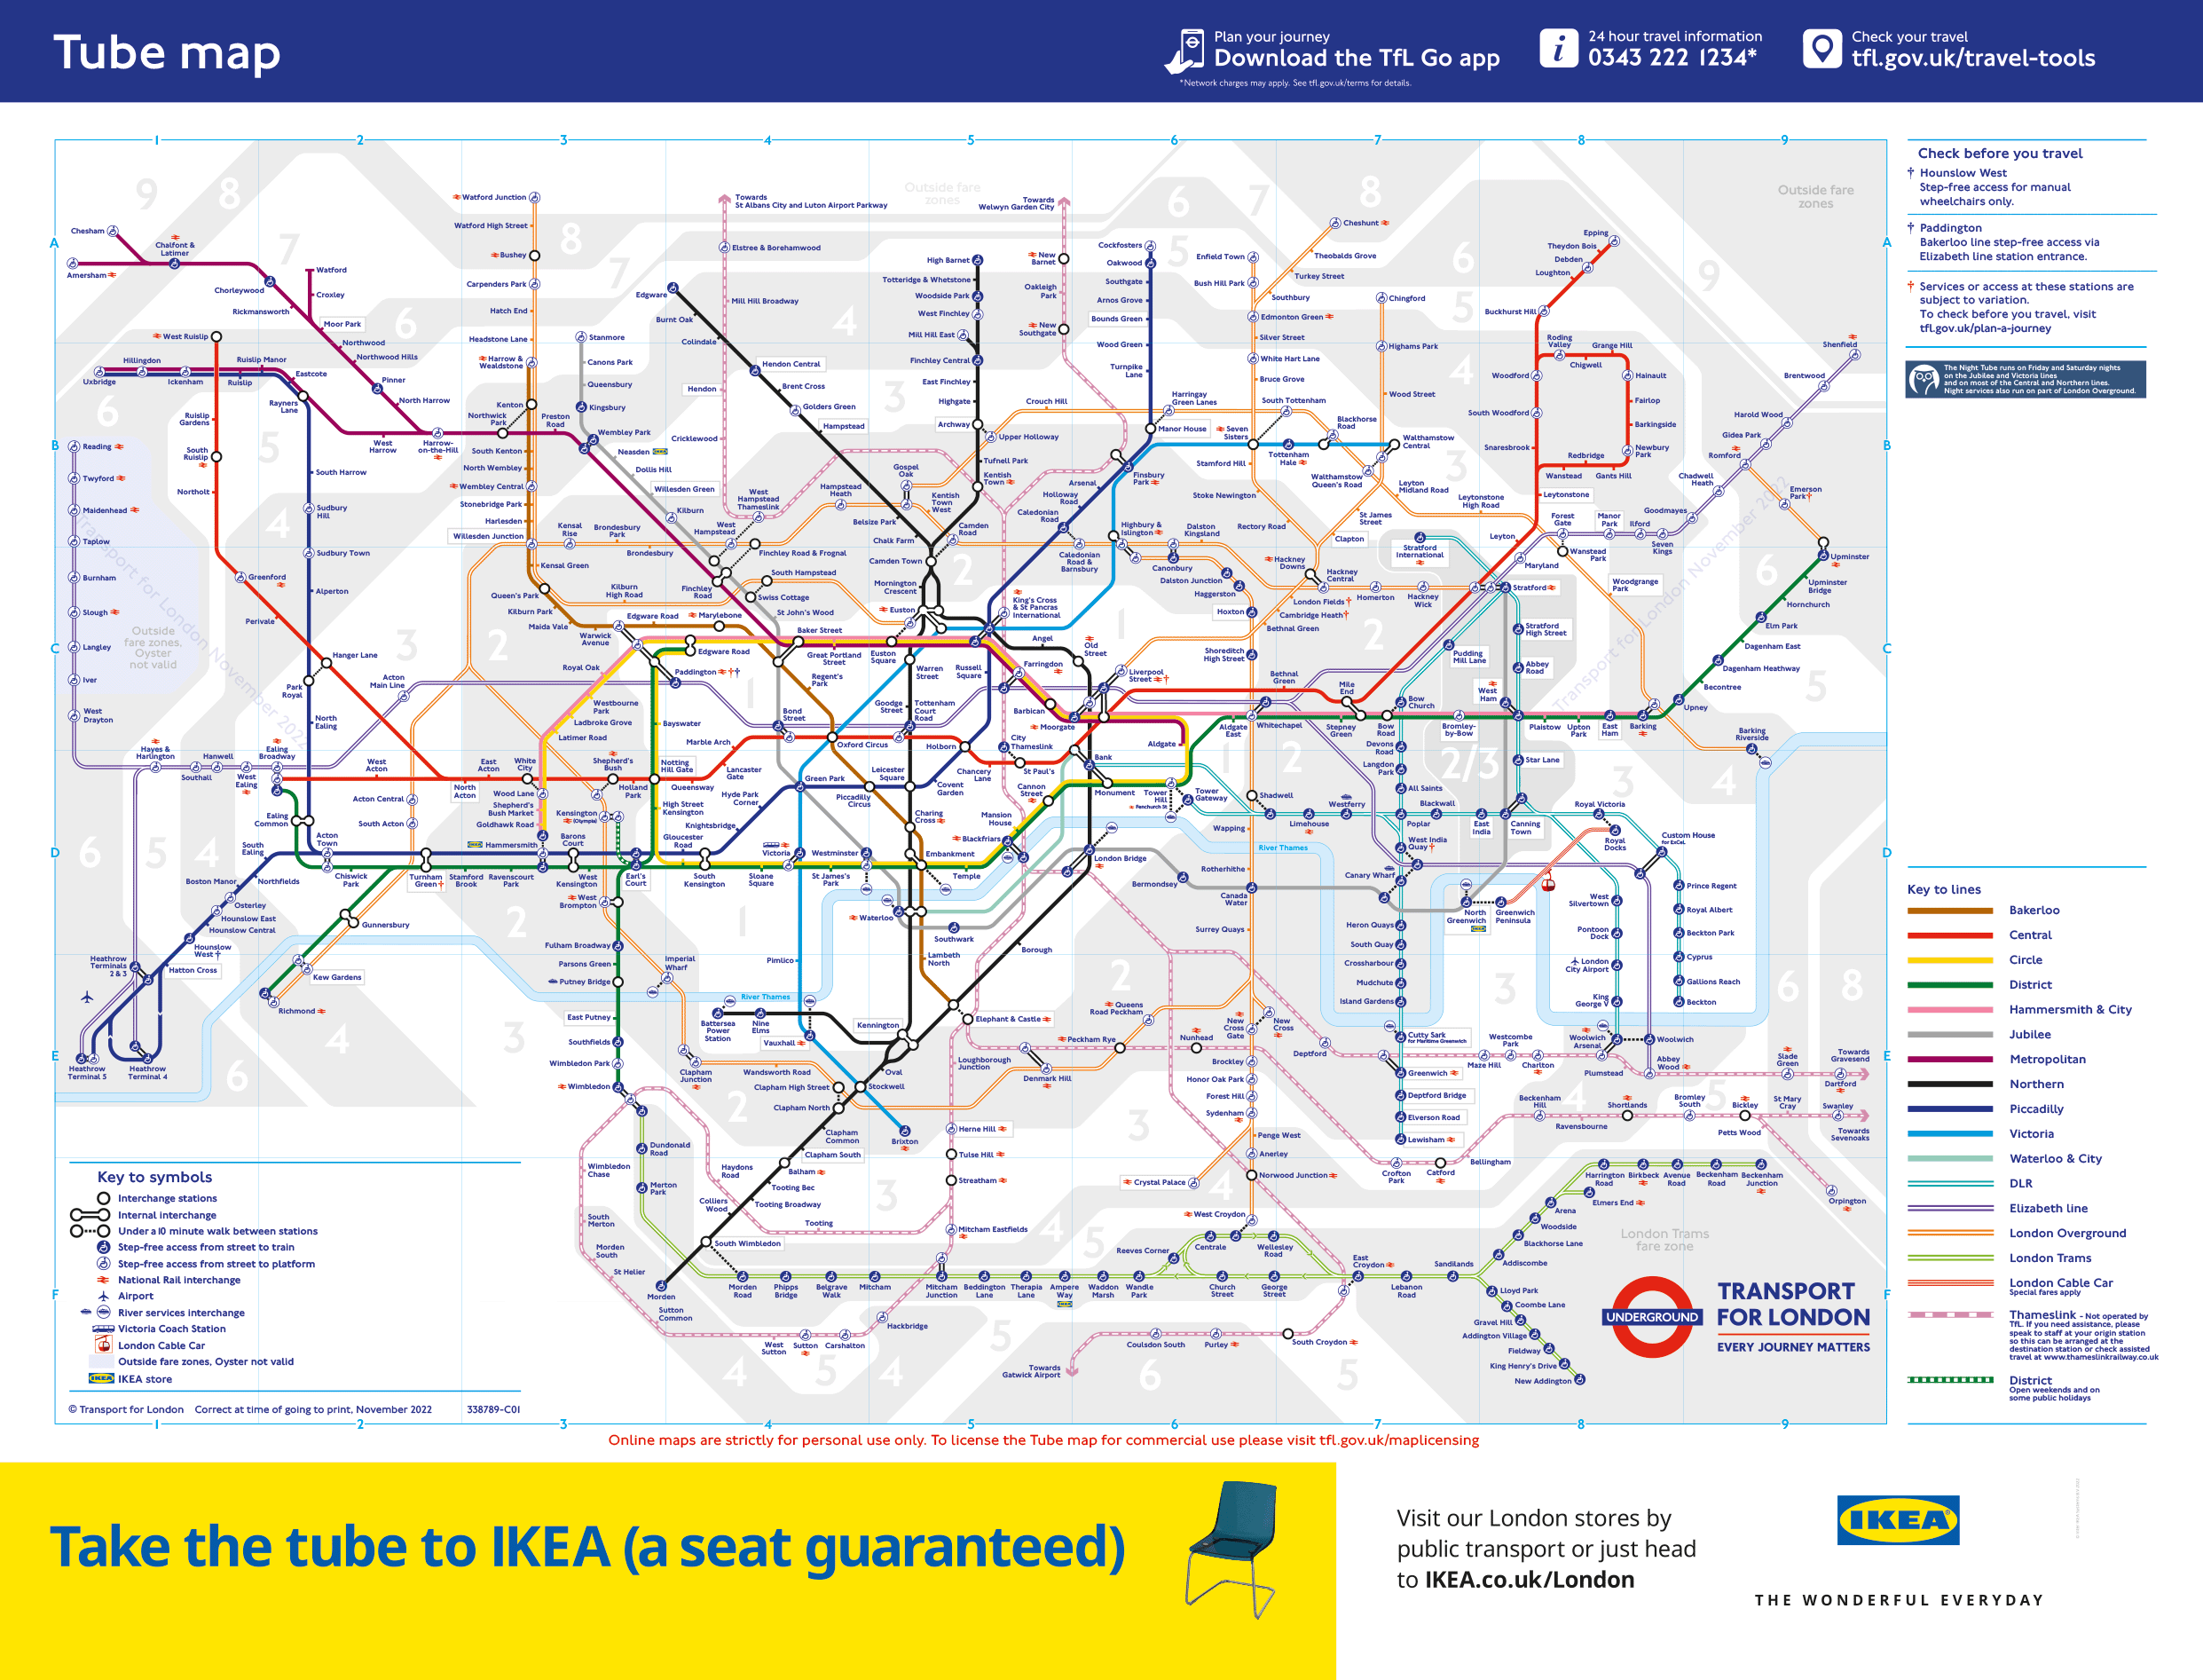
In the most literal sense, Information Design has fundamentally shaped the world and how we understand it through the means of wayfinding. Effective wayfinding is not only intuitive and unobtrusive, but also planned to suddenly “appear” where and when we need it (McFarland, 2021). In particular, the London Tube map serves as an excellent example of intuitive wayfinding. The information is streamlined so that only the necessary parts are being highlighted. In sacrificing the acute accuracy of the train paths, Harry Beck created a perfect manual for the maze of the underground. Commuters are easily able to pick out their route, even if they have never interacted with the map before. It is particularly important due to the vast amount of tourists who find themselves travelling on the Underground daily, some of whom are bound to have a limited understanding of the language.
Figure 2: Standard Online Tube Map (2022)
Roundabout designs are also about wayfinding, and aid both the local community and visitors in navigating. I want to focus on those signs in particular because of the significant application of information design to what could be a complex idea to understand, both to new drivers and those unfamiliar with the road rules in the UK. No matter how complex or simple the structure of the roundabout might be, the components remain similar, clearly indicating each turn and further using the established convictions of signage to clearly illustrate directions.
We actively seek to reinforce our beliefs and biases through the way we understand and construct our own hypotheticals. Cigarettes are an example of this: the contrast between past and present packaging reinforces a newfound negative bias towards smoking.
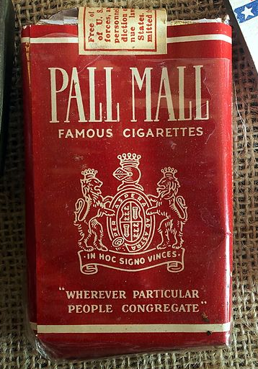
Figure 3: Old Pall Mall Cigarette packaging (1944)
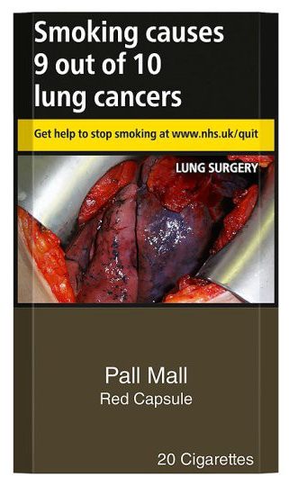
Figure 4: Pall Mall cigarettes in the standardised “plain” packaging
At first cigarette packaging was purely aesthetic, it served to draw the eye of a consumer and differentiate between brands. The bright colours were eye catching and meant to suggest the idea of luxury. However, as the adverse effects of smoking were discovered, the packaging took a turn in line with new information. The design now reflects the dangers of smoking, being equal parts informative and a deterrent. The brand identity became secondary to the informative principles of deterring smoking-based health risks. Since the introduction of standardised packaging there has been a decline in the appeal of tobacco, particularly amongst adolescents. The data from UK Office for National Statistics shows a 1.7% decrease in the prevalence of smoking in persons aged 18 or over from 2016, when the standardised packaging was introduced in the united kingdom, to 2019. (Office of National Statistics, 2019). … The new approach to presenting tobacco also highlighted the harmful effects of smoking, to both the individual partaking and those around them. In tandem with new approaches to the ramification of smoking, the design shifted to a narrative in which tobacco was no longer presented in a favourable light, firmly cementing itself as an example of Information Design seeking to shape the world for the better. One could argue that the implemented change was not of any real importance, seeing as smoking is still prevalent, despite the often-graphic images now strongly associated with the cigarette packaging and the illicit warnings predominantly featured throughout. Contradicting this, the data from UK Office for National Statistics shows (2019) that in just 3 years there is already a visible difference in the rates of smoking, proving the effectiveness of applied information design Considering the long history of the tabaco industry, the progress is astonishing.…. However, assuming this were correct and that the importance of information design could still be challenged as its impact can be hard to perceive overall, a consideration of future effects undermines this. When one looks at it as a means of preventing a new generation of smokers rather than an attempt at encouraging those who already were in the habit, it appears far more successful. Through removing the prestige of cigarettes and replacing it with the unfortunate truth of the dangers of continued consumption of many harmful substances, the new design discourages younger individuals from taking up the habit in the first place.

Moreover, Information Design does not only reinforce new conditions, but plays to existing ideals. Information Design needs to be tailored to audience as it plays an instrumental role in the transaction of knowledge. In many cases, it needs to be easy to understand, even more so in the early stages of education. Taking the ‘Catch it, Bin it, Kill it’ campaign poster as an example of a resource that would be presented to younger children, in the efforts to contain the flu outbreak, its simple layout leans into the design discipline of tailoring information to an audience. In this context, a classroom. It is laid out simply, highlighting simple steps that would be easy to follow for young children. Yet again, pictograms depicting the commands greatly aid in the broadcasting of the message, leaving nothing uncertain. At the same time, the poster would not be out of place in a more mature setting, showing that appropriate information design is applicable in any situation as long as it is fullfilling its function.
Figure 5: Catch it, Bin it, Kill it, campaign poster (2020)
One of the other primary points of importance in how information design aids our understanding of the world is its involvement in sharing information between generations. While sharing information has always been crucial in survival and development, it is the sharing of information between generations that has allowed us to progress politically, societally, and economically. How information is passed down, particularly through the process of education, has a great impact on how each new generation constructs views on the world. Furthermore, the way information is presented when imparted to students has potential to influence their perceptions which, consequently, would influence how they reciprocate the information when it is their turn to do so. Information design plays an instrumental role in the transaction of knowledge because it needs to be easy to understand, even more so in the early stages of education. For children to be able to progress to deeper levels of understanding on any topic they must first be able to grasp the basics so any further knowledge has a foundation to build from. How solid that foundation is wholly depends on the quality and design of the information.

To further investigate the impact of information design on education and consequently how each new generation comes into a clearer understanding of the world, it is imperative to consider tools used to streamline the knowledge we seek to pass down. There are always several solutions to a design problem, and through choosing to put focus on a more widely accepted one, there is an opportunity to scrutinize importance of the applied information design more accurately. One tool that has been used reliably in all levels of education is Microsoft PowerPoint. The use of PowerPoint slides has been prevalent in business settings ever since its introduction by Robert Gaskins in the late 80’s and later, when computers were introduced to classrooms, in educational settings as well. The effects of its introduction in any setting is undeniable, having revolutionised the way information was being presented, greatly simplifying the process. PowerPoint offered a better alternative to cumbrous projectors and finnicky acetate sheets, marking the progression of digital resources over older, less efficient methods.
With a particular emphasis on the use of PowerPoint in the setting of a classroom, there is an observed duality to its effect on the sharing of information. On one hand, it allows for more accessibility and has the potential of allowing a more engaging presentation. On the other hand, there is a fine line between successful information design and an overwhelming stream of indistinguishable data. There is a range of limitations, however it is ultimately a useful tool in imparting knowledge. As Worthington and Levasseur point out in the 2015 Computers & Education Journal, ‘practically any help a professor can provide with regard to course notetaking is likely to enhance student achievement levels.’ Though it can be argued that areas where the use of presentations in an educational setting has proven ineffective can be attributed to the presenter rather than the inherent nature of the presentation itself. An overwhelming amount of information on a slide will only discourage students. Ultimately this example proves that Information design principles need to be applied correctly to be most effective and that improper application can lead to an adverse effect.
In conclusion, Information Design is important because information, and in particular the sharing of it, has shaped civilizations. It has greatly influenced our understanding of the world and through it, shaped the world itself. Its influence is both subtle, in the way it has silently orchestrates public viewpoints, and equally implicit, in the information meant to be seen en masse, moulding every step of the advancements of civilizations, from the humble beginnings on cave walls to sophisticated digital systems.

Bibliography
Barrat, M., et al About: Information Design In Brief. Available at: https://www.gdrc.org/info-design/XRM.pdf (Accessed 20/11/2022)
Bergemann, D., et al. (2018). The Design and Price of Information. The American Economic Review, 108(1), 1–48. Available at: https://www.jstor.org/stable/26527944 (Accessed 11/11/2022)
Britain:, G. (2007). Know your traffic signs. The Stationery Office.
Clarke, A, et al. (2015) Understanding What We See: How We Derive Meaning From Vision, Trends in Cognitive Sciences, 19(11), 677-687 Available at: https://www.sciencedirect.com/science/article/pii/S1364661315001989 (Accessed 20/11/2022)
Klett, F. (2002). Visual Communication in Web-based Learning Environments. Journal of Educational Technology & Society, 5(4), 38–48. http://www.jstor.org/stable/jeductechsoci.5.4.38 (Accessed 27/11/2022)
Folkmann, M. N. (2013). A Phenomenology of Imagination in Design. In The Aesthetics of Imagination in Design (pp. 81–94). The MIT Press.
Gaakeer, J. (2019). Control, Alt, Delete?: Information Technology and the Human. In Judging from Experience: Law, Praxis, Humanities (Vol. 1, pp. 249–269). Edinburgh University Press.
García-Martínez, I. et al (2021) Impact of the provision of PowerPoint slides on learning. In Computers & Education. Vol. 173. Available at: https://www.sciencedirect.com/science/article/pii/S0360131521001603 (Accessed 27/11/2022)
Jones, A. M. (2003) The use and abuse of PowerPoint, In Teaching and Learning in the Life Sciences: A Personal Overview, Bioscience Education, 2:1, 1-13, Available at; https://www.tandfonline.com/doi/full/10.3108/beej.2003.02000004 (Accessed 27/11/2022)
Katz, J. (2012). Designing information human factors and common sense in information design. Hoboken, N.J: John Wiley & Sons, Inc.
Marshall, C. (2018) Discover Isotype, the 1920s Attempt to Create a Universal Language with Stylish Icons & Graphic Design. Open Culture, December 21 2018 [blog] available at: https://www.openculture.com/2018/12/isotype.html (Accessed 4/12/2022)
McFarland, P. (2022) What to consider while designing a successful signage system, HGA. Available at:https://hga.com/what-to-consider-while-designing-a-successful-signage-system/ ‘(Accessed 4/12/2021)
Medeiros, I. Thoughts on design, technology and culture. Available at: https://www.designative.info/about/what-is-information-design/ (Accessed 13/11/2022)
Office of National Statistics (2019) Adult smoking habits in the UK: 2019 Available at: https://www.ons.gov.uk/peoplepopulationandcommunity/healthandsocialcare/healthandlifeexpectancies/bulletins/adultsmokinghabitsingreatbritain/2019 (Accessed 5/12/2022)
O’Neill, Jesse. Book Review – Isotype: Design and Contexts 1925–1971, Architectural Theory Review 19:2 (2014), pp. 259–262 Available at: https://www.tandfonline.com/doi/full/10.1080/13264826.2014.968954?needAccess=true (Accessed 4/12/2022)
Owen, C. L. (1991). Design Education in the Information Age. Design Issues, 7(2), 25–33. Available at: https://doi.org/10.2307/1511404 (Accessed 11/11/2022)
Redish, J. C. (GINNY). (2000). ‘What Is Information Design?’ Technical Communication, 47(2), 163–166. Available at: http://www.jstor.org/stable/43748847 (Accessed 11/11/2022)
Shreeya, P. (2018) ‘What’s the impact of Design, you ask?’ Medium, May 31 2018 [blog] Available at: https://uxdesign.cc/whats-the-impact-of-design-you-ask-31922d394956 (Accessed 13/11/2022)
Tomboc, K. (2019) ‘What is Information Design and Why It Matters Now More Than Ever’ Easelly, April 10, Available at: https://www.easel.ly/blog/what-is-information-design/ (Accessed 20/11/2022)
Worthington, D.L. et al (2015). To provide or not to provide course PowerPoint slides? The impact of instructor-provided slides upon student attendance and performance. Computers & Education, 85, pp.14–22. Available at: https://doi.org/10.1016/j.compedu.2015.02.002 (Accessed 4/12/2022)
List of figures:
Figure 1: Glancey, J. (2014), The genius behind stick figure toilet signs, BBC, Available at: https://www.bbc.com/future/article/20140911-the-genius-of-toilet-signs (Accessed 5/12/2022)
Figure 2:Transport for London, (2022), Tube, Available at https://tfl.gov.uk/maps/track/tube (Accessed 5/12/2022)
Figure 3: Beem, A. ,Photographed at the Museum Winter 1944 in Gingelom, Belgium. (27 July 2016) 17:02:43 Available at: https://commons.wikimedia.org/wiki/File:Pall_Mall_cigarette_pack,_Museum_Winter_1944_in_Gingelom.JPG (Accessed 5/12/2022)
Figure 4: ash, (2017) Counting down to standardised “plain” packaging of cigarettes, [blog] Available at: https://ash.org.uk/media-centre/news/blog/counting-down-to-standardised-plain-packaging-of-cigarettes (Accessed 5/12/2022)
Figure 5: Infection Prevention Control (2020) Catch it, Bin it, Kill it Poster. Available at: https://www.infectionpreventioncontrol.co.uk/resources/catch-it-bin-it-kill-it-poster/ (Accessed 5/12/2022)
‌

