University of Wales Trinity Saint David
Wales Institute of Science and Art


Engineering Project Technical Report

Engineering Applications & Study Skills ACHA4007

Dewi Miller
2112045
October 2022

Contents
1. Introduction 1
2. Project Developments 2
2.1 Flow chart 3
3. Health and Safety Legislation and Standards 3
4. Environmental & Sustainability Considerations 4
Conclusion 5
References 6

Introduction
As the project leader, the first step would be to clearly define the objectives and requirements for the new mountain bike equipment. This would involve consulting with relevant stakeholders, such as professional mountain bikers, to understand their needs and preferences.
Once objectives and requirements establish themselves, the next step would be to develop a plan for the design and development of the equipment. This would involve creating and testing a prototype to ensure that it meets the required standards and specifications.
Throughout the development process, we will consider the potential risks associated with the final product. This includes ensuring compliance with health and safety legislation and conducting thorough testing to mitigate potential hazards.
In addition to these considerations, we will also be looking at ways to improve the sustainability of the product and the manufacturing process. This will involve sourcing materials from sustainable sources and considering recycling options for any waste materials.

Project Developments
There are several key steps that I would recommend for ensuring the smooth and successful execution of a mountain bike project:
- Define the problem: before beginning any project, it is crucial to clearly define the problem or challenge that needs to be addressed. This might involve conducting market research, gathering input from stakeholders, or identifying the potential risks or challenges that need to be mitigated.
- Develop a plan: Once the problem has been clearly defined, the next step is to develop a plan for addressing it. This might involve creating a project charter, identifying milestones, setting budgets and timelines, and identifying the resources and personnel needed to complete the project.
- Assemble a team: A diverse and skilled team is essential for the success of any project. When assembling a team for a project, it is essential to consider the specific skills and expertise needed to complete the project, as well as the personalities and team dynamics of each team member.
- Communicate effectively: good communication is key to the success of any project. This includes setting clear expectations, establishing channels for ongoing communication, and ensuring that all team members are kept informed about the progress of the project.
- Monitor progress and adapt as needed: As the project progresses, it is essential to regularly monitor progress and make any necessary adjustments to the plan as needed. This might involve adjusting budgets or timelines, reassigning tasks, or bringing in additional resources as needed.
- Review and evaluate: Once the project has been completed, it is vital to take the time to review and evaluate the results. This might involve conducting a formal post-project review, fathering feedback from team members and stakeholders, and identifying areas for improvement in future projects.

Overall, the key to a successful mountain bike project is to clearly define the problem, develop a thorough and well-thought-out plan, assemble a skilled and diverse team, communicate effectively, and continuously monitor and adapt as needed.

2.1 Flow chart
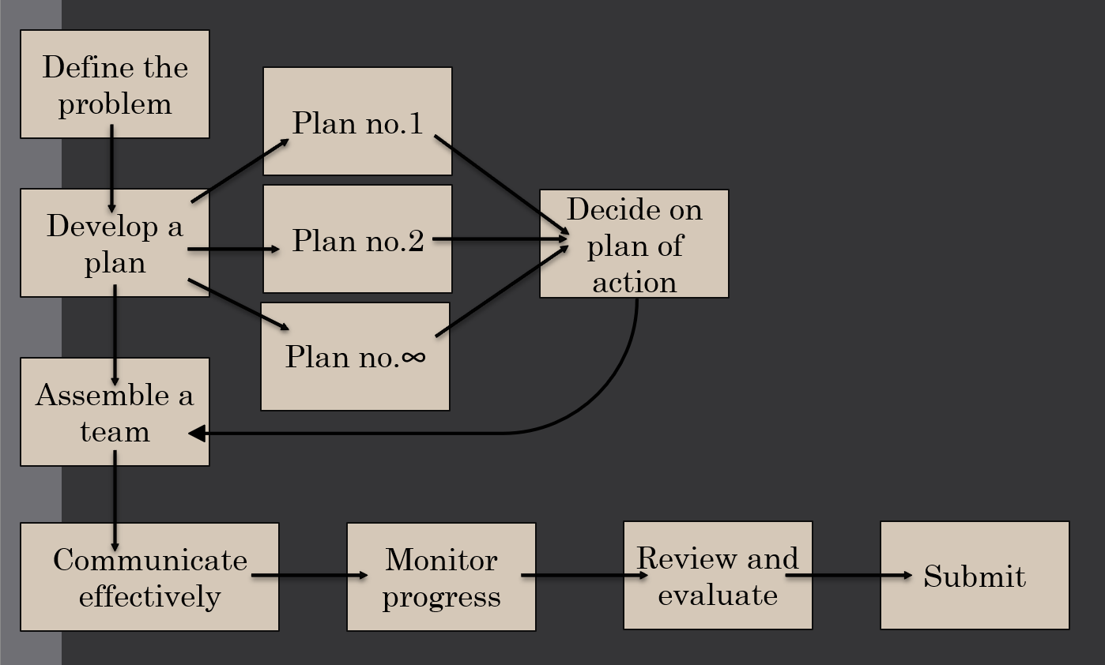

3. Health and Safety Legislation and Standards
Health and safety legislation and standards are essential because they help to protect the well-being of individuals and prevent accidents and injuries in the workplace. They ensure that companies are aware of the risks and hazards present in their product and take appropriate measures to avoid and minimize them. These laws and standards also ensure that products are safe and compliant with the relevant regulations, which helps to reduce the risk of injury. Additionally, adhering to these regulations can improve the overall reputation of a company and increase consumer confidence in its products.

- The Consumer Product Safety Act (CPSA) requires that mountain bikes meet safety standards to protect consumers from injury or death.
- The CPSA requires that mountain bikes undergo testing to ensure they meet safety standards.
- The CPSA regulates the manufacture, import, distribution, and sale of consumer products, including bicycles. The CPSA requires that all bicycles be free from defects that could cause injury to the user.
- In accordance with the Road vehicles (construction and use) regulations 1989, all bicycles must be equipped with at least one efficient brake, a horn or bell, and a rear reflector.

Additionally, the pedal cycles (Construction and Use) regulations 1983 state that all bicycles must have a white front light, a red rear light or reflector, and a yellow reflector on the pedals if they are used on the road at night.

4. Environmental & Sustainability Considerations
There are several ethical considerations that must be considered when producing a mountain bike.
- Working conditions: It is crucial to ensure that the factory workers who are responsible for producing mountain bikes are working in safe and fair conditions. This includes providing proper protective equipment and paying fair wages.
- Social responsibility: Mountain bikes are often produced in developing countries, and it is essential to consider the impact that production has on the local community. This could include investing in education and training programs or supporting local businesses.
- Consumer safety: Ensuring that the mountain bike is safe for the consumer is crucial. This includes conducting thorough testing and inspections to ensure that the bike meets all necessary safety standards.

The production of a mountain bike can have a variety of environmental impacts, depending on the materials used and production processes employed. Some of the critical areas where the production of a mountain bike can potentially impact the environment include:
- Raw material extraction and processing: The production of a mountain bike requires a variety of raw materials, including metal, plastics, and rubber. Extracting and processing these raw materials can have environmental impacts, such as air and water pollution and habitat destruction.
- Manufacturing and assembly: The manufacturing and assembly of a mountain involves a number of processes that can have environmental impacts, such as energy consumption, water usage and waste generation, for example jet cutters have a high use of water when cutting the material when manufacturing pieces.
- Transportation: The transportation of raw materials, components, and finished products can also contribute to environmental impacts, through the use of fossil fuels and the generation of greenhouse gases.
- Use and disposal: The use of a mountain bike can also have environmental impacts, such as the generation of air pollution from the burning of fossil fuels and the wear and tear on trails and other natural environments. The disposal of a mountain bike at the end of its life can also have environmental impacts, depending on how it is disposed of and whether it is recycled or disposed of in a landfill.
Overall, the environmental impact of the production of a mountain bike can be minimized through the use of sustain materials and production processes, as well as through the implementation of effective recycling and disposal programs.
The are many sustainability considerations that arise when producing mountain bikes, some issues include:
- Energy consumption: The production of a mountain bike requires significant energy inputs, which can come from fossil fuels that contribute to climate change. Additionally, transportation of raw materials and finished products can also contribute to greenhouse gas emissions.
- Waste generation: The production of a mountain bike generates waste in the form of scraps and offcuts from raw materials, as well as packing materials. Proper disposal of this waste is important to prevent pollution and minimize environmental impacts
To address these sustainability concerns, mountain bike manufactures can adopt practices such as using recycled material, optimizing energy efficiency, implanting waste reduction strategies, and using environmentally friendly chemicals.

Conclusion
In conclusion it is important for the project leader to consider the potential risks associated with the mountain bike equipment and ensure compliance with health and safety legislation and standards. This includes conducting thorough testing to mitigate any potential hazards and adhering to regulations such as the Consumer Product Safety Act. By doing so, the project leader can reduce the risk of injury and improve the overall reputation and consumer confidence in the product. It is also essential to consider sustainability in the design and development of the mountain bike equipment, including sourcing materials from sustainable sources and considering recycling options for waste materials. By following these steps, as the project leader I can ensure the smooth and successful execution of a mountain bike project.

References
(institute, 2017)
(H, 2017)
(Lewis, 2017)
(gov, n.d.)
(Road Vehicles (Construction and Use) regulation , 1986)
(Pedal Cycles (Construction and Use) Regulations, 1983)

