University of Wales Trinity Saint David
School of Engineering
Designing a race car rear wing: Fluid flow assessment
Viktoria Berces
1908705
BEng (Hons) Mechanical and manufacturing Engineering
29/06/2023
Structural & Fluid Analysis
ACMA 6010

Table of Contents
List of figures 3
1 Introduction 4
2. Discussion of Reynolds number 5
3. Discussion of boundary flow around the wing 10
4. Applicability of carbon fibre reinforced plastic 14
5. Modelling techniques 18
6. Prototype producing and testing 22
7. Conclusion 24
References 25

List of figures
Figure 1 - Boundary layer over a flat surface and transition from laminar to turbulent flow 9
Figure 2 - Inverted aerofoil 10
Figure 3 - Stream lines of rear wing 12
Figure 4 – Structure of CFRP 14
Figure 5 - Properties of CFRP 14
Figure 6 - Boundary layer over smooth (a) and rough surfaces (b) 15
Figure 7 - Mesh model of Formula 1 car 17
Figure 8 - Closed wind tunnel 19
Figure 9- Open return wind tunnel 20
Figure 10 - Porous floor and suction method 21

1 Introduction

The objective of this study is to consider the factors involved in the design of a wing for a racing car, including the geometric design of the wing, and the implications on fluid flow around the wing. Also, consideration of the materials of construction, potential experimental methodologies and modelling techniques which could be used to evaluate the effectiveness of the design.

2. Discussion of Reynolds number

The Reynolds number is used to determine whether the fluid flow is laminar or turbulent. A dimensionless number. The ratio of inertial force to viscous force.
It is intended to express the relationship between fluid flow and inertial forces and viscous forces.
Laminar or layered flow is the flow in which the particles flow without mixing, next to each other, on unique and permanent paths, without breaking the layers. So, the velocity vectors are parallel to each other, but the magnitudes differ from layer to layer. Laminar flow typically occurs at low speeds. This flow is timeless at the molecular level.

Turbulent is the flow in which the trajectories of the particles mix, i.e., intersect, due to changes in their speed and direction. Flow is chaotic due to rapid changes in pressure and velocity. The trajectory curves of the molecules and the streamlines are not identical to each other. Unlike laminar, turbulent is only time-resistant on a large scale.

When laminar flow transitions into turbulent flow, it is called transitional flow or laminar-turbulent transition.
A higher Reynolds number shows that inertial forces have a greater influence on the flow, while at a lower Reynolds number, viscous forces have more influence on the flow.

If the Reynolds number is below 2300, then the flow can be called laminar, while the transition to turbulent can be placed between 2300 and 4000. For values above 4000, the flow is considered turbulent.

The Reynolds number is determined using the following formula.

$$Re=\frac{u*l*ρ}{μ}$$

Velocity multiplied by length and density then divided by dynamic viscosity. The other formula that can also be used is the product of velocity and length divided by the kinematic viscosity.

$$Re=\frac{u*l}{v}$$

Kinematic viscosity can be expressed as the ratio of dynamic viscosity to density.

$$v=\frac{μ}{ρ}$$

The flow around the rear wing is determined by calculating the Reynolds number. To determine this number, three different speeds were assumed.

In the calculation, the assumed speed is 200 kph (1124 mph). This speed was chosen as this is the average speed of a Formula 1 car. The air temperature was assumed to be 20 degrees Celsius, while the pressure was assumed to be 1 atmospheric.
The significant length was determined to be 900 mm based on the attached CAD model.

$u=55.6m/s$;
$l=0.9 m$;
$ρ=1.204 kg/m^{3}$;
$μ=1.8250*{10}^{-5} kg/ms$;

$$Re=\frac{55.6*0.9*1.204}{1.8250*{10}^{-5}}$$

$$Re=3301269$$

It can be concluded that at a speed of 200 kph the flow is turbulent.

The second formula used to determine the Reynolds number was used to verify the above calculations.
$$Re=\frac{u*l}{v}$$
The proof of the first calculation is as follows:
$u=55.6 m/s$;
$l=0.9 m$;
$$v=\frac{μ}{ρ}$$
$μ=1.8250*{10}^{-5} kg/ms$;
$ρ=1.204 kg/m^{3}$;

$$Re=\frac{u*l}{\frac{μ}{ρ}}$$
$$Re=\frac{55.6*0.9}{\frac{1.8250*{10}^{-5}}{1.204}}$$

$$Re=3301269$$

This formula was used to verify the previous calculation. Both calculations give the same results. It can be concluded that the first calculation was correct.

3. Discussion of boundary flow around the wing

The layer that forms next to the affected surface during the flow is called the boundary layer.
The speed of those particles that are in direct contact with the body will be zero. In this layer, the effect of internal frictional forces is significant.
The boundary layer theory is primarily attributed to Ludwig Prandtl.
According to the theory, if liquid particles come into direct contact with a flat surface, they slow down completely. However, as the particles get further and further away from the surface, their speed also increases proportionally to the distance.
Figure 1 – Boundary layer over flat surface (Aerospace engineering blog, 2016) below shows the variation of the thickness of the boundary layer on a flat surface.
The thickness of the boundary layer is the distance measured from the surface where the velocity of the flow inside the boundary layer differs by only 1% from the velocity of the external flow.
Sigma is the boundary line of the flow section where the effect of viscosity prevails.
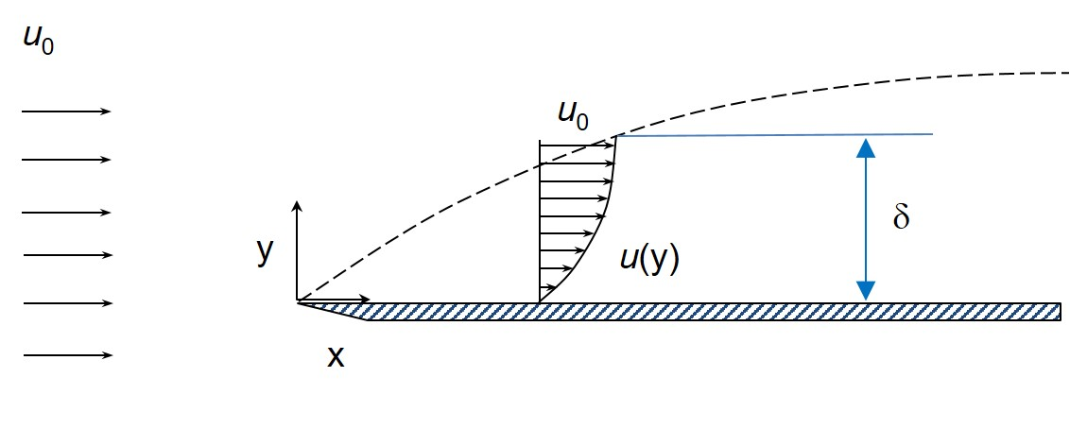
Figure 1 - Boundary layer over a flat surface and transition from laminar to turbulent flow

Close to the leading edge, the flow within the boundary layer is laminar, the thickness of this flow increases away from the edge, and as its stability decreases, it transforms into a turbulent flow.
When the airflow slows due to the position of the rear wing, the pressure increases.
In the area under the rear wing, the air flow accelerates, and this causes a decrease in pressure.
So, air speed and pressure are inversely proportional. Since the pressure is lower in the lower part of the rear wing and higher in the upper part, this creates a downward force.
So, basically, the purpose of the rear wings of racing cars is to create downforce, which improves the car's stability.
As it can be seen from Figure 2 – Inverted aerofoil (Seeniappan and Dhavamani, 2015), the rear wing is basically an inverted aerofoil, the purpose of which is to create downforce.
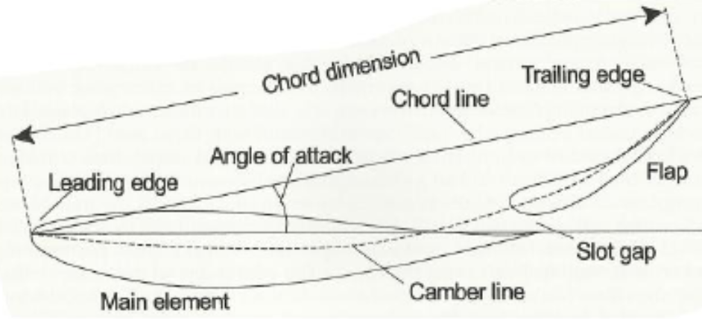
Figure 2 - Inverted aerofoil

The first part of the aerofoil is the so-called leading edge, which is the first to come into contact with the air. The rear part is the so-called trailing edge. The direction of travel of the air changes and deviates due to the encounter with the aerofoil.
In the upper part of the inverted aerofoil, the air follows the line of the aerofoil, while in the lower part the air is compressed as it comes into contact with the body. As the air reaches the trailing edge, it separates.
Benson (2019) notes that the venturi effect can be observed, i.e., if the air path is narrowed, the velocity increases and as the velocity increases perpendicular to the flow, the pressure decreases, as soon as the air rejoins the area with a larger cross-section, the velocity, and the pressure gradient decrease to the original value.
Since the pressure in the upper and front part of the inverted aerofoil is higher than in the lower and rear part, a downforce is generated.
Downforce arises as a consequence of Newton's third law. This can be interpreted (reference) as if the car is moving forward and diverts the air upwards, according to Newton's third law, i.e., the force-counterforce law, the air exerts a downward direction on the car.

A suitable design is important when designing the rear wing of a racing car, as the air moves from the high-pressure area, the upper part of the aerofoil, to the lower pressure area, i.e., the lower part of the aerofoil, as a result of which vortices are formed on both sides of the wing. To reduce these vortices, end plates are attached to the two sides of the rear wing.
With the use of end plates, high pressure will also be observed in the upper part of the rear wing, while the pressure around the end plates is low. As a result, vortices form again - as air flows from areas of higher pressure to areas of lower pressure.

To eliminate the vortices formed in this way, louvres placed on the end plates are used. The purpose of this is to equalize the pressure, so mix the high pressure at the top of the wing with the low pressure around the end plates. The purpose of the louvres in the lower part of the rear wing is also to equalize higher and lower pressure, thereby reducing vortices.
However, the mixed pressure generated in this way is lower than the pressure generated in the upper part of the rear wing, as a result of which additional smaller vortices are created.

The two notches in the back of the end plates are used to smooth out these smaller vortices. Since the pressure on both sides of the end plates is greater than the pressure on the lower part of the rear wing, the air flows from the outer area towards the lower part of the wing, creating vortices in opposite directions. The vortices created in this way balance each other with the vortices created around the louvres as it’s shown in Figure 3 – Streamlines of rear wing (Pangerl, 2018) below.
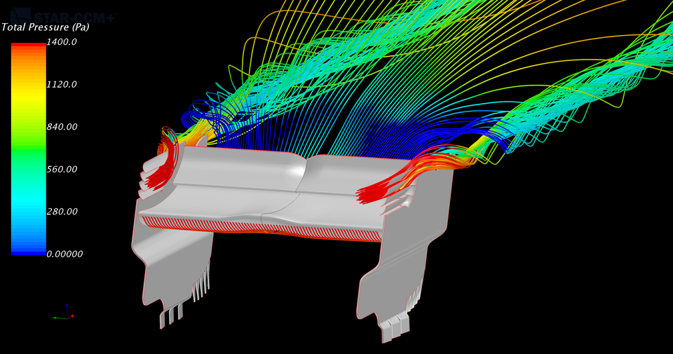
Figure 3 - Stream lines of rear wing

4. Applicability of carbon fibre reinforced plastic

According to Fentahun and Savaş (2018) when designing a racing car, it is important to strive to use materials that, in addition to complying with the regulations of the racing regulations, are light in terms of weight, thereby increasing the efficiency of fuel consumption. At the same time, the materials must have properties that enable them to absorb all the energy that is released in the event of a collision. Furthermore, it is important that the material is strong enough to resist deformation, and the appropriate thermal properties are also necessary.

Hong et al (2022) notes that in contrast to previous years, carbon fibre reinforced plastic is becoming more and more widespread due to the ever-increasing demands. This is also due to the fact that the use of components made of heavy metals used in automobile and aircraft production has been replaced by the use of elements made of other materials, such as polymer matrix composites.
Since carbon fibre reinforced plastics is a composite material, it consists of a combination of two elements, the matrix, and the reinforcement. In this composite material, carbon fibre is the component that gives it its strength. The material holding the carbon fibre element together is usually polymer resin. The properties of CFRP are determined by its two components.
In the case of CFRP, the reinforcement, i.e., carbon fibre, provides the necessary strength and stiffness characterized by stress and modulus of elasticity. The properties of carbon fibre are determined by the arrangement of the carbon fibre and its ratio to the polymer. (Handwiki, 2023)

As Liu et al (2015) notes, carbon fibres contain at least 90% carbon. These fibres can be produced from polymeric precursor materials, which have been transformed into carbon fibres using heat treatment and tensioning. Figure 4 – Structure of CFRP (Liu et al 2015) shows the structure of CFRP below.

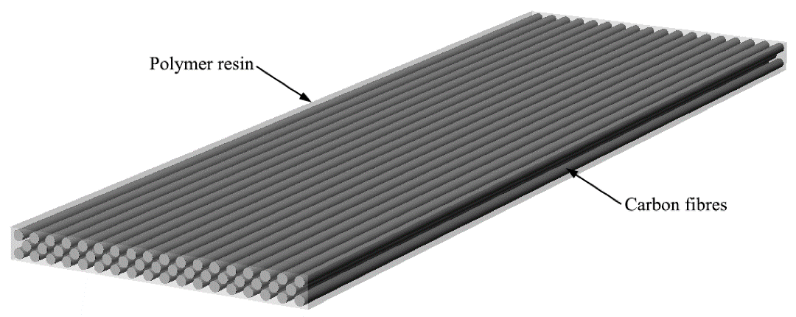
Figure 4 – Structure of CFRP

Bhatt and Goe, (2017) write in their article, carbon fibre has a high specific strength, which is strength to weight ratio. The stiffness of the material, characterized by Young's modulus, which is also high, so it is difficult to distort under high stress.
Carbon fibre is rust-proof and durable, but the materials that hold it together, such as epoxy, are sensitive to sunlight.
Its fatigue resistance property is also excellent. In terms of tensile strength, carbon fibre has good values.
Its thermal expansion values are low, so it does not expand or contract significantly under the influence of heat.
Figure 5 – Properties of CFRP (Quershi and Saleem, 2018) below illustrates the properties of CFRP.
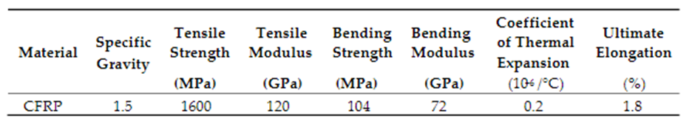
Figure 5 - Properties of CFRP

As Kadivar et al (2021) note machining the surface of CFRP can be problematic, however, having the right surface finish plays an important role. As Figure 6 – Boundary layer over smooth and rough surface (Kadviar et al, 2021) illustrates below, the surface roughness has an effect on the boundary layer.
In part "a" of the figure, you can see a boundary layer stretching over a smooth surface, where a so-called viscous sublayer is formed on the smooth surface.
The so-called buffer layer stretches between the turbulent layer and the previously mentioned viscous sublayer. Turbulence gradually appears further away from the body.
In contrast, as shown in part b of the figure, the roughness of the surface can lead to turbulence, which turns the viscous sublayer into a roughness sublayer, all of which affects pressure and heat transfer.

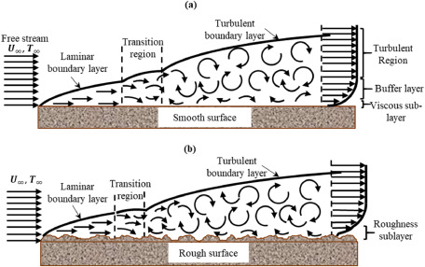
Figure 6 - Boundary layer over smooth (a) and rough surfaces (b)

A big advantage of CFRP is that different surface finishes can be achieved. In the case of the rear wing, the appropriate surface must be smooth, which can be achieved with CFRP.

5. Modelling techniques

There are two main methods for studying flow problems: CFD, i.e., Computational Fluid Dynamics and wind tunnel.
CFD became well-known in the 1960s as it can handle basic equations related to flow by involving physical phenomena. It plays an important role in all areas of fluid science. The development and spread of CFD is closely related to the development of the computer, especially the development of the processor, memory, and hardware.
The laws of conservation of mass, conservation of energy and conservation of momentum form the basis of simulation software.
During the application of CFD, the partial differential equations of the flow are replaced by numbers and these numbers are advanced in space and time, this gives the numerical description of the examined flow field.
In some cases, it is possible to solve the flow field instantaneously without time or space advance.
The advantage of CFD, in contrast to the wind tunnel, is that it is not necessary to build the model to be tested, but rather to create a 3D version of it. Another advantage of CFD is that during the simulation, information is available at any point in the range, while in the case of the wind tunnel, information is only available at those points where measuring instruments are placed.
Furthermore, in contrast to wind tunnel measurements, in the case of CFD simulation, the feasibility does not depend on the dimensions of the object to be tested, or the complexity of its geometry.
CFD is based on the Navier-Stokes equations that define fluid flow. By removing the viscous factors, Euler equations are obtained. Potential equations are obtained by removing the factors expressing vorticity.
The best method for determining the aerodynamic properties of the rear wing is CFD analysis.
CFD has 3 phases, pre-processing, processing, and post-processing.
During pre-processing, i.e., the first stage, the problem must be defined. It is necessary to add the geometry of the created 3D model to the software.
In the case of this rear wing, in order to get a more comprehensive picture, it is best if not only the wing, but also the 3D model of the whole car is used, with several simulations performed on it.
The calculation parameters must be determined, i.e., the variables that will be calculated with the simulation, such as speed, temperature, pressure, etc.
In this case, determining the airflow around the rear wing is the primary goal.

The boundary conditions must be defined on the geometry of the added model, in which calculation range the simulation will take place. So, it is necessary to define all bounding areas, it depends on the given calculation problem. In this case, especially when modelling the entire car, it is important that the bounding area is large enough.
During mesh generation, geometric shapes will be defined using different shapes, such as triangle, pyramid, tetrahedron, hexahedron. The first mesh created can be called the global mesh, which covers the entire domain. Then, during this refinement, the mesh is compressed in the areas where the parameters are expected to change, as shown in Figure 7 – Mesh model of Formula 1 car (F1 Framework, 2012) below.

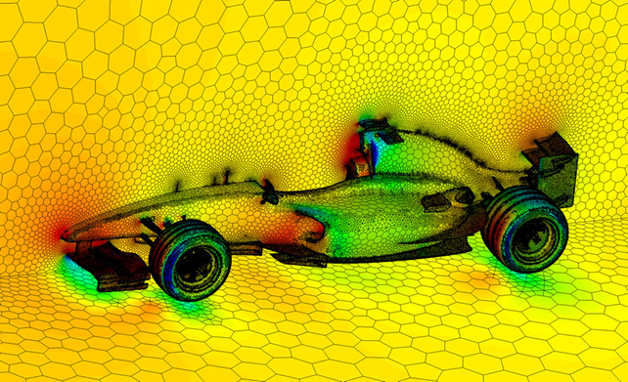
Figure 7 - Mesh model of Formula 1 car

Each cell of the generated mesh will contain the partial differential equations.
When using the solver, the specified problem is solved using the data provided during the pre-processing process.
CFD analysis usually takes more time than using a wind tunnel.
In the post-processing step, the obtained results are analysed. Graphs and plots can be used for easier understanding of the results.
Verification and validation are essential for CFD modelling. Verification ensures that the model and calculation are correct by checking the calculations against analytical results.
During validation, it is determined how closely the simulation matches real life.
If wind tunnel simulation data are available and their comparison with the data obtained by CFD simulation does not match, this may indicate that changes are needed to the parameters specified during the CFD analysis.

6. Prototype producing and testing

The basic purpose of the wind tunnel is to simulate the reaction between the bodies and the air stream. There are two types of wind tunnels, one is the so-called closed system and the other is the open system wind tunnel.
The characteristic of the closed wind tunnel is that it requires less energy for its operation (than the open system) because the same air circulates in the system, thus it does not lose its kinetic energy. As you can see from Figure 8 – Closed wing tunnel (National aeronautics and space administration, 2023) below, the closed system basically consists of a fan and a test area. The role of turning vanes is to create laminar flow. The role of the flow straightener is to make the flow through it as uniform as possible. In closed-system wind tunnels, the Reynolds number can be adjusted, as the system can be kept under pressure.
The disadvantage is that since the same air circulates in the system, it heats up as a result of its friction with the walls. As a result of the warming, the air loses some of its density, which affects the Reynolds number, so the characteristics of the transition from laminar to turbulent change.

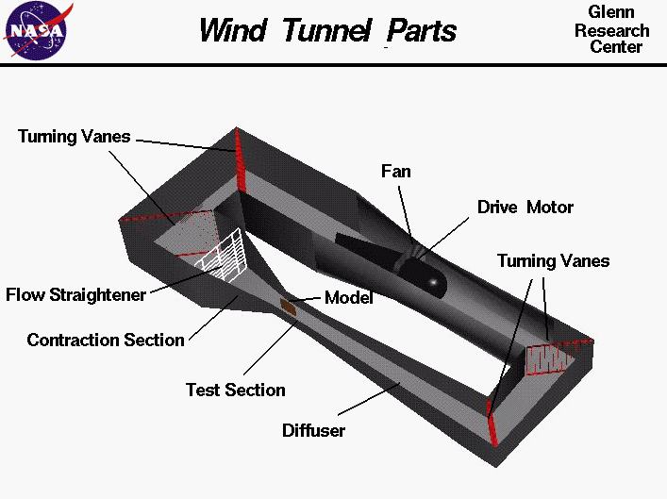
Figure 8 - Closed wind tunnel
Unlike a closed-system wind tunnel, an open-system wind tunnel requires more energy to operate because air moves from one end of the wind tunnel to the other and then leaves it, thereby losing kinetic energy. As you can see from Figure 9 – Open return wind tunnel (National aeronautics and space administration 2023), it gets the necessary air from the atmosphere, so dirt in the air can also enter the wind tunnel despite the filters used. Since it is an open system, it is not possible to keep it under pressure. Since it is open, the air does not circulate in it and the Reynolds number does not change, since the air does not heat up, so its density does not change either.
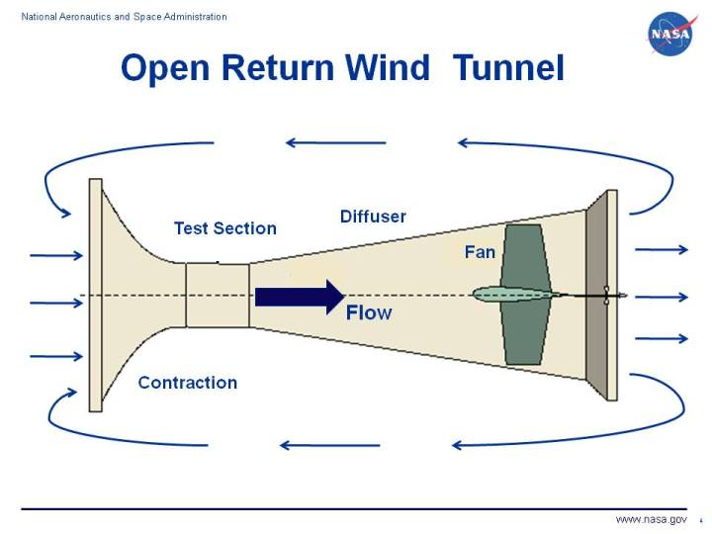
Figure 9- Open return wind tunnel

Three possible errors can occur during wind tunnel testing.
One of the problems is the so-called Reynolds number effect. The difference between full model and scale model testing is during the transition from laminar flow to turbulent flow. Due to the size differences of the two models, the transition takes place in a different area. In the case of a scale model, compared to a full model, the transition takes place in a more distant part of the body. When using a scale model, the Reynolds number needs to be modified.
The second problem is the so-called moving road problem. In wind tunnel testing, unlike in real life, the air moves relative to the car and the road, causing a boundary layer to form between the car and the road.
This problem can be solved by using a ground board. During this, the car is placed on the ground board, above the boundary layer. There is little boundary layer around the ground board leading edge, but this is negligible as long as the distance between the leading edge and the car is adequate, as well as the ground clearance. This solution is not suitable for racing cars due to the ground clearance.
The moving belt method can also be used which is suitable for race cars. During this, the floor is moved at the same speed as the air, so no boundary layer is formed. Various problems can occur during this application, such as ensuring that there is no vibration during the movement of the belt, and it moves smoothly. This can be eliminated by using a porous floor and suction. To avoid the formation of an effect between the wheels and the floor, as well as to separate the rolling resistance and drag, the solution can be the suspension of the car.

When separating the car and the wheels, the car is suspended from the roof while the wheels are secured separately. In this way, the forces acting on the wheels, such as rolling resistance or various vertical forces, are separated from the forces acting on the car.

As shown in Figure 10 – Porous floor and suction method (Formula1-dictionary, 2023), during the porous floor and suction method, the boundary layer between the car and the ground is eliminated, by suctioning into the chambers located under it.

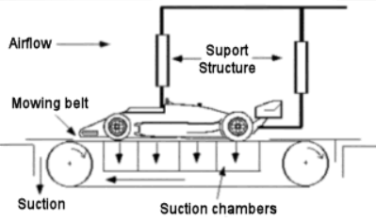
Figure 10 - Porous floor and suction method

The third problem with wind channels is the so-called blockage effect. With the initial opening of the duct, the air flows freely, however, as soon as an object enters the wind duct, the speed and direction of the flow changes. It follows from Bernoulli's principle and the law of conservation of mass that the flow accelerates if the available area decreases. The acceleration of the flow changes the Reynolds number, and it follows that the location of the transition from laminar to turbulent also changes. For this reason, the lift and drag coefficients get a higher value. This can be overcome by increasing the size of the wind tunnel, or by changing the shape of the wind tunnel to fit the object being tested.

7. Conclusion

This has found that understanding the properties of fluid flow can be used to effectively improve the performance of a racing car wing. Coupled with careful consideration of materials of construction and use of experimental and modelling techniques engineering principles can be applied to the design and analyse the performance of the wing.

References

- Aerospace engineering blog (2016) On Boundary Layers: Laminar, Turbulent and Skin Friction [Figure 1] Available at: https://aerospaceengineeringblog.com/boundary-layers/ (Accessed: 24/06/2023)
- Benson, M. (2019) The venturi effect explained. Available at: https://www.engineeringclicks.com/the-venturi-effect-explained/ (Accessed: 24/06/2023)
- Bhatt, P. and Goe, A. (2017) ‘Carbon Fibres: Production, Properties and Potential Use’, Material Science Research India 14(1) Available at: https://www.materialsciencejournal.org/vol14no1/carbon-fibres-production-properties-and-potential-use/ (Accessed: 23/06/2023)
- Fentahun, M. A. , Savaş, M. A. (2018). ‘Materials Used in Automotive Manufacture and Material Selection Using Ashby Charts’. International Journal of Materials Engineering. 8(3):40-54. Available at: http://article.sapub.org/10.5923.j.ijme.20180803.02.html. (Accessed: 16/06/2023)
- Formula1-dictionary (2023) Wind tunnel [Figure 10] Available at: https://www.formula1-dictionary.net/wind_tunnel.html (Accessed: 24/06/2023)
- F1 Framework (2012) F1 aero glossary [Figure 11] Available at: http://f1framework.blogspot.com/2012/08/f1-aero-glossary.html (Accessed: 24/06/2023)
- HandWiki. (2023) Chemistry: Carbon fibre reinforced polymer. Available at: https://handwiki.org/wiki/Chemistry:Carbon_fiber_reinforced_polymer#cite_note-2 (Accessed: 16/06/2023)
- Hong, H., Bae, K. J., Jung, H., Oh, Y., You, N. H., Lee, J. C., Yu, J. (2022) ‘Preparation and characterization of carbon fibre reinforced plastics (CFRPs) incorporating through-plane-stitched carbon fibers’, Composite Structures 284(15) Available at: https://www-sciencedirect-com.ezproxy.uwtsd.ac.uk/science/article/pii/S0263822322000150 (Accessed: 16/06/2023)
- Kadivar, M., Tormey, D and McGranaghan, G. (2021) ‘A review on turbulent flow over rough surfaces: Fundamentals and theories’, International Journal of Thermofluids, 21(10) Available at: https://www.sciencedirect.com/science/article/pii/S266620272100015X (Accessed: 23/06/2023)
- Kadivar, M., Tormey, D and McGranaghan, G. (2021) A review on turbulent flow over rough surfaces: Fundamentals and theories [Figure 7] Available at: https://www.sciencedirect.com/science/article/pii/S266620272100015X (Accessed: 23/06/2023)
- Liu, Y. , Zwingmann, B. and Schlaich, M. (2015) ‘Carbon Fiber Reinforced Polymer for Cable Structures—A Review’, Polymers 7(10). Available at: https://www.mdpi.com/2073-4360/7/10/1501 (Accessed: 16/06/2023)
- Liu, Y. , Zwingmann, B. and Schlaich, M. (2015) Carbon Fiber Reinforced Polymer for Cable Structures—A Review [ Figure 4]. Available at: https://www.mdpi.com/2073-4360/7/10/1501 (Accessed: 16/06/2023)
- Liu, Y. , Zwingmann, B. and Schlaich, M. (2015) Carbon Fiber Reinforced Polymer for Cable Structures—A Review [ Figure 5]. Available at: https://www.mdpi.com/2073-4360/7/10/1501 (Accessed: 16/06/2023)
- National aeronautics and space administration (2023) Wind tunnel parts [Figure 8] Available at: https://www.grc.nasa.gov/www/k-12/airplane/tunpart.html (Accessed: 23/06/2023)
- National aeronautics and space administration (2023) Open return wind tunnel [Figure 9] Available at: https://www.grc.nasa.gov/www/k-12/airplane/tunoret.html (Accessed: 23/06/2023)
- Pangerl, J (2018) F1 rear wing CFD study [Figure 3] Available at: https://grabcad.com/library/f1-rear-wing-cfd-study-1 (Accessed: 24/06/2023)
- Qureshi, H and Saleem, U. S (2018) Flexural and Shear Strain Characteristics of Carbon Fiber Reinforced Polymer Composite Adhered to a Concrete Surface [Figure 6] Available at: https://www.researchgate.net/publication/329795247_Flexural_and_Shear_Strain_Characteristics_of_Carbon_Fiber_Reinforced_Polymer_Composite_Adhered_to_a_Concrete_Surface (Accessed: 23/06/2023)
- Seeniappan, K., Dhavamani, R. (2015) Aerodynamic Effects on Formula One Car Using CFD [Figure 2] Available at : https://www.researchgate.net/publication/302412323_Aerodynamic_Effects_on_Formula_One_Car_Using_CFD (Accessed: 24/06/2023)
- Szucs, H. (2021) CFD-szimulacio folyamatanak kockazatelemzese. Műszaki Katonai Közlöny • 31(3) Available at: http://real.mtak.hu/131738/1/06_Szucs_89-100_MKK_2021_3.pdf (Accessed: 23/06/2023)

