|
Design and Implementation of a Relational Database System
Introduction to Web and Database Concepts
Luke Colwill
2528776
ACCA4023
2026
Table of Contents
Introduction 2
Design Process 3
ER Diagram 3
Normalisation 4
First form 4
Second normal form. 5
Third normal form. 5
Queries 5
Database implementation 5
Table design. 6
Validation rules. 9
Reflection. 10
Final Thoughts 10
Referencing 10

Introduction
EcoRider is an electric bike rental scheme that has been introduced by the local authority to encourage a greener and more sustainable mode of transport. The service allows registered riders the opportunity to cycle between locations. As the service gains popularity, a database is required to maintain the business needs.
The database Is needed to help hold information on the riders and asset tag the equipment purchased by the local authority. The database will be a benefit in ensuring the quality of service provided is of a high standard and ensuring the local authority’s assets are tracked and maintained correctly.
The aim of this report is to address the challenges and implement a database that is operational and provides the local authority with a system for storing and managing information about its riders.
The report will present the complete database development process, including the identification of system requirements including the entity relationship model, relationships of the database design, sample data and example queries. The completed database demonstrates how a well designed system can help improve efficiency, reliability and scalability of the EcoRider rental scheme.

Design Process
The design process for the EcoRider database followed a structured approach to ensure that the system met the requirements and standards required by the local authority. The first stage of the design process involved creating an Entity Relationship Diagram (ERD). The ERD provided a visual representation of the database structure, showing the entities, attributes and relationships required to support the EcoRide rental scheme. This helped identify the business requirements and ensured that all necessary data could be stored efficiently while reducing duplication and maintaining data integrity. The ERD provides a strong foundation for a successful design and implementation of the database.
Once the database structure had been planned, Microsoft Access was selected as the software platform for developing the system. Microsoft Access was chosen because it provides an effective environment for creating databases, allowing tables, relationships, forms, queries and reports to be developed within a single application.
The tables were then created using appropriate data types and field properties to ensure that rider details, bike information, rental records and maintenance data could be accurately collected and stored. Primary keys and foreign keys were implemented to establish relationships between the tables and maintain referential integrity throughout the database.
Following the creation of the tables, user-friendly forms were designed to simplify access to the data entered and reduce the likelihood of errors. A main navigation page was also developed to allow users to access forms from a single location. This provides the local authority with a clear, professional and easy-to-use database system for managing riders, tracking assets and supporting the continued growth of the environmentally sustainable EcoRide rental scheme.

ER Diagram
To help with the design and implementation of the database a ER (Entity Relationship Diagram) was completed to identify the entities and attributes for the database. These entities will help the table designs of the database. The ERD helped with selecting the relevant entities Staff Information, Rider information, Maintenance information, Bike location and Depot location these entities will be used as tables in the data base design.
The ERD helped with defining relationships between the entities. For example, one bike could have many different maintenance records, and a rider could have multiple rentals. The benefits from identifying these relationships [1]

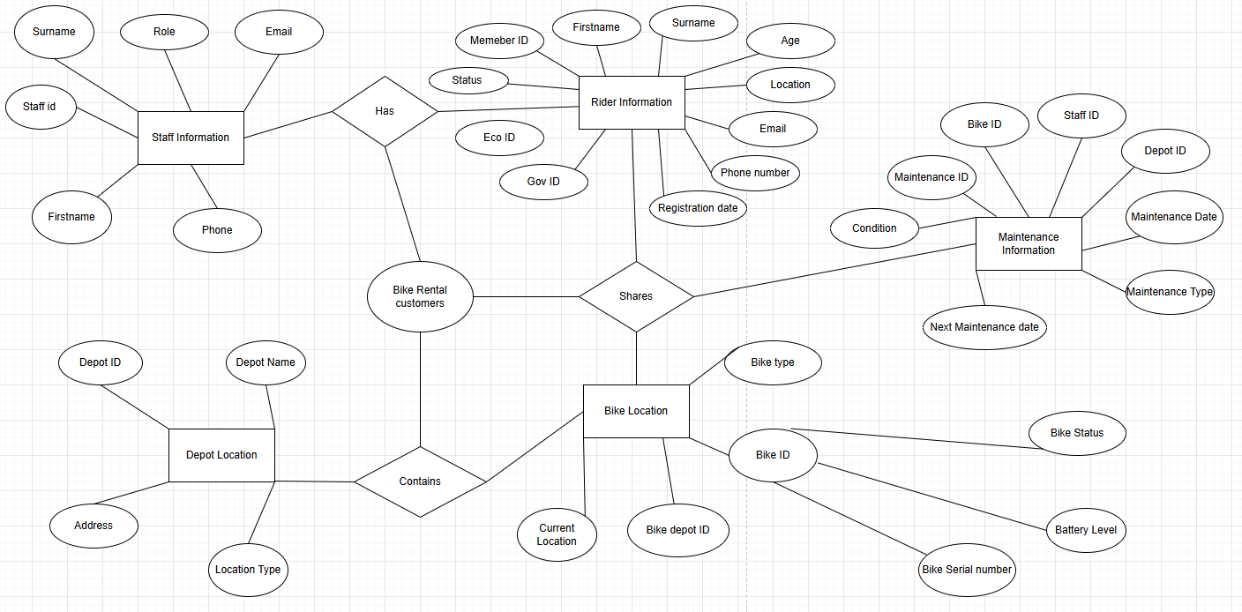
Figure 1ERD Entity Relationship Diagram

Normalisation
Normalisation is a database design process that aids with organising data into specific tables. The main benefits of data normalisation are to help minimise data redundancy and improve data integrity, making the database easier to maintain
Normalisation has different levels of criteria and rules called (normal forms) there are five normal forms, each with a set of rules that can be used to help with the structure of a database. During this design process third normal form has been used to achieve the specified task. Third normal form will provide the appropriate amount of organisation and keeping the data integrity.

First form
First normal form (1NF) is designed to ensure the databases tables are structured correctly making them easier to manage. To follow the rules set for first normal form each table must contain only one value in the cell. First normal form requires zero repeating. Also, first normal form doesn’t require data to be stored in a specific order. [1]

Second normal form.
Second normal form (2NF) Builds on from the foundations used in first normal forms rules and structure. The second normal form table must be in first normal form to function correctly. In addition, all non-key attributes must be fully dependent on a primary key rather than only part of the table. Second normal form rules then allow for reduced redundancy and ensure that data consistency is followed. [2]

Third normal form.
For third normal form to be achieved the database table structure needs to currently follow the second normal form rule set. Third Normal Form removes transitive dependencies, meaning that non-key attributes should depend only on the primary key and not on other attributes. This further reduces redundancy, improves data integrity, and makes the database easier to update and maintain. [3]

Queries.
After data has been entered into all tables in the database, staff will be able to use the queries function to retrieve specific information from the database. Queries make it easier to identify if a record meets a set criteria aiding day to day operations.
One example below is a query designed to bring back all the bikes that are below 50 percent battery. This will help staff understand if bikes need to be charged or swapped for a replacement.
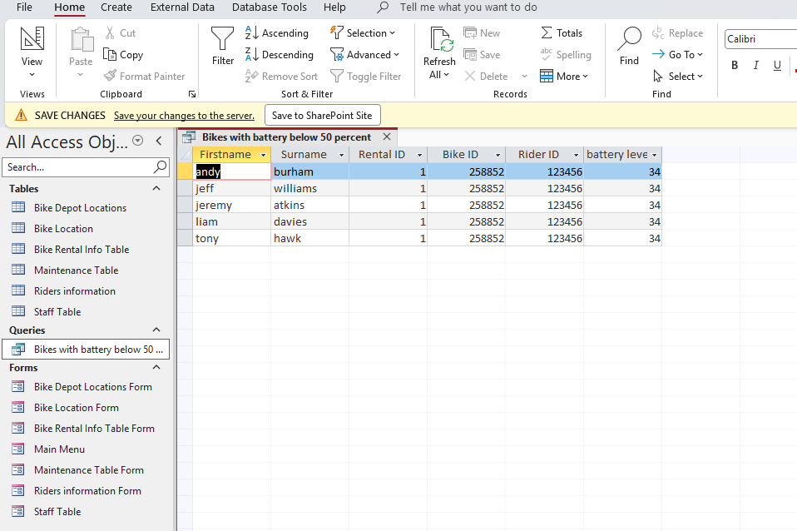
Figure 2 Bike Battery Level query

Another query that is useful to aid the staff of EcoRider would be identifying what bike requires specific maintenance. Below is a query designed to show staff what bikes required tyres and the current depot location for the bike.
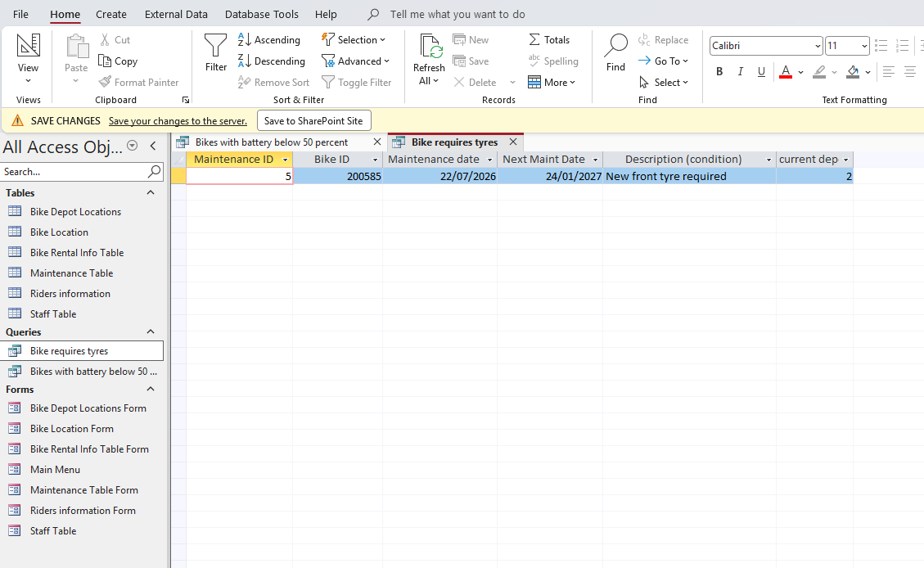
Figure 3 Bike Requires tyres query

Another query is to check what member of the maintenance team has worked on what bike’s. The query below is checking what bikes Luke Harris has worked on and the current rental status of the bike’s.
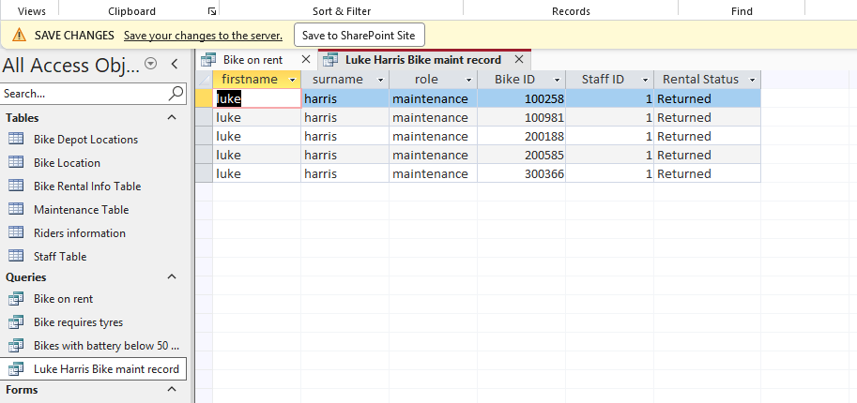
Figure 4 Luke Harris Maintenance records

Finally the last query is to check what bikes are currently on hire. This will help the staff at EcoRider know the current availability on bikes at certain locations. It will also provide the date a bike is due to return.
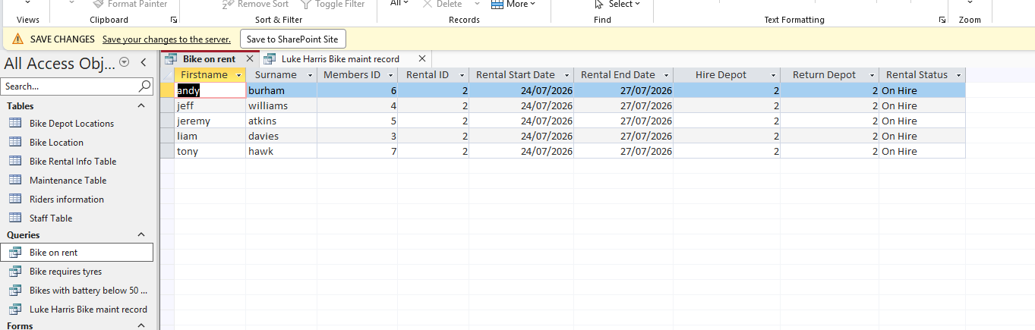
Figure 5 Bikes on hire

Database implementation
The database was constructed in the following steps. Once the entity relationship diagram was completed the following steps were taken to create the database. Starting with the bike depot table and location table to store information about the electric bikes owned by the local authority. Once these tables had been implemented the maintenance and staff tables could be added to aid the original tables.
A mixture of data type has been used to store the relevant data. AutoNumber fields have been used for all primary keys. A mixture of date/time, number, and short text have been used across all the tables in the database structure.
Primary keys were implemented across all tables to ensure that each data record could be identified uniquely. Foreign keys where then used to create relationships between the tables. [5]
Five data entries have been input into the tables across the database to help with the testing of the system. Testing preformed uncovered a few errors that required some attention to make the database more accurate and precise.
Testing proved that data validation rules worked correctly. Also helped with designing relevant queries. The testing had other benefits where tables had columns that were no longer required boosting the data minimisation. [6]
There has been a main page developed to make navigation easier to enter and retrieve data. The main page has a selection of buttons linking the relevant forms. The buttons can be added to cut down on the manual processes saving the user’s time.

Table design.
After using the information gathered from the Entity Relationship diagram (EDR) the database has been designed on a total of six different tables. Each table contains a primary key. The tables contain multiple different data collection values that can be used to make the business run smoother.
The six tables are as follows
- Bike Depot Locations
- Bike locations
- Bike Rental Information
- Maintenance information
- Riders information
- Staff information
These are the tables that have been decided on due to the data that’s required to be collected. Using the data from these tables will allow transparency and reliability when handling rental requests.
Entities used in the tables
Bike Depot Locations table
- Depot ID
- Depot Name
- Location Type
- Address
The Bike depot location table will be used to collect information on what location the bikes are stored and rented out of. The entities are used to store information on the depot location, depot name, location type, address
Bike location
- Bike ID
- Bike Serial Number
- Bike Type
- Bike Status
- Current Depot
- Battery Level
- Purchase Date
- Last Service date
The bike location table was designed to store the information linking information regarding the bikes and their availability. This will help when staff assign a bike to a potential customer, with bike information being able to be linked to the renter.
Bike Rental Information Table
- Rental ID
- Rider ID
- Bike ID
- Hire Depot
- Return Depot
- Rental Start date
- Return Date
- Rental status
Bike rental information will benefit the eco rider scheme with ensuring the customer gets the required bike, also help with checking trends in data and what customers have preferred to hire.
Maintenance Table
- Maintenance ID
- Bike ID
- Staff ID
- Depot ID
- Maintenance date
- Description
- Next maintenance date
The maintenance table will help the EcoRider scheme leaders know what bikes require what maintenance and when the maintenance is needed. The maintenance table will link the bike to the depot and member of staff who carried out any necessary works on the bike.
Riders Information
- Members ID
- First name
- Surname
- Date of birth
- Location
- Email
- Phone number
- Eco card ID
Riders’ information is taken and stored to help the company know where each asset is and how often the bikes are utilised. This table will also provide the company some information to assist with reports to improve future customer experiences.
Staff Table
- Staff ID
- First name
- Surname
- Role
- Email
- Phone
- Employment
Staff table will hold information on the members of staff that have either worked on the bikes or those who have served customers. Either with the initial rental or with an aftersales issue during the rental experience.

Validation rules.
There is multiple validation rules used through the six different tables. The aim of the validation rules is to stop the system users from inputting data that could possibly be inaccurate. Apon entering invalid data the user is shown an error message with the possible correct entry requirements. [6]
Some examples of the validation rules used during the design.
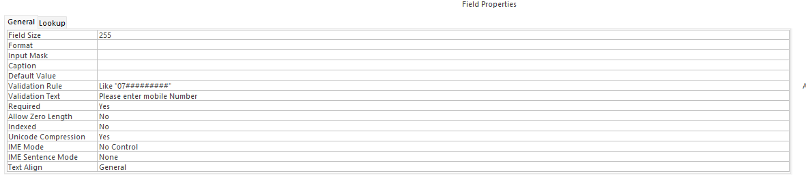
Figure 6 Validation Rule
Here the rental customer is asked to fill in there contact information during the booking process, as the phone number is critical to the eco scheme the field is set to be a requirement and the number must be eleven digits long. If for some reason a customer enters either to many or not enough numbers an error will be presented.
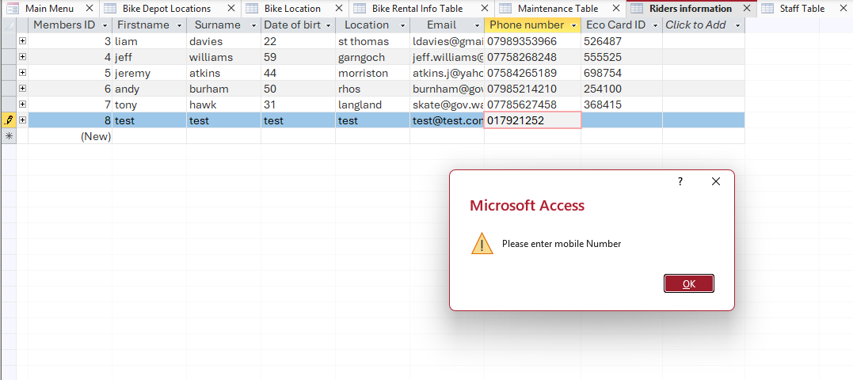
Figure 7 Testing Data entry
Here is a demonstration during a test of the validation rule. As displayed in the image above the rule has worked as it should and an error is displayed to the user.
Another good example for a validation rule is the email address field. If the user inputs an email address and the @ symbol is missing an error message similar to the mobile number will be displayed asking the email address be re-entered with the @ symbol present.

Reflection.
Through the design and implementation of the eco rider database there where many difficult challenges, coming across difficulty in certain validation rules, form set up and also the queries. If the opportunity to design the system again was available, some changes would have been made to the design to make it even more accurate and more user friendly.

Final Thoughts
Eco rider’s new data base will assist in running the business in a more effective and efficient manner. The staff will be able to keep accurate logs of many different data sets allowing maintenance records to be stored accurately and an active up to date bike location. This will allow rentals to be available more frequently through the day.

References

[1] | I. Belcic, “What is an entity relationship diagram?,” IBM, na na na. [Online]. Available: https://www.ibm.com/think/topics/entity-relationship-diagram. [Accessed 27 07 2026].
[2] | n/a, “Geeksforgeeks,” 05 01 2026. [Online]. Available: https://www.geeksforgeeks.org/dbms/first-normal-form-1nf/. [Accessed 27 07 2026].
[3] | “Geeksforgeeks,” 12 07 2025. [Online]. Available: https://www.geeksforgeeks.org/dbms/second-normal-form-2nf/. [Accessed 27 07 2026].
[4] | “Geeksforgeeks,” 25 07 2025. [Online]. Available: https://www.geeksforgeeks.org/dbms/third-normal-form-3nf/. [Accessed 27 07 2026].
[5] | A. Gomstyn, “What is a primary key?,” IBM, na na na. [Online]. Available: https://www.ibm.com/think/topics/primary-key. [Accessed 27 07 2026].
[6] | n/a, “Microsoft Learn,” Microsoft, n/a n/a n/a. [Online]. Available: https://support.microsoft.com/en-us/access/restrict-data-input-by-using-validation-rules. [Accessed 26 07 2026].

