Managing a Software Project for Disaster Recovery
Project Title: Be Safe application
Module Code: ACDA5004
Module Lecturer: Sue Maw
Student Name: Mohamad Wael Baghdadi
Student Number: 1708309
Course: (Mcomp) Software Engineering
Due Date: 25/01/2019

Table of Contents
Table of Contents 1
List of Figures: 2
List of Tables: 2
1- Introduction: 3
2- Risk management: 3
2.1- Risk identification: 3
2.2- Risk analysis and prioritization 4
2.2.1- Risk Evaluation Matrix (Probability impact matrix): 4
2.3- Risk planning 5
2.4- Risk monitoring 5
3- Code of practice 1: 6
3.1 - Sustainability issues: 6
3.2- The Impact of the project: 6
3.2.1- First Order: 6
3.2.2- Second Order: 6
3.2.3- Third Order: 7
4- Code of practice 2: 8
3.1- Legal Standards: 8
3.2- Ethical Standards 8
3.3- General Data Protection Regulation (GDPR) 8
3.4- Copyright 8
3.5- The application of the BCS 9
3.6- IEEE Code of Conduct: 9
3.7- Predictions of Brexit with the legal and ethical sector 10
5- Quality Assurance Issues: 10
4.1- Quality Assurance (QA) 10
4.2- ISO standards 10
4.3- Software quality assurance 10
4.4- The important of software quality assurance[13]. 11
Conclusion 11
References: 12
Appendix: 14

List of Figures:
Figure 1: Quality model for sustainable software[9]. 7
Figure 2: software product quality of ISO 25010 10
Figure 3: Progress sheet for the team member. 14

List of Tables:
Table 1: The range of probability level. 4
Table 2: The range of Impact level. 4
Table 3: Risk evaluation matrix. 4
Table 4: Risk planning table 5
Table 5: Risk monitoring table. 5
Table 6: BCS code of conduct. 9
Table 7: Software qualities of the project. 11

1- Introduction:
Risk management is critical to any organization because the success and operability of the organization rely on how well can manage the unique risks. Risk management is the procedure of identifying, assessing, alleviate and combating threats to the organization [1]. in this report the author has included the risk definition and how can process the risk by setting planning steps with monitoring of those risks, also the report includes a sustainability section which provides the third sector and what the team members follow for their project. as the legal and ethical issues important for every project the author has included what steps he followed to implement the project with the code of conduct. in the last section, the report includes brief of the ISO and quality assurance in software and what the quality Attributes of the project.

2- Risk management:
The Harvard University define that risk management is a method of locating identifying what problems or issues and considerate their possibility probability and how these issues could affect the project, which this process allows to the project's management to take a proactive approach to expects risk and make informed resolutions. rely on the circumstances, the company may choose to either avoid or tolerate risks[1].

2.1- Risk identification:
- Operational risk:
- R1- Gold plating
- R2- Software incompatibilities
- R3- Misunderstanding of the requirements

- Strategic risk:
- R4- Lack of required knowledge /skill in the project personnel
- R5- Project member may not contribute to the project or the project member turnover
- R6- Developing the wrong software functions
- R7- Real-time performance problems
- R8- Unrealistic time and cost estimates
- R9- Team member being distributed over a large geographical area

2.2- Risk analysis and prioritization
Risk analysis is a component of risk management. which is a review of the risks related to a specific action and it is applied to the projects, security issues, information technology or any other actions where risks might be analysed on a qualitative and quantitative basis.
The risk is part of any business or IT project. which it should take place on several recurring aspects and then be updated to accommodate any potential new threats. Strategic risk analysis reduces the likelihood of damage or any future risks[2].
Probability level | Range
High | Greater than 50% chance of happening
Significant | 30-50% chance of happening
Moderate | 10-29% chance of happening
Low | Less than 10% chance of happening
Table 1: The range of probability level.
Impact level | Range
High | Greater than 30% above budgeted expenditure
Significant | 20 to 29% above budgeted expenditure
Moderate | 10 to 19% above budgeted expenditure
Low | Within 10% of budgeted expenditure.
Table 2: The range of Impact level.

2.2.1- Risk Evaluation Matrix (Probability impact matrix):
Impact
High
Significant
Moderate
Low
 | R2 | R7 | R5
 | R3 | R4 | R6
R9 | R8
R1
Table 3: Risk evaluation matrix.
Moderate
Low
Significant
High
Probability

2.3- Risk planning
The Software risks planning is to define a precautionary measure that would reduce the likelihood or probability of different risks or reduce the impact in case a risk happens. with monitoring continuously of processes to recognize the risks as soon as they can[3].
Risks | Probability | Impact | Total | severity | Risk Plan | Risk reduction techniques
R1 | 2 | 2 | 4 | Low | accept | set instructions for the developer and what the function needs for the project
R2 | 3 | 4 | 9 | High | mitigate | checking the rules and functions all the time
R3 | 2 | 4 | 6 | Significant | Accept | make notes or explain each point for the requirements
R4 | 4 | 4 | 3 | Significant | Avoid | By training and sharing the team's ideas to support each other
R5 | 4 | 5 | 9 | High | Transfer | Splitting the work between other members
R6 | 4 | 6 | 10 | High | Transfer | Following the orders and what they are expecting from the product
R7 | 4 | 5 | 9 | High | Mitigate | Setting alternative plan
R8 | 2 | 4 | 6 | Moderate | Accept | Increasing the work hours
R9 | 1 | 3 | 4 | Low | Accept | Make the communications through online
Table 4: Risk planning table

2.4- Risk monitoring
Software risk monitoring is inserted into project activities and regular tests are conducted on the highest risks. Software risk monitoring involves: Tracking of risk plans for any major changes in real schema, attribute, or others, and preparing status reports for project management. And also the risks whose probability or impact has been the lowest possible level should be closed and still keep looking for new risks[3].
Risks | Result of the plan | Alternative plan
R1 |  | N/A
R2 |  | N/A
R3 | X | Providing more information about the requirements
R4 |  | N/A
R5 |  | N/A
R6 | X | Create an alternative product with equal functions
R7 |  | N/A
R8 |  | Asking for more time or cost
R9 |  | N/A
Table 5: Risk monitoring table.

3- Code of practice 1:

3.1 - Sustainability issues:
Environmental and social issues may appear in several different ways and affect the feasibility of the operations of the client / company invested in the financial institution. Environmental issues may pose themselves as permanent or temporary changes in the land, atmosphere, and water due to human activities, which can lead to potentially reversible or irreversible effects. Social problems may arise in the workplace of client / investor operations and may also affect surrounding communities[4].

3.2- The Impact of the project:
There are 3 orders for sustainability issues and the first one is Economic which includes cost, benefit and impact. The economic sustainability is to make sure that resources for the human are preserved for the human in the future. The continuity of economic production and replenishment must be faster than, or at least equal to, consumption[5]. The second order is Social sustainability and contain health and safety and social justice, and the third order is the environmental sustainability which include the energy, air and atmosphere, water, land and ecosystems and material and waste.

3.2.1- First Order:
All the team member used their own laptop or PCs which that can reduce the paper. Battery saving mode and moderate light in the laptop screen instead of setting the laptop is the high performance mode and high light in the laptop screen.
The team reduce the travel footprint by following several ways to communicate with each other like Skype, WhatsApp, Visual Studio live and OneDrive to share their documents or ideas. they used the whiteboard to reduce wasting of paper and if they really want to print a paper they used double sides of paper.
The team used open sources software which downloading stuff from the internet can reduce the waste of old methods like CDs and DVDs. The team were working and meeting in the university campus which is the university already turned on the electricity and air conditioner in the university, instead of working from their homes, which will be much higher.

3.2.1.1- E-waste:
According to the author’s resources, every single computer requires about 1.8 tonnes of chemicals, fossil fuels and water for the manufacture [6]. There are 1.6 billion mobile phones manufactured in 2012, electronic are packed with chemicals, toxic, lead, arsenic and polybrominated flame retardants [7]. With the newest report from UN, there are 50 million tonnes of e-waste discarded each year which they have cost around 62.5 billion dollars that are meaning more than the GDP of most countries according to the terms of material [8].

3.2.2- Second Order:
In these days most of the students and others rely to write their reports or works through the internet, which that helped to reduce the paper used, the communication through online like Skype and other social media also improved the communication in industry or work or any other area and that way reduced the travel by cars and the gas emissions from them. Also, with the benefit of the technology the cars now built in with a computer system is to reduce the gas emissions. The same for hardware or PCs the technology built them with less use of power.

3.2.3- Third Order:
Environmental sustainability often gets the most attention, so to reduce carbon emissions that come from the energy there are few ideas to help the environment. One of the good ideas to help the environment or reduce the negative impact of IT is, If the computer old but still in working conditions, it’s a good idea to give it to any other organisation, if it is not working return it to the manufacture or recycling facility instead of through it in the bin with other waste.
Even in the universities, there are still many ways to reduce the power, for example, the PCs could connect to the power switch which can switch the power completely from the PC after a period of time if it is not in use. and the electric sensors need more setting inside or outside the campus, as the light still turned on in the morning or sunny time out the campus and even if they will be in a solar system that will be many savers for the power usage.
So, with those few things that the author's mentioned, the save of power and energy will be much bigger over the year.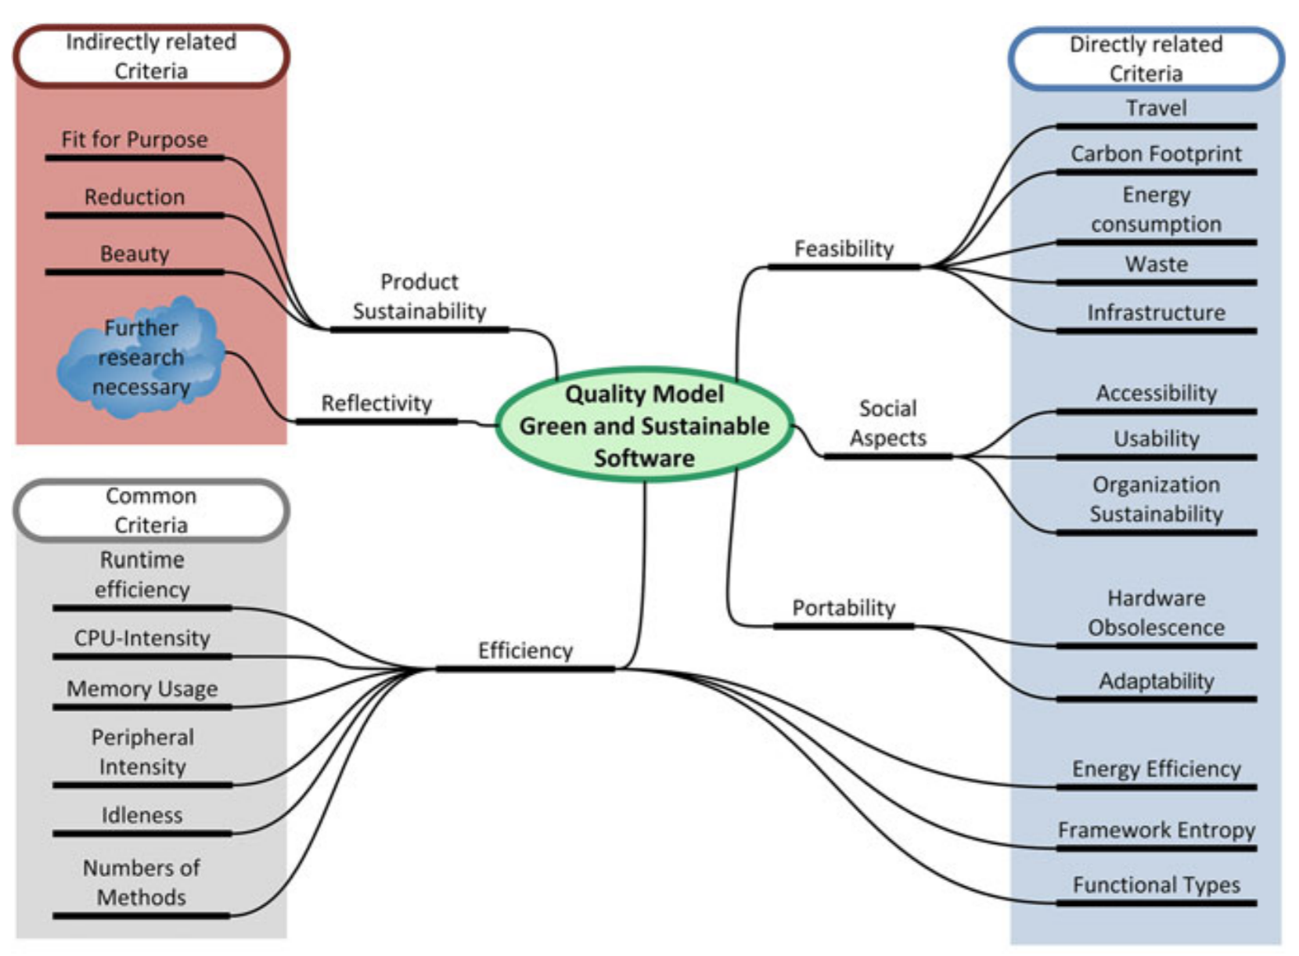
Figure 1: Quality model for sustainable software[9].

4- Code of practice 2:

3.1- Legal Standards:
Legal standards are useful, as they help people to know what they cannot do. With legal standards in place, authorities are allowed to enforce rules when people do something illegal. The legal standards are helpful because they help people know what the things they cannot do. With the application of legal standards, authorities are allowed to apply the rules when people do illegal work[10]. So, in the computer law, we can define a few steps in the legal issues which they are:
- Privacy:
The responsibility to protect data about individuals or users
- Accuracy:
Data collectors' responsibility for documenting and ensuring accuracy.
- copyright:
Who owns the software and information and how they can be sold and exchanged.
- Access:
The responsibility of data collectors to monitoring access and define what information a person is entitled to obtain from others and how information can be used

3.2- Ethical Standards
Ethical standards are based on the ethical principles of human in terms of wrong and right or how a person behaves towards a particular position, ethical standards are not necessarily linked or based on a legal basis[10]

3.3- General Data Protection Regulation (GDPR)
The General Data Protection Regulation (GDPR) is the most important change in data privacy regulation in 20 years. which is to replace the Data Protection Directive 95/46/EC and is design to:
Unify data privacy laws throughout Europe, Protect and enable all the privacy of citizens' data in the EU and restructuring the way organizations in the region deal with data privacy.

3.4- Copyright
Copyright, a form of intellectual ownership law, protects the original works of the authorship, including, dramatic, literary, artistic, musical and other works, such as computer programs, novels, film, poetry, architecture, and songs. The Copyright does not protect facts like systems, ideas, or operating methods, although they may protect the way these things are expressed [11].

3.5- The application of the BCS
The British Computer Society (BCS) Founded in 1956 as a professional body and educated community representing those working in the UK or internationally in the field of information technology, the BCS has played a very important role in educating and nurturing computer engineers and IT professionals [12].
BCS Code of Conduct
Public Interest | The team members will:  - Promote the inclusion of all sectors of society where opportunities exist and to promote equitable access to benefits in information technology  - Conduct the professional activities without discernment between on the marital status, sexual orientation, grounds of sex, colour, ethnic origin, religion, nationality, race, age or disability, or of any other specific conditions or requirement  - Have consideration for the legitimate rights of third Party.
Professional Competence and Integrity | - Develop professional skills, knowledge and competence on a consistent basis, and maintain awareness of the relevant technological procedures, developments and standards in the project area  - Respect and appreciate the other opinion, and seek, accept and offer true criticism of the work.  - Reject any offer of unethical inducement or bribery
Duty to Relevant Authority | - Any data in the project will protect and will not disclose or use for personal benefit or send to any third party, except with permission of the main authority, or as demand by law  - Avoid any situation may lead to a conflict of interest with the competent authority.  - The team will not withhold or misrepresent information on the performance of the application
Duty to the Profession | - Try to increase professional level by participation in their use, development and implementation.  - Acceptance of personal duty to maintain the reputation of the profession and not to take any behaviour that may lead to discrediting the profession.
Table 6: BCS code of conduct.

3.6- IEEE Code of Conduct:
The largest professional technical association in the world, an organization dedicated to promoting technological excellence and innovation for the benefit of humanity, designed to serve professionals working in all aspects of electronic, electrical, computer and related fields of technology and science that lie within modern civilization[13]. So here the code of conduct of the author’s project:
- The team members will be respectful of others and they will act in a professional way and they will respect the privacy of others and the security of their data and personal information.
- The team will not be part of any unethical behaviour and will not discriminate against anyone because of the colour, disability, nationality, religion or any characteristics protected by law.
- The team will not be part of any lies, defamations, malicious rumours or any other verbal or physical abuse, against anyone on the Internet or otherwise.
- Will avoid hurting others, their data, reputation, property or employment by false or malicious action
- Rejecting and refuse any kind of bribery in all forms, and protect the data of the users or their information and not share them with other third parties.

3.7- Predictions of Brexit with the legal and ethical sector
- The General Data Protection Regulation (GDPR) will not be affected between the United Kingdom and EU [14].
- Any organisation that holds data on European citizen will need to comply with the GDPR [14].
- There will be positive and clear opportunities for economic and social progress [14].
- Going out of the EU will change international relations and thus change priorities for information security [14].
- The UK will benefit from a unified strategy to create a vital information security industry for both an exported service and internal needs [14].
- Reach the digital objectives with the continued cooperation with the EU which that according to the Government’s National Cyber Security Strategy 2016-2021 [14].
- Equal data protection for the United Kingdom to be a high priority result of negotiations to leave the EU.

5- Quality Assurance Issues:

4.1- Quality Assurance (QA)
Quality Assurance (QA) is any systematic method to define whether a service or product meets particular requirements. Defines quality assurance and maintains the particular requirements for developing or manufacturing reliable products. The quality assurance system intends to progress customer confidence and organization's reliability, while also increasing work procedures and performance, and this process enables the organization to compete better with others[15]. The QA concept was popularized during World War II [16].

4.2- ISO standards
it is an international organization for Standardization, they develop and publish international standards, ISO create documents that provide requirements, guidelines, characteristics or specifications that can be used consistently to guarantee that the products, materials, processes and services are fit for their purpose

4.3- Software quality assurance
keeping the software quality is a very significant part of software testing, nowadays most of the industries depends on software, and the software programs are an integral part of critical industries like aircraft, cars, medical equipment, stocks, and so on[17].
so the software quality assurance (SQA) is a set of action for guarantee quality in software engineering processes which the result lead to the quality of software products[18].
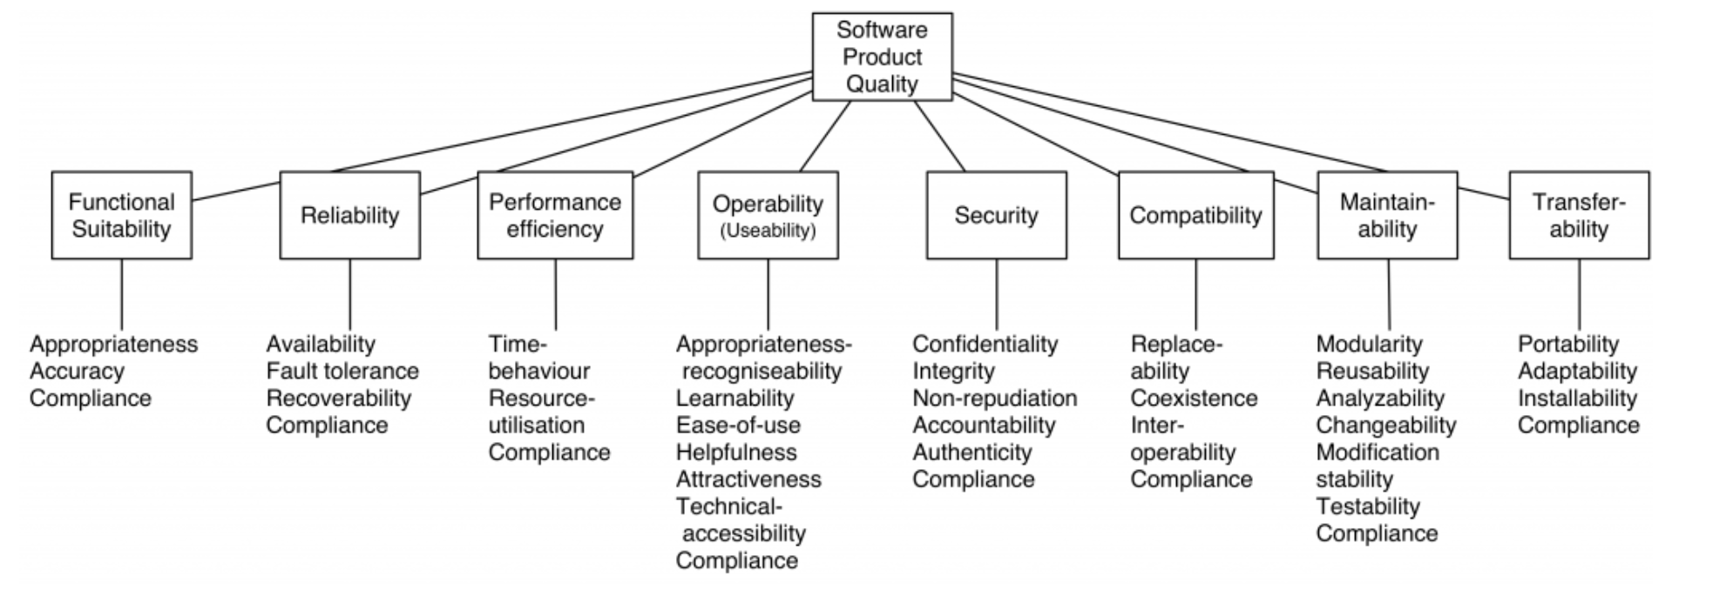
Figure 2: software product quality of ISO 25010

4.4- The important of software quality assurance[13].
- The fewer defects, makes the maintenance and testing easier
- The quality software saves money and time
- Greater reliability in software will raise customer satisfaction and the cost of maintenance will be lowers
- When the cost of maintenance will be lower, that helps to reduce of overall cost for the project
Software qualities of the project
Functionality | - The application meets all the requirements  - The application requirements suitable for the users  - Meets 100% of checklist of features (it met all the required futures)  - 100% of high priority features and 50% of low priority features
Reliability | - There are no spam notifications send to the users  - The application works correctly in desktop, laptop, iPad and mobile  - There are no more than 5 errors report per month  - The app is complying with standards relating to reliability
Efficiency | - Time behavior: The response time no more than 2 seconds, depends on the images or context  - Resource utilization: Uses no more than 5GB desk space and around 500MB memory  - Will runs in any sort phone even in old ones.
Usability | - Operability: The functions and navigation are clear and easy to use. like the text links, buttons or tools searches, easy to locate what the user looking for  - Learnability: the application design is very simple which is let the user to understand the functions easily without an effort  - The Interfaces in the application are designed to the edges with easy to read the texts.  - The target users gave the application a rating of 75% satisfaction in easy to use
Maintainability | - The code written in clean and clarity code which is can easily define any error and fix it  - There are notes for each part of the code which makes it easier to read by other programmers  - Each part in design and code and framework or logo or other has separate file, and that make it easy to change or test any part of the application
Portability  Transferability | - Installability: the application has the ability to run under different computing hardware/ software environments  - Replaceability: easy to replace any of component in the system because each file saved in different folder.
Table 7: Software qualities of the project.

Conclusion
Therefore, we can conclude that risk management is an important part of any project management plan in the organization to insure the success and that quality assurance and competition among other companies

References:
[1] Harvard University, “Risk Management & Audit Services: Change Control,” 2015. [Online]. Available: https://rmas.fad.harvard.edu/rmas-functional-areas/risk-management. [Accessed: 19-Jan-2019].
[2] M. Rouse and L. Rosencrance, “What is risk analysis?,” TechTarget, 2018.
[3] I. S. T. Institute, “What Is Software Risk And Software Risk Management ?,” International Software Test Institute, 2018. [Online]. Available: https://www.test-institute.org/What_Is_Software_Risk_And_Software_Risk_Management.php. [Accessed: 22-Jan-2019].
[4] N. Salingaro, “Environmental and Social Issues | FIRST for Sustainability,” 2018.
[5] “Types of Sustainability - Youth Thinkers’ Society.” [Online]. Available: http://ytsnepal.org/blog/types-of-sustainability/. [Accessed: 22-Jan-2019].
[6] “Impact of IT on environment.” [Online]. Available: https://www.slideshare.net/sc09b093/it-effects-on-environment. [Accessed: 25-Jan-2019].
[7] IFIXITORG, “The Problem with E-Waste - iFixit,” 2016. [Online]. Available: https://ifixit.org/ewaste. [Accessed: 25-Jan-2019].
[8] “50 million tonnes of e-waste discarded each year: UN report.” [Online]. Available: https://www.thenewsminute.com/article/50-million-tonnes-e-waste-discarded-each-year-un-report-95635. [Accessed: 25-Jan-2019].
[9] S. Naumann, E. Kern, M. Dick, and T. Johann, “Sustainable software engineering: Process and quality models, life cycle, and social aspects,” Adv. Intell. Syst. Comput., vol. 310, pp. 191–205, 2015.
[10] Yang Alcocer, “What is the Difference Between Legal &amp; Ethical Standards? - Video &amp; Lesson Transcript | Study.com.” [Online]. Available: https://study.com/academy/lesson/what-is-the-difference-between-legal-ethical-standards.html. [Accessed: 23-Jan-2019].
[11] “What Does Copyright Protect? (FAQ) | U.S. Copyright Office.” [Online]. Available: https://www.copyright.gov/help/faq/faq-protect.html. [Accessed: 25-Jan-2019].
[12] BCS, “BCS - The Chartered Institute for IT,” 2012. [Online]. Available: http://www.bcs.org/. [Accessed: 24-Jan-2019].
[13] “What is Software Quality? Definition, Examples, Attributes - Set Skill.” [Online]. Available: http://setskill.com/software-testing/software-quality-definition-examples-attributes/. [Accessed: 24-Jan-2019].
[14] British Computer Society, “Digital Brexit - Planning for a successful digital future outside of the EU,” 2018.
[15] Rouse M, “What is survey research? - Definition from WhatIs.com,” 2014.
[16] “What is Quality Control (QC)? - Definition from Techopedia.” [Online]. Available: https://www.techopedia.com/definition/9038/quality-assurance-qa. [Accessed: 20-Jan-2019].
[17] C. Janssen, “What is Software Quality Assurance (SQA)? - Definition from Techopedia.” [Online]. Available: https://www.techopedia.com/definition/4363/software-quality-assurance-sqa. [Accessed: 24-Jan-2019].
[18] Software Testing Fundamentals, “Software Quality Assurance - Software Testing Fundamentals.” [Online]. Available: http://softwaretestingfundamentals.com/software-quality-assurance/. [Accessed: 24-Jan-2019].
[19] M. Boban, Ž. Požgaj, and H. Sertić, “9. STRATEGIES FOR SUCCESSFUL SOFTWARE develop risk managemnt.pdf,” pp. 77–92, 2003.
[20] T. Arnuphaptrairong, “Cinemagraphs: Qué Son y Cómo Realizarlos,” Dzoom, vol. I, 2011.
[21] S. Y. Chadli and A. Idri, “Identifying and mitigating risks of software project management in global software development,” Proc. 27th Int. Work. Softw. Meas. 12th Int. Conf. Softw. Process Prod. Meas. - IWSM Mensura ’17, pp. 12–22, 2017.
[22] J. Langer, “Risk Management Handbook,” Ann. Phys. (N. Y)., vol. 54, p. 258, 2009.
[23] J. Harvey, “Introduction to managing risk,” Risk Manag., no. 28, pp. 1–12, 2008.
[24] E. Committee, “Quality Assurance Handbook: University of Oxford,” no. October, 2008.
[25] K. Manghani, “Quality assurance: Importance of systems and standard operating procedures,” Perspect. Clin. Res., vol. 2, no. 1, p. 34, 2011.
[26] L. A. Wallis, L. S. Wen, and S. N. Walker, “Project management,” Emerg. Dep. Leadersh. Manag., pp. 133–143.
[27] R. T. Management, “Fundamentals of Quality Assurance Table of contents :”
[28] IPCC, “Quality Assurance and Quality Control (IPCC Chapter 8),” Good Pract. Guid. Uncertain. Manag. Natl. Greenh. Gas Invent., pp. 1–17, 2001.
[29] MoEF&CC and GEAC, “Risk Analysis Framework, 2016,” no. January, 2016.
[30] K. Karthick, S. Anantharaj, P. E. Karthik, B. Subramanian, and S. Kundu, “Self-Assembled Molecular Hybrids of CoS-DNA for Enhanced Water Oxidation with Low Cobalt Content,” Inorg. Chem., vol. 56, no. 11, pp. 6734–6745, 2017.
[31] R. Chitchyan, J. Noppen, and I. Groher, “What Can Software Engineering Do for Sustainability: Case of Software Product Lines,” Proc. - 5th Int. Work. Prod. Line Approaches Softw. Eng. PLEASE 2015, pp. 11–14, 2015.
[32] E. Sargolzaei and M. Nikbakht, “The Ethical and Social Issues of Information Technology: A Case Study,” IJACSA) Int. J. Adv. Comput. Sci. Appl., vol. 8, no. 10, pp. 138–146, 2017.
[33] N. Wolfram, P. Lago, and F. Osborne, “Sustainability in software engineering,” 5th IFIP Conf. Sustain. Internet ICT Sustain. Sustain. 2017, pp. 1–7, 2018.
[34] A. Ahmed, A. Das, and S. Mukhopadhyay, “Immunoregulatory functions and expression patterns of PE/PPE family members: Roles in pathogenicity and impact on anti-tuberculosis vaccine and drug design,” IUBMB Life, vol. 67, no. 6, pp. 414–427, 2015.
[35] B. Penzenstadler and B. Penzenstadler, “What does Sustainability mean in and for Software Engineering ? What does Sustainability mean in and for Software Engineering ?,” no. March, 2016.
[36] P. Lago, S. A. Koçak, I. Crnkovic, and B. Penzenstadler, “Framing sustainability as a property of software quality,” Commun. ACM, vol. 58, no. 10, pp. 70–78, 2015.

Appendix:
In this section the author has include the resources that read or used to implement his report, and screenshots of the prototype of his project
Resources: [19], [20], [21], [22], [23], [24], [25], [26], [27], [28], [29], [30], [31], [32], [33], [34], [35], [36]

Progress sheet:
The Tables shared between team members in OneDrive:
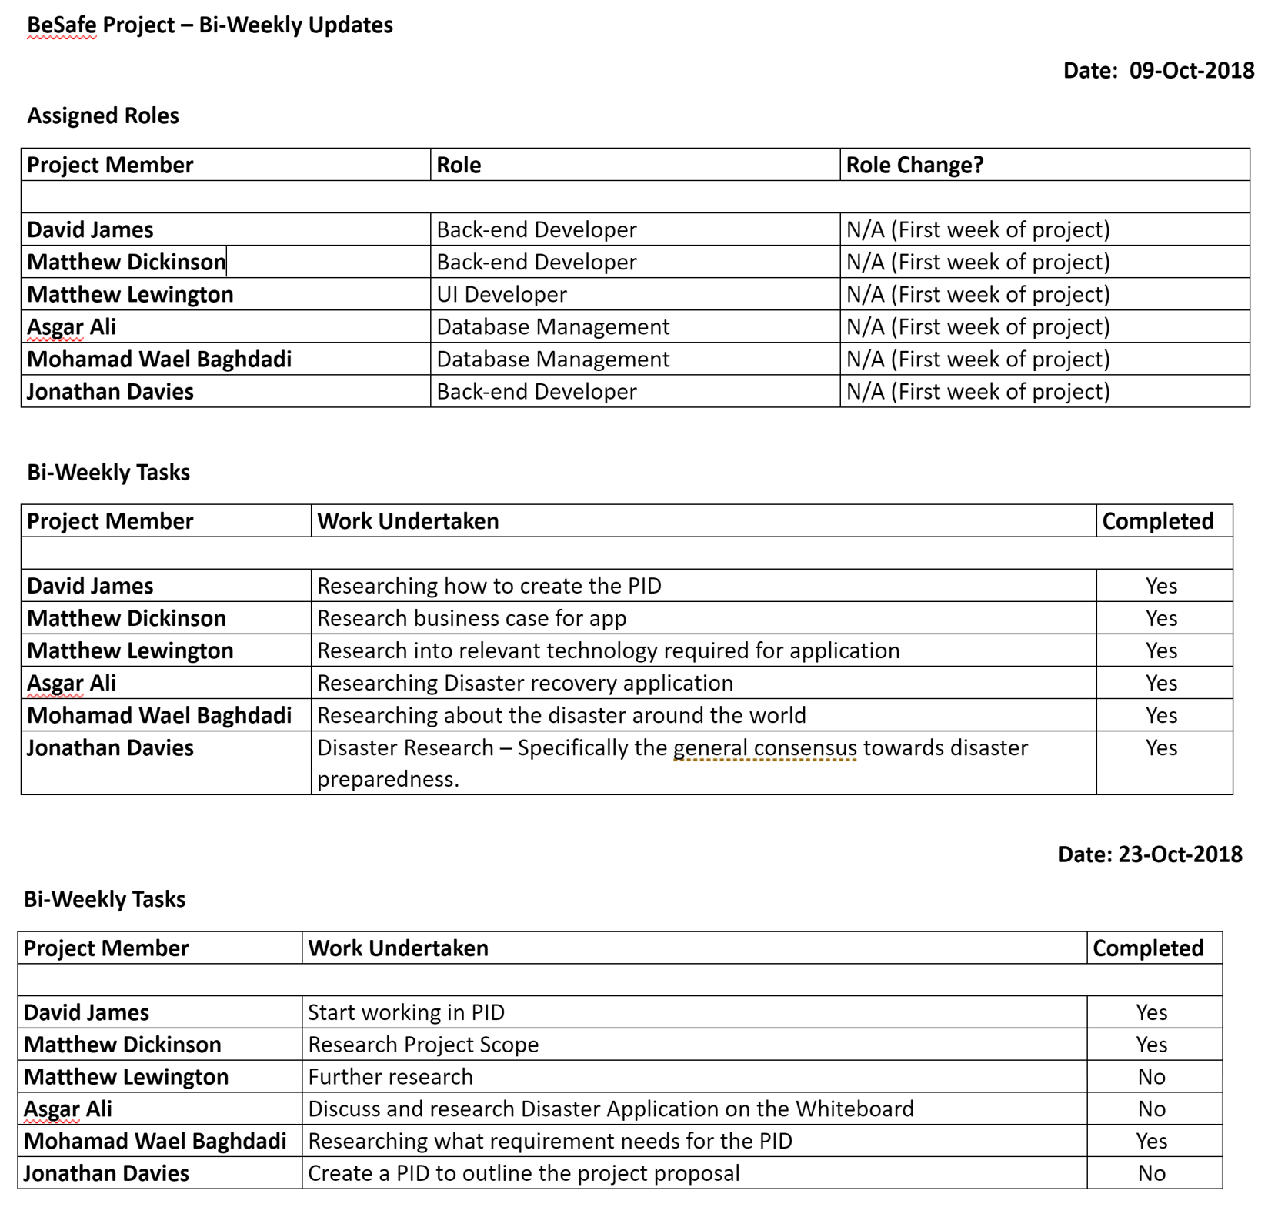
Figure 3: Progress sheet for the team member.

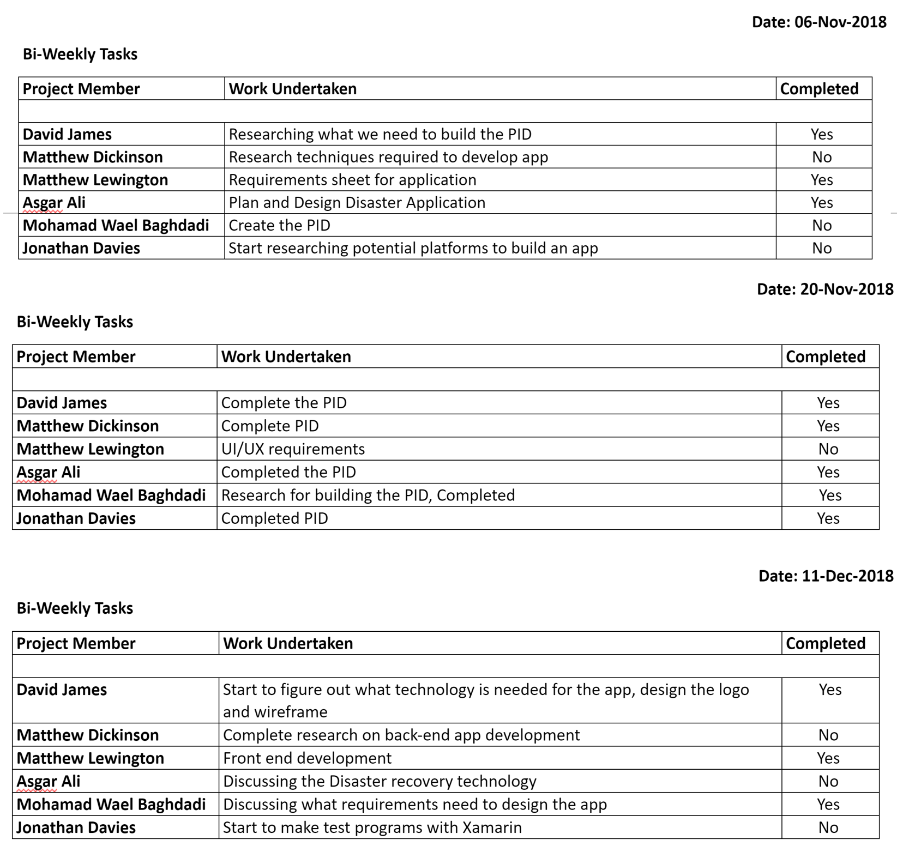
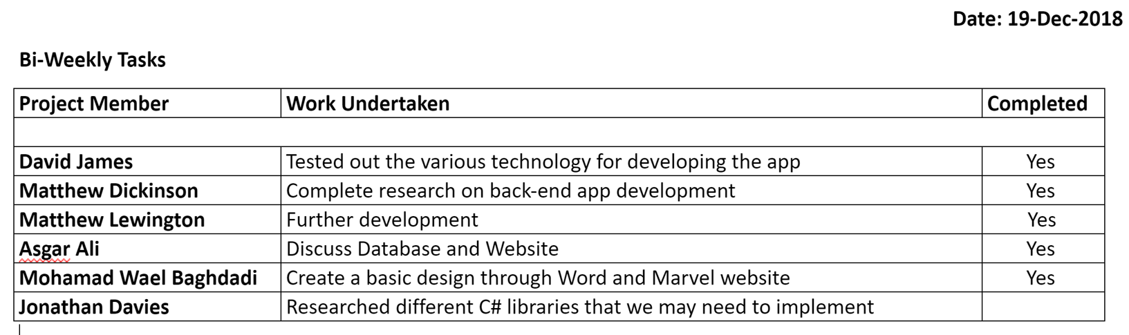

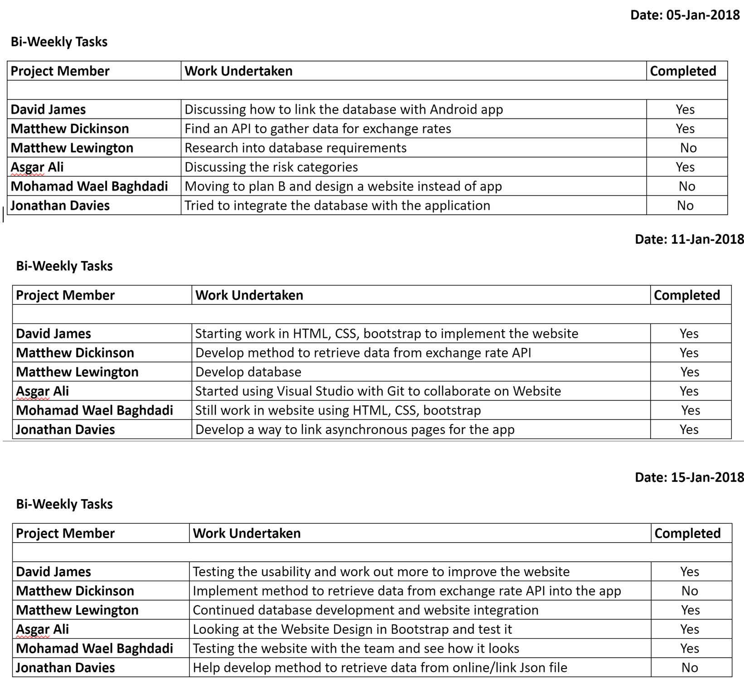
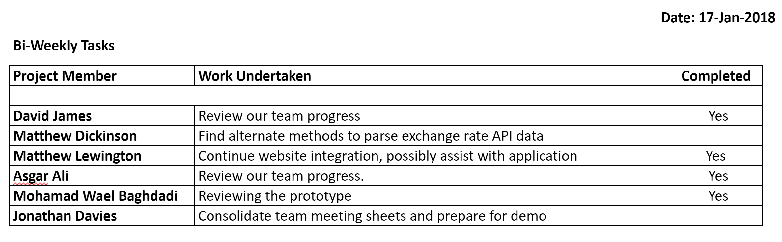

Gantt Chart diagram for the PID and Demo:
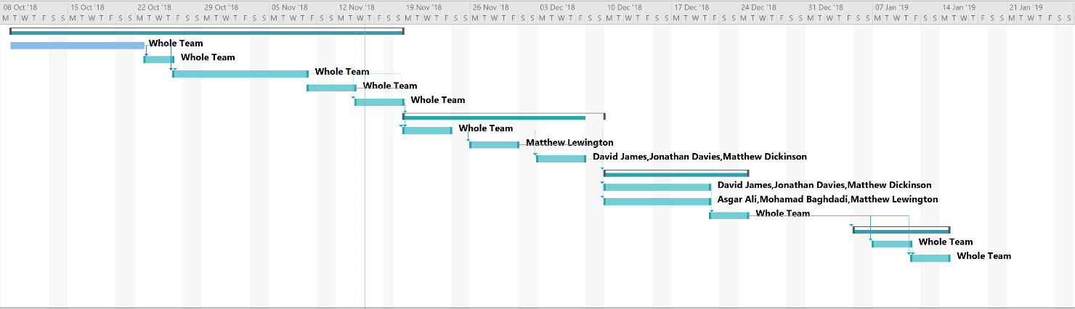

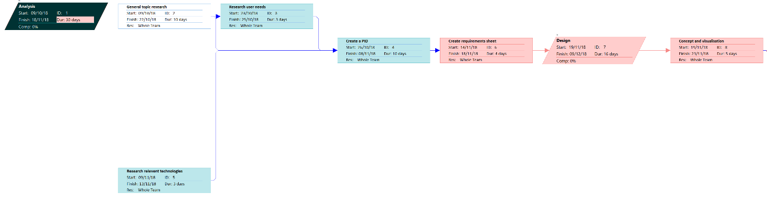

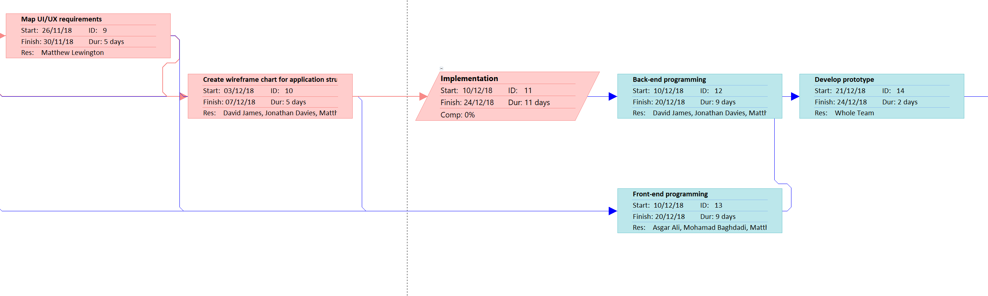

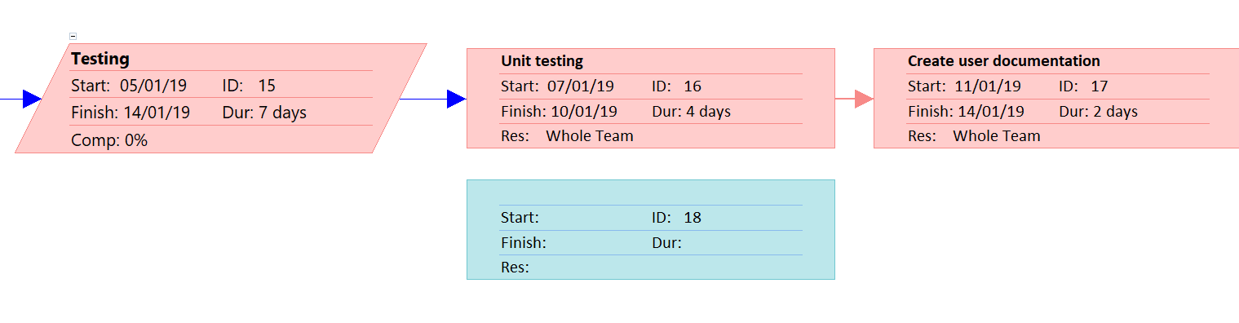
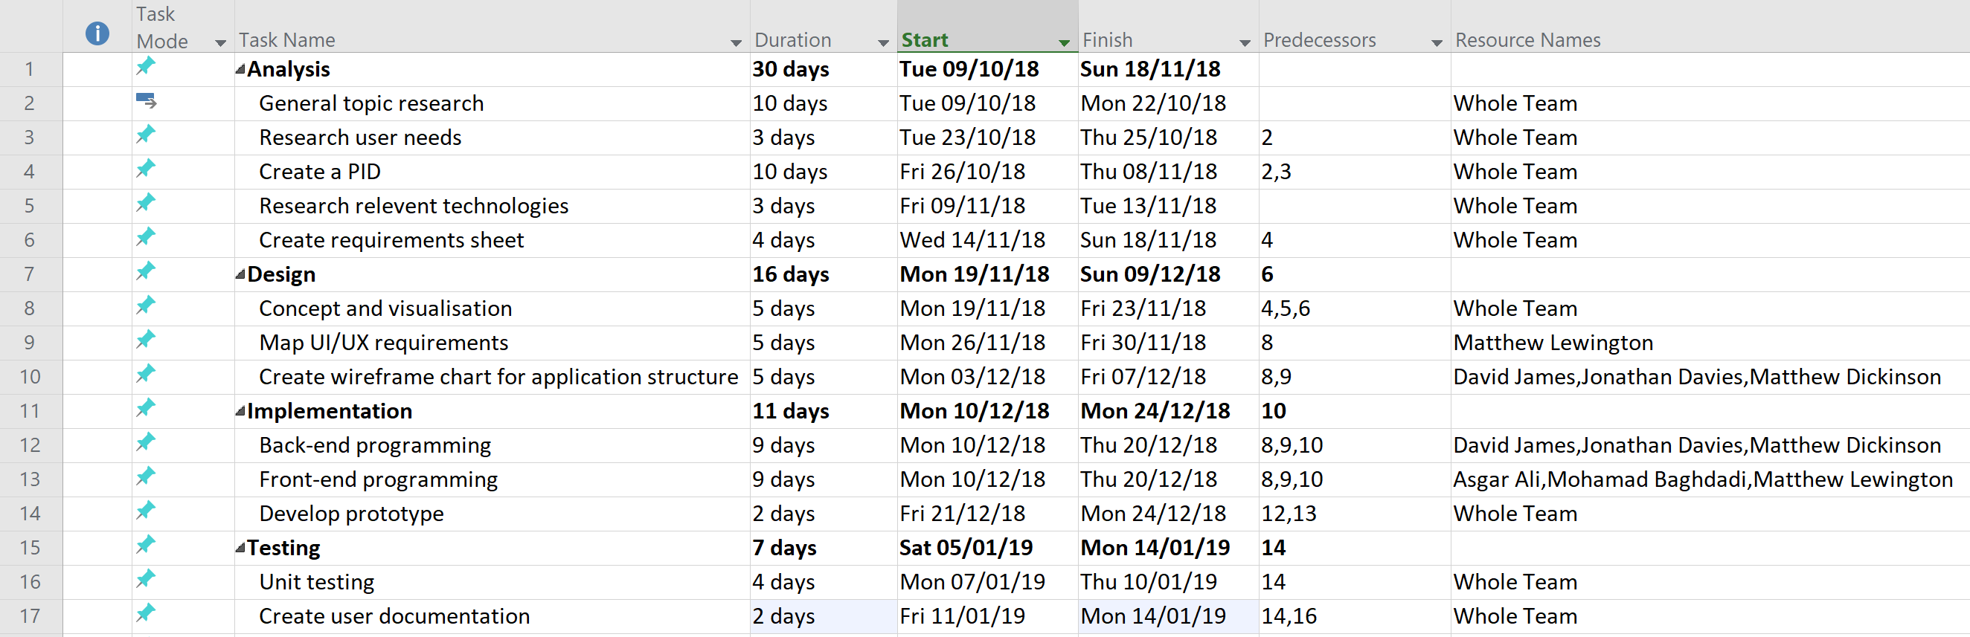

Interfaces desine for the project:


