
Network Operating Systems and Services
Configure and Manage a Virtualised Enterprise Network
5/11/26 | Luke Davies | ACCA5023

Contents
Introduction 2
Routing 3
Domain Server (Swansea) 9
Encrypted Connection between Swansea and London 13
Users 22
Domain Membership 31
DHCP Server 38
Test and Troubleshoot 43
Disk Drive 45
IIS Server 50
Remote Desktop Services 53
Conclusion 58
References 59

Introduction
The below report provides screenshot evidence of routing and other critical network infrastructure as per the requirements of this assignment. The assignment asks the user to build an enterprise network across two sites – Swansea and London. Key services required in order for the infrastructure to work effectively have been configured including active directory [2], domain name server installation [3], DHCP server installation [4], virtual private network installation [5], remote desktop installation [6], and internet information services installation [7].
Each section of the report provides screenshot evidence for different elements of network infrastructure. A conclusion and list of references end the report.

Routing
Figure 1 – RRAS Installed
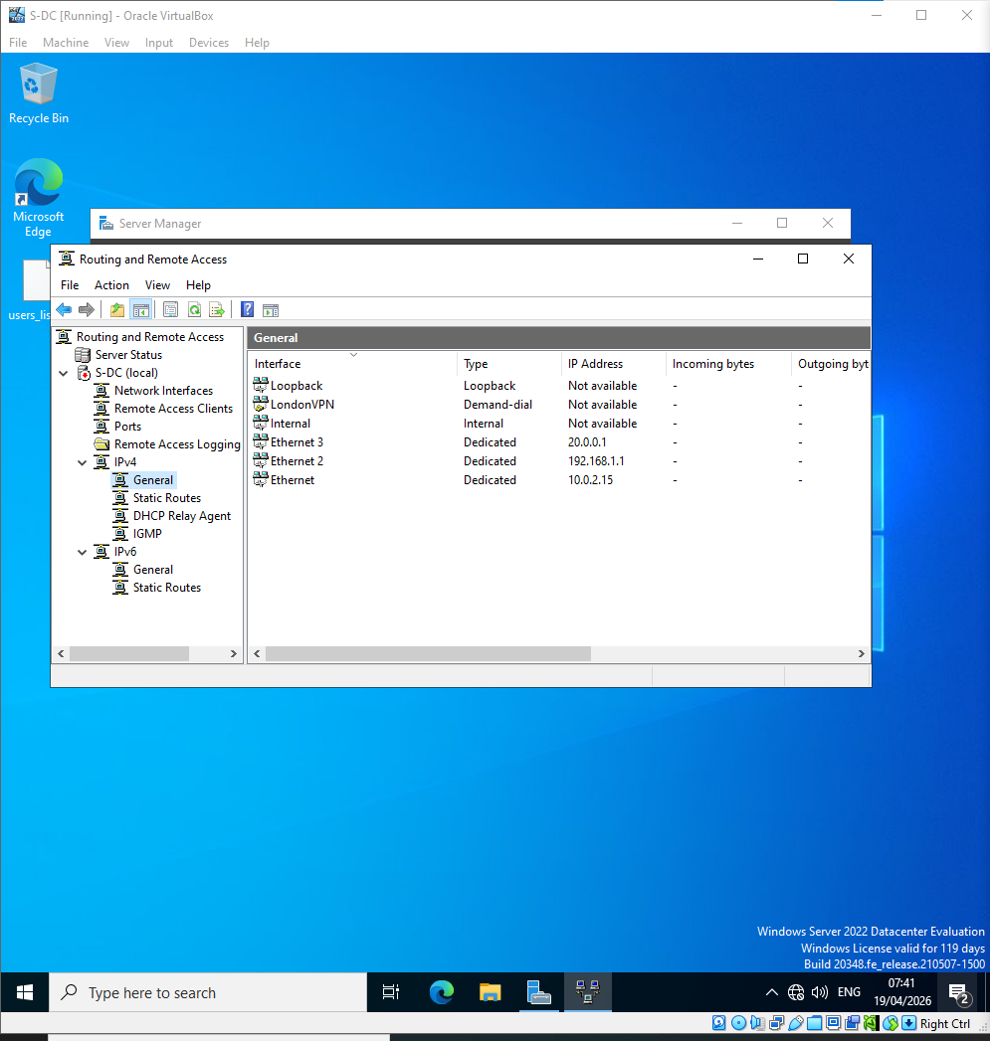

Figure 2 – ICMPv4 Traffic allowed
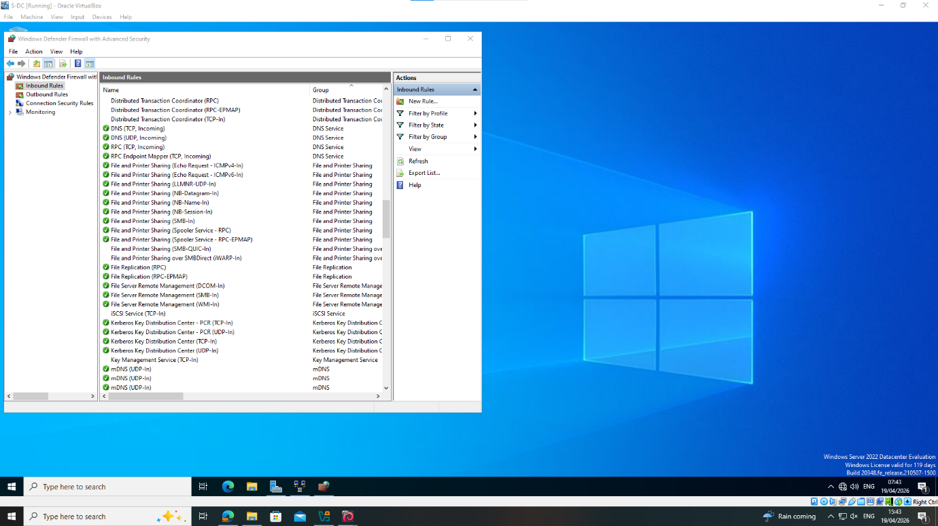

Figure 3 – Route table showing routing to London subnet via Debian server
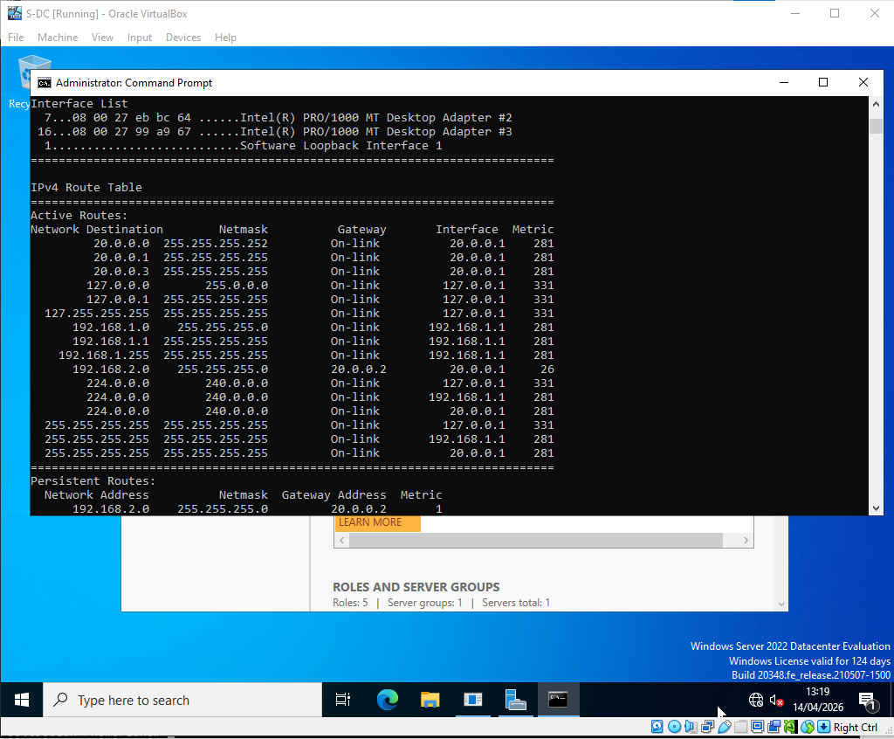

Figure 4 – Debian Configured to route to Windows subnet via Windows Server
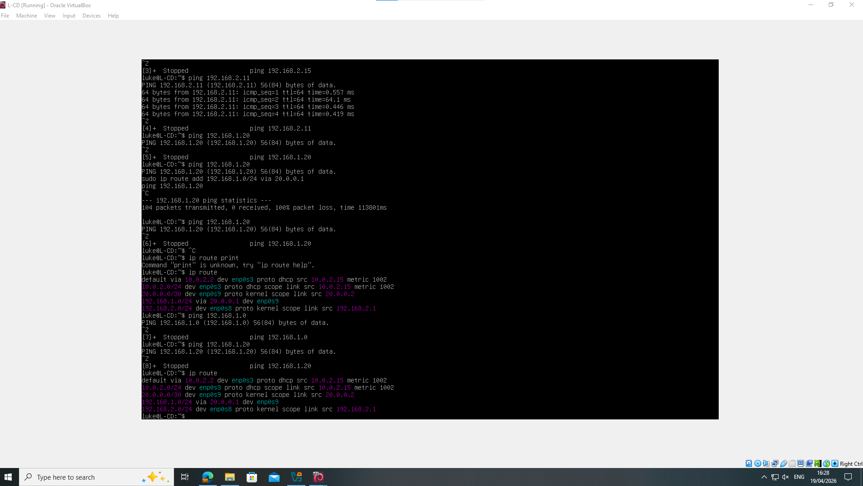

Figure 5 – Ping Windows Server to London Client
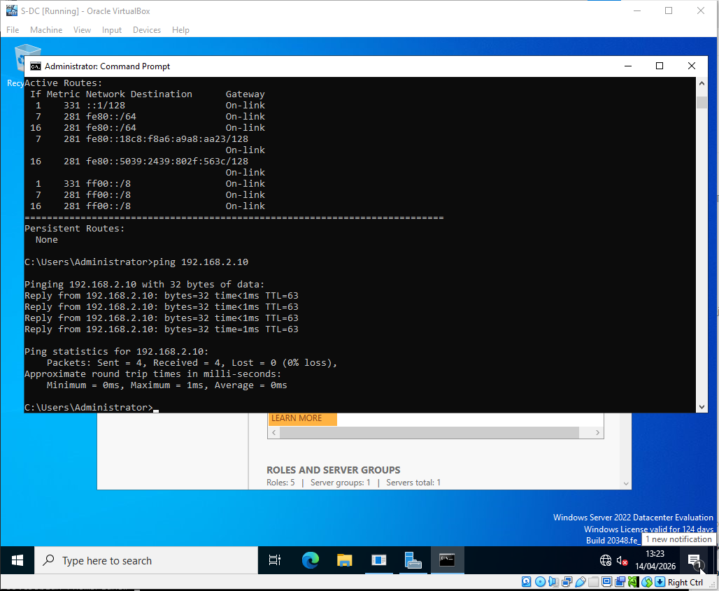

Figure 6 – Ping to Windows Client from Debian Server
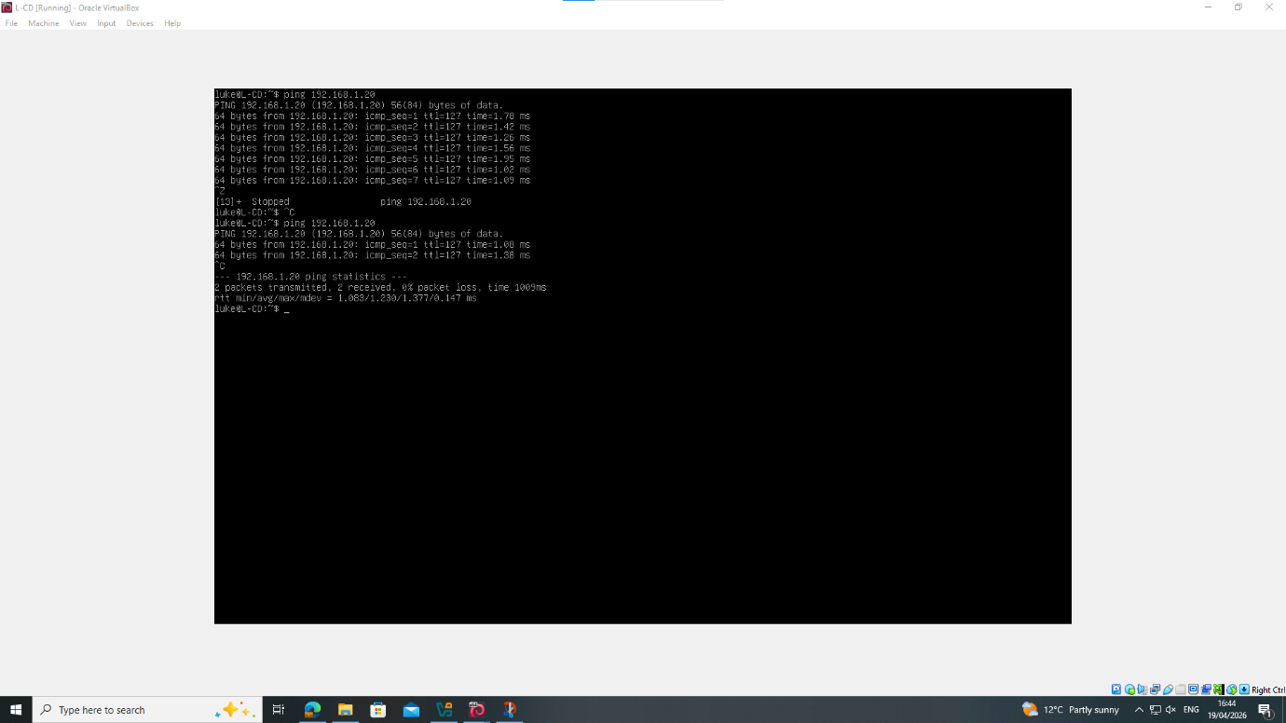

Domain Server (Swansea)
Figure 7 – Active Directory Services installation
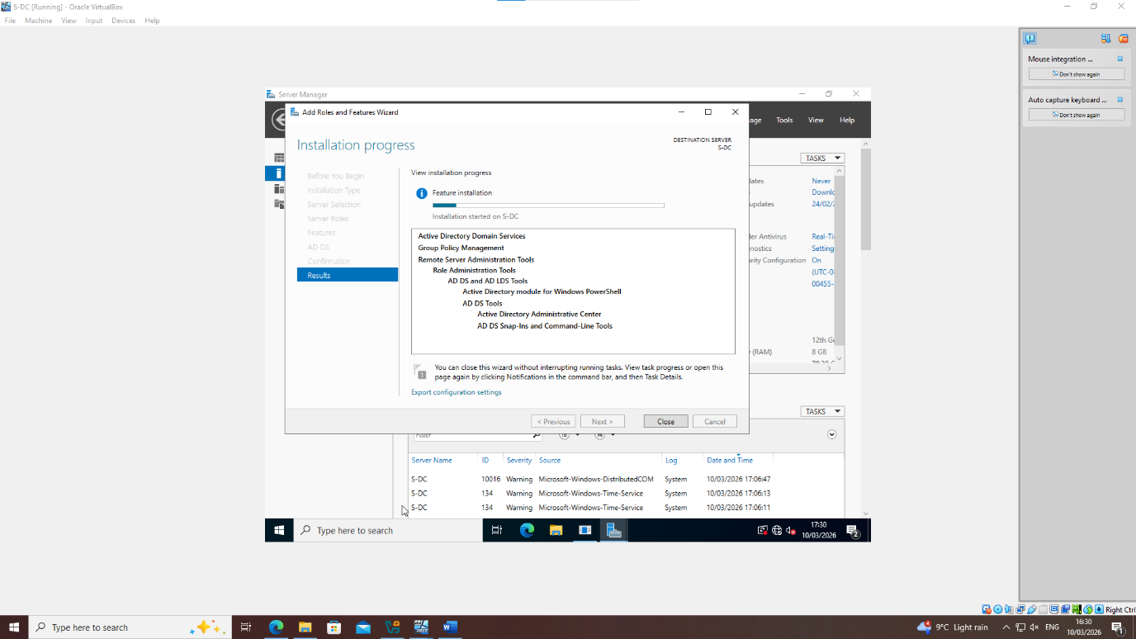
Figure 8 – Active Directory Services installation
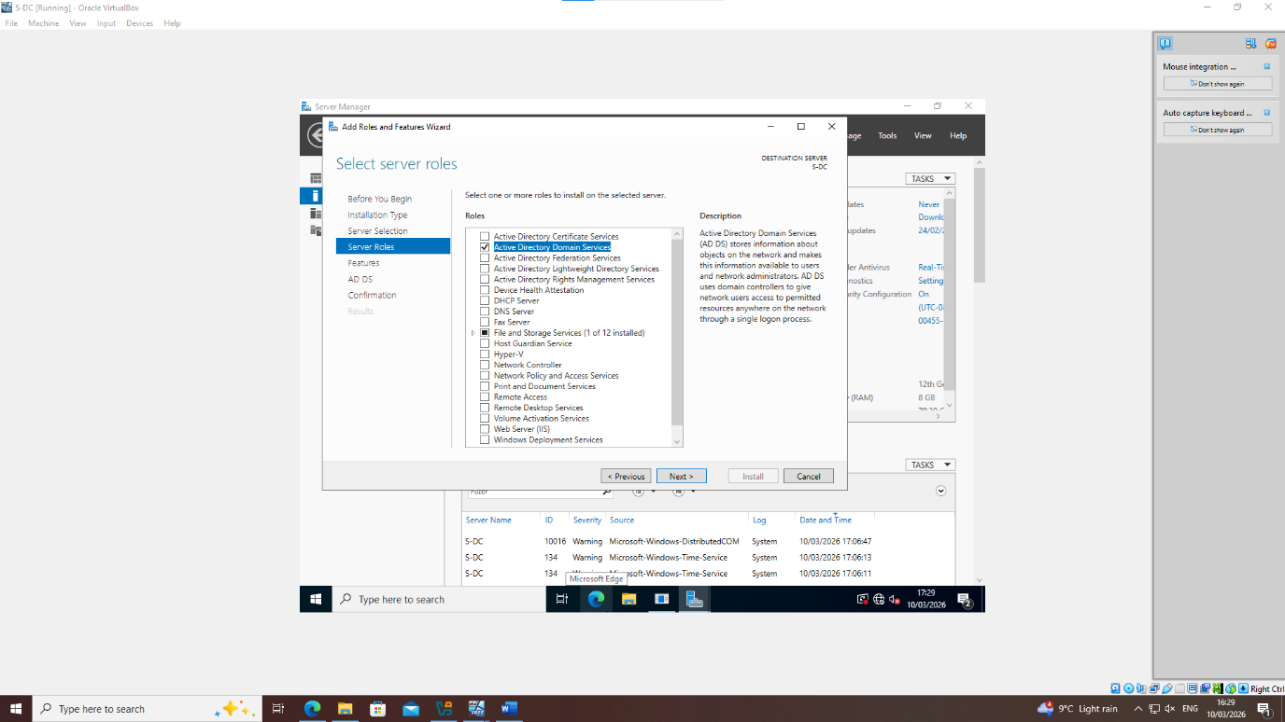

Figure 9 – Configuring Domain
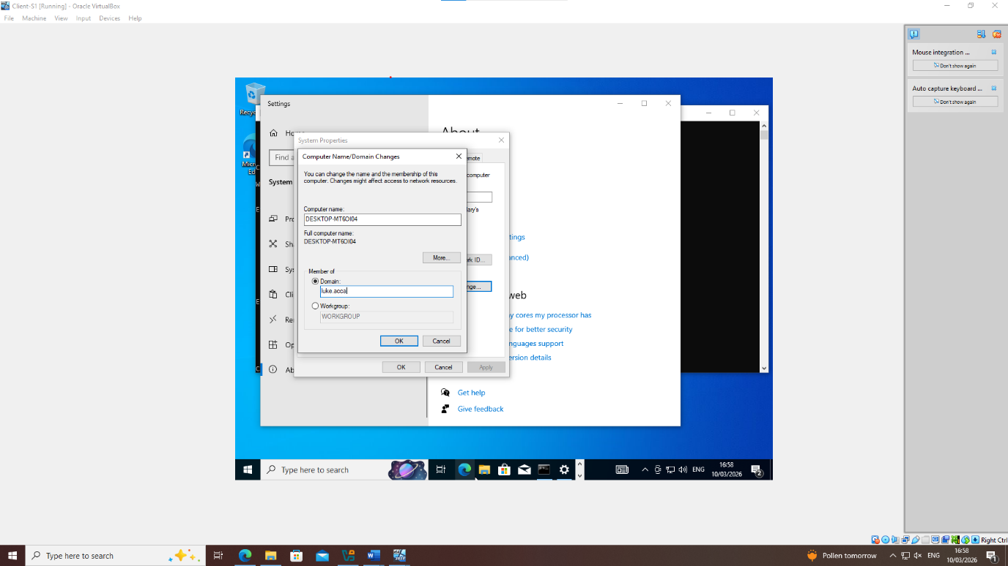

Figure 10 – Domain created
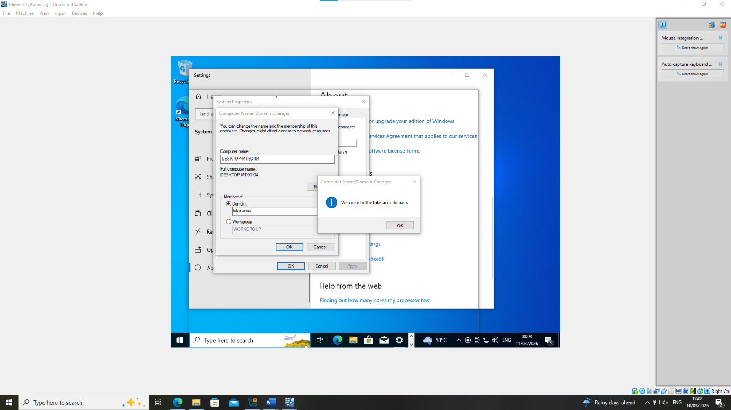

Figure 11 – Domain visible in Server Manager
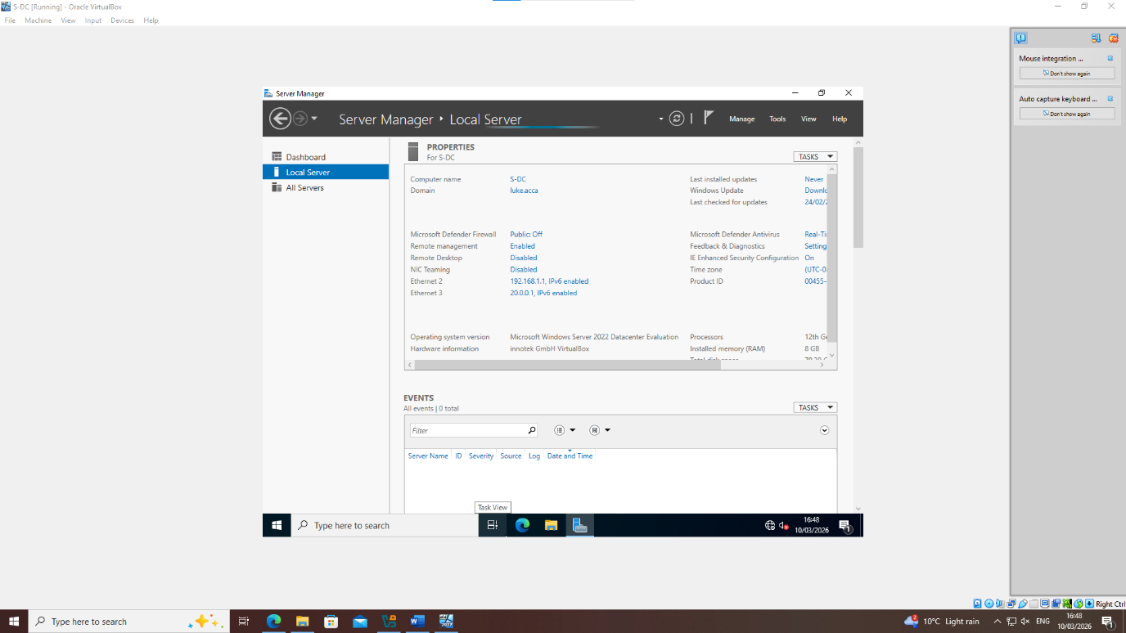
Figure 12 – Forward lookup zones created/pings working
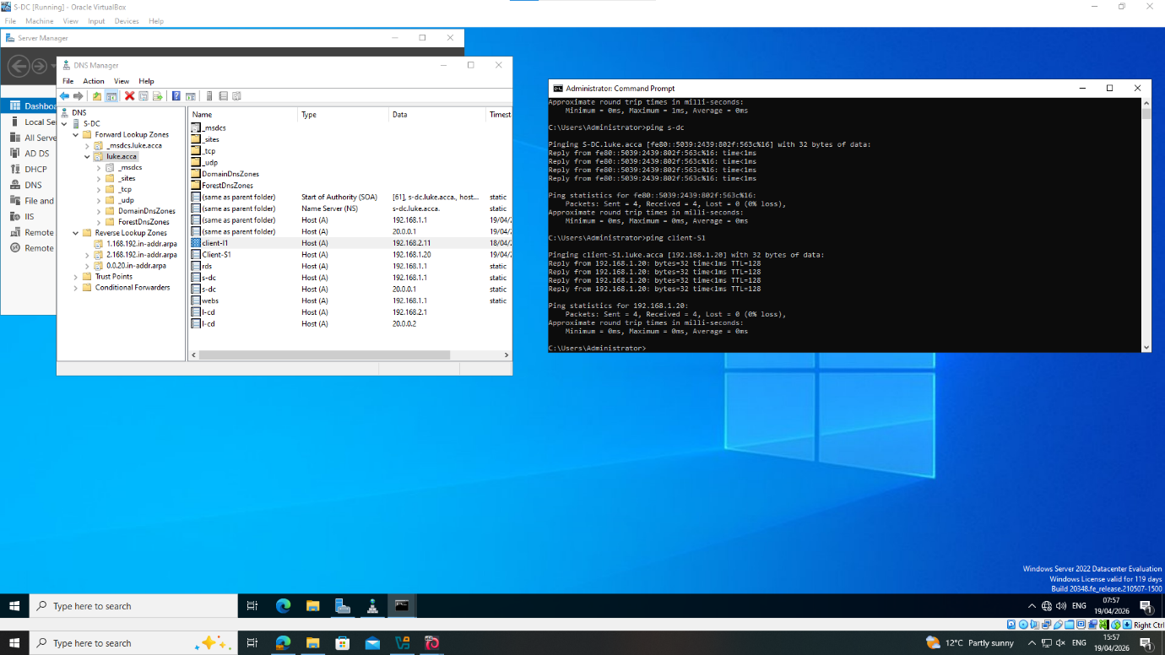

Figure 13 – Reverse lookup zones created
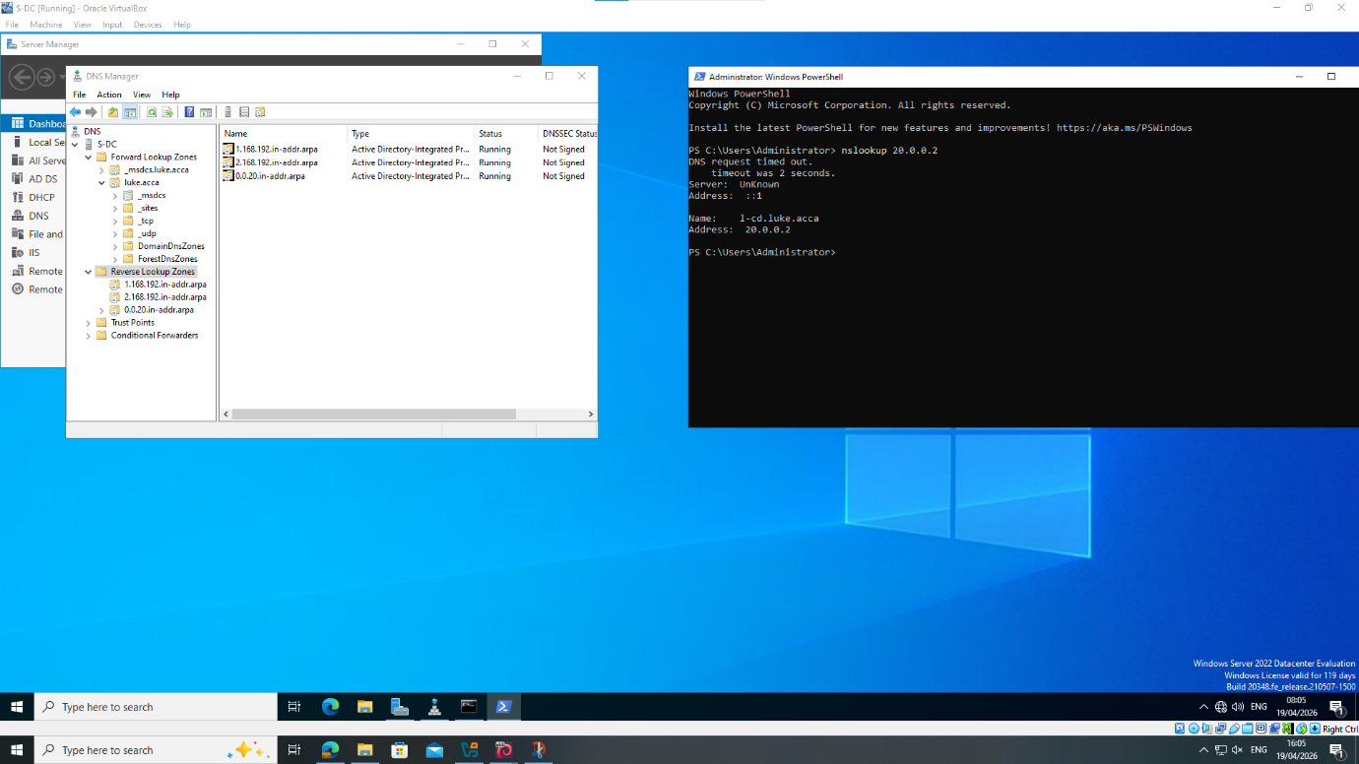

Encrypted Connection between Swansea and London

Figure 14 – VPN Installed in Server Roles
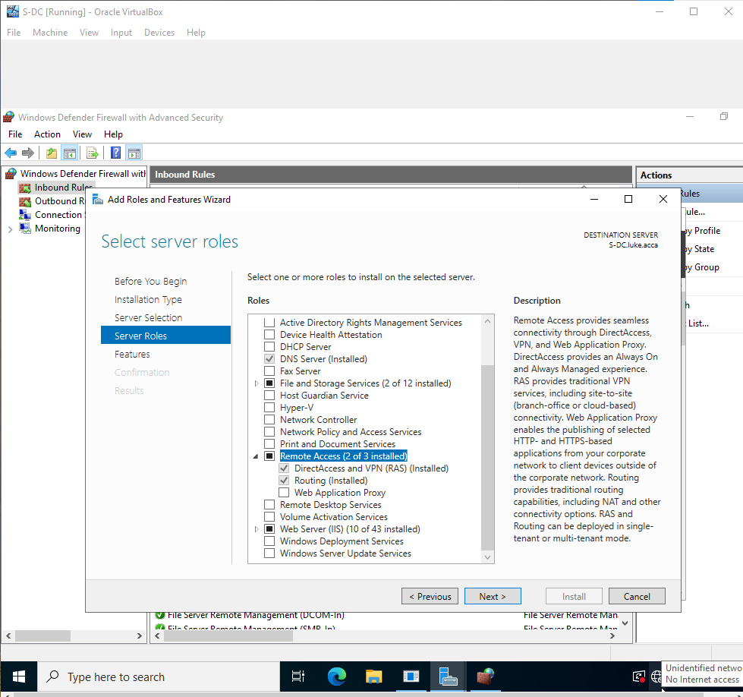

Figure 15 – Demand Dial Interface configured
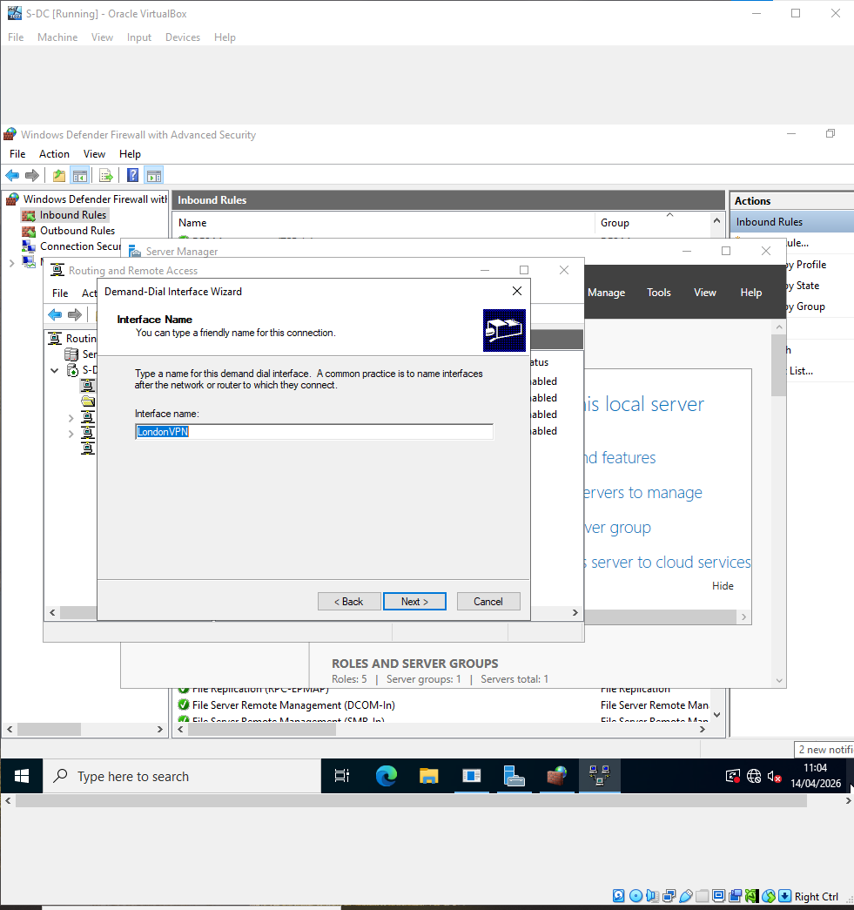

Figure 16 -Point to Point Protocol Configured
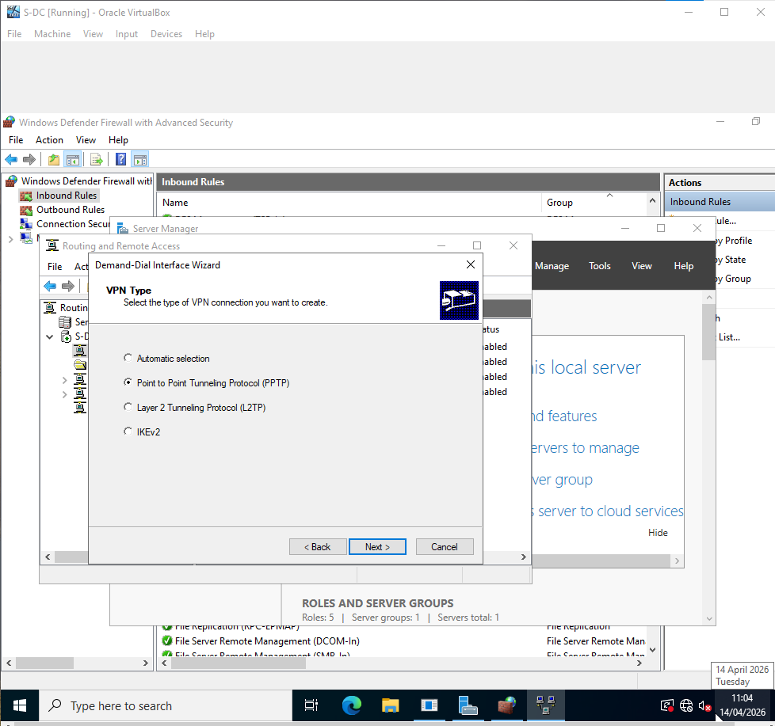

Figure 17 – Remote router address inputted
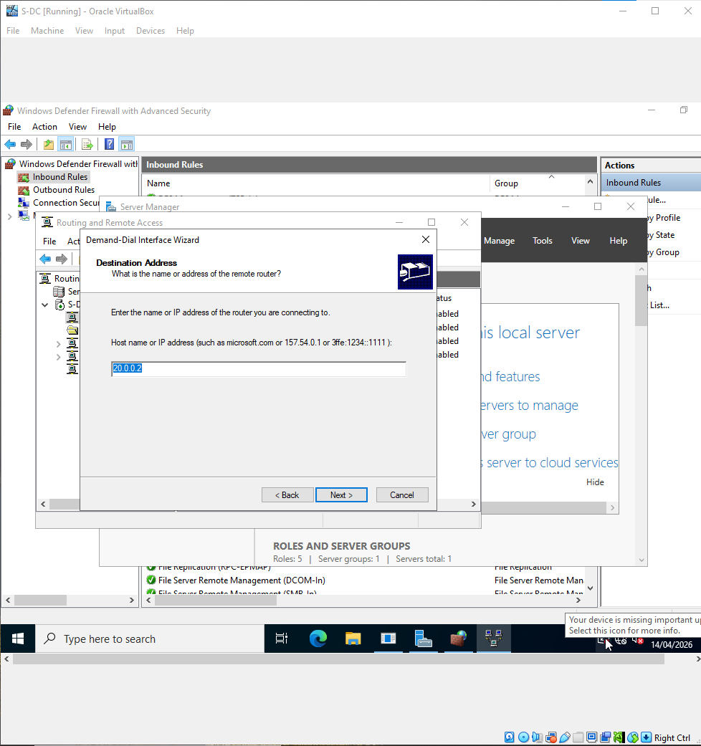

Figure 18 – Static route defined
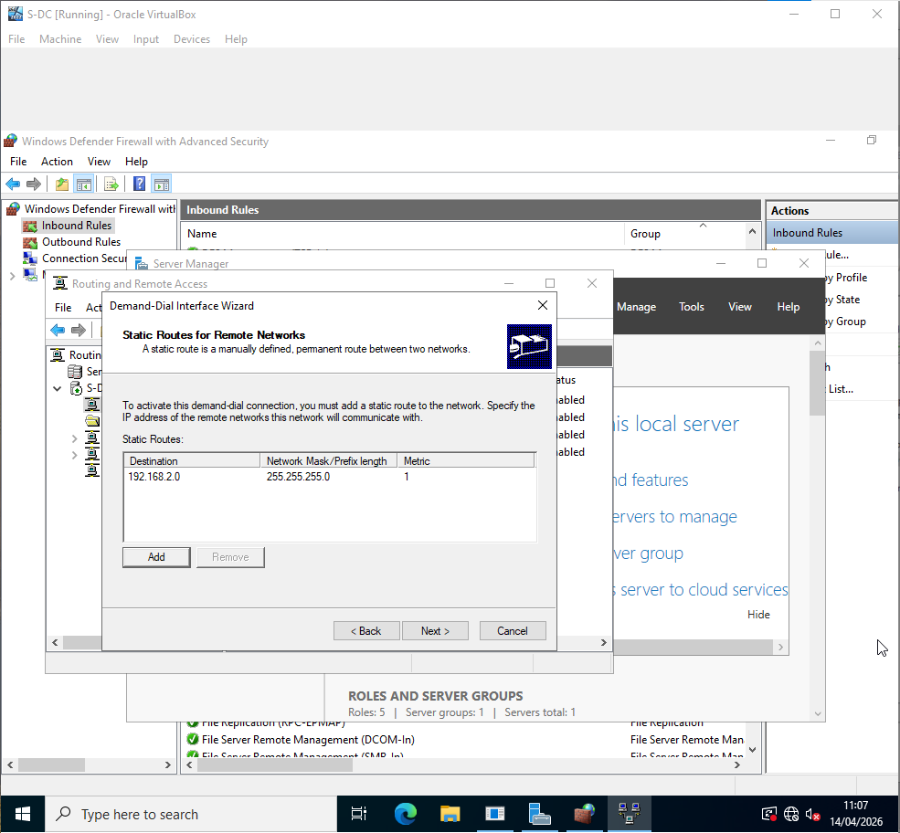

Figure 19 – LondonVPN created
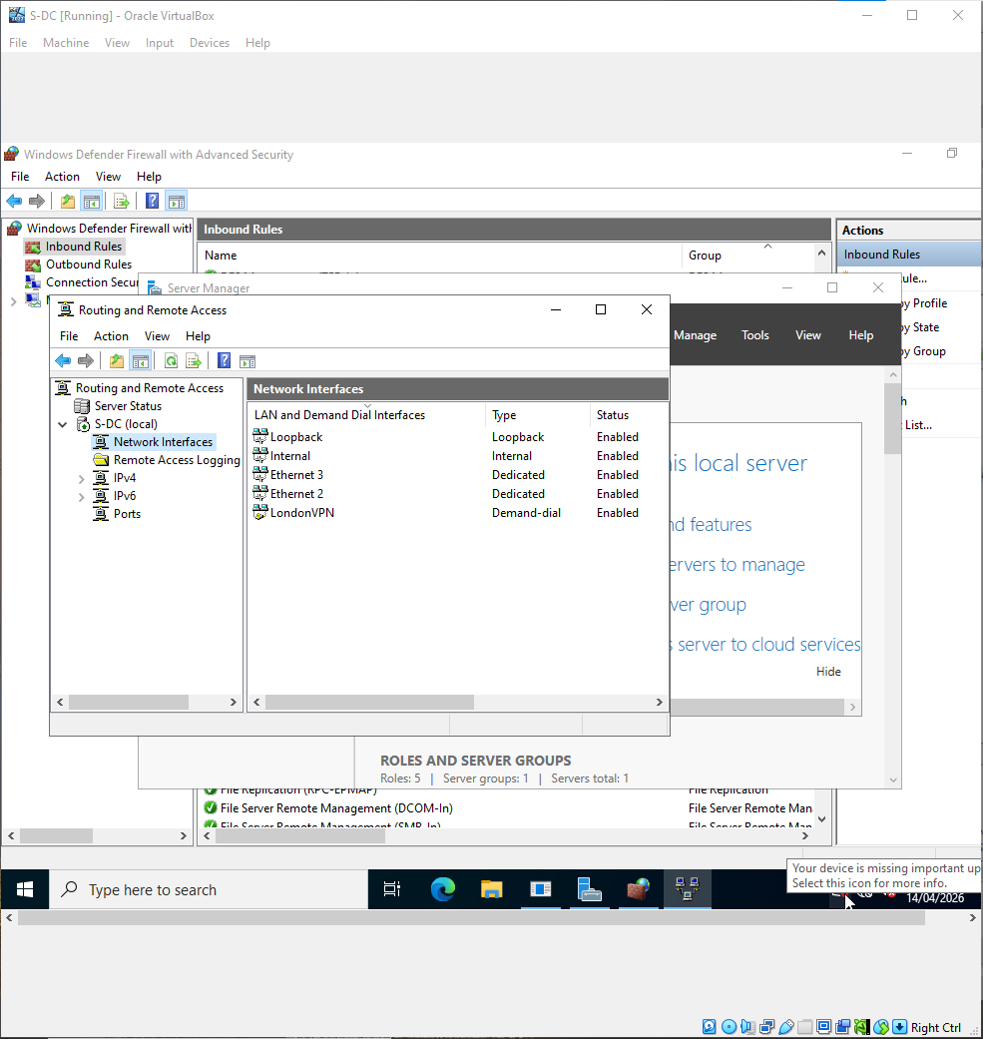

Figure 20 – LondonVPN network access given
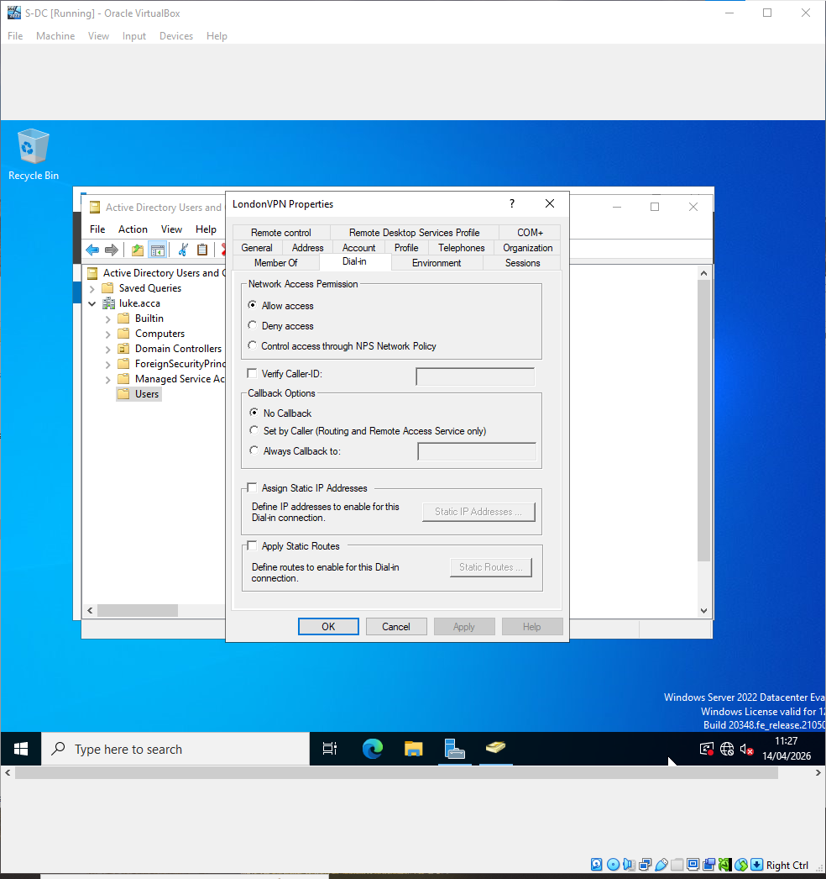

Figure 21 – LondonVPN connected
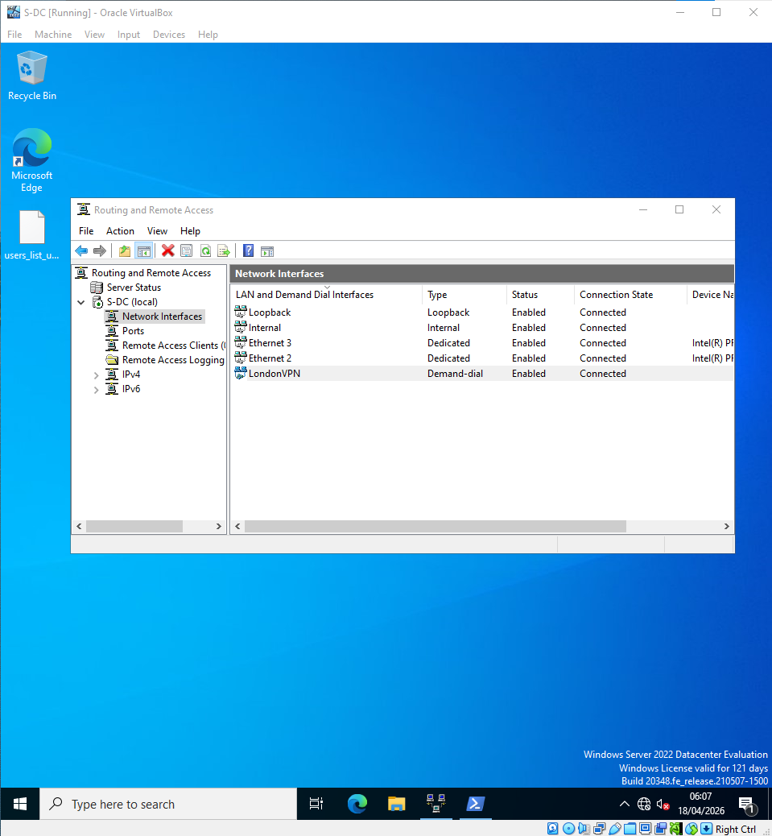

Figure 22 – Ping over VPN
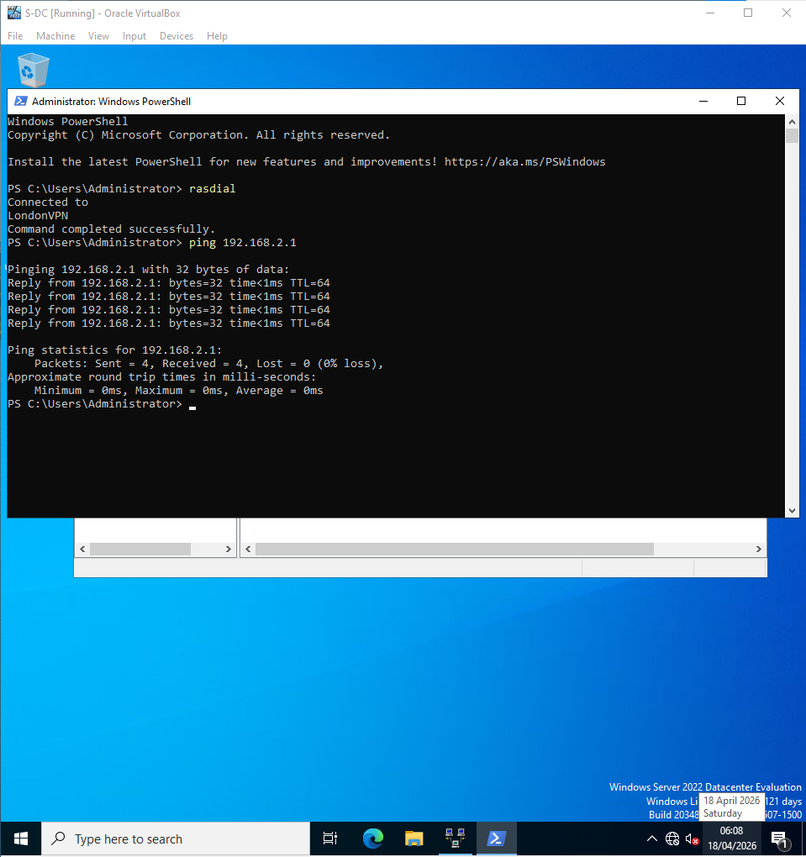

Users
Figure 23 – Copy user table
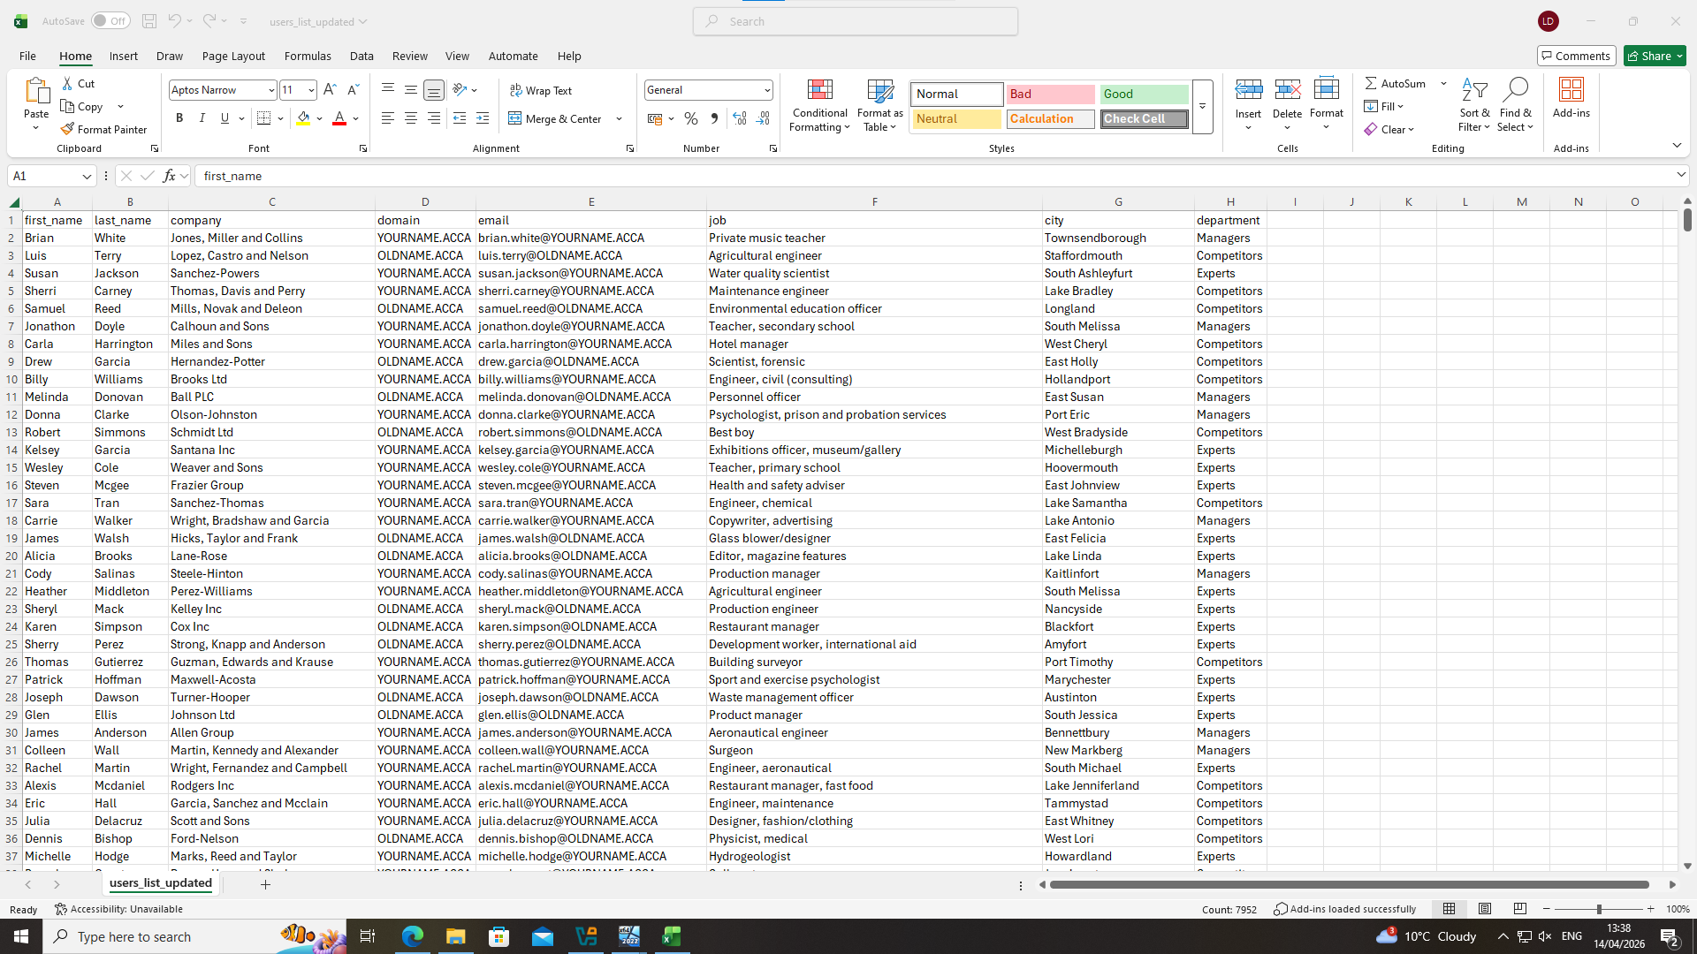

Figure 24 – Spreadsheet improved via shared drive
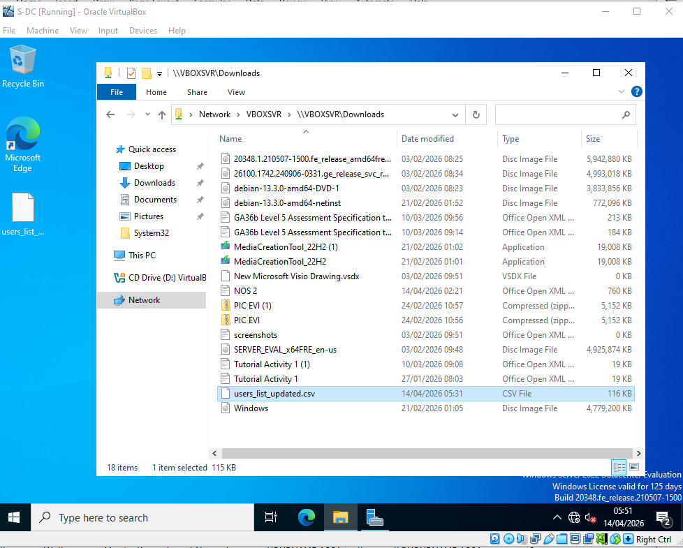

Figure 25 – Data loaded into Powershell
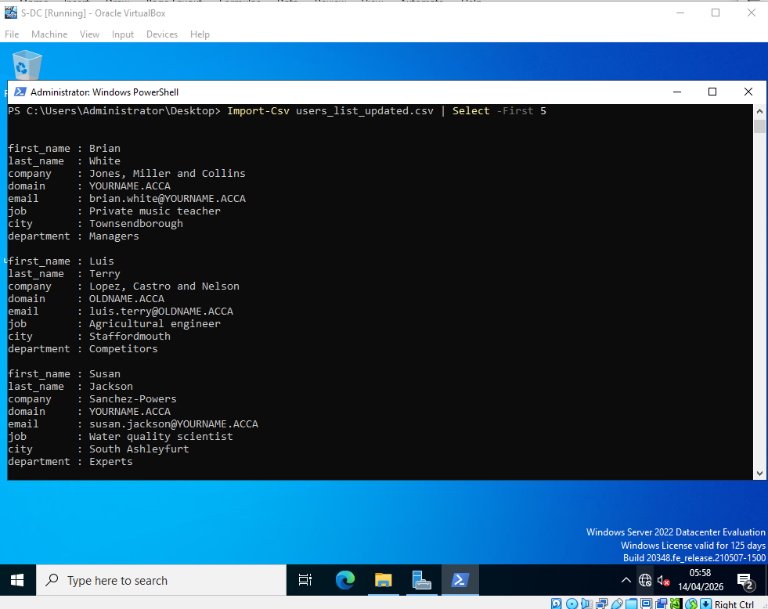

Figure 26 – Running Powershell script
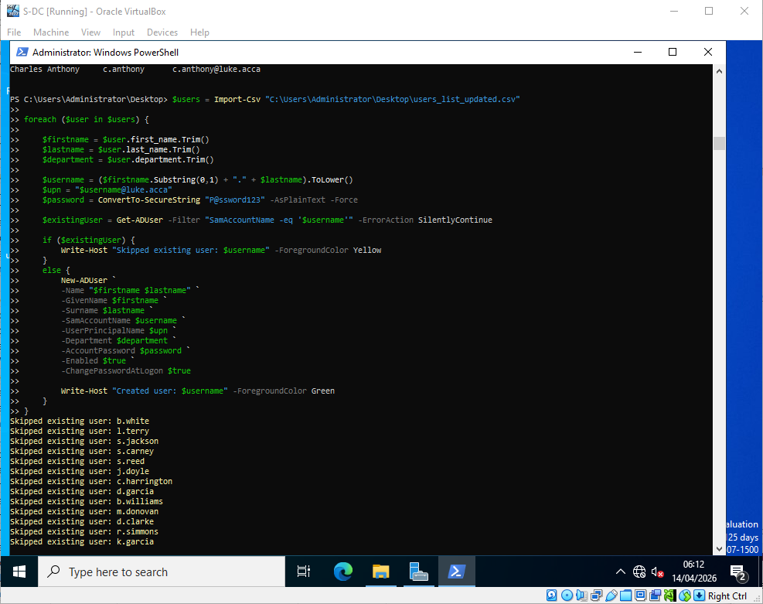

Figure 27 – Output creating users
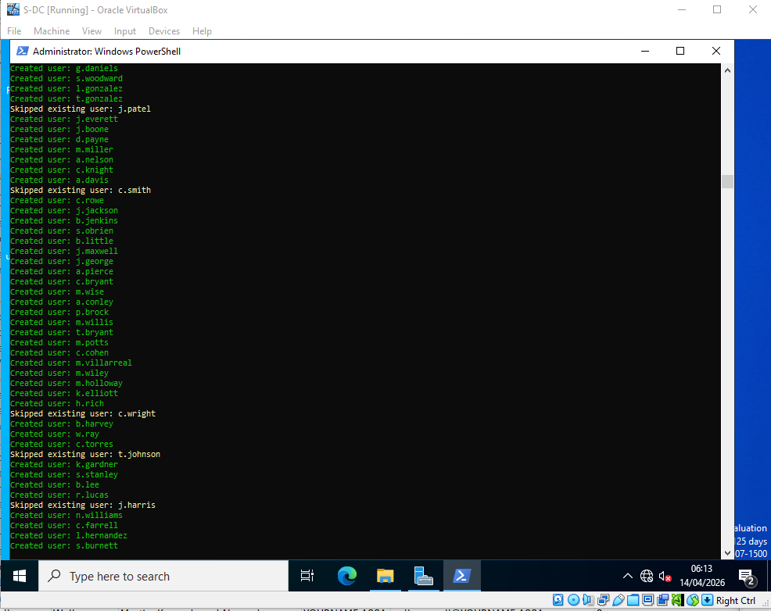

Figure 28 – Amended script to create accounts with like names e.g. b.white2
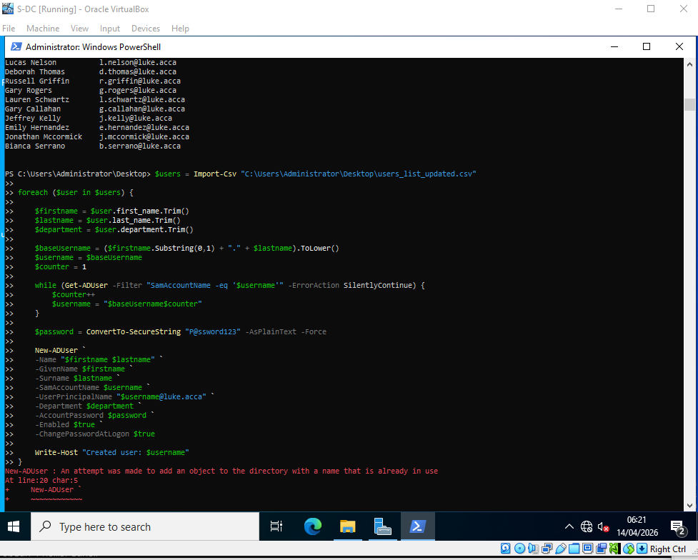

Figure 29 – List of users including where more than 1
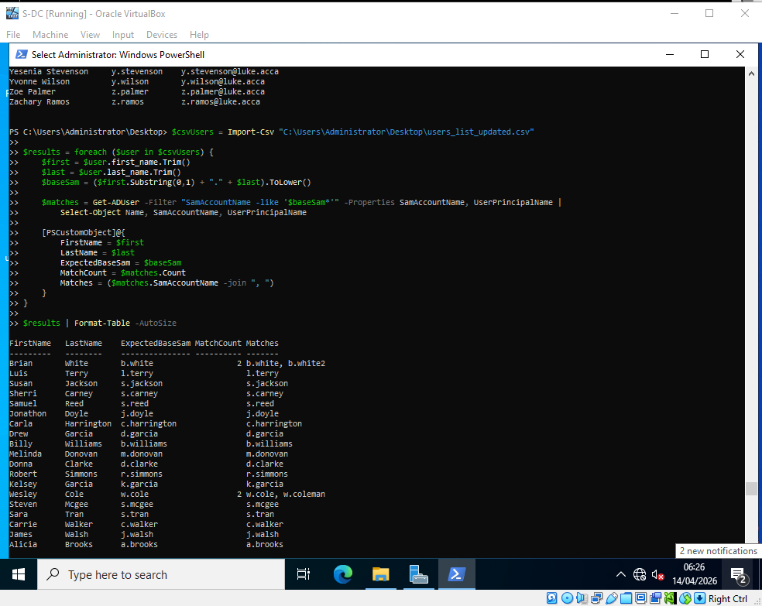

Figure 30 – No names missing
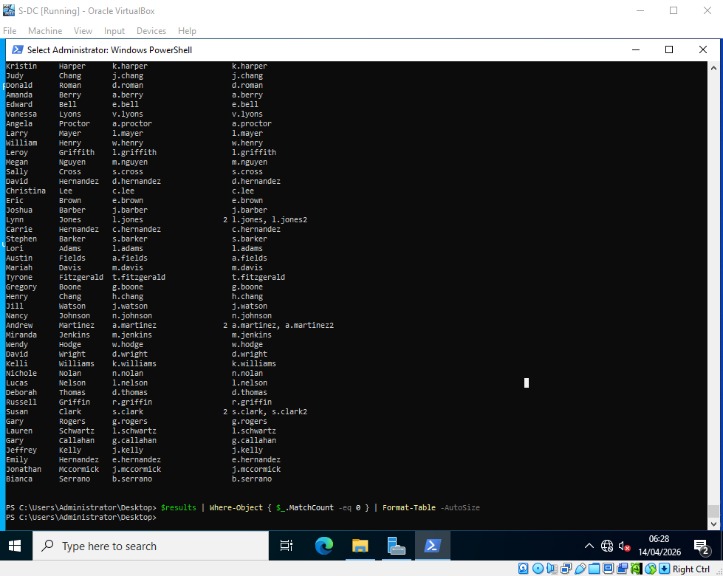

Figure 31 – Original script duplicate errors
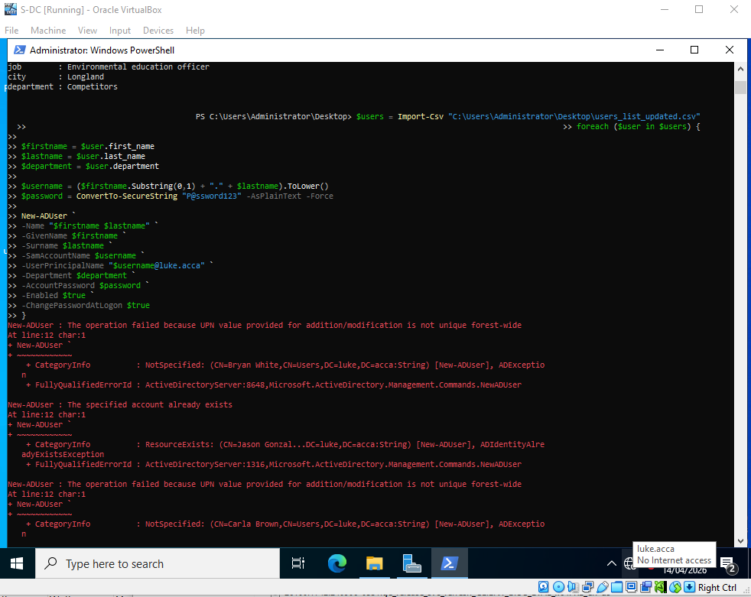

Domain Membership
Figure 32 – Adding S1 to Windows Domain
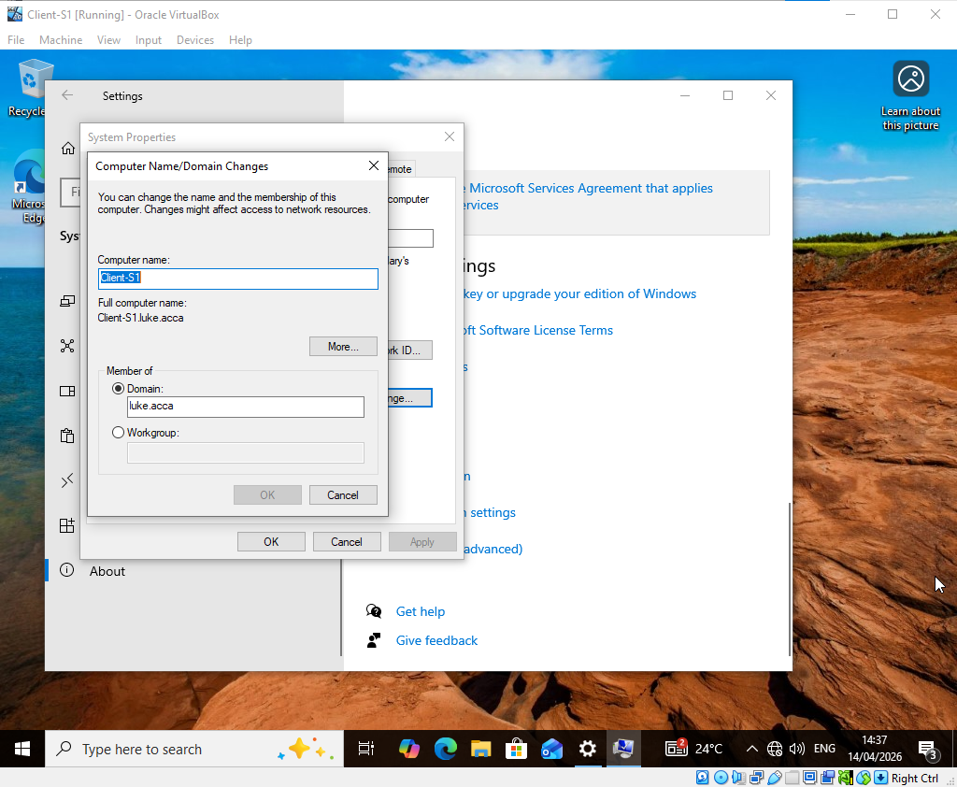

Figure 33 – Client S1 added to Domain
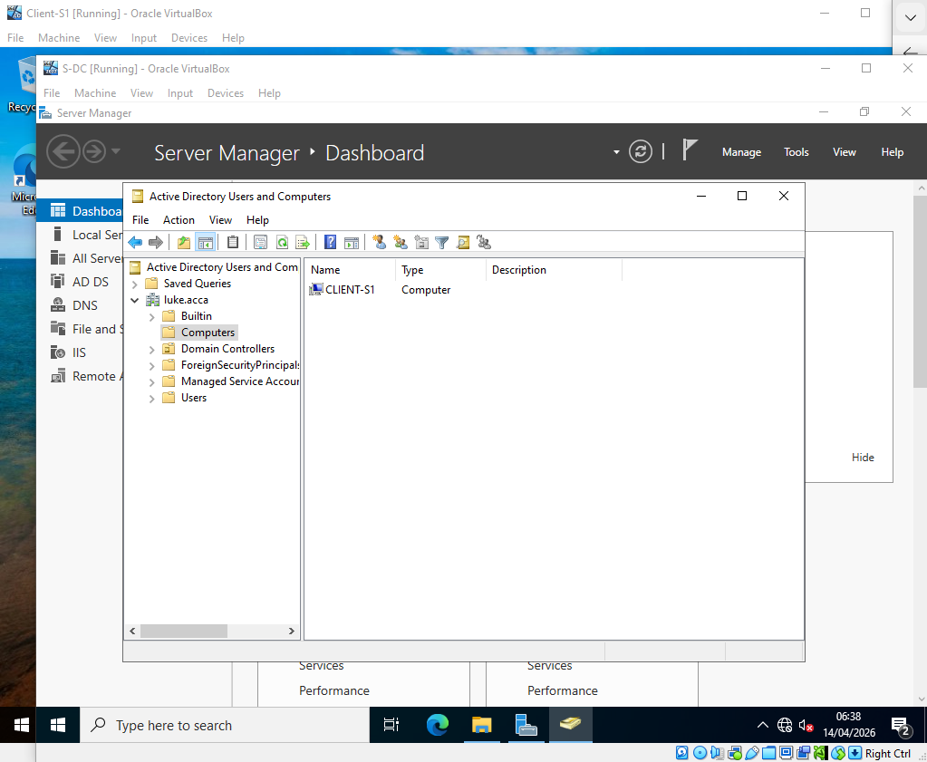

Figure 34 – Discovery of luke.acca in Debian server

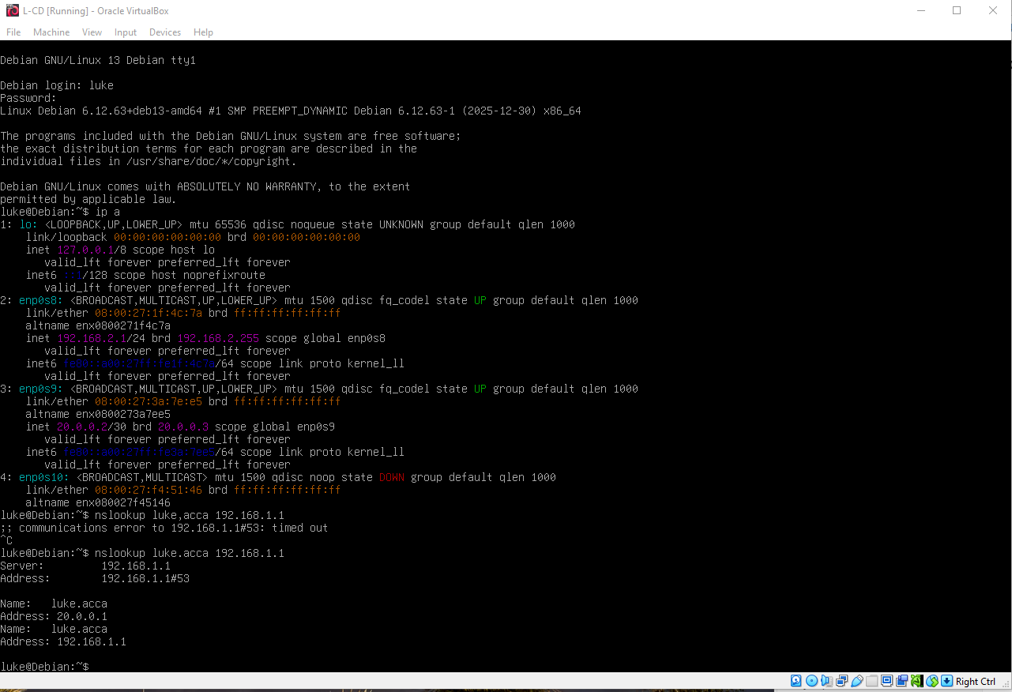
Figure 35 – Joined Debian server to luke.acca
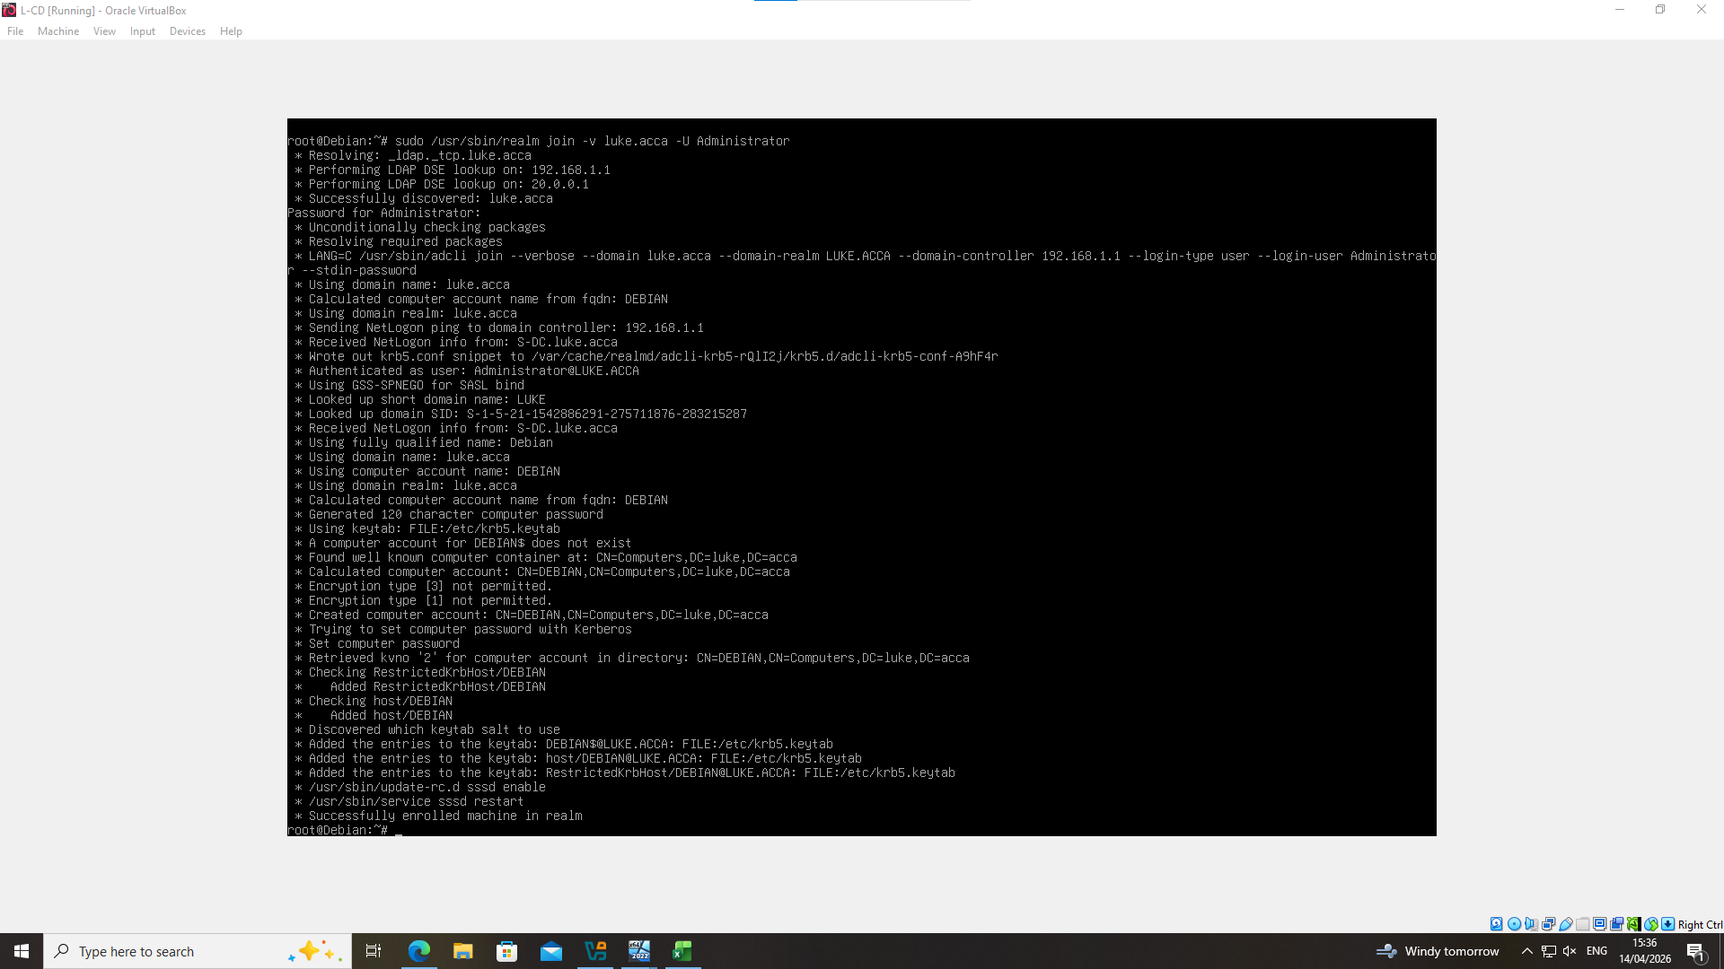

Figure 36 – Realm list command shows within domain luke.acca
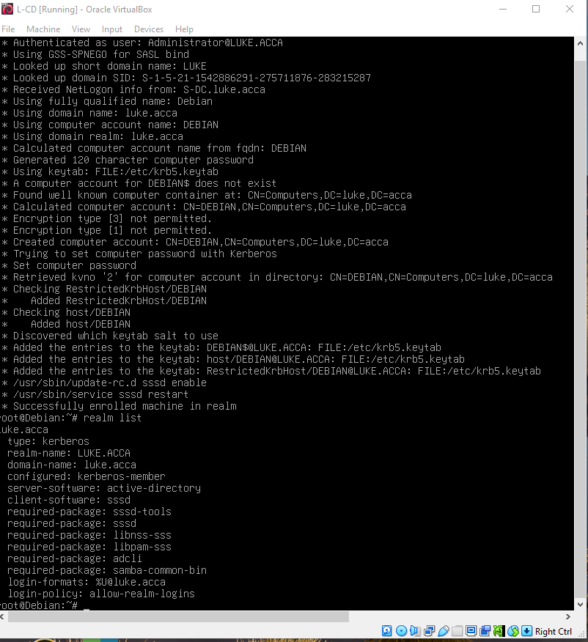

Figure 37 – L-CD added to domain
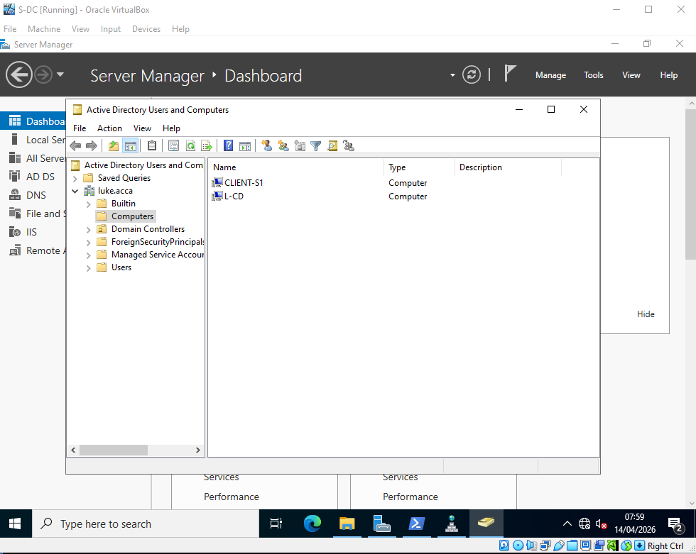

Figure 38 –Client S1 in realm
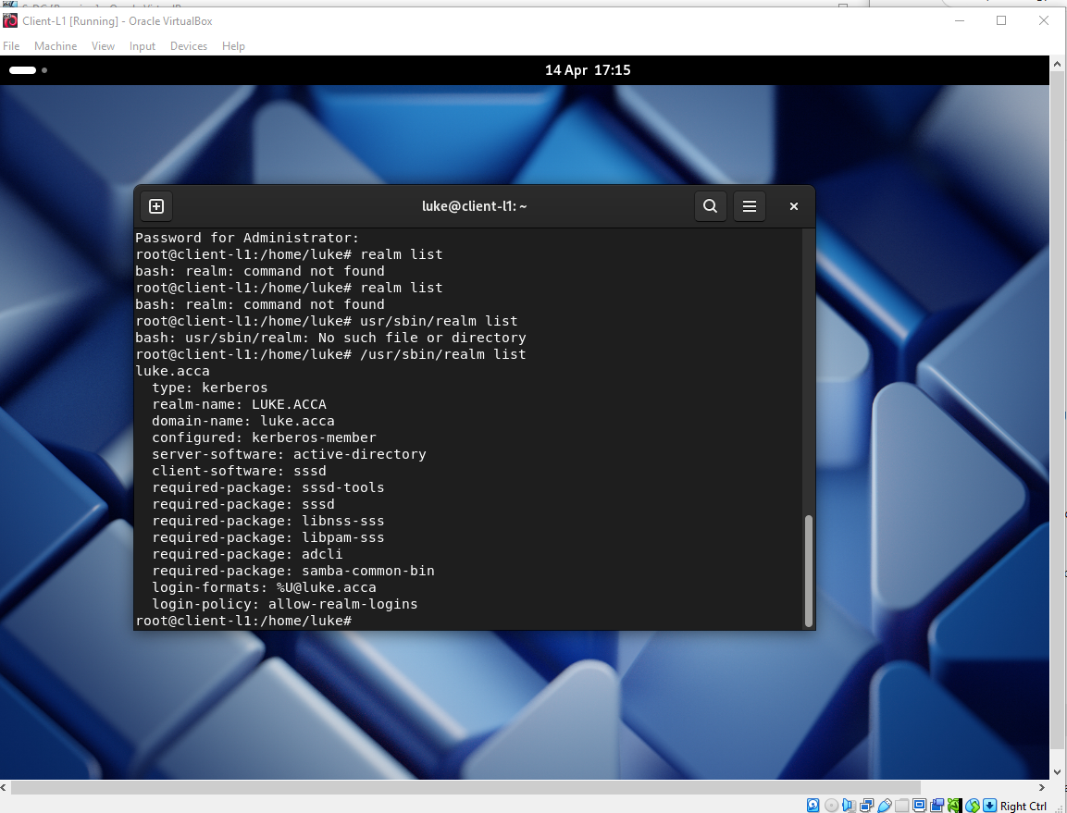

Figure 39 – Client S1 linked to domain

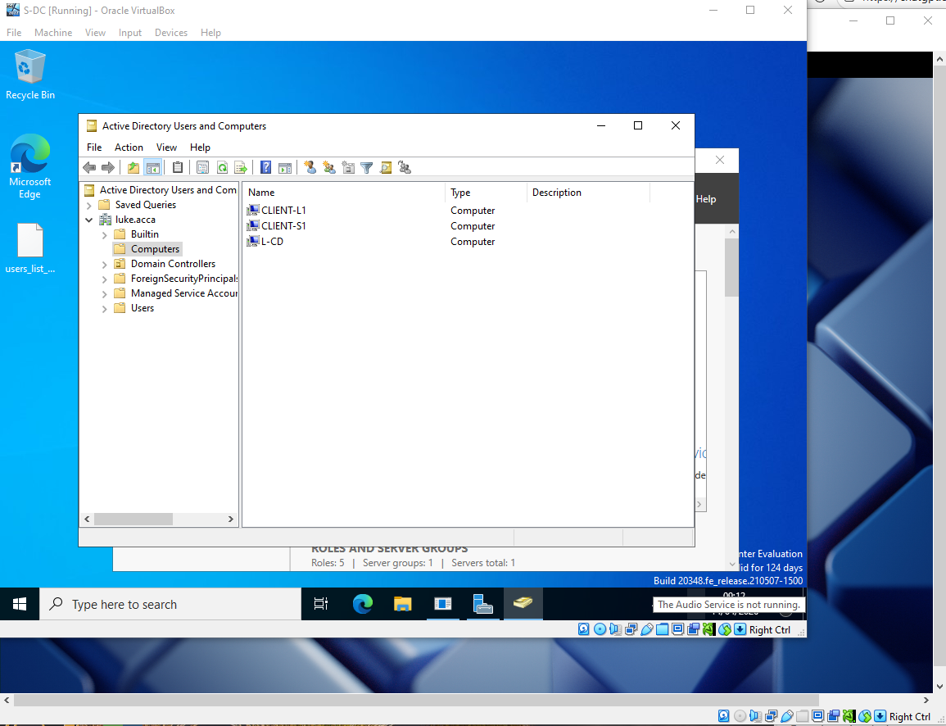

DHCP Server
Figure 40 – Installing DHCP
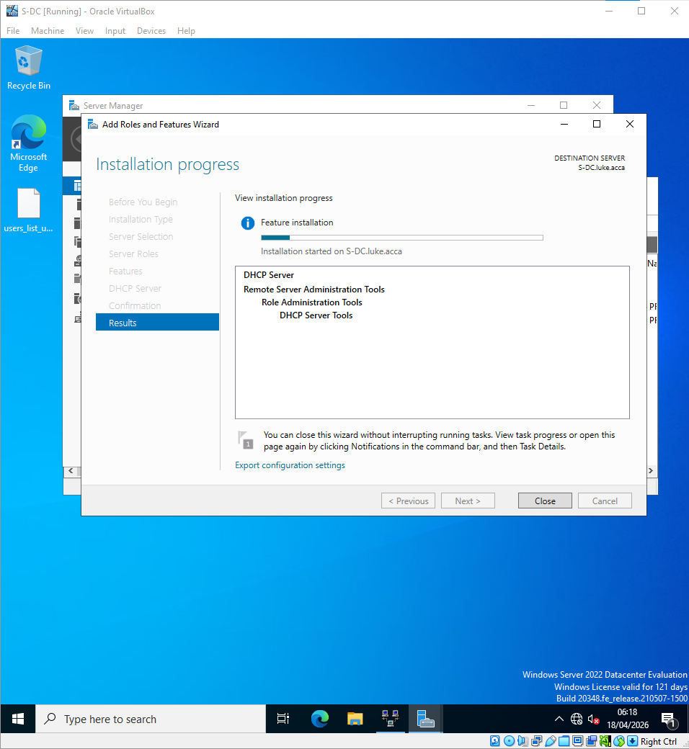

Figure 41 – DHCP Relay active
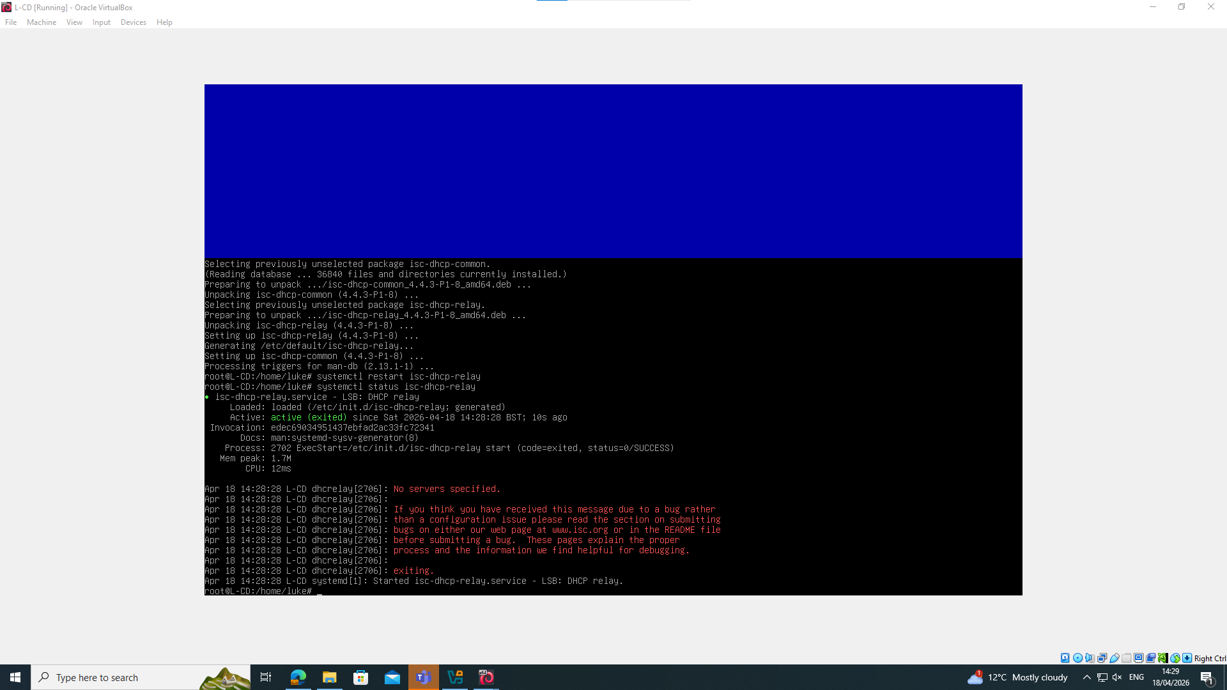

Figure 42 – Relay troubleshooted and active
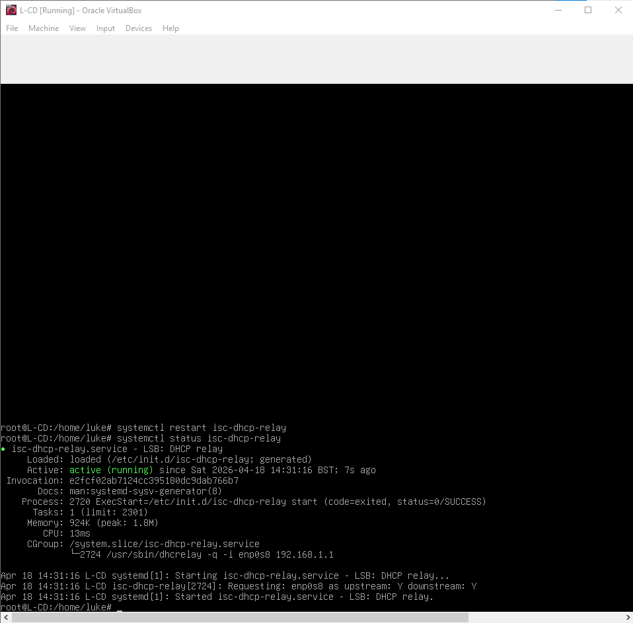

Figure 43 – Evidence of IP assigned and DHCP server – Windows client
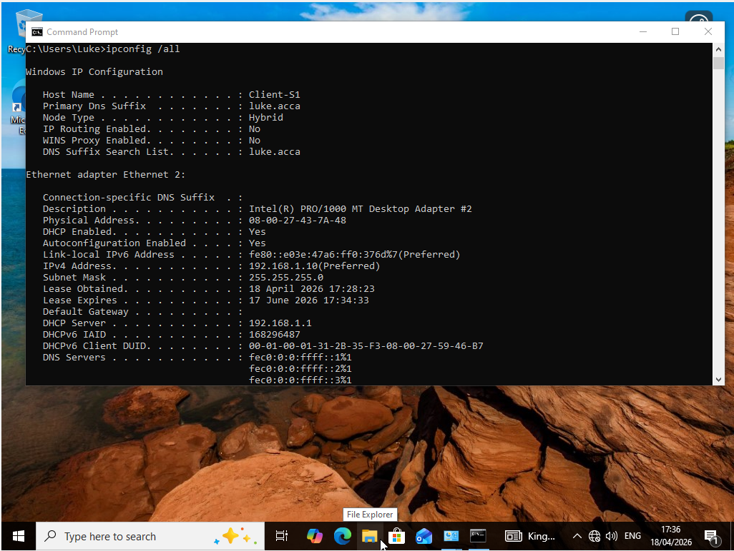
Figure 44 – Evidence of assigned IP – Debian client
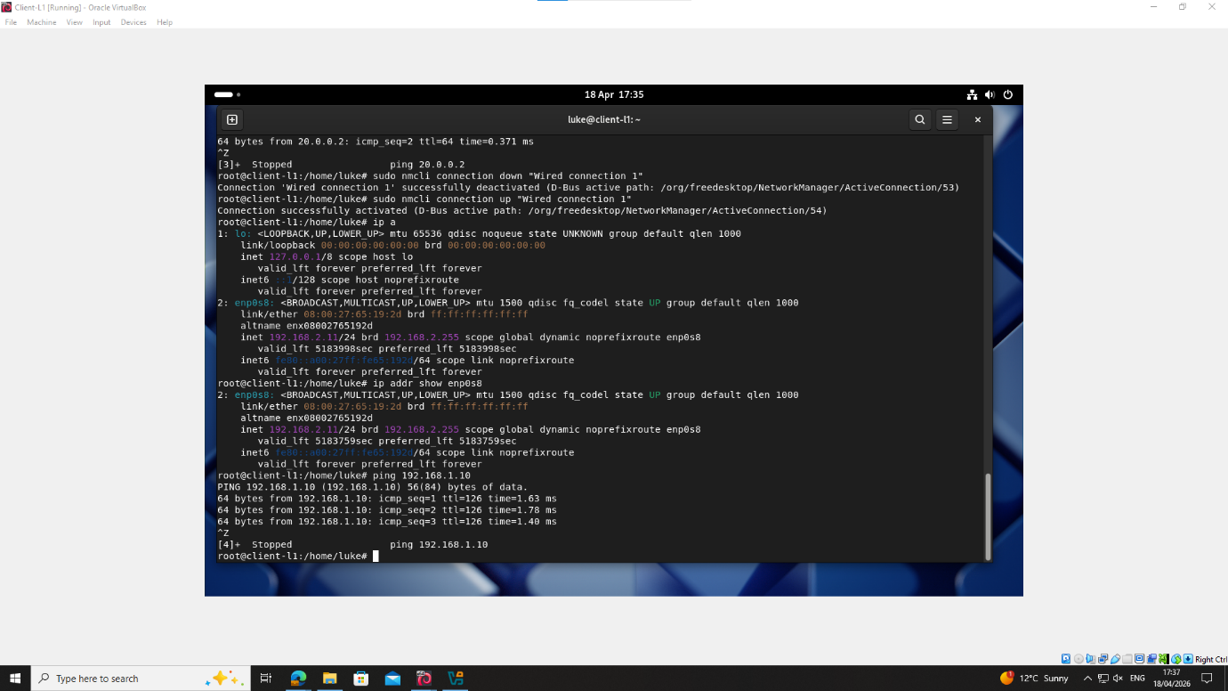

Figure 45 – Evidence of address lease – SWA
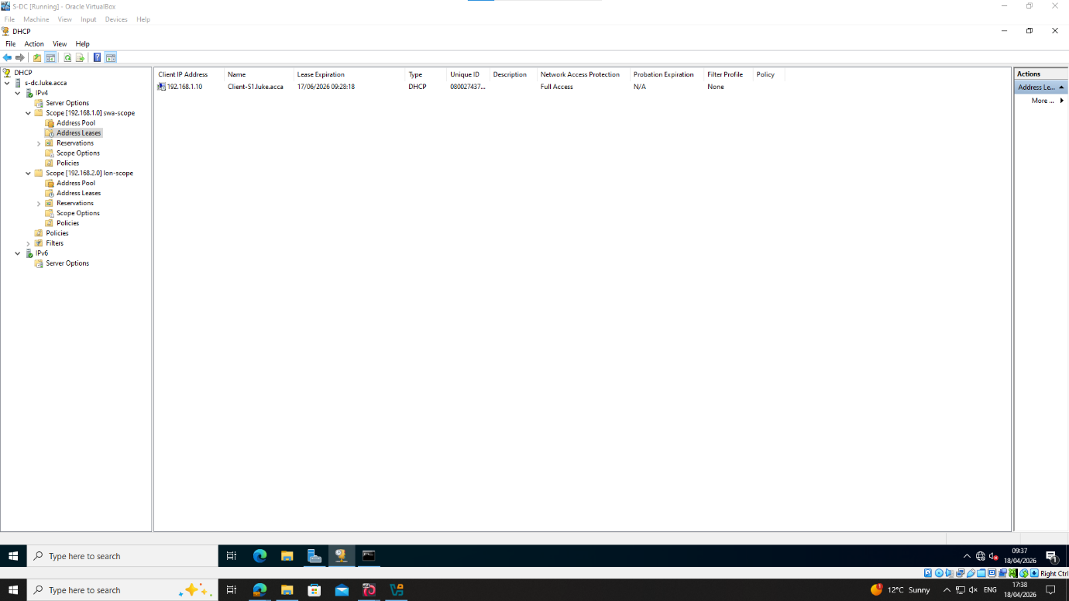
Figure 46 – Evidence of address lease - LON
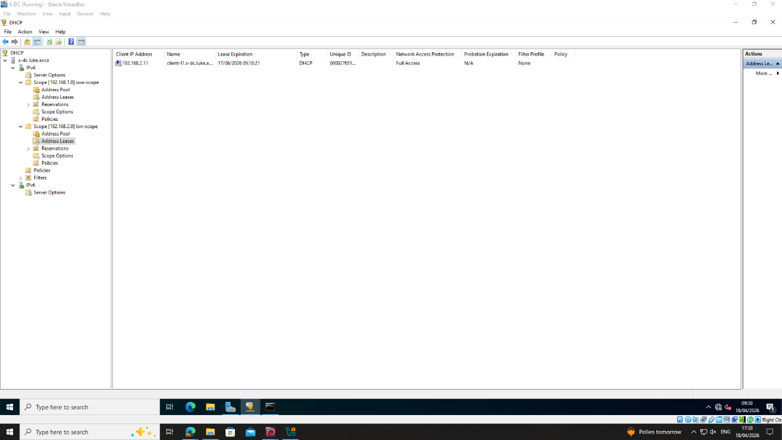

Test and Troubleshoot
Figure 47 - Client S1 pings Client L1
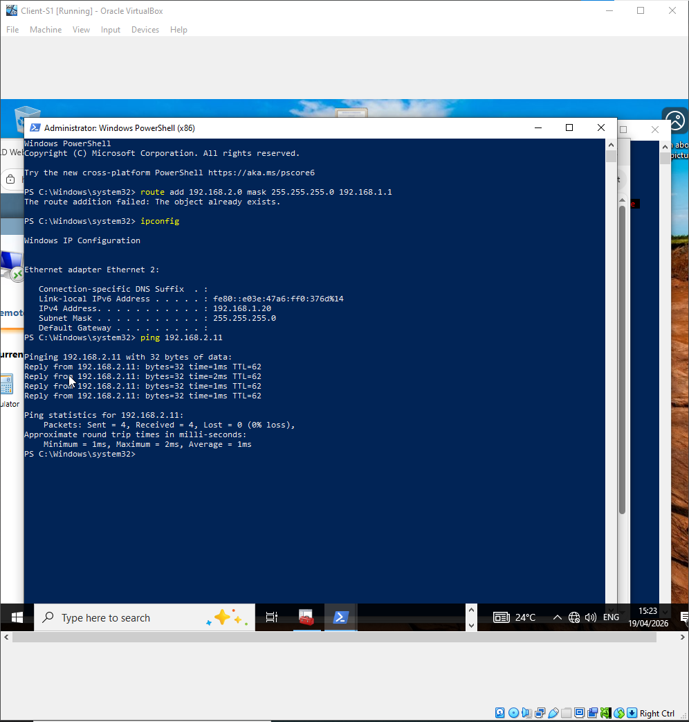

Figure 48 – Client L1 pings Client S1
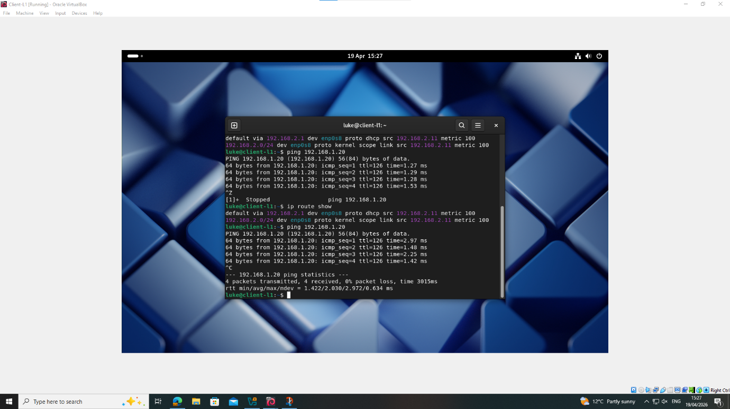

Disk Drive
Figure 49 – Creating new Disc
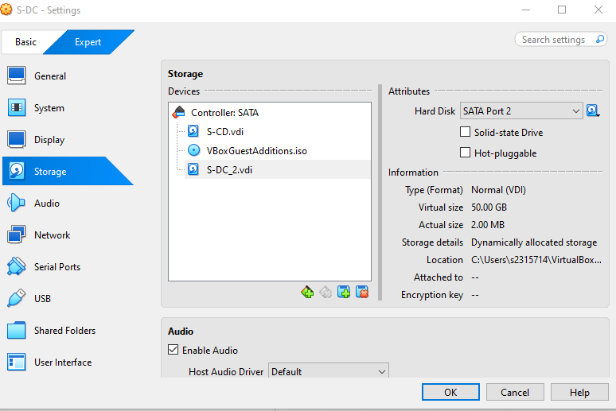

Figure 50 – Naming SwanseaFiles
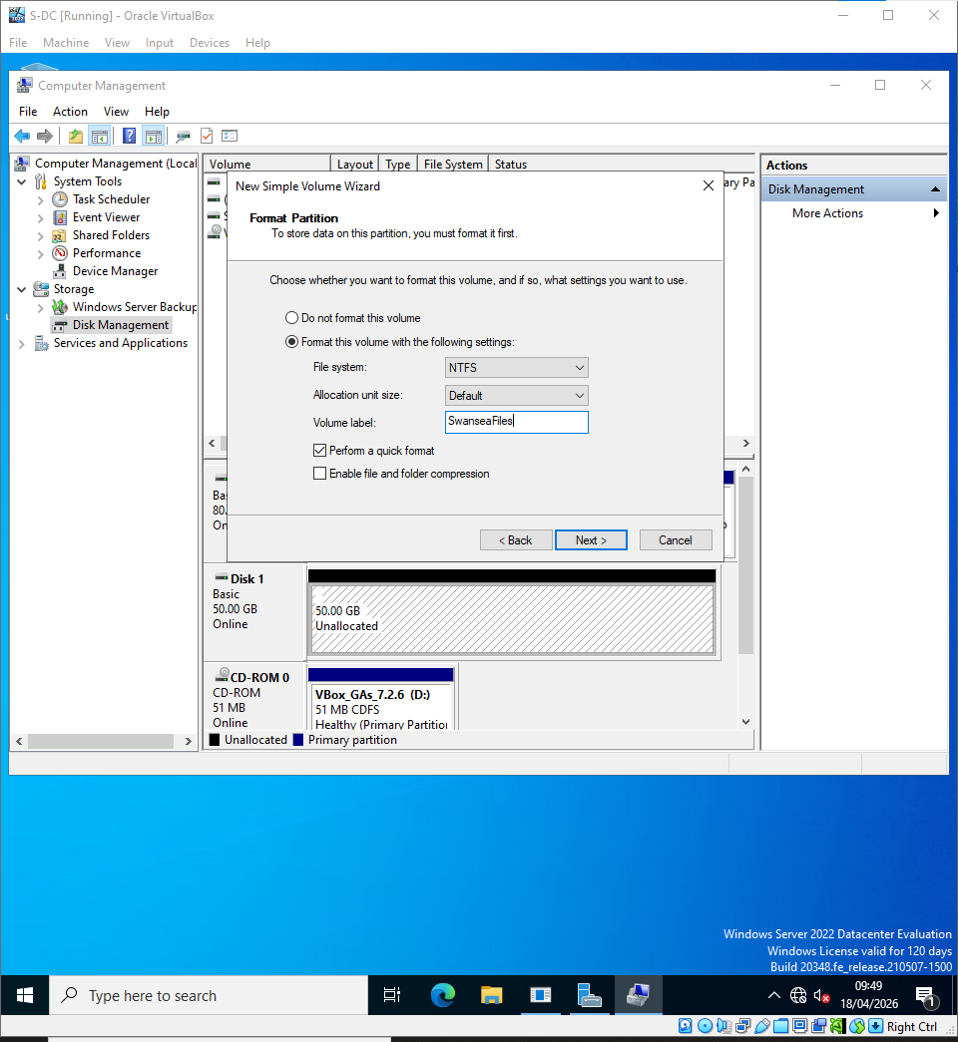

Figure 51 – Setting up Permissions
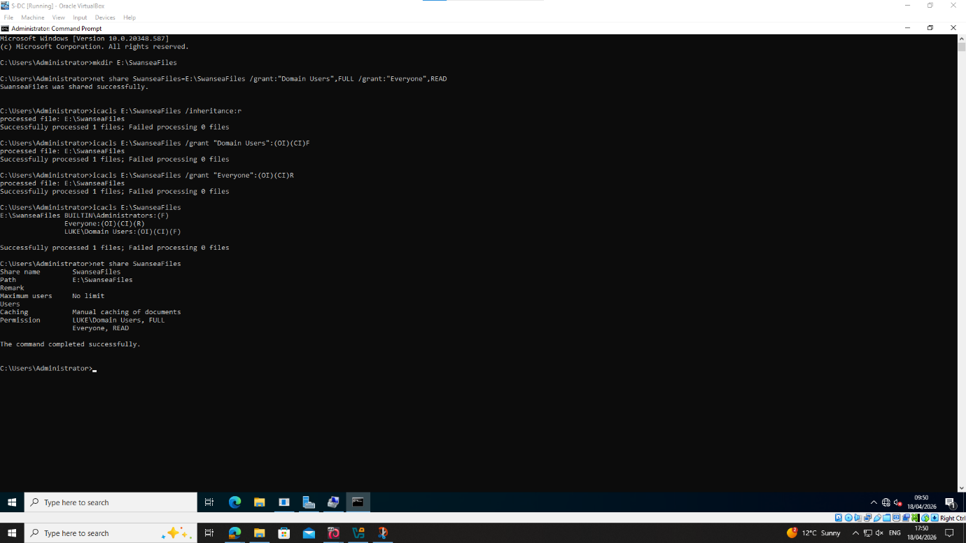

Figure 52 – Accessing drive from Windows client & editing file
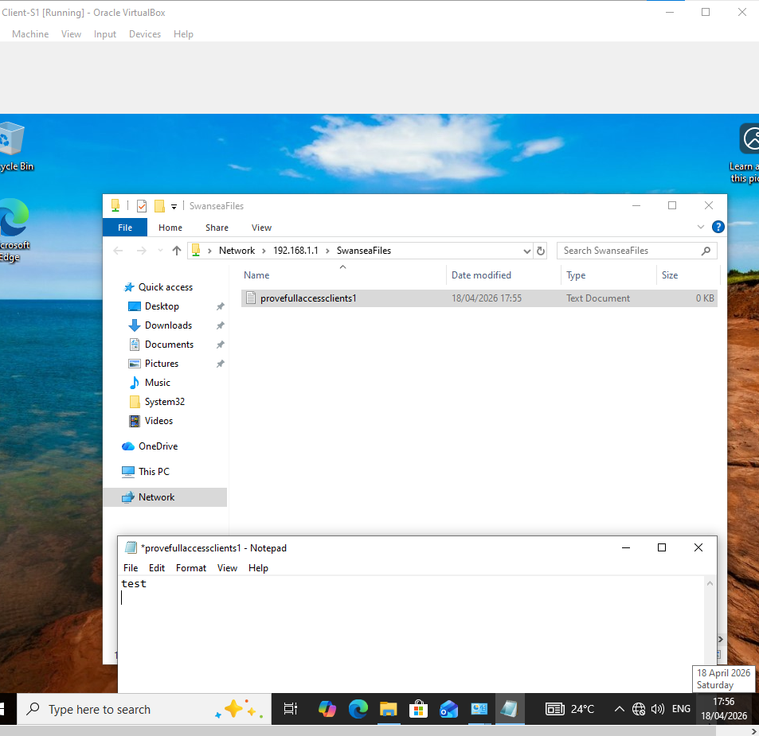

Figure 53 – Accessing drive and file from Debian server
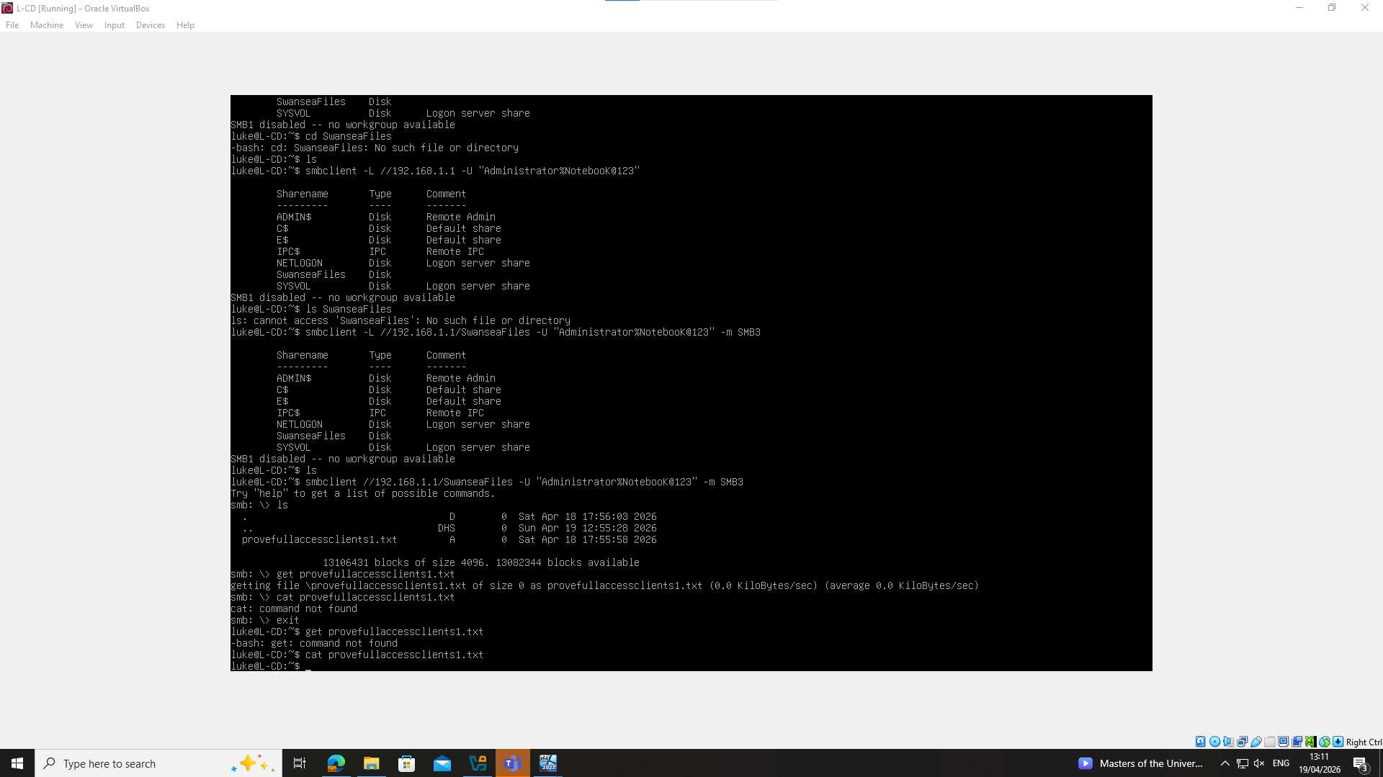

IIS Server
Figure 54 – Making IIS Server
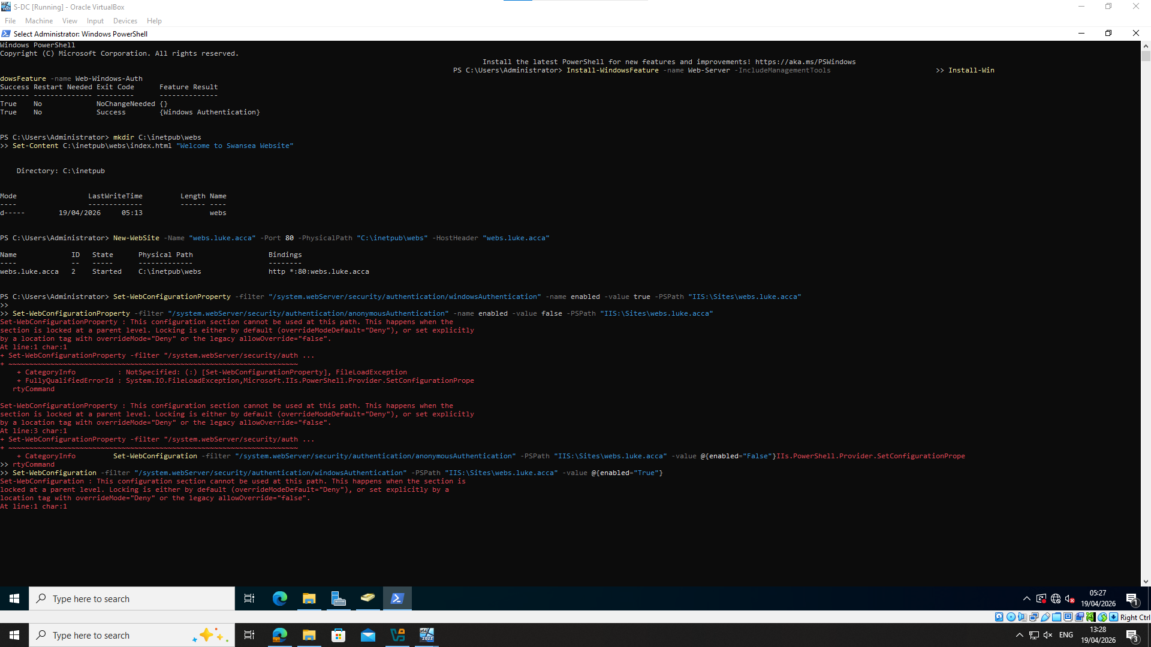
Figure 55 – Making IIS Server
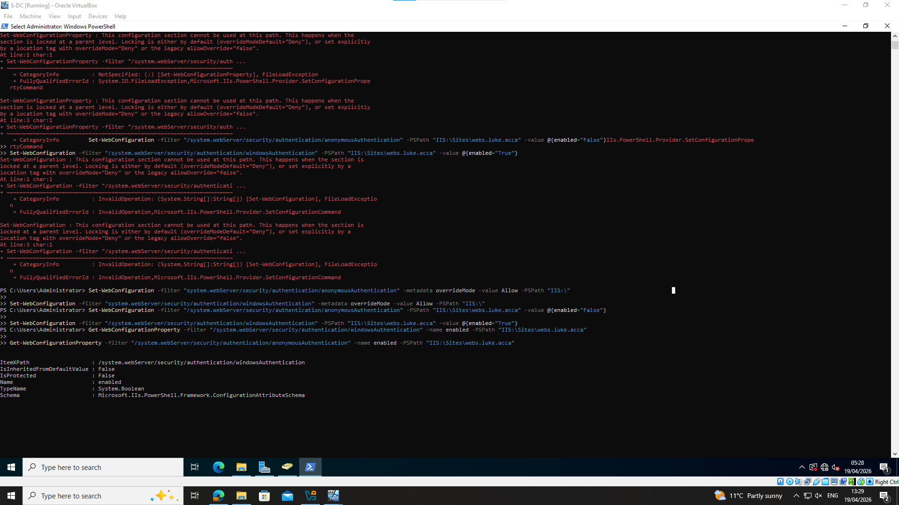

Figure 56 – Making IIS Server and Certificates
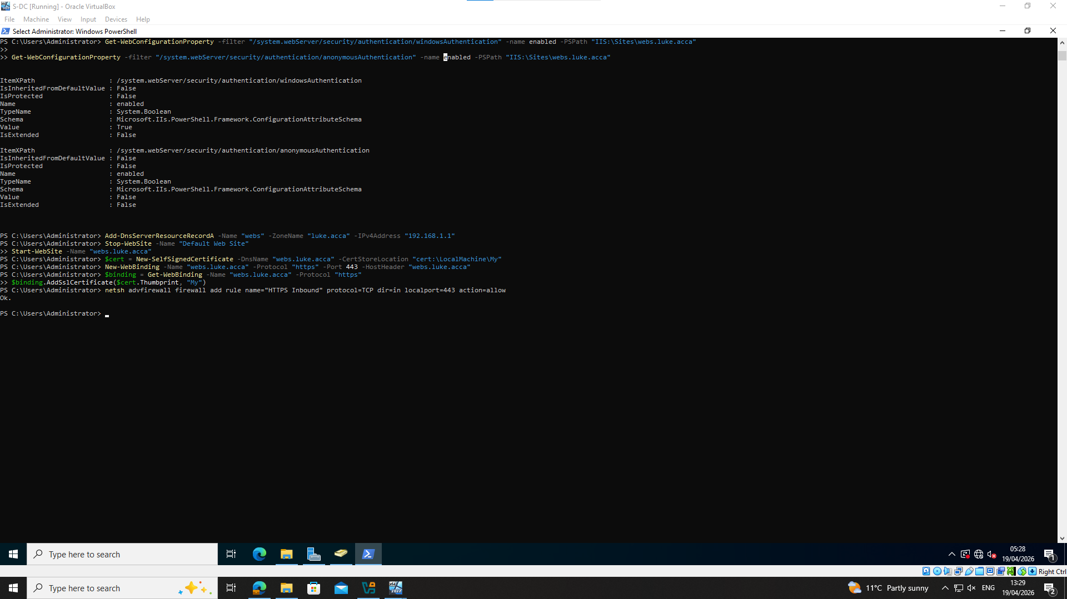
Figure 57 – Website and certificate
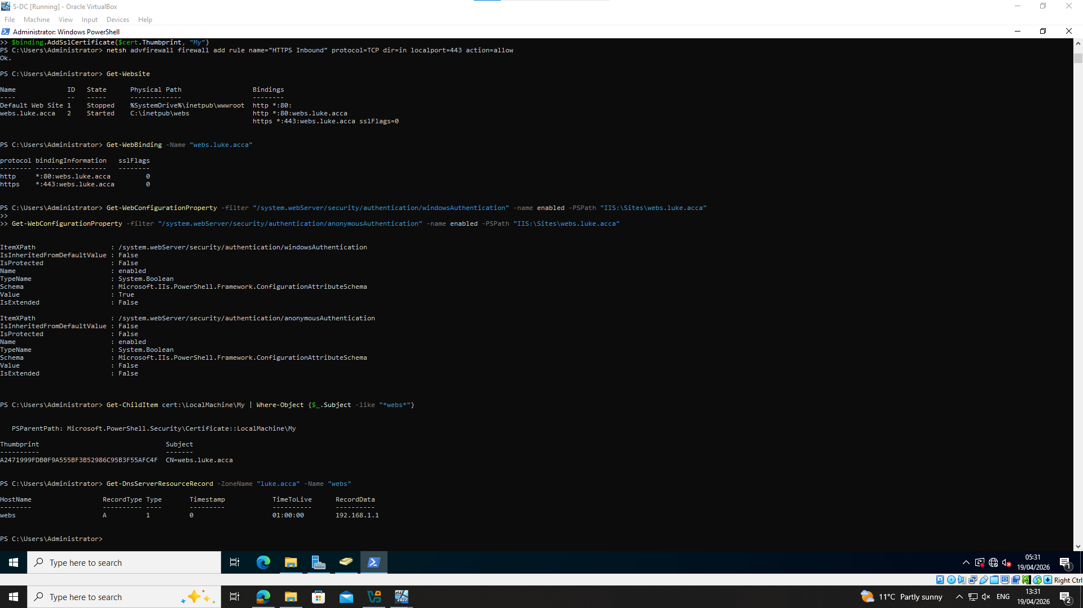

Figure 58 – Website accessible from L-CD
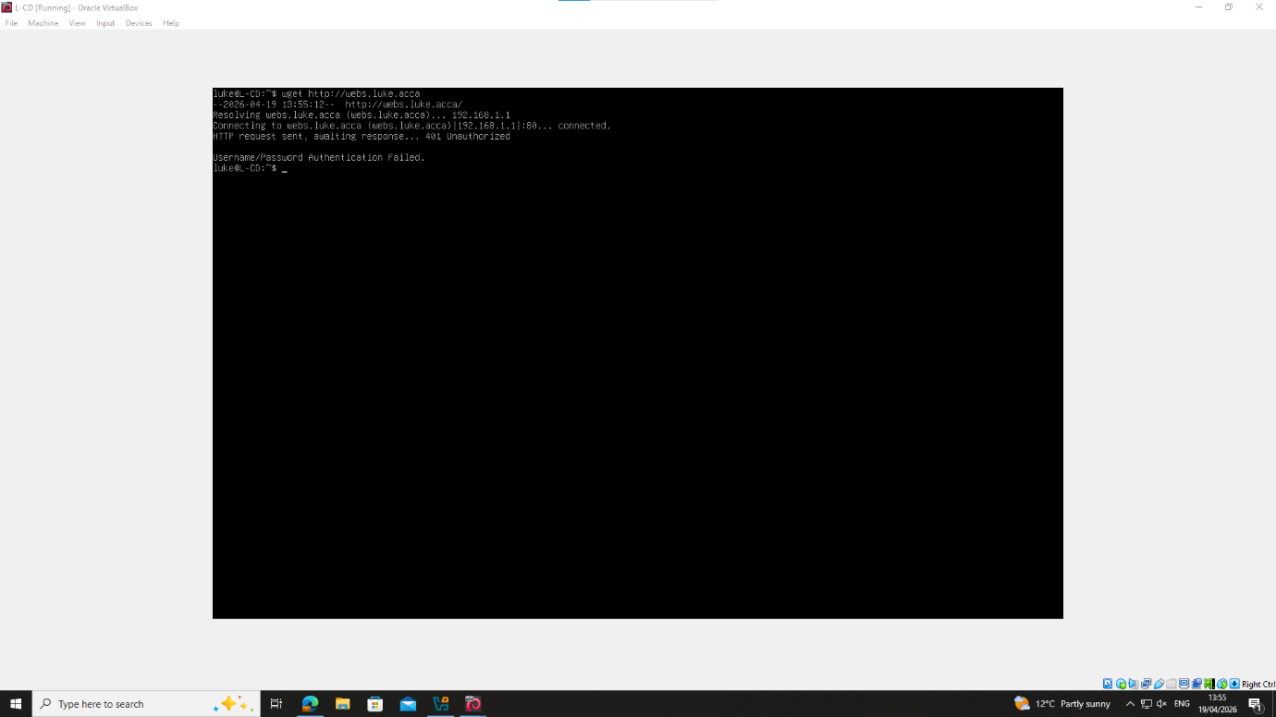
Figure 59 – Website accessible from client S1
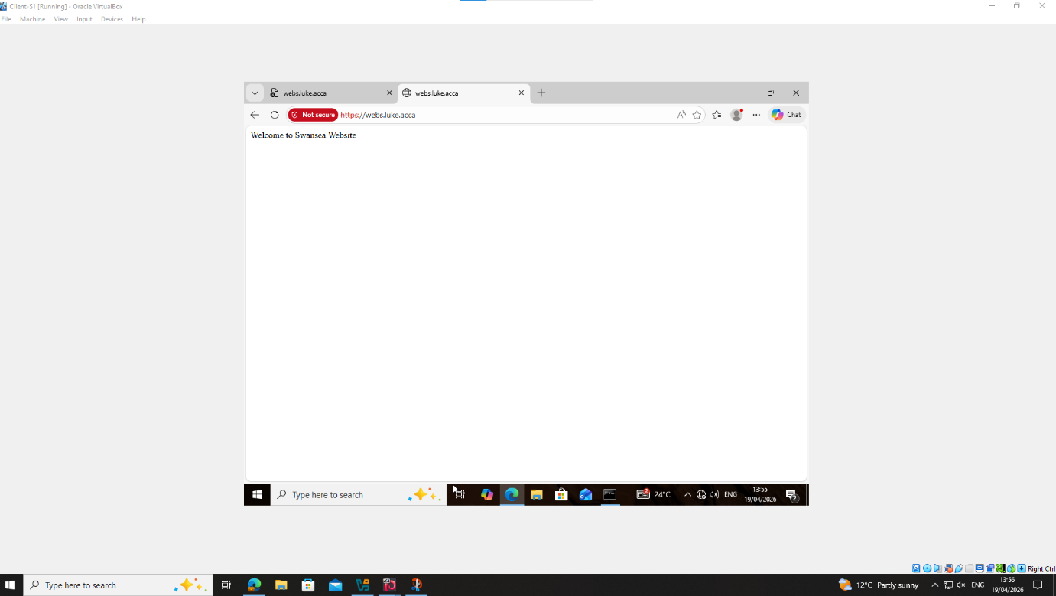

Remote Desktop Services
Figure 60 – Remote Desktop installed via Powershell
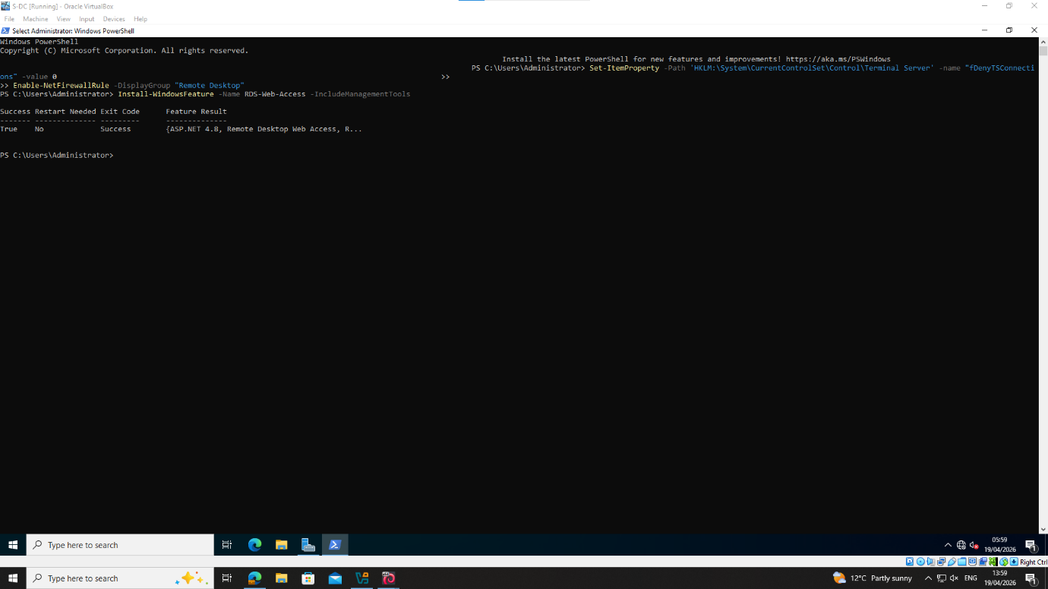

Figure 61 – Installing Remote Desktop in settings
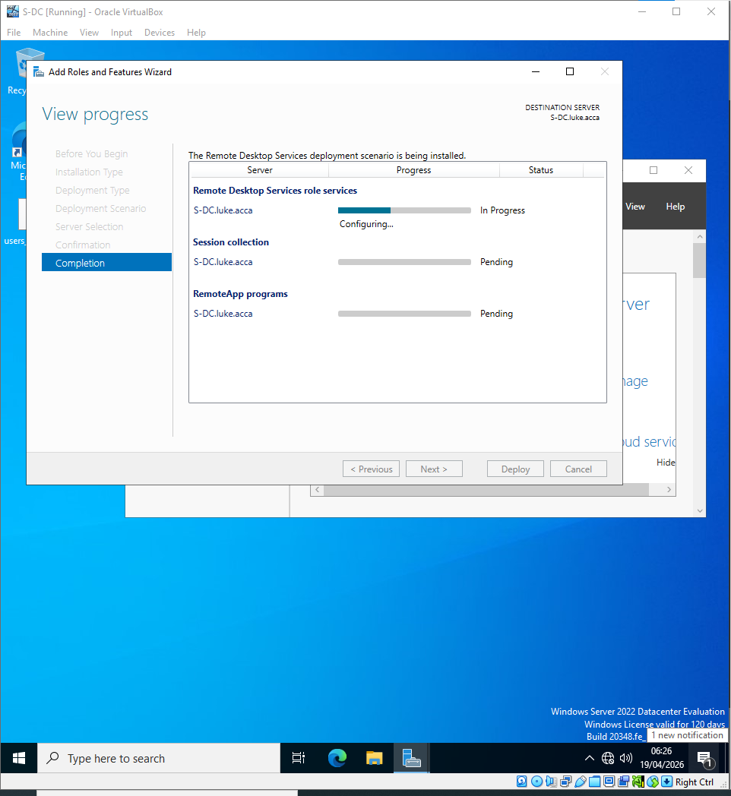

Figure 62 – Secure connection
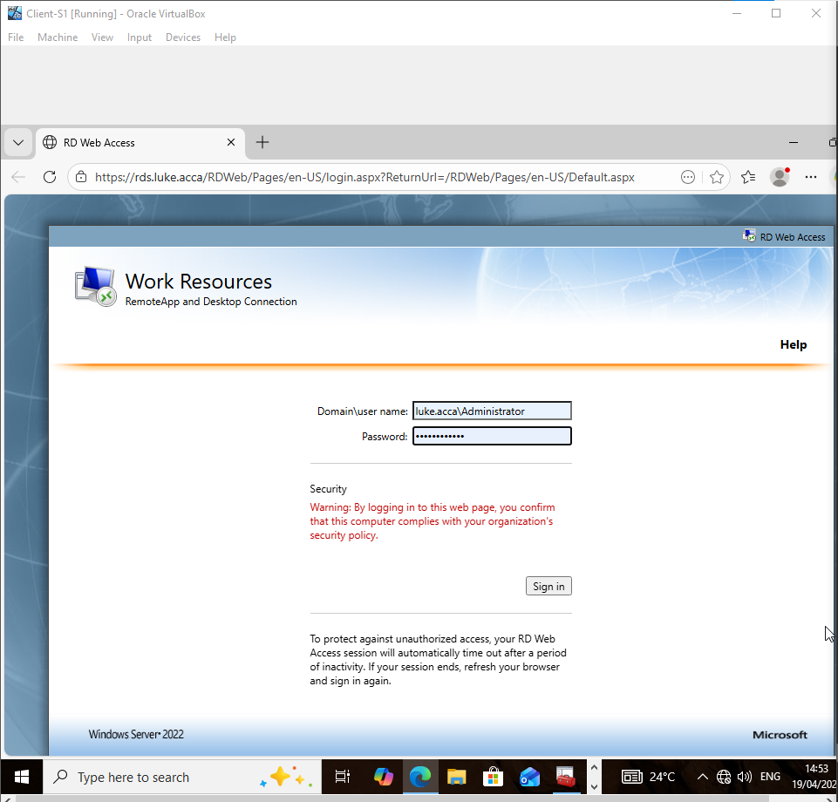

Figure 63 – Remote Access and certificate authentication
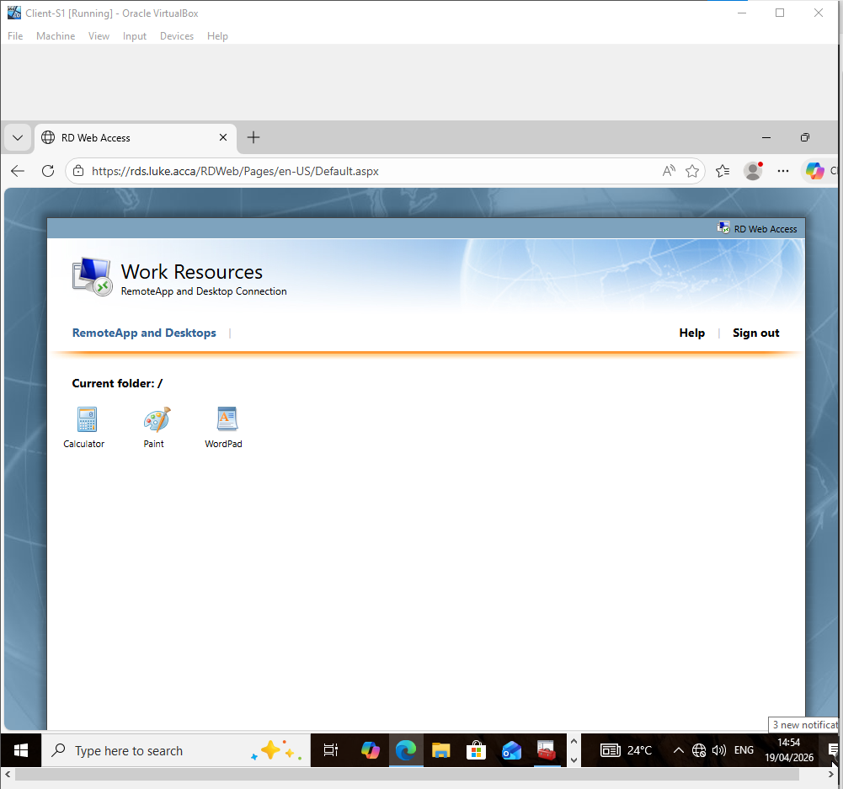

Figure 64 – Secure connection shown
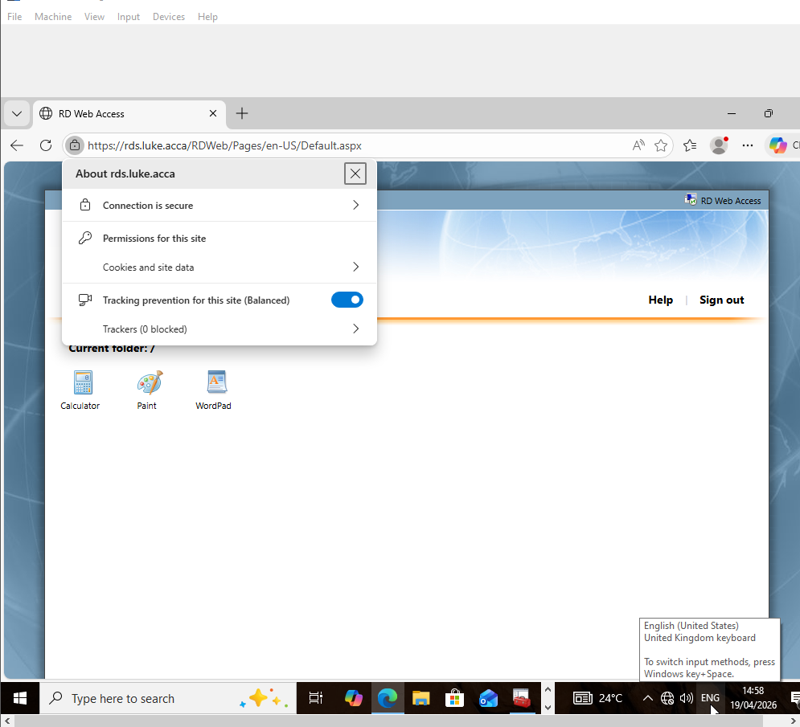

Conclusion
The above report provides screenshot evidence of networking configuration for this assignment. Various services have been installed as per the assignment brief – via the installation of a DHCP server and relay with static routing, the network allows for communication between the Swansea and London networks via a VPN site-to-site tunnel. Users are added to a single domain and as such can access shared files and resources, including a shared domain website. Powershell is utilized as tool for efficiently importing and providing usernames within the domain.
Generative AI [1] was utilized within the realms of the assignment criteria’s Task Description, specifically for research and troubleshooting during practical implementation of the assignment.

References
[1] Anthropic, "Claude (claude-sonnet-4-6)," Anthropic, San Francisco, CA, USA. [Online]. Available: https://claude.ai.
[2] Microsoft, “Install Active Directory Domain Services (Level 100),” learn.microsoft.com, Apr. 28, 2023. https://learn.microsoft.com/en-us/windows-server/identity/ad-ds/deploy/install-active-directory-domain-services--level-100-
[3] Microsoft, "DNS Server," learn.microsoft.com. https://learn.microsoft.com/en-us/windows-server/networking/dns/dns-top
‌[4] Microsoft, “DHCP (Dynamic Host Configuration Protocol) Basics,” learn.microsoft.com, Jan. 11, 2023. https://learn.microsoft.com/en-us/windows-server/troubleshoot/dynamic-host-configuration-protocol-basics
[5] Microsoft, “Virtual Private Networking (VPN),” learn.microsoft.com, Oct. 19, 2022. https://learn.microsoft.com/en-us/windows-server/remote/remote-access/vpn/vpn-top
‌[6] Microsoft, “Remote Desktop Services overview in Windows Server,” Microsoft.com, Oct. 30, 2025. https://learn.microsoft.com/en-us/windows-server/remote/remote-desktop-services/overview
‌[7] Microsoft, "Get started with IIS on Windows Server," learn.microsoft.com. https://learn.microsoft.com/en-us/iis/get-started/introduction-to-iis/introduction-to-iis-architecture
‌

‌

