Feasibility of Temperature Sensors in Orthopaedic Implants for the early detection of SSIs


Harry W. Foxton

University of Wales Trinity Saint David
School of Engineering
BEng Energy and Environmental Engineering

In collaboration with CBM Wales

Abstract
Surgical Site Infections represent the second largest cause of nosocomial infections (Healthcare related infection) (Khan, et al., 2017), largely caused by lacking sterile practice on the client and medical end during and after the surgery. With Orthopaedic surgeries entering the deepest level, Surgical Site Infections can be devastating to the healing process. A key characteristic of infection of tissue is the local increase in temperature at the site of the wound. Sensors have long been experimented with for use in-vivo with the earliest sensors using a percutaneous lead (External wire) as means of power and telemetry. With the mainstream take-off of NFC (Near Field Communication) for contactless mobile payments, the possibilities for wireless accurate close-range telemetry are expanded. An NFC based temperature sensing patch developed by Texas Instruments has been tested for validity in the environment presented in orthopaedic implants. With regular healing wounds going through normal heating patterns, it is vital that the temperature sensor and telemetry system used are not impeded on by the medium in which the magnetic induction link between sensor and transponder is made. After being put through multiple heating cycles at varying depths of simulated tissue, it was determined through the t-test that the variance in temperature readings as the medium increased was statistically insignificant with a 95.6% significance when average differential temperature for a medium was compared to all other medium thicknesses, thus proving validity for the sensors telemetry system in-vivo. The same statistical methods were used to approach infection determination, it is vital that the data can be interpreted by the final solution in a way that informs the user and medical professionals of a statistical likelihood of possible infection at the site of a given sensor. It was deemed that the Wilcoxon Signed Rank test produced a decision with a randomly generated dataset, that was representative of the key thermal characteristics of an infected wound.
Contents
1 Abstract 2
2 Acknowledgments 4
3 Introduction 5
3.1 The Case 6
4 Literature Review 7
4.1 Infection Determination 7
4.2 Temperature Measuring methods 8
4.3 Short range wireless power and telemetry 8
4.3.1 Bluetooth 9
4.3.2 Electromagnetic induction 9
4.4 Biocompatibility 11
4.5 Design for manufacture 11
5 Methodology 12
5.1 Experimental Justification 12
5.1.1 Electromagnetic properties of human tissue 12
5.2 Experimental setup 12
5.2.1 Environmental setup 12
5.2.2 Control sensor 13
5.2.3 NFC Temp Setup 13
5.3 Data Acquisition method 14
5.3.1 Texas Instruments software 15
5.3.2 Arduino Setup 16
6 Results and Discussion 16
6.1 Raw Data analysis 16
6.2 Statistical Analysis 17
6.2.1 Aims of Statistical evaluation 17
6.2.2 The students t-test for data collection and infection determination analysis 18
6.2.3 T-Test Validation for Infection determination 20
6.2.4 The Wilcoxon test for infection determination analysis 23
7 Conclusion 26
7.1 Power and Telemetry 26
7.2 Infection determination 27
7.3 Further Work 27
7.3.1 Impact on work due to COVID-19 Pandemic 27
7.3.2 Further Scope 28
8 References 29
9 Appendices 33

Acknowledgments
I would like to thank my supervisor Richard Morgan for his waivered support through the project despite the later start due to unforeseen circumstances, ensuring the context remained relevant throughout
I would also like to thank Akash Gupta (CBM Wales) for his support throughout the project, providing useful insight into the commercial setting of batch manufacturing and research.

Introduction

SSIs (Surgical Site Infections) are infections that are caused as a result of a previously performed surgery. In the case of orthopaedic surgeries in humans, SSIs are rare at just 0.4% in 2017/18 (Public Health England, 2018) due to very strict infection control and reduction policy within the NHS. As a result, the need for the implementation of wide-spread early detection of SSIs in post-op orthopaedic surgeries may be considered minimal in medical care for humans; however SSI’s represent the second largest cause of nosocomial infection (Khan, et al., 2017) therefore, the statistic is worth further investigation. When considering a veterinary application, one report suggests that 7.7% of ‘clean’ surgeries e.g. distal radial fracture, result in a post-op SSI; a ‘clean’ surgery is one with no break in sterile technique and does not enter the respiratory, genitourinary or alimentary tracts. SSIs can very negatively impact patient outcome with increased veterinary costs, increased mortality rate and frustration on both client and veterinary side (Weese, 2008). Early detection of SSIs makes treatability more efficient and effective. One of the early symptoms of infection is localised heating of the tissue surrounding the site of the infection (University of Rochester Medical Center, 2019). Being able to record temperature over time at the site of surgery, will not only allow for potential early detection of SSIs but will prove the feasibility of other sensor technologies to aid post-operative diagnosis and to quantify healing rates.
The current standard for the reduction of post-operative infections is the use of a surveillance systems, standardised by the respective public health boards. It is mandatory for Orthopaedic surgeries to be surveyed after a surgery, the data collected from the surveys are used to improve operating procedures and wound managment after the surgery (Public Health England, 2019), this surveillance also allows for a much clearer understanding of the initial signs of Surgical Site infection, making visual diagnosis more effective, however the presence of visual indicators of infection may already lead to increased healing times and potential further complications of the surgery, for what is already a physically taxing process.

Sensors have been incorporated into orthopaedic implants since the 1960s in the form of strain gauges which use a thin strips of wire closely packed together and when a strain is applied, the wire in the sensor is stretched which generates a changed resistance within the wire which can be used to calculate a displacement (Ledet, et al., 2018). However, one of the fundamental problems surrounding the use of sensors in-vivo, are the limitations surrounding power supply and telemetry to the sensor. Early sensors designed for in-vivo conditions used a percutaneous lead (cable between sensor and ‘outside world’) for both power and data transfer. This has the obvious limitation of largely increased risk of infection, rendering the technology un-feasible by todays medical standards. Another option is the use of battery power, however due to limited battery life, later surgery would be required to replace the battery. This means a sensor must be developed that can transmit data and be powered wirelessly, must be biocompatible in-vivo in terms of the materials used and fit within a small given form factor of the implant. Surgical site infections can take hold up to 1 year after the surgery has taken place, therefore the sensor must have a lifespan of at least 1 year (Owens & Stoessel, 2008) and cause no detriment to the patients’ health after this period.

The Case
CBM Wales are a batch manufacturing research company with a focus on the development of bespoke orthopaedic implants for both veterinary and later human application. With the use of EBM (Electron Beam Melting) additive manufacturing technology, implants can be fabricated with very little wasted material and to very precise and often irregular geometries. Also, due to the fabrication method, the titanium alloy (Ti6Al4V ELI) used for the implants is denser after having undergone EBM processing compared to regular casting. This results in a UTS (Ultimate tensile strength) of 894 MPa (CBM Wales, 2017) under EBM construction against 860MPa (ASM International, 1990) for regular casting methods.
The implementation of sensors into orthopaedic implants will aid many of the problems surrounding the post-operative period. Due to the often-complex geometries of the implants created at CBM, sensor implementation will have complications. This paper will investigate the feasibility of implementing a wireless, battery-less temperature sensor system into a bone salvage implants (Case ref. E1736 ‘Mixed breed’) developed in-house by CBM, with the purpose of early detection of SSIs post-surgery.

Literature Review

Infection Determination
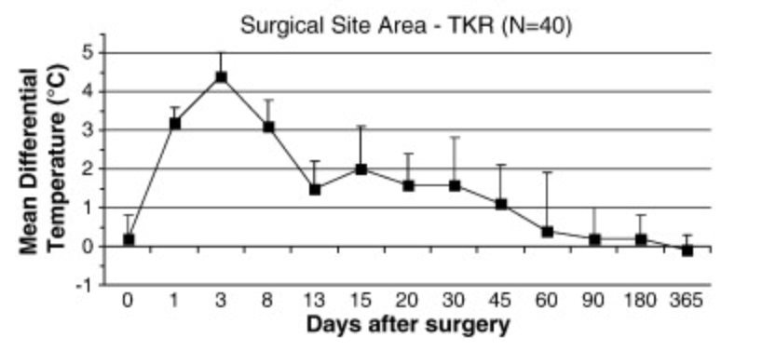
As previously mentioned, heating of tissue surrounding a wound is one of the earliest signs of infection. However, it is important to note that some visual indicators do also represent early indicators of a possible SSI, such as redness and inflammation; the issue here is that these symptoms are also a part of the regular healing process for a wound and if observed could be passed off as a part of the regular healing process and not pursued further (Wound Source, 2016). A study into the effectiveness of telethermography imaging for the diagnosis of septic knee implants determined that a time average temperature gradient from surrounding tissue of just 0.9℃ is enough to detect surgical site infection (Romano, et al., 2013). This therefore implies that a reference body core temperature is required as a comparison when determining if a surgical site infection has taken hold. It is also important to recognise that heating of tissue surrounding a wound is also a regular part of the wound healing process, the difference between this and visual inflammation is that the temperature at wound site is quantifiable and will follow a predictable trend to baseline after several months of healing (Romano, et al., 2012), Figure 1 shows the mean temperature differential in the surgical site area for the regular healing process, these temperatures were taken from a sample of 40 patients that had undergone total knee replacement (TKR). This temperature framework has potential to be used as an expected baseline to aid the determination of whether the thermal increase is due to healing or possible infection.
Figure 1 - Graph of mean differential temperature for the hottest wound spots after 1-year healing period for an uncomplicated TKR

Temperature Measuring methods
Being able to quantify temperature has played a large role in physics and engineering since 1593, when the first modern Thermoscope was developed (LiveScience, 2013). This means that as technology has progressed there are many ways, we can now quantify temperature including a range of purely mechanical and electro-mechanical system such as a modern thermostat which utilises a bi-metallic strip with varying bending moments when heat is applied allowing for a contact to either complete or cut a current depending on a given temperature threshold (Electronics Tutorials, 2014). The telemetry required to make a wireless connection to the sensor means the temperature sensor must be able to operate in a digital setting; this limits the options down to 2 major sensors; Thermocouples and Resistive temperature measuring devices (RTDs). Thermocouples operate on a bi-metallic wire which, when heat is applied generates an electrical voltage in a usually non-linear fashion known as the thermoelectric effect (Water and Waste Digest, 2000). RTDs or thermistors (thermally dependant resistors) use the properties of a selection of semi-conductors to vary in resistance in a predictable but non-linear pattern following either a positive or negative correlation with temperature. The most common form is the negative temperature coefficient (NTC) thermistor. NTC thermistors are available for around 14 pence with an accuracy of $±1\%$ and a form factor of 1.6mm x 0.8mm x 0.8mm (RS Components, 2013), making them small, accurate and affordable; meaning they are the most common form of temperature sensing method for PCB integration. The non-linear correlation tends toward 0 resistance with high temperatures, meaning there is smaller temperature differential at higher temperatures making it less accurate, this should be considered in system design.

Short range wireless power and telemetry
The key requirements of the power and telemetry system are that it must be completely wireless and battery-less and can transmit that data with minimal impact on the quality of the results produced. The signal must also be of relatively high security as it is transmitting personal information. Short-range telemetry ensures the highest level of security as the reading device must be in close proximity of the sensor.

Bluetooth
Bluetooth is a commonly used technology in the world of cellular devices being a standard feature of most mobile phones. It operates, similarly to wi-fi on a radio frequency communication protocol designed to create the principal of a ‘personal network’ (Bray & Sturman, 2001). Most current Bluetooth chips require external power which in most devices is fulfilled by the use of a small li-ion battery, some development boards utilise electromagnetic induction to power the chip (discussed in section 4.3.2) however the form required to install such as system would not be suitable for the case. A group of companies (Amazon Web Services, Avery Dennison and Samsung) have contributed $50m to the company Wiliot who are developing a Bluetooth chip and sensor that can be powered by scavenging ambient radio waves. This low powered chip has the potential to transmit sensor data to almost every mobile device without the use of an external power source making it ideal for the case of embedded wireless sensors for implants, using a cloud based security protocol and a 2m range (PR Newswire, 2019). This technology has huge implications for the project, however, is a technology that is still in development. The future of Bluetooth in ‘smart implants’ is certainly going to have a role over the next 3-4 years; however, the technology is not yet where it needs to be to be feasible at this current time.

Electromagnetic induction
When electrical current passes through an electrical conductor it generates an electromagnetic field at right angles to the conductor. Its intensity is dependent on the number of turns in the wire, the current strength, the length of coil and the type of conductors used (Electronics Tutorials, 2015). When a second coil is placed in near proximity of the first, the magnetic field generated by the first coil has the ability to induce a current in the second coil, this is known as electromagnetic induction and it allows for the close range transmission of electrical power and data. NFC (Near Field Communication) and RFID (Radio Frequency Identification) are two technologies that utilise electromagnetic coupling to transmit both power and data. NFC and RFID are the protocols in which data has the ability to transfer through. RFID tags are split into either passive or active tags, whereby active tags are self-powered and passive tags are powered through induced current by the electromagnetic field. NFC is based on RFID protocols with the major difference of having the ability to emulate a tag allowing for 2 way data transfer between 2 NFC enabled devices (ecom, 2017) a widely used example of this is tag emulation in mobile phones for contactless payments. A sensor tag developed by Texas Instruments uses NFC/RFID to sense temperature with an accuracy of 0.1℃, Texas instruments provide supported applications and handbooks for these sensors allowing for consistently updated firmware. The ability to hold on-board FRAM means there is little interrogation equipment needed to measure a temperature (Texas Instruments, 2016). One possible obstacle facing an NFC/RFID based telemetry system is the range; most NFC devices operate at a maximum of 10cm, this should be accounted for in the design process (Android Authority, 2019), the advantages of an NFC/RFID based telemetry system is that the alignment required to produce an accurate signal is not highly sensitive as long as it is within a small enough range. Another advantage is that most modern smartphones are equipped with NFC allowing for this technology to have easy future integration into the modern setting. Karipott et al. have developed a wireless temperature sensor that is built within a surgical interference screw (Karipott, et al., 2018). It uses the principle of resonant magnetic induction, with an LCR circuit (inductance L, capacitance C, resistance R). A typical LC circuit is a very common electrical component (tank circuit) that, when under an AC current, runs at a resonant frequency based on inductive${ (X}_{L})$ and capacitive $(X_{C})$ reactance which measure opposition to AC current (electronicsforu, 2019). When frequency of the AC current is adjusted to the point where ${ X}_{L}=X_{C}$ , an observable decrease in electrical impedance is detected as the inductive and capacitive reactance interfere destructively. As electrical impedance describes a circuits opposition to electrical current it accounts for resistance and reactance (Encylopedia Britannia, 2020). When a resistor is added to the LC circuit, the point of resonance is affected by the resistance in the circuit, therefore if a thermistor is used, the temperature of the thermistor has a direct correlation with the point of resonance which can be quantified by an external electromagnetically coupled coil. One issue facing this specific setup is that it requires signal analysis equipment without any simple way for the system to be implemented on a large-scale level.

Biocompatibility
ISO or the International Organization for Standardization are the key authority on the requirements, specifications, guidelines and charachteristics of materials, products, processes and services to ensure that it is fit for purpose (ISO, 2020). A standard published by ISO describes the standards for biocompatibility, known as ISO 10993-1 detailing the biological evaluation of medical devices and risk management process. For an implant device of permanent status time the implant must pass testing for the following areas:

- Cytotoxicity
- Sensitization
- Irritation
- Toxicity
- Sub-chronic toxicity
- Genotoxicity
- Implantation

In the 1960s Professor Larry L. Hench developed one of the first silica (glass) based coatings for its biocompatible properties. Silica based coatings were shown to have impressive biocompatibility with both soft and hard tissues, in the application of Orthopaedic implants biocompatibility for both soft and hard tissue is vital. Drnovšek et al. used 45S5 Bioglass®, one of the most used biocompatible glass coatings, to replace a biocompatible titanium alloy and was discovered to have a higher efficacy than the Titanium alloy. The percentage of pores filled with new bone were measured to determine the bio integration and was found to be 22% for the porous titanium compared to 38% for the glass-based coating (Drnovšek, et al., 2012). With glass used commonly in inductive based technologies i.e. inductive hobs and wireless phone charging it is clear that the glass will not have a significant impact on magnetic induction through the medium.

Design for manufacture
CBM are oriented around the development of bespoke batch manufactured goods meaning that bespoke orthopaedic implants are developed on a case by case basis. The nature of additive manufacturing means that changes to design form have little to no impact on the manufacturing of the product. CBM utilise electron beam machining to construct bespoke implants designed to fit the form of the case. The implementation of the sensors will involve an embedded slot for the form of the implant, this change in form will not highly affect the manufacturing process of the implants.

Methodology

Experimental Justification
It is suggested by the literature that following average trends a 0.9℃ local temperature increase is enough to detect a possible surgical site infection. The telemetry used for the sensor is based on electromagnetic induction therefore it is imperative that the temperature reading generated by the sensor is not affected or influenced by the tissue. A validity experiment will be undertaken to ensure the temperature reading is not influenced by human tissue.

Electromagnetic properties of human tissue
With 60% of the human body consisting of water the electromagnetic properties of human tissue are largely dictated by its water content. Pure water is known as a di-magnetic material defined as having a magnetic permeability of less than or equal to 1 (0.999 for water) (The Engineering Toolbox, 2016), meaning that water can generate its own small magnetic field, this has potential to cause issues with the telemetry of the sensor which relies on coupled magnetic induction. However, 0.4% of the human body is made of up sodium chloride (Fisher, 2016) and the presence of sodium chloride in water has a large influence on the dielectric properties of water, weakening the strength of the already weak electric field (Ori, 2017), this increases potential validity of a magnetic induction based telemetry system still functioning in vivo, however it must be determined to what extent the di-electric properties of human tissue influence the quality of the signal.

Experimental setup
An experimental rig has been designed to control as many variables as possible. The principle setup of the rig consists of a contained heating environment, an ambient heating element, a validated control temperature sensor, the NFC based temperature system and a simulated tissue medium.

Environmental setup
An enclosed environment is used to generate a range of temperatures to put the sensor and control sensor through heating and cooling cycles. The environmental temperature is not a specifically controlled heat source, it simply allows for the sensors to be exposed to a range of temperatures. To simulate the in-vivo environment of human tissue a saline gelatine mixture is used containing 0.4% sodium chloride to simulate the di-electric properties of human tissue. As previously determined the best and most common method of biocompatibility is the use of a glass coating, therefore a layer of glass is used in between the gelatine mix and the NFC reader, 5 different depths are tested to observe where temperature readings are affected by the medium (0mm,5mm.10mm,15mm,20mm).

Control sensor
The control sensor used is the DS18B20, this sensor has a factory configured accuracy of 0.2℃ from -10℃ to + 85℃ (Dallas Semiconductors, 2015) controlled through an Arduino Uno microcontroller. The sensor is to be placed within close proximity of the thermistor used on the NFC board to ensure heat exposure is as similar as possible for the case. It is not expected that the semiconductor material used for both sensors will be completely the same, therefore it is expected that the rise time and heat capacity of one sensor may be higher than another, as long as the gap between the sensor readings remains consistent through different depths of medium, this will not prove an issue.

NFC Temp Setup
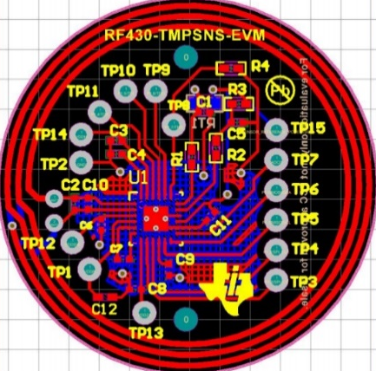
The NFC setup consists of 3 components: Figure 2 shows a schematic of the Texas instruments sensor, the main component of this board is the NFC enabled chip identified as the RF430FRL152H chip. This 13.56MHz transponder chip has embedded programmable FRAM allowing for embedded firmware installations which helps minimise external required telemetry equipment.
Figure 2 – PCB schematic of Texas instruments NFC temperature sensor (Texas Instruments, 2016)
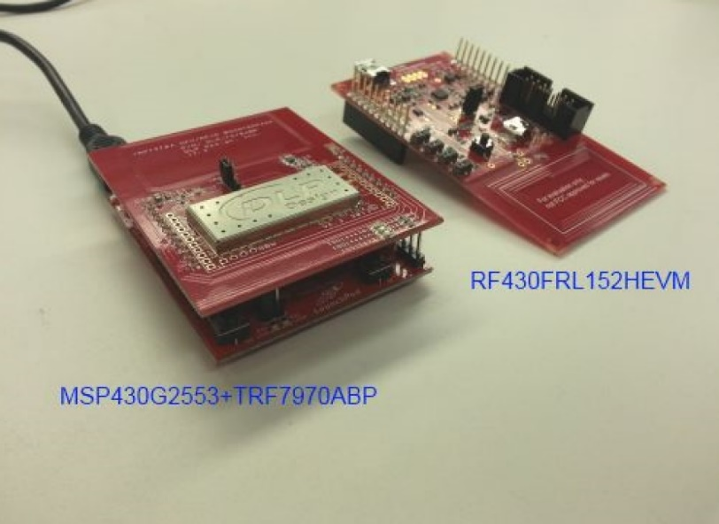
For the purpose of availability and chip customisation, an evaluation model of the board is to be used in place of the NFC patch shown in Figure 2. The evaluation model has options for battery powered and wired powering with emulation ports to directly program the firmware on the chip. The NFC receiver part of the sensor is a combination of a Texas Instruments development board, which is a custom microcontroller, combined with an NFC enabled plug-in module. This combination of microcontroller and NFC BoostPack allows for tailored sensor settings, like sample rate and threshold temperatures (shown in Figure 4 and Figure 5).
Figure 3 – Image of the development board and NFC plugin module (left) and development board for NFC based sensor (right)

Data Acquisition method
The ideal setup for data collection would be simultaneous collection of temperature sensing data from both the control temperature sensor and the NFC based sensor. This involves linking the proprietary Texas Instruments software used for data collection from the NFC board to the Arduino based data collection used to run the DS18B20. MATLAB is a mathematical based programming language which comes with a wide array of additional utilities created outside of the MathWorks company that own MATLAB, these utilities allow for ease of compatibility with a range of microcontrollers.

Texas Instruments software
The software provided by Texas Instruments is designed to only operate with the specific setup used to test this sensor and the chip. The proprietary software does allow for external communication to third part applications but is out the scope of this research to determine how to make this connection and testing will be performed within the purpose-built GUI developed for this setup of sensor and transponder. The software allows for a live display of temperature with respect to time, with previous experience in image extraction and Optical Character recognition it was simple to set up a MATLAB script that would observe the Texas Instruments GUI and transfer the current read temperature to the MATLAB script, the full script can be found in the appendices.
Figure 4 – Screenshot of sensor configuration setting in TI purpose-built GUI for RF430FRL152H EVM with TI development board (Texas Instruments, 2016)
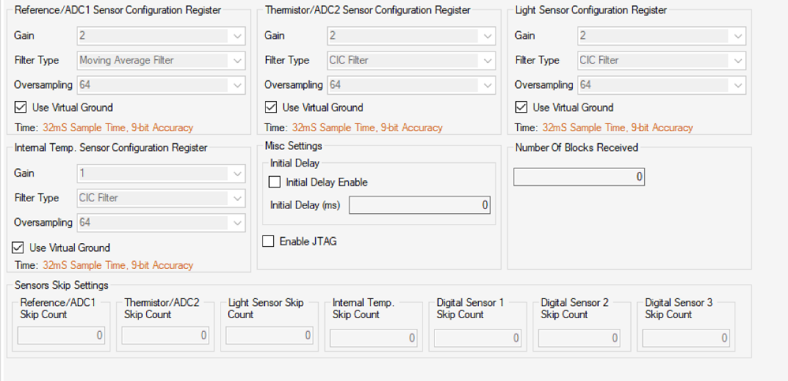
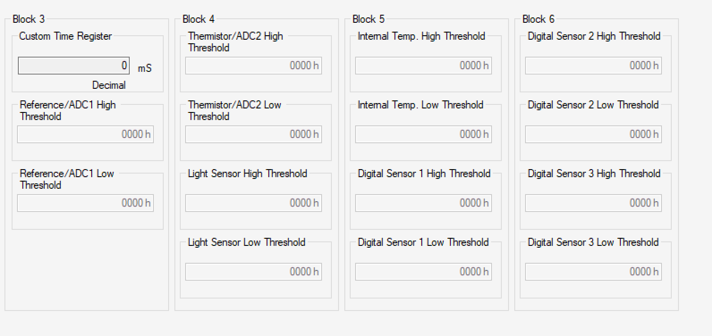
Figure 5 – Screenshot of Sensor threshold configuration in in TI purpose-built GUI for RF430FRL152H EVM with TI development board (Texas Instruments, 2016)

Arduino Setup
Arduinos are one of the most common micro-controllers used for testing purposes; the open source nature of the Arduino platform means that many utilities are available for MATLAB to interact with the micro-controllers. The Arduino Uno was used for this project as the flagship model and offers the most extensive portfolio of configurations for different sensors. The temperature signal passes through a serial port at 2 measurements per second. Which, using the MATLAB toolbox for Arduino compatibility, is saved to a new set of columns in a spreadsheet linked to the script.

Results and Discussion

Raw Data analysis
Figure 6 is a graph showing the difference between the temperature recorded on the Texas Instruments NFC based sensor and the Control sensor. This raw data doesn’t lead to any statistical quantifiable conclusions about how the accuracy changes with varying depths of tissue, but based on visual observation alone, the data does tend to suggest a few things that later need to be validated through statistical methods:
- The sensors are put through 3 heating and cooling cycles per run and because the rate of cooling is slower than the rate of heating, the sensors are hotter at the end of the run than the start. It is noted that the points at the and are more dispersed than the points at the start indicating that the higher temperatures do have an impact on the quality of results.
- There is always a positive difference in temperature between the 2 sensors of between 0.4-1.4℃ suggesting, as previously discussed, that one temperature sensor has a higher rate of thermal absorption than the other sensor, this may be due to proximity to heat source or due to the difference in size and material of the semiconductor used to generate the temperature reading.

Figure 6 - Graph showing changes in difference between control and test temperatures for 5 varying mediums of simulated human tissue

Statistical Analysis

Aims of Statistical evaluation
Statistical evaluation is going to play 2 major roles in the justification of this principle; the first will be used to determine how similar the series of data shown in Figure 6 are to one another, this will validate the use of the NFC based system for a range of depths of human tissue within a given bracket of freedom. The second important use of statistical evaluation will be used for the determination of infection. As previously mentioned, the regular healing process of a wound involves heating of the tissue, however the heating curve of an infected wound shows distinct differences from the heating curve of a regular healing wound. Statistical evaluation will be used to create a model for the determination of infection.

The students t-test for data collection and infection determination analysis
The Student’s T-test was designed in 1908 by William Sealy Gosset under the pseudonym of Student, the t-test is a means of testing for statistical significance between two sets of data by means of a standard deviation curve. The t-test will produce a p value and based on a critical p value, conclusions can be made about the probability that the data is statistically significant or whether it is random. The critical value is commonly known to be 0.05 or 5%. If a p value is below 0.05 it is considered that there is a ≥95% chance that the two sets of data are statistically significant. A t-test can be classified by 2 major factors: The ‘tails’ of a t-test is determined by how the hypothesis is worded; in this case we want to investigate if and to what extent the temperature readings are statistically significant to one another. This would be classified as a two tailed t-test as it is an open-ended question, an example of a one tailed t-test would be if it was hypothesised that one temperature reading is higher on average than another therefore, posing a specific hypothesis. The number of tails determines how the test references the normal distribution curve. The second way a t-test is classified is by the arrangement of data; the data can either be paired or unpaired, paired data means that each entry in the two data sets are correlated in some way and unpaired data means there is no specific link between each entry in the dataset. In the case of this t-test, each entry in the data set correlates to a specific iteration of the temperature reading making the data paired for this test. A t-test only allows for comparison between two data sets; so for each of the five data sets that require comparison, an individual t-test will be done to compare one data set to all other data sets, this will generate 4 p-values for each data set, an average p-value can then be determined for each data set (Kenton, 2020). Table 1 shows the results gained from the t-tests. A complete set of t-test values can be found in the appendices.
Table 1 – Table showing p-values for t-test of temperature data shown in Figure 6
Medium | No Medium | 5mm Medium | 10mm Medium | 15mm Medium | 20mm Medium
Avg. p-value | 0.0893 | 0.0208 | 0.0142 | 0.0751 | 0.0208

With a critical value of <0.05; Table 1 shows that on average some of the p-values are considered as being not statistically significant to one another. The results gained when no medium was used between the NFC transponder and receiver shows a p value of 0.0893 meaning there is a 91.07% chance that the results gained are not random. Even though this seems like a high probability; it is commonly considered that for results to be considered as statistically significant, the t-test should produce a probability of ≥95%. This high p-value average is due to the p-value produced between the no medium and 15mm medium test, with a p-value of 0.300; the temperature differential for 15mm sample changes very little through the 300 iterations compared to the no-medium sample which changes significantly through the heating and cooling cycles. Using the average p-value means that one sample is tested and compared to all other samples combined, this does allow for a general picture about how the statistical significance of one test compares to all other tests, but doesn’t allow for a look into how the statistical significance changes between medium thicknesses. Table 2 shows how the p-value changes as the thickness increases; the p-values generated between mediums are far lower than in comparison to all other mediums shown in Table 1. When looking at the average p-value for the Table shown in Table 2 there is a >99.99% chance that the collected data is statistically significant as the medium increases.
Table 2 – p-value comparison of incremental increase in medium thickness of simulated tissue between sensor transponder and receiver
Medium comparison | No medium vs. 5mm medium | 5mm medium vs. 10mm medium | 10mm medium vs. 15mm medium | 15mm medium vs. 20mm medium
p-value | 6.42207E-34 | 8.54883E-58 | 5.34735E-05 | 4.14617E-12

The Student’s t-test does show that there is a very strong statistical significance between each of the data sets which leads to the conclusion that there is a ≤0.0001% chance that the collected data is simply random; this validates the strong correlation between data sets aiding the hypothesis that the accuracy of temperature data changes very little with increased medium thickness. While the t-test does evaluate the statistical correlation, it does not quantify the extent to which temperature differential changes through increased medium.

T-Test Validation for Infection determination
Not only does statistical determination ensure the validity of the NFC based telemetry but can also act as a determination tool for infection. If two temperature curves were determined as ‘model’ curves for both an infected and non-infected healing wound, the temperature data collected by the temperature sensor will be compared against the model curves and could say to what degree the two curves are statistically significant to one another making for an objective evaluation as to the determination of infection. MATLAB will be used to prove the use of the t-test statistical model for the determination of infection, based on the results produced from telethermographic measurements (Romano, et al., 2013).

The aims of the code:
The code will be designed off two model datasets; one for a typical infected wound and one for a model regular healing wound. The code will then generate a graph that follows the heating trend of a wound over time, that dataset will be compared against the model datasets through the t-test. This will produce two p-values for each comparison. The test with the lowest p-value is then considered to have the highest likelihood of being statistically significant and will return whether that data set is for an infected wound, or a regular healing wound. Romano et al. displayed a graph of temperature differential trends for a sample of 40 adults who had undertaken total knee replacements (TKR). The graphs show a temperature differential between the knee that has undertaken the surgery and a body core temperature reading (Romano, et al., 2012). This practical application of the t-test for infection determination will take 10 generated temperature differential curves and determine through the t-test which curves are deemed by the algorithm to be infected or not infected. The full code for the t-test validation can be found in the appendices.

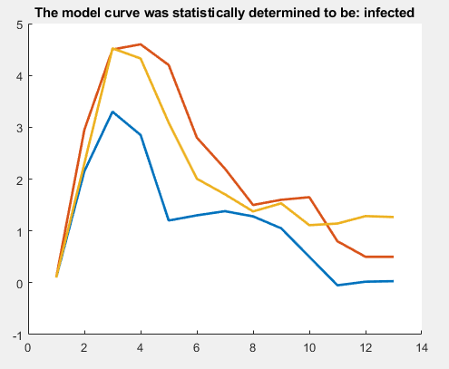
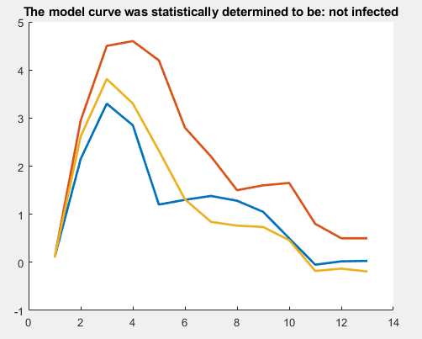
Figure 7. 2
Figure 7. 1

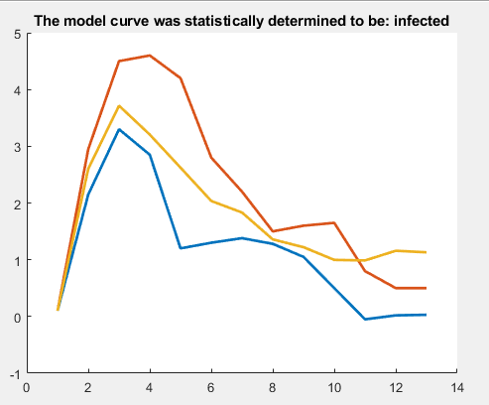
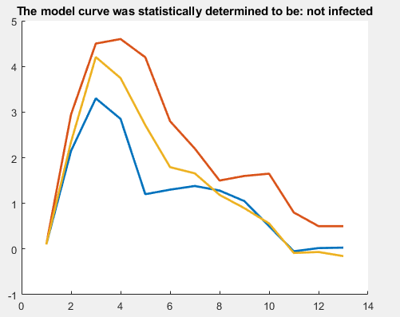
Figure 7. 4
Figure 7. 3

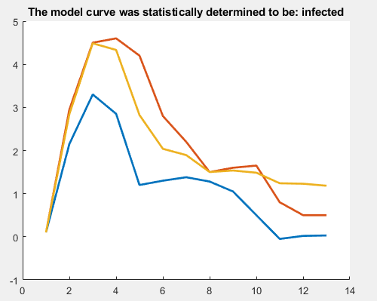
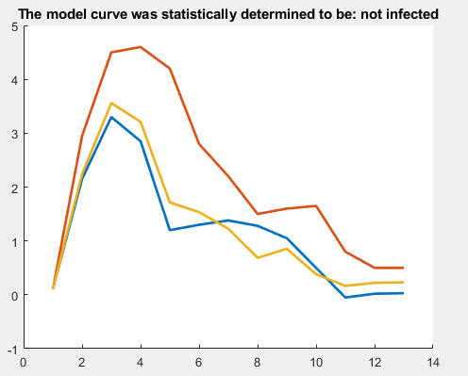
Figure 7. 5
Figure 7. 6
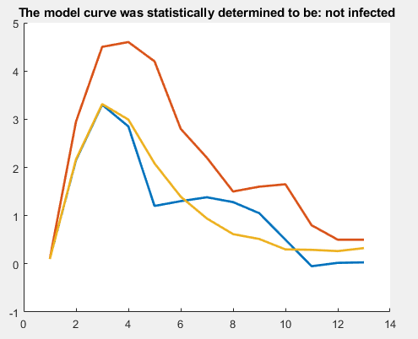
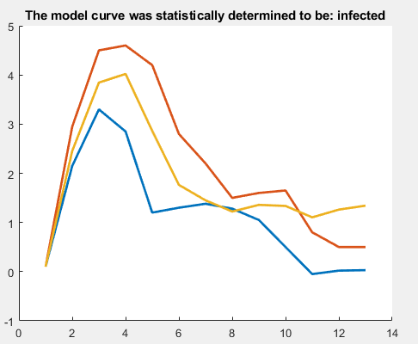
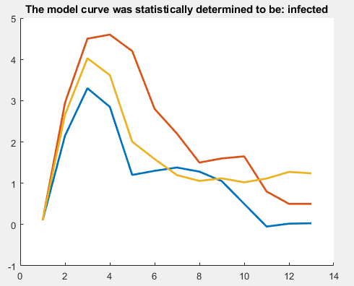
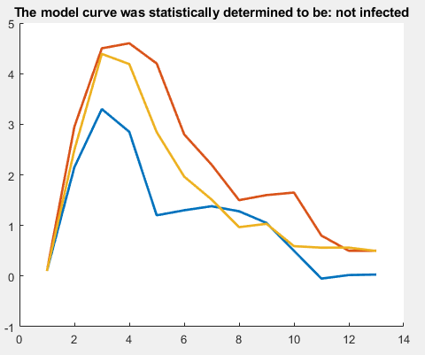
Figure 7 shows a set of 5 curves that were determined to be infected by the t-test algorithm generated and 5 curves that were determined to be not infected by the algorithm. As explained in section 6.2.2 if the statistical significance of two datasets is determined to be >0.05 it is deemed as being statistically insignificant. If the comparison between the test dataset and both model curves produces a statistically insignificant result, the code informs the user that the algorithm could not determine if the wound is infected or not based on the data sets. After 100 runs of the code all data sets made a conclusion about the state of infection, therefore meaning all 100 tests produced a statistically significant result.
Figure 7. 10
Figure 7. 8
Figure 7. 9
Figure 7. 7
Figure 7 – 10 sample curves and the determination of infection through the t-test as displayed in the title, MATLAB with differential temperature on y-axis and units of time in months on x-axis, RED = Model infected curve BLUE = Model non-infected curve YELLOW = Randomly generated healing curve
The three main characteristics outlined by (Romano, et al., 2013) through telethermographic analysis of septic TKRs for an infected surgical site are: 1) A higher peak differential temperature at the surgical site which usually occurs within a 5 days of the surgery taking place 2) A slower settling time at the site of infection 3) A more sustained temperature differential over the total healing period. Figure 7. 7 was determined by the t-test to be a non-infected wound; despite having a much higher peak temperature than the non-infected model data set, it did have a very steep temperature drop off after the peak which is not characteristic of an infected wound. While Figure 7. 4 does not have a high peak temperature, it does have a slow temperature drop off which is indicative of an infected wound. Based on the three main indicators of infection, the t-test comparison does appear at face value to provide an objective statistical look at how a test data set compared to the model data sets for infected and non-infected wounds.

The Wilcoxon test for infection determination analysis
The Wilcoxon test often referred to as the Rank Sum Test or Signed Rank test, is designed to compare two paired data sets to test a null hypothesis similarly to the two tailed based approach found in the t-test (Hayes, 2020). MATLAB again offers functionality to perform a two-tailed Signed Rank test with built in functions, with the addition of a Boolean return based on a lookup table as to whether the null hypothesis should be accepted or not based on a 5% significance level. With the addition of this Boolean statement the level of correlation between the model dataset and test dataset must be significantly stronger for the algorithm to decide as to whether the wound is infected or not. Over the course of 100 tests ran 36 were determined to have no conclusion as to the determination of whether the wound is infected or not. Figure 8 shows 10 tests that use the Wilcoxon method for infection determination, showing 5 datasets considered as infected and 5 datasets considered as not infected. Compared to the t-test method for determination the stricter requirement for determination is clear with the curves being far closer to the models to decide whether the wound is infected or not. It still does not require an exact correlation, Figure 8. 6 for example, shows a dataset with a very low peak temperature but due to its consistently high temperature over time the algorithm determined the wound to be infected.
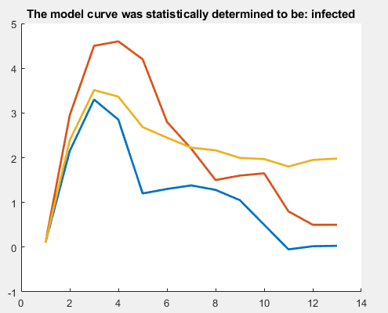
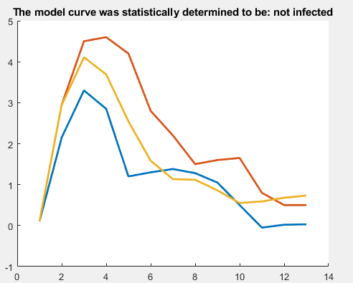
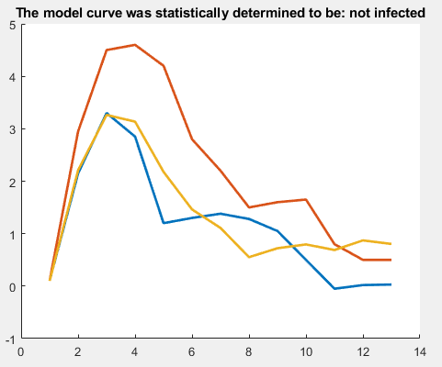
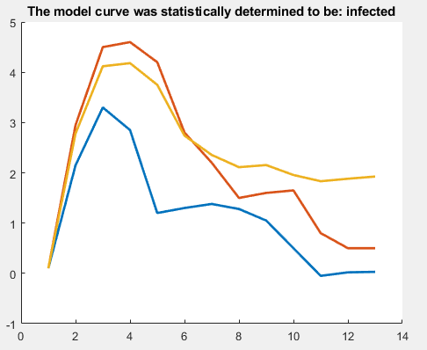
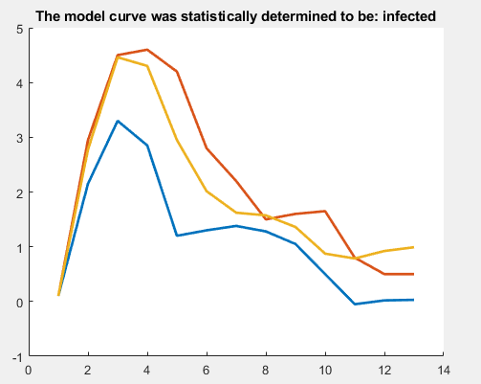
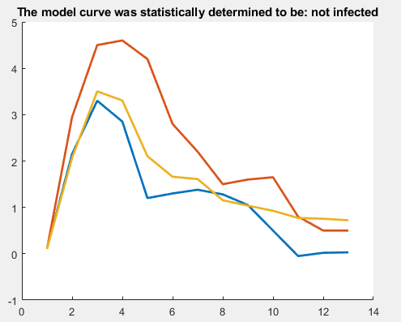
Figure 8. 6
Figure 8. 5
Figure 8. 3

Figure 8. 4
Figure 8. 2
Figure 8. 1
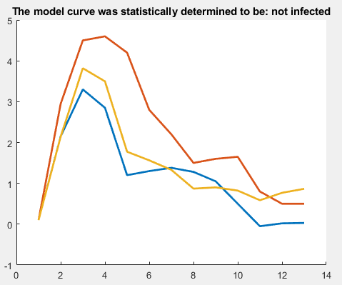
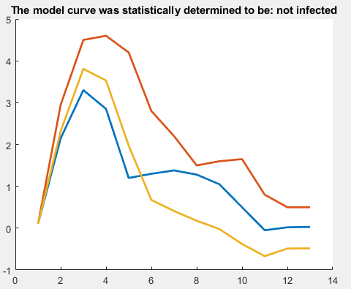
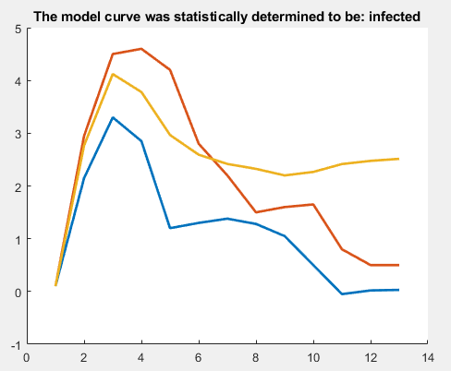
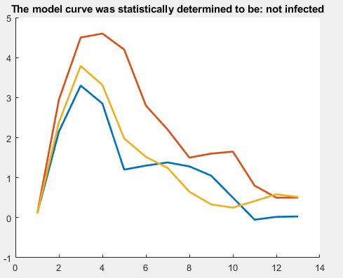
While it does appear that the Wilcoxon Signed rank test does produce a more feasible model for infection determination it is by no means perfect. Figure 8. 10 shows a data set that largely follows the model for a non-infected wound with a large rise in differential temperature near the end of the 13-month testing period, which is indicative of a late onset surgical site infection. Despite providing a useful level of analytical insight into the overall form of the data set, flaws tend to appear on the determination of possible late onset infection, this may be due to the way the rank test orders the differences throughout the test and for the most part, the difference between the model and test dataset are considered to be minimal.
Figure 8. 10
Figure 8. 9
Figure 8. 8
Figure 8. 7
Figure 8 - 10 sample curves and the determination of infection through the Wilcoxon test as displayed in the title, MATLAB with differential temperature on y-axis and units of time in months on x-axis, RED = Model infected curve BLUE = Model non-infected curve YELLOW = Randomly generated model healing curve

Conclusion
From an engineering perspective the principle of using temperature sensors in-vivo presented three major issues; how the sensor would be transmit data, how the sensor would be powered and how, when the data was collected, would be interpreted with respect to determining whether the surgical site is infected or not.

Power and Telemetry
The prospect of a Bluetooth based sensor system powered by background radio waves known as the ‘Wiliot’ has incredibly exciting prospects for the context of this project. With cloud-based encryption, the Wiliot sensor has a paper-thin form with a receiving range of more than 2 meters. This effectively means that unlike the current proposed system, a phone within close proximity of the sensor could be constantly taking data readings. This would allow for a far more representative dataset that would be able to detect discrepancy in temperature increases without mistaking for a possible Surgical Site Infection. While the accuracy of the current temperature reading system does depend on the medium through which the telemetry transmits data, it has been proven through experimentation that in the context of orthopaedic implants the medium will have a statistically insignificant impact on the quality of the temperature readings for the determination of SSIs. Ideally the technology will be used in the context of a mobile application employing the same NFC based communication protocol used for contactless phone payments. The app will require the user to hold the NFC sensor on the phone up to the sensor on a regularly timed basis to gather temperature data consistently, and will also require the use of an additional body core temperature reading to be taken and logged within the app to detect any possible anomalies in the data set i.e. if a patient has just exercised the bodies temperature will be up, therefore differential temperature is objectively more important than the stock temperature as displayed through the report.

Infection determination
While there are many areas of concern facing the use of temperature sensors in-vivo that were not as heavily explore i.e. the mechanical implications of embedding a temperature sensor within the form of the implant, which do of course play a part in the feasibility of the technology, but are underlined by technologies ability to physically detect an infection, for if this was not explored in sufficient detail would prevent the technology from ever being possible. The first step involved validity testing of the telemetry to ensure accuracy of temperature, once validated, methods of infection detection were discussed, most notably the use of statistical evaluation. The t-test and Wilcoxon test were both analysed for the determination of an infected wound based on datasets randomly generated between bounds to represent possible cases of infected and non-infected wounds. Both were based on statistical significance with a percentage of 95% required to be deemed as significant. Based on visual observation of the determinations of both statistical methods by observing key characteristics of an infected wound (Romano, et al., 2013) it is clear that the Wilcoxon signed rank test produces a determination that is representative of the key characteristics that are to be identified with an infected wound.

Further Work

Impact on work due to COVID-19 Pandemic
While some practical work was achieved within the time frame, there is more that could have been done to validate the use of the chosen telemetry and data measurement system. A test was run as shown in section 6.1 that was intended to assess how the temperature differential between the control and test sensor changed through different depths of human tissue. While the data did show that as the medium thickness increases, the change in temperature differential between control and test was considered statistically insignificant, there were further tests planned. It was planned to put the temperature sensors through long duration low heat cycles, to observe for significant drift in temperature readings over time. This would have involved a low power heat source remaining active for 24 hours and observing data over that time, this would also allow any discrepancy in temperature absorption rates between the control and test sensor to be observed as the ambient temperature will remain static for a long period.

Further Scope
The first area of further investigation would be a look into some more advanced methods of infection detection, in particular the use of machine learning which is programmed to recognise patterns that often occur with infected wounds, the reason this is out the scope of the research paper, is the requirement of thousands of datasets to train a machine learning algorithm. Possible further research from CBM’s perspective would be the use of the veterinary university link to gain larger data sets on septic and clean orthopaedic surgeries. With the currently used statistical evaluation; the algorithm is based on the data set in its entirety which can result in some misidentification of infection, whereas with the use of a machine learning algorithm, late onset infection and abnormal infection curves can be identified with a percentage of certainty.
A deep investigation into the mechanical implication of removing the material needed to embed the temperature sensors will be a necessary step for the feasibility of this technology to move forward, however with the complex implants designed by CBM, the use of these temperature sensors would have to be done on a case by case basis, CBM have already performed in house assessment of the implants using Finite Element Analysis, the continuation of this technology will ensure that embedded temperature sensors do not have detrimental impact on the structural integrity of the sensor.
Another useful step to push this project of consumer usage would be the use of flash emulation to hard code the firmware on the sensor device to allow for easy communication with a third party NFC receiving system; currently out the scope of the research, ensuring the sensor will have viable communication with mobile devices through NFC is vital to ensure this technology has a smooth implementation into the consumer market.
.

References
Android Authority, 2019. What is NFC and how does it work. [Online]
Available at: www.androidauthority.com/what-is-nfc-270730/
[Accessed 2nd March 2020].
ASM International, 1990. Properties and Selection: Non-ferrous Alloys and Special-Purpose Materials. Metals Handbook, 2(10).
Bray, J. & Sturman, C. F., 2001. Overview. In: Bluetooth 1.1. New Jersey: Prentice Hall PTR, p. 45.
CBM Wales, 2017. Tensile Testing of CBM EBM-Manufactured Ti6/4 Samples, Swansea: Swansea Materials Research & Testing (SMaRT).
Dallas Semiconductors, 2015. DS18B20. [Online]
Available at: https://cdn.sparkfun.com/datasheets/Sensors/Temp/DS18B20.pdf
[Accessed 19th March 2020].
Drnovšek, N. et al., 2012. Bioactive Glass Enhances Bone Ingrowth into thePorous Titanium Coating on Orthopaedic Implants. International Orthopaedics, Volume 36, pp. 1739-1745.
ecom, 2017. RFID vs. NFC - What is the difference?. [Online]
Available at: https://www.ecom-ex.com/en-gb/blog/post/rfid-vs-nfc-what-is-the-difference/
[Accessed 1st March 2020].
Electronics Tutorials, 2014. Temperature Sensors. [Online]
Available at: http://electronics-tutorials.ws/io/io_3.html
[Accessed 24th February 2020].
Electronics Tutorials, 2015. Electromagnetic Induction. [Online]
Available at: https://www.electronics-tutorials.ws/electromagnetism/electromagnetic-induction.html
[Accessed 28th February 2020].
electronicsforu, 2019. Capacitive Reactance. [Online]
Available at: https://electronicsforu.com/resources/learn-electronics/capacitive-reactance
[Accessed 29th November 2019].
Encylopedia Britannia, 2020. Electrical Impedance. [Online]
Available at: https://www.britannica.com/science/electrical-impedance
[Accessed 2nd March 2020].
Fisher, L., 2016. How much salt is in the human body. [Online]
Available at: https://www.sciencefocus.com/the-human-body/how-much-salt-is-in-a-human-body/
[Accessed 18th March 2020].
Hayes, A., 2020. Wlicoxon Test. [Online]
Available at: https://www.investopedia.com/terms/w/wilcoxon-test.asp
[Accessed 29th April 2020].
ISO, 2020. Standards. [Online]
Available at: www.iso.org/standards.html
[Accessed 2nd March 2020].
Karipott, S. S. et al., 2018. An Embedded Wireless Temperature Sensor for Orthopedic Implants. IEEE Sensors Journal, 18(3), pp. 1265-1272.
Kenton, W., 2020. T-Test. [Online]
Available at: https://www.investopedia.com/terms/t/t-test.asp
[Accessed 16th April 2020].
Khan, H. A., Baig, F. K. & Mehboob, R., 2017. Nosocomial infections: Epidemiology, prevention, control and surveillance. Asian Pacific Journal of Tropical Biomedice, 7(5), pp. 478-482.
Ledet, E. H., Liddle, B., Kradinova, K. & Harper, S., 2018. Smart implants in orthopedic surgery, improving patient outcomes: a review. Innov Entrep Health, Volume 5, pp. 41-51.
LiveScience, 2013. Temperature: Facts, History & Definition. [Online]
Available at: http://livescience.com/39841-temperature.html
[Accessed 24th February 2020].
MatWeb, 2020. Titanium Ti-6Al-4V ELI (Grade 23), Annealed. [Online]
Available at: http://www.matweb.com/search/DataSheet.aspx?MatGUID=c4297fb8f1094da189732c224e3be1ed&ckck=1
[Accessed 8th January 2020].
Ori, J., 2017. How Do Magnets Work in Saltwater?. [Online]
Available at: https://sciencing.com/do-magnets-work-saltwater-6382590.html
[Accessed 18th March 2020].
Owens, C. D. & Stoessel, K., 2008. Surgical site infections: epidemiology, microbiology and prevention. Journal of Hospital Infection, 70(2), pp. 3-10.
PR Newswire, 2019. First Battery-Free Bluetooth® Sticker Sensor Tag Demonstrated at NRF. [Online]
Available at: https://www.prnewswire.com/news-releases/first-battery-free-bluetooth-sticker-sensor-tag-demonstrated-at-nrf-300777079.html
[Accessed 28th February 2020].
Public Health England, 2018. Surveillance of surgical site infections in NHS in England, 2017 to 2018, London: Public Health England.
Public Health England, 2019. Surveillance of surgical site infections, London: PHE Publications.
Romano, C. L., Anchise, R. D., Calamita, M. & Manzi, G., 2013. Value of digital telethermography for the diagnosis of septic knee prosthesis: A prospective cohort study. BMC Musculoskeletal Disorders, 14(1), pp. 192-198.
Romano, C. L., Logolosu, N., Dell'Oro, F. & Drago, L., 2012. Telethermographic findings after uncomplicated and septic total knee replacements. The Knee, 19(3), pp. 193-197.
RS Components, 2013. Vishay NTCS0603E3103JMT Thermistor, 0603 (1608M) 10kΩ, 1.6 x 0.8 x 0.8mm. [Online]
Available at: https://uk.rs-online.com/web/p/thermistor-ics/6841239/
[Accessed 27th February 2020].
Texas Instruments, 2016. Battery-Less NFC/RFID Temperature Sensing Patch, Dallas: Texas Instruments.
The Engineering Toolbox, 2016. Permeability. [Online]
Available at: https://www.engineeringtoolbox.com/permeability-d_1923.html
[Accessed 16th March 2020].
University of Rochester Medical Center, 2019. Surgical Site Infections. [Online]
Available at: https://www.urmc.rochester.edu/encyclopedia/content.aspx?contenttypeid=134&contentid=144
[Accessed 28th November 2019].
Water and Waste Digest, 2000. 7 Basic Types of Temperatire Measuring Sensors. [Online]
Available at: https://www.wwdmag.com/water/7-basic-types-temperature-measuring-sensors
[Accessed 26th February 2020].
Weese, J. S., 2008. A Review of post-operative infections in veterinary orthopaedic surgery. Vet Comp Orthop Traumatol 2008, Volume 21, pp. 99-105.
Wound Source, 2016. The Four Stages of Wound Healing. [Online]
Available at: http://woundsource.com/blog/four-stages-wound-healing
[Accessed 24th February 2020].
Zhuang, J. et al., 2017. Application of postoperational CT scan. Int J Clin Exp Med, 10(7), pp. 9954-9962.

Appendices
Full MATLAB script for data acquisition used in section 6.1:
clc
clear
close all

SSpos = [100 850 90 70]; % [left top width height]
iterations = input('how many iterations? : ');

for i = 1:iterations

% Take screen capture
robot = java.awt.Robot();
rect = java.awt.Rectangle(SSpos(1),SSpos(2),SSpos(3),SSpos(4));
cap = robot.createScreenCapture(rect);

% Convert to an RGB image
rgb = typecast(cap.getRGB(0,0,cap.getWidth,cap.getHeight,[],0,cap.getWidth),'uint8');
imgData = zeros(cap.getHeight,cap.getWidth,3,'uint8');
imgData(:,:,1) = reshape(rgb(3:4:end),cap.getWidth,[])';
imgData(:,:,2) = reshape(rgb(2:4:end),cap.getWidth,[])';
imgData(:,:,3) = reshape(rgb(1:4:end),cap.getWidth,[])';
ocrResults = ocr(imgData);
%disp(ocrResults.Text)
TITempInt = str2double(ocrResults.Text);
%imshow(imgData);

s = serialport("COM8",9600);
arduinoTemp = readline(s);
arduinoTempInt = str2double(arduinoTemp);

%Array Allocation
TempArray(i,1) = i;
TempArray(i,2) = TITempInt;
TempArray(i,3) = arduinoTempInt;

clear('s');
clc
disp(' ');
disp(['iteration: ',num2str(i)])
disp(['TI Temp: ',num2str(TITempInt)])
disp(['Control Temp: ',num2str(arduinoTempInt)])
disp(['Time remaining: ',num2str((iterations - i)*1.883),' seconds'])
end

DataSheet = readtable('tempDataOut.xlsx');
SheetSize = size(DataSheet,2);
ArraySize = size(TempArray);
TempTable = array2table(TempArray);
TempTable.Properties.VariableNames = {'iteration','TI Sensor','Arduino Sensor'};
DataSheet(1:ArraySize(1),(SheetSize+1):(SheetSize+3)) = TempTable;
writetable(DataSheet,'tempDataOut.xlsx')

Complete set of t-test results for temperature difference testing shown in Error! Reference source not found.:

 | No medium | 5mm medium | 10mm medium | 15mm medium | 20mm medium
No medium | x | 6.42207E-34 | 0.056793948 | 0.300466453 | 3.17557E-12
5mm medium | 6.42207E-34 | x | 8.54883E-58 | 1.77716E-28 | 0.083015833
10mm medium | 0.056793948 | 8.54883E-58 | x | 5.34735E-05 | 1.53103E-23
15mm medium | 0.300466453 | 1.77716E-28 | 5.34735E-05 | x | 0.083015833
20mm medium | 3.17557E-12 | 0.083015833 | 1.53103E-23 | 0.083015833 | x

Full script for t-test validation shown in 6.2.3:
clc
clear
close all

clean_model = [0.1,2.15,3.3,2.85,1.2,1.3,1.38,1.28,1.05,0.5,-0.05,0.02,0.03];
infected_model = [0.1,2.95,4.5,4.6,4.2,2.8,2.2,1.5,1.6,1.65,0.8,0.5,0.5];
test_model = zeros(1,13);
test_model(1) = 0.1;
test_model(2) = 0.1+(1.95+(2.95-1.95)*rand(1));
test_model(3) = test_model(2)+(1.05+(2.95-1.05)*rand(1));
test_model(4) = test_model(3)+((-0.55)+(0.2-(-0.55))*rand(1));
test_model(5) = test_model(4)+((-1.75)+((-0.3)-(-1.75))*rand(1));
test_model(6) = test_model(5)+((0)+((-1.3)-(0))*rand(1));
test_model(7) = test_model(6)+((-0.02)+((-0.5)-(-0.02))*rand(1));
test_model(8) = test_model(7)+((0)+((-0.6)-(0))*rand(1));
test_model(9) = test_model(8)+((-0.33)+((0.2)-(-0.33))*rand(1));
test_model(10) = test_model(9)+((-0.65)+((0.15)-(-0.65))*rand(1));
test_model(11) = test_model(10)+((-0.65)+((0.25)-(-0.65))*rand(1));
test_model(12) = test_model(11)+((-0.03)+((0.2)-(-0.03))*rand(1));
test_model(13) = test_model(12)+((-0.09)+((0.1)-(-0.09))*rand(1));

[hc,pc] = ttest(test_model, clean_model);
[hi,pi] = ttest(test_model, infected_model);

if pc > 0.05 && pi > 0.05
disp('The statistical method has not determined a conclusion')
infected_statement = 'unknown';
elseif pi > pc
disp('There is a higher statistical probability that the leg is infected')
infected_statement = 'infected';
elseif pc > pi
disp('There is a higher statistical probability that the leg is not infected')
infected_statement = 'not infected';
end

hold on
title(['The model curve was statistically determined to be: ',infected_statement])
plot(clean_model,'linewidth',2);
plot(infected_model,'linewidth',2);
plot(test_model,'linewidth',2);

