

ASSIGNMENT: MENTAL HEALTH SUPPORT WORKER, SKILLS ANALYSIS, SELF EVALUATION AND ACTION PLAN

NAME: ADENIKE KUKU-OGUNFEIBO
MODULE NAME: CHANGE MAKER: BUILDING YOUR PERSONAL BRAND
MODULE NUMBER: BMHP5015
LECTURER NAME: OLUFEMI OLURANTI

INTRODUCTION
In the UK, a mental health support worker requires skills, qualities, and qualifications to provide effective, person-centred care. This work includes a self-evaluation of my abilities alongside key employability skills such as communication, empathy, teamwork, and problem-solving. It identifies my strengths, areas for development, and opportunities for progression within health and social care. A structured five-year action plan outlines my development. Furthermore, it reflects my commitment to building knowledge, experience, and professionalism to become a compassionate Mental Health Support Worker. (National Careers Service, 2024).
Analysis of Personal Employability Skills Required for a Mental Health Support Worker
Communication and Interpersonal Skills: Essential for building relationship with service users, listening effectively, providing clear instructions, and collaborating with colleagues and families.
Empathy and Compassion: The ability to understand and share the feelings of others is fundamental to providing person-centred care and emotional support
Observational Skills: Crucial for monitoring subtle changes in a service user's physical and mental state, identifying risks, and accurately reporting observations
Teamwork and Collaboration: Mental health support work is often part of a multidisciplinary team. Effective collaboration ensures coordinated and holistic care.
Problem-Solving and Adaptability: Each service user has unique needs, requiring creative problem-solving and flexibility to adapt to changing situations and individual requirements.
Organisation and Time Management: Managing daily tasks, appointments, medication schedules, and record-keeping efficiently is vital in a busy care environment.
Initiative and Proactivity: Taking responsibility for actions, seeking learning opportunities, and anticipating needs demonstrates a strong work ethic.
Basic IT Skills: For record-keeping, communicating, and accessing information systems within healthcare settings
Evaluation of my own Skills Against This Job Roles
Previous experience working with people who have complex care needs, psychosis, autism, and mental health issues is important, as it helps support staff understand behaviours and respond appropriately. I will need to develop this experience through training and job placements. According to Skills for Care (2023), competence in care roles is gained through both training and practical experience.
Key skills include time management, organisation, attention to detail, and flexibility, ensuring care tasks are completed safely and efficiently. Flexibility is especially important in mental health settings where situations can change quickly. (Health Education England, 2023). Multitasking is also essential, as support workers may need to complete documentation while assisting service users.
A driving licence is often required to help service users access the community, although I am currently working towards obtaining one. Strong communication skills, along with respect, compassion, and a positive attitude, help build trust and support recovery. Support workers must also work well independently and as part of a team, managing challenging behaviour calmly and safely (NHS, 2024; Department of Health and Social Care, 2022).
Teamwork
Support workers are members of a multidisciplinary team. This covers social workers, Personal Assistances, nurses, and other medical specialists. Structured and efficient care is facilitated by good teamwork (Health Education England, 2023).
Problem-Solving Ability
Unexpected circumstances, including an sudden shift in a service user's health, may arise for support personnel. To ensure safety, they must act fast and make the right choices.
Example of a Practical Scenario
Consider supporting Z, a young adult with anxiety and depression who struggles with daily chores and attending social events. As a Mental Health Support Worker, I would build a trusting relationship by showing empathy and actively listening to her needs and preferences. I would support Z in setting realistic goals, such as attending a weekly community activity, and help her plan and prepare for it. I would monitor her well-being, recognising signs of stress and using coping strategies learned through training. I would also work with nurses, occupational therapists, and other professionals to ensure coordinated care and adjust support where needed. This demonstrates key skills such as communication, organisation, time management, flexibility, and problem-solving. By following NHS and Skills for Care guidance, I would promote independence, social inclusion, and recovery while ensuring Z feels supported, respected, and empowered.
Lastly, the key elements of this position include having genuine passion for improving people's lives, offering emotional support, and encouraging access to community activities.

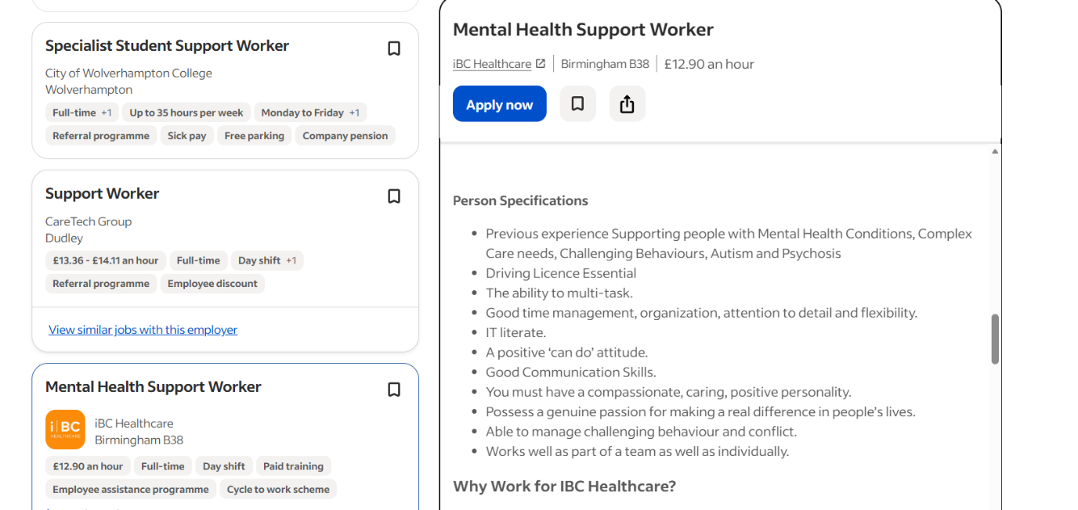

Key Skills and Requirements of a Mental Health Support Worker
I have evaluated my current skills against the requirements of a Mental Health Support Worker role. At present, I do not have experience supporting individuals with psychosis, autism, or complex mental health needs. This is an important area for development, which I will gain through training and practical experience. (Skills for Care, 2023).
However, I possess strong organisational skills, flexibility, time management, and attention to detail. These abilities help me manage tasks effectively and adapt to changing situations. I can also multitask, which is essential in busy care environments. I am willing to improve my IT skills, as digital record-keeping is important in healthcare settings (Health Education England, 2023).
Although I do not yet have a driving licence, I am working towards obtaining one to better support service users in the community.
I am empathetic, caring, and a good communicator, which helps build positive relationships. I can work independently and as part of a team, and I remain calm when managing challenging situations. I am motivated to support others and promote independence and wellbeing (National Careers Service, 2024).

Self-Evaluation of My Skills
Strengths
I have a caring and compassionate nature that always demonstrates patience, and sincere care for the welfare of others. Strong communication abilities, the capacity to listen carefully, articulate thoughts clearly, and cultivate a good relationship with people.
Effective time management and organization, setting priorities, fulfilling deadlines.
Ability to multitask, effectively managing several tasks while maintaining concentration and professionalism
Weaknesses
No experience with complex mental health needs, requiring further training, exposure, and practical experience development.
No driving licence, limiting travel flexibility and access to certain roles requiring independent transportation.
Limited IT skills, needing improvement in digital tools, software use, and confidence with technology systems
Need to develop confidence in mental health support, building knowledge, practical skills, and self-assurance through experience
Opportunities
University studies and qualifications, gaining deeper knowledge, professional credentials, and improved career progression opportunities
Training courses including mental health and safeguarding, enhancing practical skills, awareness, and professional competence
Volunteering opportunities, providing hands-on experience, confidence building, and exposure to real-life care environments
Work placements, offering practical experience, skill development, networking opportunities, and insight into professional expectations.
Threat
High competition makes securing entry-level roles difficult, requiring strong skills, experience, and a well-developed application.
Emotional demands and workload in mental health roles can lead to stress or burnout without proper support, self-care, and balancing home and work.
Lack of practical experience reduces job opportunities, making it harder to secure roles within competitive care environment.
Ongoing training is required to maintain skills, stay updated with policies, and provide effective, safe, quality care.
Building My Personal Brand and Professional Identity
My personal brand as a Mental Health Support Worker will be built on demonstrating core values and commitment to care. Your professional identity will begin from consistent presentation of your skills and expertise. (Skills for Care, 2023).
Core Values: Your existing self-assessment shows your value empathy, helping others, and a positive attitude. These are excellent foundational values. Articulate these clearly as your brand. (NHS, 2024).
My Unique Selling Point (USP): While you are developing specific expertise, your current USP lies in your strong transferable skills combined with your genuine passion. You can frame your enthusiasm and willingness to learn as a significant asset. For example, My unique blend of strong organisational skills and an unwavering empathetic approach allows me to create highly structured supportive environments for individuals on their mental health journey. According to (National Careers Service, 2024).
Online
LinkedIn Profile: Create a professional LinkedIn profile. Highlight your academic studies, any relevant volunteer work, and explicitly list your strong transferable skills (National Careers Service, 2024). Use relevant keywords like Mental Health, Support Worker, Healthcare and Wellbeing.
Engage with mental health organisations and professionals on LinkedIn; share articles about mental health awareness or support (Skills for Care, 2023).
Networking messages, when reaching out to professionals, craft concise messages that express your passion, highlight a key skill, and clearly state your objective (e.g., seeking advice, information, or experience) (NHS, 2024).
What Value Could I Add
Structured and Organised Support: Your strong organisational skills mean you can contribute to efficient daily routines, accurate record-keeping, and well-managed care environments from day one. You can help ensure that support plans are followed meticulously, providing consistency and reliability.
Empathetic and Positive Environment: Your caring, empathetic, and optimistic nature means you can immediately help create a warm, supportive, and hopeful atmosphere for service users, which is crucial for relationship building and recovery.
Ability to multitask, be flexible, and maintain calmness in difficult situations makes you a trustworthy and dependable colleague, ready to adapt to the dynamic needs of a care setting.
Action Plan and Timeline for 5 years
Year 1 (2024–2025)
Level 4 CertHE. I make sure I pass all my modules and assignments, by staying organised and managing my time well. I learnt about common conditions, their symptoms, and how to support people in a safe and respectful way.
At the same time, I will work on improving my IT skills. I want to feel more confident using computers, software, and online systems. This will help me with my studies and future work. I will practise using emails, documents, and online learning tools regularly.
Year 2 (2025–2026)
In the second year, I will complete my Level 5 Certificate. This will help me build on what I learned in Year 1 and improve both my academic and practical knowledge. I will continue to work hard and stay focused on achieving good results.
I will also attend important training courses. These will include mental health awareness, safeguarding, and first aid. These courses will help me understand how to keep people safe and respond in difficult situations.
Year 3 (2026–2027)
During this year, I will continue my university studies and aim to keep making steady progress. I will work on improving my knowledge and try to achieve strong academic results.
I will complete my degree by meeting all the requirements and successfully graduating. After this, I will begin applying for volunteering roles. This will give me real experience and help me build confidence in working with people in care settings.

Year 4 (2027)
In this year, I will focus on gaining work experience or volunteering in mental health settings. I will support individuals with different needs and learn how to work in a professional environment.
I will also develop important practical skills, such as communication, confidence, and professional behaviour. These skills will help me prepare for future employment.
Year 5 (2027–2028)
I will begin my job search between December and February. I will look for Mental Health roles and send strong applications. I will also prepare for interviews by practising answers and researching employers.
Between March and April, I aim to secure a job that matches my career goals. Once I start work, I will complete my induction and learn about workplace rules and expectations. I will also attend CPD training.
Communicating My Skills to a Potential Employer
Customise your CV for each specific job application, highlighting the skills and experiences most relevant to Mental health support worker role.
Use strong action verbs (Supported, Implemented, Observed).
Where possible, include measurable outcomes (e.g., "Implemented a new activity schedule that increased service user engagement.
Dedicated section listing both hard skills (Safeguarding Level 4 & 5 Health & Social Care, PMVA trained) and soft skills (e.g., Empathy, Communication, Problem-Solving).
Cover letter this is where you connect your skills to the specific job and organisation Express genuine interest in mental health and the role.
Explain how your unique combination of skills and passion makes you an ideal candidate. Directly address how you meet crucial points in the person specification.
LinkedIn Profile:
Online Professional Presence: Ensure your LinkedIn profile is always up to date, reflecting your current role, qualifications. Share articles or participate in discussions related to mental health to demonstrate your engagement and knowledge.

Interviews:
Enthusiasm & Professionalism: Communicate your passion for the role and demonstrate your professionalism and excellent communication skills in person.
By diligently following this action plan, you will systematically develop the necessary skills, build a strong professional identity, and promote yourself effectively to achieve your goal of becoming a Mental Health Support Worker.
Conclusion
This assignment emphasises the important part of a mental health support worker as well as the abilities, skills, and qualities required for success (NHS, 2024). By assessing my employable skills, I was able to identify both my areas of strength such as communication, empathy, organisation, and teamwork and my areas for improvement such as practical experience, IT proficiency, and confidence in mental health settings (Skills for Care, 2023). With education, training, and practical experience, my action plan offers a clear route to accomplish my objectives (Health Education England, 2023). All things considered, this work strengthens my enthusiasm and dedication to continuous learning, assisting me in becoming a skilled and caring Mental Health Support Worker (National Careers Service, 2024).

References
Department of Health and Social Care (2022) Working together to improve health and social care. Available at: https://www.gov.uk
Health Education England (2023) Digital skills for health and care. Available at: https://www.hee.nhs.uk
Mind (2024) Supporting someone with mental health problems. Available at: https://www.mind.org.uk
National Careers Service (2024) Mental health support worker job profile. Available at: https://nationalcareers.service.gov.uk
NHS (2024) Care worker skills and responsibilities. Available at: https://www.nhs.uk
Nursing and Midwifery Council (NMC) (2018) The Code. Available at: https://www.nmc.org.uk
Royal College of Psychiatrists (2023) Working in mental health services. Available at: https://www.rcpsych.ac.uk
SCIE (2022) Good practice in mental health care. Available at: https://www.scie.org.uk
Skills for Care (2023) The state of the adult social care workforce. Available at: https://www.skillsforcare.org.uk
Skills for Health (2023) Core competencies in health and social care. Available at: https://www.skillsforhealth.org.uk.

