8/14/2026
Assessment 2
Network Operating Systems and Services

Module NaMe: network operating systems and services

Module Code: acca5023

Student NAME: afroza siddique
Student ID: 1818786
Lecturer: md sadeque imam shaikh

University of Wales Trinity Saint David
London Campus
Table of Contents
Introduction 2
Main Body 2
1. Routing: 2
2. Domain Server (Birmingham) 5
3. Encrypted Connection between Birmingham and London 10
4. Users 11
5. Domain Membership 12
6. DHCP Server 14
7. Test and Troubleshoot 15
8. Disk Drive 16
9. IIS Server 16
10. Remote Desktop Services 18
Conclusion 19
Reference 19

Introduction

This report presents the planning, configuration, and testing of a network infrastructure for NOSSLONDON2026, with sites in Birmingham and London. The project focuses on creating a reliable network that supports Windows and Debian systems, domain services, routing, secure communication, file sharing, web hosting, and remote administration.
The network was developed using virtual machines to simulate the required infrastructure. Key technologies such as IP addressing, subnetting, hypervisors, Active Directory, DNS, routing, VPN, IIS, file sharing, and Remote Desktop Services were configured and tested. Connectivity tests, including ping and remote access, were used to identify configuration problems and confirm whether the network was working as intended.

Main Body

Routing:

1.1. Routing in Birmingham Network

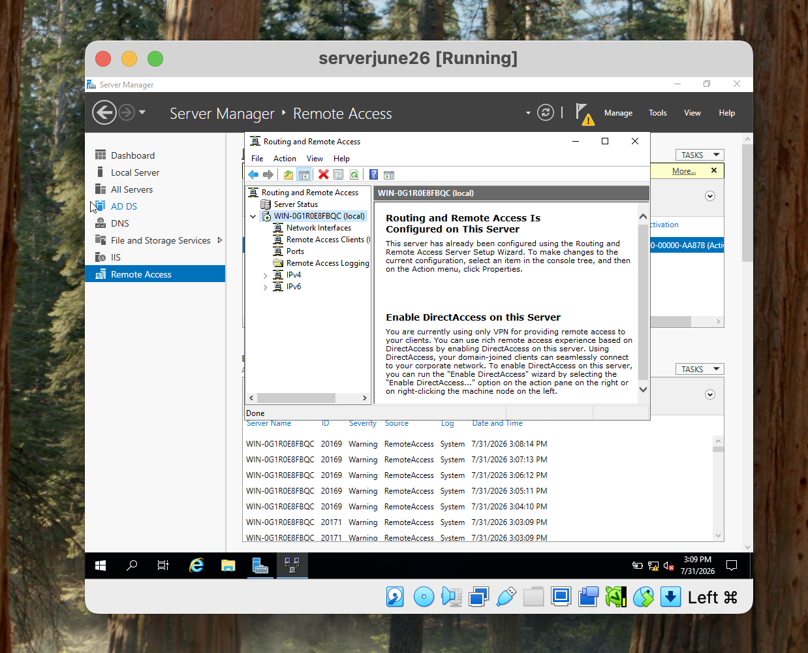

The Routing and Remote Access Service (RRAS) was installed on the Birmingham Windows Server. to allow it to route traffic between different network segments. The Windows Firewall was also configured to allow ICMP traffic, which made it possible to use ping to test whether devices could communicate.

Creating ICMP was useful for testing and troubleshooting, but it should not be allowed unnecessarily because it can increase the server’s exposure to network scanning. Therefore, ICMP should be restricted to trusted networks where possible. The RRAS configuration was checked to ensure that the server could forward traffic correctly between the required networks.

The screenshot shows the completed RRAS configuration and the firewall rule allowing ICMP traffic. This provides evidence that routing and connectivity testing were successfully configured on the Birmingham server.

1.2 Configure persistent IP Forwarding and Routing

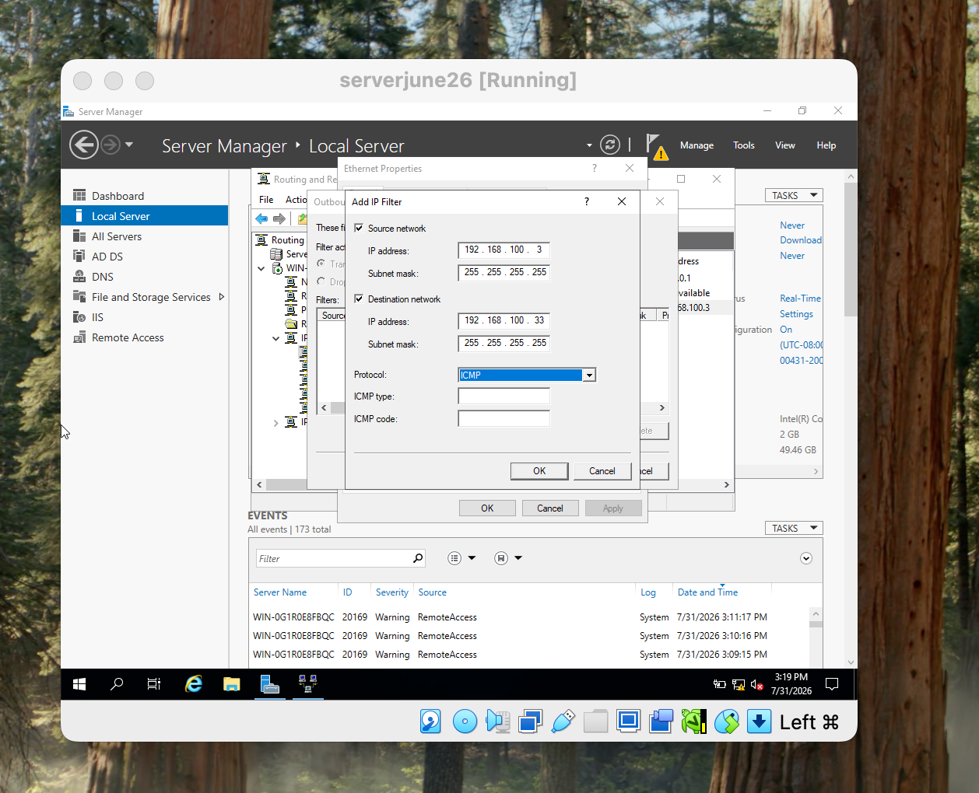
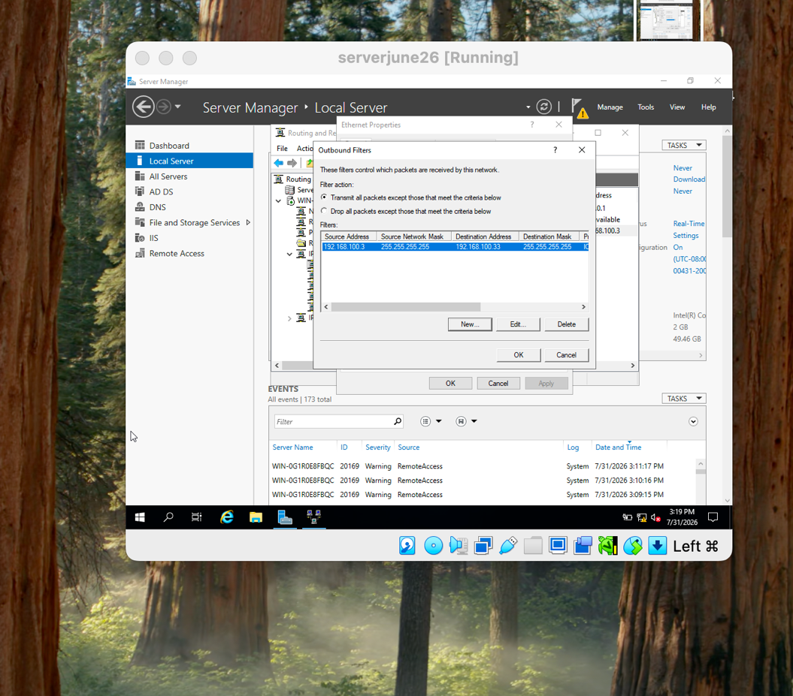

IP forwarding was configured on the London server so that it could forward packets between its network interfaces. Routing and Remote Access Service (RRAS) was used to support communication between the different network segments. This is important because the Birmingham server needs to act as a router rather than only communicating with devices on its own network.

The screenshots show the inbound and outbound IP configuration of the windows server. The inbound settings show how traffic reaches the server, while the outbound settings show how traffic is forwarded towards the appropriate network.

Persistent forwarding is useful because the configuration remains active after a server restart. However, routing should only be enabled where required, as incorrect forwarding or firewall rules could allow unwanted traffic between networks. The configuration was therefore checked to ensure that only the required network traffic could pass through the London server.

Domain Server (Birmingham)

2.1. Create a forest named yourname.acca

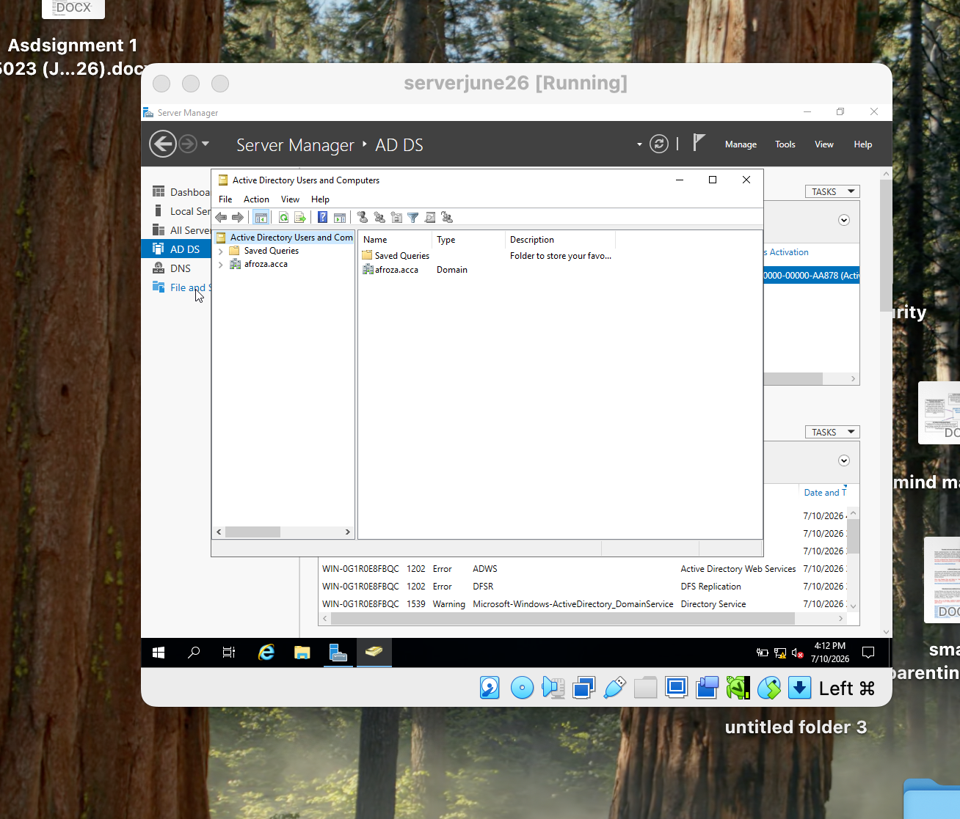

An Active Directory forest named afroza.acca was created on the Birmingham Windows Server. This was an important step because the forest provides the main structure for managing the organisation’s users, computers, domains, and security policies from one central location.

Creating the forest name makes the Birmingham server the foundation of the domain environment. It also provides a way to manage Windows client more consistently. However, the forest name and DNS configuration need to be planned carefully because mistakes at this stage can cause problems with domain joining and name resolution later.

The screenshot shows the completed Active Directory Domain Services setup with afroza.acca configured as the domain. This provides evidence that the domain environment was successfully created on the Birmingham server.

2.2. Create all appropriate A records for all servers on Birmingham and London
Network

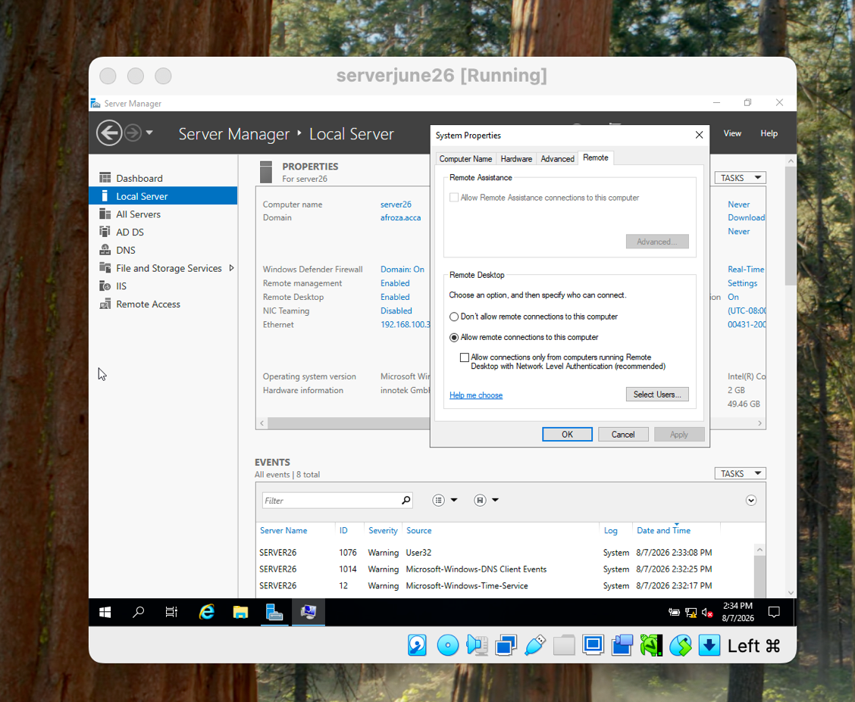

Records were created in the DNS server for the required servers in the Birmingham and London networks. Each record connects a server’s hostname to its IPv4 address, allowing users and other network devices to find the server by name instead of using its IP address.

Records are important because an incorrect IP address can cause DNS resolution and network services to fail. The records were checked to ensure that each server name matched the correct IP address.

The screenshot shows the configured records in DNS Manager, with the server names and their corresponding IPv4 addresses. This provides evidence that DNS name resolution has been correctly configured for the Birmingham and London servers.

2.3 Create a reverse lookup zone creating PTR records for all servers.

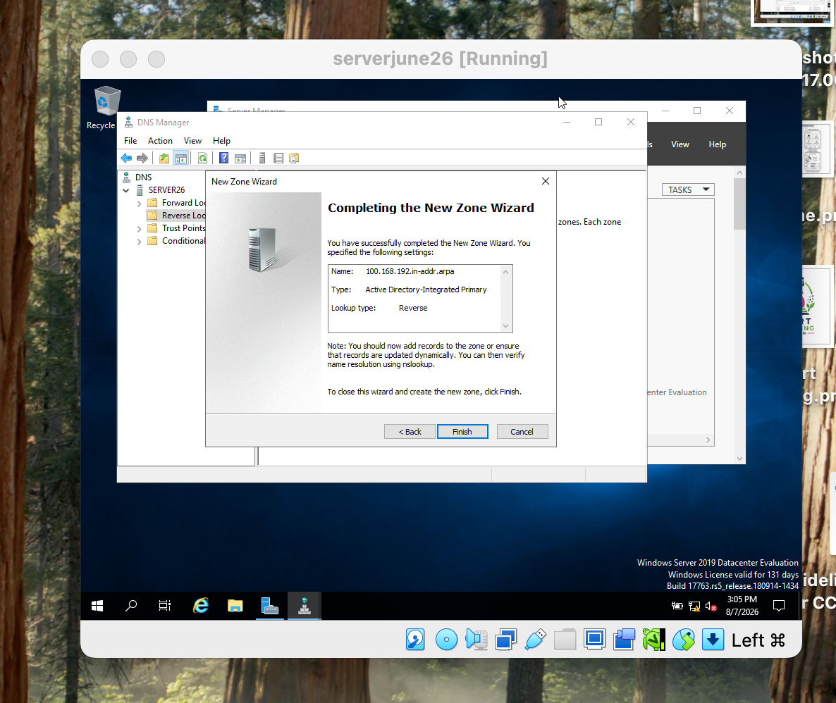

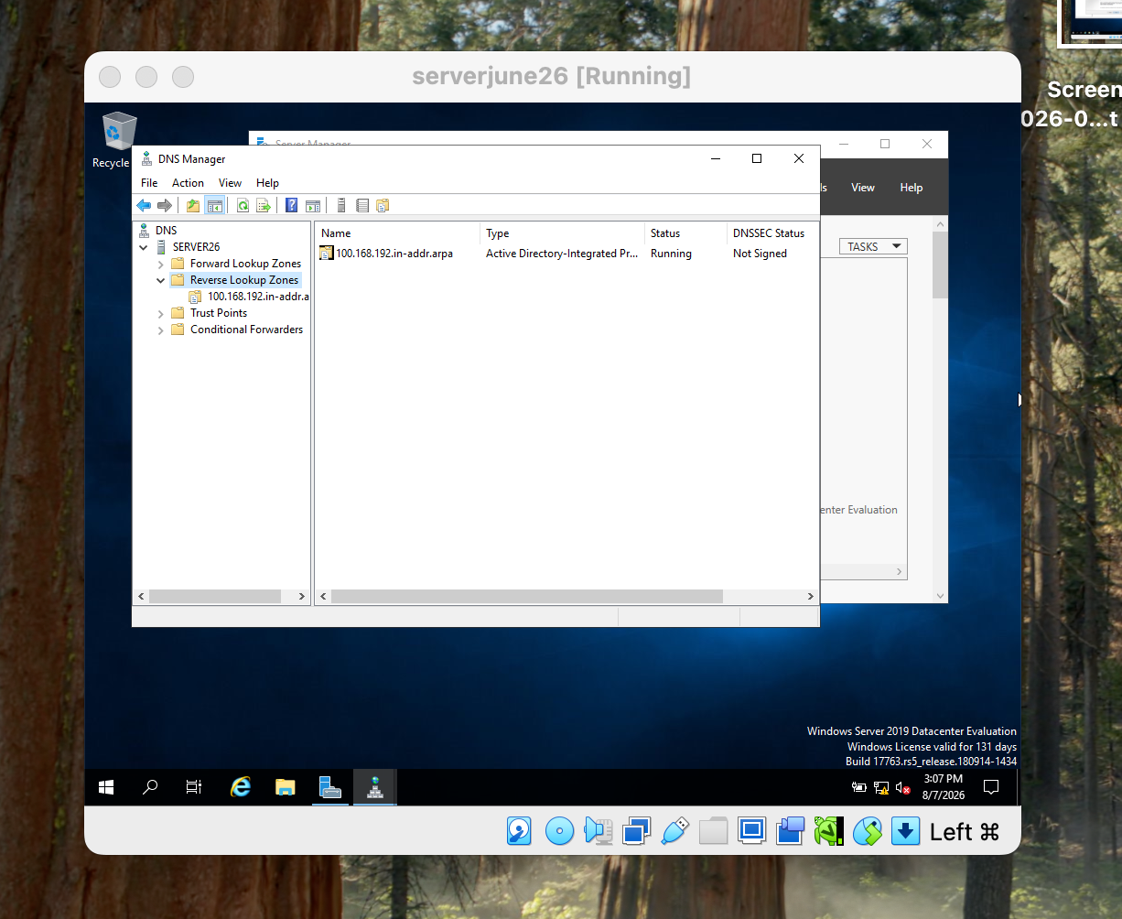

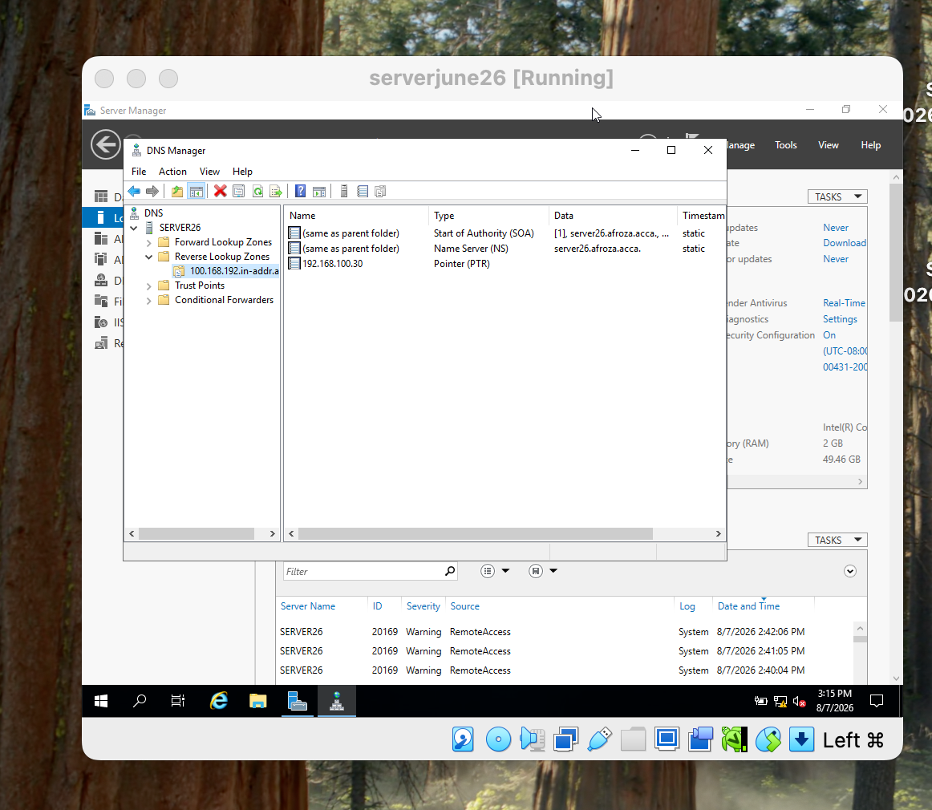

A reverse lookup zone was created to allow the network to identify a server name from its IP address. PTR records were added for the servers in the Birmingham and London networks. This is useful for checking whether the DNS configuration is correct and for troubleshooting network connectivity.

The screenshot shows the reverse lookup zone and the configured PTR records. This provides evidence that the server IP addresses have been successfully linked to their corresponding hostnames.

Encrypted Connection between Birmingham and London

Configure Site-to-Site VPN to London Network.

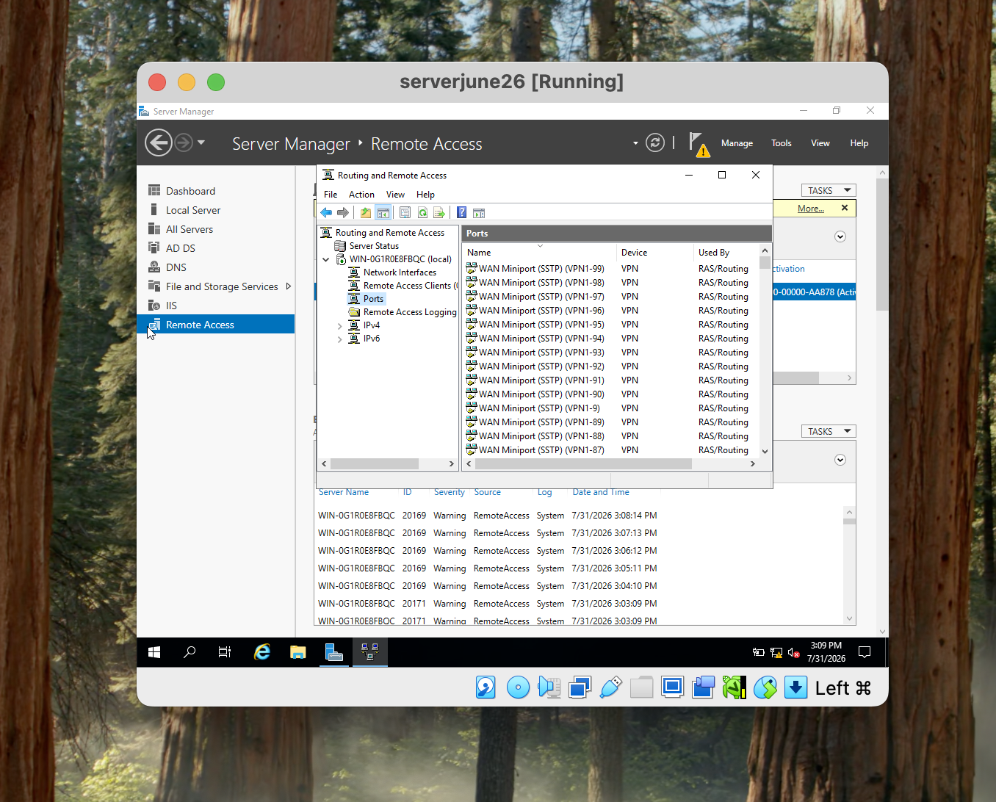

A site-to-site VPN was configured using Routing and Remote Access (RRAS) to provide a secure connection between the Birmingham and London networks. The purpose of the VPN is to allow network traffic to pass between the two locations while protecting the data travelling across the connection.

The screenshot shows the RRAS Remote Access configuration with multiple WAN Miniport (SSTP) entries being used by VPN/RAS. This provides evidence that the server has VPN functionality enabled and is ready to handle VPN connections.

Users
4.1. Create user accounts for yourname.acca domain

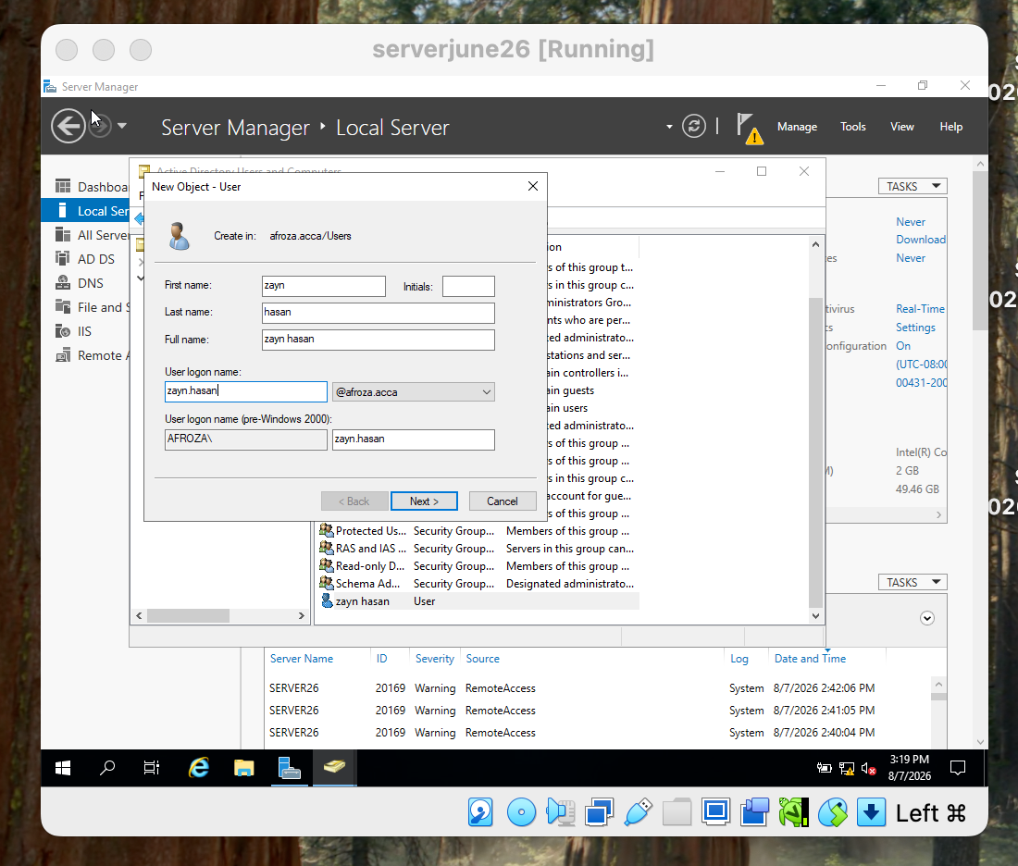

User accounts were created in Active Directory Users and Computers (ADUC) for the afroza.acca domain using the details provided in the users_list_updated.xlsx document. Each account was created with the required user information and settings. The SAM Account Name was created using the first letter of the user's first name followed by a dot and their surname, as required. For example, a user named Zayn Hasan would have the SAM Account Name zayn.hasan.

The process involved opening Active Directory Users and Computers, selecting the appropriate organisational unit, and creating a new user account. The user's name, logon name, password settings then entered. After creating the accounts, the properties of the users were checked to make sure the information matched the requirements.

The screenshots show the created users inside Active Directory and their account properties. This provides evidence that the accounts were successfully added to the domain with the required settings.

Creating users through Active Directory makes account management easier and provides better control over access to network resources. However, account security depends heavily on appropriate password policies, permissions, and account management. Giving users more privileges than necessary could create security risks, so accounts should follow the principle of least privilege. The user list should also be checked carefully because incorrect usernames or settings could cause login and access problems later.

- Domain Membership

5.1. Join L-CD, ClientS1, ClientL1 to the yourname.acca domain.

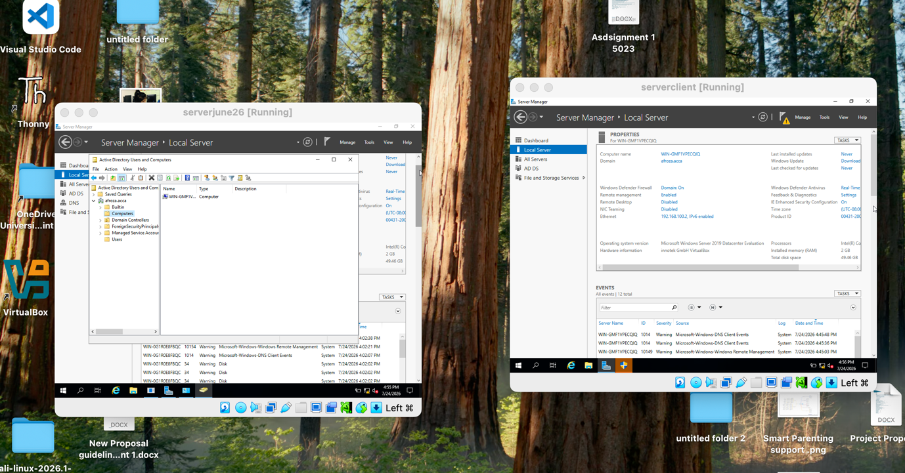

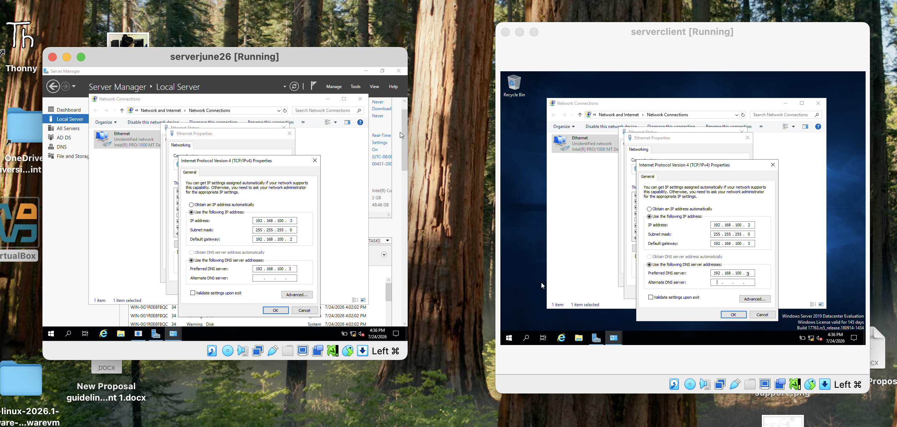

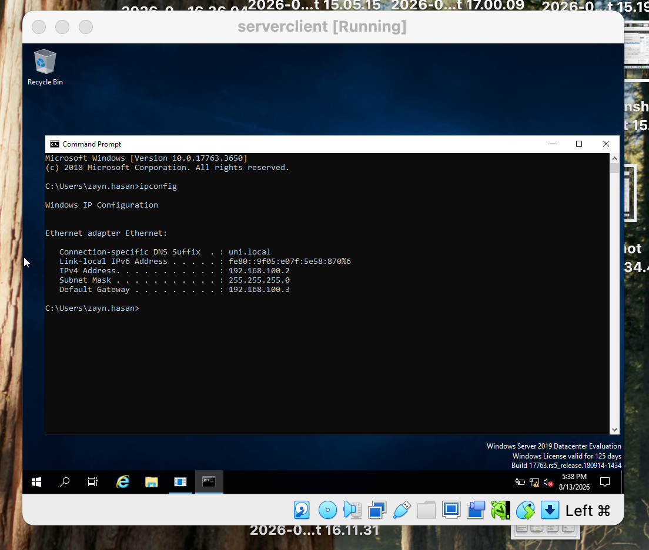

The client machine and server were joined to the afroza.acca Active Directory domain hosted on the Birmingham server. Before joining the domain, the client was configured with the correct IP address, subnet mask, and default gateway pointing to the appropriate server. The DNS settings were also checked because the clients need to locate the domain controller through DNS.
The basic process involved opening the computer’s system properties, selecting the option to join a domain, entering afroza.acca, and providing domain administrator credentials when requested. After restarting the clients, the machines became members of the domain and could be managed through Active Directory.

The screenshots provide evidence of the configuration. The Active Directory Users and Computers screenshot shows the client computer names added to the domain. The IP configuration screenshot shows the client’s network settings and confirms that the gateway and DNS configuration point to the required server.

6. DHCP Server

6.1 configure B-DC as DHCP server

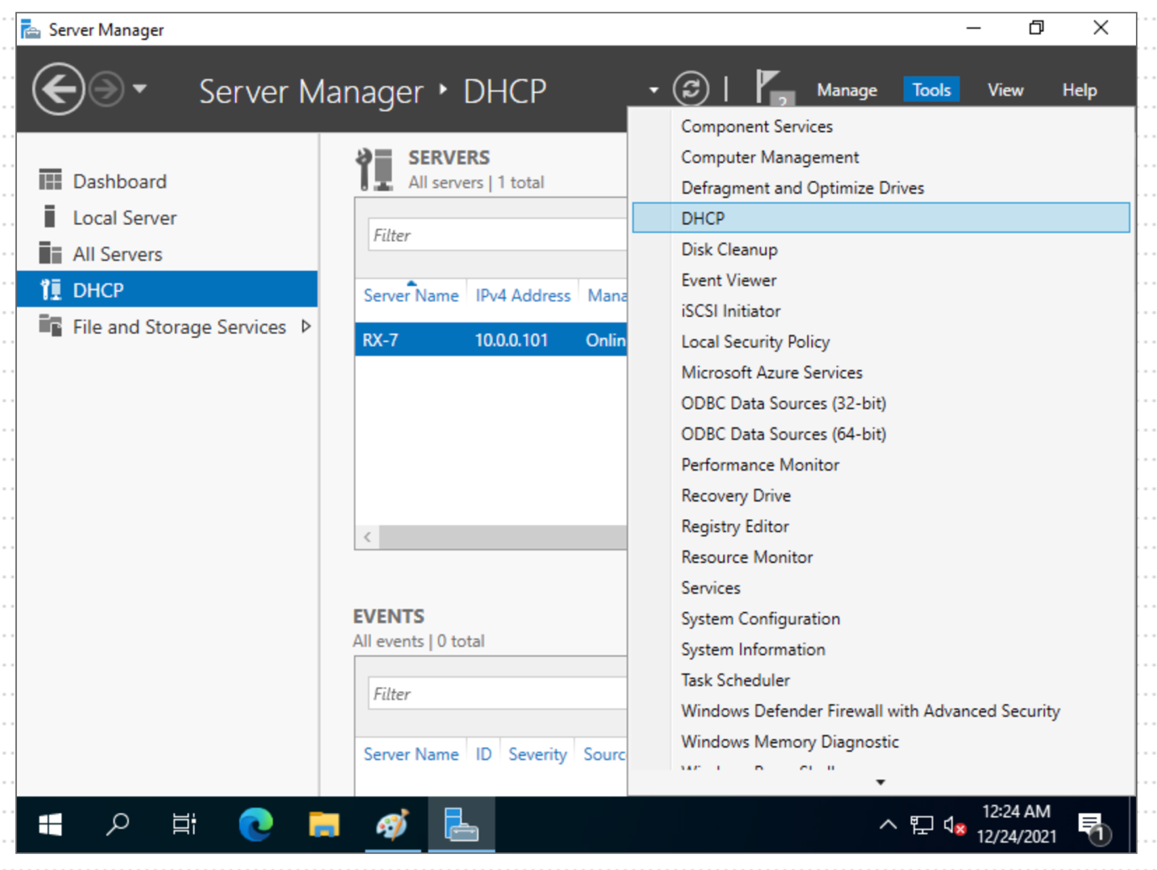

Fig. 1. DHCP Server [1]

6.2 configure L-CD as DHCP Relay Server.

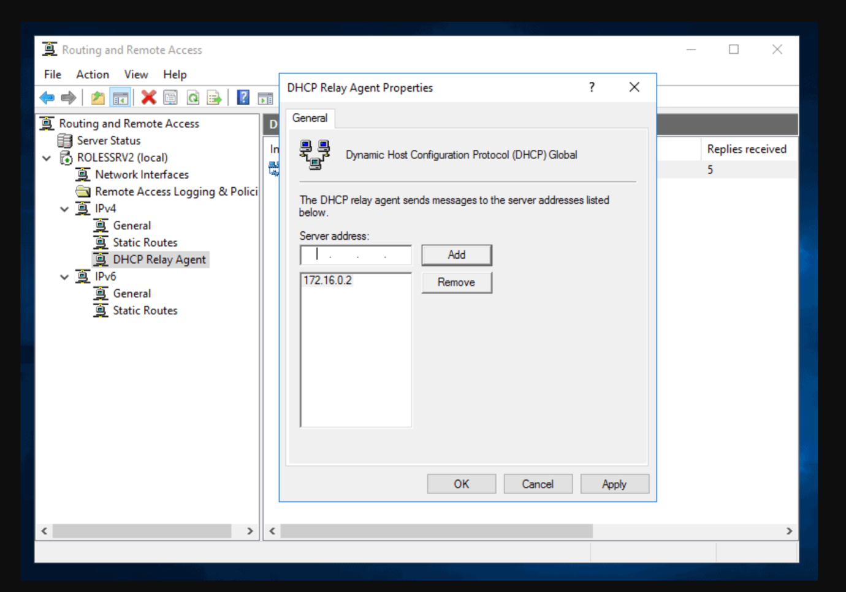

Fig. 2. DHCP Relay Agent [2]

6.3 All the Clients should receive IP Address automatically via DHCP Server

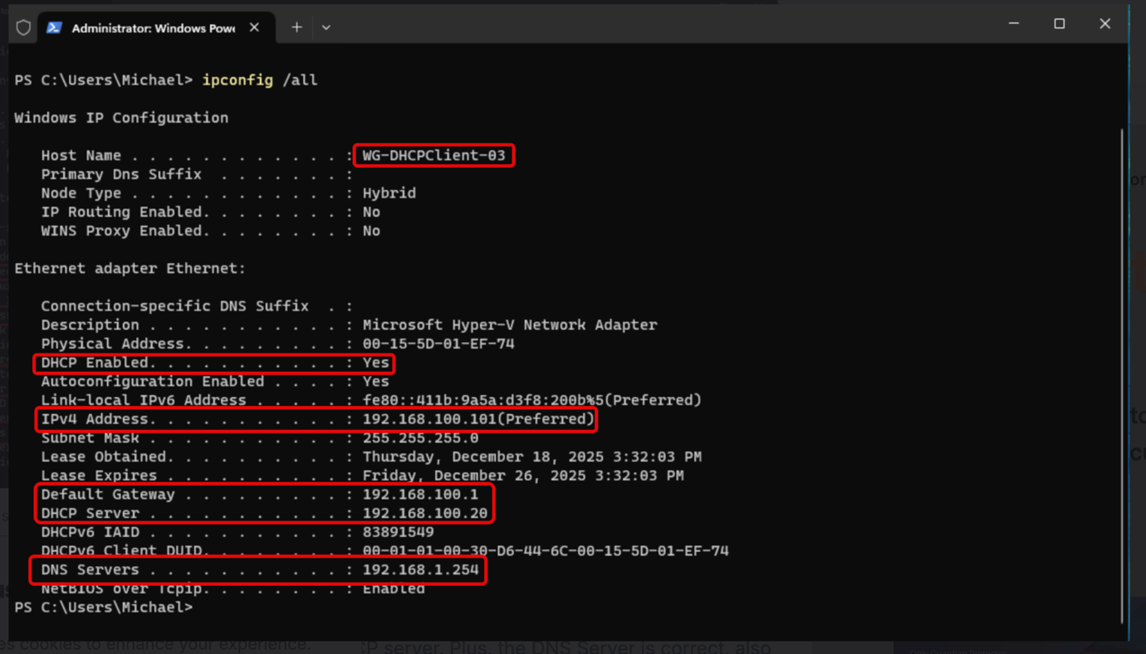

Fig. 3. DHCP IP Address [3]

7. Test and Troubleshoot

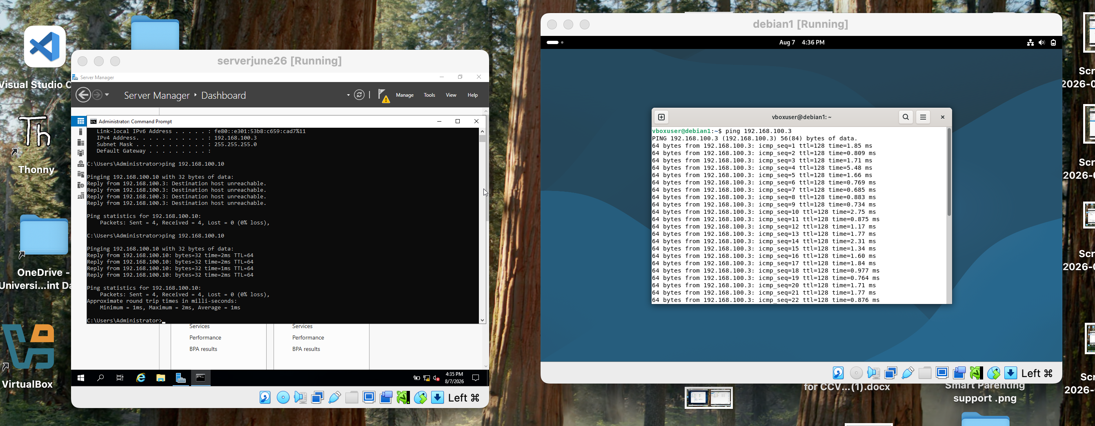

Network connectivity was tested after logging into the client machines to confirm that the servers and clients could communicate correctly. The ping command was used because it provides a simple way to check whether a device is reachable and whether IP communication is working.
First, the client was used to ping the server’s IP address. The server was then used to ping the client’s IP address. Successful replies confirmed that the IP addresses, network adapters, routing, and firewall settings were working as expected. The screenshots provide evidence of these successful tests.
Windows machine and a Linux machine were checked to ensure they were using the correct IP range and subnet. For example, the Windows machine could ping the Linux machine, and the Linux machine could ping the Windows machine. This helped confirm that communication was possible across the different operating systems.

8. Disk Drive

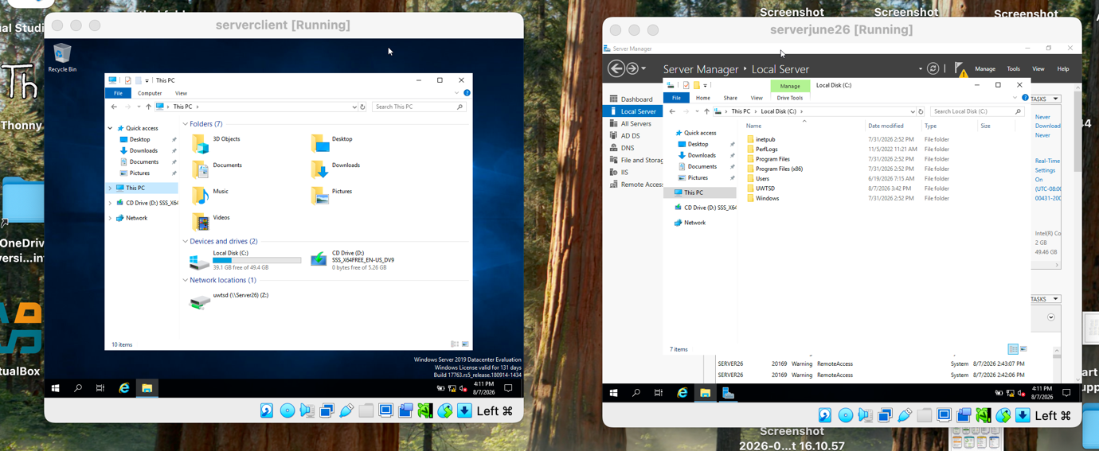

A second disk drive was mounted on the Birmingham server and assigned to UWTSD. The folder was shared across the network so that authorised users could access the required files from their client machines.
The permissions were configured so that Domain Users have Full Control, while other network users have Read-only access. This allows domain users to manage the shared files while limiting other users to viewing the data.
After the configuration, I logged into a client computer and accessed the shared drive. The screenshot shows the UWTSD drive available from the client, confirming that the network share was accessible.

9. IIS Server

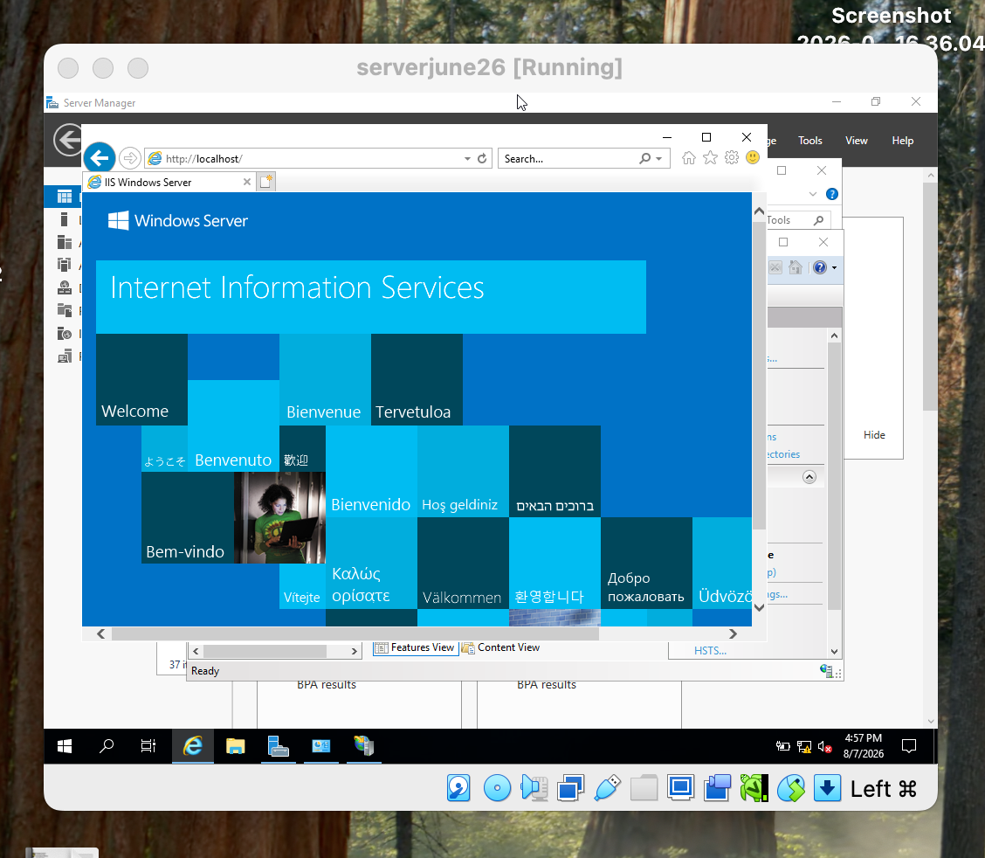

Internet Information Services (IIS) was configured on the Windows Server to host the webs.afroza.acca website. IIS is a Windows web server that allows websites and web applications to be hosted and accessed by users through a web browser.
The website was created in IIS and configured with the required domain name. Windows Authentication was enabled so that access to the website can be controlled using Active Directory user accounts. This is useful in the domain environment because users can access the website using their existing domain credentials rather than separate website accounts.
The screenshot shows the IIS server running and the website being opened successfully in a browser. This provides evidence that the IIS service is installed and able to serve web content.

10. Remote Desktop Services

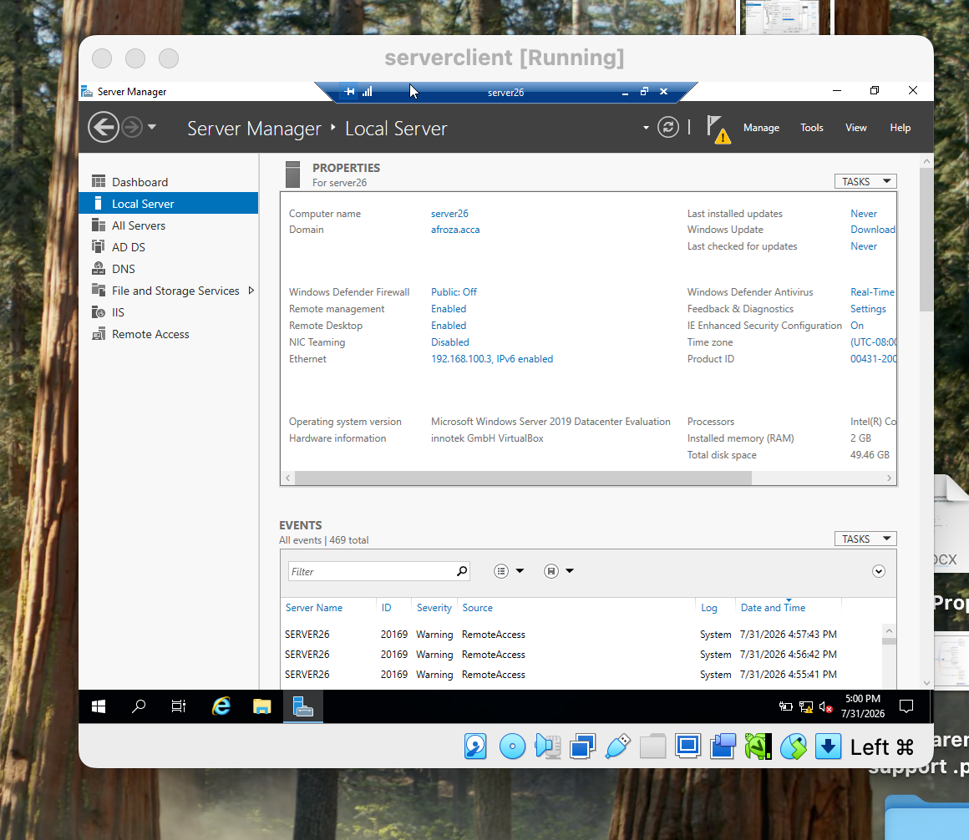

Remote Desktop Services (RDS) was configured to allow administrators to remotely access the B-DC server from another machine on the network. The client machine was used to open the Remote Desktop Connection application. The target server name was entered, followed by the administrator credentials, to establish the remote session.
The screenshot shows the server successfully connected and its desktop available remotely. This demonstrates that Remote Desktop is enabled and that the server can be accessed from another machine on the network.
RDS is useful because it allows administrators to manage servers remotely without needing physical access to the server. This is particularly important in a multi-site environment such as Birmingham and London. However, remote access also introduces a security risk. Strong passwords, appropriate user permissions, firewall rules, and restricted access should be used to prevent unauthorised users from accessing the server.

Conclusion
Overall, this project successfully demonstrated the planning, configuration, and testing of a network infrastructure for NOSSLONDON2026. Windows and Debian virtual machines were configured with appropriate IP addresses, domain services, routing, VPN connectivity, file sharing, IIS, and Remote Desktop Services. Connectivity tests helped confirm communication between devices.
The project showed that a working network requires more than simply configuring devices. IP addressing, DNS, routing, firewall rules, permissions, and security settings must work together to ensure reliable and secure communication. The use of virtual machines made it possible to test different network services without requiring additional physical hardware, However, the virtual environment has limitations, particularly in terms of available hardware resources and performance.

Reference

[1] Server World, “DHCP Server : Configure DHCP Server,” Server World. [Online]. Available: https://www.server-world.info/en/note?os=Windows_Server_2022&p=dhcp&f=2. [Accessed: Aug. 14, 2026].

[2] V. Ashiedu, “How to Configure DHCP Relay Agent in Windows Server 2016,” iTechGuides, May 6, 2019, updated Mar. 10, 2024. [Online]. Available: https://www.itechguides.com/dhcp-relay-agent-configuration-in-windows-server-2016/. [Accessed: Aug. 14, 2026].

[3] M. Reinders, “Windows Server DHCP Migration: Making a Seamless Transition,” Petri.com, Dec. 23, 2025. [Online]. Available: https://petri.com/windows-server-dhcp-migration/. [Accessed: Aug. 14, 2026].

