Student Name |  |  | Andrei Welkens-Covaci
Student ID |  |  | 1818820
Module Title |  |  | Academic and Employability Skills (BMSW4001_LON)
Assignment Title |  |  | Academic and Employability Skills
Module Lecturer |  |  | Sylvia Hoffmann
Word Count |  |  | 2059 |  |  |  | Date Submitted |  | 03.01.2020



Table of Contents
Introduction 2
Description 3
Feelings 4
Evaluation 5
Positive aspects (Good) 5
Negative aspects (Bad) 6
Analysis 7
Action 8
Conclusion 10
References 11
Appendixes 12

Introduction
In this reflective report, I have reflected on how learning received in this module has helped in developing my academic and employability skills. My reflection is based on in-class activities, in which I have written a letter applying for a head chef job requirement [Appendix 1&2]. All the in-class activities are based on judging the language and written communication skills. For constructing this report, I have used the Gibbs' Reflective Cycle to present a well-structured reflective account of the tasks and feedbacks identifying the things that I have learned and my improvement needs in the area of presentation and public speaking skills.

Figure 4: Gibbs Reflective Cycle
Source: (Brookes, 2019)

Description
The module is named Academic and Employability Skills, and it involves developing an understanding of self-academic and employability skills during a series of class tests. In term 1, I have taken two in-class exercises that were designed by the lecturer to judge the paraphrasing skills. Having good paraphrasing skills is necessary for both academic and practical employment situations because often we need to develop written pieces which are plagiarism-free and acknowledges sources of the information used in the written piece (Chen, et al., 2015). In order to have good paraphrasing skills, one must have good language and comprehension skills and, in this case, English comprehension and grammar skills. The two exercises involved paraphrasing a piece of text appropriately and determining whether some given paraphrased section is acceptable or unacceptable with justifiable reasons. A properly paraphrased section should convey the original meaning of the text with no similarity in the way information has been presented in the text. While I have attended the first exercise for which I have received feedback that my attempt was fair. I made some grammatical mistakes and perceived wrong meaning for social writer and social entrepreneur [appendix 3]. I have not attended any section of the second test, thus received no feedback for that section [appendix 4]. Moreover, I have taken more English comprehension, grammar and paraphrasing skill tests. Fortunately, I have been able to complete all the exercises in the tests [appendix 5]. However, there was an exercise where I needed to paraphrase from a student's section of which I did not attempt question 5, which was a large section [appendix 6]. I could not manage the section due to lack of time management skill. However, for the sections that I had attempted, I received positive feedback. For one particular test where I was supposed to arrange words in proper order to form sentences, all my attempts have been correct, and I received full marks. These tests and feedbacks have helped my own strengths and weakness in the area under tests alongside knowing that I lack proper time management skills.

Feelings
I have mixed feelings regarding my test attempts, results and feedbacks. During term 1, when I was taking the test, I was allotted only one hour to attend all the questions. All my allotted time was consumed in doing the exercise one, which involved paraphrasing a paragraph. I attempted to paraphrase the paragraph sentence to sentence resulting in having difficulty in structuring sentences without similarity. I received a fair grade as feedback because I happen to make some crucial grammatical errors in the text. I felt disheartened for the overall grade and my attempt because I could have done better if I could manage my time properly. For the texts taken in term 2, I felt positive. My attempts had received good grades as I have answered most sections correctly for all tests. While I was taking the tests, I was feeling positively confident. This is because, during term 1 tests, I received a fair grade, which boosted my confidence. An essential part of boosting self-confidence is receiving positive feedback from assessors and peers (Scott, 2017). This has worked well in boosting my own confidence level. I think as I was feeling positive and confident, I did well in the tests and have given most answers correctly. From my results, I observed that my skills of paraphrasing had improved significantly and my new found approach for paraphrasing is reading the sentences and extracting the best meaning from it, then rewriting the entire piece in my own words which conveys the same meaning. This has reduced the time that I usually took while paraphrasing. However, I still think I need to work harder to improve my time management skill. I also found the text is more difficult to paraphrase as it consists of data and stats. I was not sure how to avoid plagiarism in such cases where data needs to be rephrased. Thus, there was some feeling of uncertainty in this case. Understanding the feeling I have regarding my own performance has helped me in knowing my further improvement needs and that I need to work hard, even more, to improve my communication, public speaking and language skills to excel both academically and during employment situations.

Evaluation
To evaluate my own performance and feelings and my overall experience regarding the tests taken during both terms, I need to identify the good and bad aspects of the tests and feelings. After reflecting on my own performance in the duration of two terms, I can structure the good and bad aspects of the tests and my performance in the following way.

Positive aspects (Good)
The first and foremost positive aspects of the exercises are the variety of designs included in the tests. All tests involved examining the language, comprehension, grammar, sentence structure and paraphrasing skills of the student taking the test. Another good aspect of the test was the constructive feedback that I have received from taking the tests. My assessor has been kind enough to provide me with feedback that is encouraging. Especially during term 1 exercise 1 not only the feedback marked me fair but also outlined what I did wrong and what was the right approach. For example, I introduced Mike Erwin as a social worker in the paraphrased section, which my assessor has pointed as the wrong word as a social worker and social entrepreneur are two different things. The original text mentioned that Mike Erwin envisions himself as an activist and social entrepreneur. From this, I understood the essential difference between approaching a sentence and the little differences are wordings change the essential meaning of the text, thereby changing the information conveyed through the text. This has been an essential lesson as it is necessary for the paraphrased section to convey the meaning unchanged because otherwise distortion of information occurs. Another positive aspect had been me being aware of my weakness with regard to time management. In two instances, I was unable to complete my tests and answer all parts as I lacked time during the examination. During a pressured situation such as an exam, time management is an essential skill determining success or failure to a great extent (Grissom, et al., 2015). From this lesson, I am now aware that I lack this skill and need to work on it further.

Negative aspects (Bad)
There have been some negative aspects or negative experiences associated with the tests. I found all the tests being very lengthy and quite confusing at times. The second exercise of the first term involved me assessing whether paraphrasing has been done correctly and justify by feedback with reasons. I found that part of the exercise confusing as I was given multiple paraphrased sections from the same source text. Due to lack of time, I was unable to concentrate and minutely judge the sections resulting in myself not attempting that part of the test. For tests in term 2, assessor has pointed out that even though my presentation was good, I lacked confidence when I was publicly speaking or presenting. Therefore, I would need to work on mitigation of nervousness during such activities. Assessor has also suggested me to take deep breath if I am nervous as well as being a bit louder when I speak during presentation [appendix 6].

Analysis
From the evaluation of the module coursework, how the activities have helped in developing employability and academic skill can be analysed. From the analysis, it is clear that the diverse tests have helped in judging my language and written communication skills that are necessary to excel in both academic and practical work fields. These are the fundamental skills that one must have (Scott, 2017). The positive and negative feedbacks had been constructive in both cases because the positive feedback has helped me to realise and acknowledge my strengths while the negative feedbacks have helped me in identifying my weakness and areas needing development. I have gathered specific learning regarding the technicalities of different parts of speech such as nouns, pronouns, verbs, adjectives, articles, adverbs, preposition, conjunctions and interjections. Though during high school, we have learned this in English grammar; however, recapitulating these has been a positive aspect as it has helped me in developing my writing skills further. I have understood that each of these parts plays individual roles, and during paraphrasing, a sentence or a paragraph one cannot simply omit one part simply because it may seem convenient to restructure the sentence.

Conclusions
In conclusion to the entire analysis, I can point out certain think that I could have done to make the experience better and encourage my own learning and skill development further. I think I could have approached the tests in a more strategic way which would have resulted in me being able to attempt all parts in a correct manner. Moreover, I feel a strategic approach is needed during exams and similar pressured situation to manage the allotted time properly. Moreover, I have identified that I need to work further in developing my grammatical skills. Sometimes while writing, I use wrong verb forms. I think if I proofread my work, I would avoid these mistakes as spelling mistakes as well. This would greatly improve my overall language skills. I can further note that this module has enhanced my learning and existing skills while identifying further improvement needs in the existing skills.

Action
Considering all my strengths and weakness, I have developed an action plan following which I think I would be able to excel further. I have identified that I lack time management skills and need to improve my grammar and proofreading skills. My evaluation of hobbies has helped me in noticing that I am disinterested in sports. I have no recognisable hobbies. During interviews often interviewers ask about hobbies and interest. I may face difficulty in answering such questions thus should develop interest and skills regarding these. Following is my action plan:

Area of improvement | Activity | Time required
Developing time management skill | - Setting alarms  - Timing myself while doing homework and assignments  - Practising reflective journal keeping  - Setting a routine to follow every day | 3 months
Developing grammar and proofreading skills | - Attempting practice exercise from comprehensive English grammar books  - Practising writing essays and reports  - Double-checking written piece of work  - Reading more literature to develop vocabulary  - Practising more paraphrasing exercises | 4 months
Developing interest in sports | - Start watching games on television like cricket and football as these are highly popular outdoor sports  - Take part in outdoor activities and sports with friends  - Develop a hobby like collecting stamps or gardening or reading books. | 1 year
Developing presentation and public speaking skills | - I will practice public speaking and presentation in front of an audience to handle nervousness during such activities.  - I will utilise more examples to help my audience visualise about the topic I am talking about. | 6 months
Table 1: Action Plan
Source: Developed by author
If I follow these action plans, I would develop my skills further and do better next time. Good performance would further improve my self-confidence and emotional intelligence.

Conclusion

This report highlighted the relevant theories and models for understanding the employability and academic skills for an individual. Learning skills, communication skills, enterprise and initiative skills, problem-solving skills, self-management skills, teamwork skills, organising and planning skills, technology skills, and workplace and health and safety skills have been discussed thoroughly. Moreover, I think I need to work on my presentation or public speaking skills and grammatical skills further to strengthen my abilities and for that a coherent action plan has been presented in this paper.

References

Brookes, 2019. Brookes University. [Online]
Available at: http://www.brookes.ac.uk/students/upgrade/study-skills/reflective-writing-gibbs/
[Accessed 24 12 2019].
Chen, M., Huang, S., Chang, J. & Liou, H., 2015. Developing a corpus-based paraphrase tool to improve EFL learners writing skills. In: Computer Assisted Language Learning . s.l.:s.n., pp. 22-40.
Grissom, J., Loeb, S. & H, M., 2015. Principal time management skills: Explaining patterns in principals time use, job stress and perceived effectiveness.. Journal of Educational Administration , 6(53), pp. 773-793.
Scott, G., 2017. Active engagement with assessment and feedback can improve group-work outcomes and boost student confidence.. In: Higher Education Pedagogies. s.l.:s.n., pp. 1-13.

Appendixes

Appendix 1
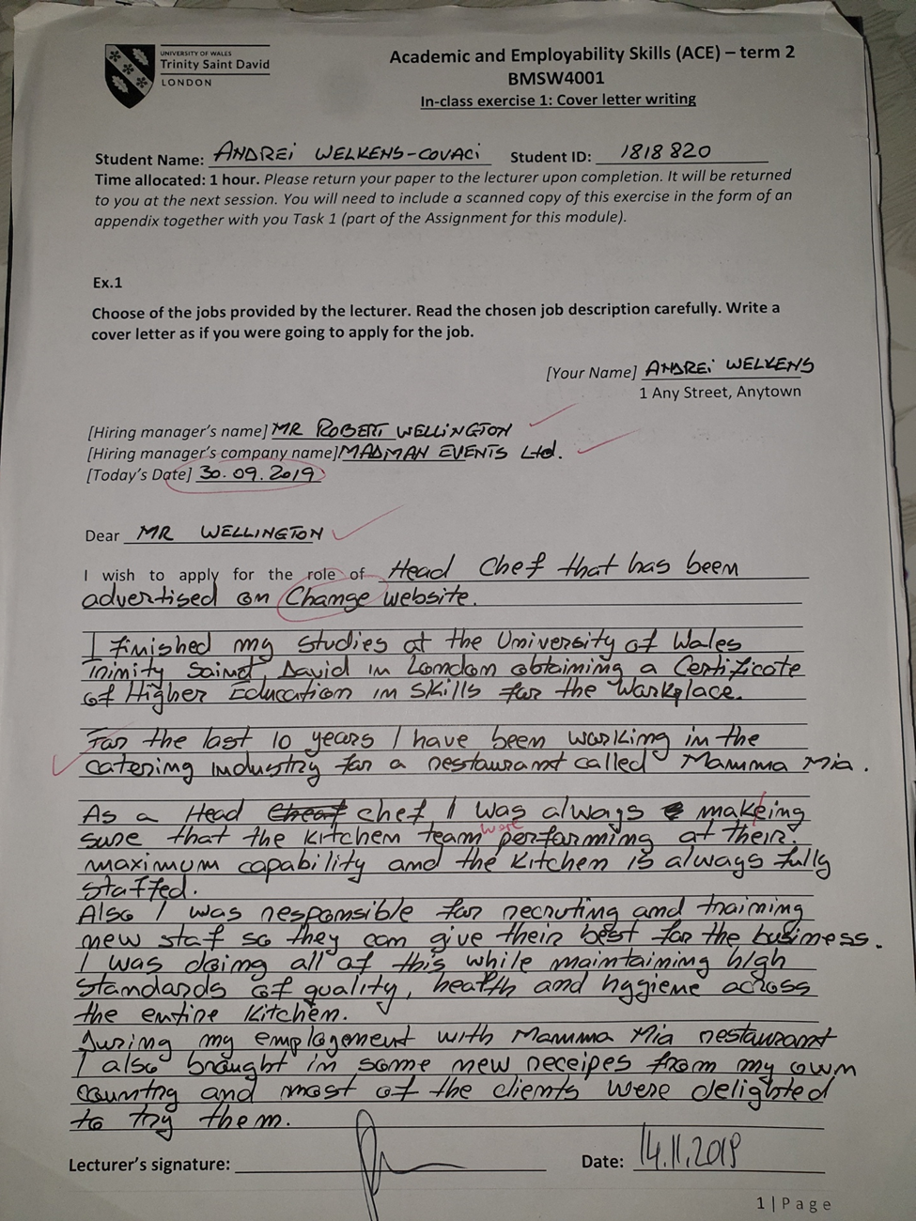

Appendix 2
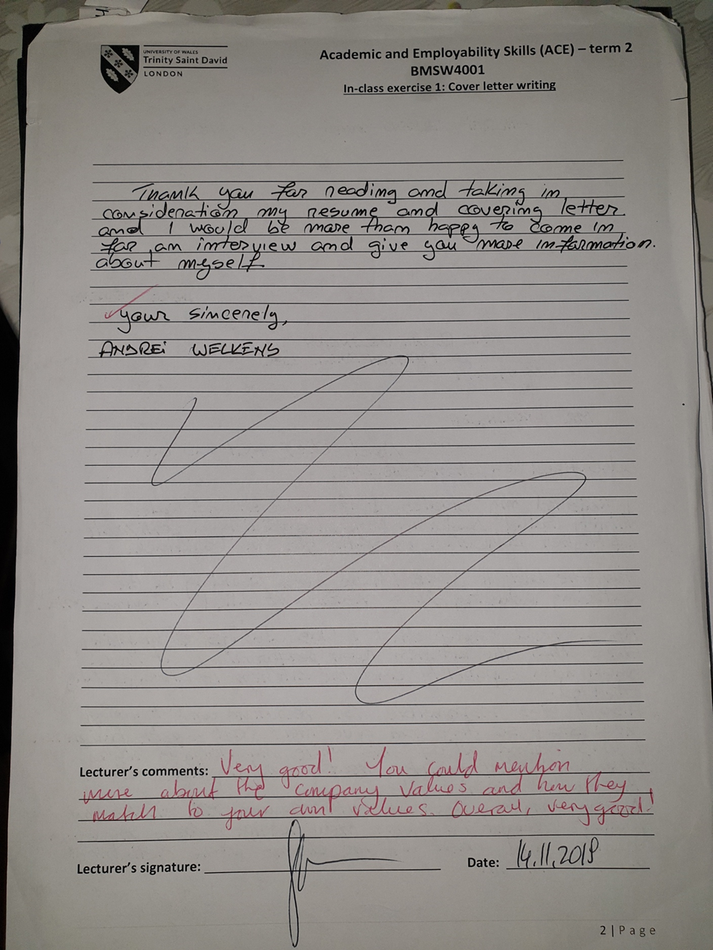

Appendix 3
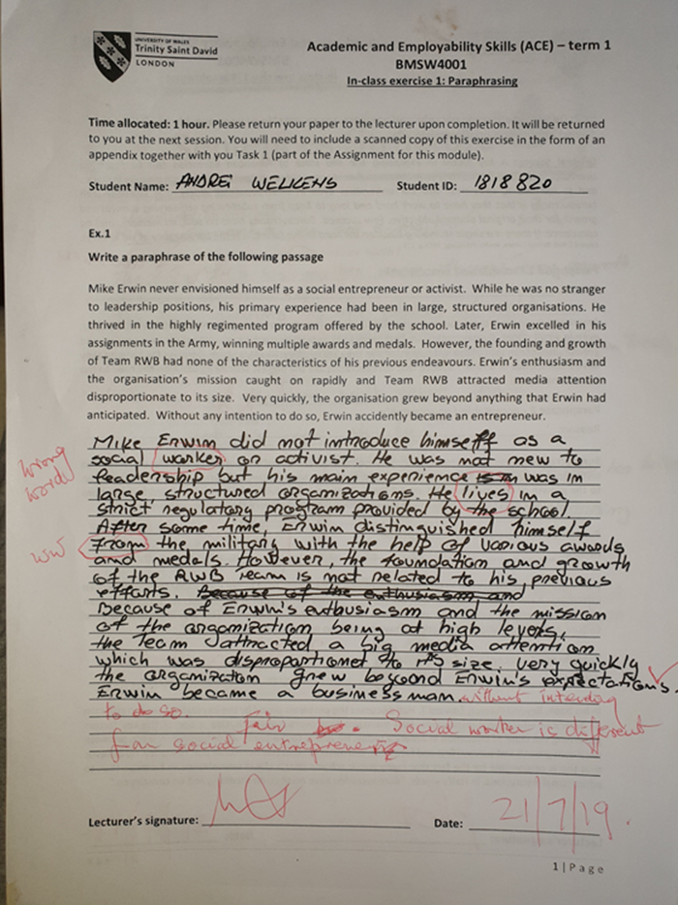

Appendix 4
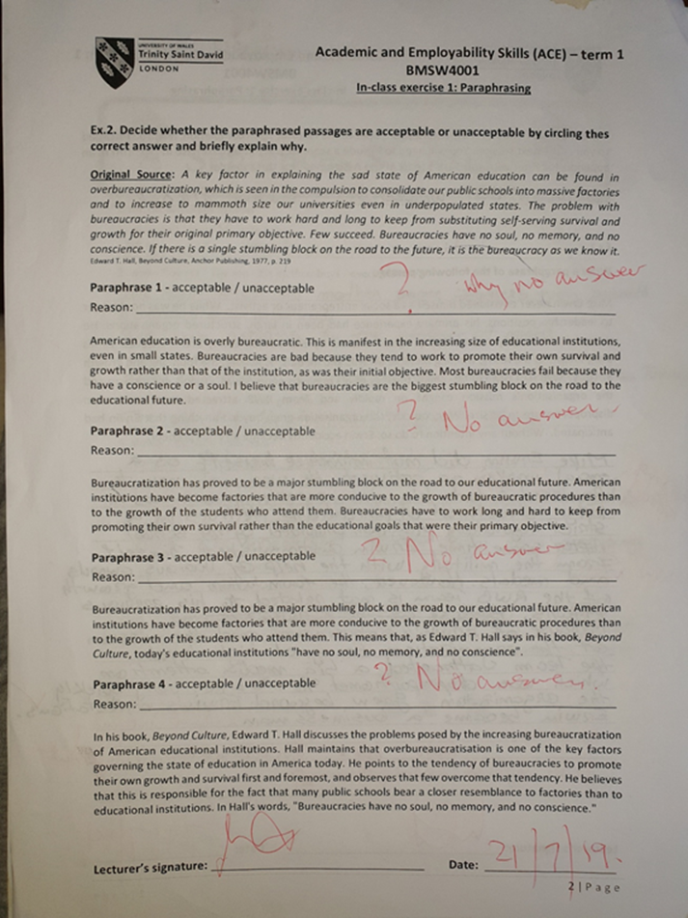

Appendix 5
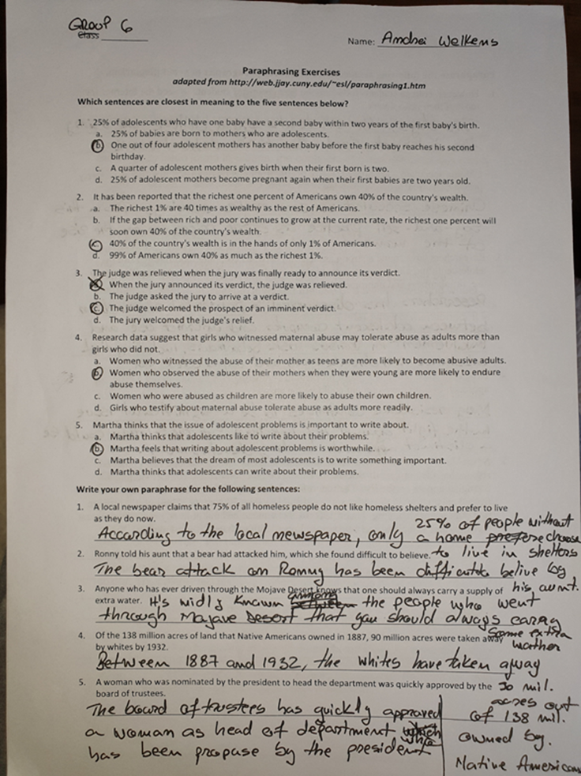

Appendix 6


