Does the “Smacking ban” actually work and is it fit for purpose? A year on from the introduction of the Children (Abolition of defence of reasonable punishment) (Wales) Act 2020

Daniel Cleland
2031307

BSc (Hons) Professional Policing Practice

Acknowledgments

I would firstly like to thank my mother and father, as well as my partner, for their continued support, motivation and endless encouragement throughout my career and university studies.
I would also like to thank my colleagues and friends who have been supportive of my research topic and have assisted me with any questions I may have had throughout the process.
I would finally like to thank my dissertation tutor, Michelle, for her patience and for keeping me on track and guiding me though the dissertation process.

Declaration

This work has not previously been accepted in substance for any degree and is not being concurrently submitted in candidature for any degree.
Signed: Daniel Cleland
Date: 01/04/2024

STATEMENT 1
This dissertation is being submitted in partial fulfilment of the requirements for the degree of BSc (Hons) Professional Policing Practice
Signed: Daniel Cleland
Date: 01/04/2024

STATEMENT 2
This dissertation is the result of my own independent work/investigation, except where otherwise stated.
Other sources are acknowledged by footnotes giving explicit references. A bibliography is appended.
Signed: Daniel Cleland
Date: 01/04/2024

STATEMENT 3
I hereby give consent for my dissertation, if accepted, to be available for photocopying and for interlibrary loan, and for the title and summary to be made available to outside organisations.
Signed: Daniel Cleland
Date: 01/04/2024

STATEMENT 4
I hereby give consent for my dissertation, if accepted, to be available on the university’s IT system to those who have consent to use the system.
Signed: Daniel Cleland
Date: 01/04/2024

Abstract

The aim of this dissertation was to investigate the impact that the “Smacking ban” in Wales has had on the ability for parents to discipline their children, contrary to Children (Abolition of defence of reasonable punishment) (Wales) Act 2020 (Legislation.gov.uk, 2020). A detailed review of existing and current literature was conducted by the researcher, surrounding the physical chastisement of children, the positives, and negatives of chastisement and why it was eventually made illegal.

The researcher has identified a gap in recent literature, allowing for them to conducted primary research by use of a survey that was disseminated to members of the public to obtain their opinions on the change in law, how it affected them and if they believed improvements could be made. The data collected was then analysed and compared to identify and trends or correlations.
The results from the project, recommendations for further research and recommendations for amendments to Children (Abolition of defence of reasonable punishment) (Wales) Act have been made.
The project achieved its aim of understanding the impact of the act on parents and children following its introduction in 2020.

Table of Contents
Acknowledgments 2
Declaration 3
Abstract 4
1.0 Introduction 6
2.0 Literature Review 7
2:1 Introduction 7
2:2 The history of physical punishment to discipline children 7
2:3 Does the physical punishment to discipline children work? 8
2:4 Impact on the smacking ban from another country – Sweden 9
2:5 Wales published a review of the evidence – 2018 9
2.6 The introduction of the “Smacking ban” - Children (Abolition of defence of reasonable punishment) (Wales) Act 2020 10
2:7 Impact on parent’s ability to discipline 10
2:8 A gap in the research 11
2:9 Conclusion 12
3.0 Methodology 12
3.1 Introduction 12
3.2 Ethical Practise 12
3.3 Research Onion 13
3.3.1 Research Philosophy 13
3.3.2 Research approach 13
3.3.3 Strategy 14
3.3.4 Data Collection Method 14
4.0 Analysis of results 14
4.1 Introduction 15
4.2 Demographic 15
4.3 Opinion on physical punishment 16
4.4 Impact of new legislation 19
4.5 Areas for improvement 22
4.6 Conclusion. 24
5:0 Findings, conclusions, and recommendations. 24
5.1 Introduction. 24
5.2 Completion of research objectives. 24
5.2.1 Objective one – To identify why the “smacking ban” was introduced in Wales. 24
5.2.2 Objective two – To evaluate the effectiveness of physical punishment as a disciplinary method for children. 25
5.2.3 Objective Three – To explore parents’ opinions on the “smacking ban”. 25
5.2.4 Objective 4 – To identify if the “smacking ban” has impacted on a parents’ ability to discipline children. 26
5.3 Recommendations 26
5.3.1 Recommendation one – Expansion of survey 26
5.3.2 Recommendation two – A change in the outcomes of the offence 26
5.3.3 Recommendation Three – Continuous monitoring and evaluation of the new legislation 27
5.4 Conclusion 27
6.0 Bibliography 27
7.0 Appendix 31
7.1 Survey Questions 31
7.2 Survey Results 40

Introduction

On the 21st of March 2022, the Children (Abolition of defence of reasonable punishment) (Wales) Act 2020 (Legislation.gov.uk, 2020) came into effect which removed the defence of reasonable punishment to discipline children in Wales, as such making any physical punishment against them illegal. This came after years of research into the topic which found that the physical punishment of children was not only ineffective, but was also harmful to the development of a child as increased antisocial behaviour and aggression levels were noted in children who were physically punished (NSPCC, 2021).
The overall objective of the Act was to protect children’s rights by ending the physical punishment of children and giving them the same protection from assault as adults (Welsh Government, 2022). It also aimed to make the law clearer so that it is easier for any parent, child, professional or any other person to understand.
However, not everyone agrees that the physical punishment of children leads to negative outcomes in their behaviour and argues that in fact child on child violence increases without the use of it. This is seen in figures of child-on-child violence from Sweden, the first country to ban smacking, which saw an increase of this type of violence by 1,791% between 1984 and 2010 (Be Reasonable , 2024). The Welsh government themselves also published a report that states in their view, the evidence for the ban on physical punishment “does not definitively show that ‘reasonable’ parental physical punishment causes negatives outcomes” (Carter-Davies & Bristow, 2018). For these reasons it could be argued that the new law change is only criminalising caring parents who are only trying to raise their children into well behaved young adults.
Since the introduction of the new legislation, there have been no published statistics on parents’ views on how the legislation change has impacted on their ability to discipline their children, and in turn how this has changed their children’s behaviour. The only data that has been released since the legislation change is the amount of police referrals, out of court disposals, and referrals to social services and the CPS that have been made (Welsh Government, 2023).
This project will aim to provide a critical evaluation of the impact that the Children (Abolition of defence of reasonable punishment) (Wales) Act 2020 has had since its introduction in 2022. The project will have four research objectives which have been listed below, and their number will be used to reference throughout the project.
- To identify why the “smacking ban” was introduced in Wales.
- To evaluate the effectiveness of physical punishment as a disciplinary method for children.
- To explore parent’s opinions on the “smacking ban”.
- To identify if the “smacking ban” has impacted on parents’ ability to discipline children.

2.0 Literature Review

2:1 Introduction

In this chapter, a critical review of current literature surrounding the physical punishment of children to discipline them will be undertaken, why changes in law were made with the introduction of the Child Act 2020 to stop the physical punishment, and to explore if the smacking ban has had an impact on a parent’s ability to discipline their children. This chapter will seek to explore and answer these topics by completing the following objectives:

2:2 The history of physical punishment to discipline children

At the end of the 18th century, and throughout the 19th century, physical punishment to discipline children was long thought to be a valued part of the education system, with many educational theorists stating that for children to achieve in school they would need to be motivated, and that the threat of physical punishment worked just as well as interesting them in their work. The practise of physical punishment was widely accepted within the educational system and seen as positive, with the aim to “help the backslider to do willingly what he ought to do”, and children accepting physical punishment as fair and just (Middleton, 2008).
In the UK, up until recently, schools and prisons have used physical punishment as a disciplinary and educative process and was often viewed as building a person’s character. Physical punishment has been steadily outlawed throughout the 20th century, with the Plowden report (Plowden, 1967) raising the physical punishment of children as a major issue, and it being fully outlawed in schools as a result of this report in 1986 (Politics.co.uk, 2022).
There was agreement amongst some experts that abusive and harsh punishment of children is detrimental to their health and development, however there is some debate about whether spanking is associated with negative outcomes from old opinions (Baumrind, 1997) and new ones (Gershoff & Grogan-Kaylor, 2016). Parents have carried on using physical punishment into the 21st century despite the negative position of some experts, with statistics showing that 80% of children around the world are spanked or physically punished by their parents (UNICEF, 2014). More specific to the UK however shows that research commissioned by the central office of information found that out of 64 children aged between 4 and 16 across England and Wales, two-thirds reported having been ‘smacked’ at some point, which occurred more frequently at younger ages (Sherbert Research, 2007).
What remains evident is throughout history and continuing through to the present day, the physical punishment to discipline children remains an incredibly controversial conversation, with conflict around the topic being persuasive on a multilevel basis. To this day, partners argue over its use; governments and political parties dispute each other, and countries debate on whether to outlaw the practise (Holden, 2002).

2:3 Does the physical punishment to discipline children work?

For over 70 years, psychologists have investigated the effectiveness of physical punishment and the consequences it can have, subsequently concluding that physical punishment was not effective and led to lasting and significant behavioural changes to those subjected to the punishment (Skinner, 1953). This is also supported by more recent studies conducted by the University College of London (UCL), backed by a team of experts with more than 20 years of experience evidencing how the physical punishment of children is not only ineffective, but is actually harmful to the development of a child with side effects of increased aggression and anti-social behaviour levels (NSPCC, 2021). On speaking to children themselves about physical punishment, it is stated that most believe it to be the most severe type of discipline, and that it is both physically and emotionally painful (Sherbert Research, 2007) (Crowley & Vulliamy, 2002).
However, other research conducted disagrees with this point of view, as (Domjan, 2000) stated that physical punishment in fact can be an effective agent to change behaviour, but certain conditions had to be met for it to work. The conditions stated were for the punishment to occur after every transgression, the punishment had to be immediately after the transgression occurred, it had to not be signalled by a discriminative stimulus and it had to be intense for at least the first transgression. Although it is widely reported that children do not like the physical and emotional pain that comes with physical punishment, some studies have found that children accept physical punishment as a “parental right” under the correct circumstances (Graziano, et al., 1996) and may even be necessary to use on younger children (Sharpe, 2004), however these views are old and may now be outdated. This shows that children believe that, when explained and administered fairly, discipline and punishment Plays a crucial role in the heathy development of a child (Sherbert Research, 2007).
An argument can also be drawn from the statistics of children who are physically punished, as if 80% of children around the world, or two-thirds within England and Wales (Sherbert Research, 2007) are punished physically (UNICEF, 2014), why are only a small portion of these children showing negative outcomes in relation to it? A medical analogy can be used to best explain this, when considering the link between smokers and lung cancer, it is estimated that 33% of all smokers will die from it (Holden, 2002). This raises the question as to why some children who are physically punished develop behavioural problems, whereas most do not. It may be the case that this is caused due to a multitude of faults in the research and reports already conducted on the physical punishment of children whereby “physical punishment” is a blanket term used not only to describe the spanking of a child, but also more serious violence and abuse such as beating, whipping, burning and punching (Holden, 2002).

2:4 Impact on the smacking ban from another country – Sweden

Sweden was the first country to ban the physical punishment of children occurring in 1979, meaning that it has had the longest period for research and studies to be conducted on the results of the ban. The impact of the ban is generally viewed as successful in changing the attitudes towards physical punishment of children and would ultimately assist the Welsh Government to argue for their new legislation to ban physical punishment. Within two years of the law changing in Sweden, 90% of parents knew about the ban on physical punishment. In the 1970s, around half of all children questioned reported being physically punished, however by the millennium this figure decreased to around 14% (Janson, et al., 2010). Furthermore, 92% of parents surveyed believed it was wrong to physically punish children, and another study by Ellonen concluded that only 3% of parents stated it is “acceptable to slap a child if he or she makes you angry” (Public policy institue for Wales, 2018). On the other hand, it is important to state that these statistics are not solely based off the ban on physical punishment but may also include the increase in welfare centres for children, clinics and parental courses that educate and aid in supporting parents (Janson, et al., 2010).

2:5 Wales published a review of the evidence – 2018

On the 19th of July 2018, the Wales Centre for Public Policy (WCPP) formerly known as the Policy institute for Wales (PPIW) published a review into the parental physical punishment of children, and child thoughts and outcomes (Carter-Davies & Bristow, 2018). The results were as follows:
- Physical punishment of defiant children is no more effective at changing the child’s short-term behaviour than different forms of discipline that are non-physical.
- Child abuse and severe physical punishment are both harmful to a child’s development.
- How parents typically punish their children both in the way they do it and in which conditions they do it in can be correlated to negative outcomes in children.
- No peer reviewed research has shown how parental physical punishment can have a positive effect on a child’s development or outcomes.
However, although the report pushes evidence to suggest that the physical punishment of children is negative, it does also state that in their view the evidence “does not definitively show that ‘reasonable’ parental physical punishment causes negatives outcomes” (Carter-Davies & Bristow, 2018).

2.6 The introduction of the “Smacking ban” - Children (Abolition of defence of reasonable punishment) (Wales) Act 2020

on Monday 21 March 2022, the Children (Abolition of defence of reasonable punishment) (Wales) Act 2020 came into effect within Wales, marking the first time that core criminal law differs between England and Wales (Cornish, 2022), but what exactly did this act do?
In short, the new act will “help to protect children’s rights by prohibiting the physical punishment of children” (Welsh Government, n.d). To understand how the change will happen, the previous law on physical punishment must be looked at. It stated that any person acting as a parent, or in the place of a parent (carer or guardian) could use the defence of “reasonable punishment” if they are charged with common assault against their own child, or a child in their care (Welsh Government, n.d). This law was set out in section 58 of the (Childrens Act , 2004). They key distinction is the law is that it only sets out a reasonable defence for physical punishment, if the punishment given is only to the level of injury identified with the offence of common assault (Criminal Justice Act , 1988), and not higher, such as offences of actual bodily harm (ABH) (Offences against the Person Act, 1861), or grievous bodily harm (GBH) (Offences against the Person Act, 1861) (Public policy institue for Wales, 2018).
The new Act did not create a new law, but instead removed the defence of reasonable punishment set out in the Children’s Act 2004, meaning that children will have the same protection as adults from physical punishment. This also means that if the police get a report that a child is getting physically punished by a parent or someone acting in loco parentis (in place of a parent), then formal police action could be taken against the person. The police would need to investigate all reports and apply two evidential tests, is there enough evidence to charge for an assault, and is it in the public interest to do so. the best interests of the child should also be considered (Welsh Government, n.d).
Surveys conducted show statistical support for the implementation, with 38% of those surveyed being for the ban, 31% not knowing, and 31% against it or needing more information (Welsh Government , 2018). However, a second survey conducted by ComRes in 2017 shows statistics that out of 1019 Welsh adults, 76% of them agreed that smacking children should not be a criminal offence, with only 11% agreeing that it should, the rest were undecided (Be Reasonable , 2023).

2:7 Impact on parent’s ability to discipline

“Be reasonable” is an organised group who oppose the banning of physical punishment of children on not only Wales but also Scotland, Northern Ireland, and England. They argue 4 main points against the banning of physical punishment on children, including the criminalisation of good parents, an increased workload of trivial cases for police and social services, the law prior to the new Act already protected children from harm, and finally that parents should decide whether or not to smack their child, not the government (Be Reasonable , n.d).
Parents have also raised concerns around the introduction of the new legislation, stating that they are worried they will be criminalised if they attempt to discipline their child lovingly and carefully by using reasonable physical punishment, in an attempt to raise their children well and with good morals and behaviours. It is stated parents will be fearful to discipline their children, and fearful of how they treat their children both in public and privately, and that it is not a healthy way for parent and child relationship to occur (Be Reasonable, 2017).
Furthermore, parents and supporters of reasonable physical punishment are worried that without the ability to discipline their child safely and legally, it will lead to an increase in the child’s antisocial behaviour and involvement in criminal activity, stating that “physical punishment may be used to control the short-term behaviour of the child and to reinforce the authority of the parent” (Baumrind, 2010). Further research also suggests that parenting which combines both physical punishment with maturity, Communication, nurturance, and demands can be linked to long-term beneficial outcomes for the child (Carter-Davies & Bristow, 2018) . This is something that could also be lost through the ban of reasonable physical punishment.
Further studies also show when looking back at the Sweden case study, that parents have become scared to say no to anything in relation to their child. Statistics also show that the level of child-on-child violence since the introduction of the physical punishment ban has increased by a staggering 1791% between the years of 1984 and 2010. Children have also become significantly less accepting of their parents attempts to discipline them through other forms of punishment such as grounding them or restricting them from entertainment such as TV or games consoles, with statistics showing that in 1995, 39% of children believed their parents had the right to threaten or forbid something, with this percentage decreasing to just 4% in the year 2000 (Be Reasonable, 2023).
With all the above taken into consideration, has the Children (Abolition of defence of reasonable punishment) (Wales) Act 2020 disabled parents from being able to successfully discipline their child, to allow them to grow up into respectable adults with good moral outcomes? Is it enabling children to do what they want, when they want, which could create a future generation of uncontrolled adolescents and even adults, who lead a life of anti-social behaviour and crime?

2:8 A gap in the research

On conducting this literature review, there was a clear lack of information and research on how the Children (Abolition of defence of reasonable punishment) (Wales) Act 2020 has affected parents and their ability to discipline their child. There is no recorded data on how the new legislation in Wales has impacted parents and how they perceive their children’s behaviour to have developed after any changes have been made to their parenting styles in accordance with the legislation change. There is however an abundant amount of research conducted by groups both for and against the physical punishment of children, providing statistics and information to validate their argument, however this research is flawed, with many of the highly cited primary studies having methodological problems, making the relationships between child outcomes and physical punishment difficult to unpick empirically (Carter-Davies & Bristow, 2018). The lack of data after the fact is something the researcher expected due to the new legislation only coming into effect recently and is the reason why this study is being completed, to seek to collate data to answer if parents think the smacking ban has impacted on their ability to discipline their children, as well as to obtain their overall views and opinions of the ban since its introduction.

2:9 Conclusion

This section of the study has critically analysed and explained all 3 of the objectives set out within the introduction and has brought to light how there is a clear lack of recorded data on the impact the new legislation has had on a parent’s ability to discipline their children in Wales.

3.0 Methodology

3.1 Introduction

This chapter will provide an overview of the research approach and methods that will be used by the research conductor to obtain and complete primary research. The definition of research is stated as “A detailed study of a subject, especially in order to discover (new) information or reach a (new) understanding” (Cambridge Dictionary, 2023). According to the literature review, since the introduction of the Children (Abolition of defence of reasonable punishment) (Wales) Act 2020, only statistical data has been obtained on the impact the legislation has had on public services (Welsh Government, 2023). This study will primarily focus on the opinions of the parents or carers in which this legislation has affected.

3.2 Ethical Practise

Before any research in a study can start, it is imperative that ethical practice is used throughout the study so that participants rights, personal privacy and data is protected and that any potential ethical risk is proportionate to the importance of the benefits intended to be obtained (Imperial College London, 2023). There are five main principles of research ethics, being minimising the risk of harm, obtaining informed consent, protecting anonymity and confidentiality, avoiding deceptive practices, and providing the right for participants to withdraw (Laerd dissertation, 2012). The study will obtain informed consent from any person who decides to participate in the questionnaire as they will be shown a disclaimer on the sheet prior to the questions, explaining how the data collected will be used and that it will remain anonymous. This will then lead on to being asked with the information provided if they consent to their anonymous responses being used as data and how to withdraw from the study at any point if they wished to do so. Before this study was conducted, an ethical approval form was completed and put forward to an ethics committee which outlined the research aims and objectives, the research method of using a questionnaire which would be used to collate data, as well as any ethical risks that participants may be exposed to that could be minimised with ethical practices.

3.3 Research Onion

The “Research Onion”, created by (Saunders, et al., 2007), helps to describe the different decisions made when developing a research methodology and works by starting from the outside of the “Onion” and moving inwards. This will assist the researcher in being able to achieve their desired outcome (Phair & Warren, 2021).
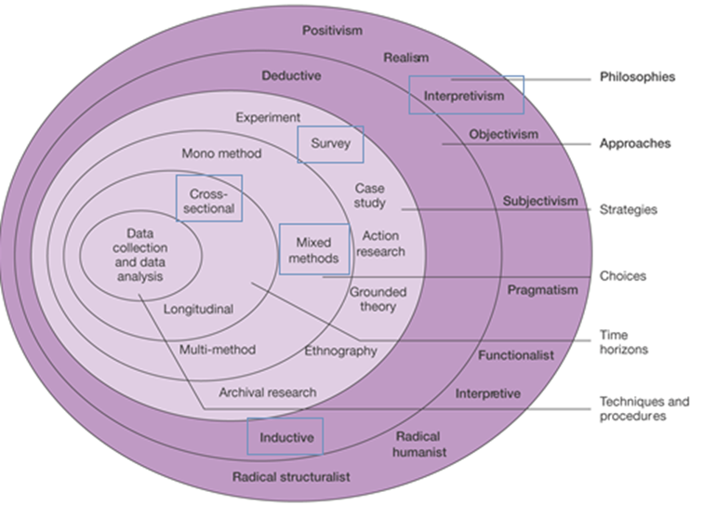
Figure 1.1 The identified path the researcher has chosen by using the research onion (Source: (Saunders, et al., 2007, p. 130))

3.3.1 Research Philosophy

The objective of the primary research is to obtain the opinions and perspectives of parents on the physical punishment of children, therefor interpretivism, which can be explained as “using qualitative research methods that focus on ‘individuals’ beliefs, motivations, and reasoning over quantitative data to gain understanding of social interactions.” (Nickerson, 2023) must be included as the data being collected will come from members of the public whose answers might vary and be subjective. Interpretivism benefits from its generated data having a high level of validity as data in such studies are usually honest and trustworthy (Dudovskiy, 2016). It is also stated that studying the beliefs of a person can be more beneficial trying to explain and interpret behaviours from an outsider’s perspective (Hammersley, 2013).

3.3.2 Research approach

This study will use one of the two main types of research approaches according to (Saunders, et al., 2016), these being an inductive approach opposed to a deductive approach, the difference being that an inductive approach uses collected data to develop a theory, whereas a deductive approach already has a theory and obtains data to try and prove it (Saleem & Burney, 2008). The inductive research method will be used to obtain the data for the purpose of this study as there is currently very little documented research on the opinions of parents on their ability to discipline their children after the “smacking ban” was introduced. Inductive research also provides a simple, straightforward approach to obtain findings, especially when focused on evaluation questions (Thomas, 2006).

3.3.3 Strategy

A large quantity of primary data is needed in order to analyse and draw a conclusion from. This data will also be used to answer the research objectives. The most appropriate method to facilitate this is by way of a survey, which is one option of a few that makes the next layer of the “Research Onion” (Phair & Warren, 2021). A survey can be defined as “the collection of information from a sample of individuals through their responses to questions” (Check & Schutt, 2012, p. 160). The researcher has considered different strategies to obtain data and has decided to use a survey as it is easy and cost effective to disseminate to a high amount of participants. The reliability and validity of the obtained data will also be stronger. Survey research is also described as a useful and legitimate research approach which has clear benefits in aiding to explore variables and constructs of interest (Ponto, 2015). The researcher also considered interviews and experiments, however, due to the sensitive nature of the research topic, face to face or online interviews were ruled out by the researcher as it may have put participants off from sharing their views or they may not have been entirely truthful or honest, and experiments would be largely time consuming, minimising the amount of participants, as well as being unethical due to the study being based on the chastisement of children. Due to time and facility constraints, although a larger scale survey would yield more realistic results, the survey will largely be focused on a local, smaller demographic.

3.3.4 Data Collection Method

The survey will use a mixed method approach to obtain both qualitative and quantitative data. Quantitative data will primarily be used as this focuses more on numerical data however qualitative data focuses more on textual, audio, or visual based data (Phair & Warren, 2021). Using a mixed method approach whereby both qualitative and quantitative data is used can provide more in-depth findings, provides stronger evidence in results and balances out the limitations of using each method individually (GOV.UK, 2020). This study will use the survey method to collect data online and anonymously from parents in Wales. This will be facilitated using Microsoft forms (Microsoft, 2023); the survey will have approximately 20 questions, most of which will have predetermined options to select and some allowing for an open opinion to be entered. It should take no more than ten minutes to complete. A copy of the survey can be located in the appendix. The data obtained through the survey will then be exported to Microsoft excel (Microsoft, 2023) where the researcher will draw a conclusion from the results.

4.0 Analysis of results

4.1 Introduction

In this chapter, the researcher will use the collected data from the responses obtained, to analyse and draw correlations and differences from, the results of which will be reviewed with the research objectives of the project.
The survey in which the data was collected from was open for two weeks, and was sent out online primarily to parents, but all persons over the age of 18 were encouraged to participate in the survey. On closure of the survey, a total of 55 responses were obtained, the number of engagements with the survey hit the researcher’s minimum engagement goal of 50.

4.2 Demographic

are you a parent?
This question was important to ask first so that the demographic of people answering the survey is understood. As the entire research project focuses on how parents have been affected by the smacking ban, having a higher demographic of parents answering the survey would give more appropriate data. In Figure 1, The graph shows that 80% of participants were a parent at the time of the survey, and after the introduction of the Children (Abolition of defence of reasonable punishment) (Wales) Act 2020.

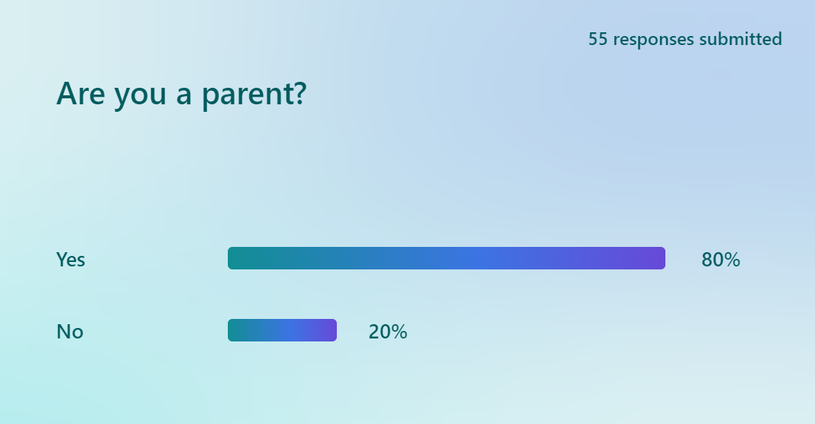

what age bracket are your children now?
Figure 2 highlights that that 50% of participants had children over the age of 18, and 19% either didn’t have a child or had one between the age of 0 to 5.
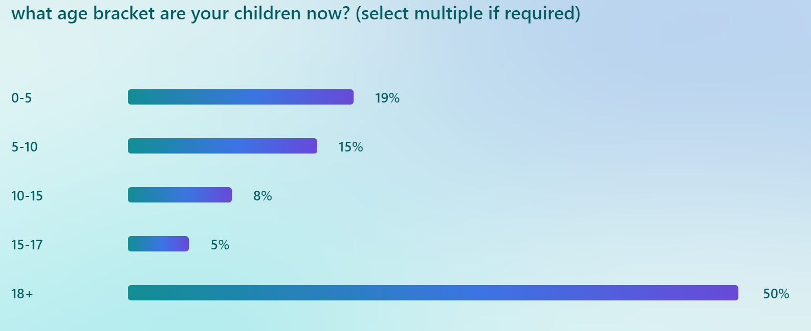

4.3 Opinion on physical punishment

Do you support the ban on child reasonable physical punishment? 2.6
This question was asked to ascertain the level of support for the new legislation, Figure 3 shows that 69% of respondents supported the ban. The data obtained backs up (Welsh Government , 2018) and goes against (Be Reasonable , 2023).
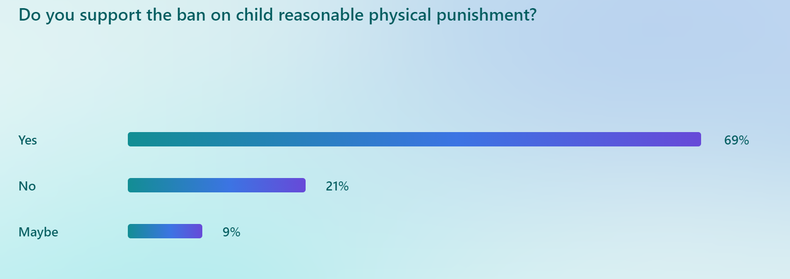

were you physically punished as a child?

Figure 4 shows that 72% of respondents said yes, 5% could not remember.
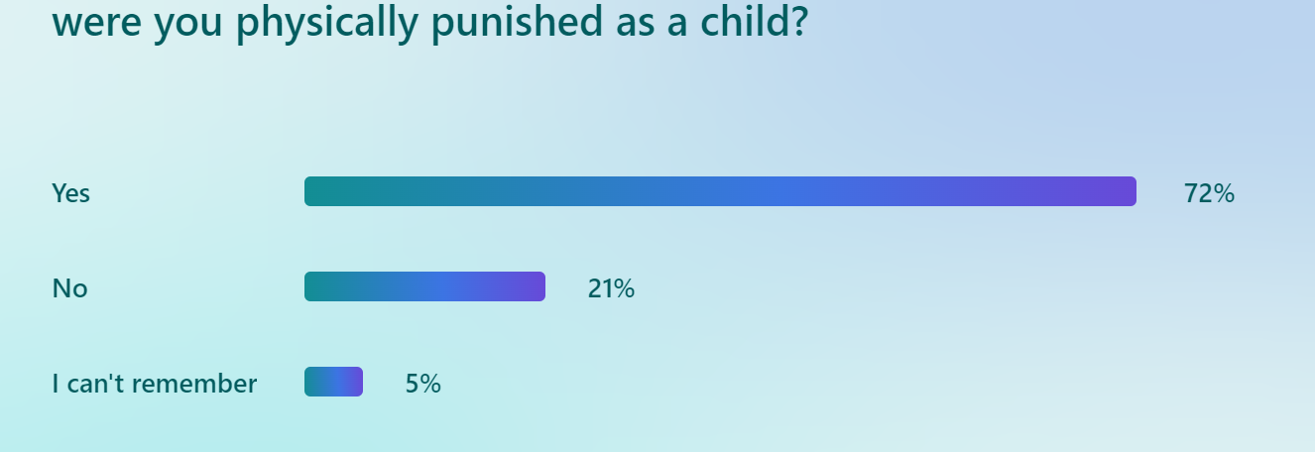

if yes, how did this effect your development and behaviour as a child growing up? 2.3
This question sought to identify what type of impact physical punishment had on the respondents. Figure 5 shows 44% of respondents said it had a positive effect, 30% thought it had a negative effect, and the remained stated they were not sure, or it had no effect. This data backs up (Sherbert Research, 2007) which states discipline and punishment Plays a crucial role in the heathy development of a child.
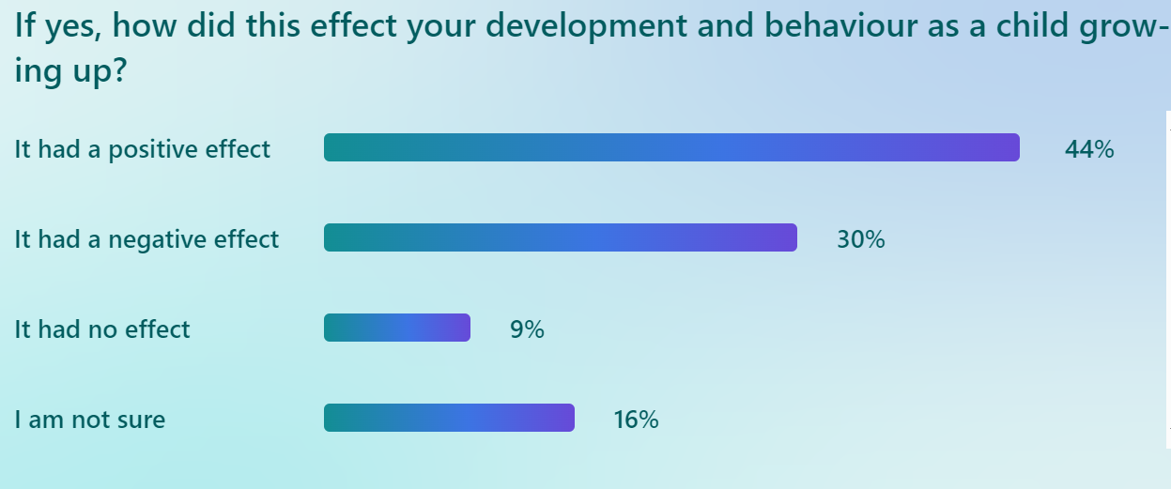

before the ban, did you use physical punishment to discipline your child? 2.2

This question looked to ascertain how many of the survey participants have used physical punishment to discipline a child before, Figure 6 shows that 76% of respondents hadn’t, which goes against research conducted by (UNICEF, 2014) and (Sherbert Research, 2007) as they both stated a higher total percentage of children are physically punished.
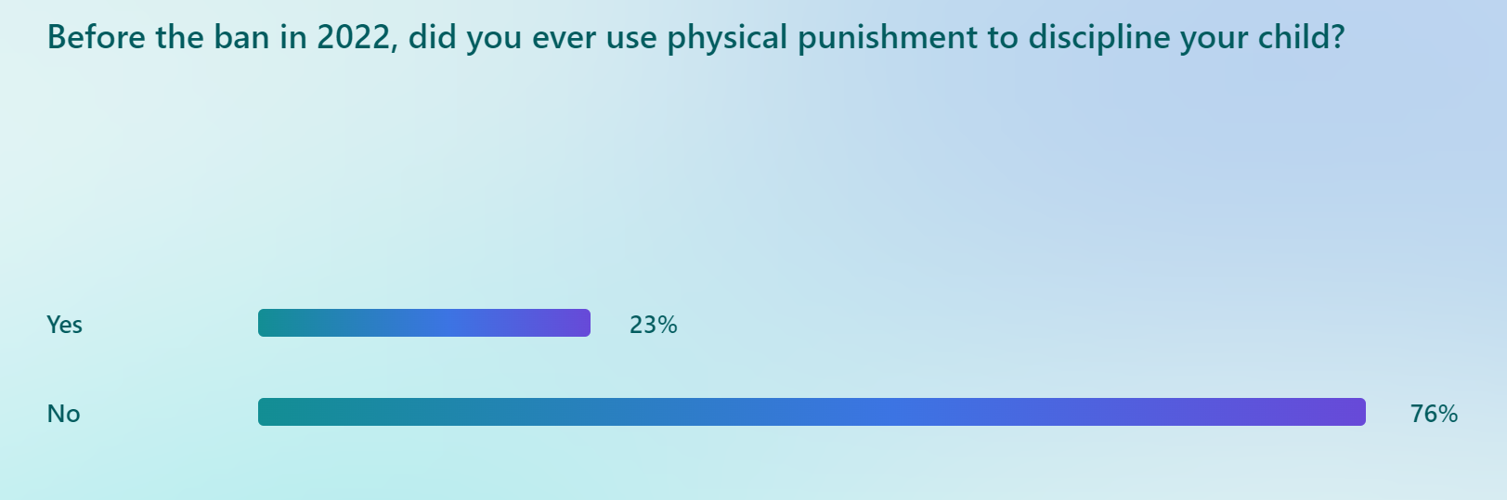

Figure 7 shows that of those who answered yes to figure 4, 10 out of 11 of them believed physical punishment helped to discipline and improve their child’s behaviour, none of them believed it made their child’s behaviour worse. This supports the arguments made by (Domjan, 2000) and (Sharpe, 2004) in chapter 2.3.
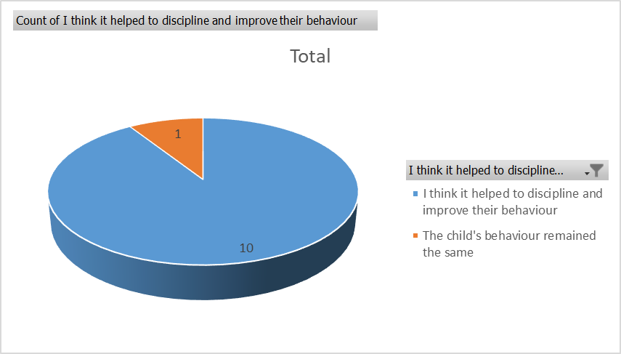

4.4 Impact of new legislation

Did you know the “reasonable” physical punishment of children was made illegal in Wales in 2022?

Figure 8 shows that 85% of respondents said yes.

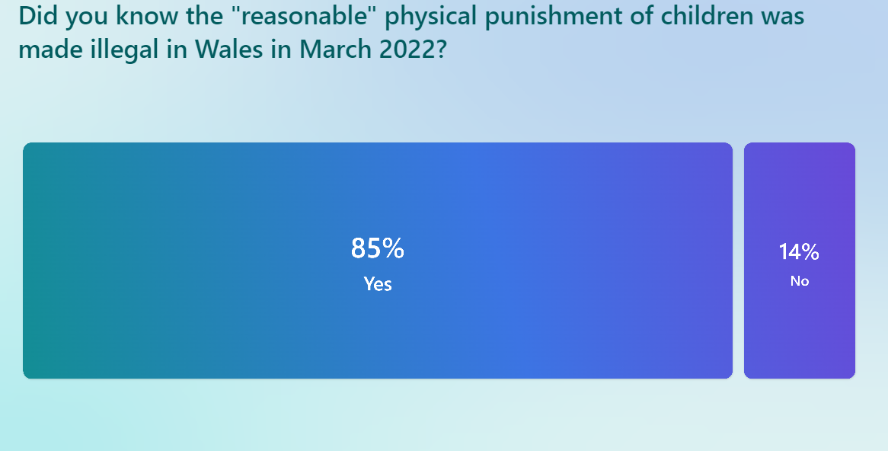

Has the ban on physical punishment impacted your ability to discipline your child?
This question sought to answer one of the main objectives of the entire research project as no research had been conducted on it. Figure 9 shows that 91% of respondents believed that the ban did not have an impact. This is likely due to other methods such as placing a ban on technology becoming more effective, as children become more addicted to their phones and social media.

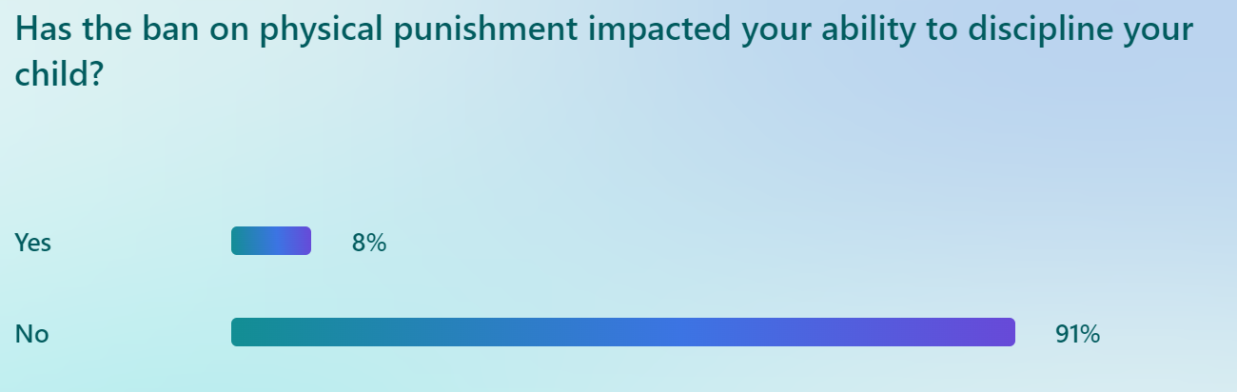
What form of discipline would you use now?
This question was open text so the respondents could suggest what they wanted. The answers have been collected and grouped into Figure 10. Out of 50 responses, 21 respondents use restriction of privileges such as removing access to mobile phones as punishment. 14 people stated they had a discussion with their child and 4 people used isolation methods such as grounding them. Most responses indicate however that a combination of all is used.

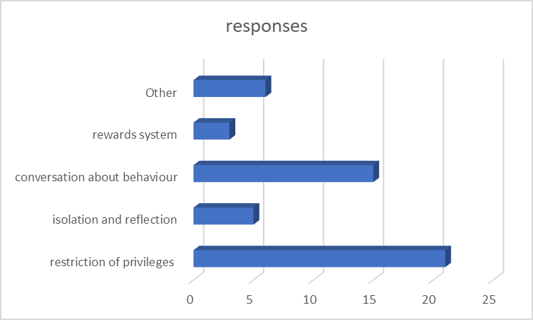

Is this form of discipline more effective than physical punishment? 2.5
Figure 11 shows that 52% of respondents thought their way of disciplining their child was more effective than physical punishment, and only 12% thought it was less effective. This supports research stated by (Carter-Davies & Bristow, 2018), that physical punishment is no more effective than other forms of discipline.
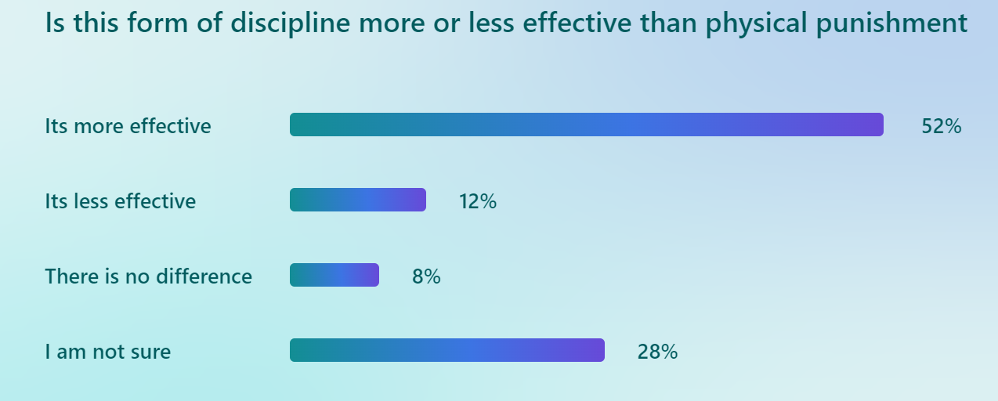

would you fear being prosecuted for using reasonable physical punishment on a child? 2.7
Figure 12 shows that 50% of respondents would fear being prosecuted which supports information published by (Be Reasonable, 2017) in which parents have stated they fear being criminalised for trying to do the right thing.

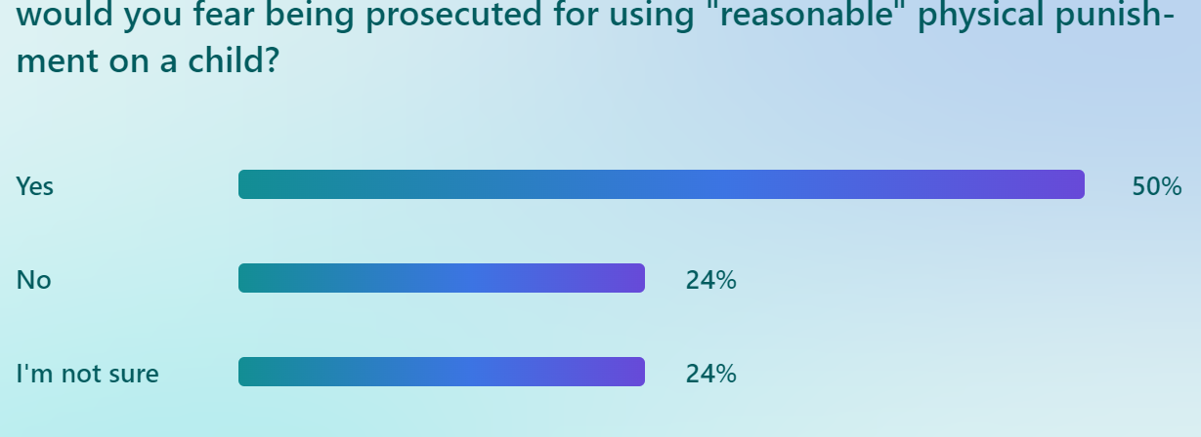

Do you think the ban on reasonable physical punishment protects children? 2.6
Figure 13 shows that 65% of respondents believes it does which supports (Welsh Government, n.d), only 9% of respondents think it doesn’t protect them.

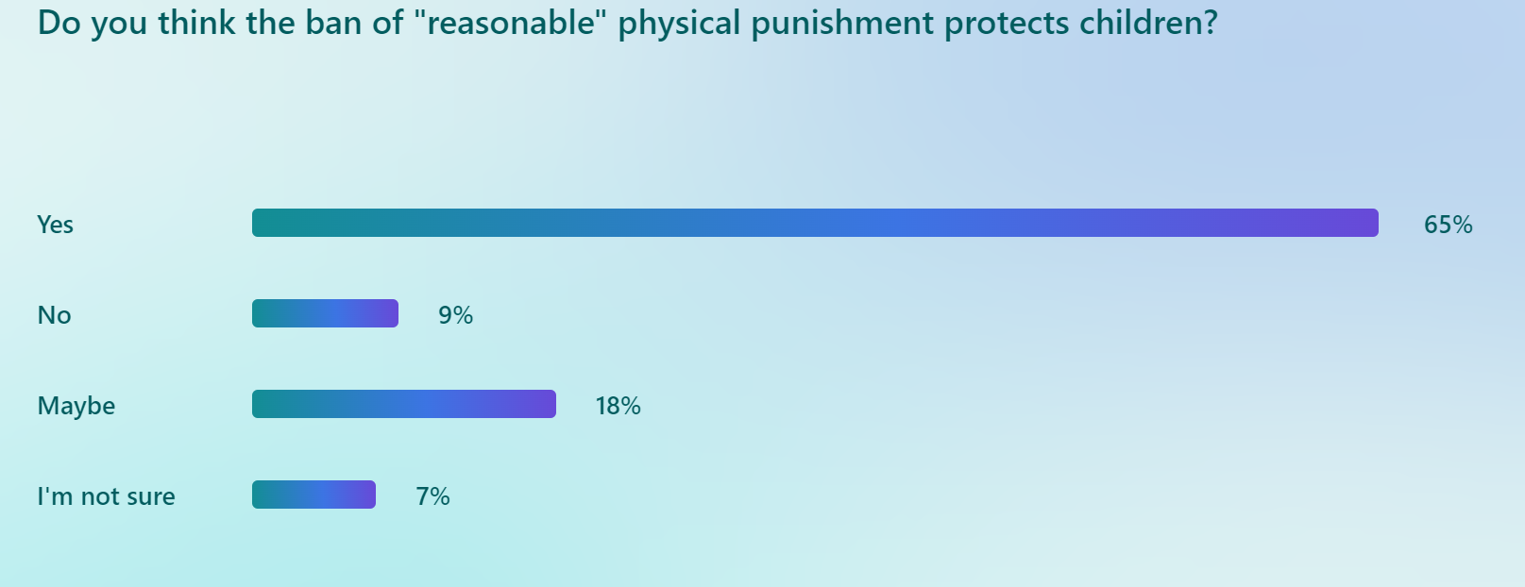

4.5 Areas for improvement

Do you think the current law in Wales on physical punishment is fit for purpose?
Figure 14 shows that only 36% of respondents believes it is, and 23% believing it is not, the remained are uncertain.

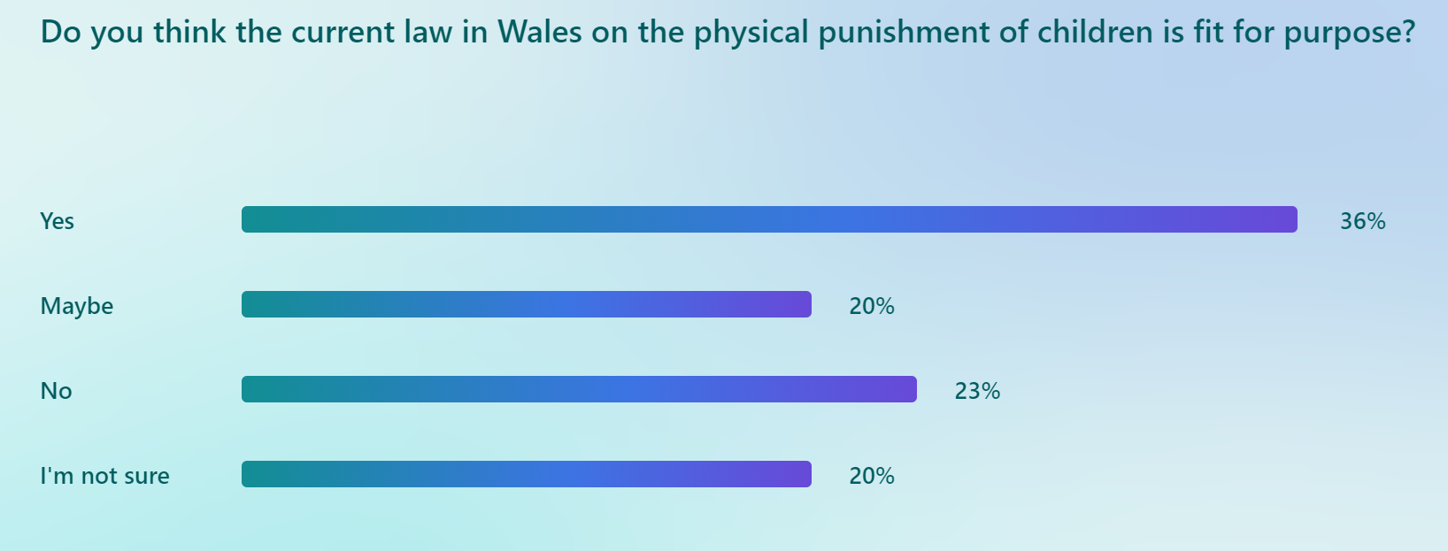

How do you think it could be improved
Figure 15 shows the results of an open text question the results of which have been grouped into categories and show in the below graph. Out of the 55 total respondents, only 35 answered this question. 10 respondents believed that more education was needed, and 8 respondents stating that physical punishment should be allowed, at very low levels and these levels need to be better defined under law. Only 2 respondents believed harsher punishments are needed, and the remained opted for a multi-agency approach, or was unsure of the question.
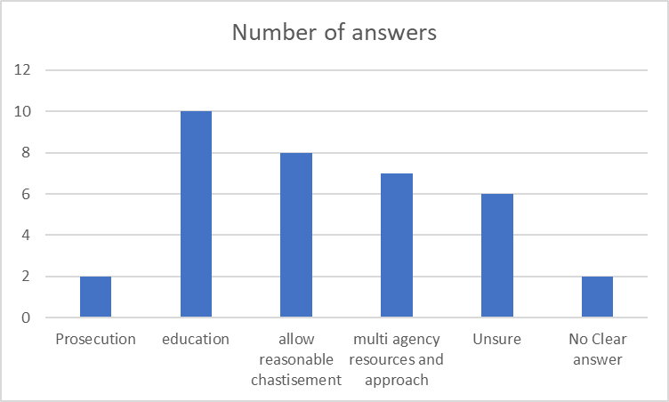

Do you think adults who still physically punish their child should face prosecution or repercussion in any form? 2.6
Figure 16 shows that 41% answered yes and supports the information stated by (Welsh Government, n.d), 36% believes they should but only in extreme cases, and 18% believe people should be educated and not punished.
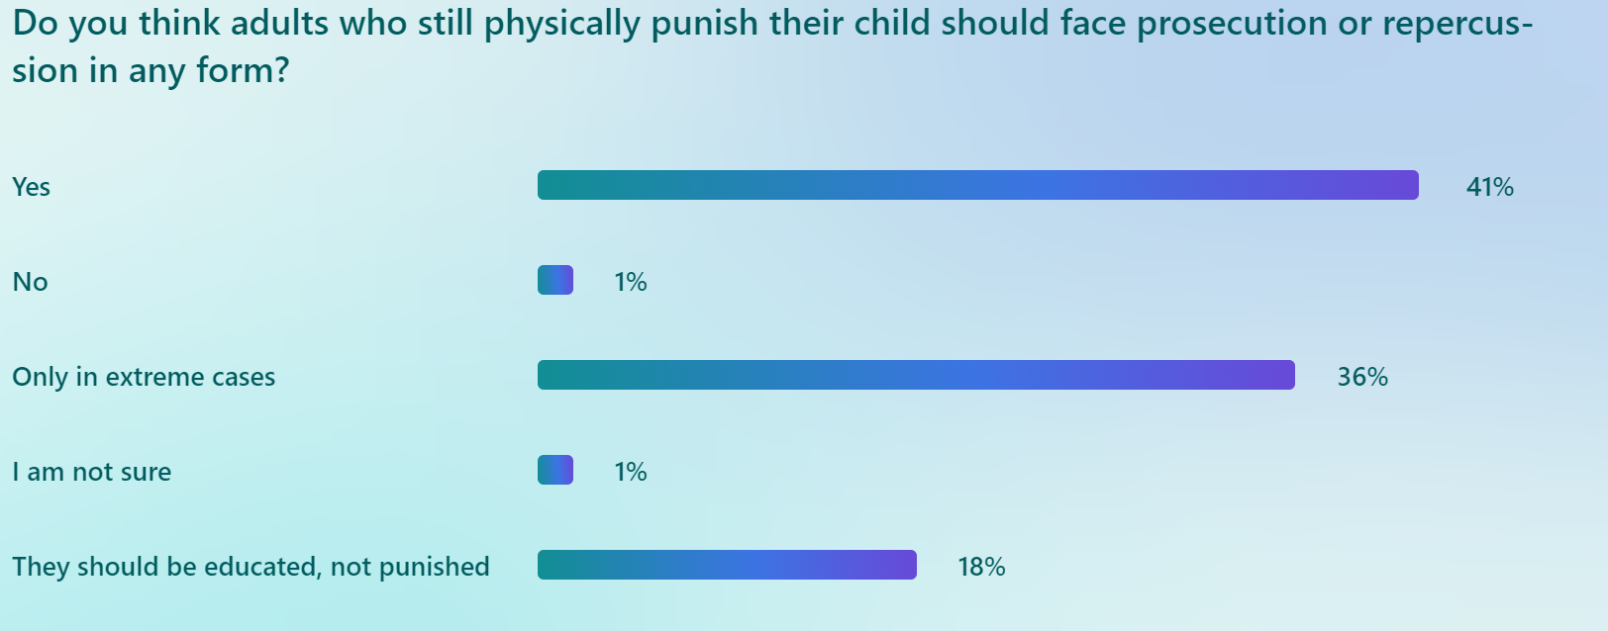

How much do you agree on the following statement? 2.6
“The ban on physically punishment of children only punishes parents who are trying to reasonably discipline their child and does nothing to stop more extreme punishment such as abuse and neglect”. Figure 17 shows that 54% of respondents agree with this statement in some manner which disputes (Welsh Government, n.d) who argue that the sole reason of the new legislation is to protect children.
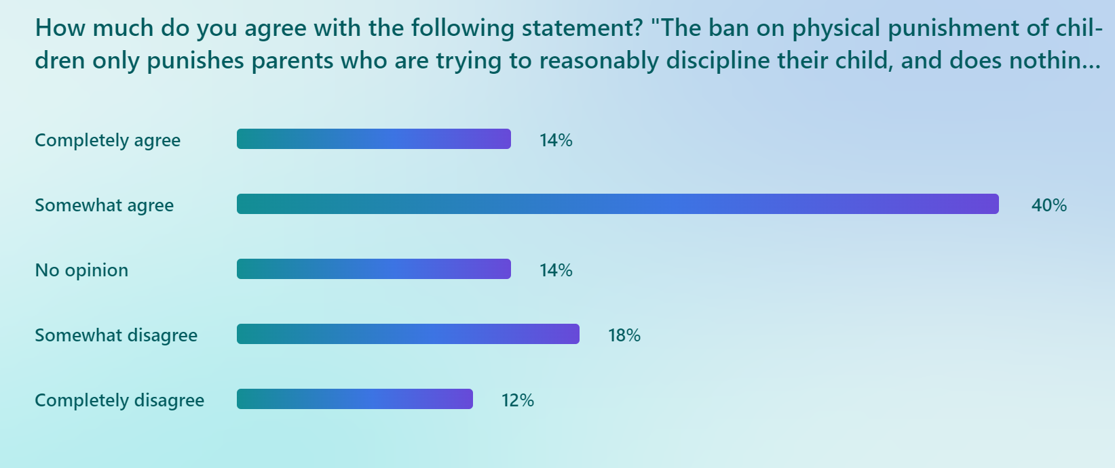

4.6 Conclusion.

The chapter has presented the findings of primary research from 55 surveys completed by members of the public, primarily of which are parents. The survey responses were analysed using text analysis techniques and were reviewed against the research objectives. The next chapter will discuss the results and use them to draw conclusions.

5:0 Findings, conclusions, and recommendations.

5.1 Introduction.

This chapter continues from the analysis chapter in which the results from the surveys completed by members of the public have been collated and analysed against the research objectives of the project. The overall objective of the research project was to provide a critical evaluation of the impact that the Children (Abolition of defence of reasonable punishment) (Wales) Act 2020 has had on a parent’s ability to discipline their children, since its introduction in 2022. This chapter will aim to answer the research objectives by drawing conclusions from the results of the surveys and comparing the results to current and previous literature, to determine a final overall conclusion.

5.2 Completion of research objectives.

5.2.1 Objective one – To identify why the “smacking ban” was introduced in Wales.

This objective was completed within chapter two of the research project, in which current literature was evaluated that documented and explained that the Children (Abolition of defence of reasonable punishment) (Wales) Act 2020 was introduced to protect children’s rights and give them the same protection under law from assaults that adults have. The argument was made that the use of physical punishment as a disciplinary method was harmful to children and was no more effective than other disciplinary methods. This was concluded in chapter 2, subsection 5 and 6 of the research project, in which it explains the Welsh government found based on evidence that the physical punishment of children was no more effective as a disciplinary method compared to other methods, that it leads to negative outcomes for children and that there is no evidence to support that physical punishment can have a positive impact on the development of a child (Carter-Davies & Bristow, 2018). The legislation was implemented on this basis and removed the defence of reasonable punishment for adults against children.

5.2.2 Objective two – To evaluate the effectiveness of physical punishment as a disciplinary method for children.

This objective was completed in both chapter two and chapter four of the research project, of which the former had more differing results, whereas the latter had more definitive results. Within the literature review, one argument was made that the physical punishment of children was no more effective at changing a child’s short-erm behaviour when compared to other forms of discipline (Carter-Davies & Bristow, 2018), with further arguments stated that it was actually harmful to a child’s development (NSPCC, 2021). However, opinions differ within the literature review as a counter argument was made, with reference to the popular case study of Sweden, that banning physical punishment leads to an increase if violent behaviour in children, and they also become less accepting of other forms of discipline (Be Reasonable, 2023). Further supporting information states that the use of physical punishment alongside nurturance and communication skills is linked to long term benefits for the child (Carter-Davies & Bristow, 2018).
The survey completed by participants of this research project supported a more definitive answer however, with reference to figure 4 and figure 5 within chapter 4.3, which shows us that out of all participants, 72% of them stated physical punishment was used against them as a child growing up, and of these 72%, only 30% stated they believed it had a negative impact on them growing up. The majority, with a result of 44%, stated they believed physical punishment had a positive effect on them growing up as a child. The effectiveness of physical punishment in disciplining is further backed up within figure 7 of chapter 4.3, in which out of the participants who stated they used physical punishment as a form of discipline for their own children, 91% of them stated it helped to improve their child’s behaviour, the other 9% stated it had no impact. This data goes completely against the argument that reasonable physical punishment has a negative impact on a child growing up.

5.2.3 Objective Three – To explore parents’ opinions on the “smacking ban”.

This objective was completed in both chapter 2 and 4 of the research project. Within chapter 2, current literature was reviewed, and it was found that opinions that could be directly linked to parents saw more negativity towards the ban on physical punishment, with concerns being raised around parents feeling scared to discipline their child in fear of being criminalised (Be Reasonable, 2017). Further opinions from parents stated that they are now fearful that without the ability to discipline their child, the likelihood of an increase in anti-social behaviour and even criminal behaviour from their child will increase. Statistical support of the physical punishment ban within Wales from parents varied between research, however the majority of cited statistics show a lack of support for the ban, with the Welsh governments own collected data only showing 38% of parents supporting the ban (Welsh Government , 2018), and a separate independent study showing that 76% of Welsh adults believed that smacking children should not be a criminal offence (Be Reasonable , 2023).
Chapter 4 of the research project again has differing results to the literature review, but also provides more insight into wider opinions surrounding the Children (Abolition of defence of reasonable punishment) (Wales) Act 2020. Of all the participants who completed the survey, of which 80% had children, only 21% of them did not support the ban on physical punishment, with 69% of them supporting the ban. The majority of participants stated they believed the new law protected children, and that punishment or repercussion was needed for any parents that broke the new law. However, other opinions are seen in the fact that only 36% of participants believed the new law was fit for purpose, and agreed that changes could be made to enforce the protection of children by way of educating parents, a social services and multi-agency approach, or even by reintroducing “reasonable” physical punishment with a clearer definition of what “reasonable is”.

5.2.4 Objective 4 – To identify if the “smacking ban” has impacted on a parents’ ability to discipline children.

A total of 55 participants of the survey linked to the project, 91% of them stated the ban on physical punishment in Wales has not impacted on their ability to discipline their child. This is mostly in part due to other disciplinary techniques such as a restriction of privileges, isolation and reflection methods, or even a rewards system becoming more effective as the new generation of young children become addicted to their mobile phones and technology, as well as wanting to go out to see friends. Further to this, participants of the survey were asked how much more effective their choice of disciplinary methods was compared to physical punishment, with only 12% of respondents stating it was less effective. This data suggests that the “smacking ban” has in fact had little to no effect on a parent’s ability to discipline their child.

5.3 Recommendations

The below recommendations have been made from the conclusions that have been drawn using the obtained data within the research project.

5.3.1 Recommendation one – Expansion of survey

An easy recommendation to make is that of expanding the survey used in this research project, or use one similar to it, in order to obtain further data from a wider but precise target audience. The Survey conducted in this research project reached 55 people, which was limited by the reach the researcher had within online platforms. It would greatly benefit the research project if this survey was seen and completed by a larger pool of participants, who have different experience and backgrounds in growing up around and using physical punishment to discipline. By obtaining this further data, this would lead to an improvement in the quality of data obtained.

5.3.2 Recommendation two – A change in the outcomes of the offence

As of right now and under the new legislation, if a parent is found to have used any form of physical punishment to discipline a child, they risk being arrested and charged with assault which could in turn lead to a criminal record. The results of the survey alongside other research suggests however that consideration should be made in instances whereby little force was used and the parent used the force with the child’s best interests in mind, that being charged for an offence of assault and obtaining a criminal record should not be the outcome. Instead, a diversion scheme to social services and other partnership agencies for support, education and assistance should be sought out for the parents first.

5.3.3 Recommendation Three – Continuous monitoring and evaluation of the new legislation

As the Children (Abolition of defence of reasonable punishment) (Wales) Act 2020 is relatively new, continuous monitoring and evaluations should be carried out to fully understand the effectiveness of the legislation. Further research can then be conducted around children’s behaviour and the impact of the change on parents throughout Wales. The legislation can then be changed around any gaps in the implementation, or any areas of improvement that have been identified.

5.4 Conclusion

This research project has concluded that in the year on from the introduction of the Children (Abolition of defence of reasonable punishment) (Wales) Act 2020, significant positive action has been made to protect children and their rights. Parents have found that their ability to discipline children has not changed under many circumstances, however support and opinions surrounding the legislation varies. The research project has also recommended on improvements that could be made going forward by carrying out further research with a larger pool size, changing the outcomes for offenders and monitoring and evaluation the legislation based upon new and accurate data.

6.0 Bibliography
Baumrind, D., (1997). Necessary distinctions. Psychological Inquiry, Volume 8, pp. 176 - 182.
Baumrind, R. E. L. a. D., (2010). ARE SPANKING INJUNCTIONS SCIENTIFICALLY SUPPORTED?. Law and Contemporary Problems, 73(2), pp. 57-87.
Be Reasonable , (2023). Public Opinion. [Online]
Available at: https://www.bereasonable.wales/en-home/public-opinion/?hp
[Accessed 14 October 2023].
Be Reasonable , (2024). FAQ. [Online]
[Accessed 13 January 2024].
Be Reasonable , (n.d.) Be Reasonable Wales. [Online]
Available at: https://www.bereasonable.wales/
[Accessed 14 October 2023].
Be Reasonable, (2017).Mum: ‘Please don’t criminalise loving parents’, s.l.: Youtube.
Be Reasonable, (2023). FAQ. [Online]
Available at: https://www.bereasonable.wales/en-home/faq/
[Accessed 14 October 2023].
Cambridge Dictionary, (2023). Research. [Online]
Available at: https://dictionary.cambridge.org/dictionary/english/research
[Accessed 24 November 2023].
Carter-Davies, L. & Bristow, D., (2018). Parental Physical Punishment: Child Outcomes and Attitudes, s.l.: Public Policy Institute for Wales.
Check, J. & Schutt, R., (2012). Research methods in education. Thousand Oaks CA: Sage publications.
Childrens Act , (2004). Children Act (2004). [Online]
Available at: https://www.legislation.gov.uk/ukpga/2004/31/notes/division/2/4/5/2
[Accessed 14 October 2023].
Cornish, K., (2022). Children (Abolition of Defence of Reasonable Punishment) (Wales) Act 2020. s.l.:Welsh Government.
Criminal Justice Act , (1988). Criminal Justice Act 1988. [Online]
Available at: https://www.legislation.gov.uk/ukpga/1988/33/section/39
[Accessed 14 October 2023].
Crowley, A. & Vulliamy, C., (2002). Listen up! Children talk about smacking, s.l.: Save the Children UK.
Domjan, M., (2000). The essentials of conditioning and learning. 2 ed. Belmont: Wadsworth.
Dudovskiy, J., (2016). Interpretivism (interpretivist) Research Philosophy. [Online]
Available at: https://research-methodology.net/research-philosophy/interpretivism/
[Accessed 3 December 2023].
Dudovskiy, J., (n.d). Interpretivism (interpretivist) Research Philosophy. [Online]
Available at: https://research-methodology.net/research-philosophy/interpretivism/
[Accessed 3 December 2023].
Gershoff, E. & Grogan-Kaylor, A., (2016). Spanking and Child Outcomes: Old Controversies and New Meta-Analyses. J Fam Psychol, pp. 453-69.
GOV.UK, (2020). Mixed methods study. [Online]
Available at: https://www.gov.uk/guidance/mixed-methods-study
[Accessed 12 December 2023].
Graziano, A. M., Hamblen, J. L. & Plante, W. A., (1996). Subabusive Violence in Child Rearing in Middle-class American Families. Pediatrics, 4(98), p. 845–848..
Hammersley, M., (2013). What is Qualitative Research?. London: Bloomsbury Academic.
Holden, G. W., (2002). Perspectives on the Effects of Corporal Punishment: Comment on Gershoff (2002). Psychological bulletin, 128(4), pp. p.590-595.
Imperial College London, (2023). Ethics approval overview. [Online]
Available at: https://www.imperial.ac.uk/research-ethics-committee/ethics-approval-overview/
[Accessed 28 November 2023].
Janson, S., Langberg, B. & Svensson, B., (2010). Sweden: A 30-year ban on physical punishment of children. In: Global Pathways to Abolishing Physical Punishment. s.l.:Routledge, pp. 241-255..
Laerd dissertation, (2012). Principles of research ethics. [Online]
Available at: https://dissertation.laerd.com/principles-of-research-ethics.php#:~:text=In%20practice%2C%20these%20ethical%20principles%20mean%20that%20as,participants%20the%20right%20to%20withdraw%20from%20your%20research.
[Accessed 28 November 2023].
Legislation.gov.uk, (2020). Legislation.gov.uk. [Online]
Available at: https://www.legislation.gov.uk/anaw/2020/3
Microsoft, (2023). Microsoft Excel. [Online]
Available at: https://www.microsoft.com/en-gb/microsoft-365/excel
[Accessed 14 December 2023].
Microsoft, (2023). Microsoft Forms. [Online]
Available at: https://www.microsoft.com/en-gb/microsoft-365/online-surveys-polls-quizzes
[Accessed 14 December 2023].
Middleton, J., (2008). The Experience of Corporal Punishment in Schools, 1890–1940. History of Education, 37(2), pp. 253 - 275.
Nickerson, C., (2023). Interpretivism Paradigm & Research Philosophy. [Online]
Available at: https://simplysociology.com/interpretivism-paradigm.html
[Accessed 3 December 2023].
NSPCC, (2021). NSPCC. [Online]
Available at: https://www.nspcc.org.uk/about-us/news-opinion/2022/equal-protection-wales-england/
Offences against the Person Act, (1861). Offences against the Person Act. [Online]
Available at: https://www.legislation.gov.uk/ukpga/Vict/24-25/100/section/47
[Accessed 14 October 2023].
Phair, D. & Warren, K., (2021). Saunders’ Research Onion: Explained Simply. [Online]
Available at: https://gradcoach.com/saunders-research-onion/
[Accessed 3 December 2023].
Plowden, B., (1967). Children and their Primary Schools, London: Her Majesty's Stationery Office 1967.
Politics.co.uk, (2022). Smacking. [Online]
Available at: https://www.politics.co.uk/reference/corporal-punishment/
[Accessed 29 September 2023].
Ponto, J., (2015). Understanding and Evaluating Survey Research. J Adv Pract Oncol, 6(2), p. 168–171.
Public policy institue for Wales, (2018). Legislating to Prohibit Parental Physical Punishment of Children, s.l.: Public policy institue for Wales.
Saleem, H. & Burney, A., (2008). Inductive and Deductive Research Approach. [Online]
Available at: https://www.researchgate.net/publication/330350434_Inductive_and_Deductive_Research_Approach
[Accessed 12 December 2023].
Saunders, M. N., Lewis, P. & Thornhill., A., (2007). Research methods for buisness students. 9 ed. London: Pearson.
Saunders, M., Thornhill, A. & Lewis, P., (2016). Research methods for business students. London: Pearson.
Sharpe, S., (2004). From Fear to Respect: Young People's Views on Violence. s.l.:Jessica Kingsley Publishers.
Sherbert Research, (2007). A STUDY INTO CHILDREN’S VIEWS ON PHYSICAL DISCIPLINE AND PUNISHMENT, s.l.: DCSF and COI .
Skinner, B. F., (1953). Science and human behavior. New York: Macmillan.
Thomas, D. R., (2006). A General Inductive Approach for Analyzing Qualitative Evaluation Data. American Journal of Evaluation, 27(2), pp. 237-246.
UNICEF, (2014). Hidden in plain sight: A statistical analysis of violence against children.. New York: UNICEF.
Welsh Government , (2018). Public attitudes to physical punishment of children: baseline survey, s.l.: Welsh Government.
Welsh Government, (2022). Ending Physical Punishment in Wales Information for the education workforce, s.l.: Welsh Government.
Welsh Government, (2023). The Children (Abolition of Defence of Reasonable Punishment) (Wales) Act 2020: first data release. [Online]
Available at: https://www.gov.wales/children-abolition-defence-reasonable-punishment-wales-act-2020-first-data-release-html
[Accessed 28 November 2023].
Welsh Government, (2023). The Children (Abolition of Defence of Reasonable Punishment) (Wales) Act 2020: first data release. [Online]
Available at: https://www.gov.wales/children-abolition-defence-reasonable-punishment-wales-act-2020-first-data-release-html
Welsh Government, (n.d). Children Wales Bill, frequently asked questions, s.l.: Welsh Government.

7.0 Appendix

7.1 Survey Questions

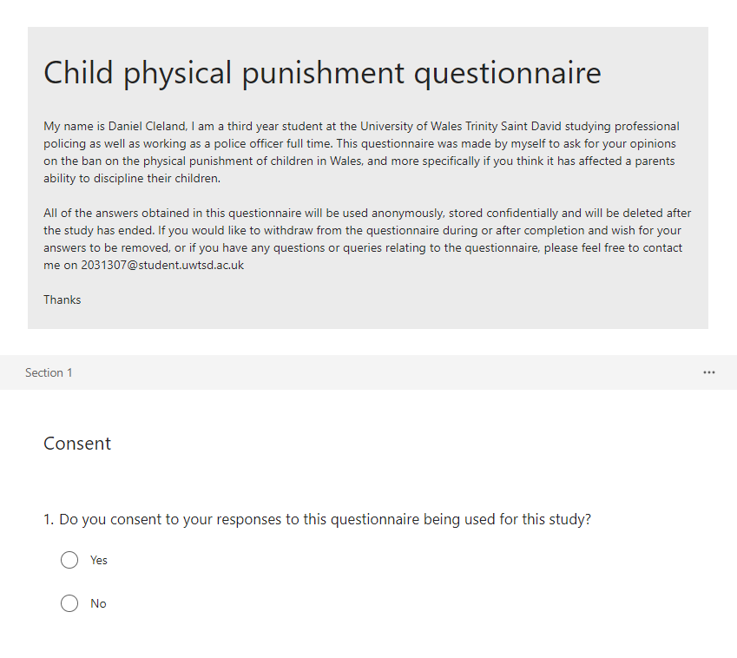

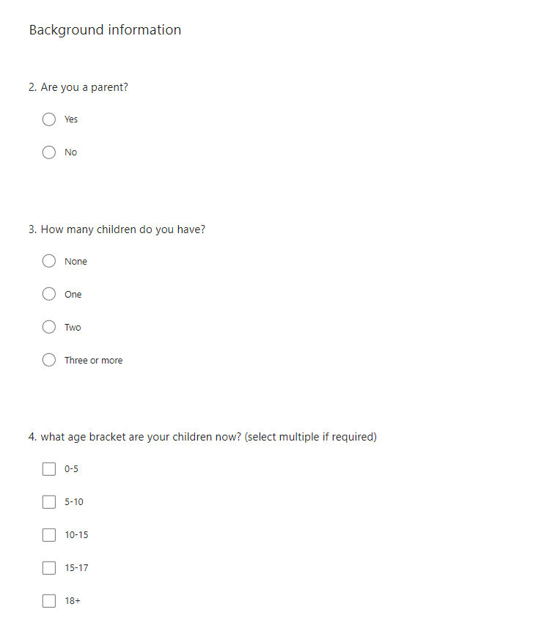

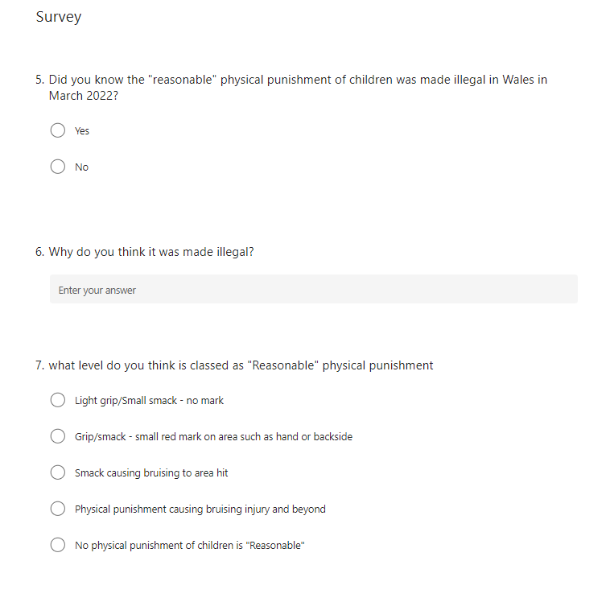

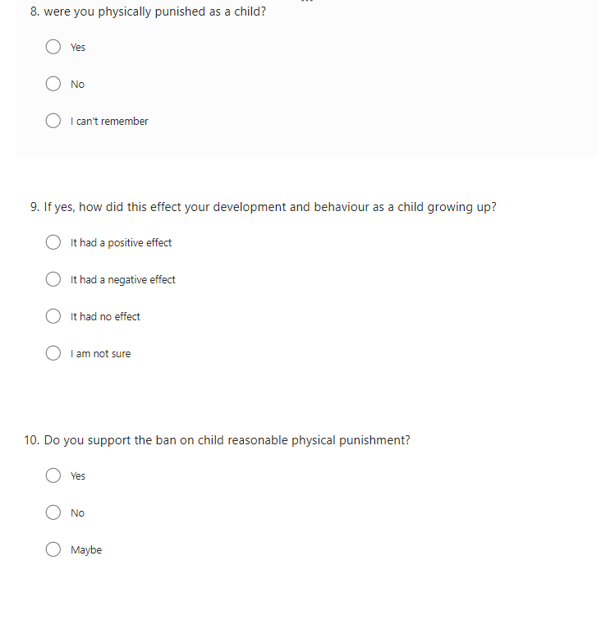

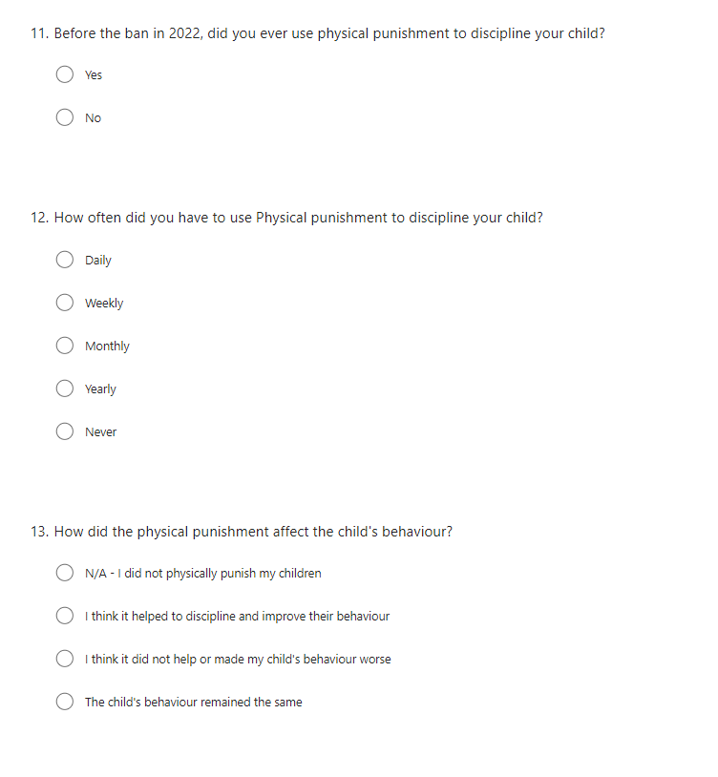

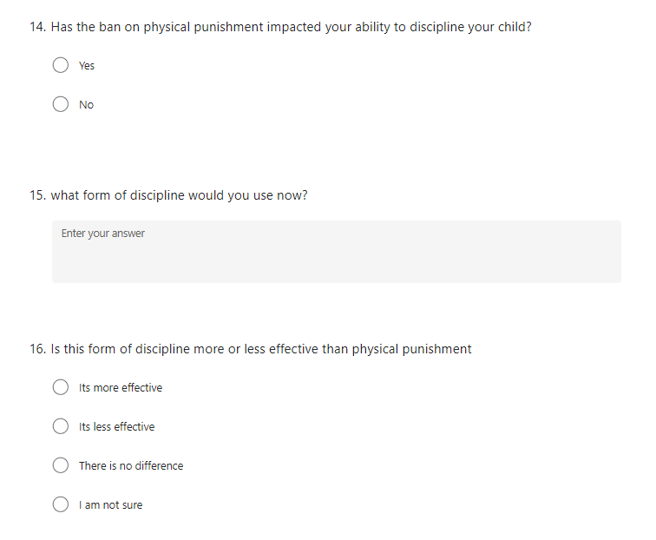



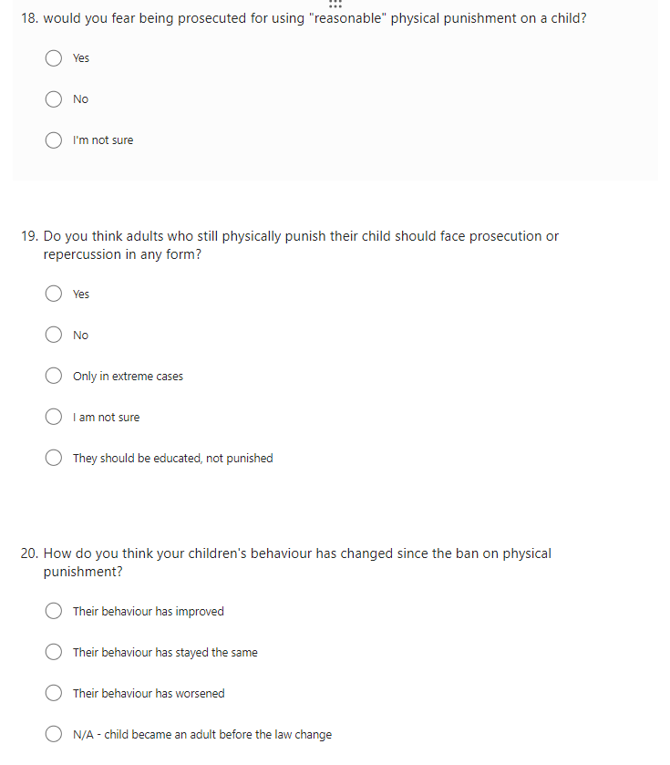

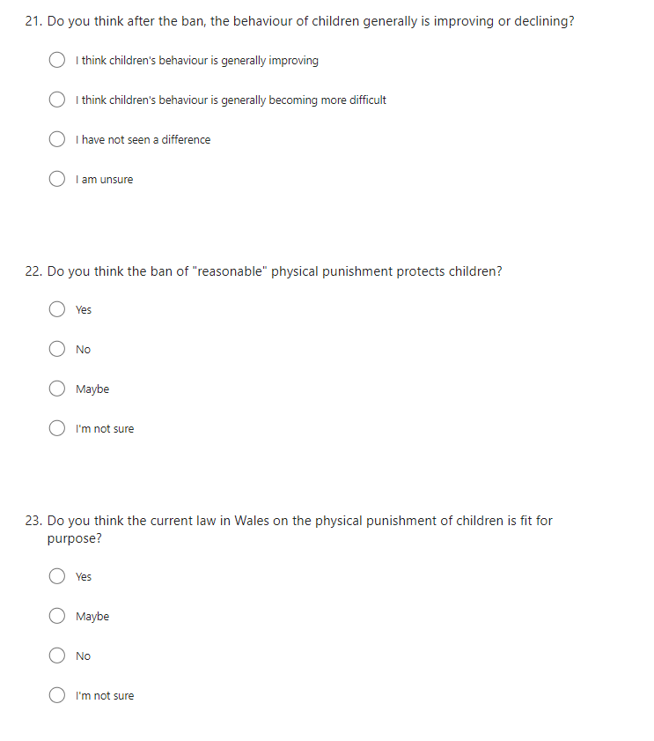

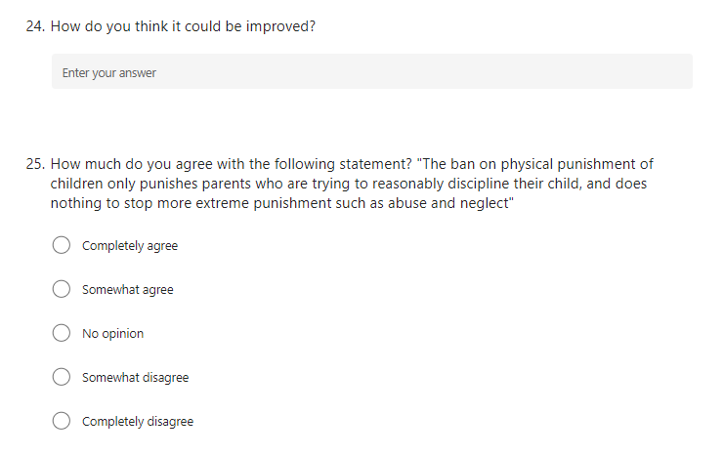

7.2 Survey Results



