Iona Cousins - 2411526
26/04/2026

Control and Automation
Applications of Automation in Wastewater Treatment
ACMA5001



Table of Contents
Table of Contents 1
1.Introduction 3
2. Wastewater Treatment Process 4
2.1 Preliminary Treatment 4
2.1.1 Screeners 5
2.1.2 Grit Chambers 6
2.2 Primary Treatment 7
2.2Secondary Treatment 8
3. Historical Development of ICA in Wastewater Treatment 9
3.1 Early Wastewater Treatment and Manual Control 9
3.2 Introduction of Basic Instrumentation 9
3.3 Digital Control and the Introduction of SCADA 9
3.4 Modern ICA 9
4. Instrumentation in Wastewater Treatment 10
4.1 Flow sensor - Ultrasonic 10
4.2 Differential Pressure Devices (DP) 11
4.3 pH Sensors 12
5. Process Controllers and Control Strategies 13
5.1 Local Single-Loop Controllers 13
5.2 Programmable Logical Controllers (PLCs) 13
5.3 Proportional-Integral-Derivative controllers (PID) 13
6. Actuators and Final Control Elements 14
6.1 Electric Actuators 14
6.2 Hydraulic Actuators 14
6.3 Pneumatic Actuators 14
7. Relationship between Sensors, Controllers and Actuators 15
8. Supervisory Control and Data Acquisition (SCADA) Systems 16
8.1 SCADA Components 16
8.1.1 Sensors and Actuators 16
8.1.2 Human-Machine Interface (HMI) 16
8.2 SCADA integration with PLCs 17
9. Regulations, Standards and Safety Requirements 18
10. Recent Advanced Technologies in Wastewater Treatment Facilities 19
11. Conclusion 19
References 20
Table of Figures 26

Introduction
Wastewater treatment facilities including early sewage farms and modern wastewater treatment plants (WWTPs) are essential infrastructure designed to remove the physical, chemical and biological contaminants from wastewater before it is safely discharged back into the environment (Veolia, 2026). The first modern “sewage farms” emerged in the late 1880s, with significant developments occurring around 1912 as populations and industrial activity increased. However, these early systems focused primarily on waste removal rather than treatment. As environmental awareness grew, particularly with the introduction of the first environmental regulations in the 1950s, WWTPs became more complex and required more advanced methods to ensure reliability and efficiency (Holland, 2025).
A key component in the effective operation of modern WWTPs is instrumentation, control and automation (ICA). ICA refers to the integration of measurement devices, process controllers and automated systems used to monitor and regulate treatment operations. Without effective ICA, the operation and maintenance of WWTPs would be significantly more challenging, less efficient and more prone to human error.
This assignment will explore the historical development of wastewater treatment and examine how modern ICA systems have transformed plant operation, focusing on sensors, process controllers, actuators, supervisory control, regulatory requirements and emerging technologies.

2. Wastewater Treatment Process
Wastewater treatment is typically divided into three main stages, each designed to progressively remove different types of contaminants and improve water quality before discharge or reuse. These stages provide framework for the application of ICA within modern WWTPs, allowing process to be monitored and optimised. The flow chart of a conventionally configured wastewater treatment plant is shown in figure 1.
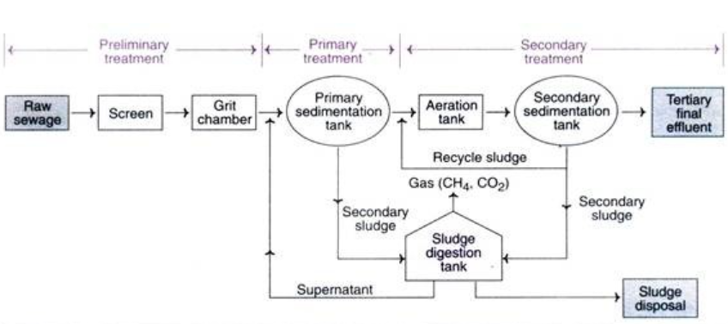
Figure 1: Wastewater Treatment Process Flow Chart (Kumar, 2025)

Preliminary Treatment
Preliminary treatment involves the removal of floating materials such as leaves, papers, rags as well as inorganic solids including sand and grit. This initial stage is designed to eliminate coarse debris that may obstruct pipework, damage mechanical equipment or compromise downstream treatment processes and automated systems (Kumar, 2024). The two types of equipment used in this stage are screens and grit chambers. Although this stage removes large solids, it does not improve the water quality.

2.1.1 Screeners
Screeners are devices with uniform sized openings designed to remove floating materials from wastewater. In automated WWTPs, screeners are often motor-driven and controlled using level sensors or differential pressure measurements to activate cleaning cycles when blockages are detected. Screening is carried out by passing wastewater through different types of screeners with various opening sizes. Bar screens as seen in figure 2 may be classified as coarse, medium or fine depending on the spacing between the bars (NetSol Water, 2024). Automation improves operational efficiency by reducing the need for manual cleaning, ensuring continuous flow through the system.
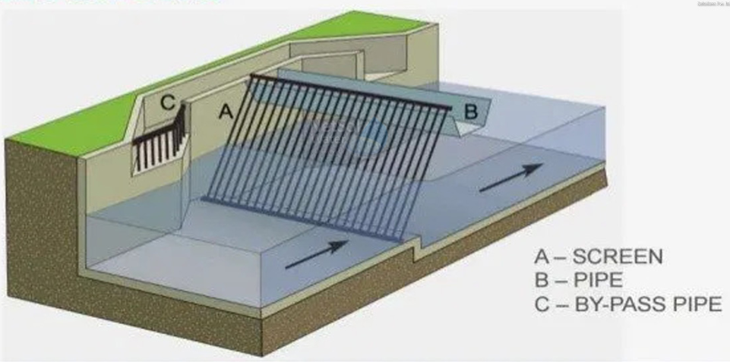
Figure 2: Bar screens (NetSol Water, 2024)

2.1.2 Grit Chambers
A grit chamber is typically the next step following screening although, may be located either before or after screening depending on plant design (Kumar, 2024). Grit chambers remove sand and other heavy inorganic materials such as metal fragments from wastewater (Dream Civil, 2022). Automated flow control within grit chambers is critical, as maintaining optimal flow velocity ensures effective separation of inorganic material without allowing organic matter to settle. This process is based on sedimentation due to gravitational force and relies on the difference in specific gravity between organic and inorganic solids to achieve separation (RACO , 2025). As seen in figure 3, grit will accumulate at the bottom of the chamber and wastewater will flow through the outlet.
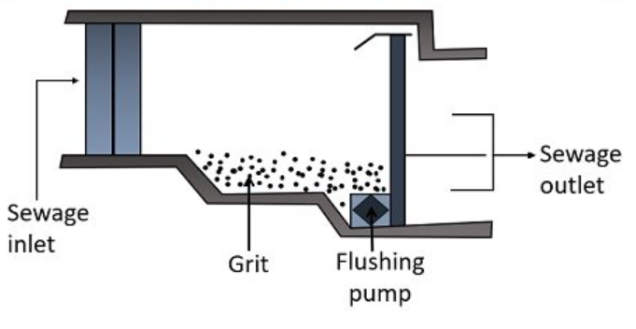
Figure 3: Grit Chamber (Aparna, 2023)

2.2 Primary Treatment
Primary treatment involves the use of sedimentation tanks, where wastewater is held to allow gravity to remove heavier suspended solids that settle at the bottom as sludge, which required further processing. This stage makes extensive use of automation, including level sensors, sludge scrapers driven by electric motors and PLCs to regulate sludge removal rates and tank performance. As shown in figure 4, organic materials such as oils and grease rise to the surface, forming a scum layer that is mechanically removes (NetsolWater, 2026).
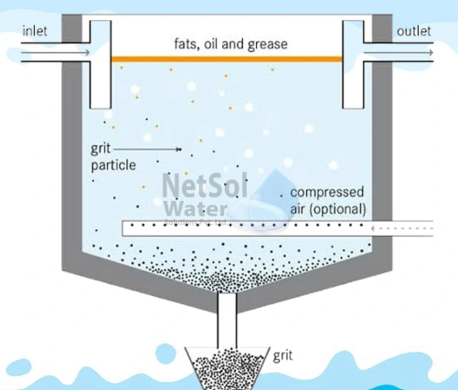
Figure 4: Sedimentation Tank (NetsolWater, 2026)

Secondary Treatment
Secondary treatment commonly referred to as biological treatment, is a key stage where dissolved organic material is broken down by naturally occurring microorganisms. This stage is highly dependent on automation and control to maintain optimal biological conditions. The microorganisms are contained within aeration tanks as seen in figure 5, and the mixture of wastewater and microorganism is known as activated sludge (Veolia, 2026). Automated aeration systems use dissolved oxygen sensors, flow meters and control valves to regulate oxygen supply. Ensuring microorganisms can effectively consume organic matter. As a result, CO₂ is released and pollutants such as nitrogen and phosphorus, improving overall effluent quality (Trade Zero, 2026).
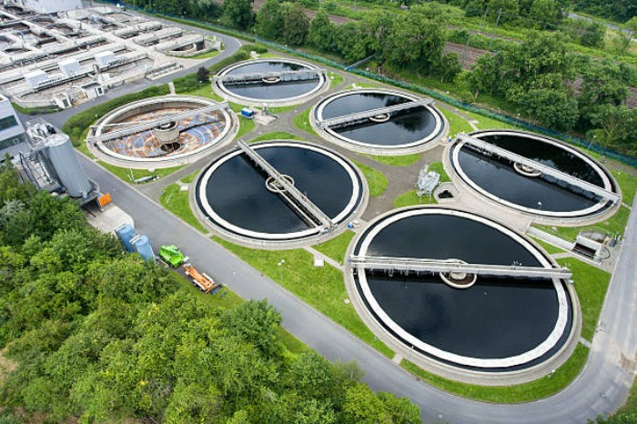
Figure 5: Second Treatment Clarifiers (Bolefil, 2023)

3. Historical Development of ICA in Wastewater Treatment

3.1 Early Wastewater Treatment and Manual Control
The earliest wastewater treatment facilities in the late 19th and early 20th centuries relied almost entirely on manual labour. Operators visually inspected flow levels, sludge accumulation and aeration conditions, adjusting valves and gates by hand. Instrumentation was minimal and typically limited to basic pressure gauges, mechanical flow meters and float-based level indicators. These tools provided limited information therefore, process control depended heavily on operator experience rather than measured data. The absence of comprehensive instrumentation resulted in inconsistent treatment performance and limited process optimisation.

3.2 Introduction of Basic Instrumentation
Manually operating larger sewage farms and the introduction of biological treatment processes became impractical. Simple instrumentation such as flow metres, level indicators, pressure gauges and temperature measurements were introduced to support operators. Although these instruments provided a better understanding of the plant behaviour, control remained largely manual and automation was still minimal.

3.3 Digital Control and the Introduction of SCADA
The digital revolution transformed WWTPs with the introduction of programmable logic controllers (PLCs) and Supervisor Control and Data Acquisition (SCADA) systems. Key developments included float-control pumps that started automatically when water levels reached a set point, early feedback control loops and time-based equipment operation. PLCs and digital electronics introduced in the late 20th century represented a major step forward for ICA. Providing flexible, programmable control logic and the ability to integrate multiple instruments into a single system. Although early digital controls were difficult to modify, they significantly improved operational efficiencies and introduced semi-automated systems.

3.4 Modern ICA
Modern WWTPs use advanced ICA systems to improve process performance, reduce energy consumption and ensure compliance with environmental regulations. Key features include advanced sensors that collect real-time data, actuators that automatically adjust equipment and control systems that maintain stable operations. Implementing ICA can significantly reduce operational costs, although it has higher initial implementation costs. Today’s systems represent over a century of progress, from manual inspection to fully integrated automated control.

4. Instrumentation in Wastewater Treatment
Implementing instrumentation into WWTPs enables processes to become measurable, controllable, efficient and compliant. Instrumentation supports effective process control by transmitting data to PID controllers and SCADA systems, allowing pumps to adjust flowrates, chemical dosing systems to respond to real-time demand and valves to operate automatically based on tank levels. Continuous monitoring ensures that plants remain within regulatory limits. Measuring devices are essential for detecting and quantifying process variables. Physical parameters can be measured using flow sensors, differential-pressure devices for water-level monitoring and pH sensors to regulate wastewater acidity or alkalinity (NetSol Water, 2026).

4.1 Flow sensor - Ultrasonic
Ultrasonic flow sensors enhance the accuracy, efficiency and controllability of WWTPs. They are widely adopted in modern facilities because they solve problems that older mechanical meters cannot. Ultrasonic sensors measure flowrate rather than relying on mechanical components (Icenta, 2026). They are particularly beneficial in wastewater applications because they handle variable, dirty and abrasive flows without clogging and do not obstruct the flow or suffer damage from grit or suspended soils (Li, 202). Additionally, they require minimal maintenance and integrate easily with SCADA and PLC systems. Figure 6 shows a fixed ultrasonic flow meter installed within a spool piece, providing continuous real-time flow data to a SCADA system.
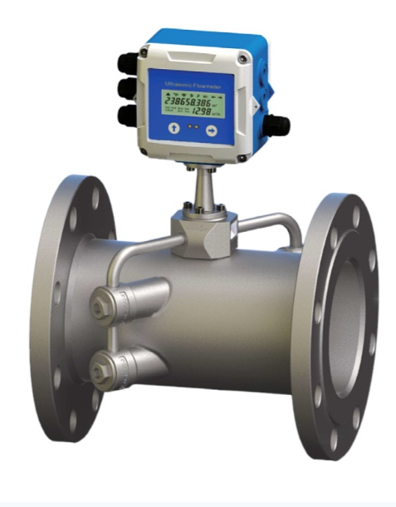
Figure 6: Fixed Ultrasonic Flow Meter (SenTec, 2026)

4.2 Differential Pressure Devices (DP)
DP devices such as orifice plates (figure 7) and venturi tubes (figure 8) are used in wastewater treatment to measure flow by creating a controlled pressure drop within the pipe. They are commonly applied in cleaner sections of the plant, including chemical dosing systems and final effluent lines, and are also used to monitor filter performance and assess pump operation. Their simplicity, robustness and low cost make them a reliable choice for many ICA applications. However, they are only practical in systems where the fluid contains minimal suspended solids.
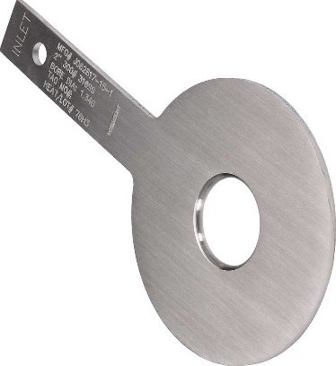
Figure 7: Orifice plate (Solken, 2025)
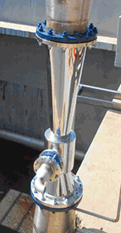
Figure 8: Venturi Tube (Lauria, 2018)

4.3 pH Sensors
A pH sensor measures the acidity or alkalinity of wastewater using an electrochemical glass-electrode principle, in which the voltage generated across a selective membrane corresponds to the hydrogen-ion concentration (Atlas Scientific, 2025). Maintaining appropriate pH levels is essential within WWTPs as incorrect pH can result in chemical-dosing overshoots of 20%-30% (Wate&Wastewater, 2024). For this reason, implementing pH sensors within WWTPs is crucial to ensure the plant remains within effluent discharge limits and operates efficiently. pH sensors also protect the biological treatment process by providing real-time data that enables dosing pumps to add acids or alkalis when required, preventing overdosing and reducing chemical consumption. Figure 9 illustrates how a wireless pH sensor can transmit signals directly to SCADA and PID controllers, enabling automates, real-time process adjustments.
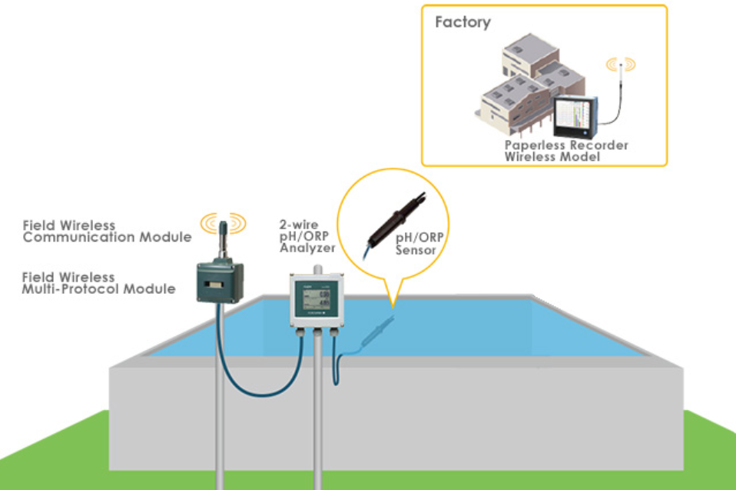
Figure 9: Wireless pH Senser Diagram (Yokagawa, 2026)

5. Process Controllers and Control Strategies
Process control systems monitor industrial processes to ensure that key variables are maintained at their pre-set value (NIBuisness, 2025). In a WWTP, controllers receive input signals from instrumentations such as flow meters and level sensors. This information is processed and output signals are sent to actuators to maintain stable operating conditions. Effective process controllers help improve energy efficiency and ensure that operational practices are carried out safely (NIBuisness, 2024).

5.1 Local Single-Loop Controllers
Local single-loop controllers receive measurement signals such as temperature, flow rate and pressure from sensors and transmit control instructions to actuators to maintain the process at its set value (Yokogawa, 2026). These controllers are widely used in WWTPs to ensure compliance with effluent-discharge requirements while minimising energy consumption. By regulating individual process units, single-loop control strategies help maintain operating conditions within their required limits (Faisal, 2023).

5.2 Programmable Logical Controllers (PLCs)
Programmable Logic Controller (PLC) are specialised computers used within WWTPs to control a wide range of automation tasks (Engineer Fix, 2021). A PLC continuously receives signals from field instruments such as flow meters, pH probes and level switches. It processes these inputs using programmed logic and then sends commands to actuators to maintain stable operating conditions. In WWTPs, PLCs are essential for maintaining stable and efficient operation. They control pumps start and stop sequences based on the tank levels (PLC Department, 2023). Modern PLCs integrate with SCADA systems allows operators to monitor plant performance from a control room, allowing the automated system to run without requiring human integration in the field.

5.3 Proportional-Integral-Derivative controllers (PID)
Proportional-Integral-Derivative (PID) controllers are widely used in WWTPs to maintain stable and efficient process control. A PID controller operates by continuously comparing a measured process variable such as flowrate, to a desired setpoint and adjusting the control output accordingly. In WWTPs, PID controllers are commonly applied to regulate aeration systems, pump speeds and sludge levels, helping to optimise treatment performance while reducing energy consumptions and process variability.

6. Actuators and Final Control Elements
An actuator functions as an ICA system because it is a self-contained device that receives energy signals, processes them and uses the energy source to produce a mechanical motion. Actuators close the loop between digital instructions and physical action by converting electrical input signals into physical movement (Eureka, 2025). Actuators can be categorised into several types, common types found within WWTPs are electrical, hydraulic and pneumatic. The actuators selected must be reliable as failure could cause water contamination within the facility (Advanced Actuators , 2025).

6.1 Electric Actuators
Electrical actuators use electrical energy to create physical motion, they are precise, easy to control and energy efficient. Electrical actuators are designed to efficiently control the flow of wastewater between the treatment processes (Shaik, 2024). They are suitable for WWTPs as they are compatible with ball valves, butterfly valves, gate valved and globe valves (Mitchell, 2020).

6.2 Hydraulic Actuators
Hydraulic actuators convert hydraulic energy into mechanical motion, often used in heavy-duty applications where high force is required. When hydraulic fluid is directed into a cylinder, pressure acts on the piston to generate a force (Elprocus, 2026). In WWTPs hydraulic actuators are used to automate equipment such as valves, gates and screens. Their ability to operate reliably under high loads and within wet environments make them ideal for this application. When integrated with sensors and control systems, hydraulic actuators enable remote operation.

6.3 Pneumatic Actuators
Pneumatic actuators operate by converting compressed air into mechanical motion, producing linear or rotary movement. Their fast response, simple design and low maintenance requirements make them well suited for frequent operation (Cowan, 2026). In WWTPs, pneumatic actuators are used to automate control valves, dampers and air distribution systems within aeration process. When controlled by PLCs they are extremely reliable, safe and a cost-effective automation of treatment process.

7. Relationship between Sensors, Controllers and Actuators
Sensors, controllers and actuators operate together in a closed-loop control system to enable automated and reliable operation within WWTP. Sensors continuously measure process variables such as flow rate, water levels and pressure. These signals are transmitted to controllers in real-time. Process controllers such as PLCs or PIDs compare the measured values with predefined setpoints and determine whether corrective action is required. If a deviation is detected, the controller generates an output signal that is sent to an actuator. The actuator then physically adjusts the process by opening or closing valves, starting or stopping pumps or regulating aeration rates. This continuous feedback loop allows WWTPs to maintain stable process conditions, respond quickly to disturbances and ensure compliance with environmental regulations.

8. Supervisory Control and Data Acquisition (SCADA) Systems
SCADA systems collect data from sensors and equipment throughout a WWTP and allow operators to monitor and control equipment remotely. Operators interact with the plant through a central control panel, enabling them to respond to operational changes from a computer rather than manually operating equipment in the field. Wastewater treatment benefits from SCADA because it can automate key processes such as chemical dosing and sludge management. This is essential in facilities where operators cannot always be physically present to open or close valves or adjust equipment.
Implementing SCADA improves operational efficiency and reduces labour requirements. Continuous data collection enhances water quality control and helps ensure the plant remains compliant with regulatory standards (Rugged T, 2023).

8.1 SCADA Components

8.1.1 Sensors and Actuators
Figure 10 shows a typical closed-loop control system used in WWTP automation. Sensors monitor parameters such as pH levels, chemical concentration and flow rates. While actuators control equipment including valves and pumps. Although installing sensors and actuators across the entire plant can be costly, it enables a highly autonomous and responsive control system.
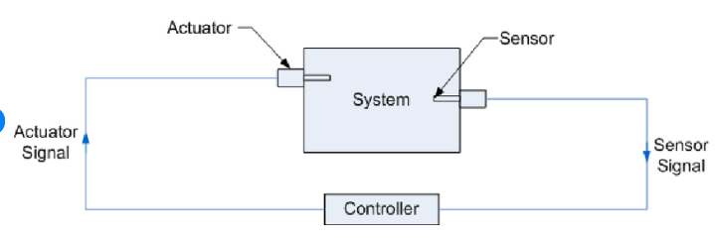
Figure 10: Closed-loop Control System Flowchart (Cho, 2009)

8.1.2 Human-Machine Interface (HMI)
The HMI displays real-time process information and allows operators to interact with the SCADA system. It visually displays data, equipment status and alarms providing essential information for operators and engineers. The HMI does not store or record data, instead it communicates real-time information and functions as the operator interface within the SCADA architecture (Inductive Automation, 2025).

8.2 SCADA integration with PLCs
SCADA and PLCs work together to provide automated and reliable control within WWTPs. PLCs perform real-time control by receiving signals from sensors, processing the data and sending commands to actuators. SCADA operates above the PLC layer, collecting data from each controller and displaying it through the HMI. As seen in the flow chart in figure 11, sensors or manual inputs send data to PLCs which then process it and send it to SCADA system for monitoring and then display this data on an HMI (Zhou, 2025).
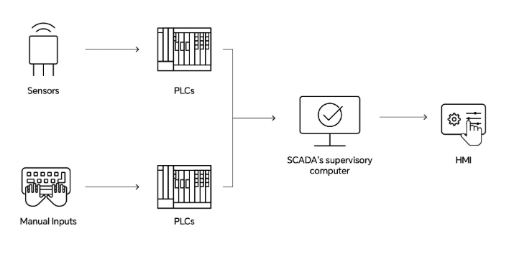
Figure 11: SCADA, PLC and HMI Flowchart (Zhou, 2025)

9. Regulations, Standards and Safety Requirements
WWTPs operate within a strict framework of environmental and health and safety regulations designed to protect public health, wildlife, environment and economic development. Water companies are legally required to comply with environmental permits when releasing treated wastewater into rivers, streams, lakes or the sea (Defrablogs, 2025). The permits define allowable limits for key effluent parameters, such as biochemical oxygen demand (BOD), suspended solids and nutrient concentration (Crystal Tank, 2026). Failure to maintain compliance can result in environmental harm, financial penalties and reputational damage. Consequently, automated systems play a crucial role in ensuring continuous compliance by providing accurate, real-time monitoring and reliable process control which manual operations cannot provide (Voltonic Systems LLC , 2025).
Instrumentation, control and automation systems enable continuous measurements of regulated variables and allow corrective action to be taken before discharge limits are exceeded. Standards such as BS EN 12566-3 and relevant ISO specifications apply to the design, performance and reliability of larger WWTP. In addition, the HASAWA 1974 and associated regulations require employers to minimise risks to personnel through safe plant design, effective monitoring and automated control. By reducing reliance on manual operation, modern ICA systems enhance operational consistency and ensure compliance with both environmental and operational regulations (EnviroSuite, 2026).

10. Recent Advanced Technologies in Wastewater Treatment Facilities
Recent advancements in wastewater treatment facilities include the integration of Artificial Intelligence (AI) and the Internet of Things (IoT). Intelligent wastewater systems are driving improvements in efficiency and sustainability. Real-time monitoring is achieved by placing smart sensors throughout the plant, providing continuous data that enhances the accuracy of AI-driven analytics. AI can then predict maintenance requirements before equipment fails, significantly reducing downtime and extends asset lifespan (Water and Waste Water, 2025). Energy savings can be achieved as AI algorithms optimise process requirement and adjust operations automatically. Increased automation within WWTPs ensures that each stage of treatment operates at maximum efficiency.

11. Conclusion
Instrumentation, control and automation have transformed wastewater treatment from a labour-intensive, manually operated process into a highly efficient, date-driven and increasingly automated system. The transition from simple mechanical instruments to advanced digital technologies has enabled plants to meet every environmental regulation, reduce operational costs and improve reliability. Sensors, controllers and actuators form the foundation of modern ICA systems, allowing operators to transition from reactive management to a more proactive approach.
Overall, the progression from manual operation to advanced ICA has enables wastewater treatment plants to become more efficient, reliable and capable of meeting modern environmental standards.

PUT IMAGE ONTO (ONLINE IMAGE) FOR PHOTOS AD DON’T UPDATE OR IT WILL CHANGE BACK

References
Advanced Actuators , 2025. Reliable Actuators for Water Utilities and Treatment Valves. [Online]
Available at: https://advanced-actuators.com/reliable-actuators-for-water-utilities-and-treatment-valves/
[Accessed 21 April 2026].
Aparna, D., 2023. Grit Chamber. [Online Image]
Available at: https://biologyreader.com/preliminary-treatment-of-wastewater.html
[Accessed 6 April 2026].
Atlas Scientific, 2025. How Does A pH Probe Work?. [Online]
Available at: https://atlas-scientific.com/blog/how-does-a-ph-probe-work/
[Accessed 21 April 2026].
Bolefil, 2023. Second Treatment Clarifiers. [Online Image]
Available at: https://www.brotherfiltration.com/secondary-wastewater-treatment/
[Accessed 22 April 2026].
Cho, H., 2009. Closed-loop control system flowchart. [Online Image]
Available at: https://www.researchgate.net/figure/Schematic-diagram-of-the-relationships-among-a-sensor-controller-and-actuator-for_fig2_255219182
[Accessed 24 April 2026].
Cowan, 2026. How Do Pneumatic Actuators Work?. [Online]
Available at: https://www.cowandynamics.com/how-pneumatic-actuators-work/
[Accessed 23 April 2026].
Crystal Tank, 2026. Sewage Treatment Plant - EN12566-3 UK. [Online]
Available at: https://www.crystaltanks.com/regulations.html#:~:text=Confusion%20Surrounding%20the%20EN%2012566,that%20was%20badly%20thought%20out.
[Accessed 23 April 2026].
Defrablogs, 2025. Regulating the water industry: legal powers and duties. [Online]
Available at: https://environmentagency.blog.gov.uk/2025/06/19/regulating-the-water-industry-legal-powers-and-duties/
[Accessed 20 April 2025 ].
Dream Civil, 2022. Grit Chamber: Types, Uses, Composition, Working Principle, Advantages & Disadvantages. [Online]
Available at: https://dreamcivil.com/grit-chamber/
[Accessed 6 April 2026].
Elprocus, 2026. What is a Hydraulic Actuator : Working & Its Applications. [Online]
Available at: https://www.elprocus.com/hydraulic-actuator/
[Accessed 23 April 2026].
Engineer Fix, 2021. What is a Programmable Logic Controller (PLC)?. [Online]
Available at: https://engineerfix.com/what-is-a-plc-and-how-do-they-work/
[Accessed 22 April 2026].
EnviroSuite, 2026. How wastewater management operators can protect their reputation with growing communities. [Online]
Available at: https://envirosuite.com/insights/news/how-wastewater-management-operators-can-protect-their-reputation-with-growing-communities
[Accessed 23 April 2026].
Eureka, 2025. What is an Actuator and How Does It Work?. [Online]
Available at: https://eureka.patsnap.com/article/what-is-an-actuator-and-how-does-it-work
[Accessed 21 April 2026].
Faisal, M., 2023. Control technologies of wastewater treatment plants: The state-of-the-art, current challenges, and future directions. [Online]
Available at: https://www.sciencedirect.com/science/article/abs/pii/S1364032123001806
[Accessed 21 April 2026].
Holland, Q., 2025. The Evolution Of Wastewater Treatment Plants: A Historical Overview. [Online]
Available at: https://shuncy.com/article/how-long-have-wastewater-treatment-plants-existed
[Accessed 6 April 2026].
Icenta, 2026. Ultrasonic Flow Meters. [Online]
Available at: https://www.icenta.co.uk/product-category/flow-meters/ultrasonic-flow-meters/
[Accessed 6 April 2026].
Inductive Automation, 2025. HMI: Human-Machine Interface. [Online]
Available at: https://inductiveautomation.com/resources/article/what-is-hmi#hmi-defined
[Accessed 20 April 2026].
Interreg, 2020. PRINCIPLE OF OPERATION. [Online]
Available at: https://bestbalticproject.eu/wp-content/uploads/2020/09/4-WWTP_-INSTRUMENTATION-CONTROL-AND-AUTOMATION-1.pdf
[Accessed 20 April 2026].
Kumar, P., 2024. Processes of Waste Water Treatment: 4 Processes. [Online]
Available at: https://www.biologydiscussion.com/waste-management/waste-water-treatment/processes-of-waste-water-treatment-4-process-with-diagram/10989
[Accessed 6 April 2026].
Kumar, P., 2025. Watewater Treatment Process Flow Chart. [Online Image]
Available at: https://www.biologydiscussion.com/waste-management/waste-water-treatment/processes-of-waste-water-treatment-4-process-with-diagram/10989
[Accessed 20 April 2026].
Lauria, J., 2018. Cut Back on Wastewater Treatment Maintenance with a Venturi Aeration System. [Online Image]
Available at: https://www.pumpsandsystems.com/cut-back-wastewater-treatment-maintenance-venturi-aeration-system
[Accessed 6 April 2026].
Li, C., 202. Doppler Ultrasonic Flow Meters. [Online]
Available at: https://www.gaimc.com/Newsinfo/ultrasonic-flow-meters-working-principles-applications-benefits
[Accessed 21 April 2026].
Mitchell, R., 2020. Electric Actuator's Suitable for Use in Specific Environments. [Online]
Available at: https://control.com/technical-articles/Basic-Applications-of-Pneumatic-Hydraulic-and-Electric-Actuators/#:~:text=Benefits%20and%20Uses%20of%20Pneumatic,the%20use%20of%20a%20screwdriver.
[Accessed 21 April 2026].
NetSol Water, 2024. Bar Screens. [Online Image]
Available at: https://www.netsolwater.com/what-is-screening-process-in-waste-water-treatment.php?blog=1621
[Accessed 6 April 2026].
NetSol Water, 2026. Measuring Devices in WWTPs. [Online]
Available at: https://www.netsolwater.com/what-are-various-instrumentation-and-control-systems-in-wwtp.php?blog=4084
[Accessed 21 April 2026].
NetsolWater, 2026. Sedimentation Tank. [Online Image]
Available at: https://www.netsolwater.com/how-primary-sedimentation-works-in-wastewater-treatment.php?blog=5939
[Accessed 20 April 2026].
NIBuisness, 2024. Process control systems in industrial processes. [Online]
Available at: https://www.nibusinessinfo.co.uk/content/process-control-systems-industrial-processes
[Accessed 21 April 2026].
NIBuisness, 2025. Process control systems for energy efficiency. [Online]
Available at: https://www.nibusinessinfo.co.uk/content/how-process-control-systems-work
[Accessed 21 April 2026].
PLC Department, 2023. PLC Programming for Water and Wastewater Treatment. [Online]
Available at: https://www.brotherfiltration.com/secondary-wastewater-treatment/
[Accessed 22 April 2026].
RACO , 2025. How a Grit Chamber Works. [Online]
Available at: https://www.racoman.com/blog/grit-chamber-wastewater-treatment-explained?srsltid=AfmBOorCD08Sb2QUkG4tsEHb7HLpiU8Gpg5rtLdxr2ipUH6v5L0L6MF0
[Accessed 22 April 2026].
Rugged T, 2023. Benefits of SCADA in Wastewater Management. [Online]
Available at: https://www.ruggedtelemetry.com/blog-posts/benefits-of-scada-in-wastewater-management
[Accessed 24 April 2026].
SenTec, 2026. Dual Channel Two-wire Ultrasonic Flowmeter. [Online Image]
Available at: https://cdsentec.com/product/fmu854-dual-channel-two-wire-ultrasonic-flowmeter/
[Accessed 6 April 2026].
Shaik, 2024. Quarter Turn Electric Actuators for Use in the Water and Wastewater Industry 2024. [Online]
Available at: https://www.cairindia.com/quarter-turn-electric-actuators-water-wastewater/#:~:text=Cair%20Euro%27s%20Quarter-turn%20Electric,700%E2%80%936500%20NM%20Torque%20Range)
[Accessed 21 April 2026].
Solken, W., 2025. Orifice Plates for Flow Measurement and Flow Restriction. [Online Image]
Available at: https://www.wermac.org/specials/orificeplate.html
[Accessed 6 April 2026].
Trade Zero, 2026. Types of Sensors in Wastewater Treatment Control. [Online]
Available at: https://zeroinstrument.com/types-of-sensors-in-wastewater-treatment-control/#:~:text=Dissolved%20oxygen%20sensors%20work%20by,of%20the%20biological%20treatment%20process.
[Accessed 23 April 2026].
Veolia, 2026. Wastewater treatment plants: the keys to sustainable wastewater management. [Online]
Available at: https://www.veolia.com/en/planetlive/wastewater-treatment-plants-keys-sustainable-wastewater-management
[Accessed 20 April 2026].
Voltonic Systems LLC , 2025. The Crucial Role of Industrial Automation in Wastewater Management. [Online]
Available at: https://voltonicsys.com/the-crucial-role-of-industrial-automation-in-wastewater-management/#:~:text=Automation%20systems%20continuously%20monitor%20wastewater,treatment%20processes%20for%20maximum%20efficiency.
[Accessed 20 April 2025].
Wate&Wastewater, 2024. pH Sensors and Testing for Water Treatment: Types and Applications. [Online]
Available at: https://www.waterandwastewater.com/ph-sensors-and-testing-for-water-treatment-types-and-applications/
[Accessed 21 April 2026].
Water and Waste Water, 2025. The Future of Automated Wastewater Treatment: AI and IoT Solutions. [Online]
Available at: https://www.waterandwastewater.com/the-future-of-automated-wastewater-treatment-ai-and-iot-solutions/
[Accessed 20 April 2026].
Yokagawa, 2026. Wireless pH sensor diagram. [Online Image]
Available at: https://web-material3.yokogawa.com/1/6014/files/wireless-pH_en.jpg
[Accessed 21 April 2026].
Yokogawa, 2026. What Are Single Loop Controllers?. [Online]
Available at: https://www.yokogawa.com/us/solutions/products-and-services/control/control-devices/single-loop-controllers/
[Accessed 21 April 2026].
Zhou, E., 2025. How SCADA Communicates with PLCs: Protocol Conversion and Interface Compatibility. [Online Image]
Available at: https://www.come-star.com/blog/how-scada-communicates-with-plcs/
[Accessed 24 April 2026].

Table of Figures
Figure 1: Wastewater Treatment Process Flow Chart (Kumar, 2025) 4
Figure 2: Bar screens (NetSol Water, 2024) 5
Figure 3: Grit Chamber (Aparna, 2023) 6
Figure 4: Sedimentation Tank (NetsolWater, 2026) 7
Figure 5: Second Treatment Clarifiers (Bolefil, 2023) 8
Figure 6: Fixed Ultrasonic Flow Meter (SenTec, 2026) 10
Figure 7: Orifice plate (Solken, 2025) 11
Figure 8: Venturi Tube (Lauria, 2018) 11
Figure 9: Wireless pH Senser Diagram (Yokagawa, 2026) 12
Figure 10: Closed-loop Control System Flowchart (Cho, 2009) 16
Figure 11: SCADA, PLC and HMI Flowchart (Zhou, 2025) 17

