Evidence of Learning EPortfolio
Afsana Begum

Summery:
‘How adverse childhood experiences shape our brains’
This journal article talks about adverse childhood experiences and how it can shape our brains. The writer is captivated by uncovering the multiple pathways involved in expanding the understanding of childhood trauma and the therapeutic response needed from help seekers. This article described recent studies on early adversity, suggesting multiple brain pathways which are influenced by early childhood effects. This article highlights supporting evidence on ‘cognitive’ pathways which may be transmitted by the effects of childhood trauma (Donohoe, 2022).
Neuroscience has given us an insight into how the brain is shaped by adverse childhood events. We have a greater understanding about the limbic system and how it's altered by early adversity and stress. One of these components is the amygdala, over-stimulation of the amygdala region in response to a threat of adverse childhood experience is one of the most robust findings. These feelings are subjective to the individuals and how threatened or triggered they are to the situations (Donohoe, 2022).
Psychologists are progressively studying whether adverse childhood events might affect cognitive processes later in adulthood. Evidence suggests that early life adversity is strongly associated with cognitive and social cognitive difficulties. Social cognition involves the ability to recognize and think about the emotions and intentions of others (e.g. emotion recognition, theory of mind). Having parents who struggle to meet basic physical needs lead to developmental challenges. Having physical needs met will provide a secure base to explore the social world (Donohoe, 2022).
There are important caveats to the kind of research described, especially these two. The first is the difficulty of making accurate causal inferences from across-sectional data. While the second one being the uncertain accuracy of retrospective accounts. Studies have shown that the effects of trauma on the brain are more broadly experienced than first imagined. Therapies that combine strategies from improving social thinking and regulating emotions by focusing on a wider range of cognitive skills are likely to be of large value in helping these individuals benefit from psychologically informed therapies (Donohoe, 2022)

Reference list:
Donohoe, G. 2022. How Adverse Childhood Experiences Shape our Brains. the british psychology society. How adverse childhood experiences shape our brains | BPS
Video presentation link:
Practitioner in Counselling Video .mp4

Poster:

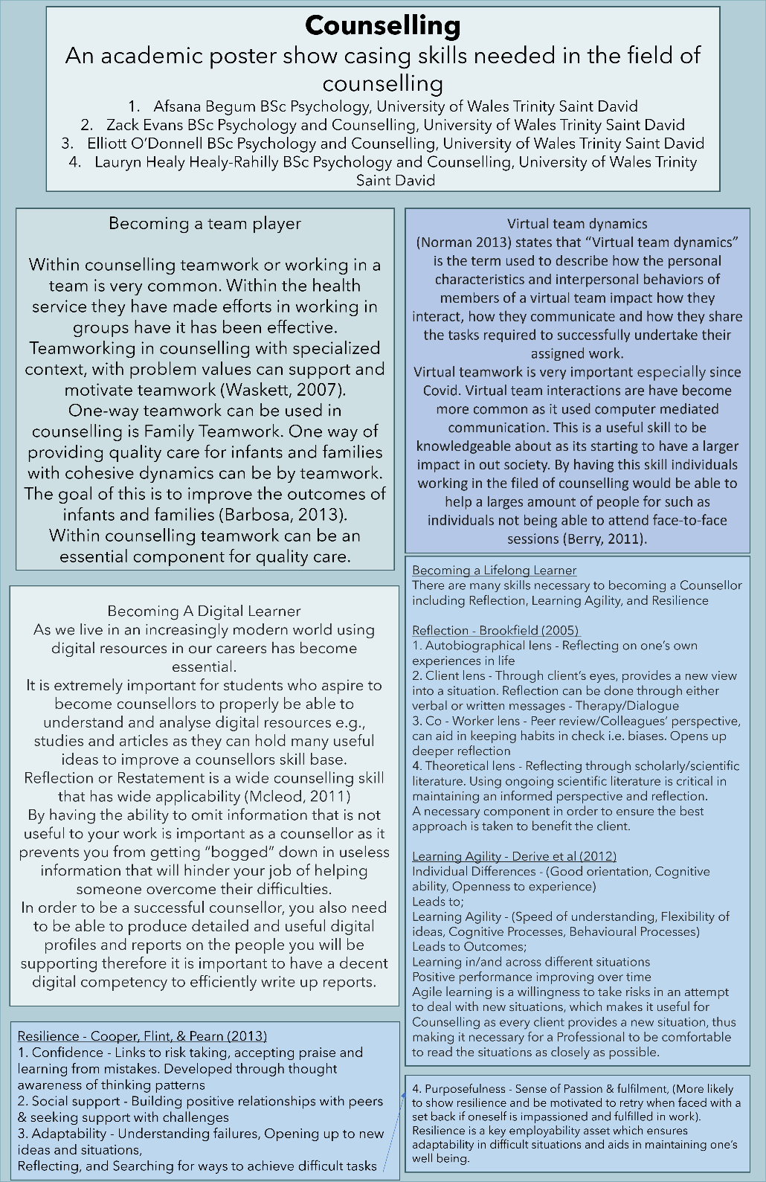
For this academic poster I created the ‘becoming a team player’ aspect of the task as well as designing and creating the poster. I learned a lot while creating the poster. There were many pieces of literature surrounding this topic area, it winded my knowledge on how important teamwork is, especially within this task seeing as we were working in groups. As there were other people contributing within this task it helped, it allowed me to think more deeply on my part of the poster.
As for future group work, I would like to improve on being able to create more work on my end and having a more equal distribution of work. Within this poster it is visible to see there wasn’t a steady amount of work distribution which I would like to include in future work. Now realising group dynamics and work load I would like to improve on these aspects in the future.


Group work evidence:



