8/10/2026
Software Solution for Business
Module No: ACCA4026
Student Name: Makawe Alsir
Student No: 2513347
Group No: 2
University Of Wales Trinity Saint david

Table of Contents
Introduction 1
Task 1. e-Commerce Website builders/software solutions 1
1.1 Wix 1
1.2 Shopify 1
Task 2. Mind-map of contemporary software applications 1
2.1 Describe mind mapping and explain the benefits of using mind mapping 1
2.2 Create a mind map of contemporary software applications 2
Task 3. Office Applications 2
3.1 Four office software solutions for business operations 2
Ms Word 2
Ms Excel 2
Ms PowerPoint 2
Ms Access 2
3.2 Test any two features 2
Mail Merge 2
IF Statement 3
Task 4. Communication and Collaboration applications 3
4.1 One contemporary Communication and one Online Collaboration 3
Gmail 3
Zoom 3
4.2 Test one feature of a freely available Communication (1) and one feature of a Collaboration (1) application 3
Gmail 3
Zoom 3
Conclusion 4
References 4

Introduction
Contemporary software applications have become an essential part of day-to-day business and organisational operations. Businesses use software solutions to improve productivity, manage information, communicate with employees and customers, support decision-making, and deliver products and services more efficiently. The development of cloud-based and online software has also made it easier for organisations to access information, collaborate with others, and manage business activities from different locations.
This assignment examines a range of contemporary software solutions and their use within business environments. It begins by examining two e-commerce website builders, Wix and Shopify, which enable businesses to create, manage, and operate online stores. The assignment then explores mind mapping and its benefits for activities such as strategic planning, business development, and marketing. It also considers four widely used Microsoft Office applications: Word, Excel, PowerPoint, and Access, focusing on how they support different business operations. In addition, selected features of these office applications are tested to demonstrate their practical use.
Finally, the assignment examines contemporary communication and collaboration applications, including Microsoft Outlook and Microsoft Teams. These applications support activities such as email communication, meeting management, file sharing, online meetings, and teamwork. Overall, the assignment demonstrates how different software solutions can support efficiency, organisation, communication, and decision-making in a modern business environment.

Task 1. e-Commerce Website builders/software solutions

E-commerce website builders and software solutions allow businesses to create, manage and operate online stores without needing extensive programming knowledge. Contemporary platforms provide much more than basic website design, offering features such as product management, online payments, inventory control, marketing, analytics, customer management, and integration with other sales channels. Two widely used contemporary solutions are Shopify and Wix



Shopify is a cloud-based e-commerce platform specifically designed for businesses that want to manage products and sell services online. It is a Software-as-a-Service (SaaS) solution, that means Shopify hosts the website and manages the technical infrastructure, like software maintenance, security and hosting. That allows businesses to concentrate on selling products, marketing, and customer service rather than managing servers.
One of Shopify's main advantages is its wide range of e-commerce functions. Businesses can create products listing, manage inventory, process payments, manage orders, and analyze sales performance from one central administration system. Shopify also can support multiple sales channels, including websites, social media, marketplaces, and physical stores through its point-of-sale systems. The platform provides access to thousands of applications that can extend its functionality, allowing businesses to connect with additional marketing, accounting, shipping, and customer-service tools.
Shopify is therefore suitable for businesses ranging from small start-ups to large international organizations. Its scalability makes it particularly useful for businesses expecting to expand their product range, customer base, or geographical market. However, businesses should consider ongoing subscription costs, payment fees, and the potential cost of additional applications when selecting the platform.



Wix is a website builder that also provides comprehensive e-commerce functionality. Unlike platforms designed primarily around online retail, Wix combines website creation with business and e-commerce tools. Its drag-and-drop editor and large selection of professional designed templates make it easy to users with limited technical knowledge. Wix currently provides hundreds of e-commerce templates that allow businesses to customize storefronts, product pages, shopping carts, and checkout experiences.
Wix provides several important e-commerce features, including products and inventory management, secure payment options, SEO tools, customer reviews, marketing campaigns, and analytics. It also supports multichannel selling, allowing businesses to connect their online stores with platforms such as social media, Google Shopping, and eBay. In addition, Wix provides mobile management through its Wix Owner app, allowing business owners to monitor products, listing orders, update and report store performance while away from a computer.
Overall, Wix is particularly appropriate for small businesses and entrepreneurs who want strong visual control over their website. Shopify, in comparison, is more focused on dedicated e-commerce operations and scalability. Therefore, the most appropriate solution depends on the organization's requirements: Wix can be good option for businesses prioritizing website design and simplicity, whereas Shopify is generally more suitable for businesses seeking a scalable e-commerce platform.

Task 2. Mind-map of contemporary software applications

2.1 Describe mind mapping and explain the benefits of using mind mapping
A) Strategic planning using Mind Mapping

Mind Mapping is used for strategic planning. As a strategic planner in a company, key priorities involve helping that company identify the goals while also giving direction and inspiration to the staff. Using a mind map can effectively scope out the business plan by identifying goals that are short and long term and then fill in the details using branches to develop a complete strategy. Strategic plans using a mind map provide great situational overviews. Everyone will be able to move in unison in the same direction, which massively improves the results.

B) Business development with Mind Mapping

Mind Mapping is very important for new business development. In this context, NovaMind65 is used to conduct, guide, and record the outcomes of brainstorming sessions.
Why brainstorm? Because the search for new company direction, mission statement, business plan, product ideas, clients and service often begins with it. A Nova Mind map presents the situation visually, so the reviewer can immediately see what is involved and how the elements link together, with additional details available in each task or objective. This is an easier way for project management (Meera P. Venkatraman, 2000). Using Mind Mapping communication is enhanced, and sales are also enhanced. But the attractive thing is that Nova Mind software is useful for investor pitches. When you need that injection of cash to get your project going, presenting in Mind Map format means that the investors can see why you need the money, what you are going to be doing with it, and how you will meet your objectives (and theirs). It is the effort to make the very best pitch and find the tack that considers investors' particular needs most inclusively that will lead to a positive outcome. There is no doubt that by using Mind Mapping software there is an opportunity to develop marketing plans. Developing marketing plans is an essential part of the business planning process. You need to know where you stand in the market right now, what the market is like, what you want to achieve, and how you are going to get there. This software enhances marketing mind maps and represents current market position, market overview, market SWOT analysis, and marketing objectives and strategies. ( M.D.Dickerson and J.W. Gentry, 2002)

2.2 Create a mind map of contemporary software applications

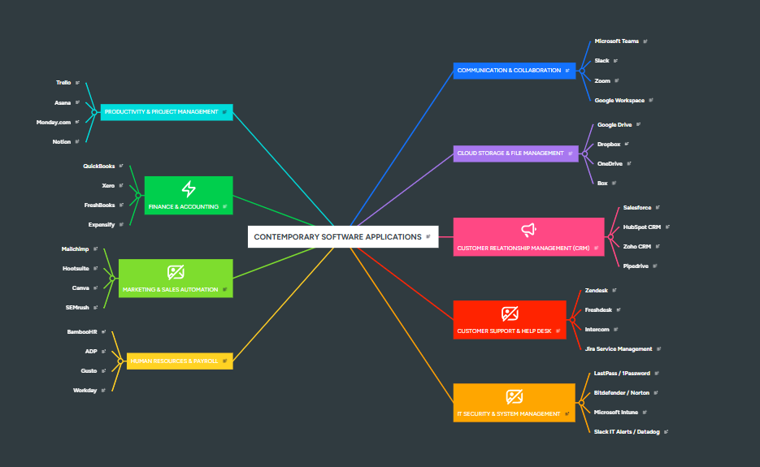

Task 3. Office Applications

3.1 Four office software solutions for business operations

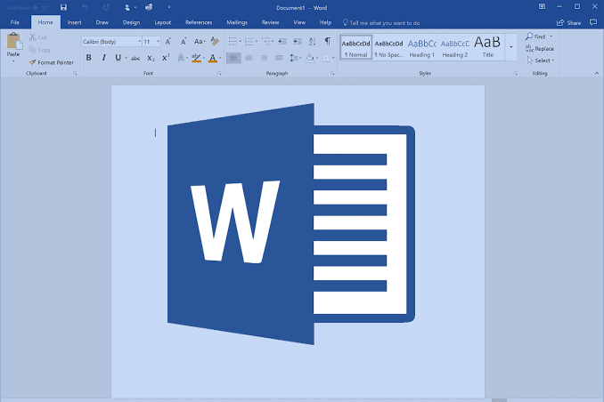 Ms Word is a highly popular word processing program. It lets you create and edit text-based documents with ease. Its features include spell check, grammar check, change tracking, and built-in dictionary and thesaurus.
MS Word is extremely easy to use and equipped with a massive array of features, making it one of the most used word processing software. More than 1 billion people are currently using MS Word from all around the globe.

The software blends basic and advanced features, making it very popular. Beginners can create simple documents easily. Experienced users benefit from the complex tools available.

Key features of Microsoft Word:
- Create a document from a blank page or use a template, add text, images, and other content, format your document, and print or share it.
- Include a number of templates for commonly used documents, such as resumes, letters, cards, flyers, reports, and much more.
- Easily collaborate with others by tracking changes, adding comments, and sharing documents.
- Fonts, page layout, margins, indentations, themes, etc. to customize your document.
- Structure your text by incorporating headings, bullet points, line breaks, lists, tables, etc.



Ms Excel
Analyze data. Use it for creating budgets, tracking expenses, or organizing information. It also lets you create charts and graphs from your data.
Excel is widely used to manage data effectively. As a small business owner, you can create a spreadsheet to list your monthly expenses. This helps you stay organized and identify potential areas for cost-saving.
You can use MS Excel for calculations. For example, it can help you calculate your monthly budget and a company’s profits or losses.
Microsoft Excel features:
- Create spreadsheets to organize data for easy analysis and reference, and filtration.
- Create charts and graphs from your data to find trends or patterns.
- Import and export data in various formats for further analysis or sharing with others. Microsoft Excel is a spreadsheet application that helps users organize and
- Calculate things easily and quickly using math formulas and functions from your data.
- A variety of commands to help you manipulate data the way you want.

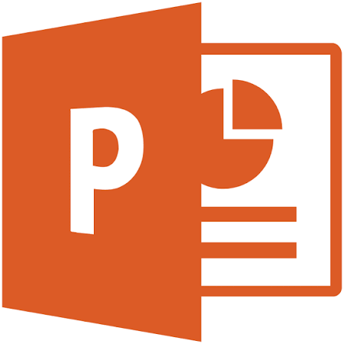

Ms PowerPoint
PowerPoint is a popular presentation software for creating slideshows to share ideas or information. It’s useful for business presentations, academic lectures, group meetings, and more.
PowerPoint : works as a desktop and web application, but it’s mostly used on desktops. You can pick from several templates or design your own slides for your presentations.
Add text, images, charts, and other objects to your slides effortlessly. PowerPoint lets you create interactive presentations with clickable buttons and smooth slide transitions, beyond just the standard slide show format.
MS PowerPoint features:
- Create interactive presentations with clickable buttons and slide transitions.
- Choose from a variety of built-in templates or create your own slideshow from scratch.
- Add text, images, charts, and other objects to slides to make them more interactive.
- Add audio, video, and other files to presentations. Present ideas in a standard slide show format.
- Add tables, infographics, charts, and other data visualizations to slides.

Ms Access
Microsoft Access is a relational database management system (RDBMS), which simply means it stores data in related tables rather than in one long list. This structure makes it easier to keep information consistent and prevent duplication. Access comes bundled with Microsoft 365 but can also be bought separately if you only need the database tool.
Microsoft Access is particularly good for small projects, desktop apps, or team collaborations where the heavy machinery of enterprise-grade database software is overkill. It’s intuitive, flexible, and works seamlessly with many other Microsoft programs.

MS Access features:
- Store data in structured tables
- Run searches and queries to find specific information
- Generate reports and summaries for decision-making
- Build applications without much programming knowledge

3.2 Test any two features

Pivot table
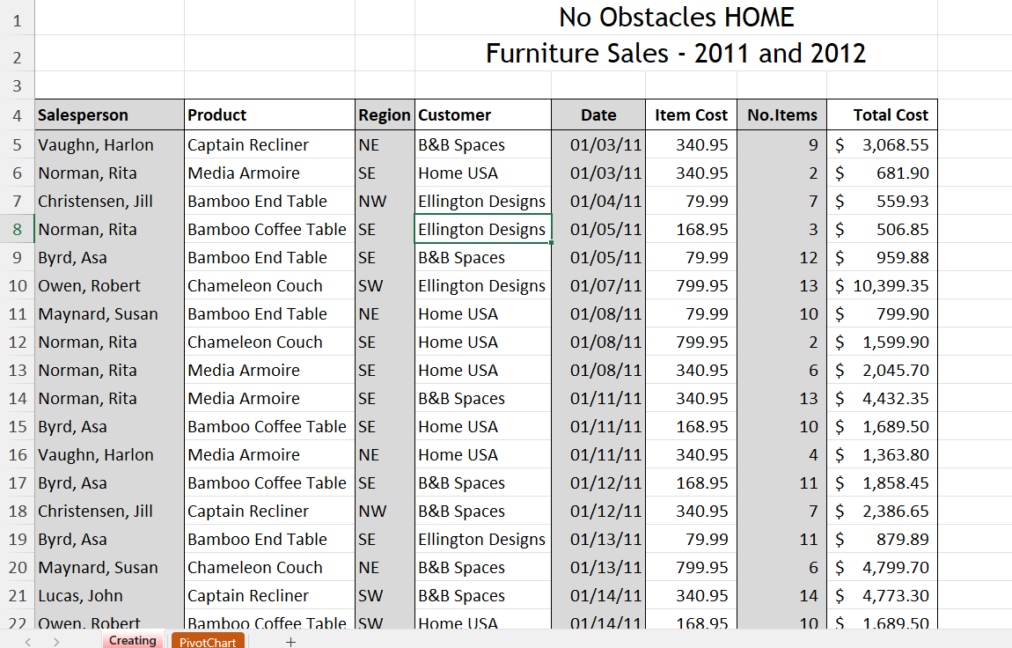

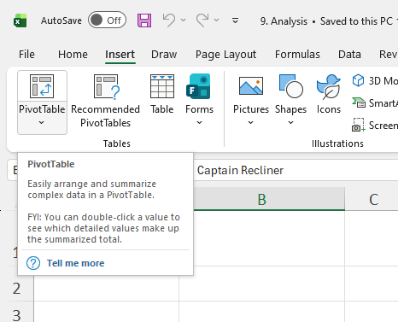
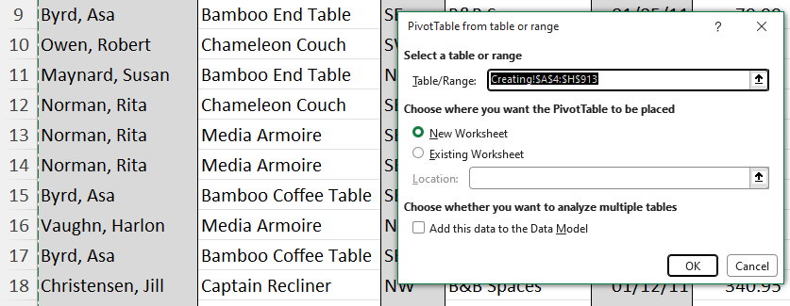

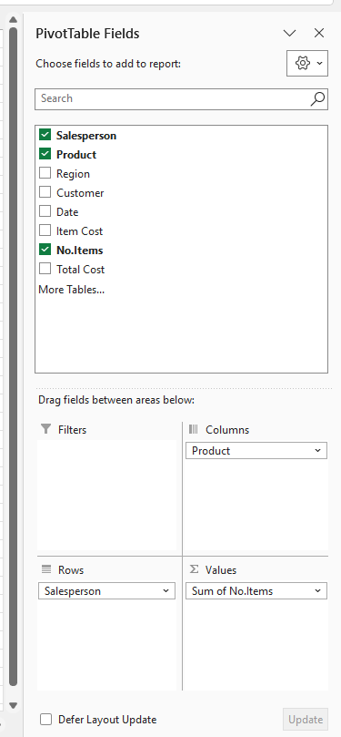
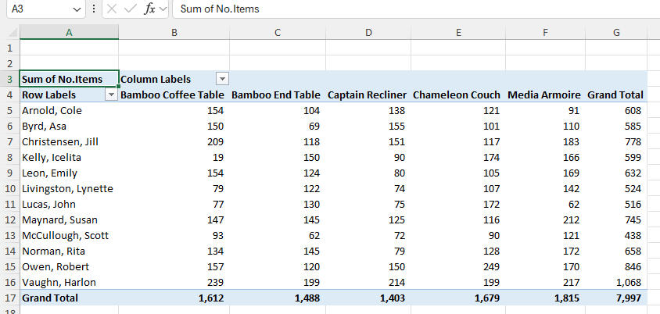

IF Statement

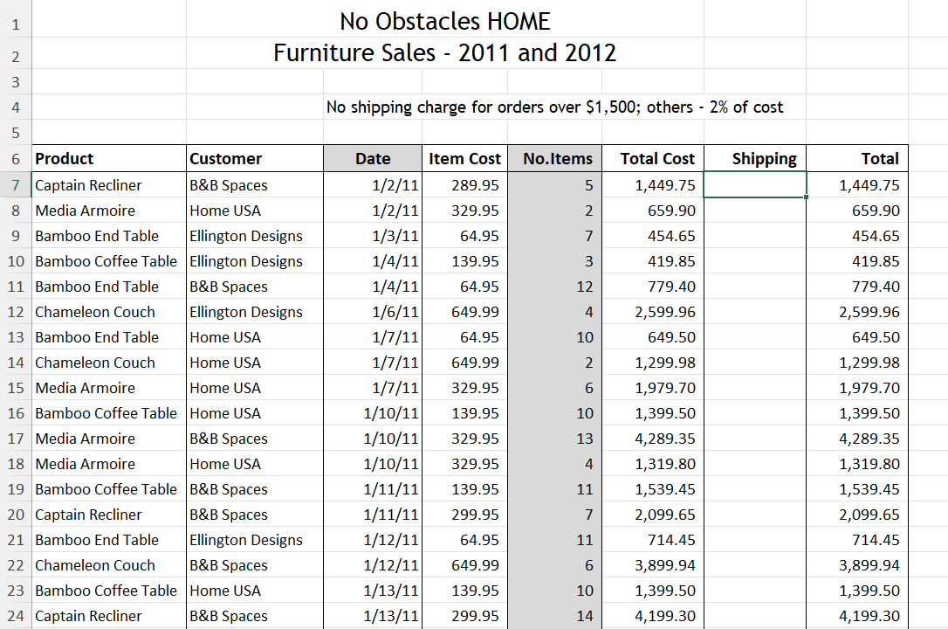
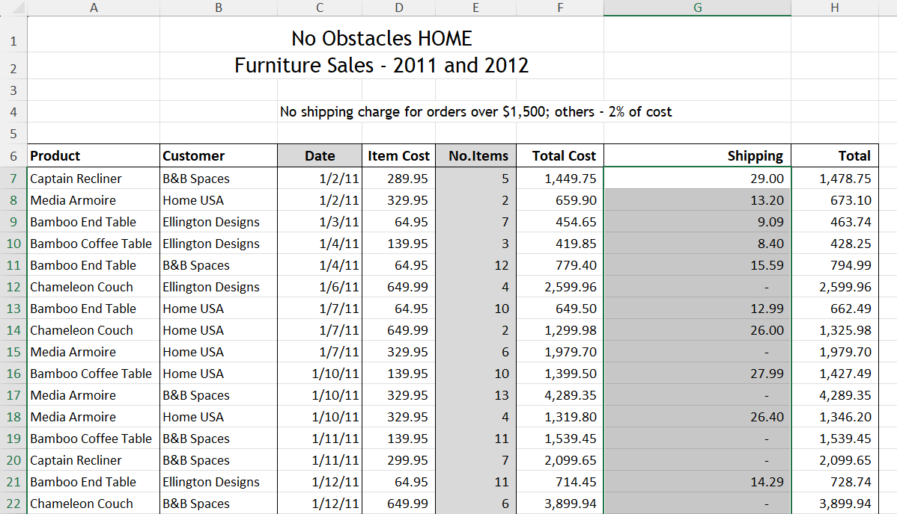
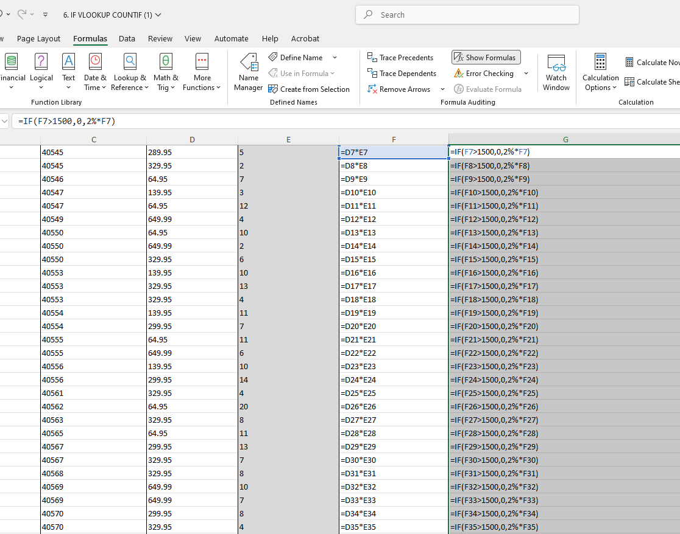

Task 4. Communication and Collaboration applications

4.1 One contemporary Communication and one Online Collaboration

Microsoft Outlook

Microsoft Outlook is a popular personal information manager and email software developed by Microsoft. It is used to send and receive emails, manage calendars, store contacts, and track tasks. It is available as a desktop app, a mobile app, and a webmail service
Core Features
- Email Management: Send, receive, and organize messages, filter spam, and flag important work.
- Calendar: Schedule meetings, view daily or weekly agendas, and set event reminders.
- Contacts & Tasks: Store address book details and manage to-do lists.
- App Integration: Works seamlessly with cloud storage and office tools like OneDrive and SharePoint.

Microsoft teams

Microsoft Teams is a cloud-based digital collaboration platform developed by Microsoft. It combines workplace chat, video meetings, file storage, and app integration into a single hub designed to help groups and businesses work together easily.
Key Features
- Chat and Messaging: Send private one-on-one messages or group chats with text, emojis, and GIFs.
- Video Meetings: Host online calls, large webinars, and virtual get-togethers with screen sharing and recording options.
- Channels and Teams: Group people by department or project using channels to keep conversations and topics organized.
- File Sharing: Store and co-author documents in real time using built-in connections to Word, Excel, PowerPoint, and OneDrive.
- App Integrations: Add extra tools from both Microsoft and outside companies to one central screen

Microsoft Outlook
<Outlook>
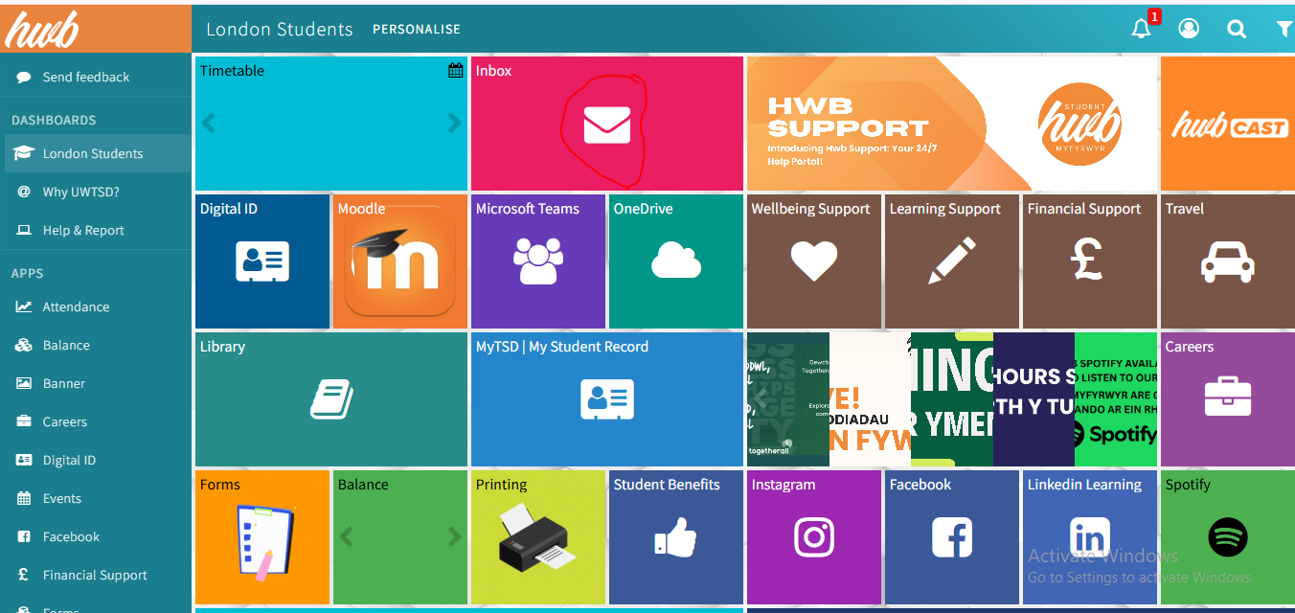

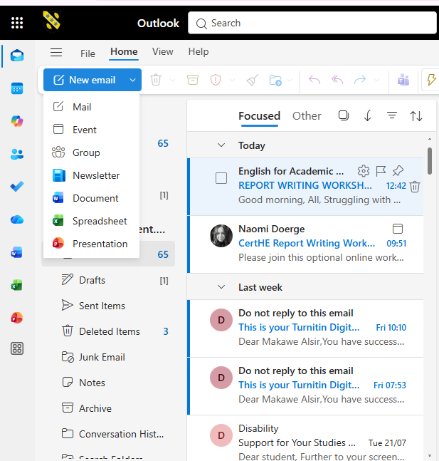

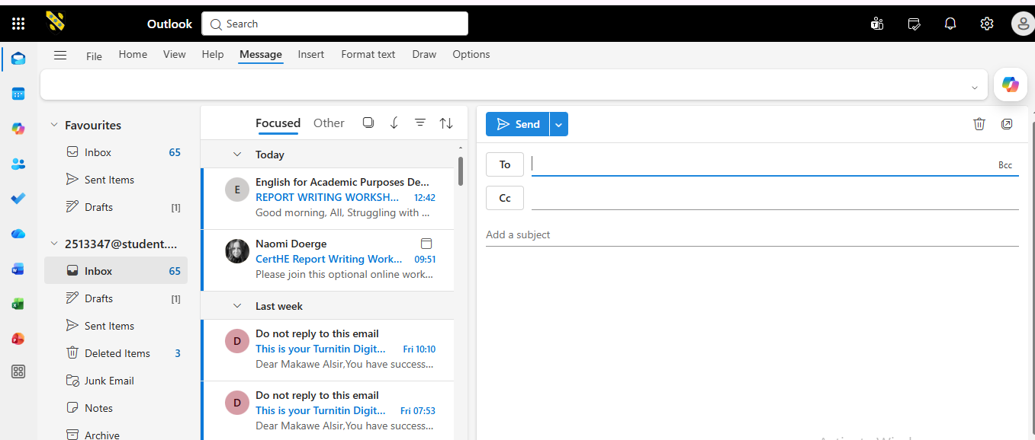

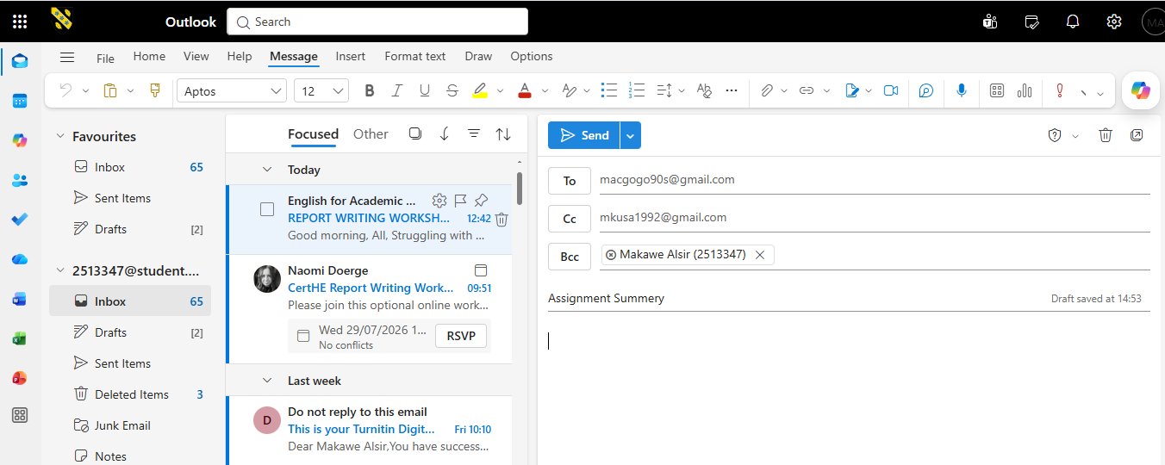

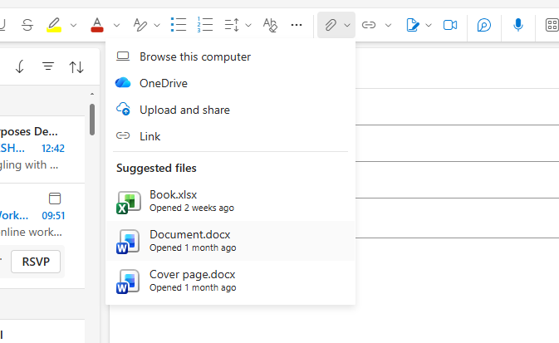

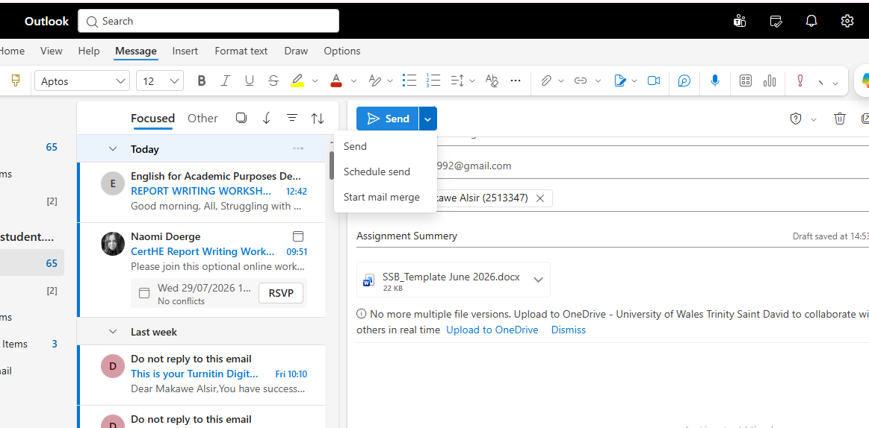

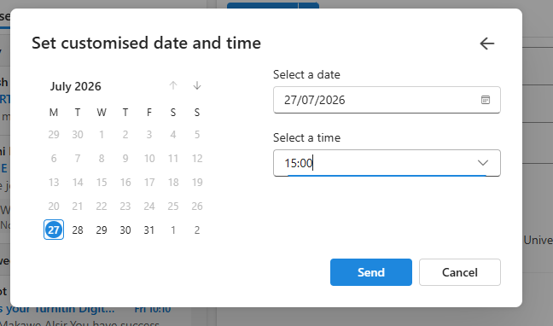

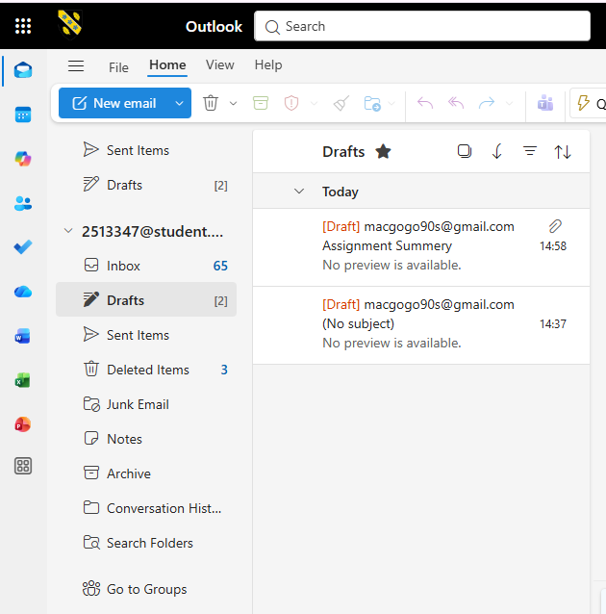
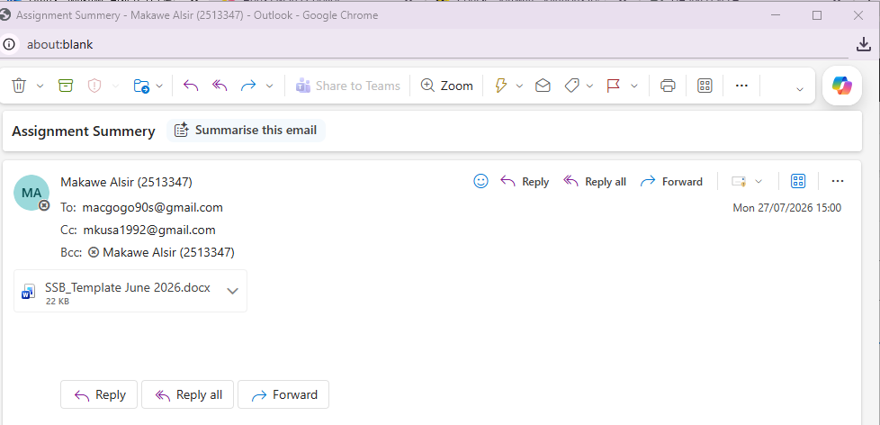

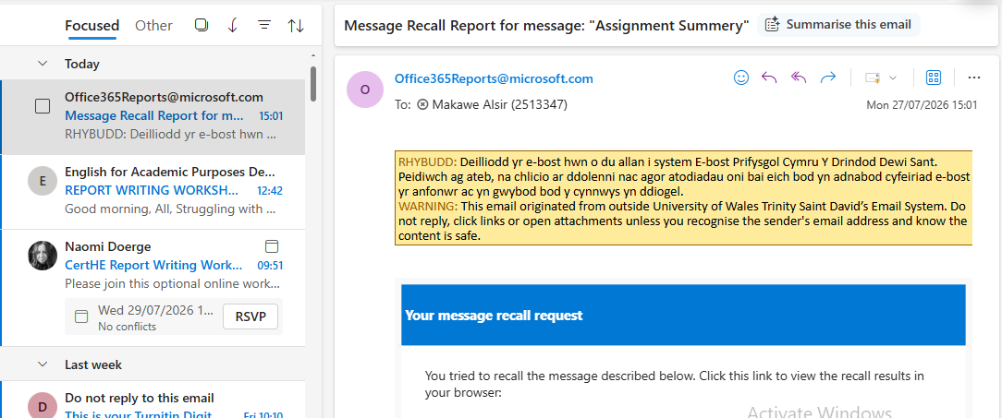
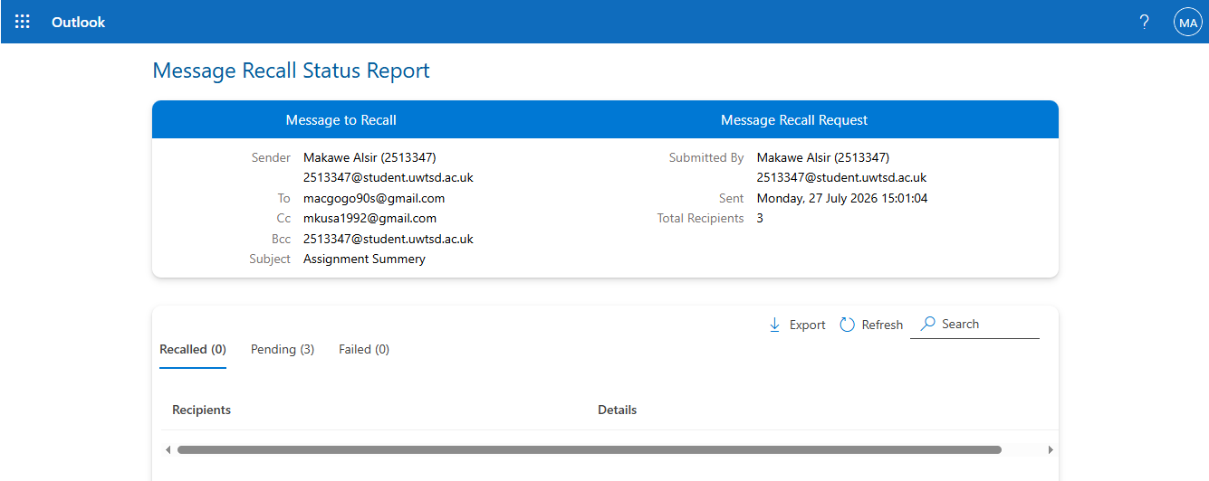
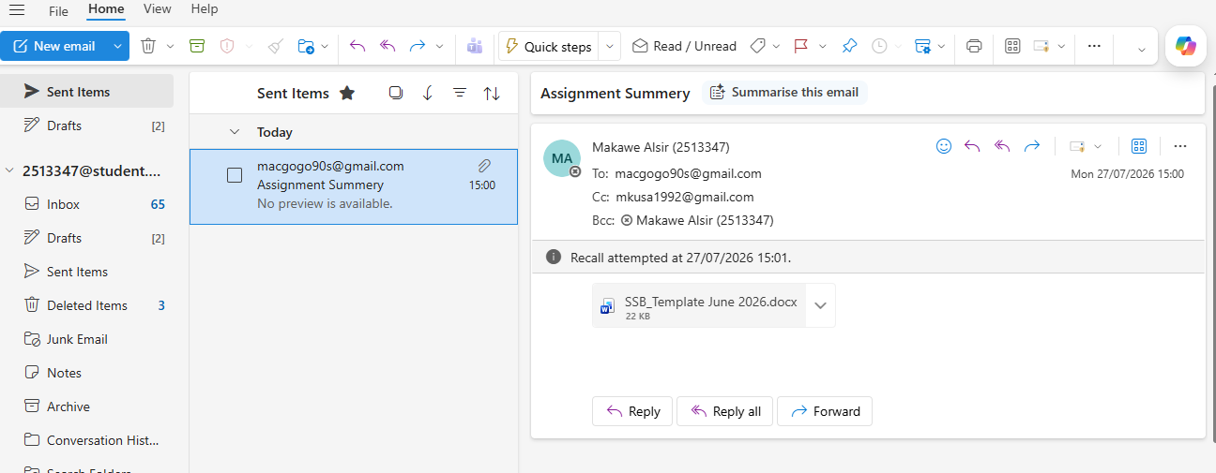

Teams

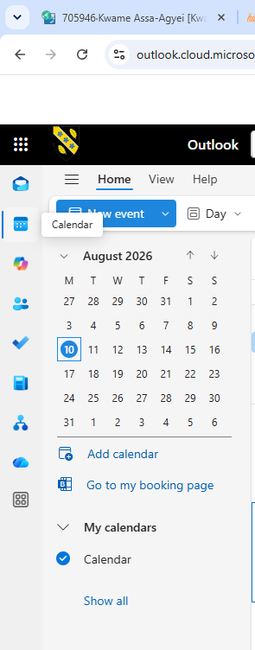

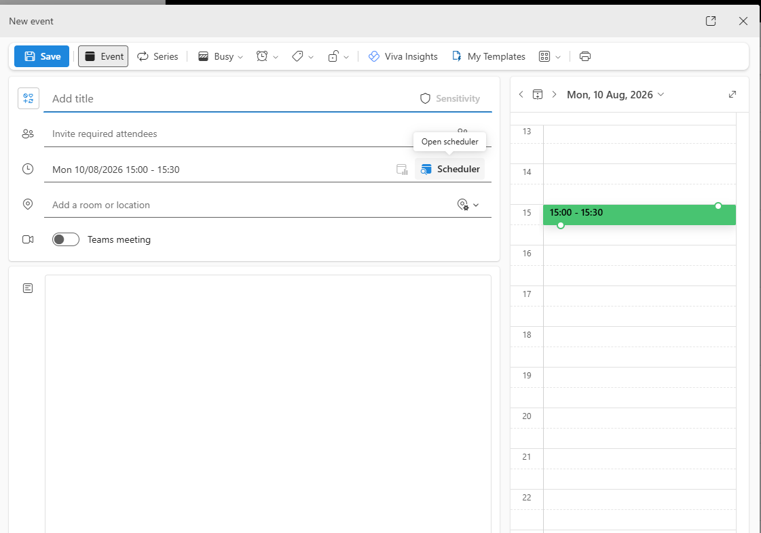

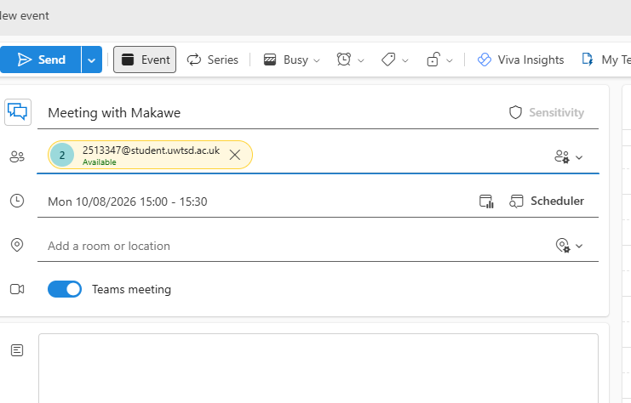

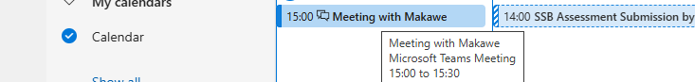

Conclusion
In conclusion, contemporary software solutions play an important role in supporting the day-to-day operations of modern businesses and organisations. This assignment has examined different types of software and demonstrated how they can be used to improve business activities, productivity, communication and the management of information.
The discussion of e-commerce website builders, particularly Wix and Shopify, showed how businesses can create and manage online stores, products, payments, inventory and sales activities. The assignment also examined mind mapping and demonstrated its usefulness for strategic planning, business development, brainstorming and marketing activities. Mind mapping can help organisations present ideas visually and understand the relationships between different business objectives and activities.
The four Microsoft Office applications, including Word, Excel, PowerPoint and Access, provide different functions that support everyday business operations. Word can be used to create and manage professional documents, Excel supports data organisation and calculations, PowerPoint helps businesses communicate information through presentations, and Access allows organisations to store and manage structured data. The testing of features such as the PivotTable and IF statement also demonstrates how software features can be applied to perform practical business tasks.
Finally, the assignment considered communication and collaboration applications, including Microsoft Outlook and Microsoft Teams. These applications support email communication, scheduling, online meetings, messaging, file sharing and collaboration. Overall, the different software solutions examined in this assignment demonstrate how contemporary technology can help businesses operate more efficiently, organise information effectively, communicate with stakeholders and support everyday organisational activities.

References
[1]
“Shopify.” Available: http://shopify.com/uk/blog/what-is-shopify
[2]
“wix.com.” Available: https://www.wix.com/about/us

[3]
“Apk mirror”, Available: https://www.appconner.com/app-microsoft-word?utm_source=bing&utm_medium=cpc&utm_campaign=650502132&utm_content=1247947069782069_77996828942708&utm_term=ms%20word&device=c&network=o
[5]
“What is power point.” Available: https://support.microsoft.com/en-us/powerpoint/training/what-is-powerpoint

