Intercultural Competence Report

Module Title: Foreign Languages and Cultural Awareness
Module Code: BMIH5003
Lecturer: Heidi Prosser

Student Name: Stefan Mihaita Lucian
Student ID: 2234126

Content table

- Executive Summary - Page 3
- Introduction - Page 4
- England vs. Greece - Page 4
- Country Analysis based on the GLOBE Project- Page 5
- Challenges of Intercultural Leadership - Page 7
- Recommendations - Page 8
- Conclusion - Page 9
- References - Page 10

Executive summary

This executive summary highlights key cultural differences between England and Greece, using insights from both the GLOBE Project and Hofstede's work. England favours flatter hierarchies and encourages individual initiative. Greece, on the other hand, prefers clear structures and places a higher value on group loyalty. Naturally, these differences can influence communication styles and perceptions of authority, posing challenges for hospitality industry leaders. Our report concludes with actionable steps for Inclusivity Hotel & Spa, including investing in specific cross-cultural training, creating inclusive team-building activities, and encouraging leadership to adopt adaptable styles. Addressing these cultural differences head-on allows the hotel to improve overall performance and teamwork.

Introduction

To lead Inclusivity Hotel & Spa's diverse team successfully, a deep understanding of the cultural practices and values of its members is vital. This report examines the cultural and leadership dimensions of the GLOBE Project, focusing on England and Greece, to determine how they affect hospitality management. This analysis is critical for implementing effective intercultural strategies in the hotel. Exploring these dimensions can help identify potential areas of cultural friction. This helps to develop leadership approaches that respect diverse cultural identities, resulting in a harmonious and efficient service environment that is consistent with the hotel's commitment to inclusivity and excellence.

England vs. Greece
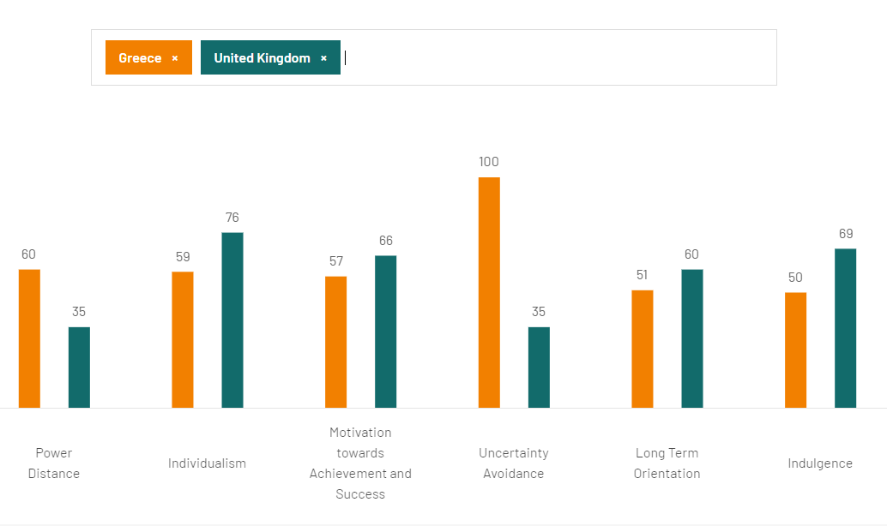
1Hofstede Insights, 2023
As a member of the Leadership Team at Inclusivity Hotel & Spa, understanding the cultural differences between England and Greece is critical for effectively leading a multicultural team. The GLOBE Project and Hofstede's research shed light on these distinctions.
England's lower Power Distance indicates a preference for flat hierarchies and employee autonomy. In contrast, Greek culture values a clear chain of command, which could influence how management is perceived (Hofstede, 2011). England also values individual achievement, whereas Greece values collectivism and group success (Hofstede Insights, 2021).
Greece ranks higher in Uncertainty Avoidance, emphasising structure and rules. This contrasts with England's relative comfort with change and flexibility (Hofstede Insights, 2021), which may influence how the hotel handles procedures and guest requests.
Communication styles also vary. English employees may be more direct, whereas Greeks may prefer a gentler, more subtle approach (House et al., 2004). To avoid misunderstandings, the team should use adaptable communication strategies.
It's important to remember that these models provide insights, not absolutes. They cannot capture the full complexity of individual identities or cultural differences (Jones, 2007). They should serve as a starting point for understanding the various dynamics of the hotel's team.

Country Analysis based on the GLOBE Project
2The GLOBE project Website, 2024
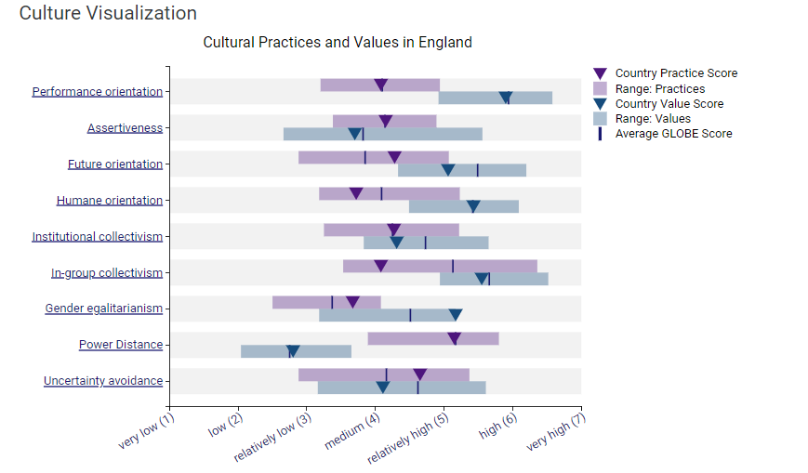
The GLOBE Project highlights significant cultural differences between England and Greece, which have a direct impact on leadership at Inclusivity Hotel & Spa. England's lower Power Distance suggests that employees there prefer a more inclusive approach to decision-making (Carmeli, Reiter‐Palmon, & Ziv, 2010; Javed, Abdullah, Zaffar, ul Haque, & Rubab, 2018). This contrasts with a potentially more hierarchical preference among Greek employees (House et al., 2004), which could lead to conflicts over management styles and employee autonomy.
3The GLOBE project Website, 2024
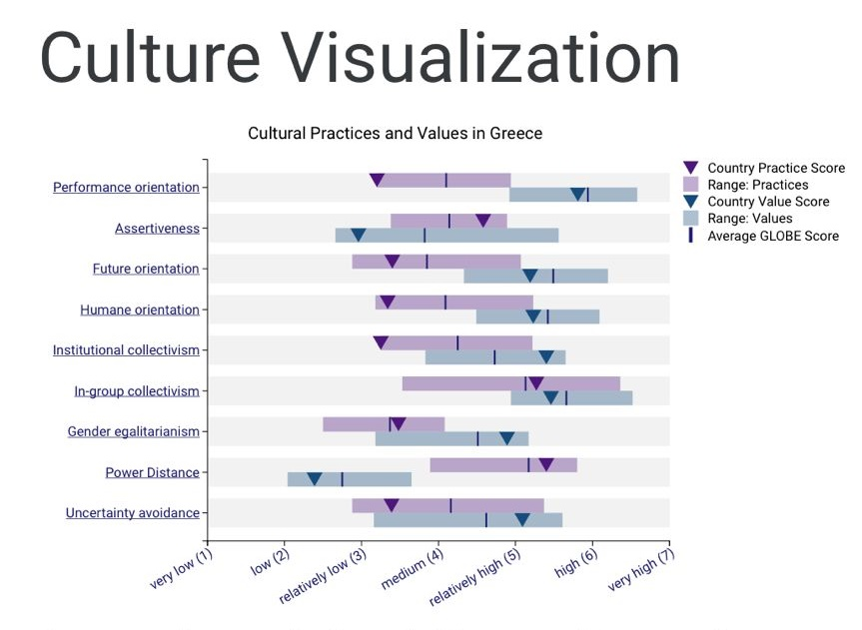
Greece has a higher Uncertainty Avoidance score, which indicates a preference for clear structures and procedures (House et al., 2004). English employees may be more adaptable, which could cause friction when maintaining consistent hotel standards.
Individualism among English employees may clash with the Greek emphasis on group harmony and shared responsibility (Hofstede Insights, 2021). This difference may strain team cohesion, particularly in guest-facing situations where a united front is essential.
Communication styles also differ: English directness may strike Greek employees as abrasive, as they are more accustomed to a gentler approach (House et al., 2004; Broeder, 2021).
Leadership in the hospitality industry must understand these subtleties. The goal should be to foster a respectful environment in which different practices are recognised and combined to ensure smooth operations. This ensures excellent guest service while respecting the cultural backgrounds of the hotel's diverse staff (Pless & Maak, 2004).

Challenges of Intercultural Leadership

4 The GLOBE project Website, 2024
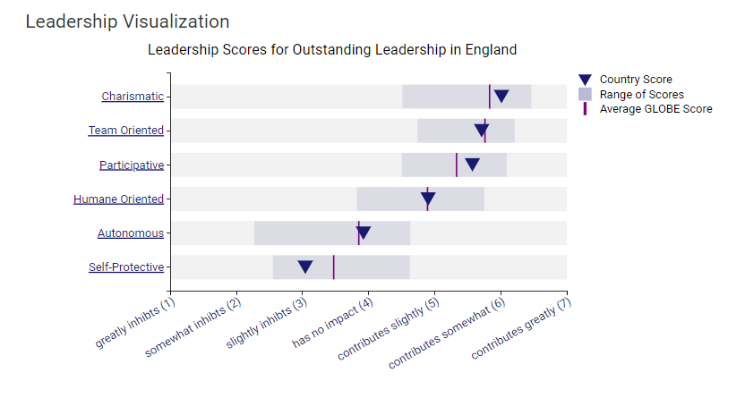 Leading a multicultural team in the hospitality industry, such as at Inclusivity Hotel & Spa, entails navigating challenges stemming from diverse cultural practices and communication styles. In the scenario presented, language barriers or misunderstandings could easily lead to errors. For example, an employee's well-intentioned suggestion based on their own culture may conflict with a guest's dietary requirements, highlighting the importance of understanding cultural differences, particularly when it comes to food (Baum, 2015).
Leadership styles also vary. A leader accustomed to UK directness may encounter friction with Greek employees, who prefer greater subtlety and indirectness in communication (House et al., 2004). This may complicate how directives or feedback are interpreted.
Furthermore, the collectivist values common among Greek employees may contrast with the more individualistic tendencies of British colleagues, influencing teamwork and task assignment (Hofstede Insights, 2021).
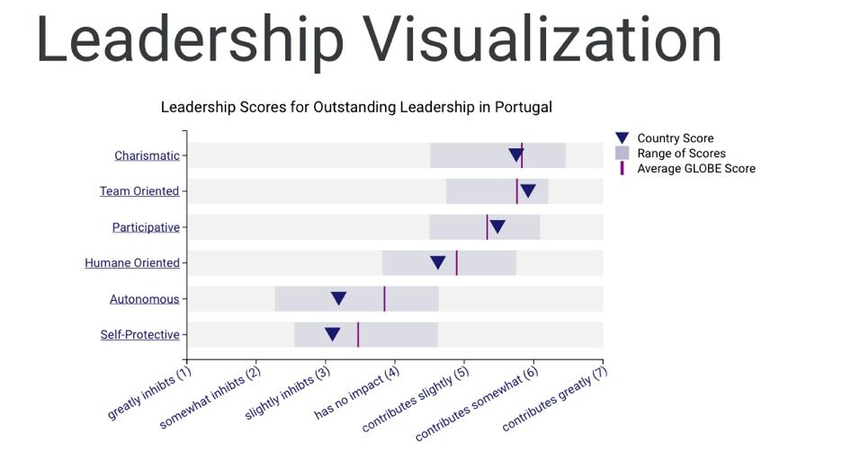
5The GLOBE project Website, 2024
To address these challenges, leaders must exhibit cultural intelligence. Models such as Trompenaars and the GLOBE Project provide useful insights for resolving conflicts and increasing team cohesion. However, keep in mind that these frameworks provide guidance rather than absolute descriptions of individual behaviour; leaders must remain adaptable and aware of individual differences (Henderson, 2007).

Recommendations

- Intercultural training programs be developed, focusing on the specific cultural dimensions and workplace expectations of both English and Greek employees, to promote understanding and mitigate conflict.
- Team-building initiatives and activities that celebrate cultural diversity should be regularly organized, fostering an inclusive environment where every team member feels valued and understood.
- Leadership training should be provided to ensure managers can adapt their styles to the cultural needs of their team, promoting a balance between assertiveness and sensitivity, and recognizing the unique contributions of each cultural group.

Conclusion
This report concludes that understanding and effectively managing cultural differences between English and Greek employees is critical for success at Inclusivity Hotel & Spa. The GLOBE Project identifies significant differences in how each culture handles uncertainty, power structures, and group dynamics. These differences can have an impact on communication styles, leadership expectations, and team performance. The report suggests three specific solutions: cross-cultural training, inclusive team-building activities, and encouraging adaptable leadership styles. Implementing these strategies will create a more harmonious work environment, thereby supporting the hotel's commitment to providing exceptional guest service.

References:

- Baum, T. (2015) 'Human resources in tourism: Still waiting for change? A 2015 reprise'. Tourism Management, 50, 204-212.
- Broeder, P. (2021). Informed Communication in High Context and Low Context Cultures. Interdisciplinary studies in social sciences – unmasking truths whilst nurturing new possibilities.
- Carmeli, A., Reiter‐Palmon, R., & Ziv, E. (2010). Inclusive Leadership and Employee Involvement in Creative Tasks in the Workplace: The Mediating Role of Psychological Safety. Creativity Research Journal, 22, 250-260
- Chang, W. (2017) 'Approaches for Developing Intercultural Competence: An Extended Learning Model With Implications From Cultural Neuroscience', Human Resource Development Review, 16, pp. 158-175.
- GLOBE Project (n.d) About. Available at: https://globeproject.com/
- Henderson, J.C. (2007) 'Corporate social responsibility and tourism: Hotel companies in Phuket, Thailand after the Indian Ocean tsunami'. International Journal of Hospitality Management, 26(1), 228-239.
- Hofstede Insights (2021) Country Comparison Tool. Available at: https://www.hofstede-insights.com/country-comparison-tool
- Hofstede, G. (2011) Dimensionalizing cultures: The Hofstede model in context. Online Readings in Psychology and Culture, 2(1).
- House, R.J., Hanges P.J., Javidan M., Dorfman, P.W. & Gupta, V. (2004) Culture, leadership, and organizations: The GLOBE study of 62 societies. Thousand Oaks, CA: Sage Publications.
- Javed, B., Abdullah, I., Zaffar, M. A., ul Haque, A., & Rubab, U. (2018). Inclusive leadership and innovative work behavior: The role of psychological empowerment. Journal of Management & Organization, 25, 554-571
- Jones, M.L. (2007) 'Hofstede – Culturally questionable?' Oxford Business & Economics Conference, 24-26 June 2007, Oxford, UK.
- Mor, S., Morris, M., & Joh, J. (2013) 'Identifying and Training Adaptive Cross-Cultural Management Skills: The Crucial Role of Cultural Metacognition', Academy of Management Learning and Education, 12, pp. 453-475.
- Pless, N. M., & Maak, T. (2004). Building an Inclusive Diversity Culture: Principles, Processes and Practice. Journal of Business Ethics, 54, 129-147

