Student Name: Chloe Mason
P Number: 1902424
Programme of Study: BA Set Design
Module: ADAD4018

Tasks in the order I received them:
Task One: Semiotic Analysis (Ryan task) = 516 words
Task Two: Manifesto (Julia Task) = 571 words
Task Three. (Jon Task) = 492 words

(Julia task)
1) Due to movie/TV production increasing over the past couple years. There is no need to look at past examples of special effects in film.
2) since CGI being developed in the early 1970s, seemingly it has now become a staple trope in film industry and now it is seemingly over used in 21st century film/tv industry and done badly.
3) Colour theory isn’t as relevant in the film/tv industry as it used to be.
4) There are other means of creating a mood in a scene besides utilising colour theory.
5) The majority of Movies and tv created today only strive due to a large budget in production value.
6) Modern Set designers can expand their deigns and ideas due to the advancement in CGI so there is no need to scout locations or make sets by hand.
7) Since in introduction of colour in cinematography in the 1950’s the film/TV industry have looked over every aspect of colour theory and would be a waste of time to look to new idea.
8) CGI and Colour Theory work hand in hand in creating the best possible outcome for the film industry and without using colour theory in CGI would be a disaster.

Keyword: Rushed
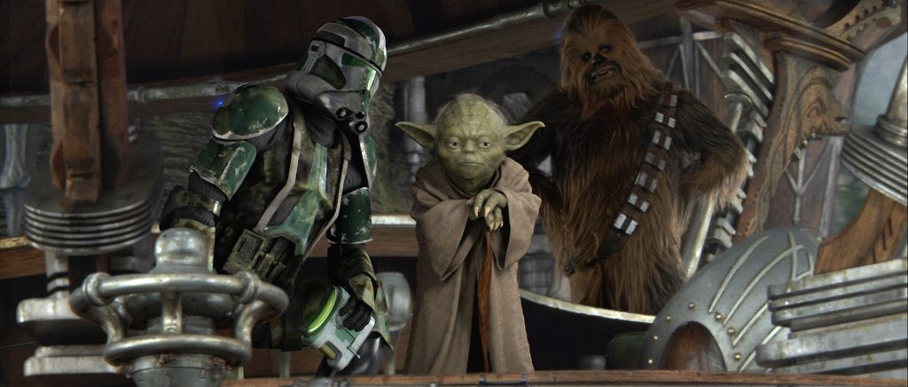
Since CGI being developed in the early 1970s, seemingly it has now become a staple trope in film industry and now it is seemingly over used in 21st century film/tv industry and badly done.
The advancement in CGI (Computer Generated Imagery) has created a new era of how 21st century films are produced. The 90’s and early 2000 created a wave of films with some questionable use of CGI; massive amounts of CGI doesn’t mean an audience will be satisfied with the out come. In turn, this can lead to the effect called the uncanny valley effect. These replicas may elicit cold, eerie feelings because of the perceived salience of their nonhuman features. (Mori 1970/2012)
Star Wars Episodes I, II, III over compensates with a heavy use of CGI. Leaving clear visual gaps in scenes as the relationship between CGI and practical effects becomes unsatisfying to the eye leaving the afore mentioned effect. “Biggest challenge in digital effects is now about getting things done fast”, (Dennis Murren, p360). Suggesting, time is needed to pull off well made effects that flow seamlessly between practical effects and CGI . Seemingly over using CGI isn’t a negative. On the contrary, if not rushed can be spectacular.“audiences are genuinely swept up by the drama and intrigued by well observed characters” (Murren,p 360). CGI shouldn’t be rushed and when done correctly audiences are swept away.

Keyword: Reinventing
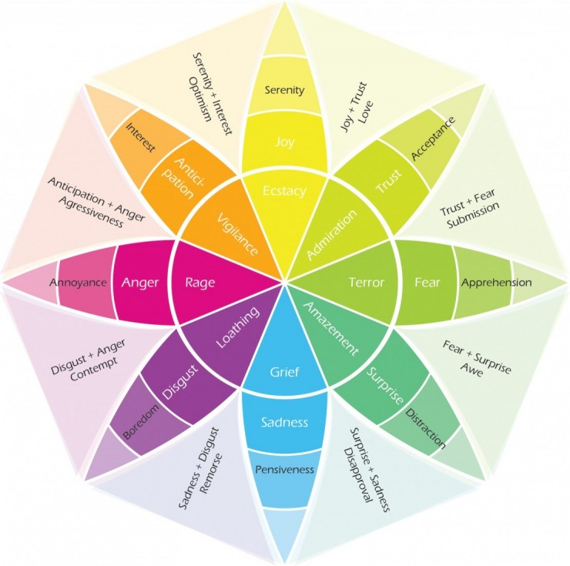
Since in introduction of colour in cinematography in the 1950’s the film/TV industry have looked over every aspect of colour theory and would be a waste of time to look to new idea.
Coloured television has been around for a lengthy amount of time, colour theory being around longer. Leaving us to wonder has every aspect been explored? Around the 16 hundreds, “ the theory of colour seem to offer something new and exciting to artists” (Karen Haller, 2019 , p6). Even in the 21st century it still offers this. We as a collective have associated colours heavily with mood, film makers exploiting this profoundly. “The taste of all minds” (Gage ,1999, p.46). as we as a whole agree that certain colours associated with different moods. As every big blocker buster hit brings new and exciting ways to exploit this idea. When used correctly bring together, ‘harmony, the devising of colour system, and the exploration of how colours relate to the mechanism of perception, and the feelings of the spectator”, (Isaac Newton, 1666-72, p46).In, conclusion the question has to be asked, will the human mind ever stop exploring this theory? No, its for ever being reinvented and explored. Colour theory within the 21st century film industry will constantly discover new ways of manipulating an audience mind through colour.

Key word: Alternative
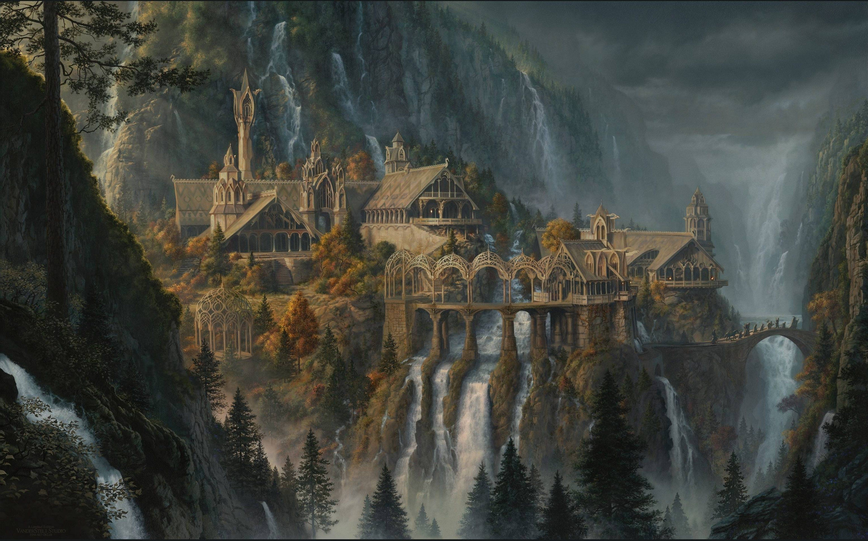
Modern Set Designers can expand their deigns and ideas due to the advancement in CGI so there is no need to scout locations or make sets by hand.

It’s not faults in saying CGI hasn’t opened a gateway and has aided the film industry in doing so. That is if its used correctly. The lord of the rings saga seemingly used huge amounts of CGI, “It wouldn’t be until the age of computer-generated imagery that Tolkien’s dreams would finally be rendered with brilliance to match theory creator’s imagination”(Richard Rickitt, 2000, p.222). That’s to say both hand made sets and scout locations were used massively, “Stunning New Zealand location..” were used “…..and full scale sets were augmented”(Richard Rickitt, 2000, p.222). Lord of the rings setting a new standard for how film/tv series should be made, as the combination of both traditional and CGI being used alongside each other to achieve the best possible out come. The future of the film/tv industry could hold a new wave of technology. “computer generated characters and environments will evolve…Whatever additional new forms of entertainment we create; they will probably used along side old methods” (Douglas Trumbull, p360). In the future CGI could be use as and alternative to the old methods, however, for a long time to come will be apace with them.

Bibliography

Debaleena Chattopadhyay. 2016. Familiar faces rendered strange: Why inconsistent realism drives characters into the uncanny valley. http://macdorman.com/kfm/writings/pubs/Chattopadhyay-MacDorman-2016-Familiar-Faces-Rendered-Strange-Why-Inconsistent-Realism-Drives-Characters-into-the-Uncanny-Valley-JOV.pdf
John Gage.1999. Colour and Meaning.Thames & Hudson.
Karen Haller.2019. The little book of Colour: How to use Psychology of Colour to Transform your life. Penguin Books.
Richard Rickett. 2000. Special Effects; The History and Technique. Watson-Guptill.
Images
Lord of the rings -https: //images.app.goo.gl/9eL1Uus2CpAxxuTq8
Colour Theory- https://images.app.goo.gl/nYvEV2c133EpVxeQ6
Yoda picture- https://images.app.goo.gl/Q8AKmJPi1VUZP9A49
Ryans task
Semiotics, can it help us?As a society we are constantly driven into a false consciousness, and fake new. (Umberto Eco 1976) defined fake new and its relationship with “semiotics as the study of what can be used to lie”. At its most basic definition as “the study of signs”. making us believe a false narrative is fact. What can semiotics teach us about representation and reality? Allegory of Plato’s Cave, gives us an example of how from infancy we have been set to believe certain facts and ideas.
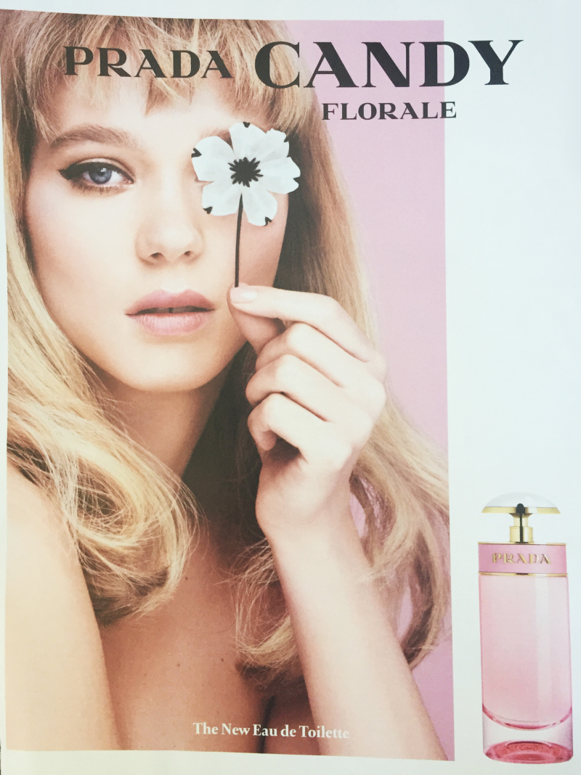
In our Western society have been brought up to believe the same basic ideas. For example, we are taught a household pet, who is fury and likes to chance mice is a cat (signified). Seeing a imagine of a cat (sign) Hearing a cat hiss, sign that its angry (signifier) These are the 3 main processes of semiotics (Sebeok, 1986)
We can be forever convinced of something that isn’t true, especially when it comes to advertisement, (Lasswell el al, 1949 ) states “symbols (words and images) affect power”. Advertisement uses images heavily grabbing the audience and having power over them. We can become a prisoner to our society and controlled and manipulated to suit the needs higher classes, people believing there is no alternative and fail to search for new ideas or change the way they think is reality. Semiotics being the frame work of advertisements.
Advertisement for Prada ‘Candy Florale’ Perfume, 2015. Elle Magazine, Issue 21. This advert shows like many other advert give the viewer a false consciousness. (Machiavelli 1952, p22) states we are “moved more by appearances than by the reality of things”, as the standing point of the image is a beautiful woman striking the audiences attention. A well designed perfume advert, however, looking at this deeper and looking at the semiotics of the advert. We see an imagine of a women and a perfume bottle, there are no profound connections between the two, only a simple connection of the bottle being pink and the women being bathed in pink background. On the contrary, leaving subtle links is how the media tricks us, visuals being one of them. Each part is screaming youthful, fresh, feminine, swaying towards a younger female group. Perhaps, bring back nostalgia to older women, even tho she isn’t clothed her style of hair an makeup is similar to that of 60’s fashion. The way the photo of her is taken look like a Polaroid photo. The word ‘Candy’ in the right hand corner being the name of the perfume, making us think of a sweet taste. Drawing all are senses to a youthful, Nostalgic, freeing. All this from very subtle signs Does it mean the person who buys this perfume will be young again?No, its only perfume not the fountain of youth. On the contrary, another great example how we are given fake news and draw into a false consciousness. When you know the signs of between reality and fake news, we begin to break out of our prison and see the world from a new perspective, Plato’s Cave Theory.

Bibliography

Daniel Chandler. 2017. Semiotics: the basics. Third Edition.Routledge.

Frank Biocca. 2015. Television and Political, Advertisement: signs, codes and images. Taylor and Francis

Kristie Lund. August 12, 2015. Week 2 semiotic analysis of advertisements. https://theoriesofvisualcom.wordpress.com/2015/08/12/week-2-semiotic-analysis-of-advertisements-kristie-lund/

Rosalind Gill. 2015. Gender and the media. Wiley

Image
Advert- https://theoriesofvisualcom.wordpress.com/2015/08/12/week-2-semiotic-analysis-of-advertisements-kristie-lund/

Jon’s task

Vincent van Gogh was born in Zundert, Netherlands on the 30th March 1853 (Melissa McQuillian,1989, p7). This was exactly one year after his older brother who was also called Vincent was still born. His tombstone was an airy reminder to van Gogh himself and his parents of his older brothers’ death, which continued to follow him through his childhood with persistent sadness ‘doesn’t mean the practice wasn’t traumatic for a child 2” and “Vincent Van Gogh was aware of and presumably visited a grave stone with his full name and date of birth on it” (Stacy Conrads 2015). The start of his many depressive episodes through his life, and depicts these episodes through is work.
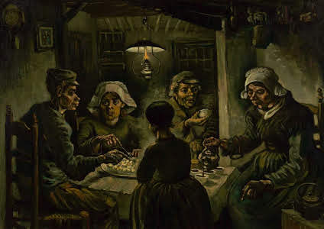

At the age of 28, Van Gogh stated “ill take up my pencil again, I’ll take up drawing and from the moment everything changed for me”(Van Gogh, p51).This being the start of his creative career. The Potato Eaters, was classed by van Gogh himself as one his first masterpieces (Van Gogh, p64).During this time there was a clear divide between the rich and the poor, however, van Gogh was more interested in the poor than the rich as he stated: “I like so much better to paint the eyes of the people than to paint cathedrals”(Van Gogh, p64). This marked the beginning of the post-impressionist movement as he choose to express the word through his own unique stand point. (one art critic wrote that potato eaters) “seemed to crawl over each other like blind puppets”(Robert Wallace, p38). Van Gogh took a lot of criticism believing “most people who know me consider me failure”(Van Gogh, p184), people criticising his work often. However, his work wasn’t intended to impress people it was a way of him getting through is depressive state and helped him see the beauty in the world. ‘I think a painter is happy because he Is in harmony with nature as soon as he can express a little of what he sees‘(Van Gogh, p178).

His work was never noticed while he was alive, only admired by his brother (Mark Roskill,1979,p266). After his death, his work became something of a revolution for the post-impressionist movement. As the pain of his life was imprinted in his work and each painting tells a story of his life and the society at the time.‘It stands to reason that this should be so; every society needs an image in its own likeness.’ (Fontcuberta,2014;10). He was “genius, madness, inspiration and individuality”(Melissa McQuillian,1989,p202) . The way he paints with such vivid colours and bold colours suggest a vast range of emotion, a key feature in the post-impressionist movement and inspired a wave of artist in the future. For many such as myself, when viewing his painting the viewer can feel hundreds of emotions, each painting depicting a therapy session. Reading his letters can bring about a whole new perspective on life and will forever inspire a new generation of people, he is timeless.
Bibliography

Fontcuberta,2014

Mark Roskill. 1979. The Letters of Vincient Van Gogh. Fontana Cassics of History and Art.

Stacy Conrad’s. July 27, 2015. Meet Vincent Van Gogh’s Brother, Vincent Van Gogh.
https://www.mentalfloss.com/article/66547/meet-vincent-van-goghs-brother-vincent-van-gogh

Robert Wallace. 1967. The World of Van Gogh. Time-Life International (Nederland) N.V.

Melissa McQuillien. 1989. Van Gogh. Thames and Hudson.

Image

Potato Eaters- https://artsandculture.google.com/asset/the-potato-eaters/7gFcKarE9QeaXw?hl=en-GB&ms=%7B%22x%22%3A0.5%2C%22y%22%3A0.5%2C%22B%22%3A9.35550055041617%2C%22z%22%3A9.35550055041617%2C%22size%22%3A%7B%22width%22%3A1.2213345359486714%2C%22height%22%3A1.237499999999999%7D%7D

