University of Wales Trinity Saint David
Motorsport Engineering
Harri Evans
2500728
27/04/2026
Materials and Manufacturing - ACHA4025
Engineering Materials
Word Count - 1973

Table of Contents
1.Introduction 3
2.Literature Review 4
3.Methodology 6
4.Test Results 7
5.Analysis 9
6. Conclusion 11
References 13

1.Introduction
This report investigates the failure of aluminium alloy drive shafts used on a motorsport vehicle during the Dakar rally. Both vehicles suffered a similar drive shaft facture with put them out of the race. Since both components were manufactured using the same design and production methods as previous components which did not fail, the failure investigation will focus mainly on the material supplied for the latest batch of components.
The drive shafts are known to be manufactured from aluminium but the exact grade and heat treatment are unknown. The team recently changed aluminium supplier which has created the suspicion that the material may have not matched the specification. During operation the maximum stress measured on the component by the team was 90MPa. This value is important as it can be compared with the results from the tensile test of the supplied aluminium sample.
The purpose of this investigation is to carry out a tensile test on the supplied sample to BS EN ISO 6892-1:2019 standards and calculate the yield strength, ultimate tensile strength and young’s modulus and then use these results to create a conclusion of why the drive shafts failed. I will also consider the appearance of the fractured surface as this will give an idea of how the break developed such as a progressive crack with a sudden failure which is common with a fatigue type of failure.
The tensile test will provide good insight into the materials resistance to static loading, however a car drive shaft will experience repeated torsional load, vibration, shock loads, stone impacts and rapid torque changes caused by acceleration, braking and rough terrain. Therefore, I will have to take this into account when coming to a conclusion.

2.Literature Review
For a motorsport drive shaft, material selection must consider strength, stiffness, ductility, toughness, fatigue resistance and traceability. The most important tensile properties are proof stress, ultimate tensile strength, young’s modulus and percentage elongation. Proof stress is especially relevant for aluminium alloys because aluminium does not always show a clear yield point. Therefore a 0.2 percent proof stress is normally used instead of a definite yield stress. Ultimate tensile strength is the maximum stress reached during the tensile test. Young’s modulus describes the stiffness of the material in the elastic region.
The main British standard for tensile testing metallic material is BS EN ISO 6892-1:2019 (Standards, 2020) This standard specifies the method for testing at room temperature and defines the mechanical properties that can be determined from the test including proof stress, elongation and tensile strength. This is relevant to the investigation as the team needs to confirm if the aluminium sample has suitable tensile properties for a motorsport drive shaft.
The testing equipment it self should be suitable for the test and is calibrated correctly to ensure that the results are accurate as it may cause an incorrect conclusion about the material strength. BS EN ISO 7500-1:2018 covers the calibration and verification of static uniaxial testing machines including tension and compression testing machines. This is important because the stress values calculated depend directly on the test measured force. (ISO, 2018)
The aluminium alloy grade also needs to be confirmed because different aluminium alloys can have very different mechanical properties. BS EN 573-3:2026 (bsi, 2026) covers the chemical composition and form of aluminium alloy products. This standard is relevant because the drive shafts are known to be aluminium alloy but the grade and temper are unknown. If the new supplier provided an incorrect alloy the shaft may have had lower strength or worse fatigue resistance than expected.
Hardness testing could also be used as a quick check when comparing material batches. BS EN ISO 6507-1:2023 specifies the Vickers hardness test method for metallic materials. Hardness testing would not fully replace tensile testing, but it could help identify whether a new material batch is noticeably different from a previously approved batch. This would be useful as part of an incoming inspection process for future supplier deliveries to prevent alloy grade mistakes. (bsi, 2023)

Although tensile testing is useful a drive shaft does not normally fail under simple static tension. In operation it is mainly exposed to torsional loading, vibration and shock loads. During the Rally the shaft would experience repeated torque changes from acceleration, braking, wheel spin, landing after jumps and rough terrain. This means fatigue resistance is a key property. BS ISO 1352:2021 is relevant because it specifies conditions for torsional, constant-amplitude fatigue testing of metallic specimens. This would be more representative of a drive shaft than a simple tensile test because the real component is repeatedly twisted during use. (bsi, 2021)
Overall, the literature shows that the failure investigation should not only rely on one tensile test result. The team should check the tensile properties using BS EN ISO 6892-1:2019, ensure the test machine is calibrated to BS EN ISO 7500-1:2018, confirm the aluminium composition and compare mechanical properties and require supplier certification. For future validation, torsional fatigue testing should be considered because fatigue is a likely failure mechanism for a motorsport drive shaft.

3.Methodology
The aluminium tensile sample was tested using the ES6 tensile testing equipment. The test was carried out using the principles of BS EN ISO 6892-1:2019, which is the British standard method for tensile testing of metallic materials at room temperature. The material was recorded as aluminium and the original gauge length was measured as 31 mm.
The sample was then fitted into the testing rig and held securely with two bolts which was important to reduce movement or slipping during the test, the load nut was then turned in gradual increments of 0.2 millimetres at a time, and the dial indicator reading was recorded at each stage.
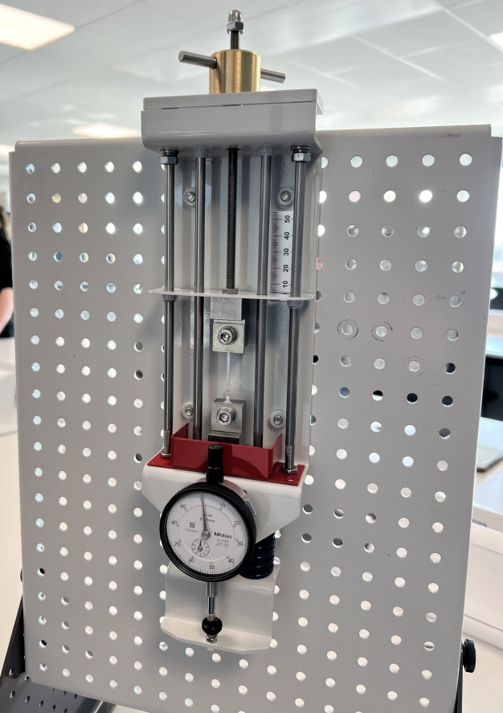
The test was continued until the aluminium sample broke. After failure, the broken sample was removed from the test rig and inspected visually and the fracture showed slight deformation before failure and a relatively clean break near the top of the sample. This suggests that the material experienced tensile loading until it could no longer withstand the applied force. The recorded load nut movement readings could then be used to calculate force, stress, extension and strain.

Figure 1.
The image above shows the testing equipment with the aluminium sample tested till failure.

4.Test Results
The tensile test results were recorded from the tensile testing equipment. The original length of the aluminium sample was 31 mm, and the original cross-sectional area was 2.0 mm². The load nut movement and dial indicator reading were recorded at each stage of the test until the sample fractured. From this data I can then calculate force, stress, extension and strain as shown in the table below.
Load Nut Movement (mm) | Dial Indicator (mm) | Force(N) | Stress(Mpa) | Extension(mm) | Strain
0 | 0 | 0 | 0 | 0 | 0
0.2 | 0.16 | 16 | 8 | 0.04 | 0.00129
0.4 | 0.35 | 35 | 17.5 | 0.05 | 0.001613
0.6 | 0.54 | 54 | 27 | 0.06 | 0.001935
0.8 | 0.72 | 72 | 36 | 0.08 | 0.002581
1 | 0.9 | 90 | 45 | 0.1 | 0.003226
1.2 | 1.08 | 108 | 54 | 0.12 | 0.003871
1.4 | 1.27 | 127 | 63.5 | 0.13 | 0.004194
1.6 | 1.45 | 145 | 72.5 | 0.15 | 0.004839
1.8 | 1.63 | 163 | 81.5 | 0.17 | 0.005484
2 | 1.81 | 181 | 90.5 | 0.19 | 0.006129
2.2 | 1.99 | 199 | 99.5 | 0.21 | 0.006774
2.4 | 2.18 | 218 | 109 | 0.22 | 0.007097
2.6 | 2.37 | 237 | 118.5 | 0.23 | 0.007419
2.8 | 2.54 | 254 | 127 | 0.26 | 0.008387
3 | 2.73 | 273 | 136.5 | 0.27 | 0.00871
3.2 | 2.91 | 291 | 145.5 | 0.29 | 0.009355
3.4 | 3.09 | 309 | 154.5 | 0.31 | 0.01
3.6 | 3.28 | 328 | 164 | 0.32 | 0.010323
3.8 | 3.46 | 346 | 173 | 0.34 | 0.010968
4 | 3.63 | 363 | 181.5 | 0.37 | 0.011935
4.2 | 3.81 | 381 | 190.5 | 0.39 | 0.012581
4.4 | 3.99 | 399 | 199.5 | 0.41 | 0.013226
4.6 | 4.15 | 415 | 207.5 | 0.45 | 0.014516
4.8 | 4.33 | 433 | 216.5 | 0.47 | 0.015161
5 | 4.5 | 450 | 225 | 0.5 | 0.016129
5.2 | 4.65 | 465 | 232.5 | 0.55 | 0.017742
5.4 | 4.78 | 478 | 239 | 0.62 | 0.02
5.6 | 4.86 | 486 | 243 | 0.74 | 0.023871
5.8 | 4.96 | 496 | 248 | 0.84 | 0.027097
6 | 5.06 | 506 | 253 | 0.94 | 0.030323
6.2 | 5.08 | 508 | 254 | 1.12 | 0.036129
6.4 | 5.13 | 513 | 256.5 | 1.27 | 0.040968
6.6 | 5.17 | 517 | 258.5 | 1.43 | 0.046129
6.8 | 5.21 | 521 | 260.5 | 1.59 | 0.05129
7 | 5.27 | 527 | 263.5 | 1.73 | 0.055806
7.2 | 5.27 | 527 | 263.5 | 1.93 | 0.062258
Figure 2.

Figure 3.

5.Analysis
From the data gathered from the experiment I can calculate the yield strength, ultimate tensile strength, and Young’s modulus as shown below.
ultimate tensile strength
$$f=5.27 X 100$$
$$f=527N$$
$$σ=\frac{F}{A}$$
$$σ=\frac{527}{2.0}$$
$$σ=263.5N/mm^{2}$$
$$UTS=263.5MPa$$
Yield strength
$$210MPa$$
The yield strength was estimated from the stress – strain graph because aluminium does not show a clear yield point.

Young’s modulus
$$E=\frac{∆σ}{∆ϵ}$$
$$F=3.28 X 100$$
$$F=328N$$
$$σ=\frac{328}{2.0}$$
$$σ=164MPa$$
$$Extension=3.6-3.28$$
$$Extension=0.32mm$$
$$ϵ=\frac{0.32}{31}$$
$$ϵ=0.0103$$
$$E=\frac{164}{0.0103}$$
$$E=15922MPa$$
$$15922÷1000=15.9GPa$$
$$E=16GPa$$
As shown in the equations above the test showed the aluminium sample had an ultimate tensile strength of 263.5MPa, an estimated Yield strength of 210MPa and a Young’s modulus of 16GPa. The Young’s modulus should be treated as an estimate as the rig may not have been calibrated correctly or there may have been play in the components which would offset the results.

6. Conclusion
The tensile test showed that the aluminium sample had an ultimate tensile strength of 263.5MPa, an estimated yield strength of 210MPa and a young’s modulus of 16GPa. The maximum recorded stress on the Dakar vehicle’s drive shaft was 90MPa, when you compared this with the measured yield strength of the sample you can determine the safety factor as shown below.
$$Safety Factor=\frac{210}{90}$$
$$Saftey Factor=2.33$$
The safety factor can then be calculated with the ultimate tensile strength as shown below.
$$Safety Factor=\frac{263.5}{90}$$
$$Saftey Factor=2.93$$
These results indicate that the drive shaft did not fail from single static load because the recorded stress of 90MPa was below the yield strength of the and ultimate tensile strength of the aluminium sample. This could be due to the environment the drive shaft experienced which would have been repeated torsional loading, vibrations, rapid acceleration, braking and impacts from rough terrain. Which is unlike the static tension conditions experienced by the test piece. The repeated load likely caused the part to fatigue and ultimately fail even though the maximum stress experienced is below the static strength of the material.
The most likely cause of the failure is the repeated fatigue, however it could have possibly made worse by an unstable aluminium alloy or incorrect heat treatment procedure from the new supplier. This theory is supported by the fact that both vehicles experienced similar drive shaft failure after the team changed aluminium supplier even though the design had not changed. This could be due to a lower grade aluminium or poor temper and fatigue.
The fracture from the photo also supports the theory of fatigue failure due to the appearance of a cleaner crack growth area and a rougher final break area, indicating that the crack had started and grown slowly before the remaining material suddenly broke.

To prevent similar failures in the future the team must improve material supplier control and each aluminium batch should be supplied with certification in accordance with BS EN 10204:2004 which will ensure the alloy grade, temper and chemical properties are correct. The material properties should be checked and compared with relevant aluminium standards.
Tensile and hardness test of the new catches of the material could also be conducted to ensure alloy quality against previous batches. To further validate the alloy quality the team could conduct torsional fatigue testing as this would be more representative of the real world conditions the drive shaft will experience than tensile testing alone. The finish of the component could be reviewed to ensure that the machining is up to standard and no marks are found where cracks could start.
Overall, in my opinion the most likely cause of the drive shaft failure was a combination of fatigue stress and possibly an incorrectly supplied alloy from the new supplier. To prevent this failure from happening again I recommend conducting the inspections and test I have mentioned above to ensure the components reliability and quality.

References
Standards, B. (2020). BSI Standards Publication Metallic materials -Tensile testing. [online] Available at: https://bpb-eu-w2.wpmucdn.com/blogs.brighton.ac.uk/dist/0/9491/files/2021/11/BS-EN-ISO-6892-1-2019-tensile-test-metals.pdf [Accessed 25 Apr. 2026].
ISO (2018). ISO 7500-1:2018. [online] ISO. Available at: https://www.iso.org/standard/72572.html [Accessed 25 Apr. 2026].
bsi (2026). BS EN 573-3:2026 - TC | 31 Mar 2026 | BSI Knowledge. [online] Bsigroup.com. Available at: https://knowledge.bsigroup.com/products/aluminium-and-aluminium-alloys-chemical-composition-and-form-of-wrought-products-chemical-composition-and-form-of-products-6 [Accessed 25 Apr. 2026].
bsi (2021). BS ISO 1352:2021 - TC | 31 Dec 2021 | BSI Knowledge. [online] Bsigroup.com. Available at: https://knowledge.bsigroup.com/products/metallic-materials-torque-controlled-fatigue-testing-1?utm_source=chatgpt.com [Accessed 25 Apr. 2026].
bsi (2023). BS EN ISO 6507-1:2023-TC | 31 Oct 2023 | BSI Knowledge. [online] Bsigroup.com. Available at: https://knowledge.bsigroup.com/products/metallic-materials-vickers-hardness-test-test-method-4 [Accessed 25 Apr. 2026].

Figure 1 (Author)
Figure 2 (Author)
Figure 3 (Author)

