

Programme: Master of Business Administration
Module: International Business Concepts
Module code: LCMB7034
Module Leader: Jean Wang

Student Name: Chiragkumar Somabhai Prajapati
Student ID: 2423111

Table of Contents
1. Introduction 3
2. Advantages and Problems of International Operations 3
a) Why Nestlé Is an MNC or TNC 3
b) Nature of Global Operations: Value Chain Analysis 5
c) Entry Modes Used by Nestlé 8
d) Benefits from International Operations 8
3. OLI Analysis: Impact on Market Entry Mode for Nestlé in India 10
3.1 Ownership Advantages and Their Influence on Entry Mode 11
3.2 Location Advantages of India and Their Impact on Entry Mode 12
3.3 Internalisation Advantages and Their Influence on Entry Mode 14
4. Cultural Differences Between Nestlé’s Home Country and India 15
4.1 Key Cultural Differences 16
4.2 Impact on Market Entry Strategy 18
4.3 Impact on Potential Success in the Market 18
5. Recommendations: Adjustments to Standard Operating Procedures (SOPs) 20
5.1 SOP Adjustment 1: Localisation of Products & Marketing 20
5.2 SOP Adjustment 2: Human Resource & Management Practices 22
5.3 SOP Adjustment 3: Supply Chain & Quality Management Adjustments 22
6. Conclusion 24
References 25

1. Introduction
Nestlé is the world's largest, most diversified food and beverages company (Nestle, 2023). It has an international presence in over 180 countries and over 2,000 brands in the name of dairy, confectionery, nutrition and beverages. Nestle as a globally based Swiss company with wide cross-border production, research capacity and decentralised systems of management is a prime example of a mature MNC that functions in complicated international markets. Nestle has around 277000 employees and its it has sales value of 91.4 billion in year 2024 (Nestle, 2023). This consultancy report aims to critically analyse the globalisation strategy at Nestle and use India as the example of the emerging economy, because of its growing middle class, consumption of packaged food and high growth potential in the field of nutrition and health-related products.
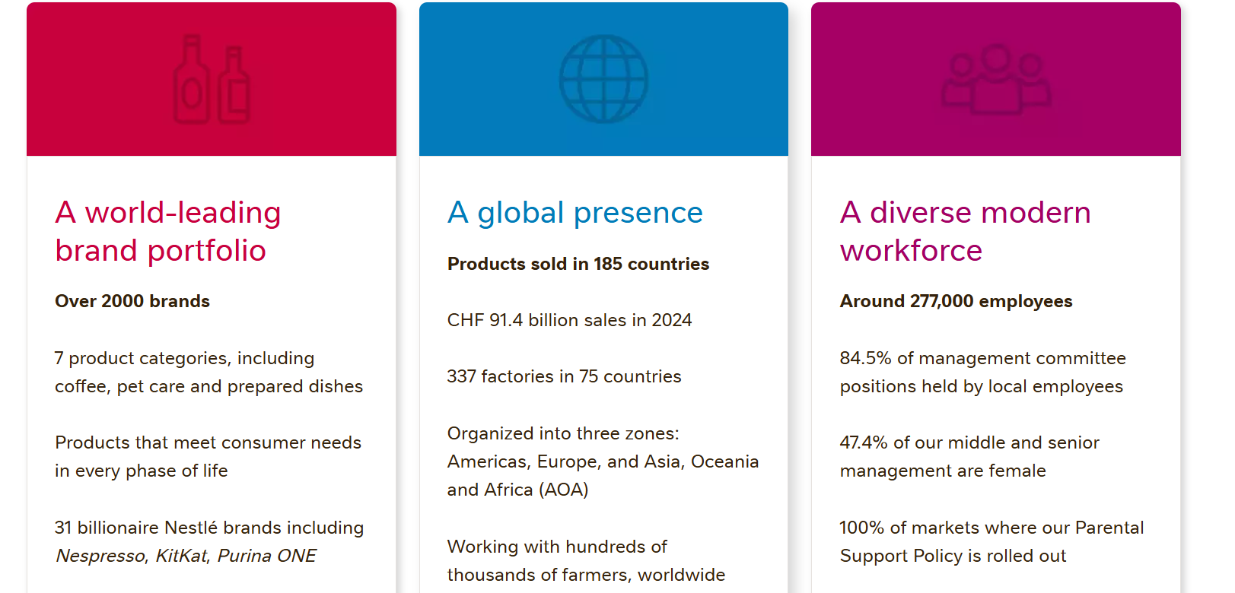
Figure 1: “Nestle International Presence”
(Source: Nestle, 2023)

2. Advantages and Problems of International Operations

a) Why Nestlé Is an MNC or TNC
Nestle is a multinational/transnational corporation in that the company has an enormous international presence, is decentralised and diversified in its international business. The corporation has world-leading brand portfolio, over 2000 brands, 7 product categories, including coffee, pet care and prepared dishes (Nestle, 2023). Its transnationalism is reflected in decentralizing strategic decision-making in regional centres located in Switzerland, the United States, Singapore and Latin America, so that it is responsive locally though globally integrated.
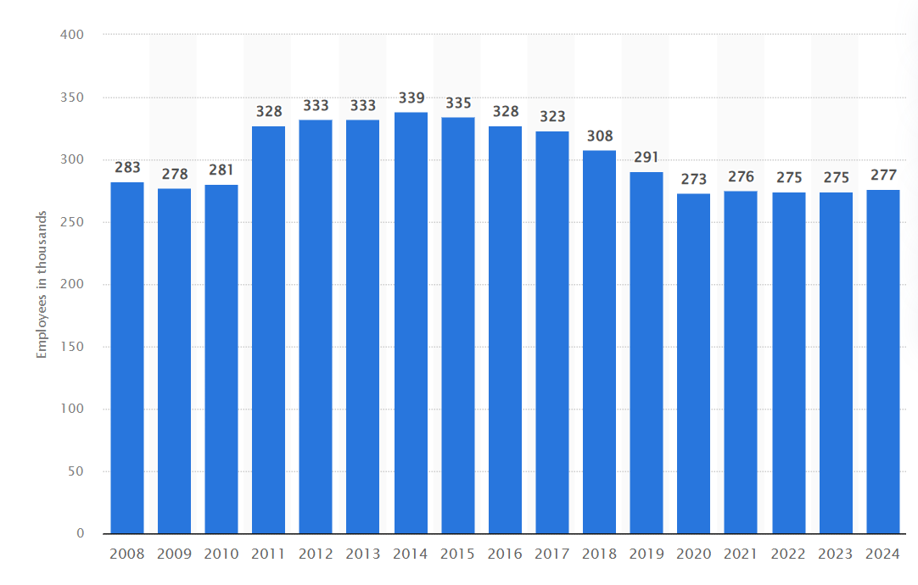
Figure 2: “Employees of Nestlé from 2008 to 2024”
(Source: Statista, 2023)
In 2024, Nestlé employed approximately 277,000 people around the world (Statista, 2023). Nestlé is a multinational consumer goods company, headquartered in Vevey, Switzerland. Its brands, including Nescafé, KitKat, Maggi, and Cerelac, are transformed and localised according to the local preferences and regulatory conditions, which is an example of transnational customisation (Nestle, 2023). Its dependency on international sourcing chain of milk, cocoa and coffee and its vast investments in R&D centres in Switzerland, China and USA.
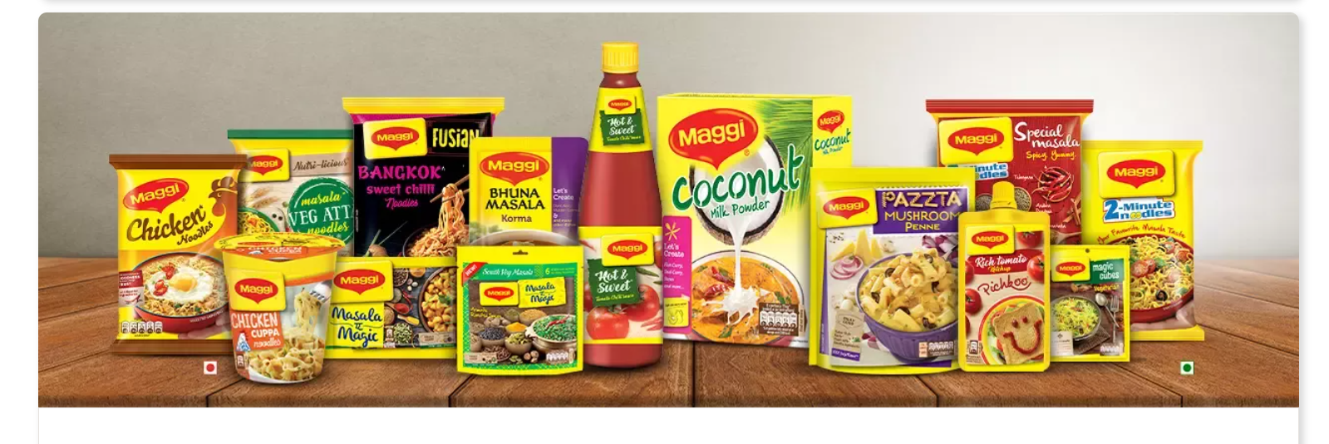
Figure 3: “Nestle brand”
(Source: Nestle, 2023)

b) Nature of Global Operations: Value Chain Analysis
Overview of the Value Chain
Porters value -chain framework emphasizes on the role of primary and support activities in strengthening competitive advantage in terms of research, sourcing, production, marketing, logistics and financial management (Ingabire, and Irechukwu, 2023). Nestle has highly globalised value chain, and its chain consists of suppliers, factories, laboratories, and distributors, located on different continents. The global integration makes it possible to achieve economies of scale, dissemination of knowledge, cost efficiency, and swift growth in the market.
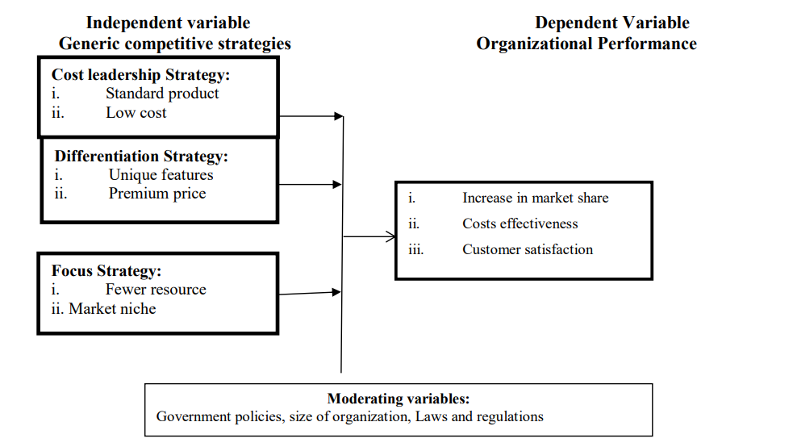
Figure 4: “Porter's value chain framework”
(Source: Ingabire, and Irechukwu, 2023)
Research & Development (R&D)
Nestle is mainly focused on R&D on the global strategy. The corporation has 23 R&D centres at the global level, among which there are large centres in Switzerland, China, the United States, France, and Singapore (Nestle, 2023 ). These facilities focus on nutritional research, product development, food safety and food packaging science. Nestle has the largest R&D investment of a year CHF 1.7 billion in the global food sector (Nestle, 2023). This vast research system facilitates the localisation of products - such as producing spicier Maggi noodles in India, and lactose-cut dairy versions in Asian countries. The ownership benefits of Nestle are enhanced by the R&D capability which helps in maintaining global standardisation and localisation at the same time.
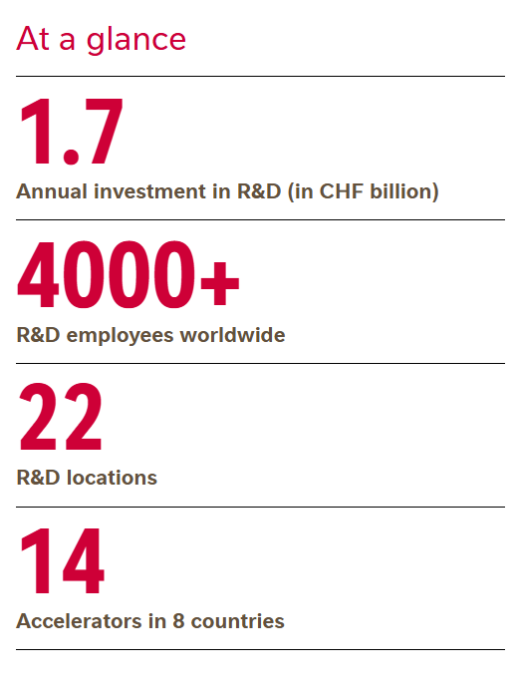
Figure 5: “R&D employees”
(Source: Nestle, 2023)
Sourcing
The global sourcing model employed by Nestle links more than 500,000 farmers through the agricultural procurement programmes (Nestle, 2023). The major imports are milk, cocoa, coffee, cereal grains, and palm oil. Nestle draws on global commodity markets as well as local sourcing systems. In India, Moga factory collects over 1.3 million kgs of milk per day during the flush season, with over 110,000 farmers in India selling milk to Nestlé (Nestle, 2023). The model will enhance the resilience of the supply chain and sustain the global approach to production in the company.
Production
Nestle has 337 manufacturing plants in various parts of the world, which allows it to distribute effectively and make socio-economic contributions to the host countries (Nestle, 2023). It has a production approach that is based on a model of globalisation -global standards and local adaptation. In developing markets, such as India, Nestle produces Maggi noodles, Nescafé, and dairy products in India to lower the import expenses, meet the local market requirements, and enhance sensitivity to consumer demands and wants.
Marketing & Sales
Marketing approach of Nestle is the combination of worldwide branding and local adaptation. Global advertising and local flavours and cultural-related messages like Maggi, are the types of brands that are used and promoted by the company. The firm uses multi-channel retailing systems which are supermarket, convenience stores, e-commerce, and direct distribution. In India, digital marketing campaigns are using local festivals, youth culture, and local language (Nestle, 2023).
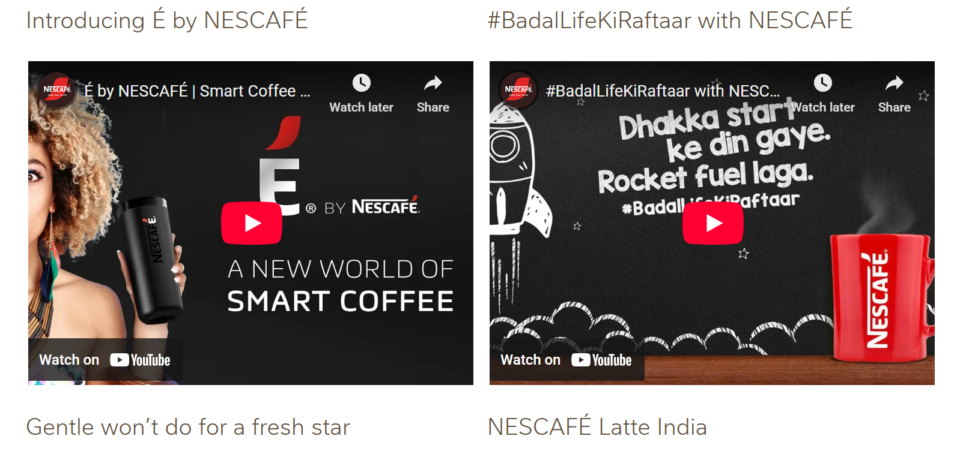
Figure 6: “Ad campaign of Nestle in India”
(Source: Nestle, 2023)
Distribution & Logistics
Nestle has a logistics network comprising of global distribution centres, cold-chain, and third-party logistics. The company has some of the highest supply-chain technologies, including traceability on blockchain and inventory optimisation on data analytics. Its size makes it possible to distribute the resources geographically and avoid the barriers of country-specific disruptions.

c) Entry Modes Used by Nestlé
In the past Nestle has been exercising foreign direct investment (FDI), acquisition, joint venture, exporting and limited licensing to spread across the world. The prevailing ones are greenfield FDI and acquisitions, which provide the company with complete control over production, technology transfer and control of brands (Anderson et al., 2024). In the emerging markets like India, Brazil, Mexico and Vietnam, Nestle creates wholly owned subsidiaries and constructs local manufacturing facilities to guarantee the provision of uniform quality, products customized culturally and thorough penetration in geographical terms. Greenfield FDI presents the strategic benefits of coordination in supply chains, regulatory compliance and market.
In addition to the Greenfield investments, acquisitions are one of the major modes through which Nestle joins new markets. Some of the brands the company has acquired include Rowntree (UK), Gerber (USA) and Pfizer Nutrition (global). It also has interests in Blue Bottle Coffee and Freshly. The moves indicate the long-term strategy of Nestle: expand market share by introducing new products into the portfolio rather than making organic growth the sole source of growth. In 1988, Rowntree plc was sold to Nabisco at an estimated cost of L 2.5 billion, which was the biggest overseas takeover of a British company to date (Imd, 2023). Through acquisitions, Nestle is able to expand within high growth markets within a short period of time such as infant nutrition, premium coffee and ready-to-eat foods.
Nestle entry strategy also comprises joint ventures. The business has a global presence in nearly 130 markets, excluding the U.S. and Canada, and it has achieved its global objectives (Nestle, 2023). The company has already conducted life-cycle analysis of various categories and eco-design has been included even in the very initial stage of planning (Nestle, 2023). But there are very rigid quality standards that limit licensing. All in all, the dominant entry mode Nestle uses is the Greenfield FDI, facilitated by specific acquisitions. These modes are most appropriate to the emphasis of the company on the operational control, food safety, and long-term brand equity.

d) Benefits from International Operations
Nestle has a strong global presence that provides the company with various strategic and financial strengths that affirm its status as the largest food and beverage company in the world. Among the advantages is economies of scale. With the purchase of raw materials all over the world, large scale production and standardised packaging and logistics, Nestle lowers the price of every unit (Nestle, 2023). The company has operations in over 180 countries and generates revenues exceeding CHF93billion and hence is capable of consolidating procurement of coffee, cocoa, dairy and grains. This purchasing power reduces expenses and provides Nestle with superior bargaining power among the suppliers.
Diversification of markets also mitigates risks of any given region since international operations are diversified. Nestle is generating income in Europe, Asia, Americas, and Africa. This diversification cushions the firm against economic recessions, alteration of policies or even political instability in a specific market. Research indicates that diversified multinationals suffer fewer earnings and reduced risk than those whose businesses are concentrated on a single country (Yadava, 2023). The other significant benefit is international research synergy. Nestle has the largest R&D organization in the food and beverage sector and it employs approximately 4,100 workers across 23 locations across the globe (Nutrition, 2023). The innovations introduced in Switzerland or U.S. can be adapted to target the Indian, Chinese, and Nigeria markets in a short time. This knowledge base contributes to localisation of products and retaining high global standards.
Availability of lower inputs and labour in the emerging economies contributes to cost efficiency. Other lower-cost markets like India and Vietnam are also cheaper in the raw materials and manufacturing labour, and they can be priced competitively without damaging the profit margin. Among the rapidly developing markets of Nestle are India (Nestle, 2023). The company has a beneficiary population of 14 9 million, social interventions, and outlets of 5.2 million. Local manufacturing also minimizes tariffs, importation costs and complexity of supply chains. Global scale provides Nestle with brand strength and sufficiency in the market. The firm has reported an increase in organic sales of 2.8, 0.7, and 2.1 in their RIG and prices respectively (Nestle, 2023). The business in numerous countries also contributes to the transfer of innovations, as the experience of new markets drives new products in the world.
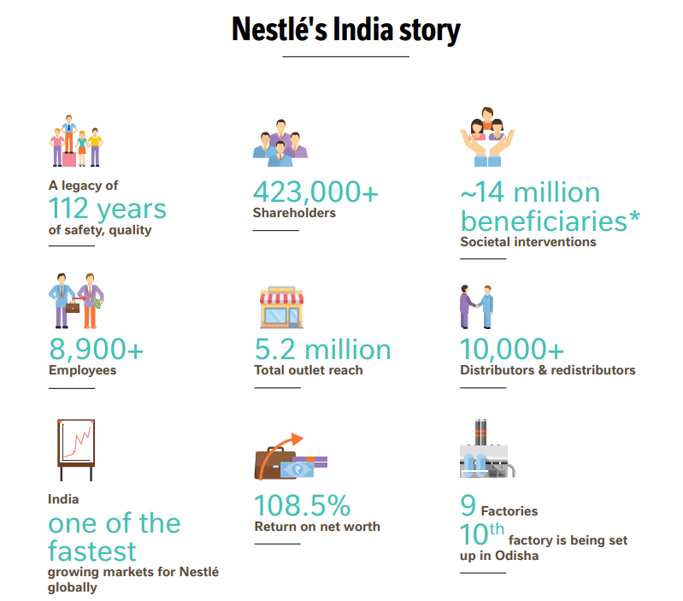
Figure 7: “Nestle India Story”
(Source: Nestle, 2023)

3. OLI Analysis: Impact on Market Entry Mode for Nestlé in India
The OLI framework created by Dunning is useful in understanding how multinational companies select certain internationalisation strategies (Batschauer et al., 2022). The combination of the three advantages of ownership, location, and internalisation demonstrate the way a firm assesses the appeal of a market and chooses the most suitable entry mode. In the case of Nestle, it is strategic to venture in India due to its high population, emerging middle class and rising demand of branded packaged food. The population of India is expanding its neo-middle class; and over 250 million individuals have crossed the poverty threshold over the last few years (Kantar, 2023). The OLI lens can be used to analyze the Greenfield FDI and acquisitions of Nestle.
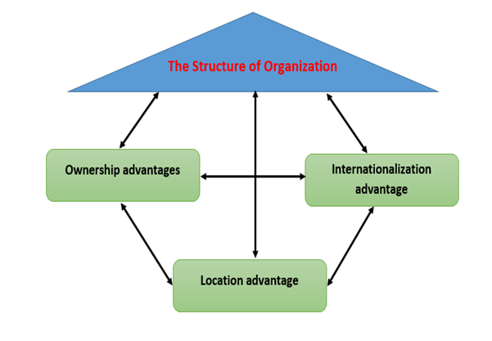
Figure 8: “Dunning’s OLI paradigm”
(Source: Batschauer et al. 2022)

3.1 Ownership Advantages and Their Influence on Entry Mode
The ownership strengths that provide a firm with competitive advantage over its local rivals are ownership advantages. These strengths in the case of Nestle are brand equity, superior technology, international R&D networks, management capabilities, and solid finances. These abilities inform the decision of Nestle to venture into India by using wholly-owned subsidiaries and Greenfield investments. Some of the internationally recognised brands owned by Nestle include Nescafé, Maggi, KitKat, Cerelac and Purina. These brands assist the customers in accepting Nestle within new markets relatively fast (Nestle, 2023). Brand equity enables Nestle to stand out of the local competitors. Maggi noodles were integrated into the Indian culture due to the support of good brands and stable quality. The ownership advantage offers by this brand power will make Nestle maintain a tight control over marketing, quality and distribution, which makes Greenfield FDI better than licensing or joint ventures.
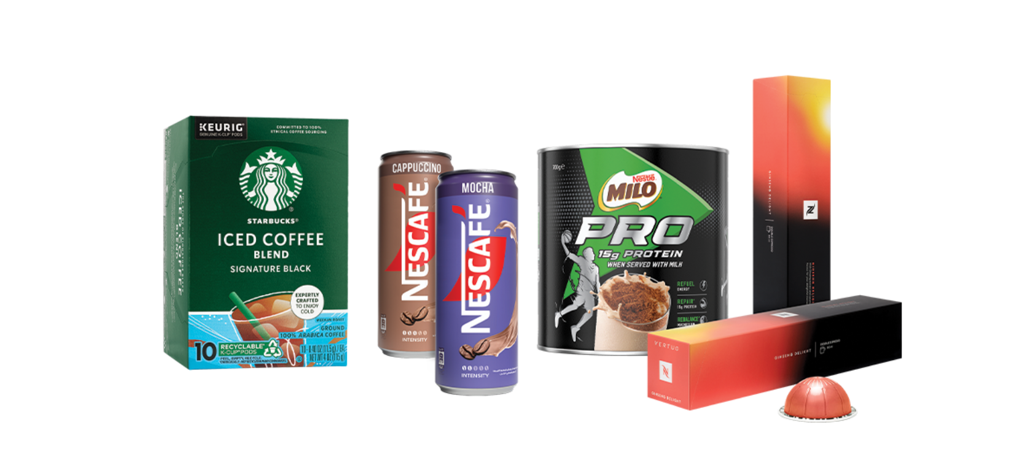
Figure 9: “Bestle Brand”
(Source: Nestle, 2023)

3.2 Location Advantages of India and Their Impact on Entry Mode
Location benefits focus on the host country being attractive to foreign investors. Socio-economic environment, institutional reforms and consumption behavior of India have developed a powerful push factor that encourages Nestle to invest in India using FDI instead of low-commitment channels like exporting. First, India has one of the largest consumer markets globally as it has a population of over 1.4 billion and is experiencing fast expansion in urban middle-class families. The packaged foods, beverages, infant nutritional, and convenience meals are still on the demand list as the disposable incomes and lifestyle lifestyles continue to increase (Ibef, 2023). This kind of large-scale consumption potential renders investment-oriented entry modes more commercially viable than exporting which would restrict the capability of differentiating products.
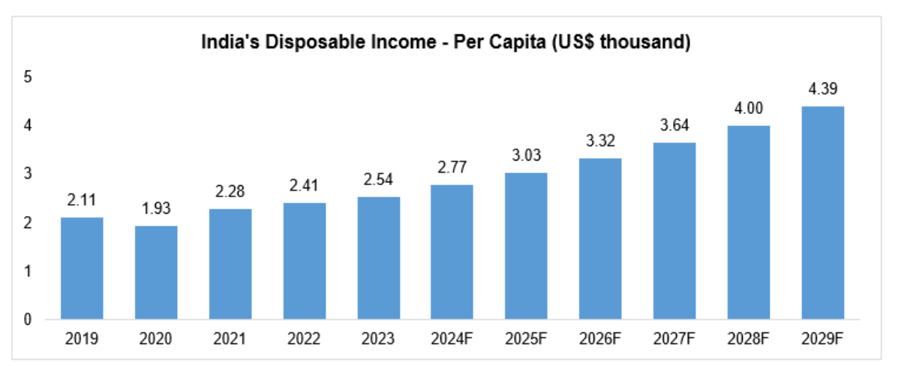
Figure 10: “India’s Disposable Income Per Capita”
(Source: Ibef, 2023)
India offers favourable factor conditions. The supply of low skilled and semi-skilled labour and access of raw materials including milk, spices and farming products make local production economical. The locational attractiveness of the domestic supply chains is reflected in the decision of Nestlé to source milk to more than 100,000 farmers in India. Moga factory receives more than 1.3 million kgs of milk a day during the flush season and has more than 110,000 farmers in India who sell milk to Nestle (Nestle, 2023). These are the economies of cost and resources that make the argument of Greenfield production facilities stronger.
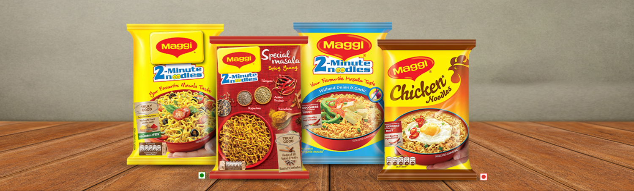
Figure 11: “Maggi in India”
(Source: Nestle, 2023)
The cultural and taste-sensitive orientations of Indian people are inclined to the development of products which are localized. Nestle has localised Maggi noodles to suit the local Indian taste by using local flavours like masala and multi-grain flavours. These types of adaptations need being close to the consumers, effective feedback, and quick production cycles that can only be achieved through local manufacturing as opposed to exporting. Lastly, the country is experiencing increased infrastructure development, cold chains, logistics, e-commerce and digital retail contribute to the efficient distribution throughout the country. The improvements in the supply-chain have been an advantage to Nestle, making the location more appealing to long-term investment.

3.3 Internalisation Advantages and Their Influence on Entry Mode
Internalisation benefits have to do with the advantage of a firm retaining control over operations, safeguarding intellectual property, quality standards, and elimination of transaction costs that may be involved in external alliances. In the case of Nestle, internalisation factor played a critical role in the choice of FDI as the key entry mode. Strict world standards of quality, safety and hygiene are required in food and nutrition products. There would have been a risk of contamination, inconsistencies in their supply-chain, or brand damage risks, which the company cannot afford to take, as a result of outsourcing or licensing production in India (Tokala, and Dubey, 2024). Internalisation of production by means of wholly owned factories enables Nestle to guarantee that its international procedures, like Hazard analysis and critical control points (HACCP), are unanimously implemented.
Internalisation lowers the costs of transacting that is related to contract negotiation, contract monitoring, quality requirements enforcement, and dispute management. Direct control is the most effective type of governance mechanism as Nestle has a long-term orientation and brand trust. Internalisation can assists Nestlé in reacting fast to changes in the market. In April 2015, one of the laboratories in India reported that it had found traces of lead in a sample of Nestle Maggi noodles exceeding acceptable amounts, and monosodium glutamate even though there was a no added MSG label (Nestle, 2023). The completely internalised model of Nestle allowed it to carry out the nationwide recovery policies, redesign the packaging, and recover the safety confidence more effectively than a joint venture setup would have.
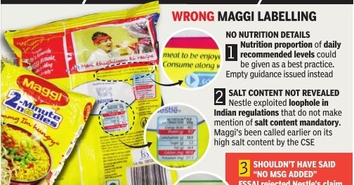
Figure 12: “Wrong Label at Maggi”
(Source: Nestle, 2023)

4. Cultural Differences Between Nestlé’s Home Country and India
The cultural differences are some of the core elements in assessing the success of Nestle in operating in India, a developing economy with profound linguistic, regional as well as socio-cultural diversity. As Jadil, et al. (2023) have argued, the six-dimensional Hofstede model of national culture was developed with the aim of comprehending the culture of various societies and countries. These six dimensions of culture are power distance, individualism, masculinity, uncertainty avoidance, long term orientation and indulgence. The cultural dimensions given by Hofstede give a systematic approach to the comparison of Switzerland the home country of Nestle and India.
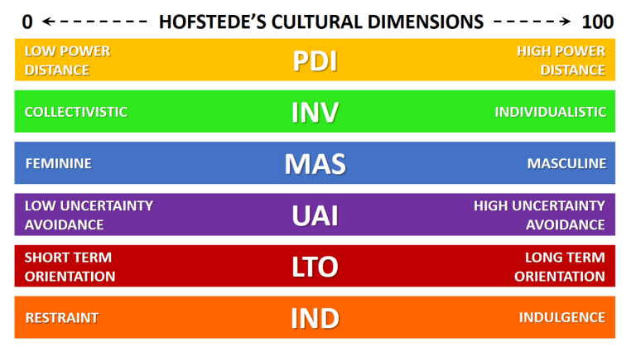
Figure 13: “Hofstede’s Cultural Dimension”
(Source: Jadil, et al. 2023)

4.1 Key Cultural Differences
Power distance is one of the biggest contrasts. Switzerland is a low power-distance (34) culture, and its level of hierarchy is low, and decentralisation is the norm with regards to decision-making (Theculturefactor, 2023). India, on the contrary, is one of the countries with a high power distance (77), whereby people usually tolerate hierarchies and top-down controls. This adaptation is evident in the Indian activities of Nestle; although its strategic control is still under the global headquarters, local decisions are more organized and senior management-oriented than in Switzerland. This alignment assists Nestle to gain rapport with local employees, distributors and government agencies who require official and formal communication.
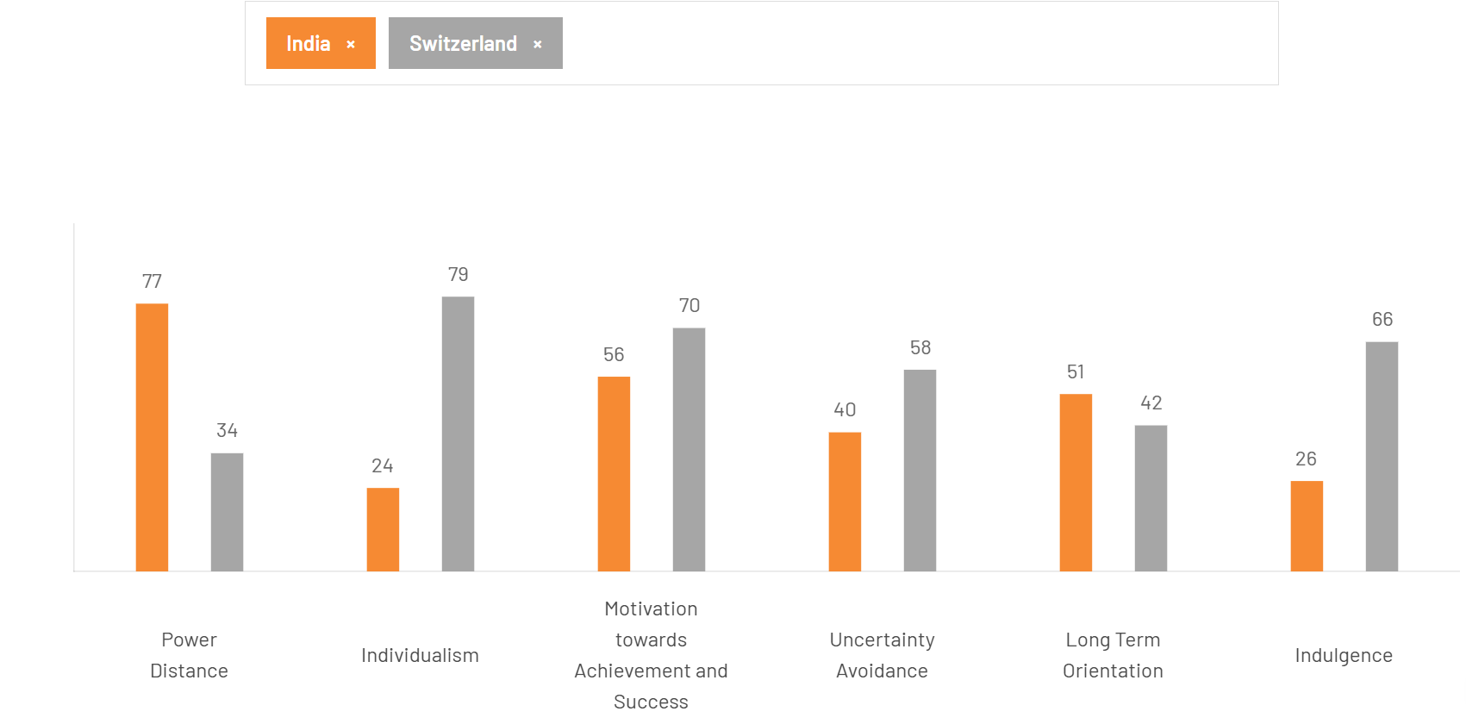
Figure 14: “Hofstede’s Cultural Differences”
(Source: Theculturefactor, 2023)
Individualism versus collectivism is also another aspect of cultures. Switzerland is a high individualism country (79), which focuses on individual responsibility and independence. However, India is collectivist (24) and has strong community relationships, family involvement, and consumption is collectivity based. The Maggi noodles localisation by Nestle is a fine example of cultural sensitivity. The families are commonly prepared by Indian families and not by individuals; hence, Nestle launched multipack value packs, local masala types, and customisable spice content to resonate with the collectivist food-sharing culture. The instant noodles company Maggi by Nestle India has already reached a market share of more than 60 per cent and nearly reached the pre-crisis value level, according to one of the top officials of the company (Economictimes, 2023). This shows that cultural adaptation is a promoter of financial performance.
As regards to uncertainty avoidance, Switzerland has a score of 58, which is considered as a high value (rules, precision and structured processes). India is rated more moderately lower (40), more flexible and tolerant of ambiguity. Nestle is able to deal with this difference through a combination of Swiss- style quality control and Indian flexibility. As an illustration, even though, in Indian markets, there are flexible norms, Nestle has stringent global food safety, and this aspect was decisive in the 2015 Maggi crisis. Following a temporary withdrawal of the product, Nestle changed communication approaches to the situational cultural demands that focused on emotional assurance, family protection, and tradition. This cultural sensitivity interaction helped Maggi to heal, allowing it to almost recover almost 57 percent market share as of 2017.
There is also cultural difference in masculinity and femininity. The Swiss culture is more feminine (70), and they appreciate the quality of life, modesty, and collaboration. India has a higher score on masculinity (56) which is achievement, assertiveness, and success. Nestle uses this through functional benefits and aspirational messages promotion in India. The Nescafe marketing communication makes coffee a beverage that represents ambition and empowerment of the youth, which aligns with the culture of the urban Indian. The message that is more subtle, lifestyle-oriented used in Switzerland would not create a similar level of engagement.

4.2 Impact on Market Entry Strategy
Cultural variations in Switzerland and India played a major role in the decision of entry mode and mode of operation by Nestle. The collectivistic culture, high power distance, and love of familiar trusted brands of India meant that the deep-rooted presence in the local market could be more appropriate than exporting or licensing. The necessity of cultural intimacy with consumers, regulators and distributors, justified the selection of Greenfield FDI, which makes it possible to have a high level of brand control and maintain a reliable interaction with stakeholders.
Cultural gaps also affect the leadership style. There is a tendency to focus on flat structures and participative decision-making in leadership. In India, the managerial expectations are characterized by the hierarchical decision authority (Prakash et al. 2023). Nestle responded by giving the senior Indian managers a better decision making power and a country specific responsibility with global oversight. This cultural fit contributed to establishment of credibility within the bureaucratic setting in India and easy negotiations with the policy makers.

4.3 Impact on Potential Success in the Market
Nestle is likely to succeed in the long run in India in terms of marketing, communication, HR management, and consumer behaviour due to cultural differences. The marketing approaches need to be in line with the collectivist features of the Indian, traditional food culture and regional diversity. The Nestle India released its collection of MAGGI Masalas of India Noodles. The new brand of MAGGI noodles will include four new flavours Amritsari Achari, Mumbaiya Chatak, Super Chennai and Bengali Jhaal (Nestle, 2023). Each of the four variants has been made by using signatory herbs and spices that are used in different regional cuisines in India in order to bring mouthwatering Indian flavours with an appetising MAGGI touch.
This cultural adjustment helped Maggi not only to become a commercial product but also a cultural icon of convenience food within the Indian families. It has had a robust cultural resonance, which has seen it experience consistent growth in revenues with Maggi taking a significant portion of the overall Nestle India annual revenues. The cultural sensitivity is also a requirement of communication strategies. The Indian consumers will very strongly react to the family, togetherness and emotional warmth stories. Mother’s Day, MAGGI campaigns in which it demonstrates that, although the teenager is very busy with last minute preparations, he is aware that his mom is even more stressed about his exams (Nestle, 2023). These stories are consistent with the collectivist culture and moderately masculine culture of India, which strengthens brand loyalty.
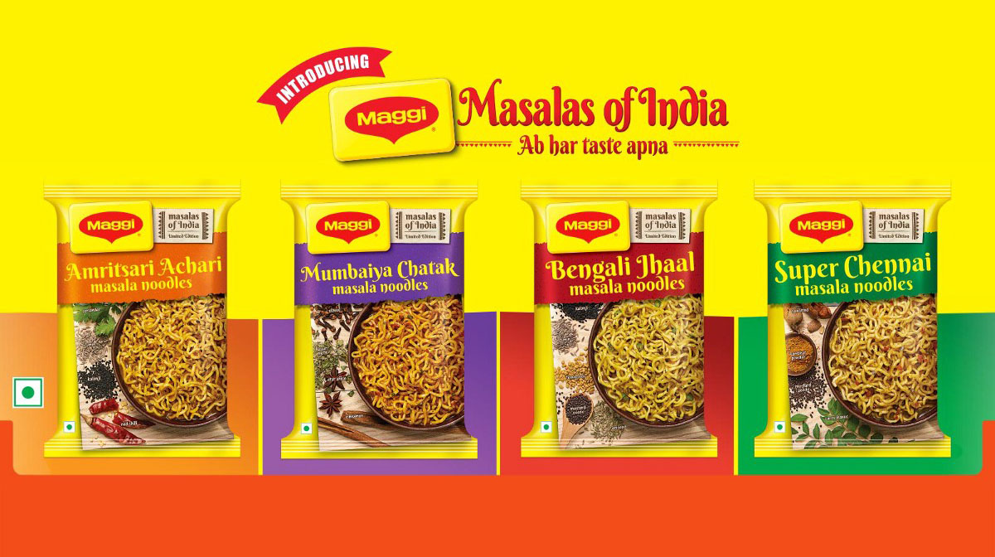
Figure 15: “Masalas of Maggi”
(Source: Nestle, 2023)
Nestle needs to operate within the high-power distances expectations of India in the HR management. Distinct hierarchies and roles, culturally oriented leadership training and respectful communication traditions contribute to the engagement of the employees. The egalitarian HR practices of Switzerland would not be entirely in tune with the expectations of Indians and the adaptation on the local level is necessary. Indian consumers tend to display value-conscious behaviour due to their reserved cultural characteristics in consumer preferences. Nestle responds to this demand by supplying small sachet packs, regional pricing, and low-price product brands.
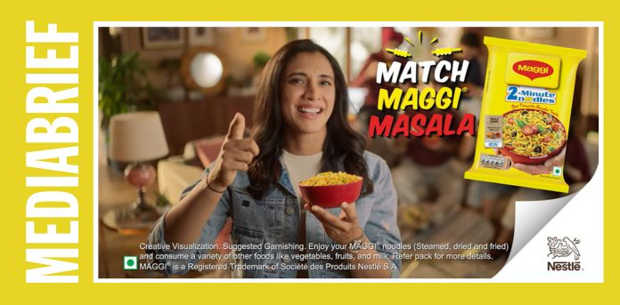
Figure 16: “Maggi Campaign in India”
(Source: (Nestle, 2023)

5. Recommendations: Adjustments to Standard Operating Procedures (SOPs)
The success of Nestle in the long term in India requires the capacity to match its operations with the cultural expectations, the market dynamics as well as the strategic knowledge based on the OLI model. The above analyses indicated that the collectivist culture of India, high power distance, long relational business context and high preference to traditional flavours necessitate a specific mode of operations. The next three SOP adjustments are product localisation, transformation of HR management, and supply-chain adjustment direct reactions to discoveries in the OLI paradigm of Dunning (Alsabe, and Alsharif, 2025) and the cultural dimensions of Hofstede (Hofstede Insights, 2023). All the recommendations enhance the ownership, location and internalisation benefits of Nestle besides meeting the cultural gaps noted above.

5.1 SOP Adjustment 1: Localisation of Products & Marketing
Among the most critical SOP modifications that Nestle will need to make in India is the further localisation of recipes and flavours, packaging formats, and advertising messages. The previous discussion has shown that the Indian consumers have high levels of collectivist behavior as well as regional tastes. This cultural fact explains the need to have operational procedures that focus on constant product adaptation as opposed to standardisation on a global scale. In terms of OLI, Nestle and its ownership benefits in terms of global R&D, proprietary technologies, and well-established brand equity need to be integrated with location benefits that India presents, especially, its taste palate and increased demand of products with a cultural appeal. Hence, Nestle must internalize SOPs that demand simultaneous R&D with its India workgroups and international research laboratories. This participatory model is to require regular flavour tests, local sensory boards and culinary research incorporating Indian spices and culinary practices. The effectiveness of Maggi Masala, the biggest in terms of sales of instant noodle flavour in India following localisation strategies, testifies to the business worth of such an SOP.
The adoption of packaging ought to be enshrined into the SOPs of Nestle. Consumers are buying smaller packs of consumer goods, which has been prompted by the skyrocketing prices of groceries and other household products that are putting strain on household incomes (Economictimes, 2023). The long-term practice of Nestle to package INR 10 KitKat and INR 2 Maggi Magic Masala sachets already is effective and is to be initiated as a company-wide practice of launching new products (Timesofindia, 2023). Cultural embedding is also necessary with SOPs related to marketing. Based on the study of cross-cultural advertising, messages based on family values, emotions, and aspirational messages are more effective in collectivist societies (Liu, 2023). The inclusion of the Indian cultural narratives, festivals, regional languages and traditional cooking imagery in any promotion planning should therefore be a requirement by the SOPs. As an example, the TV advertisements by Nestle in which mothers make Maggi to be given to children fit the Indian culture of nurturing and emotional attachment.
Localisation will be necessary to bring on board local supply-chain partners, especially small and medium-sized suppliers. A mandatory SOP clause of the percentage of local raw materials would not only be cost-justified, but it would enhance the brand credibility and the resilience of the supply-chain in terms of cultural familiarity. This SOP localisation change is perfectly aligned with OLI: the ownership benefits (R&D and brand equity) are utilised to open the location benefits (cultural diversity and market size), and internalisation benefits enable Nestlé to retain control over safety, quality, and product design.

5.2 SOP Adjustment 2: Human Resource & Management Practices
Considering the cultural difference between Switzerland and India, Nestle will need to institute SOPs that transform leadership styles, talent management, training programmes and communication systems to facilitate management practices that are aligned culturally. High power distance is an important aspect of the Indian society that, as the Hofstede model demonstrates, demands a hierarchical understanding, role division, and evident leadership. The egalitarian organisational norms of Switzerland cannot be directly applicable without any alteration.
One of the crucial SOP changes is that of compulsory cultural intelligence (CQ) training of expatriate managers and Indian leadership teams. CQ training has been established to lead to a reduction of cross-cultural conflicts, enhanced team cohesion, and greater performance in multinational subsidiaries (Kour, and Jyoti, 2022). The SOP ought to have systematic modules on the Indian cultural values, communication patterns, negotiation patterns, and employee expectations. Training should be conducted to ensure that managers develop relational leadership behaviours that appreciate respect, seniority, and community orientation to promote harmony at the workplace. In the case of the communication processes, Nestlé needs to institutionalise cross-cultural communication procedures. This involves SOPs, which are structured and need to have a channel of communication, the hierarchy of escalation, and processes which display an inclination of India to be guided and straightforward with its senior leaders.

5.3 SOP Adjustment 3: Supply Chain & Quality Management Adjustments
The size, diversity and the changing regulatory structure of India have necessitated strong and culturally oriented supply-chain SOPs. Since India is long-term oriented and relationship-based, Nestle needs to focus more on supply-chain practices that focus on the areas of local sourcing, sustainability, transparency and compliance. Among the major changes is the increase in local sourcing programmes. Nestle is already buying milk in over 100,000 Indian farms, but now SOPs must demand minimum local sourcing quantities per new product line. It can improve cost-efficiency, create trust, and comply with the priorities of economic development in India through local sourcing. Research indicates that a high level of localisation of supply chains enhances brand legitimacy and consumer confidence in new markets.
.
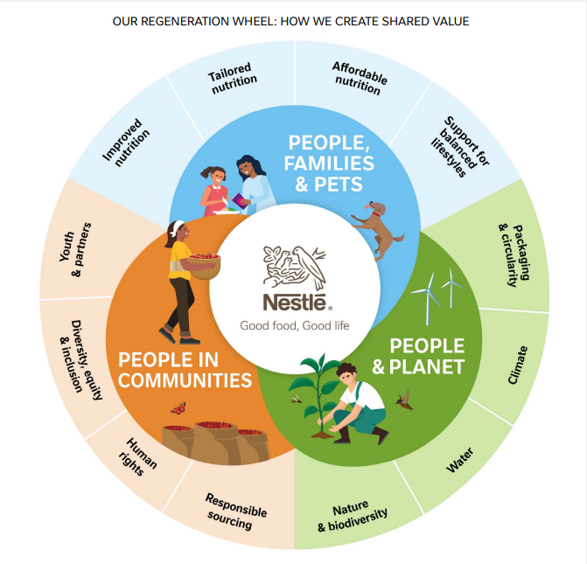
Figure 17: “Shared value”
(Source: Nestle, 2023)
The other important modification is the improvement of sustainable agriculture programmes. Agricultural issues have been a significant problem in India in the form of climate volatility, soil degradation, and water scarcity. Nestle has a variety of global sustainability obligations, including regenerative agriculture and zero-waste management, which should be institutionalised in India by ensuring they are the mandatory SOPs, requiring the farmers to be trained, irrigation systems to be water efficient, and soil health to be monitored (Nestle, 2023). The compliance locally should be raised in SOPs. India also keeps its food safety laws such as FSSAI laws updated. The SOPs which are practiced by Nestle should therefore require unceasing regulatory control and local competitive audits. It is particularly essential considering the fact that the company has had a history of regulatory issues in the past, including the Maggi scandal in 2015. Researchers emphasize that effective compliance systems minimize legal and reputational risks of MNCs.
The digital traceability systems must be institutionalized within the supply-chain SOPs of Nestle. Farm-table transparency can be improved with the help of digital technologies that include blockchain, IoT sensors, and QR codes. Nestle has been experimenting with blockchain since 2017, best known as IBM Food Trust (Nestle, 2023), and implementing it in India in a systemic manner will enhance the benefits of internalisation by ensuring strict quality control. This SOP change is quite consistent with OLI: internalisation benefits safeguard the quality level; ownership benefits allow the best supply-chain structures; and place benefits allow the increased opportunities of long-term sourcing.

6. Conclusion
The long-term global growth proves the strategic importance of being a global food and beverage producer as shown by Nestle. Its penetration and expansion in India are an indication of the need to match international competencies to local cultural, economic and regulatory realities. The OLI framework showed that the ownership benefits of Nestle, which are brand equity, R&D capacity, managerial experience, and financial power in addition to the location benefits of India, which are demographic scale, cultural diversity, and availability of resources, highly justified the decision of the company to do Greenfield FDI and internalised operations. The cultural analysis by Hofstede also revealed that there is need to create meaning in adapting in order to be accepted in the Indian high power-distance, collectivist and traditional consumption environment.
These insights are dealt with directly by the three major SOP recommendations product localisation, culturally sensitive HR practices and enhanced supply-chain systems. They are combined to make sure that Nestle has a strategic control and has made the most of cultural relevance. These SOPs enhance the capacity of Nestle to offer customised products, enhance organisational alignment, deal with regulatory anticipations, and increase long term supply chain ties in India.

References
Alsabe, A.A.A. and Alsharif, R.A.B., (2025). The Impact of Globalization on Business Administration and the Adaptation to International Markets and Diverse Workforces. International Journal of Academic Publishing in Educational Sciences and Humanities (IJAPESH), pp.69-78.
Anderson, J., Sutherland, D. and Severe, S., (2024). Does Chinese Investment into Europe Facilitate Strategic Asset Growth in the Chinese Parent Company? The Role of Entry Mode. Economies, 12(3), p.56.
Batschauer da Cruz, C.B., Eliete Floriani, D. and Amal, M., (2022). The OLI Paradigm as a comprehensive model of FDI determinants: a sub-national approach. International Journal of Emerging Markets, 17(1), pp.145-176.
Economictimes (2023) Market shares Available at: https://economictimes.indiatimes.com/industry/cons-products/fmcg/maggi-attains-over-60-market-share-touches-pre-crisis-level-in-value-terms/articleshow/65290749.cms?from=mdr (Accessed on: 12/12/2025)
Economictimes (2023) Small reshape inflations Available at: https://economictimes.indiatimes.com/industry/cons-products/fmcg/small-packs-amid-big-bills-indians-reshape-shopping-habits-as-inflation-hits-budget/articleshow/117016851.cms?from=mdr (Accessed on: 12/12/2025)
Ibef (2023) Indian consumer Available at: https://www.ibef.org/blogs/decoding-the-indian-consumer-basket (Accessed on: 12/12/2025)
Imd (2023) Nestlé Rowntree. Available at: https://www.imd.org/research-knowledge/strategy/case-studies/nestl-rowntree-a/ (Accessed on: 12/12/2025)
Ingabire, H. and Irechukwu, E.N., (2022). generic competitive strategies and organizational performance in manufacturing industries in Rwanda: A case of Sulfo Industries Ltd. Journal of Strategic Management, 6(1), pp.9-25.
Jadil, Y., Jeyaraj, A., Dwivedi, Y.K., Rana, N.P. and Sarker, P., (2023). A meta-analysis of the factors associated with s-commerce intention: Hofstede's cultural dimensions as moderators. Internet Research, 33(6), pp.2013-2057.
Kantar (2023) 250 million citizens Available at: https://www.kantar.com/inspiration/research-services/indias-growing-middle-class-pf (Accessed on: 12/12/2025)
Kour, S. and Jyoti, J., (2022). Cross-cultural training and adjustment through the lens of cultural intelligence and type of expatriates. Employee Relations: The International Journal, 44(1), pp.1-36.
Liu, H., (2023). Cultural Influence on Consumer Behavior: Strategies for Adapting Marketing Campaigns in a Globalized World. International Journal of Education, Humanities and Social Sciences, 1(1), pp.10-70088.
Nestle (2023) Nescafé, Maggi, KitKat, Cerelac, Available at: https://www.nestle.com/investors/annual-report/brands (Accessed on: 12/12/2025)
Nestle (2023) 1.3 million kgs of milk per day Available at: https://www.nestle.in/csv/case-studies/milk-farmers [Accessed on: 08/12/2025]
Nestle (2023) 277000 employees Available at: https://www.nestle.com/about/overview [Accessed on: 08/12/2025]
Nestle (2023) 337 manufacturing plants Available at: https://www.nestle.com/ask-nestle/our-company/answers/how-many-factories-do-you-have [Accessed on: 08/12/2025]
Nestle (2023) 500,000 farmers Available at: https://www.nestle.com/sustainability/nature-environment/regenerative-agriculture [Accessed on: 08/12/2025]
Nestle (2023) 7 product categories Available at: https://www.nestle.com/about/overview [Accessed on: 08/12/2025]
Nestle (2023) About Available at: https://www.nestle.com/investors/overview [Accessed on: 08/12/2025]
Nestle (2023) Blockchain Available at: https://www.nestle.com/media/pressreleases/allpressreleases/nestle-open-blockchain-pilot (Accessed on: 12/12/2025)
Nestle (2023) Celeral. Available at: https://www.nestle.com/sites/default/files/asset-library/documents/library/presentations/investors_events/investors_seminar_2005/cpw_jun2005_friendly_transcript.pdf (Accessed on: 12/12/2025)
Nestle (2023) CHF 93 billion Available at: https://www.nestle.com/about/overview (Accessed on: 12/12/2025)
Nestle (2023) Digital marketing campaigns Available at: https://www.nestle.in/brands/beverages/beverages-ads [Accessed on: 08/12/2025]
Nestle (2023) Growing markets for Nestlé globally Available at: https://www.nestle.in/sites/g/files/pydnoa451/files/2024-06/Annual-Report-2023-24.pdf (Accessed on: 12/12/2025)
Nestle (2023) India launches range of noodles Available at: https://www.nestle.in/media/pressreleases/nestle-india-launches-exciting-new-range-of-noodles--maggi-masalas-of-india (Accessed on: 12/12/2025)
Nestle (2023) Milk farmers Available at: https://www.nestle.in/csv/case-studies/milk-farmers (Accessed on: 12/12/2025)
Nestle (2023) Mother campaign Available at: https://www.nestle.in/media/pressreleases/allpressreleases/maggi%C2%AE-breaks-norm-mother%E2%80%99s-day-pay-homage-moms (Accessed on: 12/12/2025)
Nestle (2023) MSG Ban Available at: https://www.nestle.com/ask-nestle/products-brands/answers/maggi-noodles-india-msg-lead-ban-recall (Accessed on: 12/12/2025)
Nestle (2023) Nescafé, KitKat, Maggi, and Cerelac Available at: https://www.nestle.in/brands [Accessed on: 08/12/2025]
Nestle (2023) Nestlé delivered organic sales Available at: https://www.nestle.com/media/pressreleases/allpressreleases/three-month-sales-2025 (Accessed on: 12/12/2025)
Nestle (2023) Nestlé has already conducted LCA Available at: https://www.nestle.com/sites/default/files/asset-library/documents/creating%20shared%20value/performance/cdp-investor-2012.pdf (Accessed on: 12/12/2025)
Nestle (2023) Noodles maggi masala Available at: https://www.nestle.in/media/pressreleases/nestle-india-launches-exciting-new-range-of-noodles--maggi-masalas-of-india (Accessed on: 12/12/2025)
Nestle (2023) R&D Available at: https://www.nestle.com/stories/research-development-open-innovation-multi-faceted-approach [Accessed on: 08/12/2025]
Nestle (2023) R&D investment Available at: https://www.nestle.com/about/research-development [Accessed on: 08/12/2025]
Nestle (2023) Shared values Available at: https://www.nestle.com/sites/default/files/2025-02/creating-shared-value-nestle-2024.pdf (Accessed on: 12/12/2025)
Nutrition (2023) Gender nutrition Available at: https://nutrition.org/business-directory/nestle-nutrition-gerber-products-company/ (Accessed on: 12/12/2025)
Prakash, S., Sharma, V.P., Singh, R., Vijayvargy, L. and Nilaish, (2023). Adopting green and sustainable practices in the hotel industry operations-an analysis of critical performance indicators for improved environmental quality. Management of Environmental Quality: An International Journal, 34(4), pp.1057-1076.
Statista (2023) Number of Employees Available at: https://www.statista.com/statistics/255203/total-number-of-nestle-employees-worldwide/?srsltid=AfmBOooanLrii0A4Mu4N9kEhDQi8opbQVH8fJxzb2KE9ZajMdHtNNfBC [Accessed on: 08/12/2025]
Theculturefactor (2023) Comparison tool Available at: https://www.theculturefactor.com/country-comparison-tool?countries=india%2Cswitzerland (Accessed on: 12/12/2025)
Timesofindia (2023) Premium bets to driven volumes Available at: https://timesofindia.indiatimes.com/business/india-business/nestl-india-under-new-cmd-bets-on-tech-mega-brands-and-premium-bets-to-drive-volume-led-growth/articleshow/125895219.cms (Accessed on: 12/12/2025)
Tokala, V.Y. and Dubey, N., (2024). Effective Supply Chain Management: A Way Forward for Sustainability and Food Security. In Advances in Postharvest and Analytical Technology of Horticulture Crops (pp. 311-325). Singapore: Springer Nature Singapore.
Yadava, A., (2023). The role of corporate governance in mitigating financial risk: Evidence from multinational firms. International Journal of Innovative Research in Science, Engineering and Technology, 12, pp.11-17.

