MBA MARKETING MANAGEMENT(25%)
UNIVERSITY OF WALES TRINITY SAINT DAVID
TITLE: AMAZON INTERNAL AND EXTERNAL ANALYSIS
MODULE CODE LMCB7001
LECTURER: TUSHARA
NAME: TAYYABA ABDUL KARIM SHAIKH
STUDENT ID: 2131214

STRUCTURE (QUESTION A)
Introduction
Sometimes, when individuals refer to "Amazon," they are referring to the American multinational corporation. Cloud computing and online commerce are the primary focuses of the company's commercial activities. Jeff Bezos was the one who came up with the idea on July 6, 1994. The city of Seattle in the state of Washington is home to the headquarters of the firm. Jeff Bezos now serves as the president, chairman, and CEO of the corporation. Amazon started off as a website that sold physical and digital books. After some time had passed, the firm came to the conclusion that it needed to expand its product offering. As a consequence of this, the business began offering a diverse array of products, including software, jewellery, apparel, furniture, electronics, and leather goods, among other things. The products of the business are offered for sale on a variety of websites located in various parts of the globe (Cuofano, V., 2021).

Amazon PESTEL Analysis
PESTEL examines political, environmental, social, technological, economic, and legal issues.
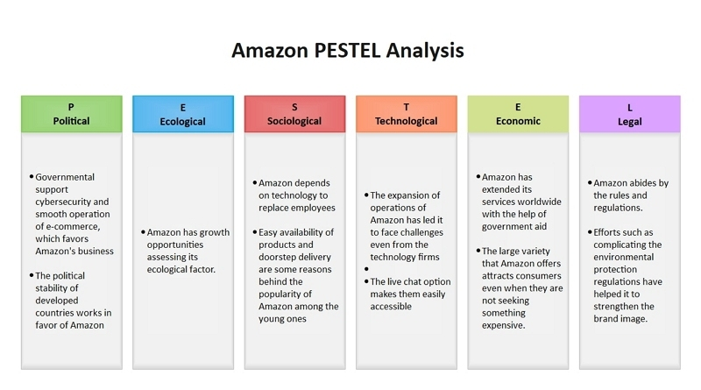
Fig 01 Amazon PESTEL Analysis
https://www.edrawmax.com/article/amazon-pestel-analysis.html
Political Factors

Government laws, regulations, and policies impact how an organization develops and evolves in each state or nation. It covers labor laws, trade policies, tax laws, and other regulations. The PESTEL analysis takes into account all of these variables. It examines commercial growth and government response. Amazon receives government assistance in cyber security and e-commerce (Cuofano, V., 2021).

Ecological Factors
The PESTEL research demonstrates the Amazon can develop ecologically. If more individuals care about environmental initiatives, business sustainability, waste management, and low-carbon lifestyles, the firm may flourish (Cuofano, V., 2021).
Social Factors
Social and cultural history influences it. Population, education, and cultural changes may help businesses evaluate a market. Amazon's operations are automated. Social issues may harm the organization due to lower employment. However, increasing internet sales and client spending will help the corporation. Amazon is popular with young and elderly individuals who don't want to leave their homes for several reasons, including the fact that things can be found easily and delivered to their door (Cuofano, V., 2021).
Technological Factors
Technical innovation is crucial to assessing a company's strengths and limitations. Automation, innovation, change, and technical competence may help firms prepare for the future. It helps companies organize production, shipping, and distribution using modern technology. Amazon's growth, particularly in digital sectors, has caused issues (Cuofano, V., 2021).
Legal factors: Amazon's consumer engagement methods are unique. They always seek improved methods to transport things. Live chat allows easy communication. Amazon needs additional workers to improve technology. They'll serve consumers better (Cuofano, V., 2021).

Economic Factors

Company profits depend on the economy. Consider interest rates and raw material prices. Based on client spending power, the corporation adjusts pricing, offers, and services. Profitability declines rapidly. Amazon's wide range attracts shoppers regardless of price. Amazon might expand in stable emerging nations (Cuofano, V., 2021).
Porters 5 Forces
Amazon dominates e-commerce. Despite fierce competition, Amazon strives to maintain its brand image. It strives to improve the customer experience and product usability. Porter's Five Forces may help us understand how Amazon reacts to the market (Frue, K., 2021).
- Businesses are struggling worldwide (a strong force).
- Players make the game harder (weak force)
- Supplier negotiating power (moderate force)
- Buyers' ability (strong force)
- A caution regarding low-quality products (Weak Force)
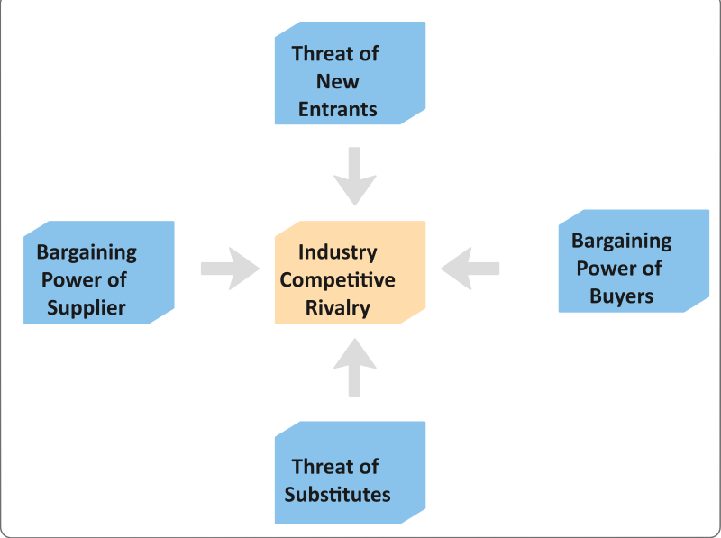
Fig 02 Porters 5 Forces of Amazon
https://www.edrawmax.com/article/amazon-porters-five-forces-analysis.html

Competition in the industry (Strong force)
Amazon's rivals have found that Amazon's market is more competitive. Startups and small firms are overtaking bigger rivals due to their cheap switching costs. Walmart, Flipkart, Alibaba, eBay, and others are Amazon's key rivals. Amazon has scale and several investment options (Frue, K., 2021).

The threat of new entrants (weak force)
Amazon's goods are well-regarded. Scale, distribution, and storage capacity are other advantages. Ecommerce, marketing, delivery, and customer support are heavily funded. Any firm would struggle to improve this brand's image and dominate its industry. Because switching is inexpensive, small enterprises can only gain a limited share of the market. Amazon's Porter's Five Forces position is that new rivals don't affect the corporation (Panmore Institute, 2021).
The bargaining power of suppliers (moderate force)
Amazon's online merchandise sales depend on suppliers. Cloud service information systems need Amazon's infrastructure and software. Amazon ranks supplier bargaining power last. Small suppliers, insufficient forward integration, and supplier scale affect this force.
Due to its scale and ease of switching vendors, Amazon controls the supply chain (Panmore Institute, 2021).
The bargaining power of customers (Strong force)
Porter's Five Forces indicate Amazon shoppers have medium-to-high negotiating power. Customers' satisfaction determines Amazon's popularity. Moving is not easy anymore, but customers have numerous alternatives. Customers can readily compare other vendors' goods and services since they have vital information (Panmore Institute, 2021).
Threat of substitute products or services (Weak Force)
Amazon's Porter's Five Forces Analysis includes competitive products and services. Low cost, quick availability and many low-cost alternatives are these perks. Customers may swap clients at a low cost. Walmart and Amazon shoppers don't pay more. Next, affordable solutions are presented. Amazon is pursuing these rivals to maintain market dominance. Amazon's trustworthiness shields it from these hazards. It provides superior warehouse management, distribution, and customer service (Panmore Institute, 2021).
SWOT Analysis
Amazon may apply emerging market strategies to its worldwide network of networked warehouses to maximize value for itself and its partners. Amazon's five-year loss leaves space for expansion. Amazon should reconsider earning so little (Bartz, D., 2017).

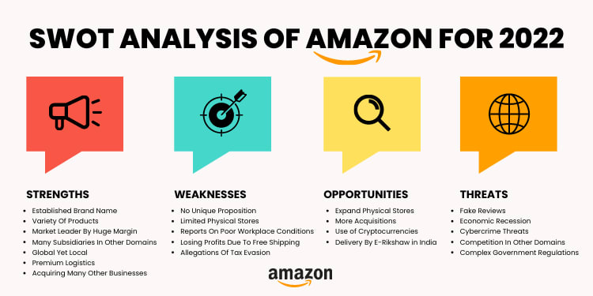
Fig 03 SWOT Analysis
https://www.strategykiln.com/post/a-totally-new-approach-to-swot

Strengths
Amazon, the largest online retailer, competes on price, uniqueness, and quantity. Companies and commercial investors have profited from this strategy. Amazon leverages IT and e-commerce as platforms to expand and scale faster than its rivals. Amazon’s top ratings from consumers worldwide are one of its biggest benefits. This knowledge helped it expand into places that many of its e-commerce rivals couldn't reach. The company outperforms its rivals in distribution and logistics. This improves service (Bartz, D., 2017).
Weaknesses
Amazon stretched itself too thin in recent years to diversify. It may now concentrate on other areas instead of selling books online. Amazon is wise to spread its risks, but if it strays from its basic capabilities, it risks losing its competitive advantage. Amazon will lose money if it offers free delivery. Amazon’s online-only strategy may collide with its development aims, particularly in developing nations. The company's poor profit margins are a major concern despite its high revenue. This reduced the company's profitability. Business analysts and others face this issue (Bartz, D., 2017).
Opportunities
Online shoppers worry most about security and privacy. Thus, letting consumers use its online payment system might help Amazon thrive. It would earn more with its own payment method. Amazon sells other brands in addition to its own. Instead of selling its partners' products, it may manufacture its own. Amazon may sell more if it stockpiles more than normal. This would protect its position and boost sales. Expanding its market and starting new enterprises in expanding regions is the fourth option. They would have an edge in the competitive online retail sector (Bartz, D., 2017).
Threats
Amazon fears identity theft and hacking, which put consumers' data in danger. This has reduced internet shopping. Amazon must promptly address website issues while ensuring privacy and safety online. The corporation has had to defend its aggressive pricing from publishers and retailers. Amazon's low prices affect the industry, and its rivals fear it will take their consumers. Since local internet firms are faster than Amazon, its big campaign hurts them too. The corporation can't merely pursue its worldwide strategy and disregard its domestic market (Bartz, D., 2017).

Relate Segmentation, targeting and positioning to the company
Amazon divides, targets, and positions itself in a lot of markets so that it can find customers and sell products and services to them. Targeting is the process of giving something to certain groups that have been identified through segmentation. Segmentation is the process of putting people into groups based on criteria that have already been set. The positioning process is all about choosing the best marketing mix for the target market (Bartz, D., 2017).
Amazon often uses two main strategies for positioning:
Dividing into Several Pieces
Amazon can make money in more than one industry at the same time because it sells a wide range of products and services. The online retail giant has more than 75 million items in stock, so it can meet the needs and interests of a wide range of customers (Dastin, J. and Sadam, R., 2017).
Positioning that's open to change
The leader in online shopping looks at how the market is changing and often changes how its products and services are positioned to meet the needs of its customers.
Positioning Aggressive
In this case positioning for a low-turnover market sector means that the business is planning for turnover to go up in the future. Amazon Web Services is a good example of positioning that looks ahead at the business is planning for turnover to go up in the future. Amazon Web Services is a good example of positioning that looks ahead. Jeff Bezos, the former CEO and founder of the company, says that no one asked for AWS. Most people didn't know this, but the world was actually ready and eager for a service like AWS. Amazon Sage Maker, Amazon Comprehend, and Amazon Recognition are used in the anticipatory placement strategy (Bartz, D., 2017).
Steps in the meantime: This method involves putting money into brands that are losing money in order to make money in the long run. In the cases of businesses like Core 10, Happy Belly, and Vedaka, the biggest online store in the world used a stopgap positioning strategy.
Marketing Mix Strategies 4Ps
Using the marketing mix to get people to visit Amazon's website has worked out well. The marketing mix, also called the 4Ps or the marketing mix is a company's set of ideas and plans for putting its marketing strategy into action (Product, Place, Promotion, and Price). Amazon gets the people it wants to buy from online by making price and ease of access important parts of its marketing mix. Amazon is the biggest e-commerce company in the world, but it faces a lot of competition that threatens its market share and chances for growth around the world. To solve this problem, the organization must make sure that its marketing mix is up-to-date in light of changes in the market. For the long-term success of its online retail business, the company uses the best marketing mix to improve the resilience and creativity of its organization (Dastin, J. and Sadam, R., 2017).
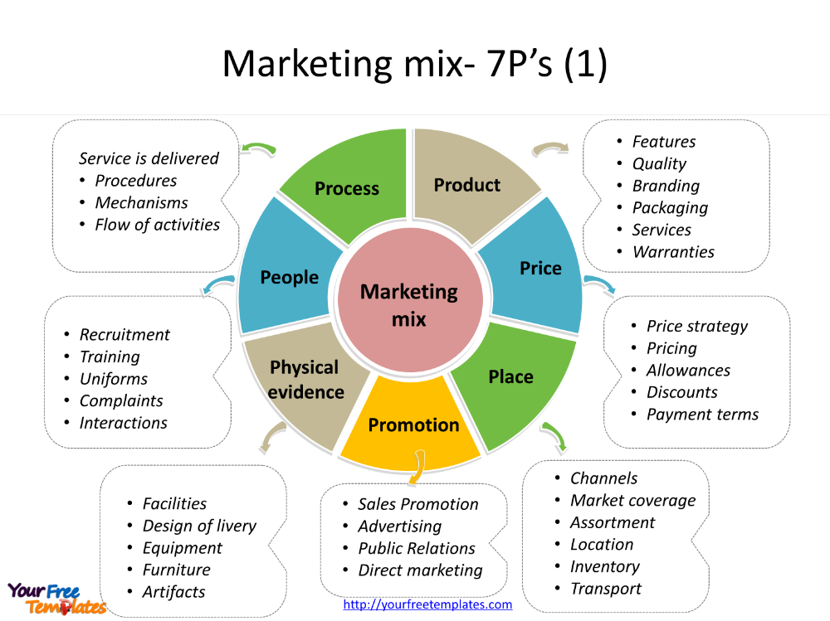
Fig 04 Marketing Mix Strategies 4Ps
https://themarketingagenda.com/2016/11/12/amazon-marketing-mix-4-ps/
Amazon's marketing mix, which is sometimes called the "4 Ps," was made to make the most of the company's online business. As Amazon.com, Inc. makes new products, this marketing mix helps the company grow and stay competitive around the world. In this part of the marketing mix, Amazon's products are taken into account. The company, which was one of the first in its field, sells a wide range of products online. This group of products helps Amazon.com, Inc., reach its goals and realize its vision. As a result of the company's continued growth and diversification, it now sells a wide range of items that respond to the market and can be bought online.
Conclusion
Since it first began selling eBooks, Amazon's company has seen significant expansion. The emergence of the internet was unquestionably beneficial to the growth of Amazon. Customers and small companies alike benefit from the convenience afforded by Amazon's online marketplace, which enables them to shop and do business without having to leave their homes. Additionally, the organization has developed original and novel approaches to accomplishing this goal. Customers who shop on Amazon will not need to be concerned about delivery times since the since it first began selling eBooks, Amazon's company has seen significant expansion. The emergence of the internet was unquestionably beneficial to the growth of Amazon. Customers and small companies alike benefit from the convenience afforded by Amazon's online marketplace, which enables them to shop and do business without having to leave their homes. Additionally, the organization has developed original and novel approaches to accomplishing this goal.
Recommendations of Future
Amazon reports a new AI conference. If not already, China will lead AI development. MARs are machine learning, automation, robotics, and space. Jeff Bezos is known for his support of technological advancements thanks to Blue Origin. It debuted at Re: MARS 2019. Amazon and other business giants spoke at the conference. Rivian electric cars with Alexa were shown by Amazon. Prime Air also uses cutting-edge drone delivery technology. This speeds delivery and transit. Amazon's Pegasus Drive sorting robot was on display. They demonstrate how much the company values cutting-edge technology. More parts in Amazon's core functions will boost production and improve shopping. The company will keep making niches and using its knowledge and traffic to beat out competitors.
References
- Cuofano, V., (2021). 'Amazon PESTEL Analysis In A Nutshell', Four Week MBA, [online]. Available at: https://fourweekmba.com/amazon-pestel-analysis/ (Accessed 16 June 2021).
- Frue, K., (2021). 'PEST Analysis of E-Retail Leader Amazon' PESTLE Analysis [online]. Available at: https://pestleanalysis.com/pest-analysis-of-eretail-leader-amazon/ (Accessed 16 June 2021).
- Panmore Institute. (2021). 'Amazon.com Inc. PESTEL/PESTLE Analysis Recommendations' Panmore Institute [online]. Available at: http://panmore.com/amazon-com-inc-pestel-pestle-analysis-recommendations (Accessed 16 June 2021).
- Bartz, D. (2017) 'Deceptive Amazon discounts under investigation by Federal Trade Commission. ‘Independent. [Online] [Accessed on 30 July 2017] http://www.independent.co.uk/news/business/news/amazon-discounts-deceptive-federal-trade-commission-whole-foods-buy-out-prices-online-a7852516.html
- BBC. (2017a) 'Amazon Prime makes first foray into South East Asia.' [Online] [Accessed on 30 July 2017] http://www.bbc.co.uk/news/business-40736830
- BBC. (2017b) 'Amazon profits fall sharply as it invests overseas.' [Online] [Accessed on 30 July 2017] http://www.bbc.co.uk/news/business-40748097
- Bedard, P. (2017) 'Obesity becomes worldwide epidemic, US is the fattest.' Washington Examiner. [Online] [Accessed on 26 July 2017] http://www.washingtonexaminer.com/obesity-becomes-worldwide-epidemic-us-is-the-fattest/article/2629712
- Boland, H. (2017) 'Amazon shares shrink as profits fall 77pc.' The Telegraph. [Online] [Accessed on 28 July 2017] http://www.telegraph.co.uk/technology/2017/07/27/amazon-boss-jeff-bezos-overtakes-bill-gates-worlds-richest-person/
- Bowman, A., Erturk, I., Froud, J., Johal, S., Law, J., Leaver, A., Moran, M. and Williams, K. (2014) The end of the experiment? From competition to the foundational economy. Manchester, UK: Manchester University Press.
- Daily Mail. (2017) 'REVEALED: Amazon is under federal investigation for selling goods to someone on the terrorism list and possible US sanctions violations.' Daily Mail. [Online] [Accessed on 30 July 2017] http://www.dailymail.co.uk/news/article-4743386/Amazon-investigated-selling-possible-terrorist.html#ixzz4oKcpcYnT
- Dastin, J. and Sadam, R. (2017) 'Amazon profit plunges with breakneck investment in global expansion.' The Independent. [Online] [Accessed on 30 July 2017] http://www.independent.co.uk/news/business/news/amazon-shares-latest-updates-profits-drop-investment-global-expansion-jeff-bezos-online-shopping-a7864156.html
- Deagon, B. (2017) 'Amazon Cloud Services Under Growing Threat from Microsoft, Google, IBM.' Investors. [Online] [Accessed on 30 July 2017] http://www.investors.com/news/technology/amazon-cloud-services-under-growing-threat-from-microsoft-google-ibm/
- Denning, S. (2017) 'Apple, Google And Amazon: How to Understand Capitalism's Future.' Forbes. [Online] [Accessed on 31 July 2017] https://www.forbes.com/sites/stevedenning/2017/07/31/apple-google-amazon-how-to-understand-capitalisms-future/#5e96759a3fa0
- Diamond, J. (2017) 'Striking protectionist tone, Trump touts US-made products.' CNN. [Online] [Accessed on 27 July 2017] http://edition.cnn.com/2017/07/17/politics/donald-trump-made-in-america-showcase-protectionist-rhetoric//
- Foss, N. J. and Saebi, T. (2017) 'Fifteen years of research on business model innovation: How far have we come, and where should we go?' Journal of Management, 43(1), pp. 200-227.
- Gilchrist, K. (2017) 'Here's what could come out of the UK trade secretary's meeting with Wilbur Ross.' CNBC. [Online] [Accessed on 24 July 2017] https://www.cnbc.com/2017/07/21/wilbur-ross-liam-fox-trade-us-uk-deal-brexit.html
- Gov. (2016) 'Sanctions, Embargoes and Restrictions.' [Online] [Accessed on 30 July 2017] https://www.gov.uk/guidance/sanctions-embargoes-and-restrictions
- Gunther, M. (2016) 'Can Amazon's new 'dream team' fix the company's sustainability reputation?' The Guardian. [Online] [Accessed on 30 June 2017] https://www.theguardian.com/sustainable-business/2016/feb/02/amazon-sustainability-edf-epa-best-buy-walmart-apple-microsoft-csr-child-labor
- Law, J. (2017) 'Amazon Development Centre Edinburgh devising and growing global innovations.' City A.M. [Online] [Accessed on 30 July 2017] http://www.cityam.com/269426/amazon-development-centre-edinburgh-devising-and-growing
- London, A. (2017) 'Amazon has launched 'Hub' - storage lockers for deliveries in your home.' Tech Radar. [Online] [Accessed on 29 July 2017] http://www.techradar.com/news/amazon-has-launched-hub-storage-lockers-for-deliveries-in-your-home

