
Skills for the Workplace
Module Assignment Submission
Student Name: | Caroline Lewis
Student Number: | 1917865
Module No: | BMSK4006
Module Title: | Managing Enterprise in the 21st Century  Part 1 Business Plan

Statement of Confirmation of Authenticity
By the act of making this submission, the student declares that this is the work of the student named above. The work has not, in whole or in part, been knowingly presented elsewhere for assessment, or where assessment has been built on a previous assessment, this has been identified. Where materials have been used from other sources it has been properly acknowledged. If this statement is untrue, the student acknowledges that an assessment offence has been committed.
Attention is drawn to the plagiarism and unfair practice policies of both the University and of ILM.

Little Welsh Dragon Coffee

Caroline Lewis Tel: 07790 771361 Email:Matthews.08@btinternet.com

Table of Contents
Table of Contents………………………………………………………………………… 3
Executive Summary ………………………………………………………………………4
Business Overview…………………….………………………………………………… 5
Markets and Competition………………………………………………………………... 7
Target Markets……………………………………………………………………… 7
Competition………………………………………………………………...….…….9
Sales and Marketing………………..……………………………………………………11
Product Positioning…………………………………………………………..……11
Marketing……………………………………………………………………..…….12
Sales………………..……………………………………………………………….15
Management………………………………………………………………………………17
Key Personnel………………..…………………………………………………….17
Advisors and support services………..…………………………………………..17
Operations………………………………………………………………………………… 20
Premises and Equipment…………….……………………………………………20
Employees………………………………….……………………………………….21
Suppliers…...………………………………………….…………………………….22
Financial Forecast..……………………………………………………………………….26
Appendices…………………………………………………………………………..….…33 References.……………………………………………………………………………......53

Executive Summary

The author is a full-time worker for the council as a rent officer and prior to this, she worked in the business rates section. Before she joined the council, she ran a post office for several years. She has two grown up children and now that she has freer time, she has decided to investigate into running a weekend business.

According to The British Coffee Organisation (2020), coffee is the most popular drink worldwide with around two billion cups consumed every day; and approximately 95 million in the U.K alone. Ground coffee is becoming increasingly popular, with 16% of buyers aged between 16 – 34. With these points in mind, this report analyses the potential business opportunity for a unique Welsh coffee trailer.

This business plan includes a SWOT, SMART, RISK ASSESSMENT and PESTLE evaluations; to establish the strengths and weakness of the venture, and if it is a suitable business for the author. It also contains the legality that is needed to set up and run this business which includes licencing, tax, health, and safety. The plan contains a list of the author’s business advisors, their C.V/skills, and their recommendations for the project. It also contains research from the coffee business market and data collected from online questionnaires.

The report contains marketing and competitor quotes to ensure the pricing of this plan is realistic. It has detailed research on costings of all aspects of the project from stock, equipment, fees, wages, licenses, and marketing. The report has a financial section on how the author will finance the setup of this business, how she will use these finances and a prediction chart of potential profits. This plan also contains future ideas and plans for the business.

Business Overview

The author’s business plan is ‘The Little Welsh Dragon Coffee’ trailer. This is a small red trailer which has a cute and quirky vintage look, with the unique selling point that it is of an all Welsh theme. It will provide a premium ‘Dragon roasted’ Welsh coffee, produced locally in the Gower, an area of outstanding natural beauty. It will also sell Welsh cakes from the popular local firm Castell. These cakes will be cut into heart shapes.

The author has previously worked in business rates for 10 years. In this post, she monitored and booked businesses in and out of Swansea for rates purposes. She noticed that more and more coffee shops were opening and having no difficulty in trading. Recently, 4 new coffee drive throughs have been built in Swansea. One is currently being built within 1 mile of the company’s other drive through. This is a good indication that there are high profits and enough demand to keep the market expanding, with more and more coffee selling outlets. Not only is coffee a growing trend, but it is an all year-round product.

Due to the authors experience in business rates and knowing the overheads that it can bring; she has seen that tying a business down to rates and rent can break a business. As her business will not be well-known, she believes that a shop would be too high a financial risk. Therefore, she has looked at a coffee trailer to get on to the market and establish the business name. She also believes that a trailer would be more suited to her, as it has more flexibility to its working hours than a standard shop.

The author has put together this demand for coffee, with a twist of making it personal to Wales.

The first market she will try to break into is weddings. Although coffee is not usually considered to be at a wedding due to it being non-alcoholic, research shows that more of the younger population are turning their backs to alcohol.

According to the NHS article Oct 2018

"Shunning alcohol becomes 'mainstream' among young people as a third are now teetotal," reports The Independent.

The author will cater to the customers wishes and for the ones who would like a small amount of alcohol, she will also provide her take on an Irish Coffee. The author’s ‘Welsh coffee ‘includes a splash of Penderyn whisky. This whiskey is an award-winning Welsh whiskey. Currently the company are restoring a local listed building as their new Swansea distillery. On hotter days, the trailer would serve ‘iced coffees’ and ‘Merlyn’ (Penderyn liquor) cream ice slushies. The author will make at home, hard boiled lollies made from the Penderyn whiskey: they can be sold as stirrers for the coffee or a small sweet.

The author will target weddings and small events at weekends first, as this will fit around her current full-time job. As the set-up fee for this coffee trailer is relatively low (£6000) and she has the security of her main employment, she will set up this business as a sole trader. She has researched the government website, and this is the quickest and easiest option to start trading. If the business fails, the main costs spent to start it would not be fully lost, as the author would be able to sell the trailer and coffee machine on. As a sole trader, she does not have the financial protection that a Ltd company has, but if the project grows into a full-time venture, then author will then change the status into a limited company. (Appendix 1)

As the business grows it will move onto larger public events such as the Red Arrows Air show, Proms in the Park, Festivals, Christmas markets, concerts, and other larger events.

Markets and Competition

Target Markets

The author’s first stage would be to target weekend weddings and small events as this would initially be a part time business.

The author believes there is a gap in the market for such a venture, especially in weddings. The author has experienced there is a lot of time before and after the service, where guests must wait around for the bride to arrive, or afterwards while photos are taken. To provide a hot or iced coffee and a Welsh cake, can bring a useful and thoughtful addition for the guests, as it can be a long time from their breakfast to the wedding meal.

It is becoming a growing trend to get married at unusual locations, such as a beauty spot or a hired cottage; therefore, caterers with vans and trailers are needed. Also, bride and grooms are hiring venues without the in-house food, as it is a cheaper option for the wedding budget, for example, they will hire instead a mobile hog roast van.

“There are many exciting catering options available to couples these days, especially for those Brides & Grooms looking to keep costs down or wanting to steer away from the traditional Wedding Breakfast!” Hla, E (2020)

The author’s trailer would be decorated in bunting and have a black board sign welcoming the guests to Mr and Mrs Blanks wedding. The Welsh cakes would be cut into heart shapes to give a ‘love ‘theme. Extra options would be available, such as personalised napkins and coffee holders stamped with the Mr & Mrs name and date. For the drivers there would be normal coffee, but there will also be an alcoholic version of an Irish coffee but with a Welsh theme, with a splash of Pendyryn whiskey added.

At this stage, the author will target market is engaged couples.

The high-quality goods and uniqueness of the brand, along with the quirky look of the project will stand out as an exciting yet useful addition to an event.

This is the only ‘all Welsh’ coffee trailer’ and this is its unique selling point.

As the business develops, the second stage of the plan would be to open to larger public events such as local food markets, corporate business events, festivals, and tourist attractions e.g. The Red Arrows Air Show

Depending on the successes of stages one and two, the author would then look at the potential of this becoming a full-time business. This plan would include a weekday timetable, delivering this service to high end business corporate events or to pitch at large work based offices, such as the D.V.L.A in Swansea, where the workforce is at 6000 in one building. The trailer could be set up near to the main car park to attract the workforce entering the building in the morning. The author has previously worked in the DVLA and has noticed the employees like to get out of their offices at lunchtime to go for a walk and get some fresh air. The author would return the trailer at this time to get the maximum potential trade. The DVLA is one of the largest and highest paid organisations in the Swansea area, with a starting pay of £19,328 per year (gov.uk) and increases annually. This suggests that the employees have expendable earnings, combined with the intense workforce catchment area, could result in a profitable place to set the pitch for this business.

Stage three would be to make ‘Welsh Coffee’ hamper baskets. These will contain a bag of Welsh coffee beans, a small Penderyn whiskey, a packet of Welsh cakes and a small packet of whiskey hard boiled lollies. It will target as a men’s’ gift for a special occasion. e.g. grooms, fathers’ day, birthdays, Christmas, or anniversary. It will be personalised inside with their name printed on the coffee cup. This style of hamper and gift idea has been extremely popular recently, this is due to lock down measures of COVID and people are not going to shops for fear of the virus. This is another way that the author can potentially make money all year round, and without large overheads. She will start by delivering the hampers locally to see how popular they become.

Competition

The author has researched local competitors, and Café Piccolo in Swansea delivers a similar coffee style venture. The two businesses differ however, as Café Piccolo’s sells Italian coffee and its products are delivered and served from a small ‘tuk tuk’: the author’s business will be from a trailer and provide a Welsh theme and products. The author believes that as Café Piccolo is run from a small ‘tuk tuk’, their travel time would be much longer to go further afield as it is such a low powered vehicle, compared to the author’s trailer. Due to this, they may not be considered as reliable as the author’s business, as she could use different vehicles if needed. If the author’s main car breaks down, this will not affect the service promised to the customer.

Camper Coffee has several vehicles within its business. They also target events, concerts, and weddings. Their USP is that they use Volkswagen vehicles, with a ‘hippie camping vibe’. They are set at the same price bracket as the author’s (camper coffee quote appendix 6) yet they are based in Exeter and are out of the local area.

These two competitors only supply coffee. They do not supply any food or have the added little extras of alcoholic lollies. However, these companies have strengths over the author’s business. Both companies have attractive websites, large fan basis, experience, and a strong network of events. Café Piccolo started in 2017, and the tuk tuk is extremely unique as it is a vintage vehicle, and this is the main attraction of the business. “Nostalgia plays a large part in the appeal of classics” Ian Davies 2015. This vehicle attraction is also evident in the yearly Classic Car show, which is held in Singleton park each year.

Vintage Camper coffee Co is a larger business and is well established. It started in 2013 and their past events have included Glastonbury festival. (Devon life 2018)

Business Idea Feedback:

The feedback on the business idea from the author’s advisor Peter Owen, previous Head of Marketing and Communication at The Ospreys.

“I think there is definitely room for this business. More and more events- wedding, sports, concerts, and festivals, are moving away from traditional catering options and looking at alternatives with a quirky touch. Local products-you tick this. Coffee-you tick this, so I can see a space in the market. “Peter Owen (2020)

A questionnaire was conducted 23.06.20 by the author via her Facebook update.

“Would anyone hire a Welsh Coffee trailer for their wedding? (The author)

The comment below shows again that there is a strong interest in this venture and a gap in the market.

“I think it’s a great idea, we had chocolate love spoons back in our wedding in 1998 and all the guests loved them. So yep, all things Welsh are a win!” Karen Patricia (2020)

Sales and Marketing

Product Positioning

The author is projecting a ‘differentiation’ price market, as the quality and uniqueness of the product demands a higher premium to a neutral, or skimming price bracket.

The author has asked for a quote (Appendix 6) from Camper Café. They have quoted for up to 4 hours and 1 barista is 450.00, excluding vat and travel charges.

The author conducted a Facebook discussion (23.06.20) on what her friends and colleagues would be comfortable paying for such a service.

“For 4 hours of unlimited coffee, I would pay 500.00. But if there was alcohol involved in the coffee, I would expect to pay more” Karen Patricia

According to Hitched (2019) the average total cost of a wedding in 2019 was £31,974, therefore the author can see that for a wedding day product a top price is achievable, and the customer expects this. Therefore, the author will set her price at £500.00 (excluding travel charges) for a 4-hour hire, which is like the Camper Café quote. If whiskey is added the charge would go up by £50.00.

For events where coffees would be sold individually:

Market research via Facebook (23.06.20) revealed that the authors friends would be happy to pay between £5.00 to £10.00 for a premier coffee and a Welsh cake, with 2.00 added on top for a whiskey shot, depending on the type of venue and customer catchment area.

Results showed:

Street trade they would expect to pay between £5 to £7

9 out of 10 were happy to pay between £8 to £10 at an event.

1 out of the 10 friends were happy to pay £10 to £15

The author asked her advisor Peter Owen, on his thoughts on pricing due to his vast experience of corporate and entertainment events. He said:

“Cost- you’ll need a sliding scale – one festival is different from another etc, but I think a basic start is around £5 to £6 for a coffee and a Welsh cake…going up to £7 to £7.50 (2.00 added whiskey shot) is in most budgets.”

Marketing

The author will market her venture at wedding fares. She will set up a mock wedding event that includes tasting samples of her products. These events are highly popular with future brides to get new ideas and trends for their wedding. Many traders are booked at these events.

The author will also advertise with contact numbers on the side of the trailer, to catch passing interest in traffic.

The author will set up a website with photos, prices, ideas of use and examples of past events. She has had a full quote for the set-up of a website from Natalia Barrett (Appendix 8 B)

This business will also have a Facebook page.

The author would also advertise in ‘Your South Wales Wedding Magazine’. This magazine is both online and printed quarterly. It is free to the public and has won best wedding magazine in the years 2014, 2015 and 2016. It is an essential read for a bride to be in helping her prepare for her big day.

The magazine also has followers on Pinterest, Instagram, Facebook, and Twitter.

The author has emailed Kirsty Cushing, the Account Manager for advertising quotes. The author thought the charges were very good value and it will be a strong marketing tool to get her business promoted. The magazines are distributed to hairdressers, wedding venues, hotels, suit hire, wedding dress shops, florists, and cake shops. Even though these shops have been closed recently due to the outbreak of COVID 19, the online magazine is showing to be extremely popular.

“The huge surge online we were expecting is now at a 300% increase. As you are aware all wedding fares have now been postponed, meaning more couples are searching online for wedding ideas for their 2021/2022 weddings.” Kirsty Cushing (2020) (Appendix 2)

More advertising by ‘Word of mouth’.

The author will also set up YouTube blogs, where she will discuss her products and upload videos of her events.

The author has also looked at the Welsh Government website and it has a ‘sell to wales’ page. On this page, businesses can search for services that they require, and businesses can also advertise here. The author conducted a search on this site to see if a coffee service was needed, and Aneurin Local Health board was advertising for one. (Appendix 7)

The author has also investigated pitching her trailer at some of Swansea’s main tourist events, especially The Red Arrows Air show. This event, held every year, has 200,000+ customers and 2 full days of trading, at a cost of £300.00 a pitch. (Appendix 5) This event alone, could produce a large amount of profit for the author.

The author will contact the Events Team in Swansea Council to be put on their list of caterers for future events.

The author has completed a STEEPLE to assess her business venture:

STEEPLE

Social: Lifestyle trends: coffee becoming a global trend. Social event: people gather with friends for a coffee. Age: growing population making the coffee market expand. Health conscious: research shows 16 to 24-year-old people are drinking less alcohol. (NHS 2018)
Technology: Equipment: Coffee equipment is improving with a faster rate of productivity. Trailer: is small yet has all the facilities needed for the venture. Mobile card payment systems: enable the business to work from all locations. However, all technology can have its failures. A flat tyre, power failure and loss of signal would all affect the running of the business and prevent trade.
Economic: Economic growth: if this becomes stagnant, it can be difficult to start-up a business or for it to grow or make a profit. COVID 19 could result in a recession, and customers disposable income could be greatly reduced. Customers would then spend on low cost coffee. Taxation is already in some media discussions, that it may rise this is due to pressure that the Government is currently under with its finances. Interest rates: they can influence the business loan which eats up more of the profit margin. Interest rates would also affect the customer and have less disposable income. However, if interest rates are reduced, this can be beneficial to the business profits, as the consumer has more income to spend on luxury items. Inflation rates: if there is an increase, the cost of the product from the supplier would be greater. This cost would then be passed on to the customer, which may affect their decision to purchase. Recession: this can also bring down the start-up costs of a business. The cost of the trailer and equipment may be purchased at a cheaper price, resulting in less over heads.
Environment: Recycling: coffee cups/plates would be made from recyclable paper. Rubbish: bin will be provided and emptied using recycled methods. Fuel: the car used to deliver the trailer would be unleaded. Deliveries: local produce to keep fuel pollution of deliveries at a minimum. Weather: coffee is an all-round product. A small gazebo would be erected if needed, next to the trailer.
Political: Law: minimum wage policy could rise but must be kept, and profits could be reduced due to this. Taxation: if tax is raised too high, this again can reduce profits. It will cause a rise in the cost of the product and this could prevent a sale. Licences: could be difficult to get through the ‘red tape’ of starting the business and the added expense to start-up costs. Potential change of Government: this could result in new licence laws and added costs. Trade restrictions: this could affect the coffee industry and the suppliers of the product. It could raise difficulty in trading and could add costs to the suppliers. However, it may be beneficial to the industry if the restrictions were reduced.
Legal: Legislation: employment rules and health and safety should be adhered to. These rules might change in the future if there is a change in Government. Consumer protection laws to be kept but these can be susceptible to change. Copy right laws to also be considered and not be broken.
Ethical: Free trade: coffee used has been researched to be a free trade product: Coffee with a conscience. Eagle, D (2020). Staff: will be family members but will receive the correct pay and conditions as non-family members.

Sales

The author understands how customers ‘brand loyalty’ to a specific coffee, can hinder her in breaking into the market. She will try and overcome this, by offering a small free tasting sample, to help persuade the customers to be tempted to change their minds. She will actively do this at all event’s and business days. The ‘try before you buy’ will give confidence to the customer of the quality of the product. If it is not to the customers taste, this still shows good customer service has been given, which is still advantageous to the business reputation.

As the products to be sold are from local small businesses, this may help sway customers to make a purchase, as they are helping the Welsh economy.

In wedding fares, she will meet the guests, talk through her ideas, and discuss the products.

She will arrange a follow up meeting if they would like, to discuss the products in more depth or in private. The author will show examples of her products and photos of her past events. She will listen to their needs and make suggestions that they may like. This meeting may take an hour of the authors time to complete, but bookings in themselves are advertising for future work. The average number of guests at a wedding according to Get Hitched (2020) is 120. Perhaps that 120 guests may wish to book the Little Welsh Coffee Trailer for their wedding, work event or birthday.

Other than weddings, she will search for potential work on Business Wales Events Finder (2020). This website advertises future seminars and events. The author could call the organiser and suggest her trailer, as a unique refreshment for their day.

The author already has prospects of sales, this is due to the connections Natalia Barrett (Co;Lab) and Peter Owen (Pobl) who are part of her team advisors. They are both head of events and marketing for their companies and are very interested in the project being part of the refreshments in one of their events.

Management

Key Personnel

The author will be the key worker. She has thirty years’ experience in customer care and ran alone a post office for three years. She believes that good customer care, can give the customer confidence in the product and services, and therefore more likely to return. Her post office duties included stock control, bookkeeping, maintaining equipment, cash handling and balancing a till with no errors. C.V (Appendix 10A)

Advisors and support services

The author’s niece Natalia Barrett, is cofounder and design manager of C:Lab Creative which is a production and events consultancy company. Their service range includes marketing, brand identity, strategic and cultural planning, and webpage design. Natalia will be a key advisor to this project. She also has a vast network of event connections and organisers to be able to promote and hire the author’s business. This network includes organisers of Christmas street events, musical projects and film making locations where a mobile coffee van would be needed. Her C.V is in appendix along with a full quote for webpage design and search engine costs. (Appendix 8 A)

A friend of the author is Peter Owen. Peter was Head of Marketing and Communications for many years with the rugby team Ospreys, and before that, for the football team the Swans. He is now Director of Communications, Marketing and Culture for the local housing organisation, POBL.

Accountant Barry Davies. Director of the local solicitors Douglas Jones and Mercer and a long friend of the author. He will be an advisor and accountant for the business.

Another advisor of marketing and set up is Mark Bolt. He has 30 years’ experience in the field of new businesses and is currently working as Sales and Marketing Consultant for IPL laser equipment. He is a member of the Chartered Institute of Marketing and Member of the Institute for Export. He has sent an email of the marketing plan for the ‘Little Welsh Dragon Coffee’ along with his credentials. (Appendix 9) His detailed plan has given the author further thought of areas to grow the business. He has suggested an online shop for her goods, and this would be something to consider due to current COVID events. The author could produce a ‘Welsh hamper basket’ that contained her products. This would be a great gift idea for birthdays, anniversaries. It would also be popular as a gift to overseas. Mr Bolt has also suggested locations where the author had not thought of pitching e.g. holiday villages and country parks. She could also provide boutique Welsh hotels with ‘Welsh Hamper Baskets’ as a welcome gift to their guests.

He also advises the author to do internet ‘blogs’ and advertise on Pin interest which would catch the global audience.

The author will also contact Business in Focus, based at Henley House in Swansea. They offer free advice and help with all aspects of starting a business and more.

These include:

Training courses: Free training courses to suit everyone, whatever stage your business is at.

Starting a business: Support and advice to help you start your new business.

Growing a business: Information and resources on finance, marketing, IT, innovation and more.

Innovation zone: Innovation can help your business become more competitive, increase sales and enter new markets.

Skill gateway: Review your current skills and find out how you can improve them.

Sell 2 Wales: Public sector procurement portal for Welsh buyers and suppliers.

Monitoring support: Connect with an experienced business mentor who can help you grow your business.

Social business Wales: Support for social enterprises, cooperatives, mutual, and employee owned businesses.

Superfast Business Wales: Access resources on IT security, communications, networking, business software, staff, and IT training.

With these advisors, the author feels confident she has the expertise the business needs to set up, be profitable and have growth.

Operations

Premises and Equipment

The author will need a small catering trailer with a sink and power facilities. The author has researched these and located one on Gumtree (appendix 4). Storing of the trailer can be in the author’s garage, as the trailer is of a small size. The author will also need a coffee making machine, equipped enough to turn out large amount of coffees. The author has looked at purchasing a second-hand machine, but as this is the main equipment for the business, she would rather purchase a new one that has a guarantee. She has located one from John Lewis stores, which is £100.00 more expensive than the second-hand one she previously costed. The John Lewis machine also comes with an inbuilt coffee grinder and free delivery, which both help in lowering the set-up costs.

The author has also researched payment methods and according to Hall, J (2017) iZettle is becoming an increasingly popular card machine option for small businesses. The reader is small, looks sleek, and is one of the cheapest options on the market. The machine is £29.00 per month flat fee. This machine will only be purchased on part two (street trade) as bank transfers will be used as payment method for weddings.

As this is a mobile business, it is not tied down to any location and there is no added costs of rent and business rates.

The suppliers of the coffee and Welsh cakes are based in the authors local area. The coffee is produced in Gower, which is 3 miles away and the Welsh cakes are made in Pembrokeshire, which is 15 miles away. This is convenient for the author to balance her stock correctly. This locality will help keep wastage to a minimum, as it will prevent over ordering or running out of produce. It is easily accessible to restock at little notice. Penderyn whiskey is sold in her Tesco and occasionally on offer. Penderyn also have a website and offer free delivery. Once the new distillery has opened in Plasmarl, which is local to the author, she will get the supply direct from them. The author plans to have discussions with them to get a discount, as she is promoting their product. She has set this as an aim in her SMART objective to be achieved by 01.12.20. (Appendix B)

As the author would like to build a relationship with her suppliers, she will regularly pick up the items she has ordered. If she occasionally has difficulties to pick up the stock, both companies also deliver using Royal Mail.

Employees

Initially the author will work alone, to keep start-up costs for employees at a minimum.

The author will train her daughter to cover on certain days (e.g. holidays, sick leave) or alongside the author at busy events, where more staff is needed. To keep the start-up costs low, they will be the only coffee barristers.

Her daughter Antonia Matthews has worked for two years in the frontline of a major ‘fast food’ company. She is knowledgeable in cash handling, customer care, hygiene, order taking, food preparation and serving.

Coffeemaking is a craft and special skills will be needed. Coaltown coffee roasters in Ammanford provide coffee training courses, and this will be booked for the author. She will then train her daughter with what she has learnt, to keep costs to a minimum. Cost of course is £380.00 a head for 3 hours.

The author and her daughter would both need Health and Safety training. They are both experienced in customer services, cash handling and till balance due to their past careers. The author has worked in banks and post offices. Their C. V’s are in appendix.10

Suppliers

Coffee:

This will be supplied by the Welsh Coffee Company. They have a service where they provide the coffee and they will specially brand it for the author’s needs. They guarantee to roast and ship every Thursday. Their coffee is a quality product and they are reasonably priced at £14.50, for a 1kg bag. If this supplier goes out of business, the author has research two other Welsh companies that would be a backup.

The Gower Coffee Co is also based locally offering a high-end product. This coffee is slightly higher in price at £15.60, for a 1kg Langland coffee bag. This is a small increase on costs, but not big enough to affect the authors profits if she had to purchase the coffee from here.

The Coaltown Coffee company is based in Ammanford. Their products are priced much higher than both previous companies. A 1kg coffee bag is £26.00, which is £10.40 more expensive than The Gower Coffee Co, and £11.50 more than The Welsh Coffee Company. This will have an impact on the authors profits if they need to change to this supplier.

Welsh cakes:

The author has chosen to sell Tan y Castell Welsh cakes, from Pembrokeshire. They have several awards for their taste and quality. They have been selling their product since 1997 and are firmly established. It would be unlikely that this company would fold. They supply all major supermarkets, manufacturing 28 million Welsh cakes a year, and voted to be the tastiest Welsh cakes by Tesco customers in 2009. They are low cost at 16p each. They have a ‘long best before’ date, which will help keep wastage at a minimum, and this will help prevent a loss in the profit.

If the author does have to look for another supplier, there are many from her local Tesco, Greggs and even fresh from her town market. Buying fresh could be a weakness to the business, as it causes time delays in ordering and collecting. Being fresh they have a short shelf life and therefore this can cause higher wastage and loss of profit to the business.

Penderyn whiskey:

This again is a well-established firm starting in 2004, and now the company is extremely successful and supplies all-round the globe. This whisky is available online with free delivery and it is also sold in local supermarkets. A new distillery is being built in the author’s town, and she would be able to purchase it there in the future. She will introduce herself and her business plan to get a rapport, and to push for a discount as her business will be promoting their product.

Coffee cup supplies:

There are over 50 suppliers on eBay for coffee cups, and they are easily delivered and restocked.

All these suppliers do not offer credit. The author does not see this as a weakness, as the products are inexpensive to purchase.

Licencing, Law and Regulations

The author must register the business name and herself as sole trader (self-assessment) with HMRC, failure to do this can cause fines. She will keep 25% of her profits aside for Tax.

The author must follow the correct licence laws. She has researched her local council website for the licences and regulations needed. She must register her food business with the council 28 days before trading. (No fee for this service) Swansea Council (2020) They will call and inspect the trailer to see if the author is adhering to the health and safety rules.

The trailer will also be insured: Quote below.

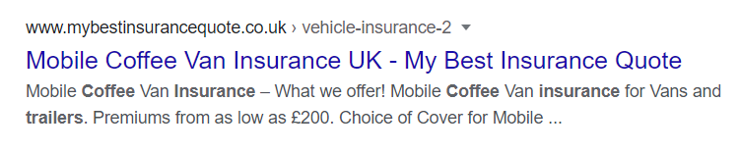

The author then looked at what alcohol and trading licences would suit her business to start up. As she will initially target weddings and not be street trading, she was advised by Swansea Council licence dept to look at temporary event notice. (appendix 3)

“A TEN can be used to authorise an event outside of the terms of an existing premises licence, or to provide authority for an event where there is no existing premises licence. To qualify for a TEN there should be no more than 499 involved at any one time.” Swansea Council (2020)

Temporary event notices. Applied for 10 days before the event. £21.00 per event.

The author believes this would be ideal for her business as the number of wedding guests fits within the 499 rule. The licence is inexpensive to obtain resulting in the best profit for the business. The author then investigated whether she would need a ‘Personal licence’ to sell alcohol as well as the notice, but she does not, which again is less expense to pay out and less paperwork.

“You do not need a personal licence for the provision of regulated entertainment or late night refreshment, or for the supply of alcohol under a club premises certificate or temporary event notice.” Swansea Council (2020)

As the business grows, with the potential of being full time using street trade, the author would need further licences:

Planning permission is needed to be obtained for ‘outer zone street trading’ licences. If planning permission is granted the charge for the licence to trade is at 113.00 per month. (Appendix11)

The author will also get yearly public liability insurance for up to £5 million, which is the required amount of cover for events such The Red Arrows Air show.

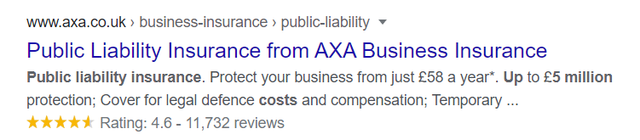
Financial Forecast

Sales

With the results of her SMART analysis, she has set her goals and a plan. She will measure her sales and profits, to see if her business is starting to get established. To do this, she will monitor her bookkeeping results, from start of trade to 01.12.20, to see if there is a progression. (Appendix B)

Cashflow

The author will also take a 25% non-refundable deposit for wedding bookings. This will not only help with the cash flow, but it will also make the booking of the wedding less likely to be cancelled, and a more secure income for the author. The full charge will be requested 6 weeks before the wedding day (this is standard practice for wedding bookings including photographer, cake etc)

Advertising in the ‘Your South Wales Wedding Magazine’ is payable 2 months after publication. The advert will potentially cause bookings, before the magazine invoice is in. (Appendix 2)

The author has set aside £2000 of her own savings as a back-up if needed, to prevent the cash flow running out.

As the start-up costs are low and the produce is inexpensive to purchase, the author would have sufficient cashflow to cover any delays in payment. The author will also have the security and finances through her main employment, as she could use if the cashflow was running low.

When the business has moved on to street trading, the iZeetle card payment machine will be used. Per transaction takes around 5 seconds, this will enable the author to move quickly onto the next customer to optimise sales. The iZeetle also promises that the money will be in the authors bank account within 2 days. This will help with the business cashflow in preventing long delays.

Profitability

Profitability | Profitability
For the finances, the author has researched start up loans for new businesses. The Welsh Government recently had a £2500 grant scheme, however the deadline for start of trade was March the 1st and the author has missed that opportunity.

The author has decided on a Start Up Loan available from Business in Focus. This scheme offers low cost, unsecured loans of between £500 and £25,000 with a fixed interest rate, currently 6%. The repayment period is from 1 to 5 years. The author has decided to have a loan for of £6000 at a repayment of £106.00 per month, for 60 months. This low amount will help with the cash flow and should easily be achieved.

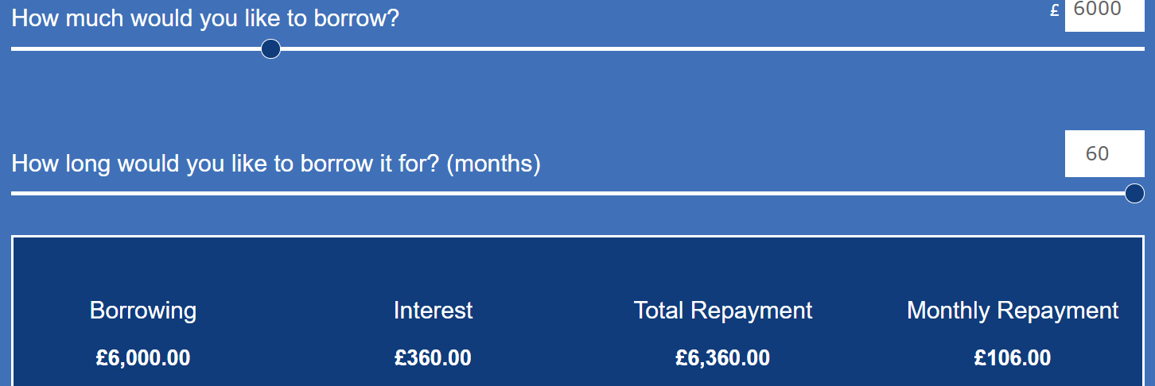

The author will also have a contingency fund of £2000 of her own money, as a backup plan for cash flow if needed.

The author has completed a full break down of the finances needed for the setup, which is £6768.04. This includes all the equipment, advertising, training needed and stock for 5 weddings. She has put the complete licence fees within this full amount if she decides to go into street trade. The cost for these licences is £150.00. Therefore, the cash flow start balance/contingency is:
£8000.00 (loan and personal money) – £6768.04 = £1231.96 (contingency)

The author will plan to get £500.00 plus petrol per stream (wedding or private event based on 100 guests).

Cost per event in products and services to author = 101.85 +100.00 (wages)= 201.85 (a)
Cost to customer = 500.00 – 201.85 (a) = 298.75 – 20% Tax 59.75 =Profit per stream at £239.00

Profit per stream 239.00 - Loan per month is 106.00 = £133.00. Therefore only 1 even a month would see the costs covered and more events would be pure profit.

The author will base her finance prediction on 3 events a month which is the most likely number for a new business.

Calendar of Expenses and predictive profit:

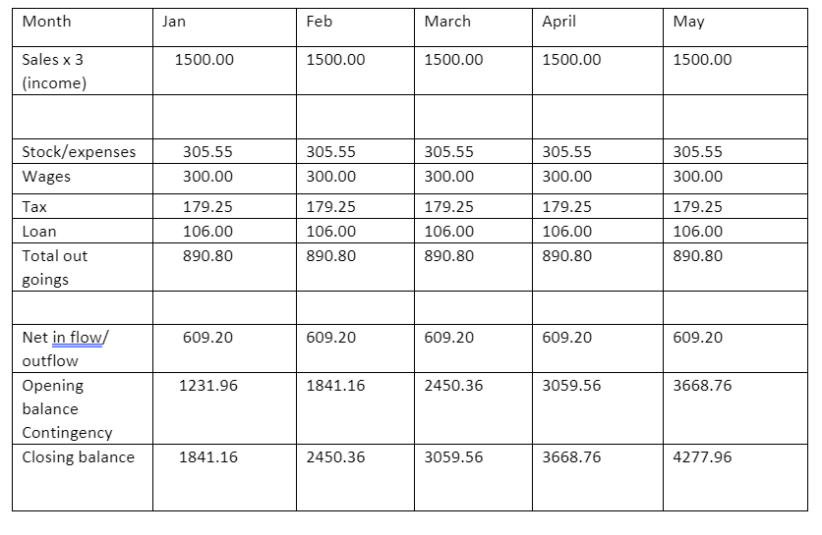

Based on the above it would take 13.1 months of trade to break even on the 6000.00 loan and the 2000.00 contingency. £8000.00 (set up) / £609.20 (monthly profit) = 13.1 months.
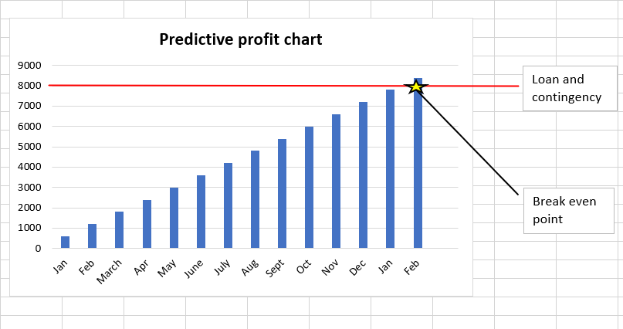

£609.20 per month is enough profit for the business to be sustainable.

This is based on stage one of the business plan. If successful, the author will look at expanding into plan 2 (street trade, public events and supplying coffee close to offices). This will have the potential of higher profits; however, it comes with more risks as the author would have to end her main employment and loose the security that gives her financially.

If in the future, the author attends events such as The Red Arrow’s Air Show, it has the potential to make large profits. To join the event for 2 days is £300.00 with 200,000 potential customers. (Appendix 5)
Equipment
Trailer | 4250.00
Petrol to get trailer | 60.00
Coffee Machine | 549.00
Brand stamp and Ink | 16.10
Portable black board (plus postage) | 18.94
Bunting | 4.95
Ice grinder (plus postage) | 76.92
Apron x 2 | 15.98
Sub total | 4991.81
Supplies for 500 units (Approx. 5 weddings)
Coffee x 5 1kg bags | 70.00
Milk | 10.00
Sugar | 3.00
Pendyryn whisky x 2 | 62.40
Merlyn liquor x 1 | 10.00
Welsh cakes x 500 | 80.00
Cups/lids | 39.89
Cup sleeves | 15.99
Napkins | 12.95
Petrol approx. (but this will be later charged to customer) | 100.00
Temporary events notice 21.00 x 5 | 105.00
Sub Total | £509.23
Training
Coaltown coffee training course | 380.00
Licence fees
Personal Licence | 37.00
Street Trade licence | 113.00
Insurance (per year)
Public liability insurance. | 58.00
Catering trailer insurance | 200.00
Advertising
Website | 299.00
YouTube | Free
Facebook | Free
Wedding fair promotions | £180.00
Instagram | Free
Sub total | 1267.00
Total | £6768.04
Breakdown cost for start-up and enough stock for 5 wedding events:

Full breakdown of references and cost of products and equipment needed are in appendix 4.

Payments:
The author will be paid by banks transfers, as these transactions are quick and incur no charges. They are also secure and an easy way to keep a track of payments for accounting purposes. For the second stage of street trade, iZeetle card payments will be taken.

Bookkeeping:
The author will keep her receipts for all costs and income from the business for accounting reasons for 5 years.
She will claim her tax back for:
Vehicle repairs, services, tyres, MOT, and mileage.
Stock, uniforms, accountants’ charges, and services.

The author has completed a risk review (appendix C)

One result of this review has brought to her attention that she would be unable to provide her service if there was a breakdown in her coffee machine. She has no replacement, and although there is a guarantee on the product, she would be unable to trade while it is being fixed. This has made her look at getting a second-hand back-up machine as soon as the profits allow.

Appendix A

SWOT

Strengths | Weaknesses
- Hard working  - Friendly/polite manner  - Dedicated.  - Wide experience of customer care and communicating with the public.  - Good at budgeting in home life.  - Conscientious.  - Has the experience of running alone a business (Post Office)  - Knowledge of local area  - Local produce therefore quick and easy to get delivery or pick up of supplies  - Mobile to take advantage of public events  - Quick to set up  - Fast product and quick service  - Little space needed to store the van and the stock  - Can use the business as little or as often as wanted  - Coffee products have a long use by date  - Low start-up costs  - Large profit margins  - Flexibility | - No previous experience of coffee or the industry  - Skills needed  - No knowledge of health and safety for a coffee van  - No prior knowledge of pricing  - No prior knowledge of equipment needed  - No knowledge of licenses needed  - Welsh cakes have a use by date of 1 month  - Long hours
Opportunities | Threats
- Unique ‘Welsh’ product angle  - Available for hire at corporate and social events, weddings, or private parties  - Initial set up is inexpensive, no rental or rates  - If unsuccessful, able to sell equipment on  - Mobile business to take opportunities other than local  - Coffee is a growing trend  - A year-round project  - Can also help the suppliers’ market their and advertise their products and take commission for this  - Other business may want their product to be also sold  - If successful other business plans can evolve from this. Larger van or more vans.  - Side lines can also be set up such as  Welsh Coffee gift sets for birthdays and special occasions | - Recession due to natural events such Covid, less money for luxury  - Competitive market  - Unrealistic targets  - Unprepared business plan  - Supply issues  - Equipment failures  - Unsuccessful marketing  - Failure to make profit  - Loss of profit of product waste as perishable  - Traffic delays  - Lack of business due to national restrictions e.g. Covid  - Competition at events  - Brand loyalty

Appendix B

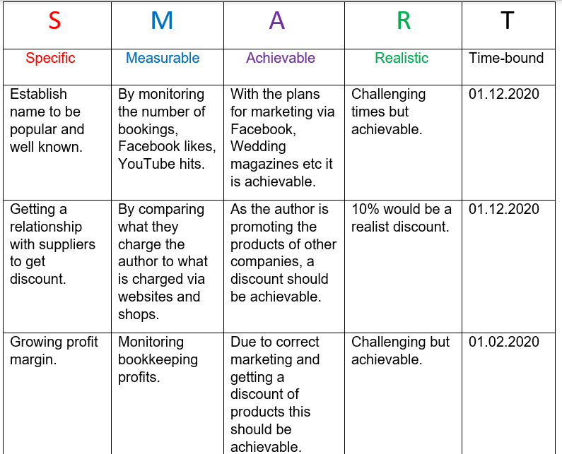

(Appendix C)

Risk Review

 | How long can you do without? | Impact of doing without. | Vulnerabilities | Contingencies if a disaster?
Personnel | 0 days | Could affect the confidence of the customer as owner not at event. | Loss of customer confidence and affects reputation of business. | Will get daughter to cover the event.
Equipment failure  (Coffee machine) | 0 days | Cancel booking. Loss of money.  Wasted food. | Reputation of business. | None. Back-up generator needed.
Food materials | 7 days | Author will have to source the food materials herself and that takes time. | Other suppliers in proximity. | As supplies are local, this will not be an issue to restock.
Transport vehicles (breakdowns) | 0 | Could be late to the event due to breakdown. | Booking may be cancelled due to late start. Business reputation at risk. | Will have a back-up of daughter’s car. Although will take time to change vehicles.  Breakdown cover.
Power | 0 | Be unable to heat water for coffee. | Loss of money from event. | None. Back-up generator needs to be sourced.

(Appendix 1)

Tax References from Gov.uk Available at:

https://www.gov.uk/income-tax-rates
https://www.gov.uk/expenses-if-youre-self-employed
https://www.gov.uk/self-employed-records (Accessed 03.07.20)
Cash based
Grant self employed
https://www.gov.uk/guidance/claim-a-grant-through-the-coronavirus-covid-19-self-employment-income-support-scheme
https://www.gov.uk/set-up-sole-trader (Accessed 03.07.20)

Appendix 2

C MATTHEWS <matthews.08@btinternet.com>
To:Kirsty Ratsep
Mon, 29 Jun at 13:21
Thank you for your email.
I will look in to it.
Kind regards Caroline

Hide original message
On Monday, 29 June 2020, 11:38:14 BST, Kirsty Ratsep <kirsty.ratsep@kdmediapublishing.com> wrote:

Hi Caroline,

Thanks for your email :)

I am currently working on our July /August online magazine for 'Your South Wales Wedding Magazine'.

We currently have some great offers to keep you firmly engaged with all of our readers. We are encouraging all of our advertisers to stay out there, now more than ever! We have never seen such an increase in online traffic and engagement from all of our readers. To help everyone through these current times we are also extending our payment term (e.g. the first payment will not be due until the middle of September).

The huge surge online we were expecting is now at a 300% increase. As you are aware all wedding fares have now been postponed, meaning more couples are searching online for wedding ideas for their 2021/2022 weddings.

Our magazines are FREE online on our website for all of our readers who are self isolating. Advertisers are also stepping up their online presence to get ahead of everyone. Over 8,000 copies will be sent directly to all members of our database, along with any easy accessible FREE Online magazine, for anyone else who would usually go to the shops to buy one!

What we offer:
- Full page advert in our July/ August issue
- 2 months 'find a service' listing on our website
All for: £250+ VAT
(Market rate £550)

Or a half page advert - £150+VAT
Quarter page advert - £90+VAT
(both with - 2 months 'find a service' listing on our website)

Again, no payments are due until September!

Please let me know if your happy to book this in :)
Best regards,
Kirsty Cushing
Account Manager
Your South Wales Wedding Magazine
Part of the CWM Magazines Group
Direct: 01376 538491
Tel: 01376 514000
Fax: 01376 535608
Email. kirsty.ratsep@county.wedding
Web. www.yoursouthwales.wedding
Web. www.county.wedding
Web. www.countyweddingevents.com



Best Wedding Magazine 2014, 2015 & 2016
http://welshnationalweddingawards.co.uk
Like us at Facebook.com/CountyWeddingMagazines
Follow us at Twitter.com/CountyWeddings
Follow us at www.pinterest.com/countyweddings
Follow us at www.instagram.com/cwm_wedding

Web. www.christmaspartyguide.co.uk

Appendix 3

From: Rachel Loosemore <Rachel.Loosemore@swansea.gov.uk>
Sent: 17 June 2020 16:43
To: Caroline Matthews <Caroline.Matthews@swansea.gov.uk>
Subject: RE: Licence laws
Hi
Thank you for your email. I hope you are well.
If you are attending different places for weddings/events/festivals then you would need to ensure the area you are supplying alcohol from holds a premises licence or is covered by a temporary event notice.You would need to apply for a premises licence to us if you were intending on selling alcohol, late night refreshment (hot food/drink between the hours of 2300-0500) or providing regulated entertainment at a fixed place within Swansea. I have attached a link to our Licensing page which provides more detail including the process and costs. There is also guidance on temporary event notices and personal licences
https://www.swansea.gov.uk/alcoholandentertainmentlicences
I would suggest you contact Safety regarding Food Registration/New Business Advice and maybe Trading Standards for Street Trading Advice.
I hope this helps.
Stay safe.
Kind regards
Rachel
Rachel Loosemore
Swyddog Trwyddedu
Licensing Officer
( 01792 635600 | 07557481466
* rachel.loosemore@abertawe.gov.uk

Appendix 4

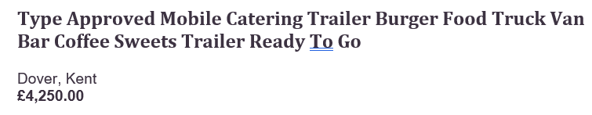

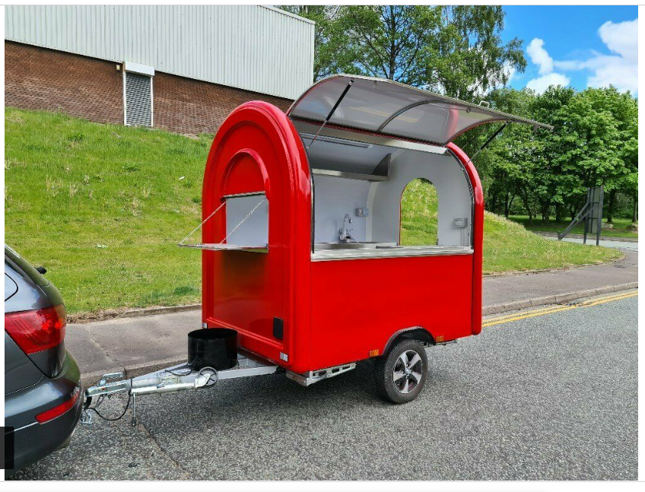

Apron (embroidered with logo) £7.99 each (Free delivery) Online Available at:
https://www.spreadshirt.co.uk/-C10181?productType=141&appearance=2&view=1&isDiscounted=true&currentDiscountAmount=2 (Accessed 04.07.20)

Bunting 4.57 Free delivery)
Ebay online Available at:
https://www.ebay.co.uk/i/362732212368?chn=ps&norover=1&mkevt=1&mkrid=710-134428-41853-0&mkcid=2&itemid=362732212368&targetid=908661474856&device=c&mktype=pla&googleloc=9045406&poi=1007460&campaignid=10199630617&mkgroupid=101938327397&rlsatarget=pla-908661474856&abcId=1145985&merchantid=115108929&gclid=EAIaIQobChMIwfLCqqaB6gIVQYBQBh0QiwViEAQYAyABEgLkGvD_BwE (Accessed 26.02.20)

Coffee cups with lids x 500 £39.89 (Free delivery) eBay online Available at :
https://www.ebay.co.uk/itm/Disposable-Ripple-Triple-walled-Paper-Coffee-Cup-Brown-Cups-with-without-Lids/143199574686?var=442132286453&hash=item21575c1a9e:g:gVYAAOSwHF5cpHKz (Accessed 28.06.20)

Cup sleeves x 500 (Free Delivery) eBay online Available at:
https://www.ebay.co.uk/itm/50-2000-Coffee-cup-Brown-Sleeves-Kraft-Cardboard-Paper-cups-8-12-16oz-Hot-Cups/323918712227?var=512954065973&_trkparms=ispr%3D1&hash=item4b6b0f4da3:g:U94AAOSwiqNdgL6n&enc=AQAFAAACYBaobrjLl8XobRIiIML1V4Imu%2Fn%2BzU5L90Z278x5ickk5v8gVt3hEWLVg%2F253w6XCbwzx4%2BPWMXmkVU%2BaTeMHGqbyTZslpzIQOLn%2BAnn7SuvpzIDRTFQaROmywtSRU%2BM1F4ORRI3z%2Fp1zuNs%2BiSAOVNEglku62TBZ69Vk8PvgpZJA7MH3NnWBTi8kqfIfyHZWHx7Iwv5Dq1KFSLaILaw%2Fq2RYM9OqHBUIldWv4%2Fh%2F4FW3ln%2BUb50P59sKWNcnMYRUxfPuDQlbSWJFYUf1gmmdzmD99OMveu113YWIqZS5dYqOlHH0pjsBRgb0Ms03CP%2FTDIhv%2BKeMD%2Fr4GIcZrKSA%2FfWgQv3U8h6QmZgXjD6GhRSdJDMl9nN%2BMoH5tGYdu%2BJM0jNbtbGxLg7yMr3SBpKKitu9uqHXWg3rj8rRH9b5kjZz6im7c%2Bn7Rf8Iq6dax%2FDJ6VpsDJzLUsIPPhMxkxyF5Vj%2B8FkPZxRml9CArULUvevkfgX0il72pG%2FglhqrW7LiFXZyWRn2jxUnFUpl1UBFTbuJFtbhcNbe4gqIw3txWT8aueCoouSrpFdXK6otXBN6nTa%2BRJc8XL7SPCsrwUxI09t1tlgekVuQXMQmOdwSj1rR2Ac9cj%2B9nAi%2BrJbtP5h%2Fw2%2FGScYvvsojRONlratLIcLkxO2QCkE0I15%2FA38jkTjjEWyub3Rp3gwvtzXOUA1bFzCDpdV4q2r%2FhSVDBczgCFlC4Soy1OpA%2Bxhm8wfKUXYqKF9ItEXtRw2gfXKhZsKA5WELh%2B0npKo6GMvosqvKJOh18NIV6aW6zlTJXLvaNRC&checksum=32391871222799f7de5473524724aa0a87649e000abc (Accessed 28.06 20)

Coffee machine with coffee grinder. £549.00 (Free delivery)
Sage Barista Express Bean-to-Cup Coffee Machine with Milk Jug, Stainless Steel, Stainless Steel John Lewis online. Available at:

https://www.johnlewis.com/sage-barista-express-bean-to-cup-coffee-machine-with-milk-jug-stainless-steel/p3495241?sku=234865235&colour=Stainless+Steel&s_ppc=2dx92700053277635607&tmad=c&tmcampid=2&gclid=EAIaIQobChMI073Q--uk6gIVwoXVCh1MaQrBEAYYAiABEgIkbfD_BwE&gclsrc=aw.ds (Accessed 26.03.20)

Dark Pine Blackboard £12.99 + £5.95 postage
eBay online Available at:
https://www.ebay.co.uk/i/311378361874?chn=ps&norover=1&mkevt=1&mkrid=710-134428-41853-0&mkcid=2&itemid=311378361874&targetid=910259638509&device=c&mktype=pla&googleloc=9045406&poi=1007460&campaignid=10195651646&mkgroupid=105678501967&rlsatarget=pla-910259638509&abcId=1145985&merchantid=113738396&gclid=EAIaIQobChMIpfqyov6B6gIVjbHtCh0fQw95EAQYAiABEgLnwfD_BwE (Accessed 26.06.20)

Merlyn Welsh Cream Liqueur £10.00 Amazon online Available at:
https://www.amazon.co.uk/Merlyn-Welsh-Cream-Liqueur-70/dp/B00439ZD38/ref=sr_1_11?adgrpid=55898126631&dchild=1&gclid=EAIaIQobChMIs6Ds7Zel6gIVB-7tCh1RvghmEAAYASAAEgLwtfD_BwE&hvadid=259008060927&hvdev=c&hvlocphy=9045406&hvnetw=g&hvqmt=b&hvrand=16827668605316284385&hvtargid=kwd-299231597944&hydadcr=8652_1724522&keywords=penderyn&qid=1593371153&sr=8-11&tag=googhydr-21(Accessed 28.06.20)

Napkins x 500 £12.95 (Free delivery) eBay online Available at:
https://www.ebay.co.uk/itm/CHEAPEST-CLEARANCE-WHITE-PAPER-NAPKINS-SERVIETTES-33CM-X-33CM-TABLEWARE-2PLY/143524932734?_trkparms=ispr%3D1&hash=item216ac0ac7e:g:yxYAAOSwMIVeOvIf&enc=AQAFAAACYBaobrjLl8XobRIiIML1V4Imu%2Fn%2BzU5L90Z278x5ickk7d4nremBkvNKtcC0ZwqXDNnvuDYBLBj88JKehvlO6mWEVnATV4uAmTj0LwGUsNWQpColsykMLiuiviyuzlFH1TYyBLfVMsPDjJ3zZf%2F%2BNcPZNyQeu0ZAdfPSTzrHYqYkxLnyDmQ3K%2FT3qZGfUBU%2FBzAtDnJ6rgKXlfjIVNp8b4i42d2%2FZPCA%2FitFm6vsYvlH5XgABNHSXVUSH8JgVYXTjVXI1D%2B7G4%2BCCZC5hbydF944xKLYcILdnQmJyCoanT%2FyG9uunjSE%2BawrO9vJwPuKxVglLYKqznePBMv5rMvSBqfCC04XW46NLU2oIV39NyolXxZ7D8WNLqhmHLZob4ar5N50zFJkUcLFa5BqVG3woCkkX3zXISaRGytABPFNVryKFIi96pAqL2QLieNjLrwnNvvV6zGGXUNrwcCsO82hCbCckfS0lRbu0kp6s9t5%2BArSLqNu%2FZmy7e2XfWS4fZCSNavnF%2BUlLioOS7HwsfcHq8OpBnpq4uB6c3%2FeyhjeqG%2B0YtMQYD3wspFDlCSlYhniABXnUPmy4XX7V5%2BDVCsB1oBUf7JRYHbTHxpjBkszxVlw3citLzhQPqxjY9wlmm0BXQikhTx0LulC4ZHb7Fddqac2MvJQWUMjeIrfOeZMy829crfALGl2mnh4JAJvSWeHAX%2B2VIyhl5MkhO4AoTQaohxzLcdG8z41Bd2VFawllWPurNBiS%2FYEQ%2BOOZ%2FNMd7aJ0jW0Ws5p8xZWabMWW6EN29OKjBUP8Oz37%2FMVkEhGd1SI&checksum=14352493273496e7ca0d15db45f78df4d0c1a95cf4f9 (Accessed 28.06.20)

Ice Grinder £65.92 + £11.00 Postage. Amazon online. Available at:
https://www.amazon.co.uk/Crusher-electric-container-Attachable-Stainless/dp/B07CHLG9Y3/ref=sr_1_8?adgrpid=52620400945&dchild=1&gclid=EAIaIQobChMI_Pzb6_Wk6gIVWuztCh0y4QueEAAYASAAEgKQ8PD_BwE&hvadid=259055155415&hvdev=c&hvlocphy=9045406&hvnetw=g&hvqmt=b&hvrand=18129172680312096373&hvtargid=kwd-302656417864&hydadcr=18481_1816599&keywords=ice+crusher+for+cocktails&qid=1593361427&sr=8-8&tag=googhydr-21 (Accessed 27.06.20)

iZettle card payments machine £29.00 per month. Online. Available at:
https://www.izettle.com/gb/card-readers (Accessed 26.06.20)

Appendix 5

Trade Stand and Pitch Applications
Trade applications for the Wales Airshow present an excellent opportunity for you to promote your trade to a massive audience, with prices starting from only £300.
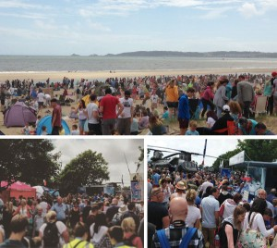
With a trade pitch at the Wales Airshow, you get access to:
- A family audience
- 2 full day’s trading
- A variety of pitch sizes
- Wales biggest Airshow
- Wales biggest free event
- Access to 200,000+ potential customers
Space is allocated on a first come first serve basis.
Rules and Regulations for Traders
Fire Risk Assessment for Traders and Market Stalls
Bespoke trade options also available:
- Banner space
- Advertise your voucher on our App for only £50 extra
- Sole roaming rights licence
- Website banner adverts – Over 300,000 page views during the 2 months leading up to the event.

Appendix 6
Quote from Camper Cafe

Hello | Camper Cafe <hello@camper-cafe.co.uk>
To:matthews.08@btinternet.com
Mon, 8 Jun at 21:57
Good evening,

Thank you for your enquiry about the mini. As a very rough guide prices start from £450+VAT for a half day (up to 4 hours service) plus mileage. This covers:
-hire of the vehicle with integral coffee machine and grinder
- serving bar
- unlimited coffee, tea, hot chocolate including cups, lids and sundries (sugar etc) for up to 100 people
- 1 barista

We can discuss numbers if they are larger than 100 and we can also provide food items if that’s of interest. The mini requires a power supply but we have other options if that isn’t possible.

I hope that helps and I’d be happy to chat through your event in a bit more detail if you want me to give you a call.

Many thanks,

Will
07590 681878

Appendix 7
Sell 2 Wales

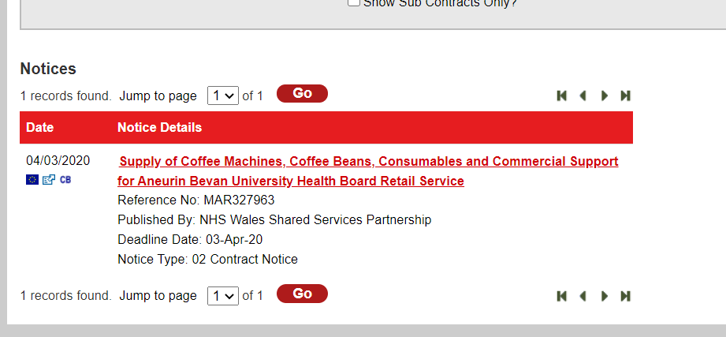

Appendix 8
(A)

Natalia Lewis marketing advisor C.V

Co:Lab Creative <team@colabcreativesw.co.uk>
To:matthews.08@btinternet.com
Sun, 28 Jun at 14:07
Hi Caroline,

Here is the information below:

Qualification:

2.1 (Upper class) BA (HONS) Open Degree
Theatre and Performance, Business management, marketing and finance and Advanced creative writing
Studying MA Arts Management (Part Time - 2021)

My roles:

Co:Lab Creative: Co-Founder
Re:ACT: Founder

Events role:

They say two heads are better than one… well we’ve got three…

With over a decade of experience, Co:Lab Creative is innovative in its approach & delivery of bespoke thinking; we strive for the
best with care & passion for each individual project as if it were our own. With stringent attention to detail, no matter the scale of the task, we provide end to end, person centred experiences. Our ethos is done with, not done to.

From lighting installations to full scale theatrical productions, from graphic design to technical hire.

There are no limitations; we are for anyone, anywhere.

No matter the scale, our approach ensures shatterproof results. It is tried & tested, establishing why a client needs our support & delivering a project on budget, on time & on target, with analytics & insight.
​
- Project, Event Design & Production, Experience & Stage Management
- Facilitating, Directing, Producing, Writing, Copy-writing & Theatrical production
- Marketing, Brand Identity, Strategic & Cultural Planning
- Graphic Design
- Website Design
- Lighting & Sound Design
- Photography, Video & Music Production & Provision
- Technical Hire, Installs & Services

From an event's point of view, I can be involved from any stage of a project with any organisation, this can be organising fundraising/arts funding for local council or town council venues, to managing £125,000 show installations for large organisations such as Bluestone National Resort for which I installed their first production into their new Cloud Theatre.

Thanks very much,

Tal
colabcreativesw.co.uk

Appendix 8 (B)
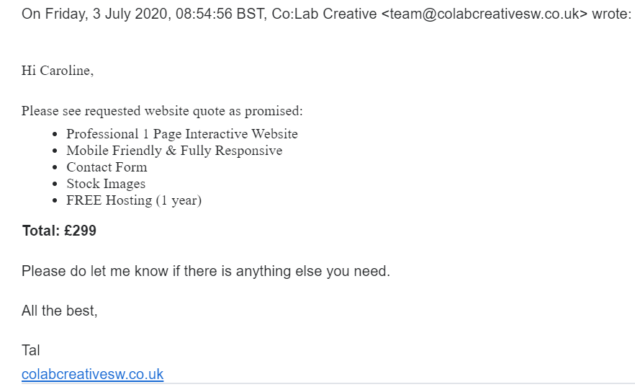

Appendix 9

Mark Bolt C.V

Mark Bolt <mbolt1972@gmail.com>
To:matthews.08@btinternet.com
Sat, 27 Jun at 14:57
So - the details of 4ps Marketing Plan:

1. Price: you intend to position the pricing at a higher than competitors to try and establish as 'premium' - people expect better quality at a higher price

2. Product: you will source unique local produce that is not available on supermarkets or Costa etc. You will position it as Unique and high quality

3. Place (this is the 'where' you are selling it):
- you will have at exclusive events venues (through your mobile facility / trailer/ converted horse box)
- online through your own web shop.
- you would distribute to high end retailers like Waitrose, Sainsburys and John Lewis.
- you will use your extensive network of contacts to go B2B (business to Business) and persuade hotel chains, holiday villages, country parks, sporting grounds to trial your products at weddings and events).
- you will also take distributor events promotional stands to connect with events distributors to sell your products at other events across the country.

4. Promotion: this is how you talk about it and spread the word. With limited budget you will send exclusive taster packs to bloggers and trialists and produce a PR plan. Via online and social media, you will create blogs, digital assets for use on Insta, Facebook, Twitter, Pinterest and your own web site including a functional web store. There will be limited budget for PPC and SEO (pay per click and search engine optimisation) and so a lot of the promotional activity will be organic and driven by word of mouth and specialised bloggers taking samples and testing.

So that's the outline of a marketing plan. Let me know if you need more detail or to talk through it.

Mr Bolt

Mark Bolt, Sales and Marketing Consultant
Specialising in FMCG distribution in the UK and International Markets. Experienced in starter brand-building and establishing a challenger brand versus global giants such as P&G / Unilever and Philips. Experienced Marketing professional and Member of the Chartered Institute of Marketing and Member of the Institute for Export. Mark works with numerous types of distributors (B2B & B2C) and retailers (Boots, John Lewis, Argos, Current Body, Next, Debenhams) and has established marketing campaigns for products such as mobile phones, IPL laser devices and creams.

Appendix 10 (A)
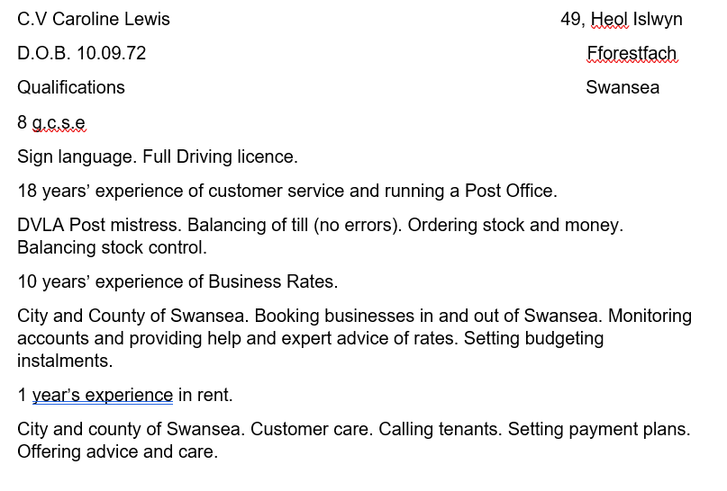
Appendix 10 B

Antonia Matthews
49 Heol Islwyn Fforestfach Swansea SA5 4NZ · 07496995888
mantonia92@yahoo.com · National Insurance – PH415387D · DOB – 03/01/2002
I am an educated 18 year old looking for a new job within my gap year. I have had a significant amount of work experience and always open to learning new skills!

HOURS - I am very flexible with working hours as I have recently finished my A-Levels and left college.

Experience

September 2018 – current

Team Member, KFC
This includes tasks such as taking orders from customers and managing money, using a till, packing, and serving food, cleaning the shop floor thoroughly, unloading deliveries, sorting out stock and in general, working in a busy environment. Therefore, this job has given me confidence, independence, and taught me the importance of good customer service.
** CURRENTLY NOT WORKING HERE DUE TO THE RESTURANT BEING VERY QUIET, SO I AM LOOKING FOR A NEW POSITION FOR SOME EXTRA HOURS**

August 2018

factory worker, dr organic
During this job, I undertook multiple roles including packing, labelling, and sorting out the Dr Organics products. Due to the job being full time work, I was unable to continue as it would have overlapped with my school hours. This job helped me develop skills such as team work as we would often be in groups and helped me communicate with all types of people.

Volunteer for south wales police
In February 2020 I volunteered at the Dog and Mounted Section in South Wales Police. Here I unloaded deliveries that they had, walked the police dogs, helped maintain the horse’s stables and in general helped around with anything that they needed.

Education

GCSE’S, BISHOP VAUGHAN CATHOLIC SCHOOL
- English Language & Lit – B
- Mathematics – B
- Biology – A
- Physics – C
- Chemistry – C
- Sociology – A
- History – B
- R.E – B
- Welsh – B

2018 - 2020

a-levels, Bishop vaughan sixth form
- Sociology – B
- Forensics – D*
- Health and Social Care – D*

Skills
- Well organized (reflected in GCSE results)
- Good time management
- Teamwork and communication shown from previous job
- Ability to multi-task and work in a fast pace environment and under pressure
- Friendly, approachable, and presentable
- Dedicated and an adaptive learner
- Able to adapt quickly in new scenarios as an individual and within a team
- Ability to manage money and work on a till
- Able to work efficiently

Appendix 11

References for licenses

Temporary event notice Swansea Council (2020)Available at:
https://www.swansea.gov.uk/ten(Accessed 30.06.20)

Fees for outer zone street trading Swansea Council Available at:
https://www.swansea.gov.uk/article/57341/Fees-for-outer-zone-street-trading-licences (Accessed 30.06.20)

Personal Licences Swansea Council (2020) Available at:
https://www.swansea.gov.uk/article/4272/Personal-licences (Accessed 30.06.20)

References

British Coffee Association: Coffee facts. Coffee is the most popular drink worldwide today with around two billion cups consumed each day. (2020) Available at:
https://www.britishcoffeeassociation.org/coffee-in-the-uk/coffee-facts (Accessed 06.07.20)

Business in focus Available at:
https://www.businessinfocus.co.uk/services/business-advice/business-wales/ (Accessed 27.06.20)

Business Wales Events Finder Online Available at :
https://wales.businessevents.org.uk/en/eventsearch/?location=wales&locationDistance=&dateFrom=20%2F06%2F2020&dateTo=&dsSector=86&dsTopic=141&dsType=9&dsBusinessStage=&priceMin=&priceMax=&organiserName=&text= (Accessed 02.07.20)

Café Piccolo Available at:
https://www.cafepiccolo.co.uk/ (Accessed 27.06.20)

Coffee with a Conscience: Social and Ethical Improvements in the Industry (2020)Available at:
https://www.kounta.com/blog/coffee-ethics-improvements-industry-2/ (Accessed 01.07.20)

Camper café (2020) Online , Available at :
https://camper-cafe.co.uk/coffee-van/mini-coffee-van/ (Accessed 12.06.20)

Coaltown coffee. Available at:
https://www.coaltowncoffee.co.uk/products/pit-prop-no1-alternative-espresso-blend?variant=14302333319 (Accessed 27.06.2020)

Devon Life(2018)The history of Camper Coffee, Devon’s favourite mobile coffee shop Available at:
https://www.devonlife.co.uk/people/history-of-camper-coffee-1-5591766(Accessed 27.06.20)

DVLA wages Available at:
https://www.gov.uk/government/news/come-and-work-at-dvla
https://www.indeed.co.uk/cmp/UK-Government---Department-For-Transport/salaries?job_category=customer (Accessed 27.06.20)

Gower Coffee Company (2020) Online. available at; https://www.gowercoffeecompany.co.uk/shop/rhossili-bay/(Accessed 27.06.20)

Hitched (2020) Average wedding cost Available at:
https://www.hitched.co.uk/wedding-planning/organising-and-planning/the-average-wedding-cost-in-the-uk-revealed/(Accessed 27.06.20)

Hla, E. THE WEDDING VENUE BUDGET . Available at:
https://cocoweddingvenues.co.uk/the-blog/planning/coco-advice/the-wedding-venue-budget/ (Accessed 04.07.20)

Natalia Lewis marketing advisor company website Available at:
www.colabcreativesw.co.uk (Accessed 26.06.20)

Penderyn Myth Whiskey £31.90 at Amazon online. Available at:
https://www.amazon.co.uk/Penderyn-Myth-085037-70-cl/dp/B00XL3WOOS/ref=sr_1_2?adgrpid=55898126631&dchild=1&gclid=EAIaIQobChMIs6Ds7Zel6gIVB-7tCh1RvghmEAAYASAAEgLwtfD_BwE&hvadid=259008060927&hvdev=c&hvlocphy=9045406&hvnetw=g&hvqmt=b&hvrand=16827668605316284385&hvtargid=kwd-299231597944&hydadcr=8652_1724522&keywords=penderyn&qid=1593371153&sr=8-2&tag=googhydr-21(Accessed 28.06.20)

Sell 2 Wales Available at:
https://www.sell2wales.gov.wales/search/search_mainpage.aspx?results=true (Accessed 20.06.20)

Shop coffee. How many cups for 1kg of coffee beans? Available at:
https://www.shopcoffee.co.uk/coffee/many-cups-1kg-coffee-beans/#:~:text=So%2C%20an%20industry%20standard%20dose,120%2D140%20cups%20of%20coffee. (Accessed 27.06.20)

Simply business Public liability business. £6.81 a month Available at:
https://www.simplybusiness.co.uk/welcome/sole-traders-insurance/?mkt_medium=ppc&mkt_source=bing&mkt_campaign=Search%7CMain%7CBI%7CCompanyType%7CExact&mkt_term=self%20employed%20liability%20insurance&msclkid=722df5453e0a1917f0e9abbdcaf2dd8a&utm_source=bing&utm_medium=cpc&utm_campaign=Search%7CMain%7CBI%7CCompanyType%7CExact&utm_term=self%20employed%20liability%20insurance&utm_content=self%20employed%20liability%20insurance&gclid=CJTV9MakpeoCFVWThQod_9cN1w&gclsrc=ds
(Accessed 28.06.20)

Welsh cakes Tan y Castell .Online. Available at:
https://www.welshcakes.com/awards/ (Accessed 27.06.20)

Welsh Coffee Company (2020)Available at:
https://welshcoffee.com/wholesale-coffee-beans-wales/ (Accessed 27.06.20)

Why do people love classic cars? Available at:
https://petrolicious.com/articles/why-do-people-still-love-classic-cars (Accessed 27.06.20)

Young people turning their backs on alcohol 2018 Available at:
https://www.nhs.uk/news/lifestyle-and-exercise/young-people-turning-their-backs-alcohol/ (Accessed 26.06.20)

Your South Wales Wedding Magazine Available at:
https://www.yoursouthwales.wedding/?gclid=EAIaIQobChMIjp2nxPSh6gIVR7TtCh1BYASnEAAYASAAEgKosfD_BwE (Accessed 27.06.20)

Bibliography

Alcoholic lollies Available at:
https://www.keyingredient.com/recipes/186311649/liquor-lollipops/
https://www.bbcgoodfood.com/recipes/collection/boozy-ice-lollies(Accessed 27.06.20)

Maund, A et al (2017) Certificate in Higher Education: Skills for the Workplace Student Yearbook. London: SAGE Publications Ltd

7 Best Coffee Grinders of 2020, According to Kitchen Pros (2020) Accessed26.06.20 Available at:
https://www.goodhousekeeping.com/appliances/coffee-maker-reviews/g30986295/best-coffee-grinders/

The best card machines for small businesses (and how to take card payments) Hall.J (2017) Accessed 26.06.20 Available at:
https://www.simplybusiness.co.uk/knowledge/articles/2017/12/best-card-machine-for-small-business/

