

Table of contents

Introduction…………………………………………………………………………...…...….2
Case study summary...…………………………………………………………………..….2
Introduction and description of the chosen organisation……………………….………..3
Principles of support in health and social care sector…………………………..………..3
Principles of support, policies and practices of the AGE UK……………………..……..4
Analyses of relevant principles of support and practices……………………………..…6
Advantages of the principles of support, policies and practice……………………..…..7
Disadvantages of the principles of support, policies and practice………………………8
Evaluation of the support provided by AGE UK related the case study…………….….8
Impact of these principles on Mr and Mrs T daily life………………………………….…9
Recommendations…………………………………………………………………….……..9
Conclusion…………………………………………………………………………………..12
References…………………………………………………………………………………..13
Appendix…………………………………………………………………………………….14

Life with Dementia – challenges and difficulties of elderly life

Introduction
This is a case study report which will be focused on principles of support, policies and practices related with Mr and Mrs T case study, how the chosen organisation provides help and can be useful for their daily life challenges.
The population of elderly people is increasing, that’s why there is a huge need of different charities and organisation to help them later on in their life. As people get older they begin to face physical as well as mental problems. The most common mental condition is dementia. Dementia is a disorder that causes a loss of brain function such as: memory loss, confusion and speech difficulties and understanding. (Alzheimer’s society, n.d.). Physically dementia causes a loss of nerve cells and is visible on brain scans (see Appendix 1). Depending on which areas of the brain are affected – different functions are lost or damaged. The most common disease that causes dementia is Alzheimer’s disease, however it can also be caused by a stroke. Dementia is a progressive condition which means that the symptoms worsen as time goes on.
On average, 1 in 6 people over the age of 80 in the UK are living with dementia. (AGE UK, 2021). However, it can also affect adults under the age of 65. In the UK there are currently 42,000. (Alzheimer’s society, n.d.)

Case study summary
An independent elderly couple over the age of 85 – Mr and Mrs T. Firstly, Mr T has chronical conditions and progressive dementia. Secondly, Mrs T faced physical harm caused by a fall resulting in her having hip surgery. Due to her accident, Mrs T decided to check different organisations that provide personal care to help them live as if the accident never happened. She was looking for an organisation that can help both her and Mr T with hygiene, dressing, eating, running their errands, physical therapy, social activities etc.

Introduction and description of the chosen organisation
AGE UK
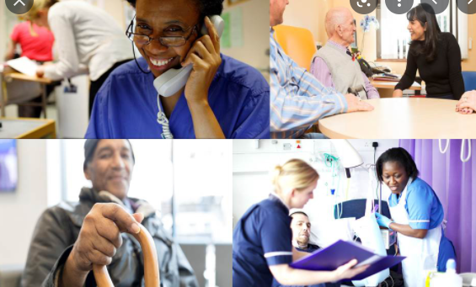

Photo credit: Department of Health and Social Care. Available at: https://www.gov.uk/government/publications/department-of-health-and-social-care-outcome-delivery-plan/department-of-health-and-social-care-outcome-delivery-plan-2021-to-2022

Based on the criteria that Mr and Mrs T have the organisation that fits perfect is AGE UK. AGE UK is a charity organisation that offers day care services, handyperson services, social activities, exercise and physical activity as well as basic home supports which best fits based on elderly people’s needs.
They provide support and personal care for elderly people based on their current state. AGE UK is the most popular charity organisation that focuses on elderly people and provides them with different services. AGE UK was formed in 2009. They also provide support and services at local and national level for inspiring, enabling and supporting older people (AGE UK, 2021). In the organisation works more than 75,000 volunteers that help elderly people all over the country.

Principles of support in health and social care sector
Principles of health and social care practice refer to the values that guide social and health care providers when taking care of their patients (Goldsmith, 2011). They include empowerment, providing safety and safeguarding the confidentiality of their patients. The role of the health care service is to provide relevant support to the service users and ensure that their wellbeing and rights are not violated. Care providers have the responsibility of keeping all the information regarding the service user private, and any disclosure of information relevant to the service user is considered unethical unless with the consent of the service user. Principles of health and social care practice also require all care users to be provided with the appropriate medical care regardless of their personalities, beliefs, cultures, gender or race, as stated in the Equality Act 2010 (Heppe, 2010, pp. 11-24).

Principles of support, policies and practices of the AGE UK
Living and ageing well is a fundamental requirement, and it is a core principle of support and care available at AGE UK. (AGE UK, 2021).
The AGE UK organisational policy covers all the basic guidelines for health and social care sector - health and wellbeing care and support, safe at home and active communities (AGE UK, 2021). Age UK is allowing elderly people to make choices and have control over the support they receive. Their individual needs and preferences are captured, and they are provided with support and services suited to meet their needs and preferences. This is extremely beneficial for Mr and Mrs T because it is exactly what they are looking for.
The organisation recognises the impact of both physical and mental health in maintaining the wellbeing of older people, therefore, recognises the need for supporting to sustain the wellbeing of older people in their later life, which captures the service and requirements of Mr and Mrs T. The organisation provides physical activity to older people with the aim of improving their mobility, enabling them to connect with their communities and preventing them from the risk of depression and dementia – which is suitable for Mrs T’s condition. Age UK supports people with dementia to give them the opportunity to live well and continue being active members of society (Age UK, 2021) – which is also suitable for Mr T’s condition.
Dealing with a patient with dementia at home it is primarily very important for Mrs T to take care of herself as she can feel better and cope better with her caring role if she treats herself properly. Furthermore, it is also very essential for her to have great patience as providing care to Mr T may lead to feelings of sadness, confusion, guilt, or anger.
AGE UK emphasise the need of adopting new and existing homes of an ageing population to their changing needs as a way of promoting their independence and self-determination. Poor and inaccessible housing would have severe implications on people with mobility dysfunction like Mrs T. There were 13.3 million people living with disability in the UK as recorded in the year 2015/2016, 44% of whom were older people within the state pension age (Hatton, 2017). However, only 7% of homes had the necessary features for enabling accessibility by people with mobility challenges like Mrs T. Some of the essential features that enhance accessibility in homes include: level access to the main entrance, a flush threshold to the main entrance, WC at entry-level and circulation space. Living independently can be difficult for elderly people like Mr T and Mrs T. Many older people live in houses that would require upgrading to adapt their needs. There are some home improvement agencies that help thousands of elderly people to repair and establish adaptation features in their homes and AGE UK works in a successful partnership with them.
Medication management
AGE UK provides medication supervision to their patients following The National Institute for Health and Care Excellence (NICE) guideline. This guideline suggests how to manage the medication intake for elderly people that receive support at home. (Renoux, 2016).
Social needs
AGE UK has lots of different social activities to help elderly people maintain their communication and socialising skills, and to reduce their feeling of loneliness. They offer various activities in their local area such as: art, bingo, coffee, photography club, dance and many others.
Meal preparation
AGE UK are very considerate of what each individual person enjoys to eat, therefore they provide personal shopping and meal preparation services. Their carers help elderly people create shopping list with fresh and nutritious products weekly. They also help them make their own menu based on their preferences and cook delicious meals for them.
These support services listed above describe the exact care that Mr T and Mrs T require, thereby making AGE UK the best choice for the couple.

Analysis of relevant principles of support and practices
Adult-safeguarding-policy
People aged 65 years and above are at a greater risk of abuse and neglect, and therefore, they are the target group that require safeguarding. Incidences of abuse and neglect on older people are criminal offences, some of which may be in the form of fraud, theft, assault, among other forms of harm.
A majority of the older people are not able to protect themselves against harm and abuse, and therefore AGE UK have a responsibility to safeguard their wellbeing by ensuring that they live safely, free from abuse and neglect (Graham et al., 2016).
Mental Capacity Act 2005
The Mental Capacity Act proves that people must be allowed to make as many decisions as possible for themselves and where they are not able to do so, decisions must be made for them but in their best interests (Brown et all, 2015). Older people, especially those living with dementia, lack the mental capacity to make sound decisions, thereby having little or no voice in society. They may end up feeling excluded from society, deprived of their basic rights to freedom, equality and autonomy - the main principles. The Mental Capacity Act 2005 (Office of the public guardian, 2014) provides a legal framework for deprivation of liberty safeguards in situations where people without mental capacity are completely unable to make decisions about what is best for them. Care homes and hospitals have the option of seeking authorisation to deprive a person of liberty as a result of being confined to a hospital or care home.

Health and Social Care Act 2012
Social Care Act 2012 seeks to persuade health bodies such as Clinical Commissioning Groups, Department of Health Public Health England and NHS England to demonstrate their commitment towards reducing health inequalities among people in England (Pollock et all, 2012). It was previously observed that people from wealthy social setups were better educated, enjoyed better wellbeing and had better access to health care and services while their other people from poor backgrounds largely relied on public services. Bridging these inequalities would involve building infrastructure, promoting education for accessibility by everyone and diversifying health services to make them affordable and accessible by everyone equally. This would not only promote good health in equal measure across the society, but it will also enhance cohesiveness and inclusivity. (Department of health and social care, 2012).

Equality Act 2010
The act was introduced to incorporate of the advancement of equality across all bodies subject to the duty. The act provides that everyone must have the right to be treated equally with respect and integrity regardless of their differences in gender, beliefs, age, disability or cultural backgrounds (Wadham et al., 2010). The act requires health service providers to understand the diversity that characterises the society to be able to treat them in a way that cannot be interpreted as discrimination. Age UK has policies that require that everyone be treated with dignity and integrity, respecting their values and diversities. This is extremely important in promoting equality, inclusivity and reducing inequalities within England at local and national levels.

Advantages of the principles of support, policies and practice
Policies give an opportunity for organisations for defining top management objectives. Through policies the executive management communicates its leadership and views to the staff and other workers, and therefore, policies in the health and social care sector are important in providing guidance to health care providers at all levels. (Ventola, 2014, pp. 491-499).
Policies also provide a framework which decisions are based on and guide the implementation of an action plan. Policies ensure that employee actions are consistent with the executive expectations by defining the rules and procedures that must be followed by all employees.
Disadvantages of the principles of support, policies and practice
Policies do not go without limitations in that they are often difficult to communicate to everyone across large organisations. Even after communication, employees may have a negative view towards the policies, thereby making them hard to follow. Since policies set down procedures and expectations, they can limit individuality and flexibility.

Evaluation of the principles of support, policies and practice provided by AGE UK
There are different principles of support relevant to Mr and Mrs T case study.
It can be stated that privacy, individuality and choice will be maintained because AGE UK respects them. Dignity is highly relevant in this context as the couple wants to live independently while using necessary support from the organisation. Respecting diversity and providing equal opportunities to the couple are useful as each of their requirements can be addressed individually by the organisation.
Person-centred care can be a very appropriate principle of support for the organisation as by this it can provide dedicated and effective services to Mr T as he has progressive dementia and other chronic diseases (Cunnington, 2021). With this approach, he can get individual treatment at the home.
It’s very beneficial for the couple because AGE UK provides the services that they need such as:
- Help with daily activities – eating, dressing, help with hygiene
- Groceries
- Transportation to GP, social events, day care
- Finance management

Impact of the principles in daily life
It can be noted that the principles of support, policy and practice of Age UK can create a huge impact on the daily lives of Mr and Mrs T. Practices regarding making decisions can be very influenced by the standards of the organisation. For instance, the shopping habit of the family can get changed significantly by the principles. Mrs T as well as caregivers of the organisation can purchase on the behalf of Mr T as the Mental Capacity Act will allow them to do so- therefore Mr T wouldn’t have to experience any trouble making his own purchases. (Alghrani et al. 2016, pp. 311-317). In addition to that, the level of care can be increased in the house as the organisation suggests focusing on personal care first before attending to a patient with dementia. This certain practice can develop the later life of the aged couple hugely. Besides, safety measures in the house will be positively increased by creating a safety culture (Cheney, 2018). Mrs T will get effective feedback from the organisation concerning the overall maintenance of the house due to her mobility issues which will help her to focus on safety measures. Moreover, the presence of an attendant or team-based care service can also increase safety as both of them will be attended to efficiently while doing different activities. With these standards, personal hygiene will be improved as well because Mrs T has to enhance the cleanliness of her companion, which will develop their overall condition.

Recommendations
Based on the above evolutions it can be stated that there are several areas where the organisation’s future policy and practices can be improved. These are stated below:
- The organisation needs to develop its management structure so that it can offer its services to every aged people across the country who are in serious need of it. The number of elderly people in the UK has increased (See Appendix 2) and reached nearly 938.7 thousand as of 2020 who were aged 55 (Clark, 2021).
Therefore, the number of vulnerable older adults will be also increased. With effective management, the company can attend to all of them efficiently and provide the right care.
- Age UK needs to employ more staff as caregivers in their foundations. With the increased number of staff, the charity can conduct its campaigning and research in a more productive manner which can be very useful to aged couples like Mr and Mrs T.
- The organisation should add better facilities and technologies, especially for their home care services. Also, a wireless health monitoring system can be used by the organisation for homes. It can effectively help to observe the current health condition of the patient (Anderson, 2020). As suffering from dementia, it would help massively to Mr and Mrs T.
- Age UK should reconsider their payments in terms of providing the best treatments to older people. It has been identified that the need for the social care of older people increased greatly due to the current Covid-19 pandemic (LGA, 2021). Therefore, by making the services charges low, the organisation can offer its services to more people, which will be also beneficial for Mr and Mrs T.

Conclusion
In conclusion, there is a number of principles of support, policies and practice that guide health organisations and home caregivers in delivering the correct health services and support to service users. It is important that employees for these institutions understand the various policies and principles of support to be able to help their organisations to achieve their goals and to help in improving the quality of life of older people and those living with disabilities. Health service users need to do a background check to understand the various principles of support, policies and practice available in different organisations to be able to choose the one that matches their needs. There exist a number of different legislations that have been established to ensure the effectiveness in accessing health care services for elderly people in the UK. These legal frameworks try to promote equality and reduce inequalities, safeguard health service users’ wellbeing and protect them from poor health, abuse or neglect from society. Principles of support, policies and practices have both advantages and disadvantages, but the advantages outweigh the negatives- further proving that AGE UK will be extremely helpful for Mr and Mrs T. It is also important to adapt and change to help in improving the daily lives of elderly people with regard to such aspects as accessing shopping services, property care, safety and personal hygiene, because every elderly person should live with dignity and pride.

References
AGE UK, (2021). Dementia support. Available at: https://www.ageuk.org.uk/services/in-your-area/dementia-support/ (Accessed: 18th August 2021).
AGE UK, (2021). Our policy positions. Available at: https://www.ageuk.org.uk/our-impact/policy-research/policy-positions/ (Accessed: 19th August 2021).
AGE UK, (2021). Who we are? Available at: https://www.ageuk.org.uk/ (Accessed: 17th August 2021).
Alghrani, A. et all. (2016). The Mental Capacity Act – ten years on. Medical Law Review. Vol.24, Issue 3. pp. 311-317
Alzheimer’s Society, (n.d.) What is dementia (video). Available at: https://www.youtube.com/watch?v=fqculysjrj8&t=1s (Accessed: 19th August 2021).
Alzheimer’s Society, (n.d.) What is dementia. Available at: https://www.alzheimers.org.uk/about-dementia/types-dementia/what-dementia (Accessed: 18th August 2021).
Anderson, M. (2020). What are the components of a patient monitoring system? Available at: https://atltechnology.com/blog/components-of-patient-monitoring-systems/ (Accessed: 24th August 2021).
Brown, R. et all. (2015). ‘The Mental Capacity Act 2005.’ A Guide for Practice. 3rd edn. London: SAGE Publications
Cheney, C. (2018). Guiding Principles to Improve Home Health Safety. Available at: https://www.healthleadersmedia.com/clinical-care/ceos-make-healthcare-worker-safety-top-priority (Accessed: 23rd August 2021).
Clark, D., (2021). UK: population, by age 2020. Available at: https://www.statista.com/statistics/281174/uk-population-by-age/ (Accessed: 24th August 2021).
Cunnington, S. (2021). The Importance of a Person-Centred Approach - Care at home. Quality Compliance System. Available at: https://www.qcs.co.uk/the-importance-of-a-person-centred-approach/ (Accessed: 23rd August 2021).
Department of Health and Social Care. (2021). Outcome delivery plan: 2021 to 2022. Available at: https://www.gov.uk/government/publications/department-of-health-and-social-care-outcome-delivery-plan/department-of-health-and-social-care-outcome-delivery-plan-2021-to-2022 (Accessed: 19th August 2021).
Goldsmith, S. (2011) Principles of health care management: foundations for a changing health care system. 2nd edn. London: Jones and Bartlett Publishers.
Graham, K. et all. (2016). ‘Models of adult safeguarding in England: a review of the literature’, Journal of Social Work, Vol. 16. Issue 1. pp. 22-46. Available at: https://journals.sagepub.com/doi/abs/10.1177/1468017314556205 (Accessed: 21st August 2021).
Hatton, C. (2017). ‘Living arrangements of adults with learning disabilities across the UK’ Tizard Learning Disability Review, Vol.22. Issue 1. Available at: https://www.emerald.com/insight/content/doi/10.1108/TLDR-11-2016-0040/full/html (Accessed: 19th August 2021).
Heppe, B. (2010). The new single equality act in Britain. The Equal Rights Review. pp. 11-24.
Local Government Association, (2021). LGA responds to Age UK report on an increase in older people’s social care need due to the pandemic. Available at: https://www.local.gov.uk/about/news/lga-responds-age-uk-report-increase-older-peoples-social-care-need-due-pandemic (Accessed: 24th August 2021).
Office of the Public Guardian, (2014). Mental Capacity Act 2005. Making Decisions. Available at: https://www.gov.uk/government/collections/mental-capacity-act-making-decisions (Accessed: 23rd August 2021).
Pollock, A.M., et all. (2012). ‘Dismantling the signposts to public health? NHS data under the Health and Social Care Act 2012’. Bmj, 344. Available at: https://www.bmj.com/content/344/bmj.e2364/rapid-responses?int_source=trendmd&int_medium=cpc&int_campaign=usage-042019 (Accessed: 23rd August 2021).
Renoux, L. (2015). Dementia: Supporting people with dementia and their carers in health and social care. Available at: https://www.ageuk.org.uk/globalassets/age-uk/documents/reports-and-publications/consultation-responses-and-submissions/health--wellbeing/crs_aug15_dementia_supporting_people_with_dementia_and_carers_in_health_social_care.pdf (Accessed: 22nd August 2021).
Ventola, L. (2014). Social media and health care professionals: benefits, risks, and best practices. Pharmacy and therapeutics, 39(7), pp .491-499. Available at: https://www.ncbi.nlm.nih.gov/pmc/articles/PMC4103576/ (Accessed: 23rd August 2021).
Wadham, J. et all. (2010). Blackstone's guide to the Equality Act 2010. Oxford University Press

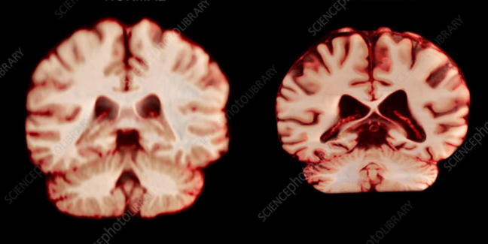
Appendix 1
Normal brain
Photo credit: Science photo library. Available at: https://www.sciencephoto.com/media/932580/view/normal-brain-vs-alzheimer-s-disease-mri-scan
Dementia / Alzheimer

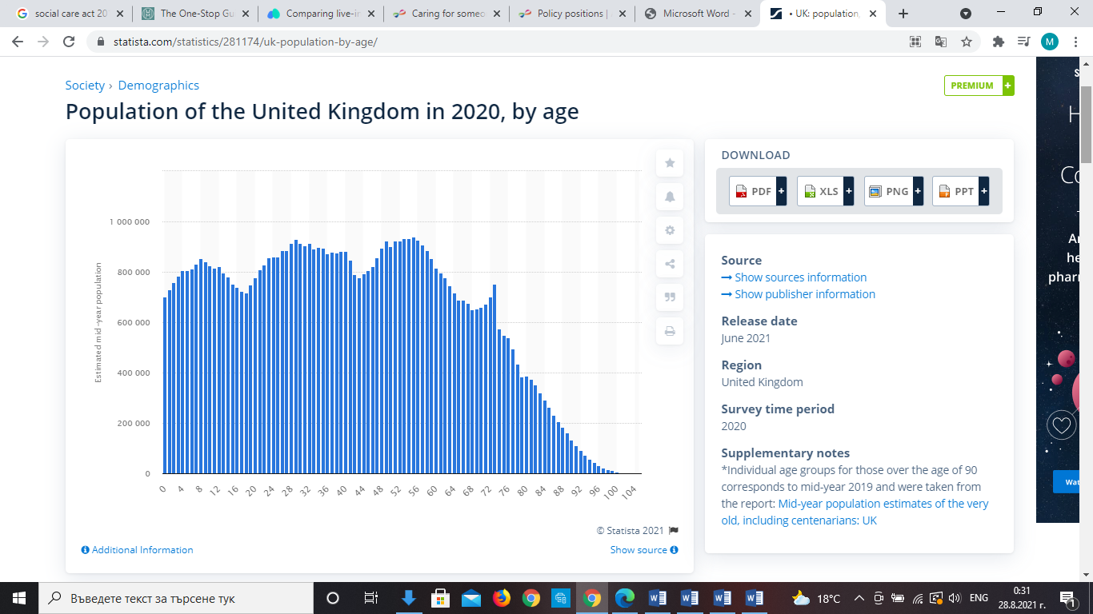
Appendix 2
Photo credit: Statista UK. Available at: https://www.statista.com/statistics/281174/uk-population-by-age/

