Managing Enterprise in the 21st Century

Business Overview and Market Research

Student Name – Corin Rentea
Student ID – 2113708
Lecturer’s Name – Musfiqur Rahman
Word Count - 2425

Table of Contents
Concept of the Business 3
Background of the business 3
Mission Statement 3
Objectives 4
Market Research 4
Questionnaire 4
Customer profile 7
Demographic segmentation 7
Geographic segmentation 8
Psychographic segmentation 8
Behavioral segmentation 8
Market Analysis 9
The Global Market 9
The UK Market 10
References 11

Concept of the Business
The main concept of this business is a restaurant that offers customers Italian cuisine and keeps the tradition alive through their authentic taste of the food. The restaurant aims to offer food that will make the customer’s break time more enjoyable in the most possible way by offering fresh dishes and cocktails. Nowadays people love to spend their free time with their family members and friends by going to a good restaurant and having food that makes them feel good (Hague et al., 2004). They not only go for good food but also to spend some quality time with their dear ones in a nice environment. The main aim of this business is to let people know about their restaurant by offering them good foods that will be unforgettable and satisfy the customer through their flavor of ingredients.

Background of the business
Naples Ristorante is a restaurant that started its journey back in 1952, October 7th on Capri Island by the Marchesi family. It is a partnership business and they shifted their business to the UK in 1990 and continued to satisfy the customer from that time. The restaurant started its journey by giving focus on Italian food and giving priority to quality and professionality. The restaurant is run by three family members where Corin Rentea is the manager, Andreea Clorascu is responsible for finance and Daniela is responsible for shared responsibility. The business is dedicated to providing the client best experience through their professionalism and dedication. The best thing about this business is they have experienced staff and provide valuable products and services to their customer.

Mission Statement
Naples Ristorante is such a restaurant that provides good authentic foods to their customer and at the same time tries to hold the traditional taste of the food and their dishes are mainly Italian food. However, the mission of the company is to impress their client by offering them good services along with maintaining professionalism and dedication to their work. The restaurant also has a mission to provide the best authentic food at a very fair price so that customers can enjoy the food rather than think about the prices. The restaurant has also another mission and it is to decorate and arrange its restaurant in such a way so that customers become impressed with the concept of decoration and its beauty.

Objectives
The restaurant has several objectives to work on and its first objective is to create a chain of restaurants around the world so that every customer can taste Italian food. The business also wants to have customers from all nationalities so that everyone can know about their Italian food. The business also aims to make a profit of £100.000 every month and it will become possible when their outlets will be many. They also aim to establish a strong team who will support their business to grow up and provide the best service to their customer. The major aim of this business is to keep the family business alive as it started with their family.

Market Research
As the restaurant is a family-owned partnership business so the other partners think very logically as well as practical as they wanted to expand their business and for that, they have conducted a detailed study to know about their target market and for that, they have made a questionnaire survey (Auty, 1992). They have made their questionnaire by focusing on demographic segmentation. From the demographic segmentation, they have targeted age, income, and occupation.

Questionnaire
Questions | Age Group of the people |  |  |  |  | Annual income range |  |  |  | Occupation
Questions | 15-20 |  | 20 -30 | 30-40 | 40-above | <£15K | £20K-30K | £30K-£40K | £40K to above | Student | Business person | Private job | Govt job
I love Italian food restaurant
I sometimes visit the Naples Ristorante
I come here with my family and friends
I spend more than £200 at a restaurant on an average
I love their restaurant decoration
Their customer service and dedication attract me

The questionnaire has three sections. The first section asked the audience based on their age group and the age group was divided into 4 parts. The first age group was between 15 to 20, the second was 20 to 30, the third was 30 to 40 and the fourth was 40 to above. The second part of the audience has been chosen from the annual income section where 4 categories have been chosen which are above £15,000, £20,000-£30,000, £30,000-£40,000, and £40,000 to above. The third section was about the profession of a targeted group and for those four basic professions have been chosen which are student, business person, private job holder, and govt job holder.

To finish the survey random number of 60 people has been chosen and the result was quite satisfying because most of the people who love Italian food restaurants are from the age group 20 to 30, and they also come to the restaurant with their family and friends. The age group 15-20 sometimes visits the Naples restaurant and other responses also came from the age group 20-30.

The target audience who comes here with their family and friends mostly earn between £30K to £40K, people who love Italian food restaurants are from the income group £20K to £30K, and customers who visit Naples Ristorante are from the income group who earns more than £15K, a customer who spends much money on having restaurant food are from the income group £20K to £30K, and rest of the questions answer were also from the income group £20K to £30K.

From this survey targeted group occupation came to know where most of the private job holders come to the restaurant with their family and friends, a business person loves their restaurant decoration and spends more money on food and love Italian food restaurants, private job holders get attracted by their customer service and dedication. Students visit their restaurants sometimes.
From the analysis, it is quite clear that most of the targeted customers are from the age group 20-30 who loves to come and eat at the restaurant with their family and friends and their annual income is also from the £20k to £30K and most of them are the from the private job holder but a good portion is also from the business.

Customer profile
Naples Ristorante aims to serve worldwide and all nations so that every people can taste their Italian food. As it has a plan to expand its business worldwide so it will have to be very careful about its market segmentation and its target group of customers and below four segmentations have been added so that it can guide them.

Demographic segmentation
This segmentation targets their customer based on their age, gender, occupation, income range, and so on. This is the most common and widely used segmentation to find the right target audience. However, from the above analysis, it has come noticed that the target audience of the restaurant will be in the age group of 20 to 30, and their annual income range is 20-30k and most of them will be business people and private jobs holders (Dube et al., 2021). From the analysis, it has become clear that private job holders love to eat food in a restaurant with their friends and family members and after that business persons are the second group who also love to spend a good amount of money to eat in a restaurant.

Geographic segmentation
Market segmentation techniques like geographic segmentation divide potential customers into groups according to their residences. Geographic segmentation helps marketers target consumers in a country, city, or area with a message that speaks to their particular wants and needs. People who live in the same environment tend to have similar desires and requirements (Han et al., 2009). This segmentation targets the customer from a specific location. Currently, the restaurant is serving only in the UK but it has a plan to expand its business globally and nationally, and for that, the business can target the big and small cities of the UK where people would love to enjoy Italian cuisine. After that, they can target Asian, African as well as American countries to spread their business and gain a lot of customers for their Italian food items.

Psychographic segmentation
This segmentation is related to the targeted customer psychology about choosing or taking a service. In the case of the restaurant, the customer identifies a lot of things such as quality of the food, freshness of the food, decoration of the restaurant, sitting arrangement of the restaurant, service facilities, and so on (Myers et al., 2011). Customers find all of this because it is related to their psychographic traits such as their lifestyles, likings, values, personality, and so on. It is a little bit difficult for a restaurant to find out and that is why these decoration and service-related questions have been added to the questionnaire to get some information about the psychography of the targeted customer.

Behavioral segmentation
Using their previous encounters with the marketing organization, target prospects are categorized into behavioral segments. To successfully track interactions between distinct prospects and the brand across various marketing touchpoints, marketing organizations must adhere to this widespread practice. Marketers may classify consumers based on their interactions with brands, online behavior, buying trends, or spending habits (Mooi et al., 2014). The analysis part, has already shown how much money a customer spends in a month for eating in a restaurant. Consumers’ buying patterns and spending habits depend on their behavior and the following company can easily track that by following their spending pattern for specific food items in their restaurant.

Market Analysis

The Global Market
For the last few years, the outlook for the global market has been cautiously hopeful, and this has been reflected in the restaurant business globally. Larger markets in the United States, UK, Europe, and Asia have all had consistent growth. The worldwide foodservice market is being driven in part by rising consumer demand for personalization and innovative menu offerings. A wide range of options is offered to customers so they can tailor their meals to suit their tastes, dietary needs, and financial constraints (Thomas, 2007). Due to their growing preference for convenient, wholesome, and hygienic food that is always available, millennials and working professionals are the primary target consumers for the industry. Additionally, commercial eateries and cafés have developed into accessible locations for youngsters, families, and young professionals to unwind and interact, spurring market expansion. The market for restaurants and mobile food services is anticipated to increase at a compound annual growth rate (CAGR) of 10.7% from $2,672.94 billion in 2021 to $2,958.31 billion in 2022.
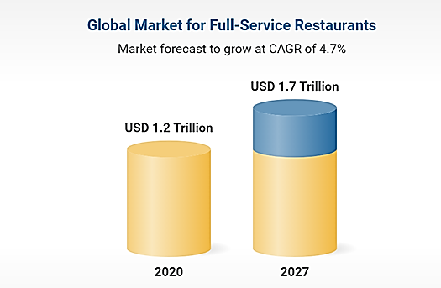
Figure 1: Global market for the full-service restaurant (Statista, 2022).
The following information depicts that the global restaurant business is doing well and, in the future, it is estimated to grow by USD 1.7 trillion and the compound annual growth rate will be 4.7%.

The UK Market
The restaurant sector is extremely interesting in part because of how quickly it changes and develops. Change has been plentiful over the past year thanks to Covid-19. The structure of the sector is still being shaped by this varying pace. The restaurant and hospitality industries have suffered significant setbacks in the UK (as well as the rest of the world), having an impact on everything from employment to the availability of food (Wedel et al., 2002). Every business owner understands how crucial it is to stay current. However, the level of utter pandemonium that occurred between 2020 and 2021 has left many UK restaurateurs feeling overburdened and worn out. The UK restaurant sector is anticipated to rebound to 94% of its 2019 value in 2022, according to a new report from Lumina Intelligence. The paper claims that in 2021, the UK restaurant market expanded by 25.9%, or £2.3 billion, reaching a total value of £11.2 billion (ONS, 2022).
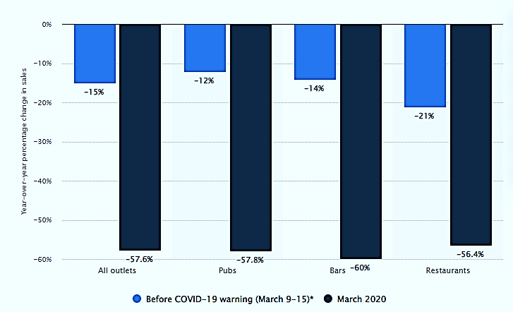
Figure 2: Condition of UK’s Restaurants and food service activities (Statista, 2022)
Due to the pandemic, the restaurant business in the UK saw some losses as people were not allowed to have food sitting in a restaurant. However, the revenue earned from the restaurant industry was not bad at all and it is hoped that in near future it will overcome all the losses that occurred due to the pandemic and again will contribute to the economy of the UK.

References
- Auty, S., 1992. Consumer choice and segmentation in the restaurant industry. Service Industries Journal, 12(3), pp.324-339.
- Canziani, B.F., Almanza, B., Frash, R.E., McKeig, M.J. and Sullivan-Reid, C., 2016. Classifying restaurants to improve usability of restaurant research. International Journal of Contemporary Hospitality Management.
- Dube, K., Nhamo, G. and Chikodzi, D., 2021. COVID-19 cripples global restaurant and hospitality industry. Current Issues in Tourism, 24(11), pp.1487-1490.
- Hague, P.N., Hague, N. and Morgan, C.A., 2004. Market research in practice: a guide to the basics. Kogan Page Publishers.
- Han, H. and Ryu, K., 2009. The roles of the physical environment, price perception, and customer satisfaction in determining customer loyalty in the restaurant industry. Journal of hospitality & tourism research, 33(4), pp.487-510.
- McDonald, M., Christopher, M. and Bass, M., 2003. Market segmentation. In Marketing (pp. 41-65). Palgrave, London.
- Myers, J.H. and Tauber, E., 2011. Market structure analysis. Marketing Classics Press.
- ONS, 2022. Coronavirus and its impact on UK hospitality - Office for National Statistics. [online] Ons.gov.uk. Available at: <https://www.ons.gov.uk/businessindustryandtrade/business/activitysizeandlocation/articles/coronavirusanditsimpactonukhospitality/january2020tojune2021/previous/v1> [Accessed 14 August 2022].
- Sarstedt, M. and Mooi, E., 2014. A concise guide to market research. The Process, Data, and, 12.
- Statista, 2022. Global food service market size 2028 | Statista. [online] Statista. Available at: <https://www.statista.com/statistics/1095667/global-food-service-market-size/> [Accessed 14 August 2022].
- Statista, 2022. UK pub and restaurant sales fall due to COVID-19 2020 | Statista. [online] Statista. Available at: <https://www.statista.com/statistics/1105174/uk-pub-and-restaurant-sales-fall-due-to-covid-19/> [Accessed 14 August 2022].
- Steenkamp, J.B.E. and Ter Hofstede, F., 2002. International market segmentation: issues and perspectives. International journal of research in marketing, 19(3), pp.185-213.
- Thomas, J.W., 2007. Market segmentation. Decision analyst, pp.1-4.
- Wedel, M. and Kamakura, W.A., 2002. Introduction to the special issue on market segmentation. Intern. J. of Research in Marketing, 19, pp.181-183.

