University of Wales Trinity Saint David
School of Engineering



Kinetic Energy Recovery

Alternative Propulsion Systems ACHA5010

Nicholas Davey
2104746
Wednesday 17th January 2024

Contents
1.0 Introduction 1
2.0 Vehicle Choice 2
2.1 Vehicle / Dynamic Characteristics 2
3.0 Worldwide Harmonized Light Vehicle Test Procedure (WLTP) 3
3.1 WLTP Cycle for Chosen Vehicle 3
4.0 WLTP Cycle Data: Renault Clio 182 Trophy 4
4.1 Low Phase 4
5
4.2 Medium Phase 6
6
6
7
4.3 High Phase 8
8
8
9
4.4 Extra High Phase 10
10
10
11
5.0 KER Systems 12
5.1 Mechanical KERS 12
5.2 Electrical KERS 12
6.0 Moments of largest Possible KERS Power Input and Energy Storage Requirements 13
13
7.0 14
8.0 Kinetic Energy Recovered, Returned to Wheel Road Contact 15
9.0 Assumptions made through KERS and Variations of Driver Feedback when Compared to the Conventional ICE and Friction Brake Vehicle 16
10.0 Summery 17
Bibliography 18

1.0 Introduction
In this assignment, we were tasked to Analyse the effects of introducing a Kinetic Energy Recovery System into a car of our own choosing to reduce vehicle fuel consumption. Throughout this paper I will be doing continuous research into the chosen car so that this data can be used to complete the appropriate Worldwide Harmonized Light Vehicle Test Procedure. Using the gathered data, I will be producing spreadsheets plotting the cumulative tractive and braking energy required at the wheel during the test cycle. From here we will be able to point out the largest ‘possible’ KERS power input and energy storage requirements and use this information to specify a suitable KER system for the vehicle considering component size and part efficiency / effectiveness. This will then allow us to plot the Kinetic Energy recovered that is returned to the wheel road contact. Lastly, I will explain how the KER system works, assumptions made and driver experience in comparison to the conventional ICE and frictional brake vehicles.

2.0 Vehicle Choice
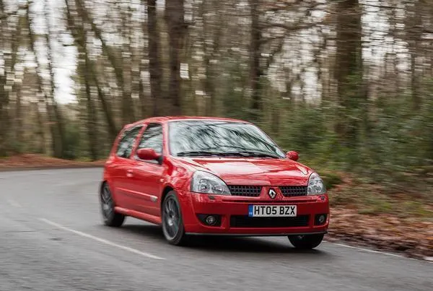
Figure 1 Renault Clio 182 Trophy (Cackett, N. 2018)
The vehicle I have decided to pick is the Renault Clio 182 Trophy. I’ve decided to pick this car as it is a fiery and charismatic hot hatchback underneath its stealthy shell. The Clio Trophy was widely known to be one of he most iconic hot hatches from its time, ‘In July 2005, Autocar's cover line said it all: 'World's Greatest Hot Hatch'. Hyperbole, you think? No. The Renault Sport Clio 182 Trophy was that good. Then, now, always’ (Cackett, N. 2018). It was lightweight, fast, agile, simple and personally a dream car to own.

2.1 Vehicle / Dynamic Characteristics
Power (hp) = 182 @ 6,500rpm
Torque (Nm) = 200 @ 5,250rpm
Top Speed = 138mph
Unladen Mass (Kerb Weight) = 1,075Kg
Displacement = 2.0 l
Power / Weight = 166 bhp / t
Frontal Area = 1.94m^2
Rolling Resistance Coefficient (On Dry Tarmac) = 0.015
Drag Coefficient = 0.35
Height = 1414mm

3.0 Worldwide Harmonized Light Vehicle Test Procedure (WLTP)
The Worldwide Harmonized Light Vehicle Test Procedure, or WLTP for short is a test over four phases to determine the official fuel consumptions and Co2 emissions of a car and was brought into place in September 2017 replacing the previous methods of testing called the NEDC test procedure.
The WLTP offers a much greater advancement from the previous and somewhat outdated NEDC procedure. This is because where the NEDC was measured using ‘theoretical driving’, the WLTP laboratory tests have been put in place to give a more accurate picture of the pollutants, fuel consumption and emissions our cars produce.
A vehicle would have to go through four phases to complete the test that consist of Low, Medium, High and Extra High. Each of these phases requires the car to go through vigorous driving, stopping acceleration and braking periods in correlation to the specific phase.
Using a class system of class 1 – 3, the WLTP can group similar cars together based off their power values. The Class 3 cycle would group together all vehicles with the highest power to mass ratio. Following on from this class 2 would group together all lower power vehicles and class 1, all vehicles with the lowest power such as tractors etc.

3.1 WLTP Cycle for Chosen Vehicle
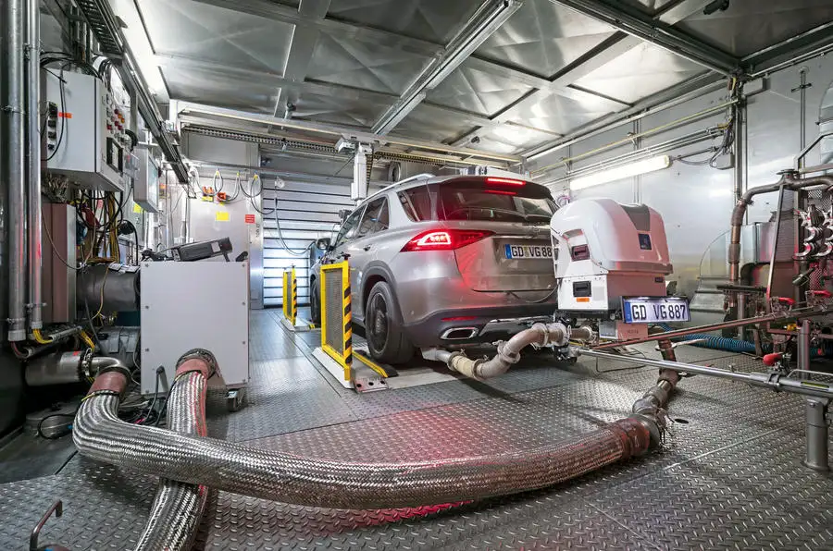
The Renault Clio 182 Trophy would be categorized into the Class 3b cycle as this is for vehicles that have a V_max of greater than or equal too 120km/h. With a greater power output, the Clio has been put into this group so we can get the most accurate results under higher speeds for the vehicle. The test helps to assess the characteristics of vehicles at higher speeds, however, there also needs to be considerations for different testing conditions for the overall guide to a vehicle’s capabilities or specifications.
Figure 2 - Shows part of the Process towards a WLTP Cycle

4.0 WLTP Cycle Data: Renault Clio 182 Trophy

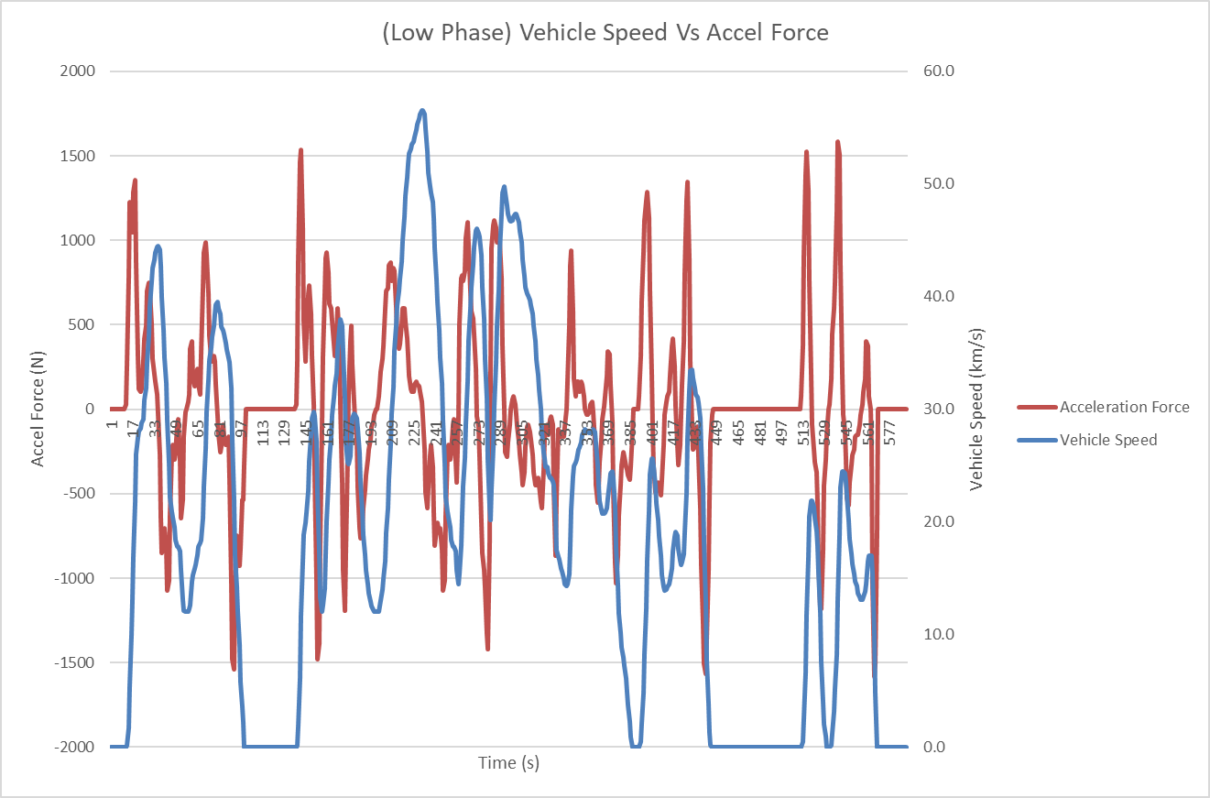
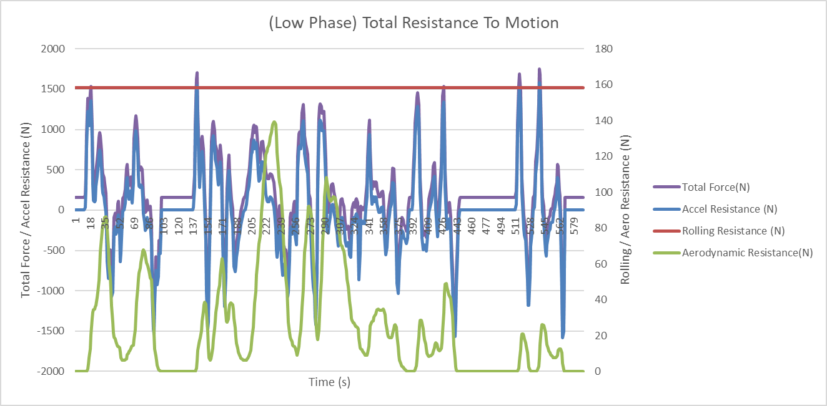
4.1 Low Phase
Graph 2 - Total Resistance to Motion, Low Phase of WLTP Cycle
Graph 1 - Vehicle speed Vs Acceleration Force, Low Phase of WLTP Cycle

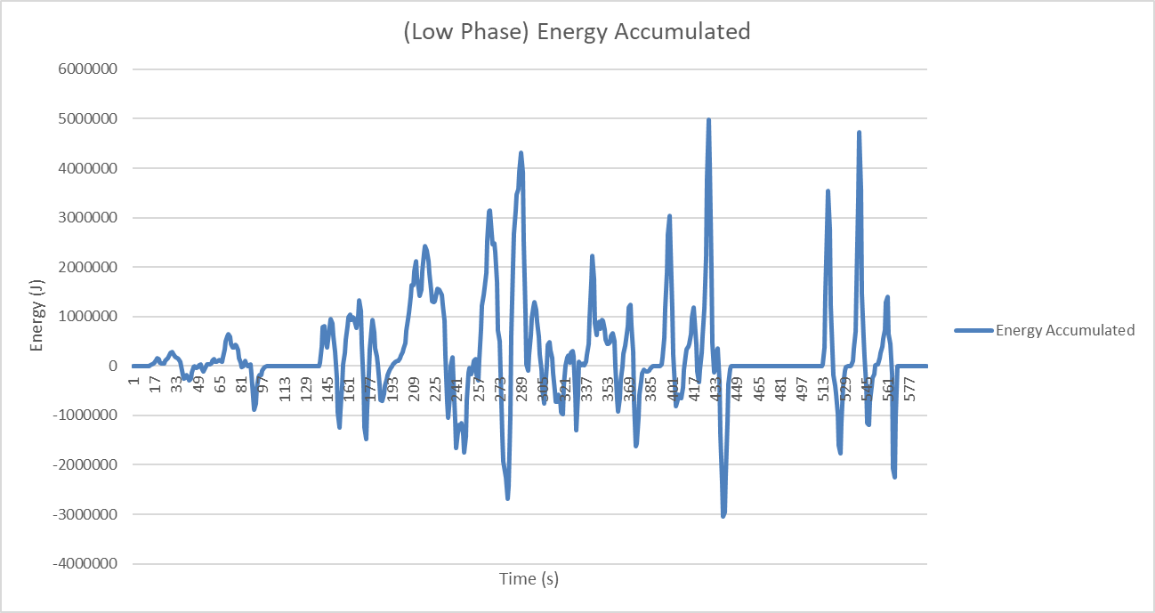
Graph 3 - Accumulated Energy, Low Phase of WLTP Cycle

Graph 4- Cumulative Braking Energy Vs Cumulative Tractive energy, Low Phase

4.2 Medium Phase

Graph 5 - Shows Vehicle Speed against Acceleration Force, Medium Phase

Graph 6 - Total Resistance to Motion, Medium Phase
Graph 7 - Shows Total Accumulated energy, Medium Phase

Graph 8 - Cumulative Braking Energy Vs Cumulative Tractive energy, Medium Phase

4.3 High Phase

Graph 9 - Shows Vehicle Speed against Acceleration Force, High Phase

Graph 10 - Total Resistance to Motion, High Phase

Graph 11 - Shows Total Accumulated energy, High Phase

Graph 12 - Cumulative Braking Energy Vs Cumulative Tractive energy, High Phase

4.4 Extra High Phase

Graph 13 - Shows Vehicle Speed against Acceleration Force, Extra Phase

Graph 14 - Total Resistance to Motion, Extra High Phase

Graph 15 - Shows Total Accumulated energy, Extra High Phase

Graph 16 - Cumulative Braking Energy Vs Cumulative Tractive energy, Extra High Phase

5.0 KER Systems
A KER System refers to a Kinetic Energy Recover System. Typically used in racing applications specifically Formula 1, they are systems can recover kinetic energy so that it can be stored and used later in the race. Older cars without a KER System wouldn’t act the same way as a newer car with an automotive KER System implemented. Rather than recovering Kinetic Energy during braking, the car would lose this energy due to heat dissipation caused from the friction brakes.
When a car with a KER System brakes, Kinetic Energy is being recovered and sent to an energy storage device such as a Flywheel, Battery or supercapacitor. This Stored Kinetic Energy can then be used, for example when coming out of a corner, to aid acceleration or give the car a ‘boost’. However, this stored energy is used differently depending on the type of KER System being used.

5.1 Mechanical KERS
Flywheel KER Systems are more common in an average car. It is a mechanical KER system, fitted to the Rear Axle of the car and during deceleration, the braking energy causes the flywheel to rotate at a very fast rate until the brake is taken off. While stationary, for example at a set of red lights, the flywheel will continue to rotate storing this Kinetic Energy until the vehicle sets off again. When the accelerator is depressed, this stored energy is transferred to the rear wheels which benefits the acceleration of the vehicle and can also help in a reduced fuel consumption. A great example of the implementation of Mechanical KERS would be Volvo.

5.2 Electrical KERS
Electrical KER Systems are very common in Formula 1. Many F1 teams have adapted to using electrical generators referred to as a Motor Generator Unit - Kinetic (MGU-K). The MGU-K can use the heat energy produced from heavy braking and convert it into electric energy which is then stored in a battery. This stored energy can be used by the driver for a tactical advantage. At the press of a button, the driver can release the stored energy which works inline with the engine to produce more power at the wheels of the vehicle, like a ‘Boost’.

6.0 Moments of largest Possible KERS Power Input and Energy Storage Requirements
Using the data from the WLTP test on the Renault, we can look closely into the graphs to see where the KER System is working most efficiently and at points where it’s producing the largest possible power input at specific moments during the test.

Graph 17 - Combined Phases, Vehicle Speed Vs Braking Energy
Using ‘Graph 17’ we can take a deeper look into the points where the largest KERS power output can possibly occur. The green line shows braking energy across the four phases of the test. This means that where the braking energy was at its peak, this was the point of the most Kinetic Energy being transferred and stored into the KERS system. At its peak, the Braking Energy is at 19180.29122 Joules,781 seconds and around 900 seconds into the test which is the medium phase of the WLTP test.
However, in Phase 3 the Clio also experiences high points of braking energy which again are points of largest possible KERS power input and storage efficiency.

7.0 Implemented KER System
The Clio Trophy from factory did not come with a KER System. Being a small, snappy hatchback, it was not needed for the cheap and cheerful runaround back when it was first sold. However, implementing a KER System to a Clio Trophy in my opinion would be very interesting. A suitable system which could be used would be Flywheel based KERS. This would be a viable option as it is a tried and tested method in newer cars on the road today. As stated previously, Volvo use a Flywheel based system in some cars to aid the when accelerating but also reduces fuel consumption as well.
Unlike some Volvo cars, the Clio is a small, Front Wheel Drive car the flywheel system would need to be attached to the driving wheels of the which leaves much less space to fit such a system. As said before, when during deceleration, the braking energy produced will cause the flywheel to spin, while the car is stopped the flywheel continues to spin until the driver accelerates again. During acceleration, the energy from the rotating flywheel is sent to the driving wheels. This reduces the amount of fuel used during acceleration and slightly better acceleration. Doing further research, the Volvo system is the first ever Flywheel based KER System to be tested on roads and is already stated to be able to cut fuel consumption down by 20% with an addition increase in 80 horsepower at full capacity.
In a Clio, this system would be unique. With such a lightweight and quick car, this Flywheel based KER System will be able to produce similar if not better figures in fuel consumption and additional added horsepower. However due to the lack of space on the front of the car it would be hard to fit such a system and would prove very challenging.
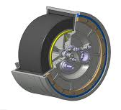
Figure 3 – Volvo’s Flywheel Based KERS

8.0 Assumptions made through KERS and Variations of Driver Feedback when Compared to the Conventional ICE and Friction Brake Vehicle
When comparing the conventional ICE vehicle with frictional brakes to a vehicle with a KER System on board, many assumptions can be made about how the two vehicles would react differently to each other.
Firstly, a vehicle fitted with a KERS would feel more responsive to a driver when coming out of a corner after braking. Traditionally the typical ICE vehicle with frictional brakes relies entirely on the horsepower it has at the wheel from the engine. A KER System allows a driver to control the stored energy and use it to gain an advantage over opposition. This Acceleration boost can also help to reduce fuel consumption providing a more economical driving experience.
Using frictional brakes, lots of energy is wasted through heat dissipation. Whereas, in a KERS assisted vehicle the energy is stored and used to accelerate the car which helps to use energy more efficiently with less waste. This better energy efficiency is also more environmentally friendly through regenerative braking which in turn aids in the wear and tear of the brakes as it takes significant portion of the braking load.
The Brake pedal in a car with a KERS may feel slightly different compared to one with frictional brakes due to the implementation of regenerative braking, potentially providing a more integrated and controlled experience. Furthermore, from this the driver may possibly experience reduced brake fade as the KER System takes a large load from the frictional brakes benefiting the lifetime of the brakes providing longer effectiveness in hand.
The utilization of a KER System can also provide an overall smoother driving experience during acceleration, with the power delivery feeling much more responsive and continuous.
However, the different variations and type of feedback that the driver would feel will also be dependant on driving styles of an individual user. Driven appropriately, the user would feel a much more dynamic experience from the engine compared to the Conventional ICE and Friction brake vehicle.

9.0 Summery
In conclusion, I believe that putting a Flywheel based KER System into a Renault Clio Trophy would be beneficial as it would help aid the power output providing a more engaging experience for the driver, however, it also would help to improve the efficiency of fuel consumption through the provided research. Although, I also believe that this entirely depends on how the driver applies this system in their own driving habits. A driver would experience advanced stop-and-go efficiency from the car. In urban areas, this system can prove very advantageous by minimizing energy waste during braking in city appliances. Reduced brake wear means results in a lower maintenance cost for the driver and longer brake life.
Overall, a KER System depending on the right application can prove incredibly beneficial when considering fuel economy. With the advantages of stop-start driving technology in real life scenarios, KERS offers a multifaced approach when improving the fuel efficiency, driving experience and eco friendliness of a vehicle. By harnessing the energy that would otherwise be wasted as heat dissipation, the vehicle becomes more economical making it a more desirable option for those seeking better fuel economy and a greener driving experience.

Bibliography

- Cackett, N. (2018) Renault Clio 182 trophy: Ph heroes, PistonHeads. Available at: https://www.pistonheads.com/news/ph-features-heroes/renault-clio-182-trophy-ph-heroes/37580 (Accessed: 17 January 2024).
- Toone, C. (no date) Renault clio 182 tophy review, Rush Magazine. Available at: https://www.rushmagazine.co.uk/clio-182-trophy-review (Accessed: 17 January 2024).
- The Worldwide Harmonised Light Vehicle Test procedure (WLTP) (no date) Vehicle Certification Agency. Available at: https://www.vehicle-certification-agency.gov.uk/fuel-consumption-co2/the-worldwide-harmonised-light-vehicle-test-procedure/ (Accessed: 19 January 2024).
- Autocar (no date) The Autocar Guide to WLTP emissions testing, Autocar. Available at: https://www.autocar.co.uk/car-news/features/autocar-guide-wltp-emissions-testing (Accessed: 19 January 2024).
- Abidi, Y. (2022) How does the KERS system in F1 cars work?, MUO. Available at: https://www.makeuseof.com/how-the-kers-system-in-f1-works/ (Accessed: 20 January 2024).
- The flywheel KERS (kinetic energy recovery system) (0:36) (no date) Volvo Cars Global Media Newsroom. Available at: https://www.media.volvocars.com/global/en-gb/media/videos/38350 (Accessed: 20 January 2024).
- Roth, D. (2011) Volvo shows off KERS flywheel tech [w/video], Autoblog. Available at: https://www.autoblog.com/2011/05/31/volvo-shows-off-kers-flywheel-tech-w-video/?guccounter=1&guce_referrer=aHR0cHM6Ly93d3cuZ29vZ2xlLmNvbS8&guce_referrer_sig=AQAAACDTsSBvHICetllomfjwTHqLgGO6oRbCkOFf0uHlVnkd-5_efjr1uZHA7npCrVG2LN5AframXpxZwFQgSfFFZDKpmyJnH4hTkbQkHAYzMh3g2EgTtZ7EWdR90-DHSN3bEQgw5nkqQWRWca663vm9ju62SEVc6pdFq_n4bZEnbtom (Accessed: 21 January 2024).

