TASK1A Essential Academic and Employment Skills
Academic and employment skills
Academic skills are set of instruments, which you use to work with knowledge. The essential academic skill and definition are illustrated in Table1.

Table1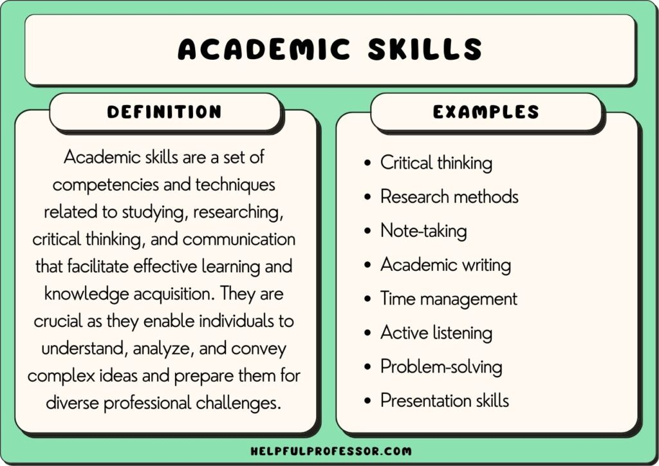
[1]
Employment skills are set of cognitive, social and digital competencies that support successful participation in the labour market. They allow person to effectively adapt and perform tasks at workplace and are grouped as: hard/technical and soft skills. Productivity of hard skills depends on the degree of proficiency in soft skills. They connect education with labour market requirements, as they combine technical knowledge with communication, teamwork and problem-solving abilities, initiative and self-motivated, working under pressure and to deadline, organisational skills, ability to learn and adapt, negotiation, time management. [2] [3] [4]
Their balance is important for employer/career development.
Essential academic skills for my professional success in DATA SCIENCE are strong cognitive and analytical skills, ability to think critically, work with data and use an academic writing style with correct citations and references. My communication and presentation skills with digital competence at a higher academic level will help me to communicate in proper standard and define what kind of information and how to be represented. These skills allow for proper understanding, analysis, and clarify information for taking better business decisions in dynamic environment.
Essential employment skills for my professional success - In order to meet the demands of labour market, developing my digital literacy - high competency of programs of Microsoft Office; working in a dynamic environment; analysing; numeracy; defining and structuring marketing problems; preparing projects for solving problems; teamwork and communication skills; quickly mastering software programs; taking on commitments and taking initiative; dealing with deadlines and working under pressure, are skills that make me competitive and constantly evolving. Collaborate with everyone who relates to my business role - share information, communication, resolving problems in standard that my role required, is the wining approach for both: my professional development and business.

References

[1] | C. Drew, “106 Academic Skills Examples,” helpfulprofessor.com, 16 JANUARY 2024. [Online]. Available: https://helpfulprofessor.com/academic-skills-examples/. [Accessed 15 MARCH 2026].
[2] | OECD, “OECD Skills Outlook 2019 Thriving in a Digital World,” oecd.org, Paris, 2019.
[3] | W. Tyson, Teaching and Learning Employability Skills in Career and Technical Education, Cham: Palgrave Macmillan, Cham, 2020.
[4] | “mentornets.in,” [Online]. Available: https://www.mentornets.in/employability-skills. [Accessed 10 MARCH 2026].

