LDE Assignment 1
E-Portfolio

Module Name: Learning In the Digital Era
Module Code: ACCA 4025

Student Name: SEWELL L FERNANDES
Student ID:2539400
Group: 2
Lecture’s name: Suneth Fernando

Student ID:2539400
Group: 2
Date:24/07/2026
Lecturer’s Name: FERNANDO SUNETH

E-Portfolio Link: https://2539400-e-portfolio-showcase.editor.wix.com/edit/od/c8a46a24-3b2e-4980-9e42-bae92117e85c?metaSiteId=2079b896-b366-4306-93f0-74f7612cb7d8

University of Wales Trinity Saint David
London campus
Table of Contents
Introduction 3
Main Body 3
Task 1: Essential Academic and Employment Skills for the future career Path 3
Task 1 (a): Report on Essential Academic and Employment Skills 3
Task 1 (b): Evaluation of Task 1 (a) based on Similarity report 4
Task 2: Collaborative Mind Map and Individual Poster 4
Mind map (collaborative) 5
Poster (Individual) 5
Task 3: Virtual Collaboration and RefWorks 5
Report on Virtual Collaboration 6
Step-by-step process of using RefWorks with visuals 6
Task 4: E-Portfolio Creation and Evaluation 9
Task 4 (a): E-Portfolio Creation 9
Task 4 (b): Illustrative Review of E-Portfolio tool Selection 9
Conclusion 11
References 11
Task 1 References: 11

Introduction

This assignment explores the development of essential academic, digital and employment skills required for future career development. It covers key arear including academic and employment skills, collaboration working, virtual collaboration, the use of automatic referencing tools, and the creation of an online portfolio. The assignment also demonstrates the use of digital technologies to communicate, collaborate, organise information and present academic work effectively. As part of the assessment, a collaborative mind map and an individual academic poster have been created, alongside a report on virtual collaboration and practical evidence of using RefWorks. Finally, an online e-portfolio has been created using Wix to organise and present the completed tasks in a clear and accessible manner format.

Main Body
The main body of this assignment presents the work completed for each task and demonstrates the development of academic, digital and employment skills. The creation and evaluation of an online e-portfolio using Wix, which provides an organised platform for presenting and reviewing the completed academic work.

Task 1: Essential Academic and Employment Skills for the future career Path
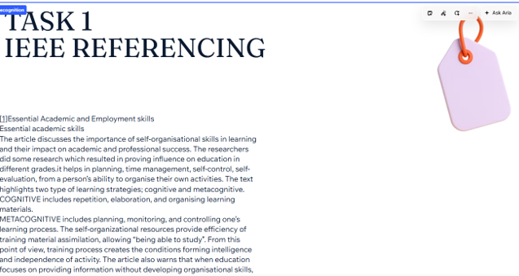

Task 1 (a): Report on Essential Academic and Employment Skills
Developing strong academic and employment skills is important for achieving success in higher education and future employment. Academic skills such as research, critical thinking, communication, time management and referencing help students complete their studies effectively. Employment skills, including teamwork, problem-solving, adaptability, digital literacy and professional communication, are also important for working successfully in a professional environment.
Digital skills are particularly important in the modern workplace because many organisations use computers, online communication platforms and digital systems to complete daily tasks. Employees need to be able to use technology confidently, communicate effectively through digital platforms and work collaboratively with others. Teamwork is also an important employment skill because employees often work together to achieve shared goals.
Time management and organisation are essential for balancing academic responsibilities and employment tasks. Good time management helps individuals meet deadlines, prioritise important activities and complete work efficiently. Problem-solving and critical thinking are also valuable because they enable individuals to analyse situations, identify challenges and develop appropriate solutions.
Communication skills are important in both academic and professional environments. Effective written and verbal communication allows individuals to share ideas clearly, participate in discussions and build positive working relationships. In addition, adaptability and willingness to learn are important because technology and workplace requirements continue to change.
Overall, developing a combination of academic, digital and employment skills can help individuals become more confident and prepared for their future careers. These skills can support academic achievement while also improving employability and enabling individuals to contribute effectively to the workplace.

Task 1 (b): Evaluation of Task 1 (a) based on Similarity report
After reviewing the similarity report for Task 1(a), I evaluated the areas of my work that required improvement. The report helped me identify sections that were like existing sources and encouraged me to review my writing and referencing. I made sure that information taken from sources was appropriately acknowledged using citations and that the work was written in my own words. This process helped me improve my academic writing, avoid unnecessary similarities and understand the importance of using appropriate references when completing academic assignments.

Task 2: Collaborative Mind Map and Individual Poster
Effective Teamwork is essential for success in education and the workplace. Good communication helps team members share ideas and avoid misunderstandings. Collaboration allows people with different skills to work together to achieve shared goals. Strong leadership provides direction, motivates the team, and ensure tasks are completed efficiently. Trust and respect create a positive environment where everyone feels valued and confident to contribute. Together, these skills improve productivity, strengthen relationships, reduce misunderstandings, and help team complete tasks successfully. These teamwork skills are essential for success in higher education and professional careers, particularly in computing and cybersecurity, where collaboration is vital for solving complex problems.

Mind map (collaborative)

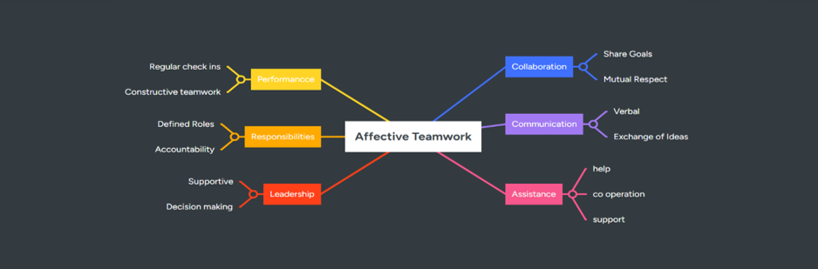

Poster (Individual)

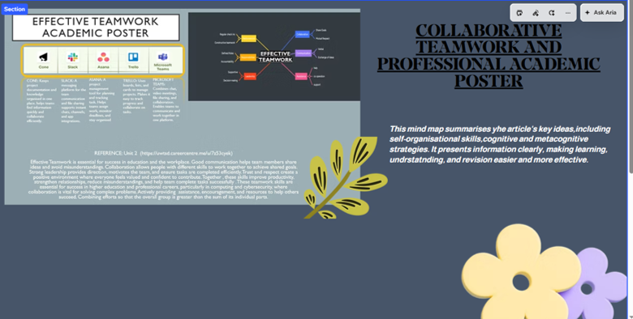

Task 3: Virtual Collaboration and RefWorks
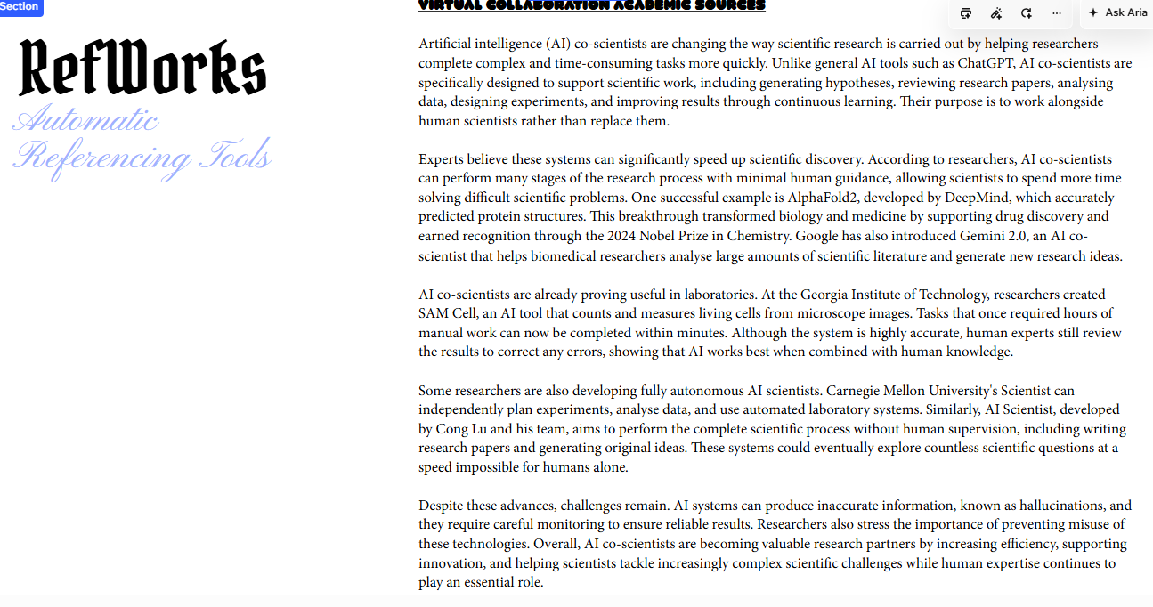

Report on Virtual Collaboration
Virtual collaboration refers to the process of individuals working together using digital technologies when they are not necessarily in the same physical location. It allows people to communicate, share information, manage tasks and work towards common goals using online tools and platforms.
There are many digital tools that support virtual collaboration. Video conferencing platforms allow team members to communicate face-to-face online, while instant messaging tools provide quick communication. Cloud-based applications allow users to create, edit and share documents with other members of a team. These tools can improve productivity because team members can access information and collaborate from different locations.
Effective communication is an important part of successful virtual collaboration. Team members should communicate clearly, respond to messages appropriately and ensure that everyone understands their responsibilities. Good organisation and time management are also important because team members may be working at different times or from different locations.
Virtual collaboration has several benefits. It can provide flexibility, save travel time and allow organisations to work with people from different locations. It can also support teamwork and make it easier to share knowledge and resources. However, virtual collaboration can also present challenges, including technical problems, poor internet connections, communication misunderstandings and difficulties in maintaining team engagement.
To overcome these challenges, teams should establish clear communication methods, agree on deadlines and use suitable digital collaboration tools. Members should also participate actively in online meetings and communicate regularly with other team members. Overall, virtual collaboration is an important digital skill that can support academic study and modern employment. Developing the ability to collaborate effectively online can help individuals become more adaptable and prepared for the changing workplace

Step-by-step process of using RefWorks with visuals
RefWorks is a reference management tool that can help students collect, organise and manage academic sources. I used RefWorks to support the referencing process for my academic work. The tool helped me organise my sources and create citations and references in the required referencing style.
Step 1 – Creating or accessing my RefWorks account: I accessed RefWorks and signed in to my account.
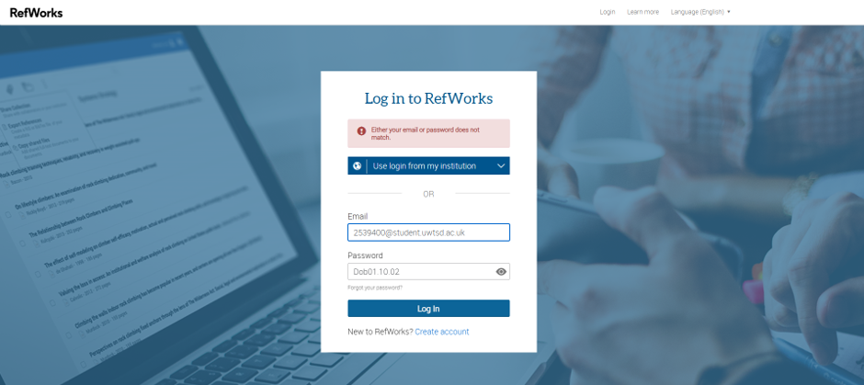
Step 2 – Adding academic sources: I added relevant sources to my RefWorks reference library and checked that the information was correct.
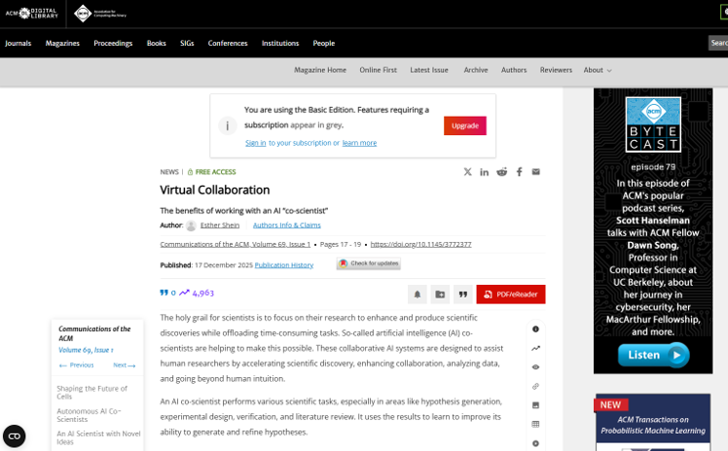
Step 3 – Organising references: I organised my sources so that they could be easily located and used when completing my assignment.
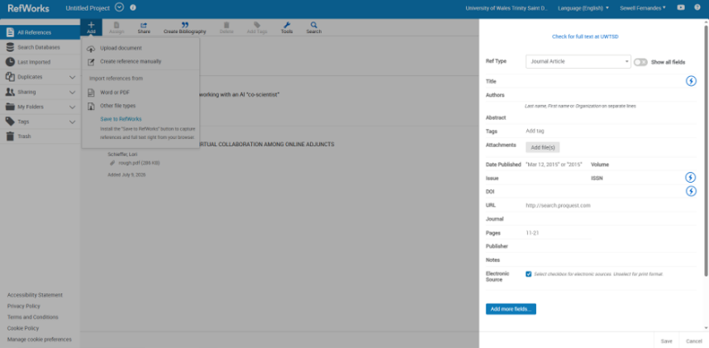
Step 4 – Creating citations: I used the referencing features to add citations to support information taken from academic sources.
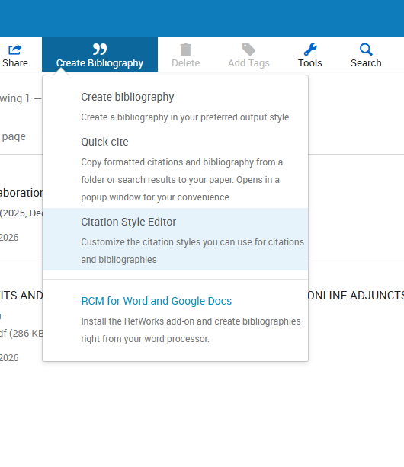
Step 5 – Creating the reference list: I generated a reference list using the required IEEE referencing style and checked the references for accuracy.
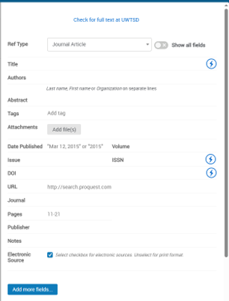
The use of RefWorks helped me understand the importance of academic referencing and made it easier to manage the sources used in my assignment.

Task 4: E-Portfolio Creation and Evaluation
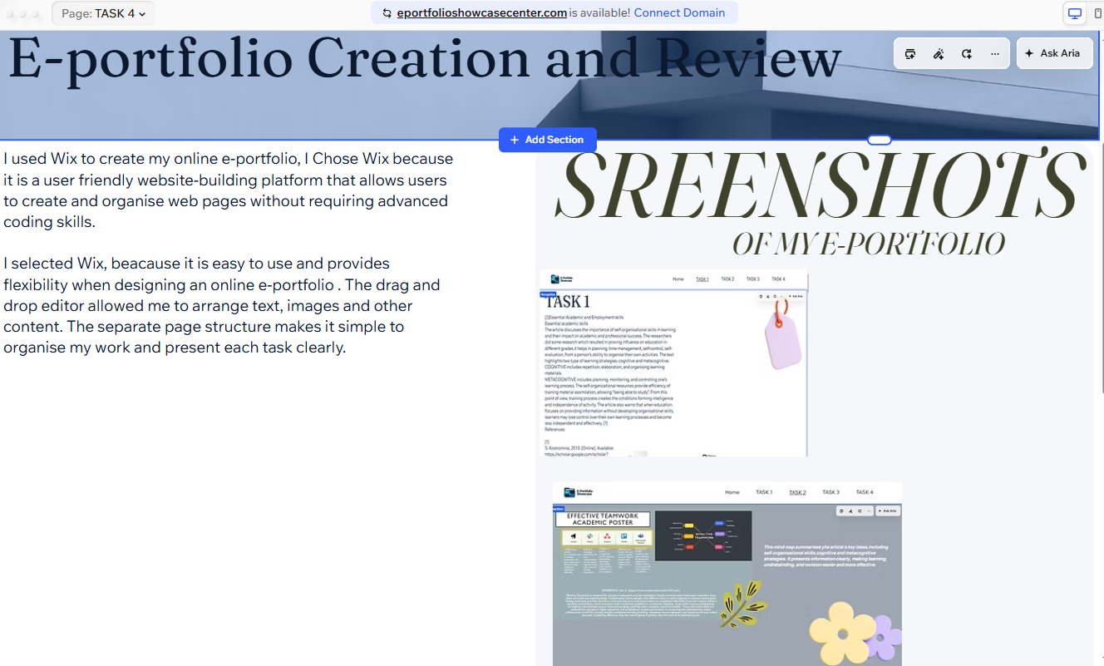

Task 4 (a): E-Portfolio Creation
For Task 4, I created an online e-portfolio using Wix to organise and present my completed academic work. The e-portfolio contains separate pages for the different tasks, allowing the work to be presented in a clear and organised format. The portfolio includes a Home/Welcome page, Task 1, Task 2, Task 3 and Task 4.
The Home page introduces the e-portfolio and gives information about the purpose of the website. The Task 1 page presents my work on essential academic and employment skills. The Task 2 page contains my collaborative mind map and individual poster. The Task 3 page presents my work on virtual collaboration and the use of RefWorks as an automatic referencing tool. The Task 4 page explains the creation of the e-portfolio and provides a review of the Wix platform.

Task 4 (b): Illustrative Review of E-Portfolio tool Selection
I selected Wix as the platform for creating my e-portfolio because it is a user-friendly website-building tool that allows users to create and customise websites without requiring advanced coding knowledge. The drag-and-drop editor made it easy to add and arrange text, images and other content.
I chose Wix because it provided flexibility when designing my e-portfolio and allowed me to create separate pages for each task. This helped me organise my academic work clearly and made the portfolio easy to navigate. Wix also allowed me to present my work in an online format that can be accessed through a shared link.
Overall, using Wix helped me improve my digital skills and understand how online platforms can be used to create and present an e-portfolio. The experience also improved my confidence in organising digital content and presenting academic work in a professional and accessible way.

HOMEPAGE: INTRODUCTION AND WELCOME
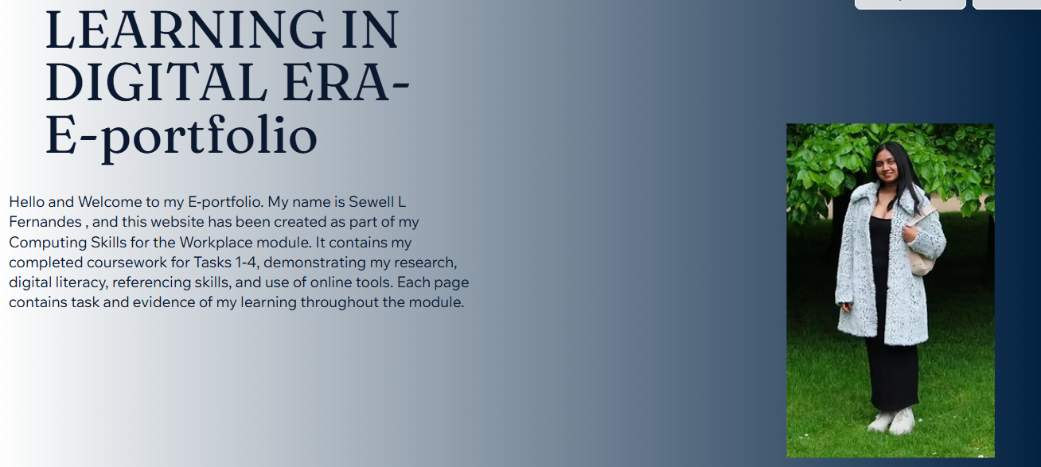
PAGE 2: TASK 1 IEEE REFERENCING
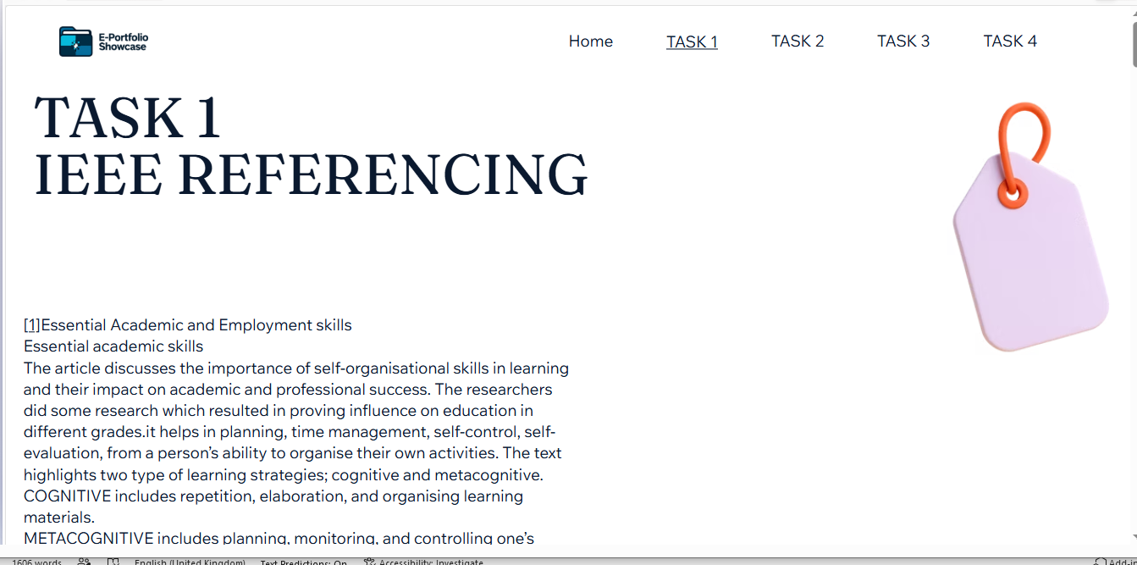
PAGE 3: TASK 2
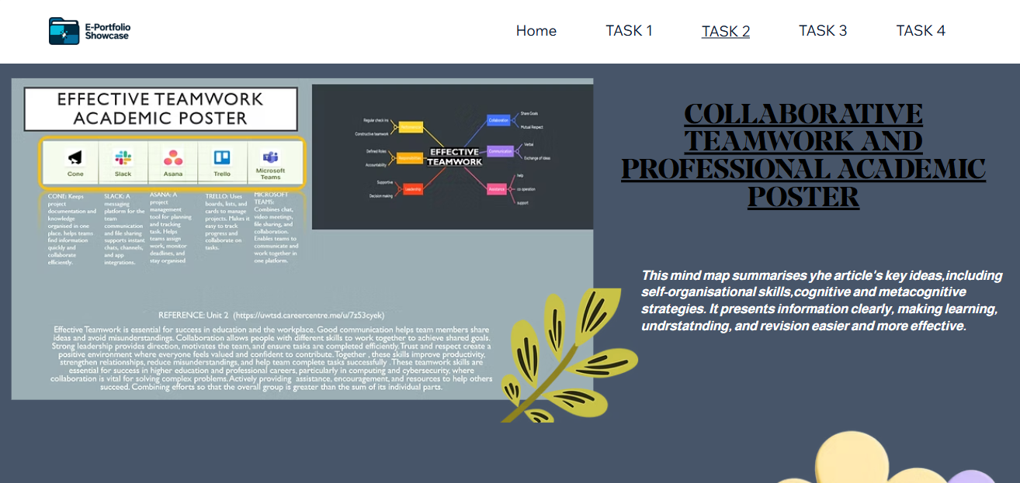

PAGE 4: TASK 3
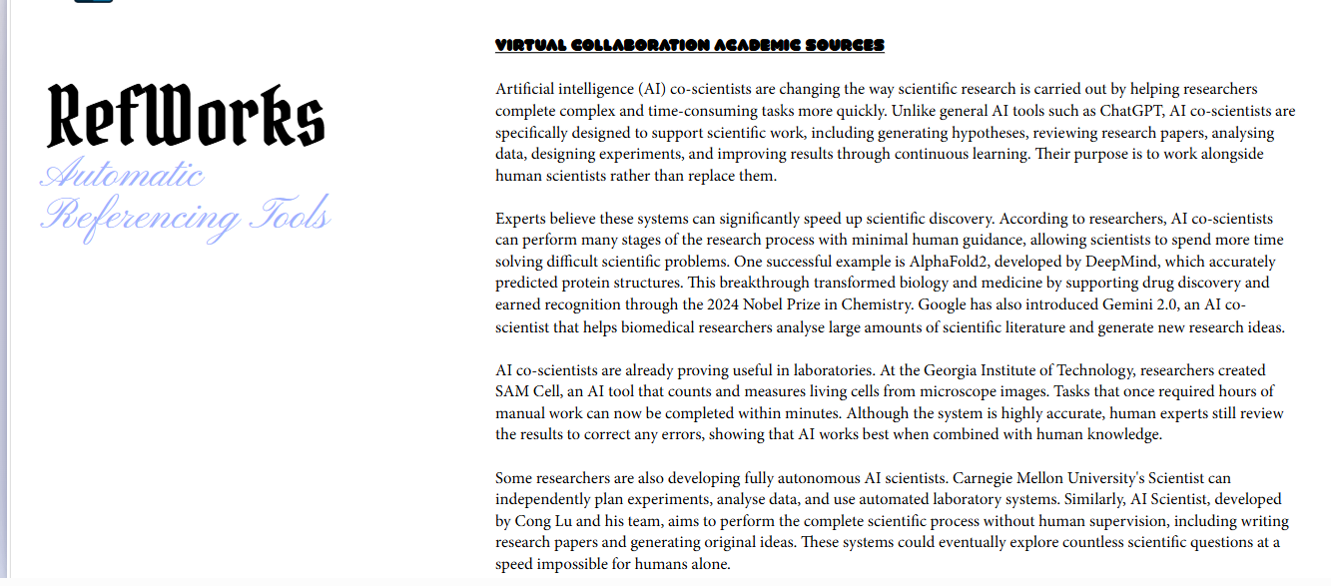
PAGE 5: TASK 4
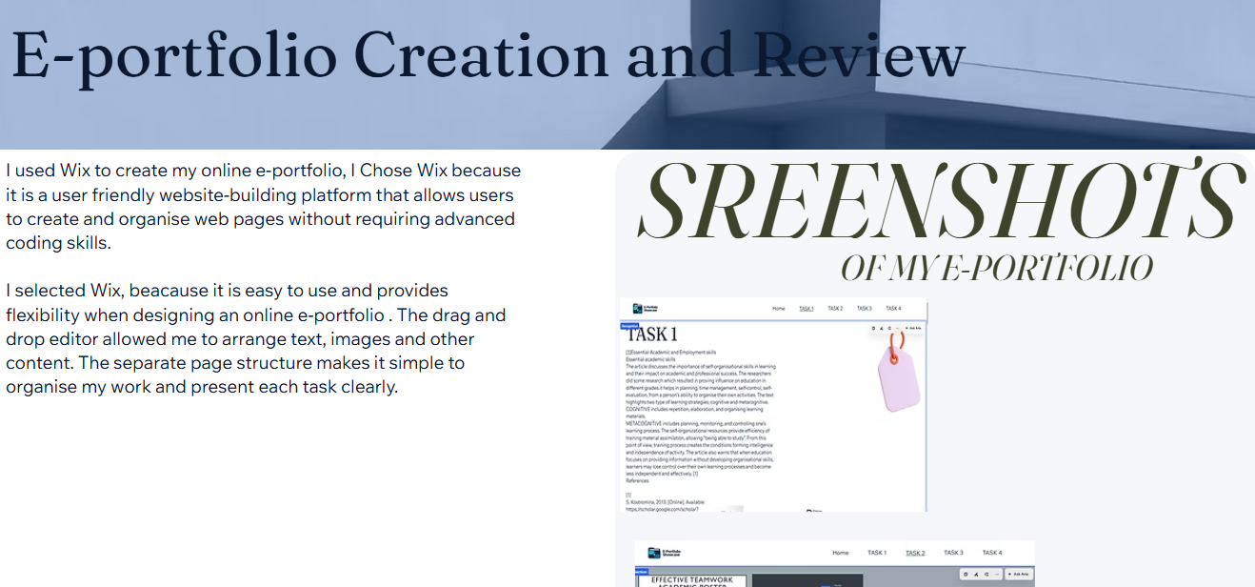

Conclusion
To conclude, I have learned a lot from completing this assignment. I have improved my academic and digital skills and learned more about the importance of communication, teamwork and virtual collaboration. I also learned how to use RefWorks to manage my references and understand the importance of using the correct referencing style. Creating my e-portfolio using Wix helped me improve my confidence in using digital tools and organising my work online. Overall, completing these tasks has helped me develop useful skills that I can use in my studies and in my future career.

References

Task 1 References:
[1] | S. Kostromina, 2013. [Online]. Available: https;//scholar.google.com/scholar?hl=en&as_sdt=0%2C5&q=essential=academic=skills&oq=essential=Aca#d=gs_qabs&t=178178004426&u=%23p%3Dg2dwfCn-icQJ.
[2] | Z. Soproni, 25 10 2023. [Online]. Available: https://dpi.org/10.52398/gjsd.2023.v3.i2.pp53-65.
[3] | [Online].

Task 3 References:
[1] Esther Shein. "Virtual Collaboration
The benefits of working with an AI “co-scientist”." [Online]. Available: https://dl.acm.org/doi/10.1145/3772377

