Module: Employability and Career Development
Assignment Title: Portfolio of written tasks
Table of Contents
Task 1 3
Job Adverts and Identification of Key Skills 3
Task 2 6
Self-Assessment 6
Evidence of Readiness 7
Task 3 8
Set Employment Goals 8
Develop a Personal Development Plan 9
Reference list 11

Task 1

Job Adverts and Identification of Key Skills
I compared two employment postings for Store Manager at Morrisons and Store Manager at One Stop (Tesco) to know the skills and knowledge required for a Store Manager position. The retailers are different in size and operating model, but both adverts underscore the similarities of competencies that are vital in the management of retail.
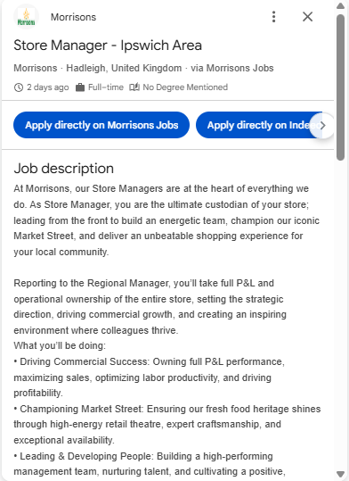
Figure 1: Job advert of Morrisons
(Source: LinkedIn, 2026a)
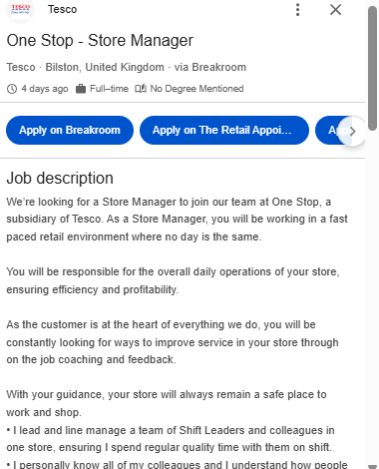
Figure 2: Job advert of One Stop (Tesco)
(Source: LinkedIn, 2026b)
Leadership is one of the most important skills in the two adverts. At Morrisons, the focus is on developing ‘high-performing management teams’, ‘nurturing talent’, and establishing a ‘workplace culture of inclusion’ (Morrisons, 2022). Similarly, One Stop provides Store Managers to mentor Shift Leaders and other colleagues, coach staff, control performance levels, and ensure a high motivation rate. This proves that to be successful Store Managers, individuals should be able to motivate teams, assign duties, and create a positive working atmosphere.
The two adverts are also focused on commercial awareness and operational management. Morrisons expects managers to be in charge of profit and loss (P&L) accountability, maximise sales, optimise labour productivity, and increase profitability. Similarly, one stop requires the Store Managers to oversee key performance indicators (KPIs), have businesses under control, manage labour budgets, track competitors and undergo business upgrades (Tesco, 2017). These job duties demand high analytical capabilities and making sound business decisions that can optimise the performance of the store.
Customer service and compliance are another area of knowledge that is common. The two organisations require managers to provide an exceptional shopping experience, and food and health and safety compliance, inventory and legal standards. These roles underscore the need for high standards of operations coupled with customer expectations.
Leadership is the most important of these competencies in my opinion that will make the most difference in my future career. Being a present-day retail specialist at Sainsbury’s, I have acquired some experience in assisting colleagues, organising the day-to-day activities, and upholding customer service levels. I will utilise this leadership skill in a future position of Store Manager by providing motivation to employees, coaching them regularly, giving good feedback, fixing workplace issues, and encouraging teamwork (Jain, 2025). It will also be through effective leadership that I can enhance organisational goals, customer satisfaction, and improve employee engagement. Hence, leadership skills will not only enhance my performance in my professional career, but they will also assist me in achieving my long-term dream of being promoted to senior retail management.
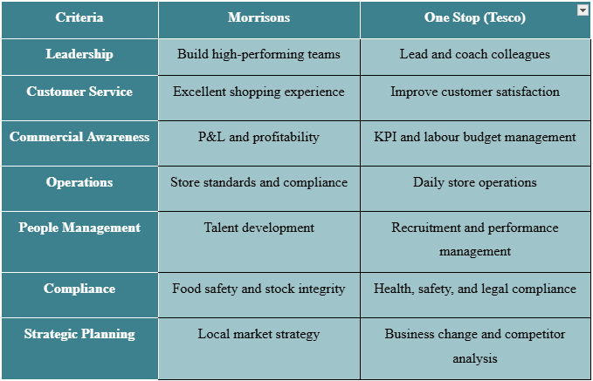
Table 1: Comparison of Two Job Advertisements

Task 2

Self-Assessment
SWOT analysis can be a useful instrument to analyse personal strengths and weaknesses and recognise the areas for lifelong learning.
Being highly experienced in the retail industry is one of my potential strengths. I started working at Sainsbury in 2015. Since that time, I have been promoted to a leadership position, where I collaborate with daily store operations, supervise other employees, ensure proper customer service, and help to meet the operational objectives of the company. Before this, I served in the hospitality sector in the Pride of Asia, where I had been promoted to the position of Restaurant Supervisor due to my commitment, leadership qualities and skills to enhance the quality of services delivered. These have reinforced my ‘problem-solving’, ‘communication’, ‘teamwork’ and ‘decision-making’ skills, which are highly demanded in both job advertisements (Meneses-La-Riva et al., 2025). I have successfully achieved a ‘BA (Hons) degree’ in Business and Management, which has strengthened my knowledge of the aspects of leadership and organisational behaviour.
Despite all these strengths, I see some more areas to develop further. The Morrisons advertisement puts great focus on full ‘profit and loss (P&L) accountability’, whereas the One Stop places emphasis on strategic ‘workforce planning’, dealing with multifaceted employee relations. Though I have been helping with operational performance and team management, I have not been assigned full responsibility for the financial management of the store at large or official cases about employee relations. The competencies that I will develop enhance my preparedness to become a Store Manager.
Various opportunities can be used to contribute to my professional development. The position that I currently have at Sainsbury gives me chances to collaborate with good managers, attend leadership training programs, and be exposed to the field of commercial decision-making (Aktaş, 2026). My background in business education and my desire to learn would enable me to take in additional professional training in retail leadership, financial management and people management.
Nevertheless, retail is a highly competitive sector in which the demands on commercial performance, digital transformation, and leadership ability are growing. There might be challenges from competition with qualified applicants who are more exposed to strategic management. For these threats, I will keep improving my leadership aptitudes, expand my commercial knowledge and pursue other management roles (Khoshnaw and Karadas, 2025). Therefore, I have a good base of professional development and understanding of the requirements to explore further and focus on new learning and knowledge.
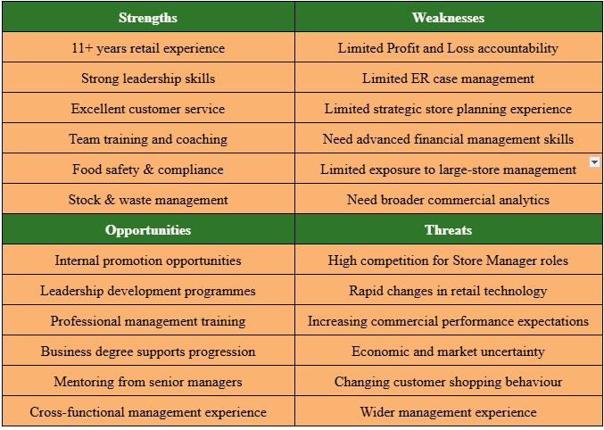
Table 2: Personal SWOT analysis

Evidence of Readiness
My educational background, work experience and personal growth evidence that I am well equipped to work in the retail management field. The competencies listed in the Morrisons and One Stop (Tesco) store manager jobs advert are what I have gained during both my studies and work process.
The work experience I have gained in the retail and hospitality sectors exceeds ten years of professional experience. As a new employee of Sainsbury since 2015, I have acquired hands-on skills related to customer service, managing a team, and operational effectiveness, managing stock, and ensuring adherence to company policies and food safety regulations. I have further developed my ‘coping skills’, adjusted to ‘constantly shifting’ business demands and cooperative skills with fellow workers working in a high-pressure retail setting (Sjöberg, 2025). I have also assisted during busy times and supported keeping high standards of service experience, which increased my leadership experience.
I joined Sainsbury after having worked in Pride of Asia, where I was able to work in the company as an entry-level worker for eighteen months as a Restaurant Supervisor. This indicated my high work ethic, my desire to always improve and my capacity to lead and influence other people. In this position, I implemented better ‘staff training protocols’, minimised ‘food waste’ by managing the stock better and efficiently addressed the concerns of the customers (Montesdeoca-Calderón et al., 2023). I can provide operational enhancements and manage teams effectively.
The completion of a BA (Hons) Business and Management course has provided a framework of ‘leadership’, ‘human resource management’, ‘strategic planning’, and ‘organisational behaviour’. Moreover, I have excellent digital skills, such as being knowledgeable in ‘Microsoft Word’, ‘PowerPoint’, ‘Excel’, and ‘Outlook’. This facilitates effective communication, reporting, and management of operations. The academic work increases my practical experience and enables me to make informed management decisions.
Outside the formal level, my curiosity in travelling, music, and outdoor activities has led to ‘resilience’, ‘communication’, ‘adaptability’, and ‘teamwork’. In addition, good career growth and growing responsibilities within me show confidence in my performance and leadership capacity (Junaini and Rizky, 2024). All these experiences show that I am knowledgeable, skilled, and possess a professional attitude to be employable and further my career progression towards fulfilling my long-term goal of becoming a successful Store Manager in the UK retailing business.

Task 3

Set Employment Goals
According to my SWOT analysis, my short-term employment objective is to enhance my understanding of financial management, employee relationships, and store strategic planning. Despite a broad range of experience developing organisation and operations at Sainsbury, I find that I need to acquire knowledge in areas like managing profit and loss (P&L), human resource management and dealing with official cases in employee relations (Chali and Lakatos, 2024). My career objective is to work to the position of a successful Store Manager in one of the top retail companies in the UK. I will be able to guide high-achieving teams, boost commercial success, and provide high-quality customer care. These are significant objectives in the field of Business and Management, including my work experience in a retail management role and my aspiration to advance to senior management with a positive contribution to the success of the organisation.
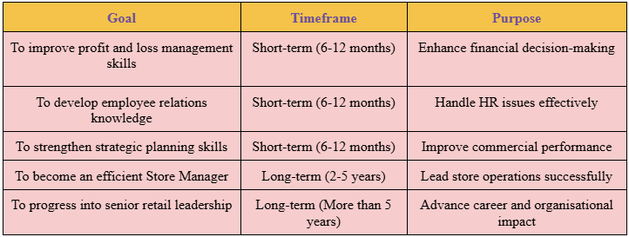
Table 3: Employment Goals

Develop a Personal Development Plan
To overcome the weaknesses that I have found in my SWOT analysis, I will engage in several developmental activities within the next 12 months. I will use three months to find the help of seasoned Store Managers who can help me develop my commercial decision-making and employee relations knowledge. In the next six months, I will be involved in internal leadership and financial management training provided by my employer, and become more engaged in budgeting, performance analysis, and workforce planning processes (Micheli et al., 2023). Professional reading and online material on retail management will also enable me to further my learning. My development will be assessed by successful completion of training programmes, positive feedback from managers, performing more responsibilities in my current job and being able to manage managerial functions confidently. The actions will make me stronger in the leadership aspect and will enable me to be promoted one day to Store Manager.
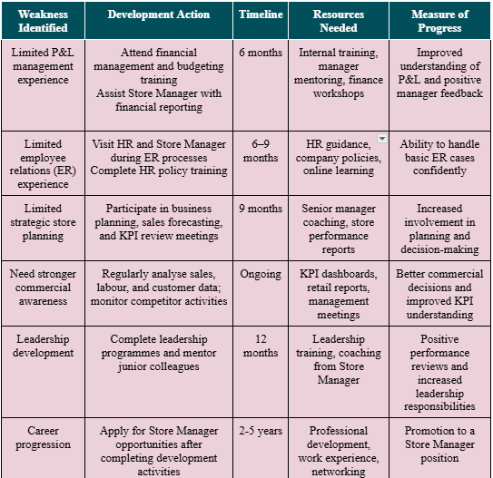
Table 4: Personal Development Plan

Reference list
Aktaş, B.N. (2026). Collaborative Leadership and Employee Perception in Decision-Making: The Meditating Role of Team Excellence. İş ve İnsan Dergisi, 13(1). Available at: https://doi.org/10.18394/iid.1854239 [Accessed 30 July 2026].
Chali, B.D. and Lakatos, V. (2024). The impact of human resource management on financial performance: A systematic review in cooperative enterprises. Journal of risk and financial management, [online] 17(10), pp.439–439. Available at: https://www.mdpi.com/1911-8074/17/10/439 [Accessed 30 July 2026].
Jain, D. (2025). The Role of Leadership in Enhancing Employee Motivation and Engagement. ResearchGate. Available at: https://www.researchgate.net/publication/389692718_THE_ROLE_OF_LEADERSHIP_IN_ENHANCING_EMPLOYEE_MOTIVATION_AND_ENGAGEMENT [Accessed 30 July 2026].
Junaini, N. and Rizky, M.C. (2024). The influence of leadership style, career development and competence on employee performance by job satisfaction as an intervening variable at Pt Angkasa Pura Aviasi Bandara Kualanamu International. International Journal of Science and Research Archive, 13(2), pp.3670–3684. Available at: https://ijsra.net/content/influence-leadership-style-career-development-and-competence-employee-performance-job [Accessed 30 July 2026].
Khoshnaw, D. and Karadas, G. (2025). Enhancing knowledge sharing through transactional leadership in an emerging economy: The strategic role of human capital. Sustainability, 17(12), pp.5572–5572. Available at: https://www.mdpi.com/2071-1050/17/12/5572 [Accessed 30 July 2026].
LinkedIn (2026a). Morrisons hiring store manager - Ipswich area in Hadleigh, England, United Kingdom | LinkedIn. LinkedIn. Available at: https://www.linkedin.com/jobs/view/store-manager-ipswich-area-at-morrisons-4444134195/ [Accessed 30 July 2026a].

