University of Wales Trinity Saint David
Wales Institute of Science & Art


Optimum Lap Report
Module Code (ACHA4035)

Hassan Khan
2502126
12 / 2025

Contents
1 Introduction 3
2 Methodology 3
3 Setup Changes and Rationale 4
3.1 Silverstone 4
3.2 Monaco 8
3.3 Le Mans 11
4 Conclusion 14
5 References 14

Introduction
This report evaluates optimal prototype setups for Silverstone, Monaco, and Le Mans using Optimum Lap simulation software. The goal is to achieve the fastest lap times within a 150-credit limit by adjusting five parameters: Mass, Aero Map, Tyres, Engine Map, and Drive Efficiency. Trade-offs between straight-line speed and cornering stability are analysed for each circuit.

Methodology
Data was collected by systematically testing one parameter at a time across multiple prototypes. Each test isolated a single variable to measure its impact on lap time. Results were organized in spreadsheets and visualized using speed-distance and lateral acceleration graphs. Theoretical no-credit setups were also simulated to establish performance ceilings.

Setup Changes and Rationale

Silverstone
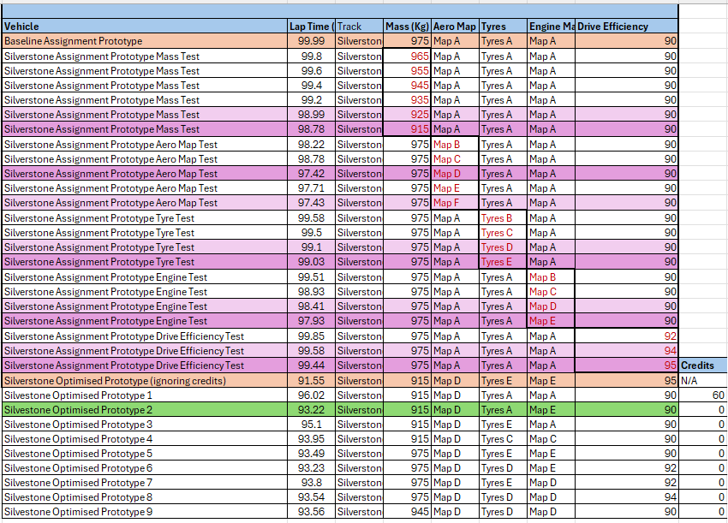
This is the data for Silverstone.

Here is a graph that shows us two vehicles with differing downforce levels on Silvers
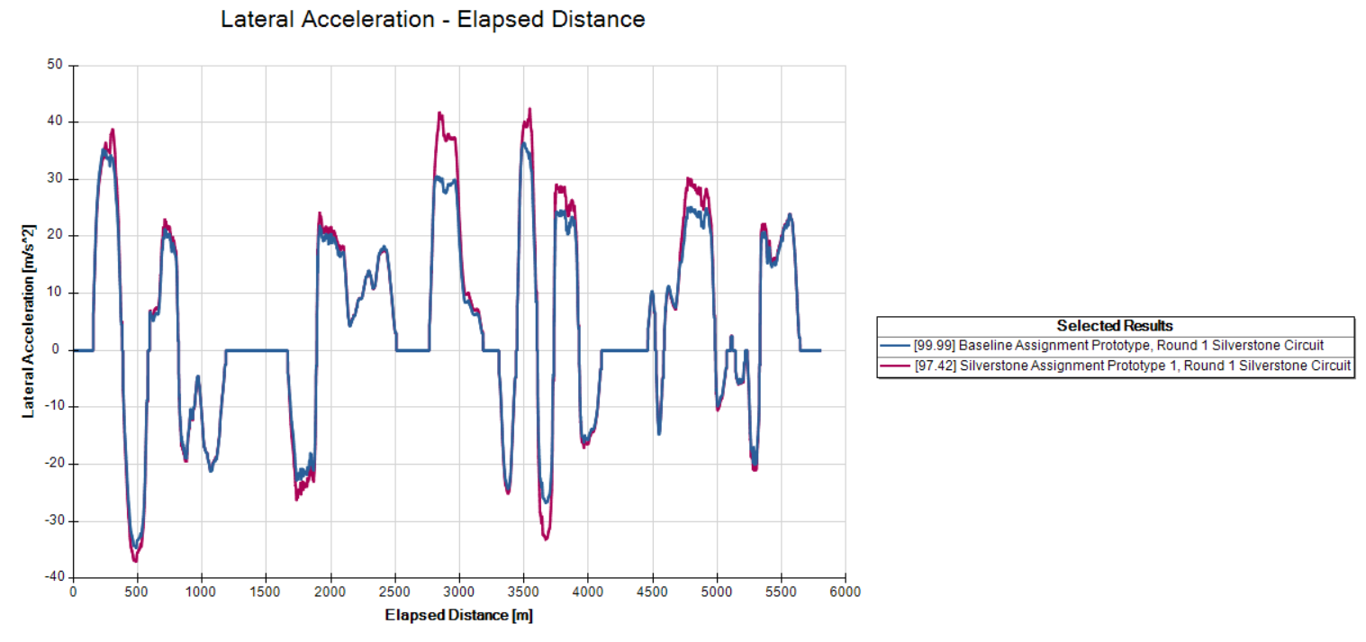
The blue line is the baseline vehicle, and the magenta line is the high downforce test using Map D. This graph shows us how the lateral acceleration has increased with more downforce on the car; this means we are pulling more speed in corners – resulting in faster lap times. The test vehicle is 2.57 seconds faster than the baseline.
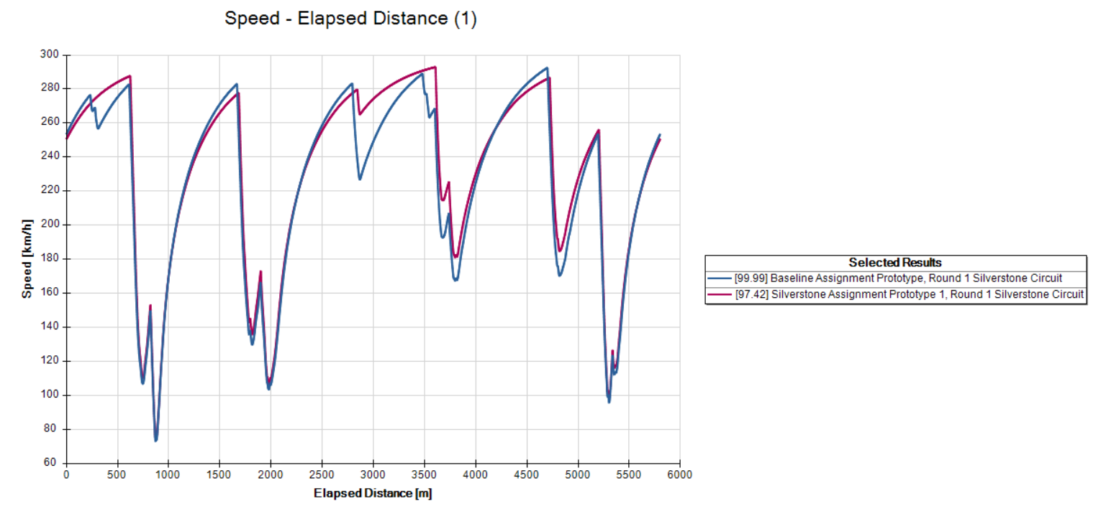
As you can see in the speed – distance graph, our top speed has decreased in the straight sections of the track, as map D has more drag than map A which the baseline car is using. The car makes it up however, with superior cornering speed as seen at the three thousand metre mark. Below is a map of the track.
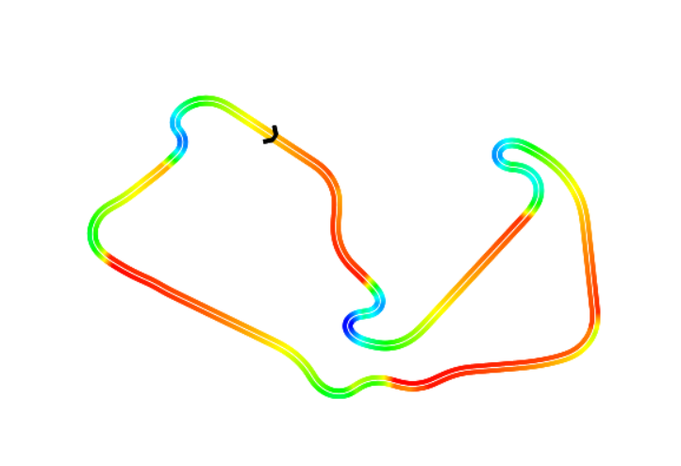
This entire section is from Cotes to Maggots and Becketts. (The portion of the track between A and B).
The inner line data is the vehicle with Aero Map D, and the outside line is the baseline vehicle. The high downforce cars medium speed cornering is better than the baseline. Hence why I decided to follow through and use Map D for the optimised setup.
For the last four values (Mass, Engine, Tyres, and Drive efficiency) higher is better – as they are all linear values.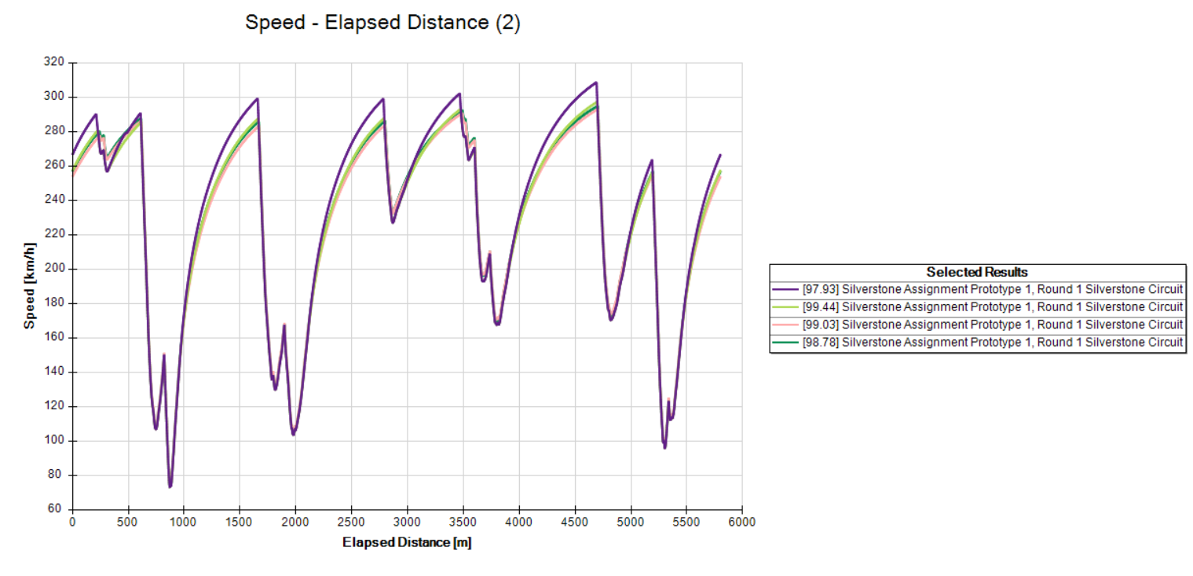
The purple line is the fastest lap for the engine map E, lime is drive efficiency, pink is tyre E, and turqoise is the mass 915. The fastest mass, tyre and drive efficiency data are all relatively close to each other, with mass being the fastest out of the three, however this is eclipsed by the engine and the gains we get from increasing its power. This allows us to reach faster speeds on the straights, and this car’s brakes are able to utilise it without compromising its braking zones.
A vehicle was produced with the data of the fastest lap with each parameter, regardless of credit cost. 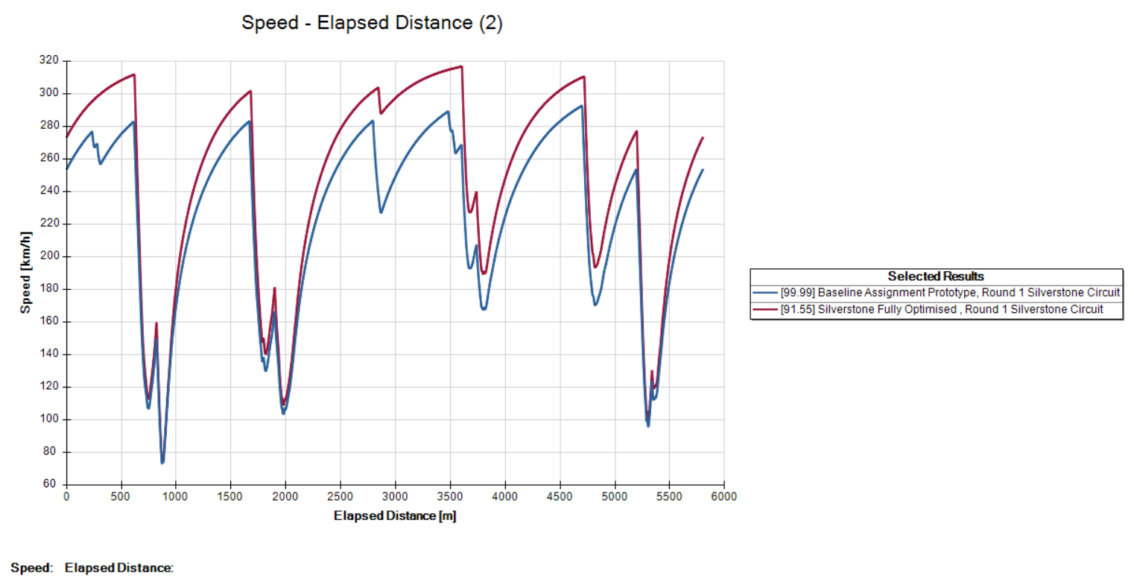
Now I know that my target is to get as close to 91.55 seconds as I can with the limitations of the credits. I made nine prototypes with two ideas in mind. 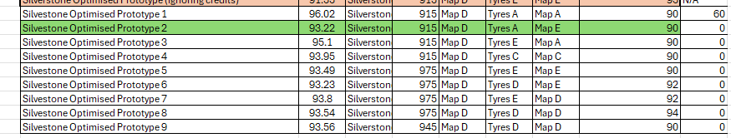
All nine prototypes used Aero Map D and prototypes one - four were all using the lowest mass possible with the highest Engine Map. From five to nine, I changed philosophy and focused on the tyres instead of the mass, and used any remaining credits on drive efficiency. With this, I managed to get two fast lap times, 93.22 seconds for prototype two and 93.23 seconds for prototype six. Prototype two was consistent with all the data I had previously looked at, it had the lowest mass, optimal aero and highest engine map. Prototype six had the highest mass and used the credit savings to upgrade to tyres D and an extra two percent in drive efficiency.

Monaco
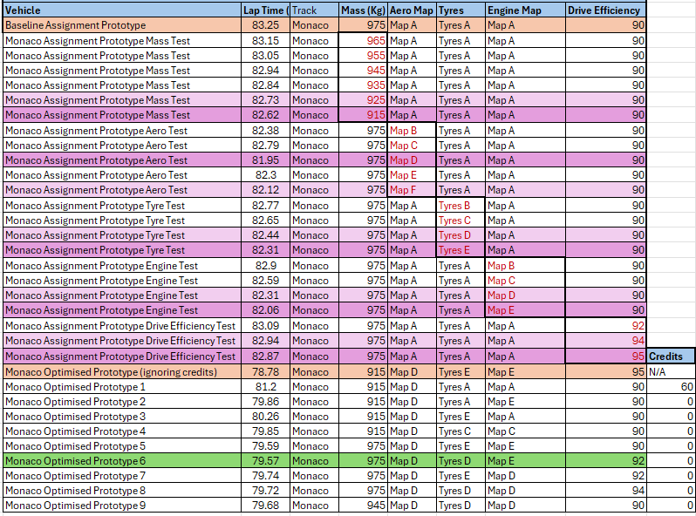
This is the data table for Monaco. 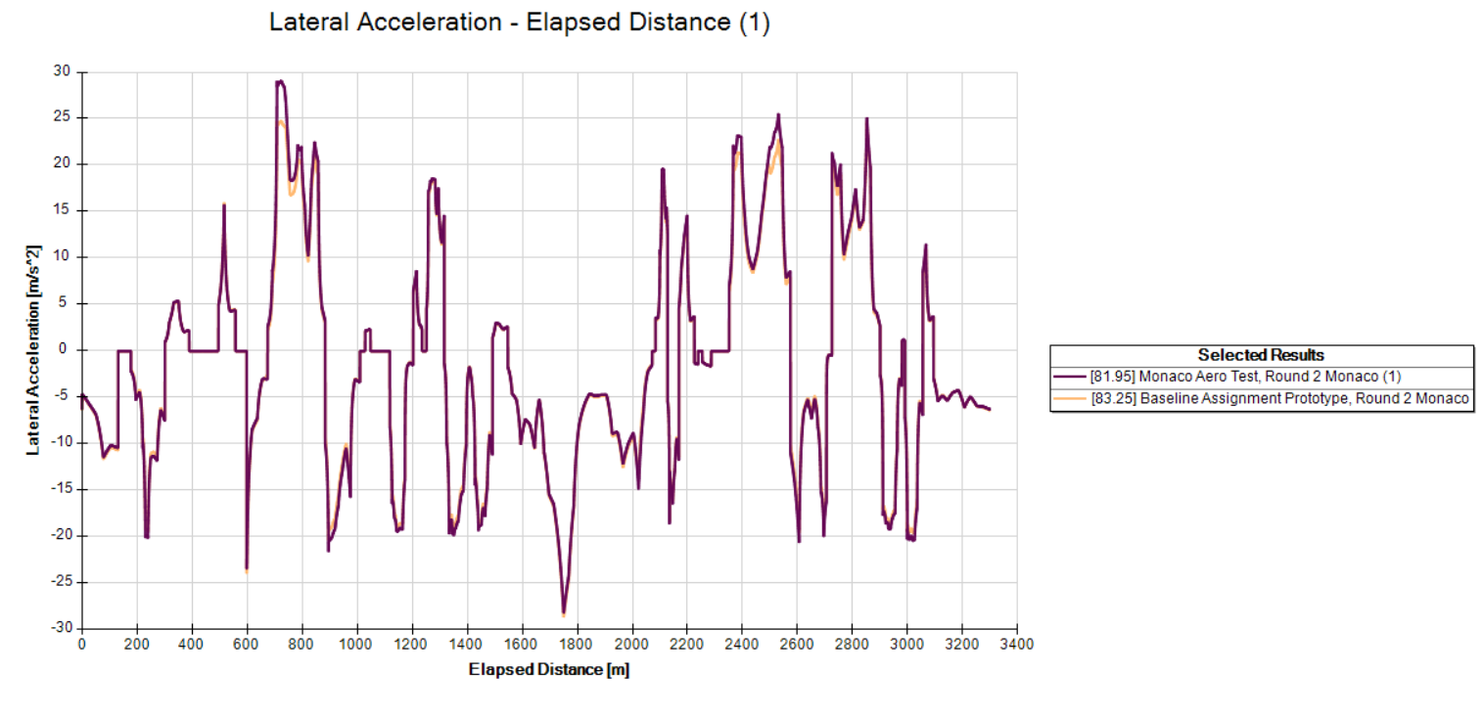
Here we can see that the lateral acceleration from the Aero Test vehicle on map D (high downforce) and the Baseline vehicle on map A (low downforce). Similarly to silverstone we have improvements in lateral acceleration, mainly around the medium speed corner coming up into the casino. Due to Monaco having such tight corners and small straights, the losses due to drag aren’t as severe as they are in Silverstone. 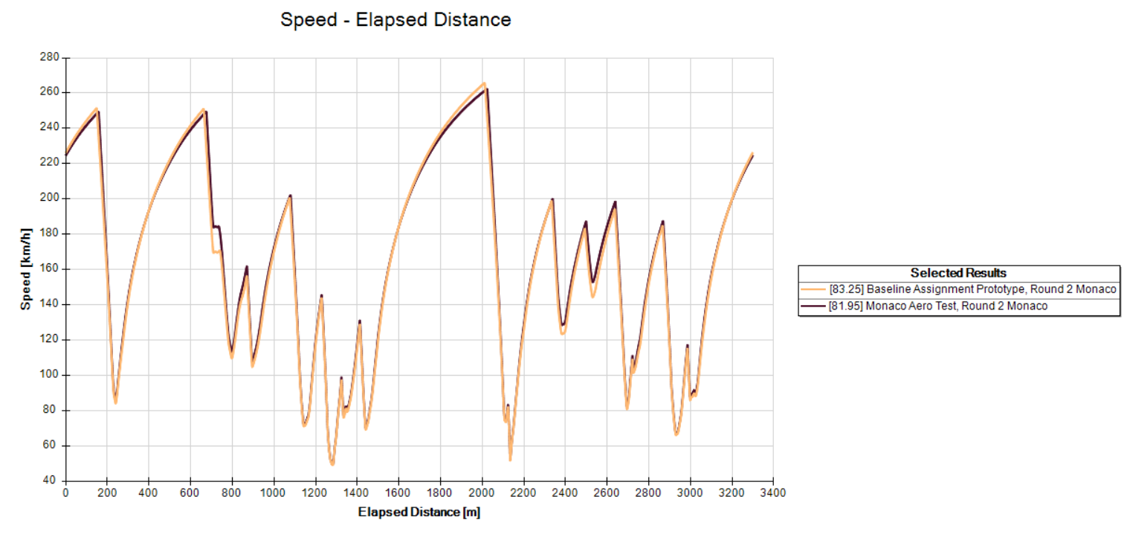
The high downforce vehicle only loses time in the starting straight, and the casino straight. We have smaller more consistent gains across all the chicanes of the track, especially the corner before the casino straight and the pool section. This results in savings of 1.3 seconds over the Baseline.
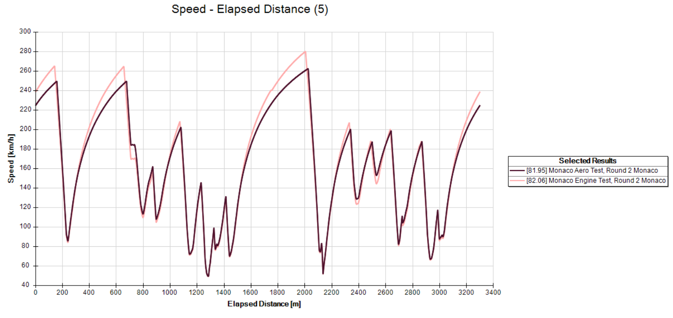
Here we can see aero map D against engine map E. While Engine map E has much faster speeds on the straights, the car doesent have enough downforce to make the apex’s of the corners. This results in the aero focused car being consistently 3-4 km/h faster in the apex’s than the engine focused car. Even though the engine focused vehicle is 20km/h faster on the straights, the losses are too much – resulting in aero map D being a tenth faster. These two parameters will be the baseline of our final car.
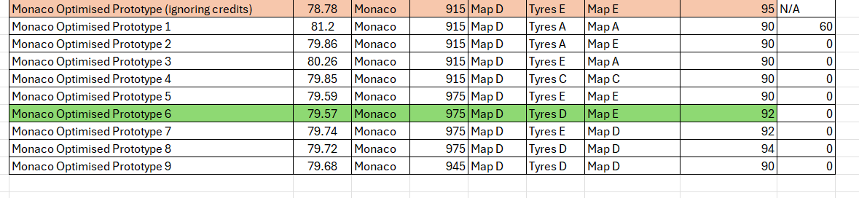
These final prototypes for Monaco all prioritise aero map D and focus on getting the highest engine map possible. Prototypes one through four were all focused on mass and downforce, however the struggle of getting a strong engine map without compromising the mechanical grip was reflected in the results. Hence I kept the mass at its stock value and that enabled me to focus more on the tyres and drive efficiency, getting within a second and a half of the baseline test. This culminated in prototype six’s laptime of 79.57 seconds. 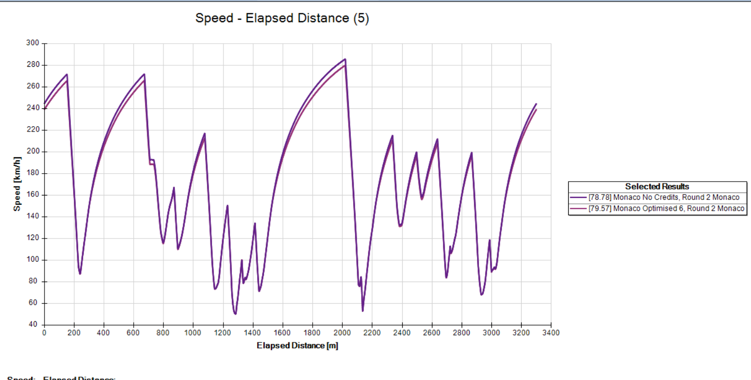
The main loss against the no credit car was the top speed, this is due to the car having much less mass than the optimised one.

Le Mans
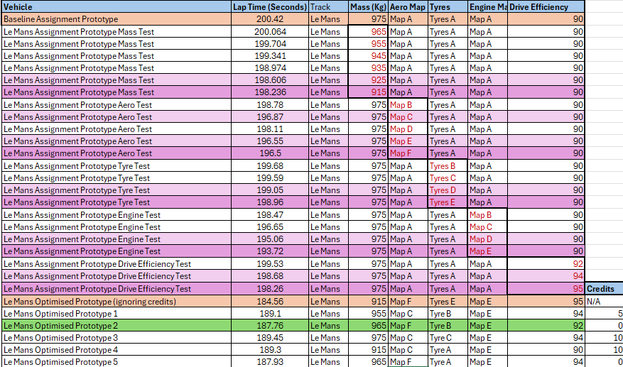
Le Mans places unique demands on the prototype: very long straights culminating in hard braking into the chicanes.
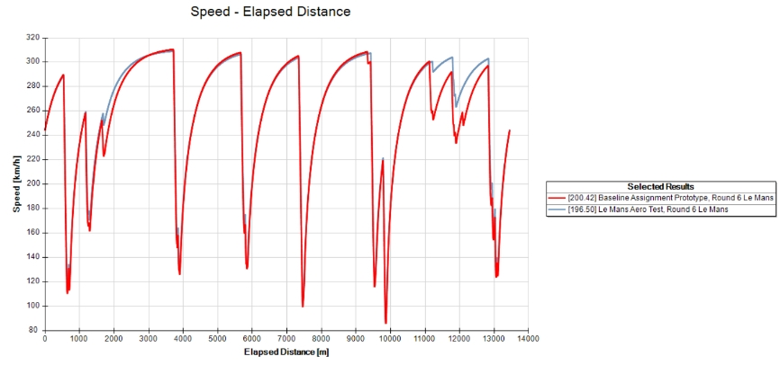
Compared to the baseline (Map A), the efficient downforce Aero Map F reduces lap time by 3.9 s. The gains are concentrated in medium/high‑speed sections and corner exits.
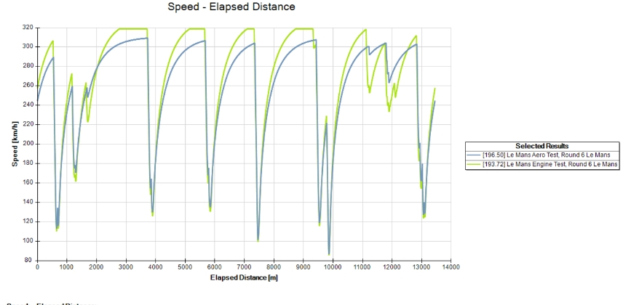
Directly contrasting Aero F with Engine E highlights the long‑straight advantage of power over downforce at Le Mans: Engine Map E is quicker due to higher terminal velocities and shorter time between chicanes, while Aero F is better at cornering but cannot offset the straight‑line deficit. The optimal engine is 2.78 seconds faster than the optimal aero.
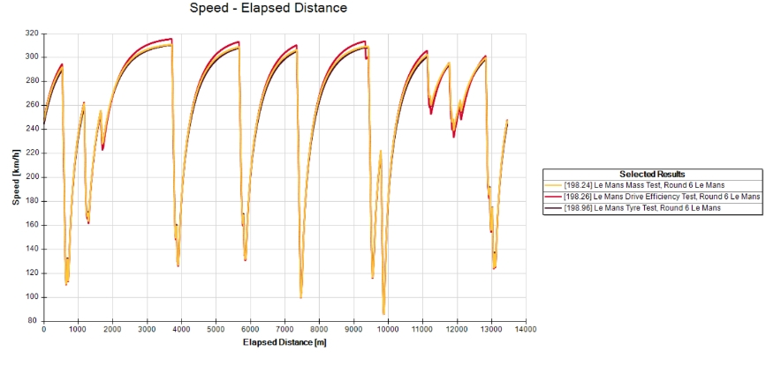
Mass, tyres, and drive efficiency produce relatively modest improvements versus aero/engine changes. The best mass run is barely ahead of drive efficiency, with tyres providing the smallest gain. This establishes a clear hierarchy for credit spend at Le Mans: engine first, aero second, then small optimisations in mass/DE/tyres.
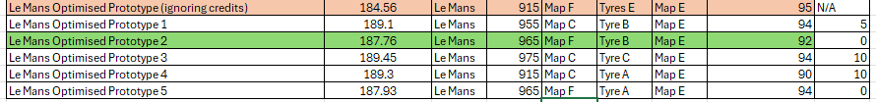
Here we can see that the optimised prototype 2 car focuses on Aero and Engine power. We keep the efficient aero map F, with its low drag and relatively high downforce and the maximum power of engine map E. The optimised car also is the only prototype which was able to fully utilise its credits and have the fastest lap time at 187.76 seconds.
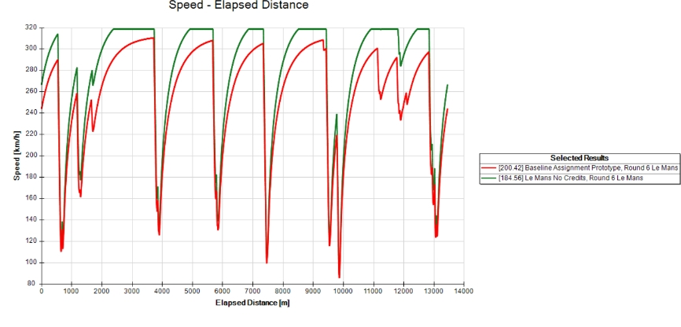
The no‑credit car demonstrates the theoretical ceiling. The graph shows substantial gains on every straight and more stable high‑speed cornering, compressing overall lap time by 15.86 s versus baseline.
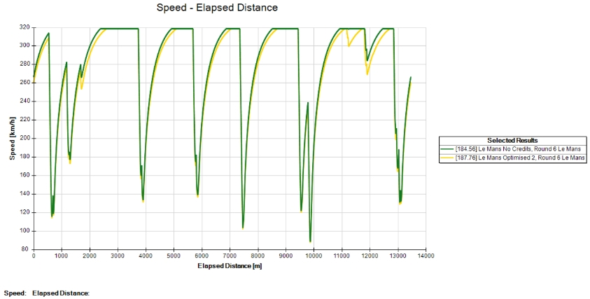 Optimised 2 trails the “no credit car” primarily at the points of highest speed; however, the speed‑distance overlay indicates very similar exit profiles from key corners, confirming that our compromises were sufficient. We only lose only 3.2 seconds to the theoretical limit. Which in comparison to the length of the track isn’t too far.

Conclusion
Each circuit has their own unique traits to cater to. Le Mans with its high speed straights, Silverstone and its fast-flowing corners and Monaco’s slow speed chicanes. Silverstone and Monaco benefit from high downforce setups the most, while Le Mans prioritises engine power due to its aforementioned straights. Overall, the trend showed that aero and power setups dominated the three tracks, with them being the most influential parts to change on the prototypes. Mass played a key role; however, it wasn’t essential as shown in Monaco. Tyres and drive efficiency offered consistently minor improvements, incentivising use only when allowed by the remaining credits supply. Having the baseline “no credit” vehicle was essential for me to be able to understand the limits of these prototypes and to not chase false gains.

References
- OptimumG (2025) OptimumLap [Computer program]. Available at: https://optimumg.com/product/optimumlap/ (Accessed: 12 December 2025)

