D. Stevens
Minibuses

Project Initiation Document (PID)
Project Consultant: Emily McDonagh
Module: Consultancy Project
Level: 6
Submission Date: 18th March 2019
Lecturer: Michael Davies

Contents Page
Contents
Contents Page 2
1.Project Justification 3
1.1 Background 3
1.2 Project Aim 3
1.3 Project Objectives 3
1.4 Rationale 3
1.5 Project Scope and Exclusions 3
1.6 Project Constrains and Assumptions 4
1.7 Project Team 4
2. Project Case and Approach 4
2.1 Potential Project Costs 4
2.2 Potential Benefits and Outcomes 4
3. Project Management and Team Structure 5
3.1 The Structure 5
3.2 Project Organisational Structure 5
3.3 Project Communication Plan 6
4. Research Methodology 6
5. Project Timeline (Gantt Chart) 7
6. References 8

1.Project Justification

1.1 Background
D. Stevens is a company in the locality which is owned and maintained by a couple who live in the community. The business has been running for many years and has mostly specialised in school contracts. The company focuses on helping to delivery transport for children with disabilities back and forth school around the Blaenau Gwent area. The business began in 2000 with two mini buses. Since then, the company has expanded and now consists of 7 vehicles, but they aren’t all put to use on a daily basis. The company offer other facilities such as mini bus hire and airport transport however don’t seem to get much interest in this. Throughout school half terms and the summer months, the business tends to struggle.

1.2 Project Aim
The aim of this project is to critically evaluate the issues regarding why the business is struggling and come up with a solution to generate a better income.

1.3 Project Objectives
- To analyse the current practises of other similar companies.
- To review the business’ current marketing strategies.
- To make recommendations to the company with how to improve their promotional strategies and increase their public trade.

1.4 Rationale
Making a profit is usually the aim for most businesses. D. Stevens the mini bus company has a generous amount of local competition. The consultant believes that advertising other facilities for the company such as airport transfers, then this will become an advantage over the company’s competitors, resulting in a profit gain throughout half terms and the summer months when the company tends to struggle due to not having the local schools to rely on.

1.5 Project Scope and Exclusions
- The project will only entail market research, the analysis of data and the use of recommendations.
- The consultant and the University of Trinity Saint David will not be reliable for any financial outputs as part of the project.
- The consultant will report back to the company on a weekly basis through emails and face to face visits.
- Any research into the company’s competitors will take place around the local area of Blaenau Gwent.
- The overall report will demonstrate an understanding of how the business could improve its marketing techniques and strategies. However, any amount of money that will be spent on this will be finalised by the managers decision.

1.6 Project Constrains and Assumptions

One major constraint of the completion of the task is time. There are many sections to the report that need to be completed by the hand in date. In order to keep up to date, the researcher will undertake weekly reviews to ensure that each portion of the report is under control.
Findings from any surveys and questionnaires could be a potential constraint. The researcher could gather a lack of responses due to members of the public not having the time of day. Hence why the consultant will conduct face to face questionnaires and interviews, as well as publishing them online over social media sites so get the best response possible.
Often, participants tend to not answer questions fully or instead answer them falsely. Due to this, the researcher may need to conduct further research and ask follow up questions to ensure they have the correct research.
The consultant assumes that the business owners will have time for a face to face talk every week, when actually they are very busy people, so communication may have to be done through a messaging service instead.

1.7 Project Team
The consultant will work alone to conduct research for the business and then apply the research to the final report. The consultant has a keen interest in the travel sector of the tourism industry, therefore knows exactly what they want to find out. Gathering research regarding the company’s competitors will be easy due to the researcher living in the locality.

2. Project Case and Approach

2.1 Potential Project Costs
Potentially the project will require very little financially. Due to the consultant volunteering to help out a local business. Currently it isn’t possible to give any exact costs at this stage, but the figure will be minimal. Any costs that arise will not be funded by the consultant or the University of Trinity Saint David, but instead will be paid by the business, D.Stevens.

2.2 Potential Benefits and Outcomes
The main benefit of the research will be an improved advertisement strategy for the business. This will benefit the company by increasing the number of customers and improving the customer relations. The customers will feel valued and listened to as a result of the surveys and questionnaires they have taken part in. If the consultants research is correct and helps to gain the business more custom, then the business will benefit money wise and have an increased revenue.

3. Project Management and Team Structure

3.1 The Structure

For any project to be successful it’s important for there to be a team structure in place, so that each individual knows their role and responsibilities allowing the project to run smoothly. The business owner understands that the consultant is undertaking the project and completing specific research alone. The owner doesn’t need to be involved in every aspect of the project, but due to the plan, there business owner will need to be available so that the consultant has access to needed information.
D.Stevens has a small number of employees including bus drivers and escorts. These employees will have very little input within the project. The business owner David, and his partner Paula will be involved with the project alongside the consultant.
Overall, the consultant, Emily McDonagh, will coordinate the project, and well plan and manage it. The consultant will be responsible for gathering the required research and undertaking all sections of the project.

3.2 Project Organisational Structure

The business owner has authority over the business, making any final decisions regarding the staff employed. Throughout the project, the consultant will be in control of all aspects and things utilised. The consultant holds the responsibility for all project assignments throughout the task, but will work very closely with the business owner and his partner in order to achieve things to a high standard.

3.3 Project Communication Plan
According to Blundell, et al (2008), communication is a very important aspect of many areas of a business. Communication is a necessity to ensure that stakeholders are reassured that thins are being done; creative and innocative strategies are being devised; and that overall project is on time.
The consultant will be responsible for using effective communication strategies throughout the project in order to keep the business owner informed with what’s happening on a regular basis. Less formal methods of communication are likely to take place between the consultant and the business owner. These methods include chatting face to face and being able to discuss the project and new ideas with one another. Phone calls will be used to communicate when information is required more urgently. Also, there will be emails sent on a weekly basis so that the consultant can visually show the business owner any progress that has been made, allowing the owner to provide feedback they feel could be useful.

4. Research Methodology
According to Bryman (2008), in order for research to be reliable it is important that both qualitative and quantitative research takes places. He suggests that various strengths of both methods of research can be capitalised upon whilst the weaknesses are somewhat offset. Supporting this, a mixture of primary and secondary research should be used so that the research is as reliable as possible.
The consultant believes that this study will be best used with the mixed methods approach. Meaning a mixture of qualitative and quantitative research will take place throughout the project. The quantitative research that will take place will mostly be carefully considered customer surveys and questionnaires. As stated previously, this will be via online social media sites as well as face to face in order to achieve answers from a wide range of people. This will allow the consultant to achieve an overview of what is wanted from the public and whether there is a gap in the market for it.
The researcher will conduct a number of interviews with people in the locality, as well as with the business owners. This will enable the consultant to gather some qualitative data and form hard facts and statistics to help the management with future decisions.
The latter is a combination of primary research, as well as this the consultant will conduct some secondary research as this is a cost-effective way of gathering information that is already on the market. The consultant will look closely at research which has already been undertaken, whilst baring in mind that it may not be as accurate or as useful as the primary research they have gathered.

5. Project Timeline (Gantt Chart)
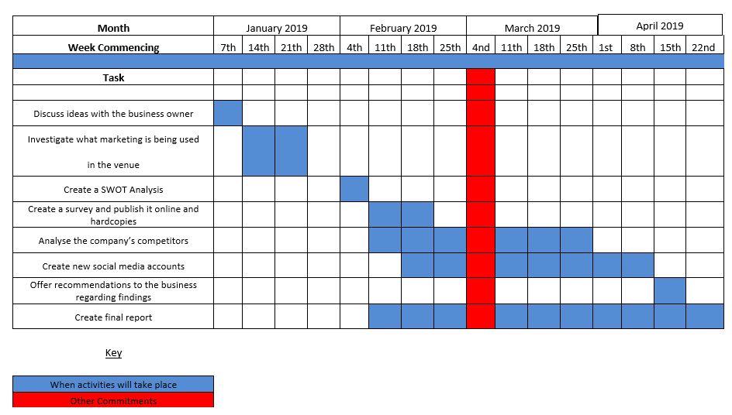

6. References

APM. (2018). What is Project Management?. Available: http://www.apm.org.uk/WhatIsPM. Last accessed 12th March 2019.

Blundell R and Ippolito K Effective organisational communication perspectives, principles and practices [Book]. - Harlow : Pearson Education Limited, 2008. - 3rd Edition.

Bryman A Social Research Methods [Book]. - Oxford : Oxford University Press, 2008. - 3rd Edition : p. p603.

Survey Monkey Create Online Surveys for Free [Online] // Survey Monkey. Available: https://www.surveymonkey.com/survey-closed/ Last accessed 15th March 2019.

