Research Report: From Assessment to Intervention: The Occupational Therapy Assistant Practitioner’s Contribution to the management of Postural Hypotension: A Case Study in A&E.

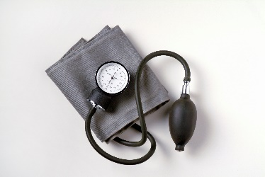
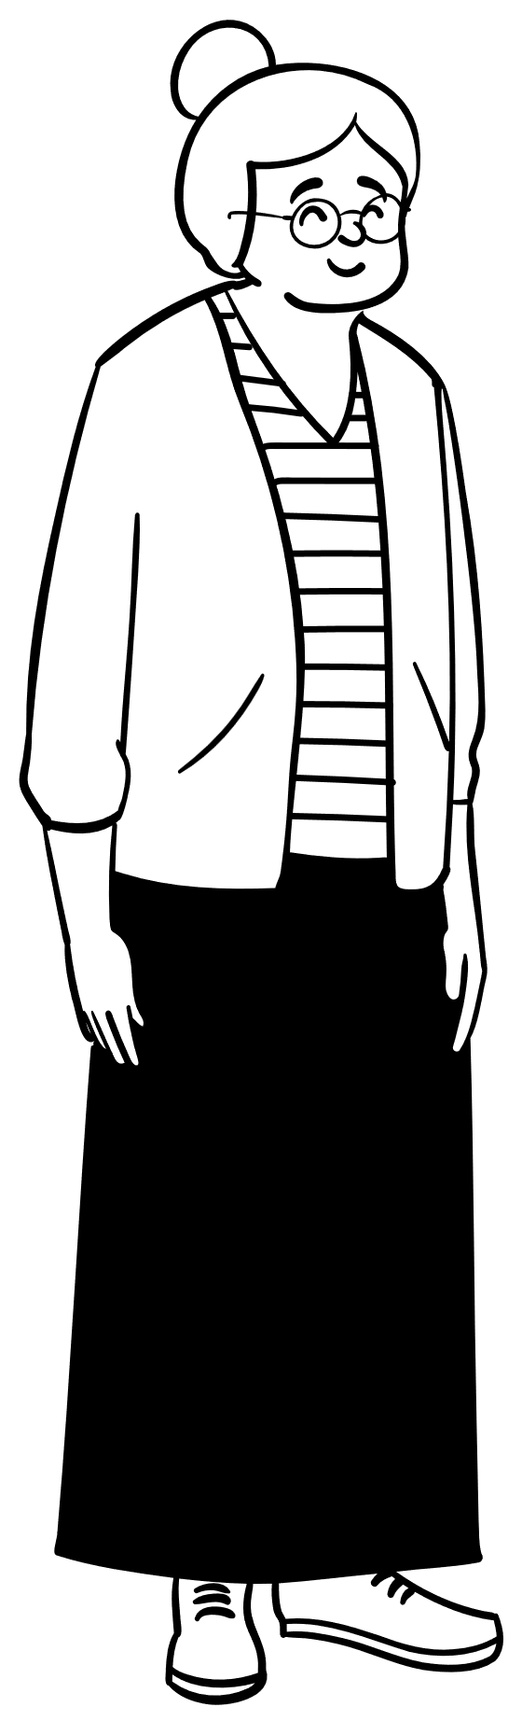

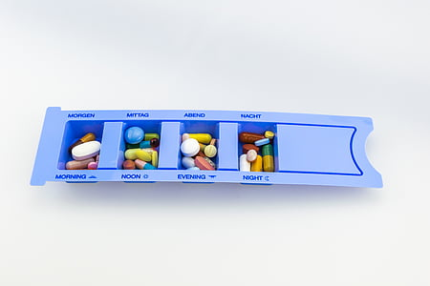



2316489
Sian Morgan
Contents Page.
Page 1. and 2., - Contents page.
Page 3. - Introduction and Case study.
Page 4. - Overview of postural hypotension.
Page 5. - Approaches in management of postural hypotension and Previous and Current therapeutic approaches.
Page 6. - Factors influencing the occupational therapy assistant practitioner’s clinical reasoning.
Page 7. - Co-production.
Clinical governance and supervision relevant to the role of the occupational therapy assistant practitioner.
Page 8. - Conclusion.
Page 9. - Recommendations.
Page 10.- Appendix 1. Reference critique table.
Page 11 – Appendix 2. Diagrams of interest relating to PH management.
Page 12.,13.,14. and 15. - Reference list.

Introduction
This research report will focus on the condition postural hypotension (PH) and the role of the occupational therapy assistant practitioner (OTAP) within the Accident and Emergency (A&E) department. The research report will present a case study of an older patient pseudonymously named Mary, who suffered recurrent falls and was subsequently diagnosed with PH. It will show the therapeutic interventions with the adoption of a holistic approach along with the collaborative and co-production efforts required to meet her complex needs. This research report contributes to the understanding of PH management and the fear of falling in the older person, highlighting the significant role that occupational therapy plays when improving patient outcomes. It also considers the factors that affect clinical reasoning and decision-making within the OTAP’s role, how evidence-based practice can be promoted, and ongoing professional development can be achieved. This research report draws on pertinent studies that are cited and included in the reference list. The following headed sections will provide an overview of PH, discuss management methods, review past and current therapeutic strategies, and consider the clinical governance and supervision framework finally concluding with future recommendations for improving OTAP practice via comprehensive management strategies, ongoing education as well as compliance with health care policies relevant to their role.

Case study
This case study will look at the role of an OTAP within the acute front door occupational therapy service based in the A&E department following receipt of a referral for a medically fit patient who requires initial and functional assessment with provision of interventions to facilitate safe discharge. The case study will focus on a patient who was referred to the service after a fall. To ensure confidentiality, the case example will be given the pseudonym Mary. Mary is an 87-year-old lady who lives alone in a bungalow she presented accompanied by her daughter to A&E with a seven-day history of experiencing dizzy spells which have resulted in several falls the last fall resulted in a head injury where bruising and a lump on the back of her head was evident. Mary cannot recollect how she has ended up on the floor. Nice, (2023), guidelines recommend that a person who is age 65 or over with loss of consciousness or amnesia following a head injury should undergo an X-ray image Computed Tomography (CT). Mary didn’t sustain any bony injuries and her CT head scan result was nil acute. Xu et al., (2022), proposes that falls without causing harm are attributed with negative consequences, such as stress, depression, and reduced mobility. A review of Mary's medical records revealed no previous mentions of falls or balance issues, and she had no significant neurological background, however Mary was taking a lot of medication which included furosemide (a diuretic) which had not been reviewed for several years. Mary was diagnosed with postural hypotension (PH) as the reason to why she had been falling. Mary underwent a polypharmacy review before being considered medically fit for discharge. The review pinpointed the underlying cause of her PH diagnosis. Rivasi et al., (2020), put forward that the assessment and treatment of PH are crucial in-patient healthcare and prognosis and furthermore add that medication treatment is a frequent cause of PH, medications that pose the greatest risk of PH encompass cardiovascular medications like diuretics, as well as non-cardiovascular medications including antidepressants. When collateral history was gathered from Mary, she expressed before the recent falls she had remained independent with most activities of daily living and was independently mobile within her home environment. Mary states she has some support from her daughter for domestic tasks and shopping and had enjoyed regular weekly outings using her four wheeled walker to mobilise outdoors with friends and family. However, the last seven days reports she doesn’t feel safe to go out, she has remained at home. Mary reports she is low in confidence and is very fearful of further falls. The negative effects that fear of falling has on an individual's life are highlighted by Baltes et al., (2022), linking them to psychological, social, and physical consequences.

Overview of Postural Hypotension.
PH defined by Ringer and Lappin, (2020), “is a drop in blood pressure (20 mm Hg systolic and/or 10 mm Hg diastolic) that occurs within 3 minutes of standing from a lying or sitting position”. Symptoms listed by the Cleveland Clinic, (2020), include light-headedness or fainting. PH increases the risk of falling, cardiovascular disease, depression, dementia, and mortality, according to Gilani et al., (2021). In 2022, Bhanu et al., examined the incidence of PH between 2008 and 2018. The source population consisted of all patients over 50 who were registered with a GP practice. The study made use of anonymised electronic primary care records that contained data on hospital admissions, out-patient clinics, clinician consultations, general practitioners, and nurses. These records involved over “18 million patients from over 700 practices, between 2008 and 2018, 24,973 out of 2,911,260”, of individuals that had a new diagnosis of PH. Chew et al., (2020), estimates the prevalence of PH in people over sixty may exceed 20%. This theory is supported by Ricci et al., (2015), who also show that the incidence rises to over 20% in individuals 75 years of age and older. Based on the intensity of their symptoms, Ricci et al. argue that a better understanding of PH can lead to accurate diagnosis and better patient care. Fall recurrence is 2.5 times more common in older adults with PH than in those without the condition. Furthermore, PH has been found to be independently associated with increased mortality rates. These mortality rates are associated with dementia, cognitive decline, and detrimental effects on wellbeing and cognitive function, as well as the associated medical expenses of necessary care. According to Bhanu et al., falls account for over £2.3 billion in annual NHS costs, which include social care and acute care needs.

Approaches in Management of Postural Hypotension
Mol et al., (2019), found a positive association between PH and falls in the older population. This indicates that orthostatic blood pressure testing holds clinical significance, and exploring treatments for PH may prove to be an effective approach for preventing falls. Similarly, Arik et al., (2020), reflected this by relating PH and fear of falling being two significant factors in the older adult that are closely related and additionally support the theory that the greater the severity of fear of falling, the stronger its association with PH, therefore, it is imperative to consider PH when evaluating an older adult with fear of falling and vice versa. A successful management of both conditions could lead to a reduction in common complications associated with each condition. Dani et al., (2021), validates the consensus that PH is a widespread, enduring, and debilitating condition commonly seen in everyday clinical practice. It severely compromises quality of life and causes swift and progressive deconditioning and functional decline.
Previous Therapeutic Approach.
Prior therapeutic approaches have assessed the home to find possible risks and make the required adjustments. A fall risk assessment of the surrounding environment and exercise regimens that promote strengthening, balancing, and better gait were part of this. These earlier programs were designed to increase physical fitness to reduce the risk of falls. Castro et al., (2021), draw attention to the fact that traditional therapies for fear of falling include progressive balance training in addition to physical therapy aimed at improving muscle strength and flexibility. These techniques target areas such as weak muscles and sluggish reaction times to lessen motor deficiencies that impair task performance. In contrary to this Honaker et al., (2006), state that older adults fear of falls can be reduced by using a multimodal approach that includes education, counselling, balance rehabilitation, and cooperative risk assessment. This comprehensive strategy significantly improves older adults' quality of life and successfully reduces their fear of falling. However, due to activity limitations and a fear of falling, Painter et al., (2012), found a link between depression, anxiety, and lower levels of activity. It is Painter et al., opinion that occupational therapy practitioners must assess elderly patients for anxiety, depression, and fear of falling because these conditions may raise their risk of falling and cause them to engage in fewer activities.
Current Therapeutic Approach
Occupational therapy assistant practitioners are key in addressing the fear of falling and its association with postural hypotension. OTAPs, provide essential support to older individuals who have a fear of falling. Under the supervision of occupational therapists, OTAPs implement safety-enhancing strategies and confidence-building measures. Linking with physiotherapists, they work to strengthen balance and gait, which are vital for stability. OTAPs also manage fall risk factors by evaluating home safety, and referring individuals to appropriate community services this also includes the use of behavioural therapy to lessen the psychological effects of fear of falling. Their holistic approach includes therapeutic assessments, personalised goal setting, and education on fall prevention, postural hypotension management and adaptive strategies. Leland et al., (2012), argue there is a gap in research on behavioural interventions for fear of falling and postural hypotension management, they note that while occupational therapy is part of fall prevention studies, evidence supporting its effectiveness is limited. This is supported by Wu et al., (2020), who observe that the fear of falling, a typical psychosocial response after a fall, is infrequently studied. They conducted a scoping review to identify strategies occupational therapists can use to reduce this fear in older adults. The review, which included thirteen electronic databases and 22 studies, found that cognitive behavioural therapy is effective in lessening the fear of falling, underscoring the significant role of occupational therapy. Additionally, Kiernan et al., (2022), found emerging evidence that falls prevention education for patients can decrease fall rates and related injuries, while also enhancing the knowledge and skills of the older adult supporting the theory that educational programs can be effective in lessening the fear of falling.
Factors influencing the OTAP’s clinical reasoning.
The OTAP supervised by an occupational therapist can integrate their expertise with patient-centred considerations to make well-informed clinical decisions that improve patient outcomes. An OTAP's experience and knowledge greatly influence their clinical reasoning, which is informed by an understanding of occupational therapy theories, principles, and evidence-based practices. As early as 1997, Lloyd-Smith, W. highlighted the advantages of an evidence-based practice approach, noting its contribution to patient care by merging research with practice, and fostering informed decision-making in patient care, management, and policy. Conversely, Shafaroodi et al., (2014), challenge that the clinical reasoning of occupational therapists is affected by more complex factors, which include patient knowledge and circumstances, therapist perspectives, and the workplace environment, each exerting a positive or negative influence on their clinical reasoning and decision-making processes. Reflecting on their clinical reasoning process through informal/formal meetings with their supervisor assists OTAPs in identifying areas for improvement and understanding the factors that influence their practice. Brannigan et al., (2009), advocate that reflective practice and evidence-based practice are fundamental to professional reasoning in occupational therapy. They assert that these practices, when combined, provide therapy practitioners with a comprehensive skill set that enhance their ability to creatively overcome challenges while providing services. Therefore, effective clinical decision-making relies on continuous learning and reflective practice adhering to the structures and policies of healthcare organisations.

Co-production
Co-production involves a joint effort between patients, their families, medical professionals, therapy professionals and any other services to deliver quality care with a person-centred approach. Within health research it involves collaboration among diverse groups, including patients, physicians, and researchers, working together to make decisions and share ideas, ensuring that the research benefits all parties and enhances its quality. McMullin, C., and Needham, C., (2018), champion the significance of co-production in healthcare, linking it to enhanced patient care and greater provider efficiency, yet, realising these benefits necessitates overcoming hurdles like organisational culture and professional resistance to co-production. Likewise, Williams et al., (2020), concurs and further suggests academics sometimes focus too much on technical details and forget the benefits of collaboration. Comparably Grindell et al., (2022), found that co-approaches do not have much evidence that they improve health therefore requiring more research. The co-approach with reference to the case study, was firstly, Mary’s diagnosis of the condition postural hypotension following geriatrician review which included a comprehensive geriatric assessment, concluded that a polypharmacy review was also necessary. Mary's medication prescriptions were reviewed by the A&E pharmacist and changes were made to best manage her condition. Mary's discharge planning depends on several variables which are dependent on a timely collaborative approach when working with other professionals to carry out interventions. Mary being at the forefront of her care decisions along with due regard taken for any concerns Mary’s daughter may have. It is the view of Wiig et al., (2013), that co-production requires patients to actively participate in identifying needs and problems in partnership when providing services. Treating Mary’s fear of falling can be supported by behaviour modification interventions which include education and condition management by providing targeted strategies via referrals to community services. Mary’s diagnosis meant she was at further risk of falling due to being at risk of further blood pressure drop when standing therefore this would require further review from her general practitioner. After completing the initial and functional assessments tailored to Mary's individual goals, interventions are implemented, along with follow-up referrals to community services. These include community therapy services and the National Exercise Referral Scheme, all aimed at supporting Mary to achieve optimum level of independence and functionality as well as providing education on self-management taking into consideration and addressing Mary’s low confidence and increased anxiety over fear of further falls.

Clinical Governance and Supervision Framework Relevant to the role of the OTAP.
Clinical governance is the mechanism through which National Health Service organisations ensure they provide excellent patient care. This framework promotes patient safety, continuous improvement, and accountability. According to the DFID Health Systems Resource Centre, (2001), effective clinical governance relies on the enthusiasm and support of committed clinical staff, as well as the leadership of clinical champions. The Public Health Wales Clinical Governance Framework, (2023), holds, “NHS organizations and their staff accountable for continually improving service and patient care”. In line with the Allied Health Professions' Support Worker Competency, Education, and Career Development Framework, (n.d.), the OTAP adopts competency-based approaches discussed during supervision, fostering self-reflection and appraisal meetings. The framework emphasises identifying current and future development needs, supporting ongoing professional growth, and applying these methods. Occupational therapists provide OTAPs with supervision and guidance, establishing clear role boundaries within their scope of practice. Learning supports and develops the OTAP within their role, Diamant et al., (2018), reflect this in their study which involved 351 practitioners, and evaluated 20 competencies in areas such as co-operation, values, roles, and communication among occupational therapists and assistants, providing significant insights for training and professional development and yielding advantages of intra-professional collaboration within occupational therapy. Clinical governance and the supervision framework support the OTAP to deliver high-quality services, ensuring quality assurance, risk management, and continuous learning, to secure the best patient outcomes therefore ensuring the safe and appropriate delegation of tasks and responsibilities, enhancing professional competence and teamwork.

Conclusion
This research report highlights the therapeutic role of the OTAP in supporting the management of PH at front door point of contact within the A&E department. The complexities associated with the diagnosis and treatment of PH are brought to light through the narrative of Mary. The case study sheds light on the psychological effects of PH, manifested in Mary's decreased confidence and increased fear of falling. Such fears are justified, given the research by Bhanu et al., (2022), which associates PH with higher mortality rates and significant healthcare costs due to falls. The accumulated research of Mol et al, (2019), Arik et al., (2020), and Dani et al., (2021), suggest that PH management is not only a medical concern, but also a quality-of-life issue that requires a holistic approach when delivering patient care, taking into consideration physical and psychosocial needs. The research report demonstrates the evolving therapeutic approaches and reflects the co-approach effort needed to tackle the issues presented by PH. Mary's experience highlights the significance of co-production by collaboration resulting in the identification of furosemide following a polypharmacy review as the contributing factor to Mary’s diagnosis of PH. The research report emphasises that competent clinical reasoning and decision-making within the role of the OTAP is required and can be achieved by adherence to healthcare policies and structures, experience-based learning, and continual practice. Furthermore, as demonstrated by the care given to Mary, the case study highlights the effectiveness of co-production in meeting the individual needs of patients.

Recommendations for future OTAP Practice.
The subsequent recommendations for future OTAP practice in supporting the management of PH are obtained from the findings of this research report and aimed to enhance future practice in the role of the OTAP when providing patient-centred, evidence-based care that benefits patient outcomes and addresses the complexities associated with PH.
- PH can be managed holistically by adopting a comprehensive approach that addresses both the psychological and physical aspects of the condition.
- Encouragement of co-production by collaboration between medical staff, patients, and their families to achieve optimal patient outcomes.
- The OTAP can support within their role through development of strategies that empower patients and educate them regarding PH management.
- The OTAP can improve their clinical reasoning skills through experiential learning and continuous education.
- The OTAP can attend regular training sessions to remain informed about the latest research and treatment approaches.

Article Title | Author(s) | Year of publication | Journal name | Abstract  (y or n) | Methods/  instruments used | Reliable  (y or n) | Validity  (y or n) | Ethical Consideration  (y or n) | Reference list  (y or n)
Incidence of postural hypotension recorded in UK general practice: an electronic health records study. | Bhanu, C., Petersen, I., Orlu, M., Davis, D. and Walters, K. | 2022 | British Journal of General Practice. | y | Retrospective cohort study using data from UK electronic health records database over a period of 10 years analysing incidence of postural hypotension of 10,000 adults over 50 years of age. | y | y | y | y
The association between fear of falling and orthostatic hypotension in older adults. | Arik, F., Soysal, P., Capar, E., Kalan, U., Smith, L., Trott, M. and Isik, A.T. | 2020 | Aging Clinical and Experimental Research. | y | Cross sectional study which analysed data from 314 older outpatients comparing different variables for correlation between fear of falling and PH. | y | y | y | y
The use of co-production, co-design and co-creation to mobilise knowledge in the management of health conditions: a systematic review. | Grindell, C., Coates, E., Croot, L. and O’Cathain, A. | 2022 | BMC Health Services Research, 22(1). | y | This was a review of 24 qualitive international studies on key-aspects of co-approaches to improved knowledge in management of health conditions. | y | y | y | y
Examining Intra-professional Competencies for Occupational Therapist and Occupational Therapy Assistant Collaboration. | Diamant, R., Pitonyak, J. S., Corsilles-Sy, C., & James, A. B | 2018 | Occupational Therapy in Health Care, 32(4), 325–340. | n | ‌This was an online survey rating 20 competencies that were statistically analysed to help the researchers understand the competencies valued for effective collaboration. | y | y | y | y

Appendix 1. Reference Critique Table.

Appendix 2. Diagrams of interest relating to (orthostatic hypotension) PH management.
Figure 1. Proposed algorithm for screening of PH. Figure 2 Practical tools to adopt.
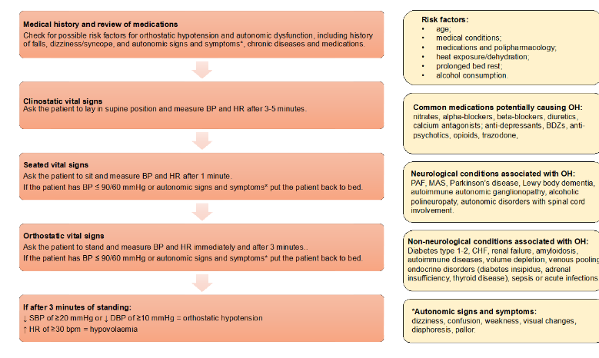
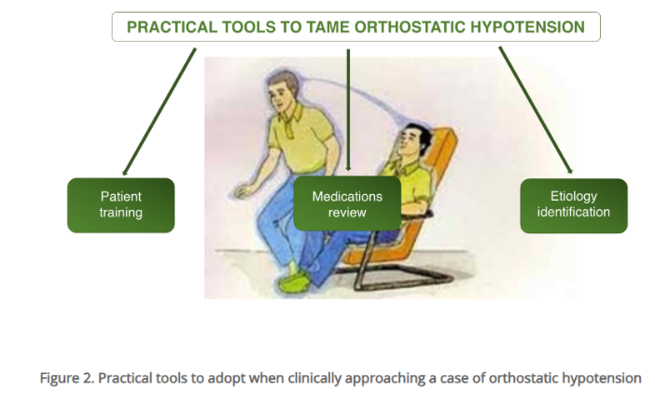
Cacciatore, Spadafora and Landi., (2022).

References
Allied Health Professions’ Support Worker Competency, Education, and Career Development Framework. (n.d.). Available at: https://www.hee.nhs.uk/sites/default/files/documents/AHP_Framework%20Final_0.pdf. Accessed 25 April 2024.
Arik, F., Soysal, P., Capar, E., Kalan, U., Smith, L., Trott, M. and Isik, A.T. (2020). The association between fear of falling and orthostatic hypotension in older adults. Aging Clinical and Experimental Research. Available at: Doi: HTTPs://doi.org/10.1007/s40520-020-01584-2. Accessed 12 April 2024.
Baltes, M., Herber, O.R., Meyer, G. and Stephan, A. (2022). Fear of falling from the perspective of affected persons—A systematic review and qualitative meta‐summary using Sandelowski and Barroso’s method. International Journal of Older People Nursing. Available at: Doi: HTTPs://doi.org/10.1111/opn.12520. Accessed: 28 February 2024.
Bannigan, K. and Moores, A., (2009). A model of professional thinking: Integrating reflective practice and evidence-based practice. Canadian Journal of Occupational Therapy, 76(5), pp.342-350.
Bhanu, C., Petersen, I., Orlu, M., Davis, D. and Walters, K. (2022). Incidence of postural hypotension recorded in UK general practice: an electronic health records study. British Journal of General Practice. Available at: Doi: HTTPs://doi.org/10.3399/BJGP.2022.0111. Accessed 11 April 2024.
Cacciatore, S., Spadafora, L. and Landi, F. (2022). Orthostatic hypotension in elderly: Do you measure orthostatic and clinostatic blood pressure? Heart, Vessels and Transplantation. Available at: Doi: HTTPs://doi.org/10.24969/hvt.2022.349. Accessed 30 April 2024.
‌

Castro, P., Vadera, S., Bancroft, M.J., Buttell, J. and Kaski, D. (2021). Case Report: Acute Onset Fear of Falling and Treatment With ‘Cognitive Physical Therapy’. Frontiers in Neurology, Available at: 12. Doi: HTTPs://doi.org/10.3389/fneur.2021.707840. Accessed 10 April 2024
Cleveland Clinic (2020). Low Blood Pressure (Orthostatic Hypotension): Causes, Symptoms & Treatments. Cleveland Clinic. Available at: https://my.clevelandclinic.org/health/diseases/9385-low-blood-pressure-orthostatic-hypotension. Accessed: 12 February 2024
Dani, M., Dirksen, A., Taraborrelli, P., Panagopolous, D., Torocastro, M., Sutton, R. and Lim, P.B. (2021). Orthostatic Hypotension in Older people: considerations, Diagnosis and Management. Clinical Medicine, 21(3), pp. e275–e282. Available at: Doi: HTTPS://doi.org/10.7861/clinmed.2020-1044. Accessed 11 April 2024.
DFID Health Systems Resource Centre (2001). Clinical governance in the UK NHS.] GOV.UK. Available at: https://assets.publishing.service.gov.uk/media/57a08d59ed915d622c001935/Clinical-governance-in-the-UK-NHS.pdf. Accessed 25 April 2024.
Diamant, R., Pitonyak, J. S., Corsilles-Sy, C., & James, A. B. (2018). Examining Intraprofessional Competencies for Occupational Therapist and Occupational Therapy Assistant Collaboration. Occupational Therapy In Health Care, 32(4), 325–340. Available at: https://doi.org/10.1080/07380577.2018.1465211. Accessed 25 April 2024.
Gilani, A., Juraschek, S.P., Belanger, M.J., Vowles, J.E. and Wannamethee, S.G. (2021). Postural hypotension. BMJ, 373(8289), p.n922. Available at: Doi: HTTPs://doi.org/10.1136/bmj.n922. Accessed: 28 February 2024
Grindell, C., Coates, E., Croot, L. and O’Cathain, A. (2022). The use of co-production, co-design and co-creation to mobilise knowledge in the management of health conditions: a systematic review. BMC Health Services Research, 22(1). Available at: Doi: HTTPs://doi.org/10.1186/s12913-022-08079-y. Accessed 23 April 2023.
Honaker, J., Kretschmer, L., Daniel, E., Choo, P. and Shumrick (2006). A Team Approach Risk of Falling Assessment and Remediation Program for Community Dwelling Older Adults with a Fear of Falling and Balance Disorders. Available at: HTTPS://etd.ohiolink.edu/acprod/odb_etd/ws/send_file/send?accession=ucin1163703882&disposition=inline. Accessed 12 April 2024.
Kiernan, N. and Freehill, L. (2022). Exploring the Outcomes of an Occupational Therapy Led Falls Education Group in the Acute Hospital Setting. International Journal of Integrated Care, 22(S3), p.147. Available at: Doi: HTTPs://doi.org/10.5334/ijic.icic22311. Accessed 18 April 2024.
Lei, L.Y., Chew, D.S. and Raj, S.R. (2020). Differential diagnosis of orthostatic hypotension. Autonomic Neuroscience, 228, p.102713. Available at: Doi: HTTPs: //doi.org/10.1016/j.autneu.2020.102713. Accessed 30 March 2024.
Leland, N.E., Elliott, S.J., O’Malley, L. and Murphy, S.L. (2012). Occupational Therapy in Fall Prevention: Current Evidence and Future Directions. American Journal of Occupational Therapy, 66(2), pp.149–160. Available at: Doi: HTTPs://doi.org/10.5014/ajot.2012.002733. Accessed 18 April 2024.
Lloyd-Smith, W. (1997). Evidence-Based Practice and Occupational Therapy. British Journal of Occupational Therapy, 60(11), pp.474–478. Available at: Doi: HTTPs://doi.org/10.1177/030802269706001103. Accessed 21 April 2024.
McMullin, C. and Needham, C., (2018). Co-production in healthcare. In Co-production and co-creation (pp. 151-160). Routledge.
Mol, A., Bui Hoang, P.T.S., Sharmin, S., Reijnierse, E.M., van Wezel, R.J.A., Meskers, C.G.M. and Maier, A.B. (2019). Orthostatic Hypotension and Falls in Older Adults: A Systematic Review and Meta-analysis. Journal of the American Medical Directors Association, 20(5), pp.589-597.e5. Available at: Doi: HTTPs://doi.org/10.1016/j.jamda.2018.11.003. Accessed 12 April 2024.
National Institute for Health and Care Excellence (2023). Recommendations | Head injury: assessment and early management | Guidance | NICE. www.nice.org.uk. Available at: https://www.nice.org.uk/guidance/ng232/chapter/recommendations#criteria-for-doing-a-ct-head-scan. Accessed: 13 February 2024.
Painter, J.A., Allison, L., Dhingra, P., Daughtery, J., Cogdill, K. and Trujillo, L.G. (2012). Fear of Falling and Its Relationship with Anxiety, Depression, and Activity Engagement Among Community-Dwelling Older Adults. American Journal of Occupational Therapy, 66(2), pp.169–176. Available at: Doi: HTTPs://doi.org/10.5014/ajot.2012.002535. Accessed 11 April 2024.
Public Health Wales (2023) Available at: https://phw.nhs.wales/about-us/policies-and-procedures/policies-and-procedures-documents/clinical-governance. Accessed 25 April 2024.
Ricci, F., De Caterina, R. and Fedorowski, A. (2015). Orthostatic Hypotension. Journal of the American College of Cardiology, 66(7), pp.848–860. Available at: Doi: HTTPs://doi.org/10.1016/j.jacc.2015.06.1084. Accessed 30 March 2024.
Ringer, M. and Lappin, S.L. (2020). Orthostatic Hypotension. PubMed. Available at: https://www.ncbi.nlm.nih.gov/books/NBK448192/ Accessed: 28 February 2024.
Rivasi, G., Rafanelli, M., Mossello, E., Brignole, M. and Ungar, A. (2020). Drug-Related Orthostatic Hypotension: beyond Anti-Hypertensive Medications. Drugs & Aging, 37(10), pp.725–738. Available at: Doi: HTTPs://doi.org/10.1007/s40266-020-00796-5. Accessed 28 February 2024.
Shafaroodi, N., Kamali, M., Parvizy, S., Mehraban, A.H. and O’Toole, G. (2014). Factors affecting clinical reasoning of occupational therapists: a qualitative study. Medical journal of the Islamic Republic of Iran, 28(8), p.8. Available at: HTTPs://www.ncbi.nlm.nih.gov/pmc/articles/PMC4154286/. Accessed 23 April 2024.
Wiig, S., Storm, M., Aase, K., Gjestsen, M. T., Solheim, M., Harthug, S., Robert, G. and Fulop, N. (2013) ‘Investigating the use of patient involvement and patient experience in quality improvement in Norway: Rhetoric or reality?’, BMC Health Services Research, 13(1)
Williams, O., Sarre, S., Papoulias, S.C. et al. Lost in the shadows: reflections on the dark side of co-production. Health Res Policy Sys 18, 43 (2020). Available at: HTTPs://doi.org/10.1186/s12961-020-00558-0. Accessed 23 April 2023.
Wu, S.Y.F., Brown, T. and Yu, M. (2020). Older Adults’ Psychosocial Responses to a Fear of Falling: A Scoping Review to Inform Occupational Therapy Practice. Occupational Therapy in Mental Health, 36(3), pp.1–37. Available at: Doi: HTTPs://doi.org/10.1080/0164212x.2020.1735977. Accessed 18 April 2024.
Xu, Q., Ou, X. and Li, J. (2022). The risk of falls among the aging population: A systematic review and meta-analysis. Frontiers in Public Health, 10. Available at: Doi: HTTPs://doi.org/10.3389/fpubh.2022.902599. Accessed: 12 February 2024

‌

