BMSW6104-Strategic Management for SMEs

Module Name: Strategic Management for SMEs
Module Code: BMSW6104
Student Name:Andreea Oana VLasceanu
Student ID:2108084
Lecturer name: Dr Oluwaseun Adegbite

Contents
Introduction 3
Main Body 4
Task 1: Strategic Plan of Milton Sandford Wines Ltd. 4
Critically appraise the current strategic direction of Milton Sandford Wines Ltd. 4
Using environmental scanning tools such as PESTLE and SWOT, a critical analysis of external and internal environment with the aim of identifying the big picture of the organisation 6
A stakeholder analysis and critical evaluation of the expectations of the different stakeholders and their relative power. 10
Strategic growth choices for SMEs in markets and proposing a new strategy with justification for sustainable strategy in the long-term 12
Strategic recommendations 14
Task 2: Individual Presentation 15
Conclusion 24
References 25

Introduction
The aim of the report is to prepare a strategic and sustainable business strategy for Milton Sandford Wines Ltd. as a chosen business using a variety of scanning tools. Initially, it prescribes a briefing of the case study based on SMEs context using the implications of prior studies (Milshina & Vishnevskiy, 2017). It also comes up with the remaining strategic direction of the selected venture. Besides, it presents a big picture of organisational environment using the framework of SWOT and PESTLE respectively to highlight the challenges and opportunities for more strategic and sustainable business journey (Ojha et al., 2023). With stakeholder analysis, it describes a comment on the expectations and exercising power of involved stakeholders with the organisation. Furthermore, it discusses the strategic growth opportunities and proposes the most sustainable one with its justification for accelerating the growth of the organisation in the long run (Pavlák & Písař, 2020). Eventually, it provides a few recommendations so that the organisation can encounter existing and upcoming biases towards seamless and strategic development.

Main Body

Task 1: Strategic Plan of Milton Sandford Wines Ltd.

Critically appraise the current strategic direction of Milton Sandford Wines Ltd.
Around 98% of total private enterprises in the UK are classed into this category. SMEs are considered a cornerstone of social and economic development because they create employment opportunities, enhance productivity, foster innovation as well as help capital formation (Angeloska-Dichovska et al., 2022). In general, this type of enterprise employs 0 to 499 people whereas small enterprises (1-49), medium-sized (50-499) and the turnover is less than 100 million (Caiazza, 2015). Statistical evidence shows that about 5.51 million SMEs operate the business in the UK which provides a huge contribution to the economy (Dess et al., 2021). SMEs create employment opportunities for more than 60% of total employees employed in the private sector and the contribution is more than 50% of the privet sector's turnover.
Milton Sandford Wines Ltd. is an SME that operates its business in the UK market by producing premium quality wine. Doerga (2017) stated that the founders of the company utilise their experiences and expertise to establish Milton Sandford Wines Ltd. in a sustainable and customised manner. The company designs its wine portfolio by considering individual perceptions and demands (Evans, 2019). The company focuses on creating employment opportunities for the local community and is committed to providing superior customer values. The company grabs a strong market position with product diversity, innovation, reliability as well as professionalism (Garengo, 2018). Therefore, it has to face the challenges of market competition, demand fluctuation, the changing nature of the market, and new market segmenting criteria.
In general, strategic direction refers to the way of determining business workforces, core processes, business objectives, goals, vision, missions, and values that enforce business toward success (Ginter et al., 2018). A business sets its goals or objectives and sets strategic directions to fulfill the setting objectives. Strategic direction includes a set of action plans that need to be implemented to perform in a certain manner (Henry, 2021). It works as a framework that is based on priorities, business scope, and current policies. Milton Sandford Wines Ltd. has some current strategic directions that build connections among business vision, mission, and founders' expectations (Hill et al., 2017). Those strategic directions determine the workforce for the business as well as assist in prioritising the core operational tasks. Here, the current strategic direction analysis of Milton Sandford Wines Ltd. includes the following discussion:
Vision
Vision is generally related to long-term business objectives about where the business wants to establish itself in the future. Jones & Sisay (2014) proclaimed that vision is the highlight of Milton Sandford Wines Ltd.’s ultimate objectives and the company sets its mission based on it. As the company sets its vision to become a renowned wine supplier with premium quality, it modifies its current business operation and activities by considering visionary objectives.
Mission
A mission is aligned with what a company's purpose is and why it operates its business. Lynch (2018) argued that businesses use the mission as a framework and design workforce to achieve ultimate objectives. Here, Milton Sandford Wines Ltd. sets its mission to acquire a market leadership position in the premium wine market by considering consumers' perceptions and quality rather than quantity.
Current strategic initiatives
Milton Sandford Wines Ltd introduces some current strategic initiatives for contributing to overall business performance (Md. Dahalin, 2020). The company focuses on a product diversification policy based on individual customers' choices as well as cultural dimensions. In the case of business operations and production, the company enables sustainable practices to minimise the environmental impact as well as reduce winemaking wastages (Meluchová & Vlčko, 2023). Besides, the company enables technological adaptations that result in efficient operation, healthy management, and fluent customer engagement.
Opportunities and challenges
The company is thinking about an expansion plan worldwide by using a distinctive distribution channel. Here, the company follows a direct customer engagement approach that allows immediate feedback (Mihaylova & Papazov, 2022). Therefore, the company faces challenges in terms of mitigating competition, ensuring distribution in new market segments, and maintaining the supply chain by considering brand perception.

Using environmental scanning tools such as PESTLE and SWOT, a critical analysis of external and internal environment with the aim of identifying the big picture of the organisation
SWOT Analysis of Milton Sandford Wines Ltd.
SWOT analysis is a tool that is used for assessing the Strengths, Weaknesses, Opportunities, and Threats of companies (Dess et al., 2021). The tool provides companies with a framework of what to do in the days to come. Following is the SWOT analysis of Milton Sandford Wines Ltd.

Figure: SWOT Analysis of Milton Sandford Wines Ltd. (Self-made)
Strengths
Over the years, Milton Sandford Wines Ltd has been successful in building strong brand recognition by ensuring high-quality wines of a wide range. Doerga (2017) mentioned that this strong brand recognition has led to an ease for the company in the process of market positioning and loyalty programme management. Apart from the benefits of strong brand recognition and a wide range of wines, Milton Sandford Wines Ltd enjoys superiority in its product distribution process. The company has an extensive distribution network (Evans, 2019). Through this extensive distribution network, the company ensures that its products reach both the domestic customers and the international customers (Garengo, 2018). This extensive distribution process also allows the company to exercise, to an extent, control over the overall industry.
Weaknesses
The cost of production, vineyard maintenance, harvesting, and processing is comparatively high for Milton Sandford Wines Ltd. This high cost, in some cases, has a noticeable impact on the margin of profitability (Ginter et al., 2018). Besides the high-cost issue, Milton Sandford Wines Ltd suffers from its dependency on seasonal factors. As the company relies heavily on grapes, The seasonal fluctuations in grape harvest largely affect the level of production and the level of overall revenue (Henry, 2021). In addition to these, the company has limited production capability and this limited production capability is likely to be unable to meet the future demands of wines capitalize on market opportunities.
Opportunity
With time passing by, the demand for premium wines is increasing dramatically and this increasing demand for premium wines is very likely to keep increasing in the future. In this case, Milton Sandford Wines Ltd, a renowned premium wine producer, will have a chance to expand its customer base and have a positive impact on the level of its overall revenue (Hill et al., 2017). With the increasing demand for premium wines, the advancement of e-commerce has come as a new opportunity. Using electronic commerce, it is possible for Milton Sandford Wines Ltd to reach new customers and expand its distribution channels (Jones & Sisay, 2014). Besides the increasing demand and the advancement of e-commerce, the comparatively new concept “Wine Tourism” has added a new level to the wine industry. Milton Sandford Wines Ltd can exploit the market of wine tourism.
Threat
In general, the wine industry is highly competitive. In this competitive industry, Milton Sandford has to face extreme competition from a number of existing competitors (Lynch, 2018). Apart from these existing competitors, the company has to face the threat of new entrants. With this competition has been added the impact of climate. Due to climate changes, the production of grapes is greatly being hampered, and this is posing a significant threat to the overall wine industry (Meluchová & Vlčko, 2023). In addition to those, the recent economic downturn has decreased the ability of consumers to spend and this has appeared as a notable threat to the wine industry.
PESTLE Analysis of Milton Sandford Wines Ltd
According to Mihaylova & Papazov (2022), PESTLE analysis, a tool for business analysis of political, economic, social, and technological factors, provides an external analysis of the environments in which business organisations operate their business operations. The analysis guides the future course of actions that business organisations will take. Following is the PESTLE analysis of Milton Sandford Wines Ltd.
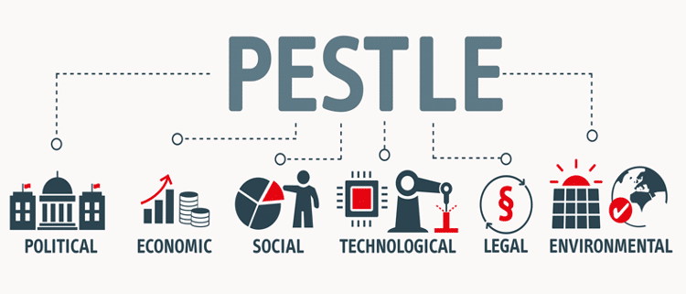

Figure: PESTLE Analysis of Milton Sandford Wines Ltd. (Miladi, 2014)
Political
The wine industry usually goes through a number of government regulations regarding alcohol production, labelling, and distribution. Milshina & Vishnevskiy (2017) reported that as a player in this industry, Milton Sandford Wines Ltd is likely to be affected by any changes in government regulations regarding alcohol production, labelling, and distribution. To the degree that government regulations regarding alcohol production, labelling, and distribution matter, trade policies play a crucial role in the wine industry (Ojha et al., 2023). Any changes regarding tariffs or trade agreements among different countries can have a serious impact on Milton Sandford Wines Ltd's exports and imports, and thus affect the company’s operations internationally and the level of profitability.
Economic
The recent economic downturn has resulted in a decrease in the level of disposable income and a lack of confidence. Pavlák & Písař (2020) proclaimed that this decrease in the level of disposable income and a lack of confidence are very likely to negatively influence the purchasing decisions for products like premium wines and thus have an effect on the demand for the wines of Milton Sandford Wines Ltd. Apart from this, the continuous fluctuations in the exchange rates will have an impact on the company's export revenues and import costs.

Social
With the passage of time and the advancement of technology, customers’ preferences are shifting toward the concept of sustainability. More customers are now willing to go for options that are sustainable from the process of production to ultimate consumption (Pira & Fleet, 2023). This new shift in customers’ preferences can have an impact on the overall demand. Adaptation to this new shift is required in this case (Raković et al., 2019). Besides this shift, the overall attitude toward alcohol consumption is changing positively and this change will open more opportunities for Milton Sandford Wines Ltd.
Technological
The advancements in technology are playing a crucial role in production efficiency, product quality, and sustainability practices and this process is likely to continue. Using these advancements in technology will provide Milton Sandford Wines Ltd with a competitive advantage (Schilling, 2017). With that, the concept of electronic commerce can help the company reach a wider range of customers and expand the company’s online sales channels.
Legal
In the case of alcohol production and distribution, it is obligatory to ensure labelling requirements, age restrictions, and licensing. Non-compliance can cause Milton Sandford Wines Ltd to face legal repercussions and damage the company's reputation (Zhang, 2023). Apart from that Protecting trademarks, brand names, and proprietary production methods from infringement will allow the company to have a competitive advantage and market position.
Environmental
The changes in climate have greatly affected the growing conditions of grapes, the main ingredient of wines. These changes in climate have resulted in poor quality and vineyard sustainability (Wheelen et al., 2018). In this case, Milton Sandford Wines Ltd is likely to face a lack of raw materials. Aside from that, customers’ awareness of sustainability is increasing. Customers are more likely to go for the options that are sustainable (Mihaylova & Papazov, 2022). In this case, Milton Sandford Wines Ltd is required to go for the practices that are sustainable.

A stakeholder analysis and critical evaluation of the expectations of the different stakeholders and their relative power.
A stakeholder analysis of Milton Sandford Wines Ltd. includes a process of identifying total stakeholders, their influencing ability, expectations from business as well as their relative power. Miladi (2014) reported that a good understanding of stakeholders' influencing ability assists in shaping decision-making ability and helps in determining responding areas in order to win their support. This section includes a comprehensive stakeholder analysis by using a stakeholder power-interest mapping tool (Milshina & Vishnevskiy, 2017). This stakeholder power-interest mapping framework classified total stakeholders into four different categories based on their activities, engagement, power grid as well as influencing ability in the decision-making process.
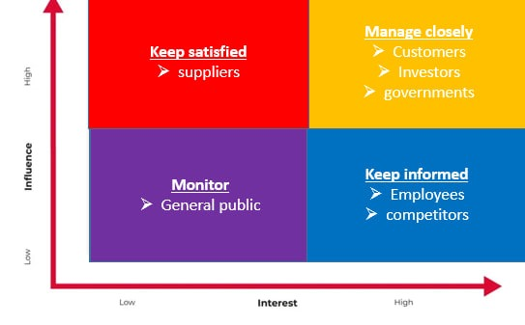
Figure: Stakeholder power-interest mapping tool (Ojha et al., 2023)
- High power, High interest: This section includes customers, investors and government. Those stakeholders have both significant levels of power and interest in business operations, investment and regulations (Pavlák & Písař, 2020).
- High power, Low interest: This type of stakeholder has high bargaining power but low interest in operation (Pira & Fleet, 2023). Such as suppliers who create a strong impact on supply chain management.
- Low power, High interest: Employees and Competitors are considered here. They have a strong interest in business operations but limited ability to influence the decision-making process (Raković et al., 2019).
- Low power, Low interest: This phase includes the general public who have lower power as well as interest and for that, need minimum effort to maintain the relationship (Schilling, 2017).
The expectations of different stakeholders and their relative power
Customers
Most of the business activities are aimed at connecting huge target audiences and turning them into actual customers. According to Wheelen et al. (2018), customers generally expect high quality wine at a reasonable price in a sustainable as well as healthy manner. These high customer expectations are considered the power that influences the Milton Sandford Wines Ltd. revenue progression and decision-making stage (Zhang, 2023). The company should focus on customer preferences with innovation and sustainable practices.
Investors
Investors provide the financial support that is required for operating the business. Investors have a strong interest towards business and they expect exact and transparent financial reporting, proper planning for further investment, satisfied return on investment (AlQershi, 2021). However, investors have high relative power such as managerial body, voting rights etc. This relative power impacts strategic decision-making purposes that will be beneficial for stakeholders or enhance share value.
Employees
Employees perform all the business activities on behalf of the company. Employees expect an efficient remuneration policy, equal compensation, professional development opportunities, training and development program, sound working environment etc. (Angeloska-Dichovska et al., 2022). Employees have a strong interest in business activities but moderate power. Milton Sandford Wines Ltd. should maintain effective communication to get superior outcomes from employees.
Competitors
The competitors of Milton Sandford Wines Ltd. are those who offer similar kinds of wine in the market for sale. Competitors generally expect fair competition within the market and maintain faithful industry relationships and ethical business practices (Ansoff et al., 2018). Besides, competitors have moderate power of influencing ability in wine pricing and marketing strategies. Milton Sandford Wines Ltd. should maintain a collaborative and adaptation manner in order to eliminate biased competition and foster innovation.
Government
The government is a common stakeholder that contributes to every business decision. Generally, the government impose rules and regulations, operational standards, taxation policies etc. to control business activities in order to ensure equal opportunities for all (Caiazza, 2015). The government expect operational standards, ethical practices, environmental consciousness, fair tax return and such (Dess et al., 2021). This high relative power dominates revenue progression and business expansion policy.
Local community
The local community has a low interest as well as low influencing power. This type of stakeholder expects employment opportunities, environmentally conscious policy and community engagement (Doerga, 2017). Businesses need minimal effort to maintain those stakeholders. Milton Sandford Wines Ltd. should implement an effective corporate social responsibility policy that results in raising public opinion, word of mouth marketing, enhancing brand values and revising customer loyalty.

Strategic growth choices for SMEs in markets and proposing a new strategy with justification for sustainable strategy in the long-term
Strategic growth requires capitalising the strength to claim both the on-going and upcoming feasibilities and bypassing the challenges with strategic measures and hedging features. For growing as a leading business venture in the SME industry, Milton Sandford Wines Ltd. requires analysing the dimensions of Ansoff’s growth matrix (Meluchová & Vlčko, 2023). It can track the business to develop a sustainable growth strategy based on the critical evaluation of available growth opportunities (Hill et al., 2017). However, the dimensions of the matrix aligning the business environment of the case company are as follows with the respective briefings:
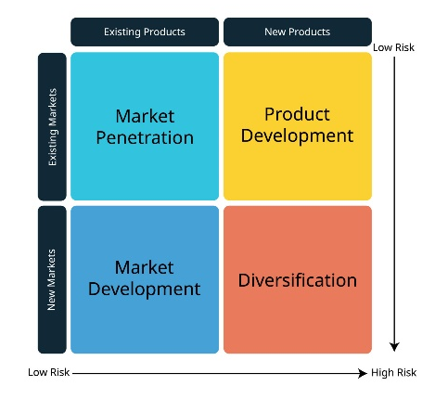

Figure: Ansoff’s Growth Matrix (Lynch, 2018)

Market Penetration
The understanding of market penetration drives the organisation to connect more retailers with broader distribution approach as the products can be readily available before a larger audience (Milshina & Vishnevskiy, 2017). Enhanced reach can result in improved brand conformity to ultimately influence the consumers to a greater extent. It can also offer discount, commission on continuous purchase, and relevant promotional strategy (Mihaylova & Papazov, 2022). Thus, the organisation will be able to increase the volume of sales and the market share to sustainably grow with EOQ and wider reach of products in the operational marketplaces.
Market Development
When the product life cycle of existing products in the existing marketplaces are in their peak, the organisation requires assessing the demands of such products in the newer marketplaces. It helps to continue the business operation with more sales and revenues introducing similar products in the newer segments of marketplace (Ojha et al., 2023). Considering this growth opportunity, the organisation can critically assess the demands of its products in Europe, South Asia, and America as the newer segment for the market development strategy.
Product Development
Complying with the bargaining power of rivalry businesses, the business can go through the line of developing new products for the marketplaces it serves. The newness of products motivates the consume to taste how actually they are (Pavlák & Písař, 2020). To retain existing consumers, the strategy works well and it is effective to influence the new ones too.
Diversification
Mitigating the adverse effects of economic changes, diversification plays a significant role. It provides hedging benefits through which the business remains safe during crisis period. Pira & Fleet (2023) claimed that the concurrent economic condition due to COVID-19, Russia-Ukraine war, and the battle between Israil and Palestine proposes diversification strategy for Milton Sandford Wines Ltd as a sustainable choice to grow and expand the business in the long run with the possible outcomes of generated hedging features.

Strategic recommendations
The critical analysis of the business environment of Milton Sandford Wines Ltd. reveals a variety of challenges. As a result, the business is to approach strategic roadmap so that it can navigate concurrent and upcoming challenges to result the desire level of growth and development (Raković et al., 2019). In doing so, the business is recommended with the following strategic measures:
- Practicing sustainable frameworks with strategic approaches in the newer segments of the marketplace can release the burden of remaining challenges. According to Schilling (2017), it will be resulted in promoting the brand conformity with large sales and increased revenue.
- Connecting a few channels to reach the audience of Europe, South Asia, and America with the offerings of its products can be effective to grow and develop the market share in the long run (Wheelen et al., 2018). It will significantly be helpful to broaden the scope of business operations.
- Diversification strategy is proposed for the business as it can provide stunning performance to hedge the risks and uncertainties (Zhang, 2023). Therefore, the business is highly recommended to apply the implication of the strategy with more diversified products, policies, and processes to ensure the development for the long run in the future.

Task 2: Individual Presentation

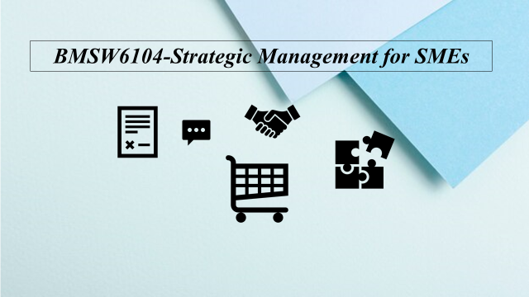
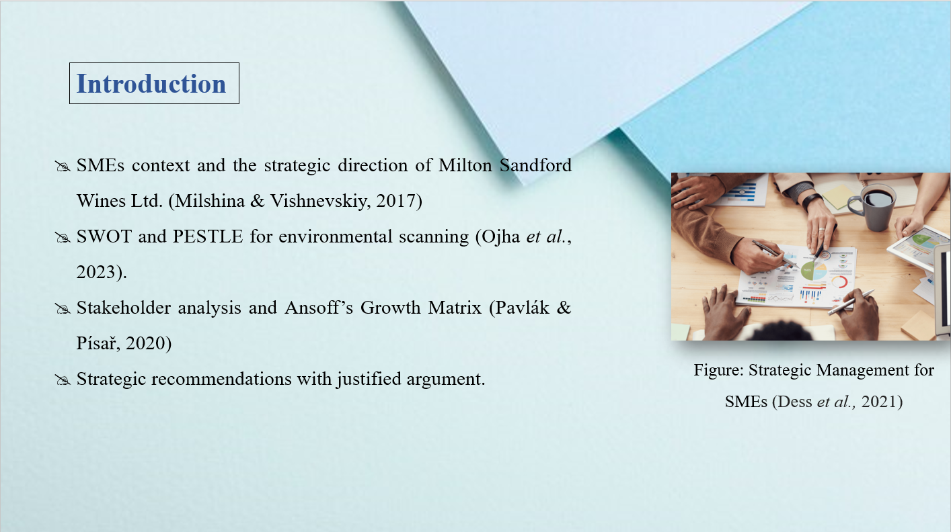
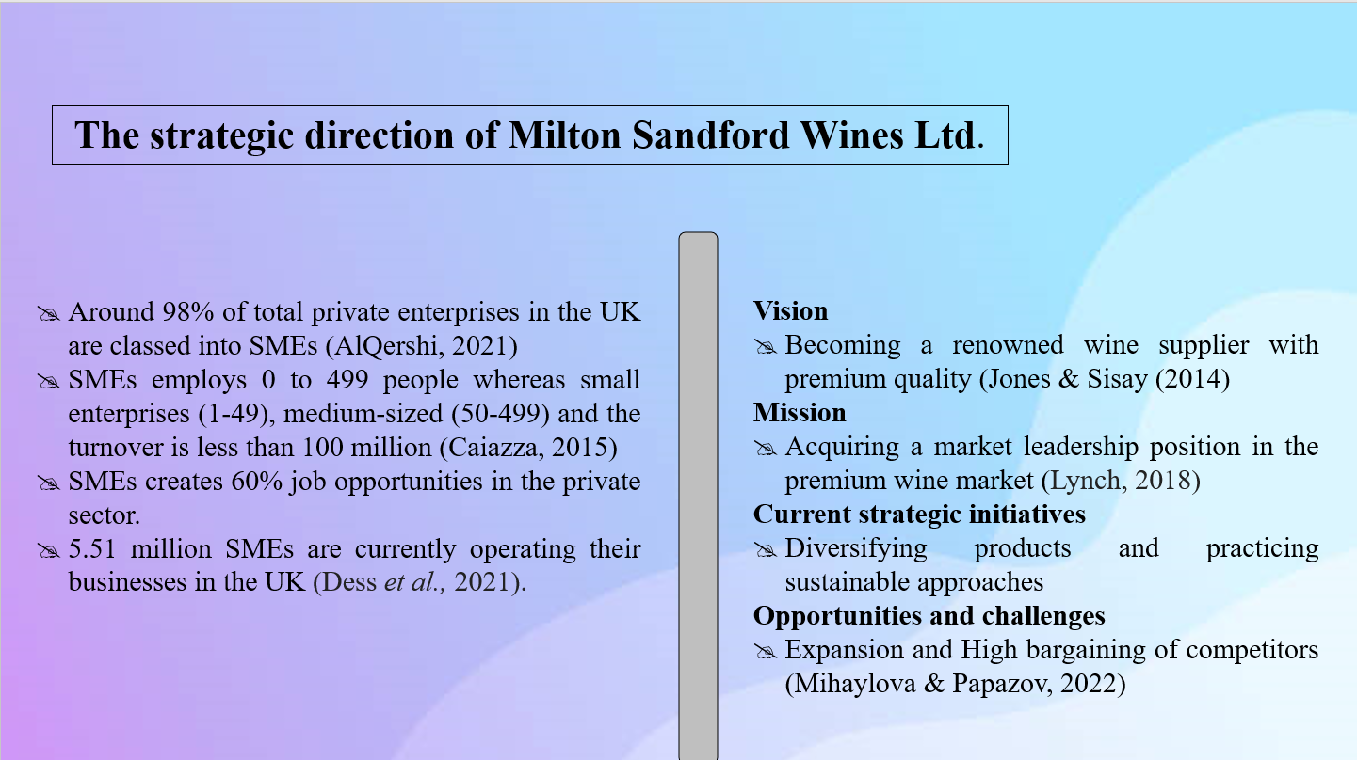
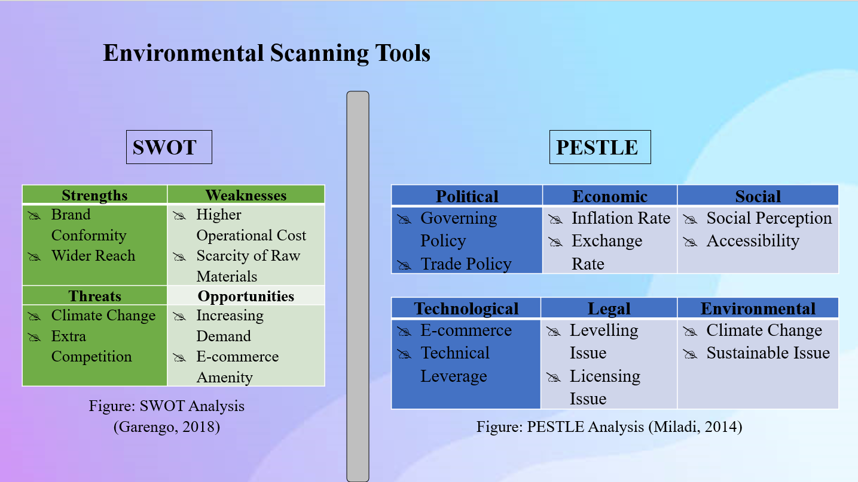
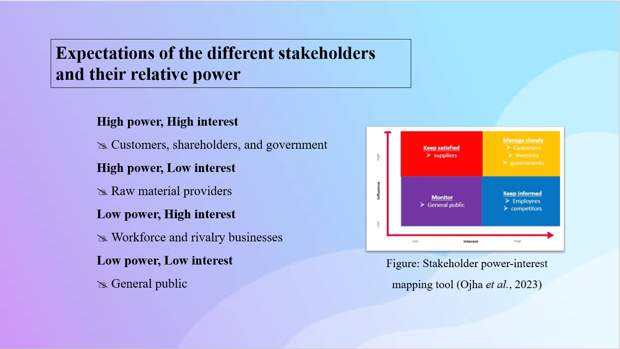
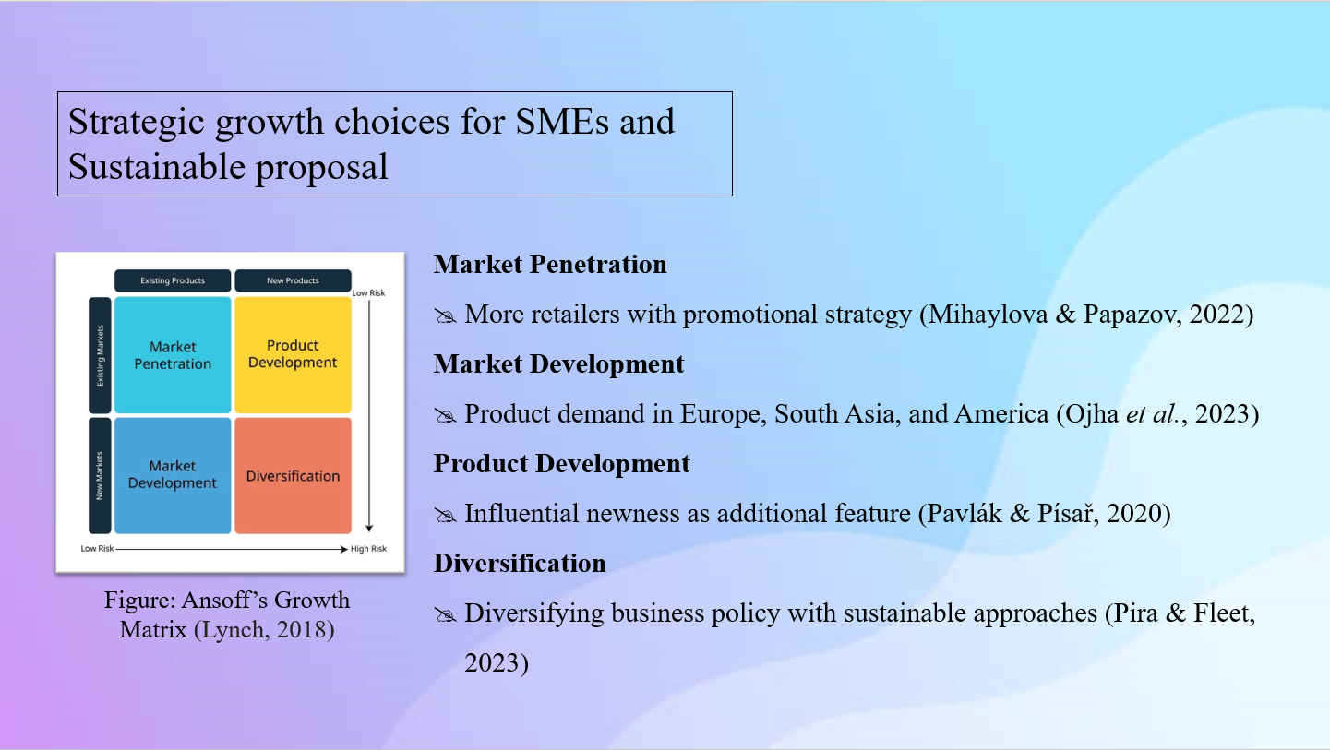
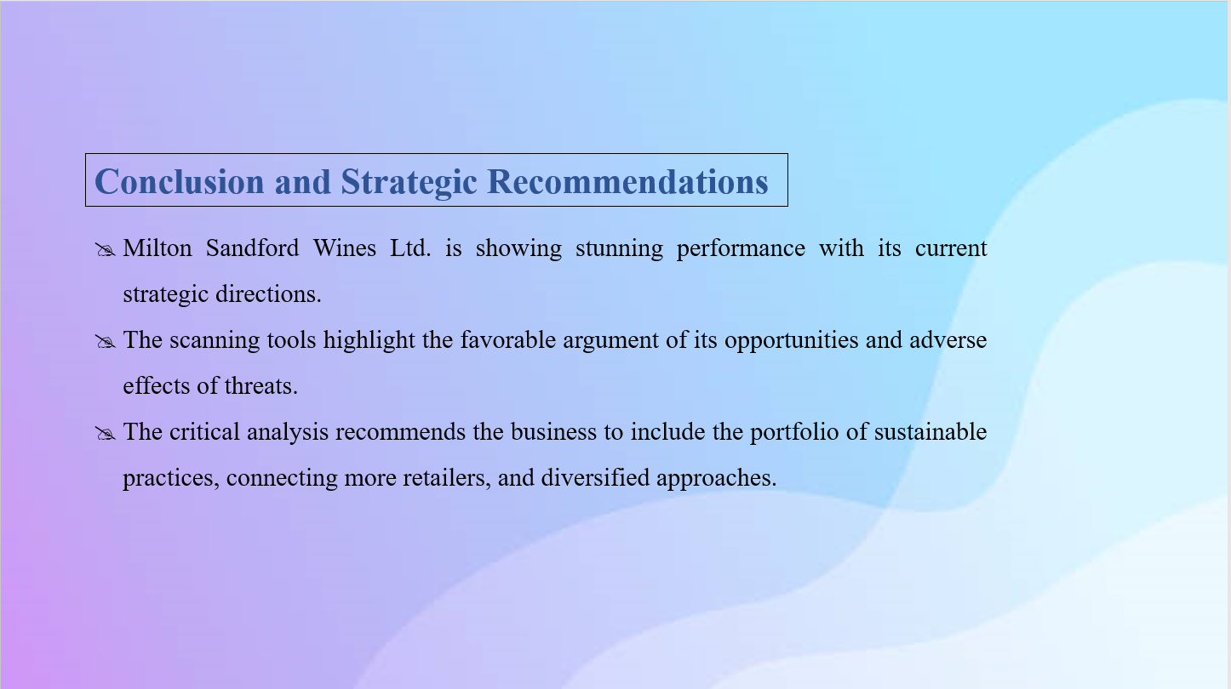
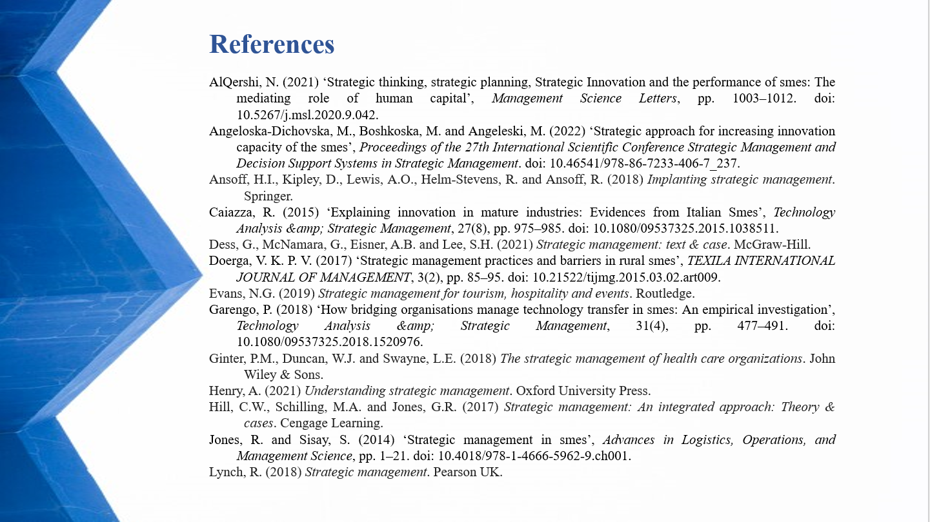
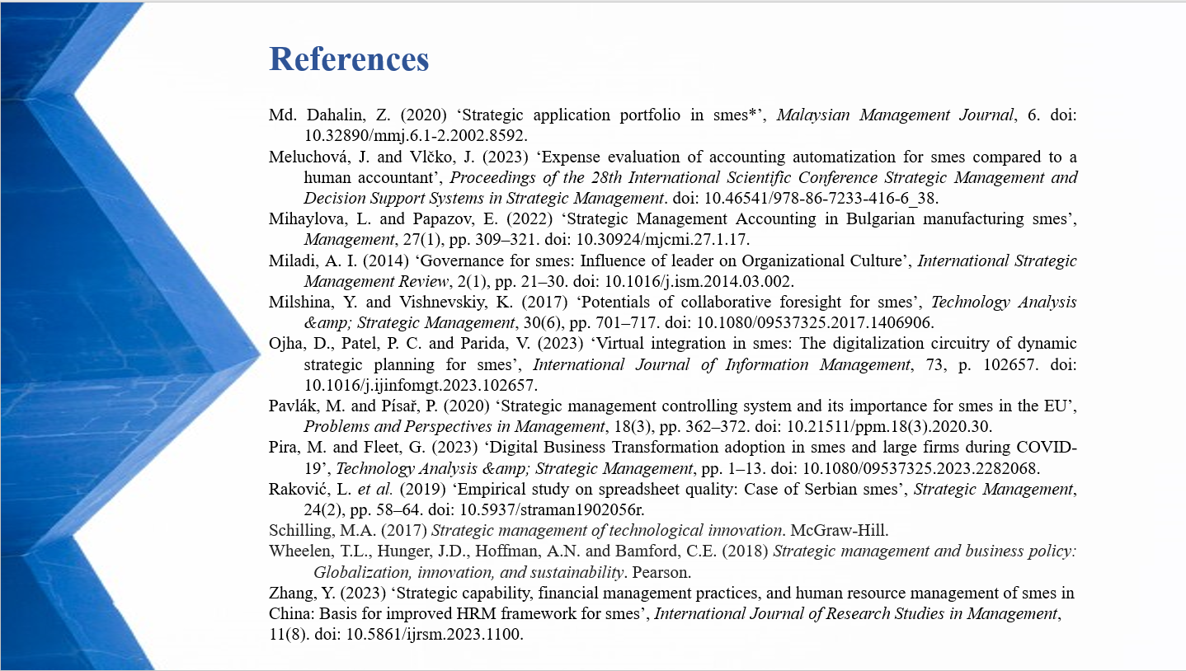

Conclusion
In conclusion, the report has extensively unearthed the processes, functionalities, challenges, and opportunities of strategic management for SMEs aligning the business operations of Milton Sandford Wines Ltd. using various frameworks such as SWOT, PESTLE, Stakeholder Analysis, and Ansoff’s Growth Matrix. The summary of these scanning tools demonstrated that the business is doing well hedging the concurrent challenges with its strengths. To be more strategic for the desire level of growth and development, the organisation is recommended with some strategic measures such as practicing sustainable frameworks, connecting a few more channels, and diversifying the business policies with newness. These recommendations are justified for the strategic and sustainable development in the long run for the future.

References
AlQershi, N. (2021) ‘Strategic thinking, strategic planning, Strategic Innovation and the performance of smes: The mediating role of human capital’, Management Science Letters, pp. 1003–1012. doi: 10.5267/j.msl.2020.9.042.
Angeloska-Dichovska, M., Boshkoska, M. and Angeleski, M. (2022) ‘Strategic approach for increasing innovation capacity of the smes’, Proceedings of the 27th International Scientific Conference Strategic Management and Decision Support Systems in Strategic Management. doi: 10.46541/978-86-7233-406-7_237.
Ansoff, H.I., Kipley, D., Lewis, A.O., Helm-Stevens, R. and Ansoff, R. (2018) Implanting strategic management. Springer.
Caiazza, R. (2015) ‘Explaining innovation in mature industries: Evidences from Italian Smes’, Technology Analysis &amp; Strategic Management, 27(8), pp. 975–985. doi: 10.1080/09537325.2015.1038511.
Dess, G., McNamara, G., Eisner, A.B. and Lee, S.H. (2021) Strategic management: text & case. McGraw-Hill.
Doerga, V. K. P. V. (2017) ‘Strategic management practices and barriers in rural smes’, TEXILA INTERNATIONAL JOURNAL OF MANAGEMENT, 3(2), pp. 85–95. doi: 10.21522/tijmg.2015.03.02.art009.
Evans, N.G. (2019) Strategic management for tourism, hospitality and events. Routledge.
Garengo, P. (2018) ‘How bridging organisations manage technology transfer in smes: An empirical investigation’, Technology Analysis &amp; Strategic Management, 31(4), pp. 477–491. doi: 10.1080/09537325.2018.1520976.
Ginter, P.M., Duncan, W.J. and Swayne, L.E. (2018) The strategic management of health care organizations. John Wiley & Sons.
Henry, A. (2021) Understanding strategic management. Oxford University Press.
Hill, C.W., Schilling, M.A. and Jones, G.R. (2017) Strategic management: An integrated approach: Theory & cases. Cengage Learning.
Jones, R. and Sisay, S. (2014) ‘Strategic management in smes’, Advances in Logistics, Operations, and Management Science, pp. 1–21. doi: 10.4018/978-1-4666-5962-9.ch001.
Lynch, R. (2018) Strategic management. Pearson UK.
Md. Dahalin, Z. (2020) ‘Strategic application portfolio in smes*’, Malaysian Management Journal, 6. doi: 10.32890/mmj.6.1-2.2002.8592.
Meluchová, J. and Vlčko, J. (2023) ‘Expense evaluation of accounting automatization for smes compared to a human accountant’, Proceedings of the 28th International Scientific Conference Strategic Management and Decision Support Systems in Strategic Management. doi: 10.46541/978-86-7233-416-6_38.
Mihaylova, L. and Papazov, E. (2022) ‘Strategic Management Accounting in Bulgarian manufacturing smes’, Management, 27(1), pp. 309–321. doi: 10.30924/mjcmi.27.1.17.
Miladi, A. I. (2014) ‘Governance for smes: Influence of leader on Organizational Culture’, International Strategic Management Review, 2(1), pp. 21–30. doi: 10.1016/j.ism.2014.03.002.
Milshina, Y. and Vishnevskiy, K. (2017) ‘Potentials of collaborative foresight for smes’, Technology Analysis &amp; Strategic Management, 30(6), pp. 701–717. doi: 10.1080/09537325.2017.1406906.
Ojha, D., Patel, P. C. and Parida, V. (2023) ‘Virtual integration in smes: The digitalization circuitry of dynamic strategic planning for smes’, International Journal of Information Management, 73, p. 102657. doi: 10.1016/j.ijinfomgt.2023.102657.
Pavlák, M. and Písař, P. (2020) ‘Strategic management controlling system and its importance for smes in the EU’, Problems and Perspectives in Management, 18(3), pp. 362–372. doi: 10.21511/ppm.18(3).2020.30.
Pira, M. and Fleet, G. (2023) ‘Digital Business Transformation adoption in smes and large firms during COVID-19’, Technology Analysis &amp; Strategic Management, pp. 1–13. doi: 10.1080/09537325.2023.2282068.
Raković, L. et al. (2019) ‘Empirical study on spreadsheet quality: Case of Serbian smes’, Strategic Management, 24(2), pp. 58–64. doi: 10.5937/straman1902056r.
Schilling, M.A. (2017) Strategic management of technological innovation. McGraw-Hill.
Wheelen, T.L., Hunger, J.D., Hoffman, A.N. and Bamford, C.E. (2018) Strategic management and business policy: Globalization, innovation, and sustainability. Pearson.
Zhang, Y. (2023) ‘Strategic capability, financial management practices, and human resource management of smes in China: Basis for improved HRM framework for smes’, International Journal of Research Studies in Management, 11(8). doi: 10.5861/ijrsm.2023.1100.

